**Sri Lanka Institute of Information Technology**



**Data Warehousing & Business Intelligence**

**Assignment 02**

**IT Number – IT20083182**

**Submitted by – Senadeera N. A. J. N.**

**Batch – Year 03 Semester 01 (Y3S1.5.1 (DS))**

Contents

01. Data Source 3

02. SSAS Cube Implementation 3

• *DimDate* 5

• *DimUser* 5

• *DimHotelCategory* 6

• *DimLocation* 6

03. OLAP Operation 8

• Roll Up 8

• *Drill-Down* 9

• *Slicing* 10

• Dice 10

• *Pivot* 11

04. SSRS Reports 12

## Data Source

For this purpose use Hotel_DW as Data warehouse which implemented in last Assignment (Assignment1).

## SSAS Cube Implementation

In here first create data source view using previous implemented data dimensions and fact table.

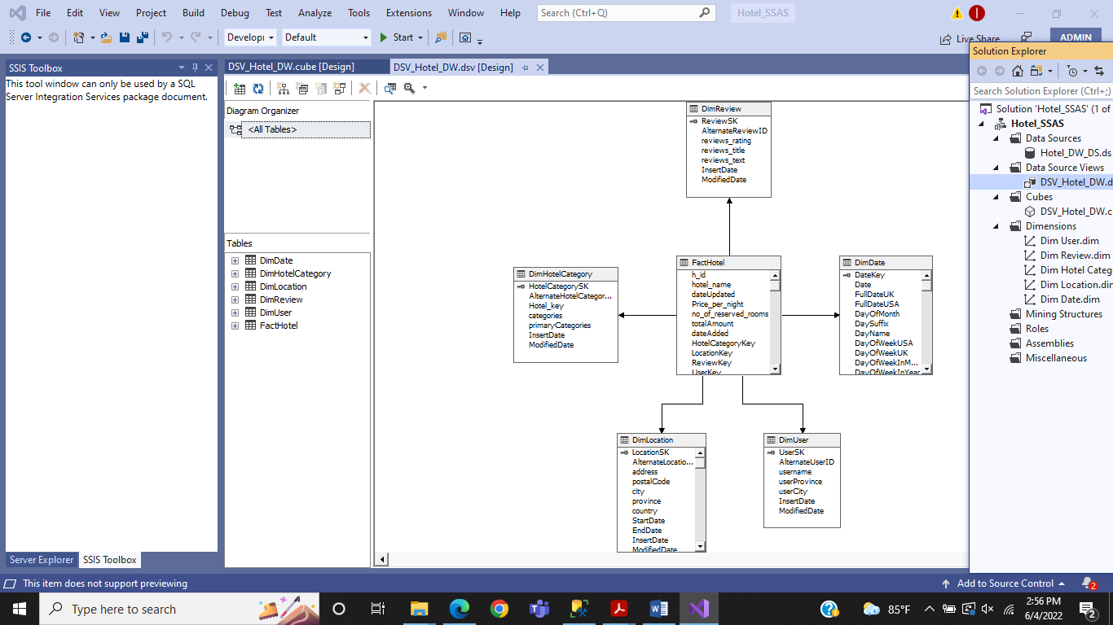

Then create Data Cube,

In here I choose FactHotel as measure group, DimDate, DimLocation, DimHotelcategory, DimUser and DimReview as dimensions.

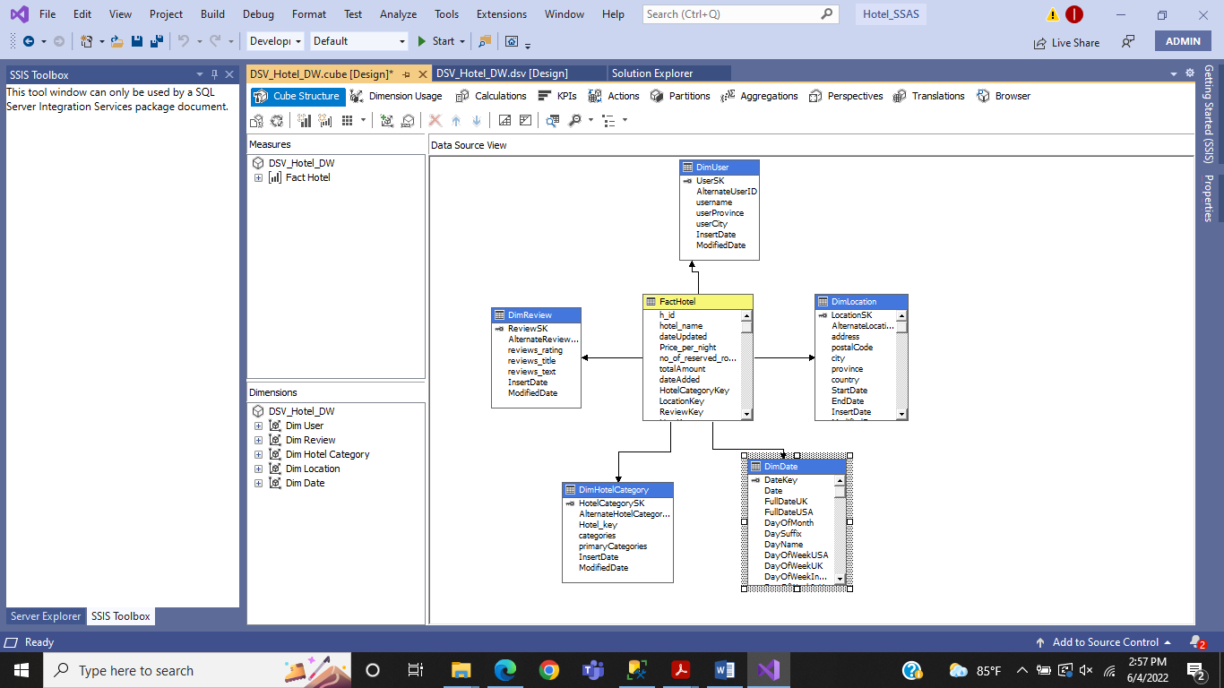

After that configure all the dimension with proper way

### DimDate

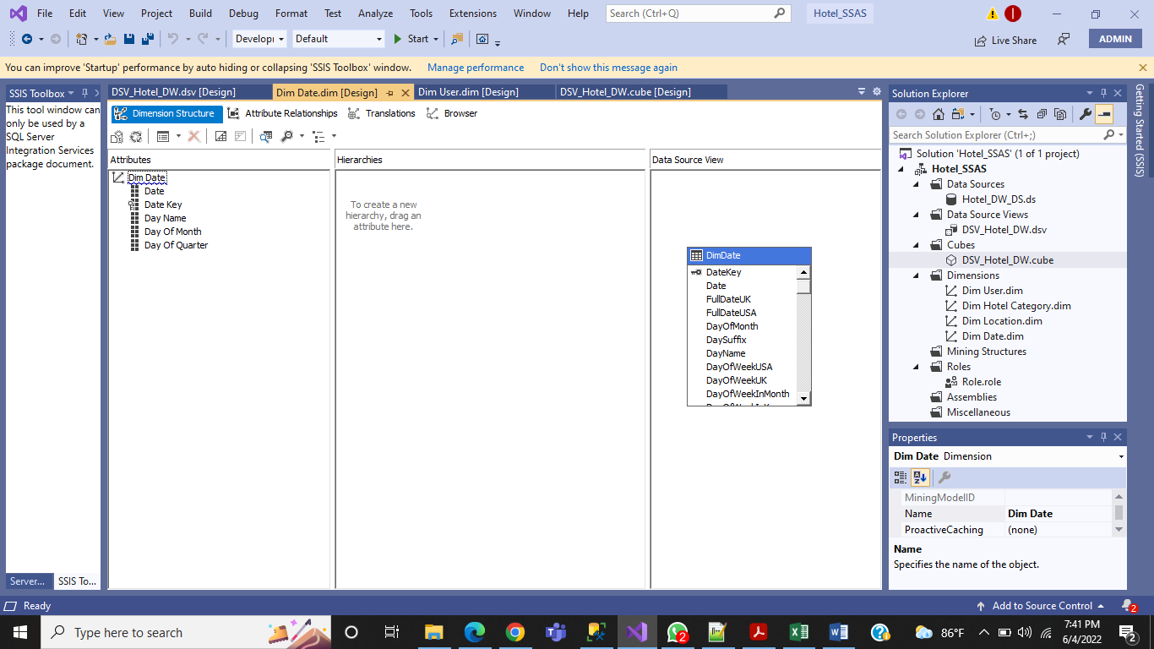

### DimUser

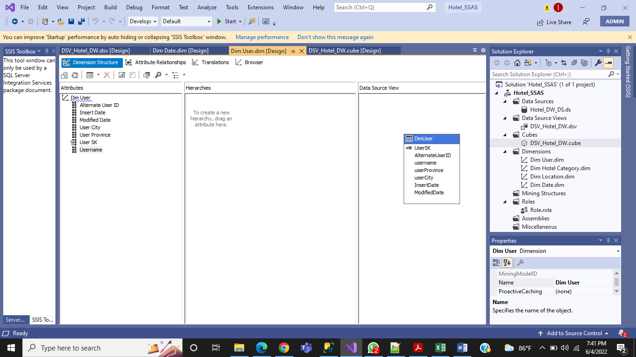

### DimHotelCategory

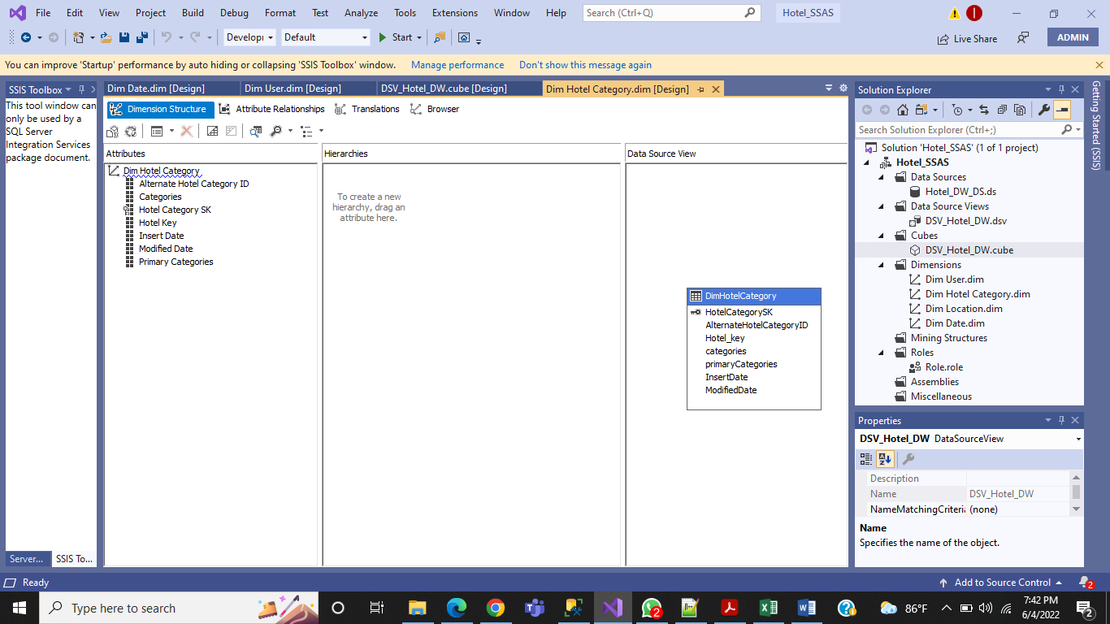

### DimLocation

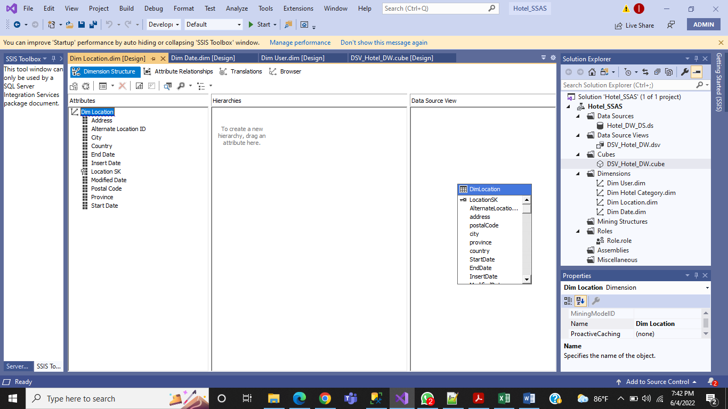

Then Deploy the Cube.

After deploying of this Cube look like this,

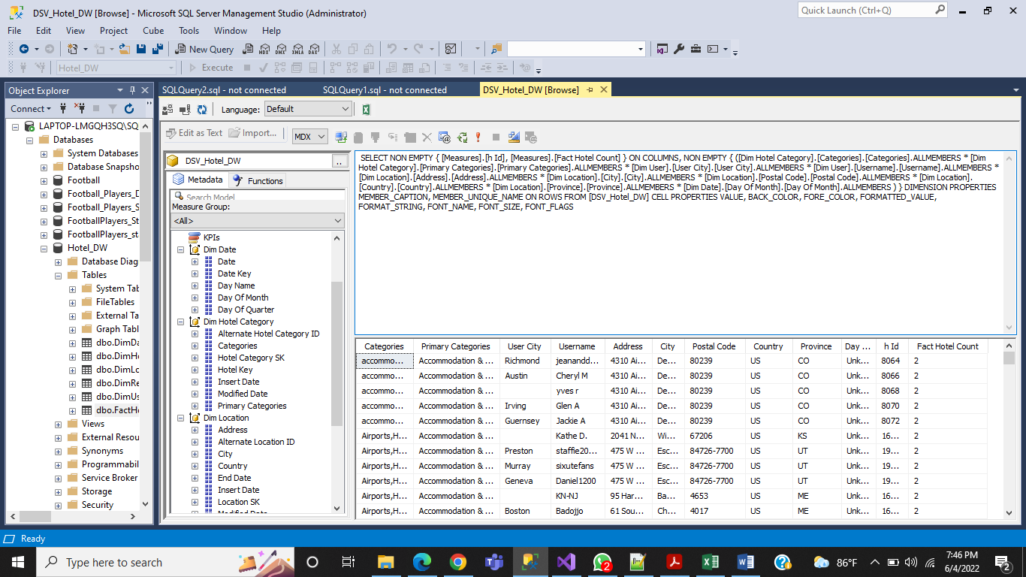

## OLAP Operation

Using Excel Power Pivot, we can do all OLAP operation

### Roll Up

The roll-up operation performs aggregation on a data cube, either by climbing up a hierarchy or by climbing down a hierarchy**.**

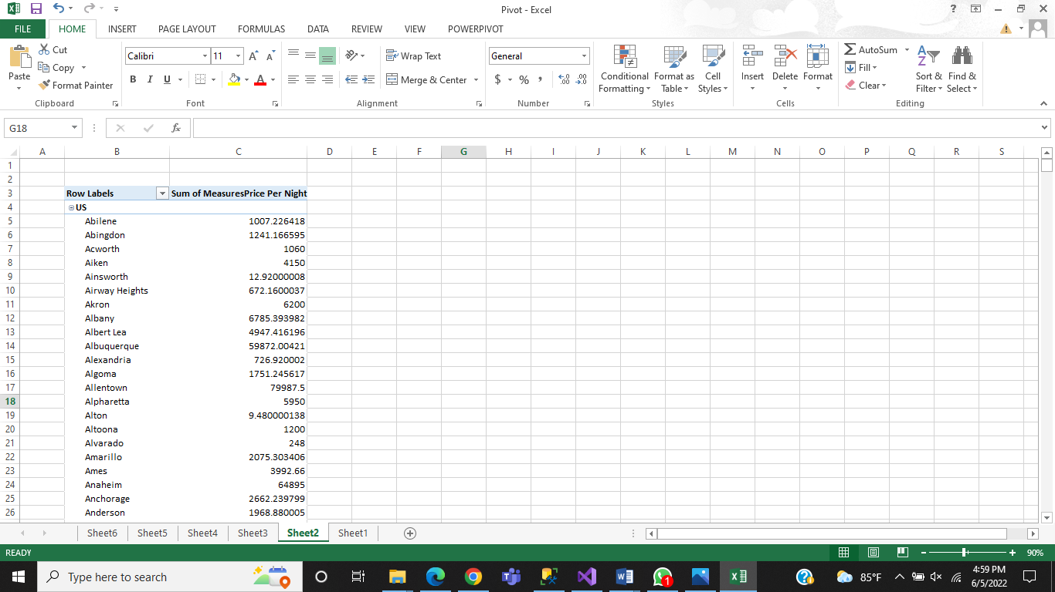

### Drill-Down

The Drill down operation is the reverse of roll up. It navigates from less detailed data to more detailed data.

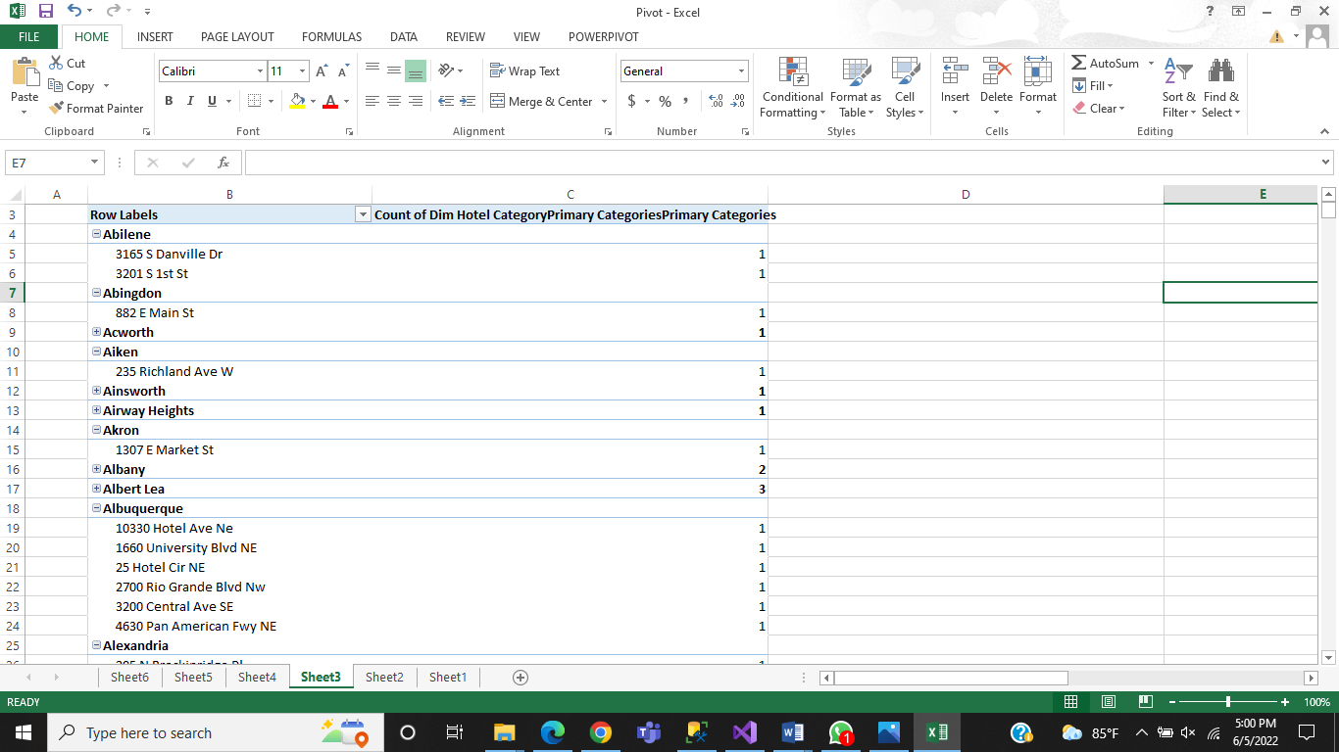

### Slicing

Slice performs a selection on one dimension of the given cube, thus resulting in a sub cube. 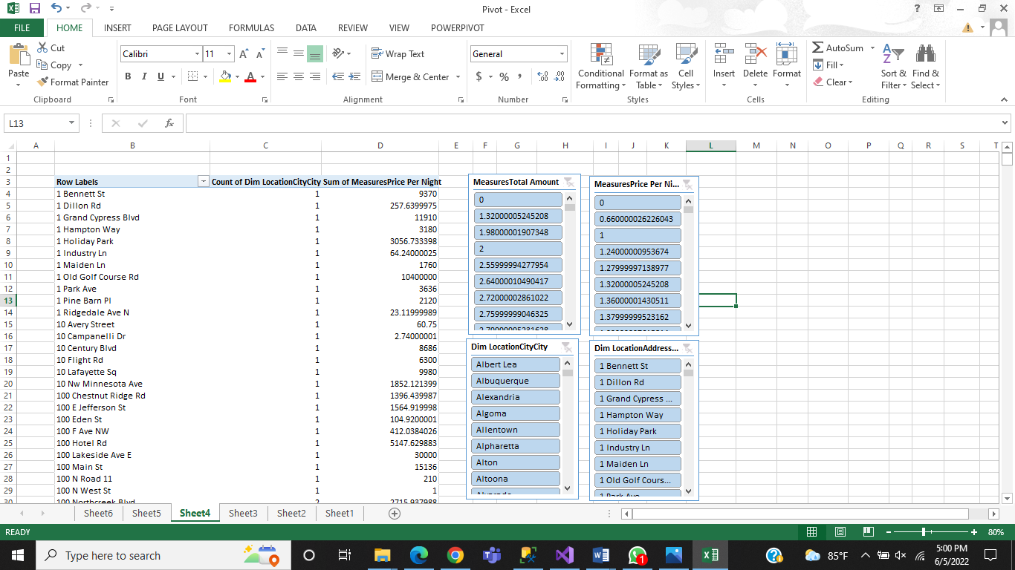

### Dice

The dice operation defines a sub cube by performing a selection on two or more dimensions.

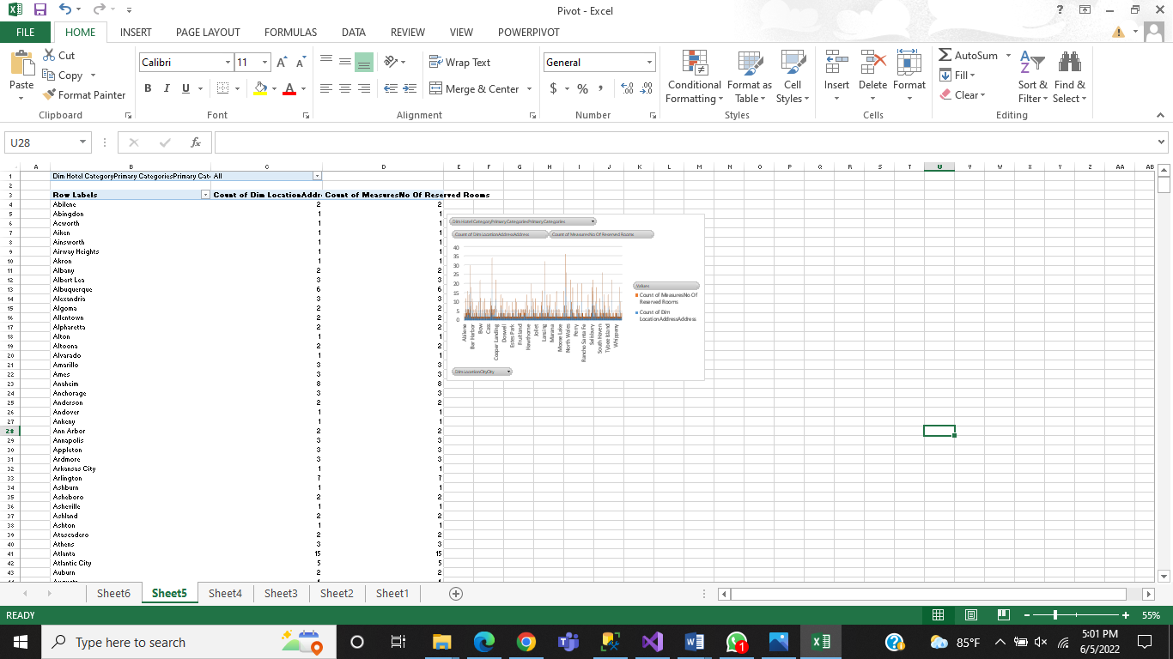

### Pivot

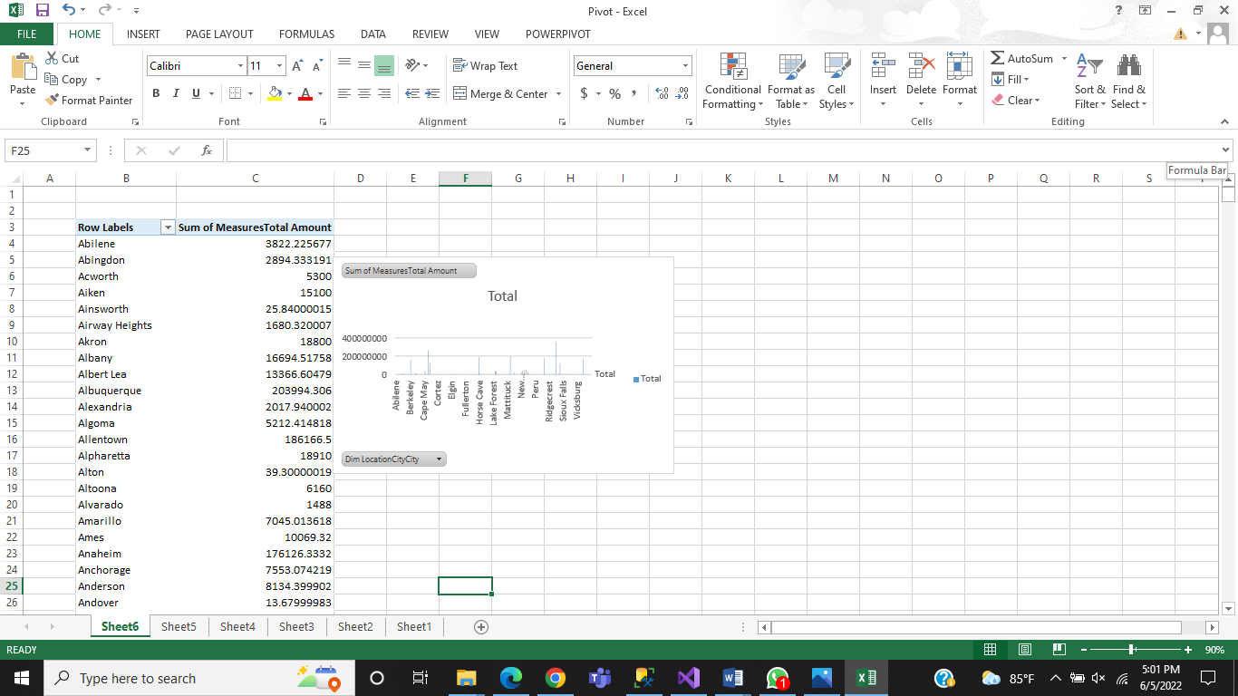

## SSRS Reports

**Report 01:**

Report with Matrix

In here yearly Hotel report Hotel name , Primary category and Price_Per_Room

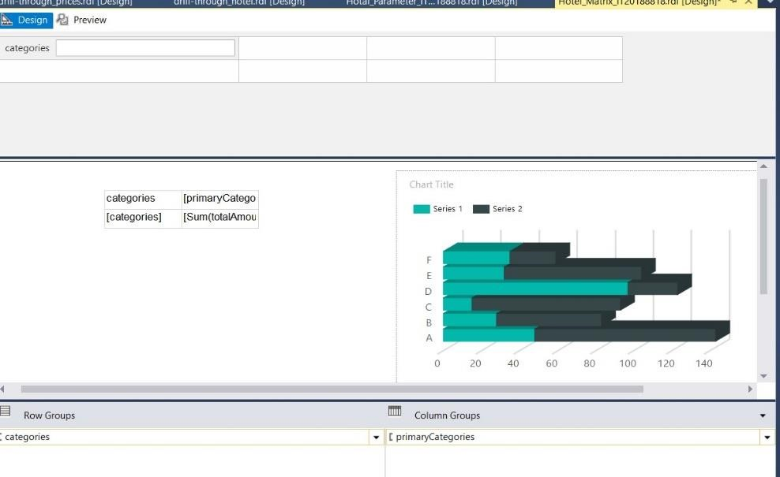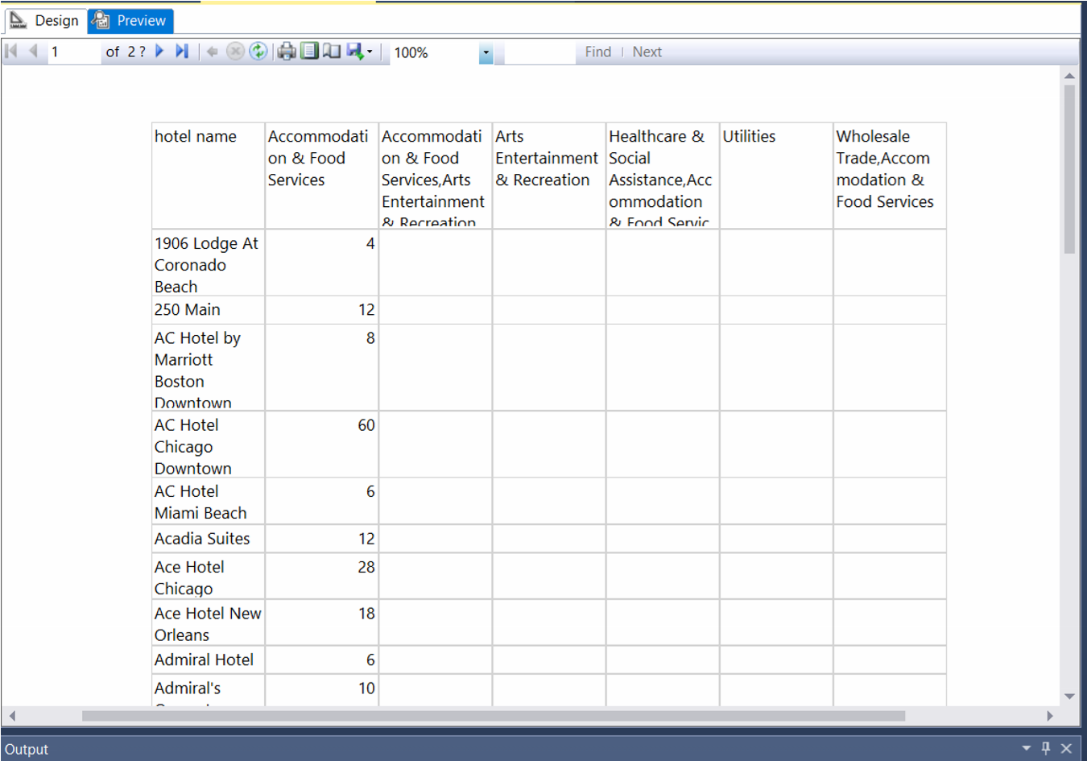

**Report 2:**

Report with more than one parameter this report has

3 parameters

* Categories
* Primary Categories
* Province

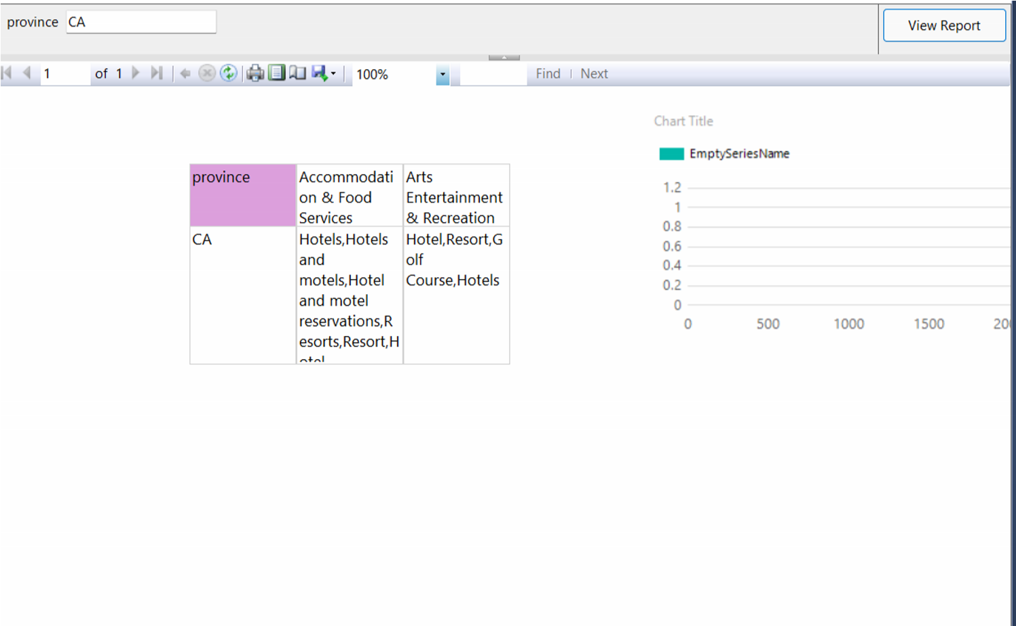

**Report 3:**

SSRS drill-down report

This report is yearly total price of the hotel.

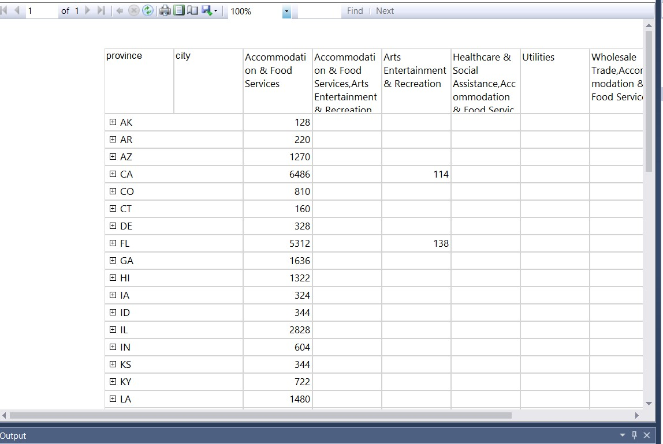

**Report 4:**

SSRS drill-through report

In this repot link through the Hotel_ID (h_id)

