Project 1 – Dog breeds classification - project report: 06/05/2020

Resnet :

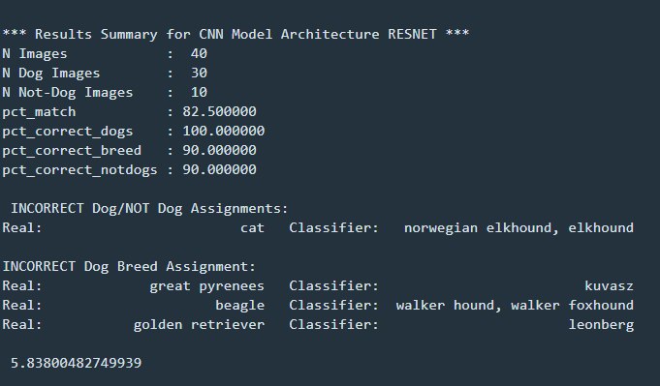

Alexnet:

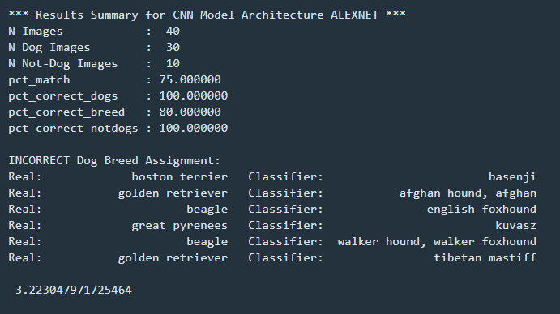

Vgg:

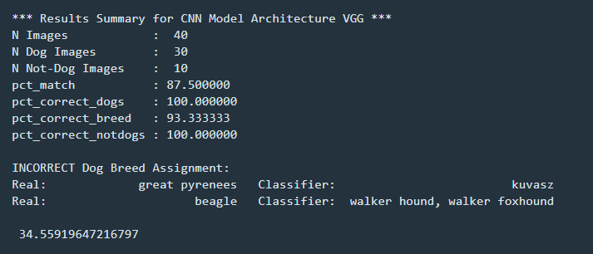

Consolidated results from 40 test images:

|  |  |  |  |  |
| --- | --- | --- | --- | --- |
| **CNN architecture** | **% dogs correctly classified** | **% not dogs correctly classified** | **% breed correctly classified** | **% Match** |
| **VGG** | **100.0** | **100.0** | **93.33** | **87.5** |
| AlexNet | 100.0 | 100.0 | 80.0 | 75.0 |
| Resnet | 100.0 | 90.0 | 90.0 | 82.5 |

***Answers to questions:***

**1.** Did the three model architectures classify the breed of dog in *Dog_01.jpg* to be the same breed? If not, report the differences in the classifications.

There were no classification differences, all three architecture predicted correctly “great pyreneese” and “golden retriever”

**2.** Did each of the three model architectures classify the breed of dog in *Dog_01.jpg* to be the same breed of dog as that model architecture classified *Dog_02.jpg*? If not, report the differences in the classifications.

There were no classification differences, all three architecture predicted correctly “great pyreneese” and “golden retriever”

**3.** Did the three model architectures correctly classify *Animal_Name_01.jpg*and *Object_Name_01.jpg*to **not** be dogs? If not, report the misclassifications.

* Alexnet msclassified chameleon as a “**bubble**” and images with people and cartons as “**rain** **barrel**”
* Resnet misclassified image of a black panther as “**tiger, cat**”, while vgg and AlexNet identfied it as panther

From the misclassification shown above, I conclude that **vggnet** has better generalizability on Dog and non-dog classifications overall.