EDUGENIE
Google Gemini Powered Learning Assistant
FINAL PROJECT DOCUMENTATION
Easy Explanation + Code + Output
Backend: FastAPI
Frontend: HTML, CSS, JavaScript
AI: Google Gemini

Project Description
EduGenie is an AI-based learning assistant for students. It is a web application that helps students ask questions, understand topics, practise with quizzes, summarize text, and create a learning path.
The project uses FastAPI for the backend and HTML, CSS and JavaScript for the frontend. Google Gemini is used for the main AI responses.

Problem and Objectives

Problem
Students may need different tools for different study tasks. EduGenie combines these tasks in one simple application.

Objectives
• Answer student questions.
• Explain difficult topics in simple language.
• Generate quizzes for practice.
• Summarize long study material.
• Suggest a step-by-step learning path.

Main Features
Feature | What it does
Q&A | Answers a student's question.
Explanation | Explains a topic in simple words.
Quiz | Creates three MCQs with four options.
Summary | Makes long text shorter and keeps key points.
Learning Path | Gives a study plan from beginner to advanced.

System Architecture
You can explain the architecture in four steps:
• Student – gives a question, topic or text.
• Frontend – collects the input and sends it to the backend.
• FastAPI Backend – receives the request and calls the correct Python module.
• AI / Modules – the selected module creates the result using Google Gemini or the project's fallback logic.
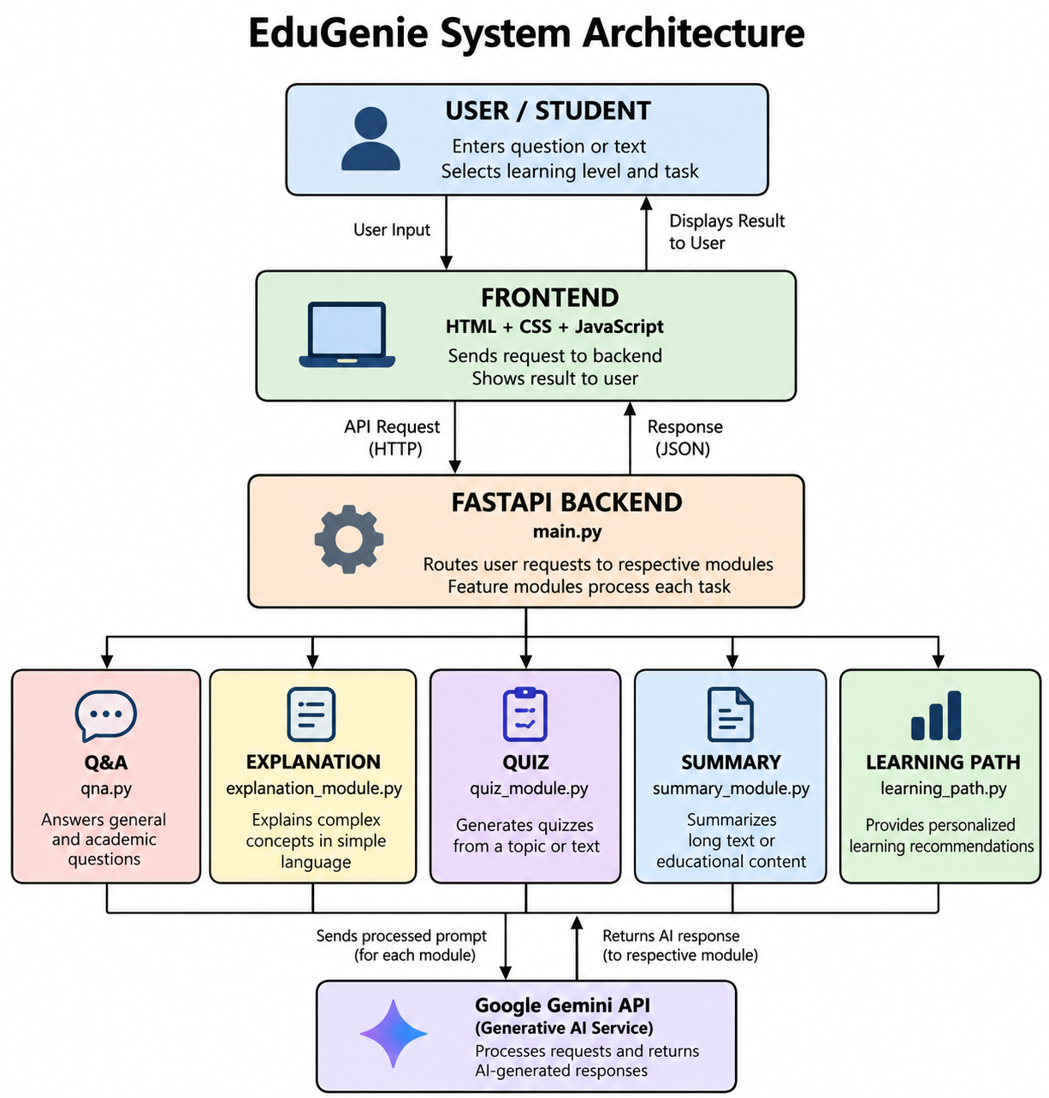

Project Workflow

Milestones
MILESTONE 1: Model Selection and Architecture
Activity 1.1: Select AI Models
- Gemini 1.5 Pro (via API):
Used for: Q&A, summarization, quiz generation, learning paths
Benefits: Advanced reasoning, structured outputs, and cloud inference
- LaMini-Flan-T5-783M (local):
Used for: Concept explanation
Benefits: Instruction-tuned, lightweight, CPU-compatible

Project Structure
EduGenie/
├── main.py
├── ai_client.py
├── qna.py
├── explanation_module.py
├── quiz_module.py
├── summary_module.py
├── learning_path.py
├── requirements.txt
├── templates/
│ └── index.html
└── static/
└── style.css

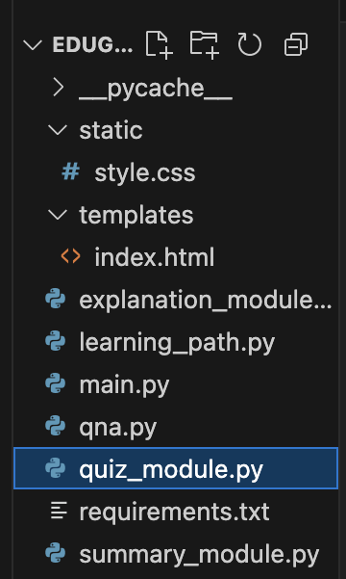

MILESTONE 2: Core Functionalities Development
Activity 2.1. : Module Implementation
- Explanation Module
EduGenie utilizes the LaMini-Flan-T5 model, a lightweight yet powerful generative AI, to deliver educational content in a simplified and highly readable manner. This model is specifically fine-tuned to provide concise, context-aware responses that break down complex topics into easily understandable language. By focusing on clarity and brevity, EduGenie ensures that learners with minimal background knowledge or technical experience can grasp essential concepts without feeling overwhelmed. This makes it particularly valuable for beginners, school students, or self-learners seeking straightforward explanations. The integration of LaMini-Flan-T5 empowers EduGenie to act as a reliable and accessible study companion for foundational learning across subjects.



- QnA Module
EduGenie is powered by Gemini 1.5 Pro, enabling it to handle a wide range of general knowledge and academic question-answering tasks with precision. Its advanced understanding and contextual capabilities make it an effective tool for learners seeking accurate, AI-driven assistance across diverse educational topics and subjects.


- Quiz Module
EduGenie generates three multiple-choice questions (MCQs) from a given passage, each containing four carefully crafted options. It utilizes the Gemini model to comprehend the context and meaning of the passage, ensuring that the questions are relevant and the distractors are plausible. The final output is structured in JSON format for easy integration.

It sends a structured prompt to the model, expecting a valid JSON response with each question containing four options and a correct answer. To ensure proper parsing, it cleans any Markdown code blocks using the clean_json_blockfunction. The cleaned response is then parsed into a Python list. If an error occurs during generation or parsing, it returns a detailed error message for debugging.
- Summary Module
This feature leverages Gemini’s generative capabilities to summarize long paragraphs into concise, easy-to-understand versions, making it ideal for quick revision. It ensures the core information is retained while eliminating redundancy, helping learners absorb key points efficiently without losing clarity or context.


- Learning Path Module
The get_learning_recommendations function uses Google Gemini to generate a personalized, structured learning path for any given topic. By crafting a detailed prompt, it instructs the AI to suggest beginner to advanced concepts, organized by difficulty, and supported with useful resources such as videos, articles, or books. It ensures adaptability to the learner’s level. The function safely handles API responses and errors, providing either the generated text or a helpful error message if the response is invalid or incomplete.


Activity 2.2 : Backend API with FastAPI
- Defined RESTful endpoints for each module:
- /qa
- /explain
- /quiz
- /summarize
- /learn/recommendations
- Connected each endpoint to a respective module logic



MILESTONE 3: Frontend Development
Activity 3.1: Build Web Interface
- HTML Form (index.html):
- Task dropdown (Explain, QnA, Quiz, Summary, Recommend Path)
- Text area for user input
- Submit button
- CSS Styling (style.css):
- Responsive design
- Styled buttons, input areas, and result container


Activity 3.2: Live Integration
- Form submission sends POST request to FastAPI backend
- Result appears below input box in real-time

MILESTONE 4: Deployment
Activity 4.1: Run Locally
Run locally with uvicorn main:app --reload
Navigate to: http://127.0.0.1:8000

Activity 4.2: Functional Testing
Ask a question
Get an explanation
Generate a quiz
Summarize content
Get a personalized learning plan

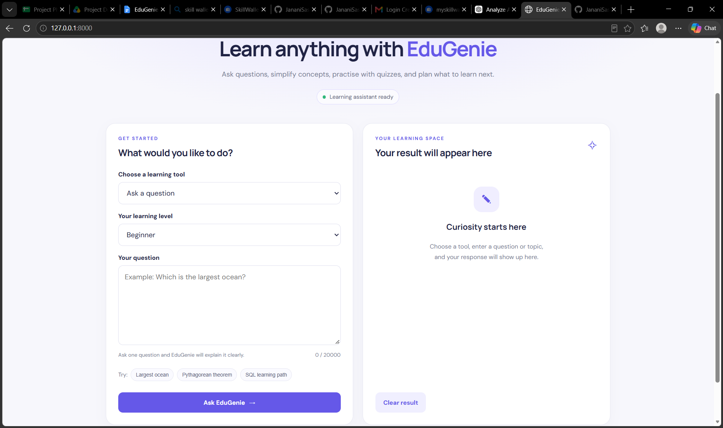

Exploring EduGenie:
a.Asking questions
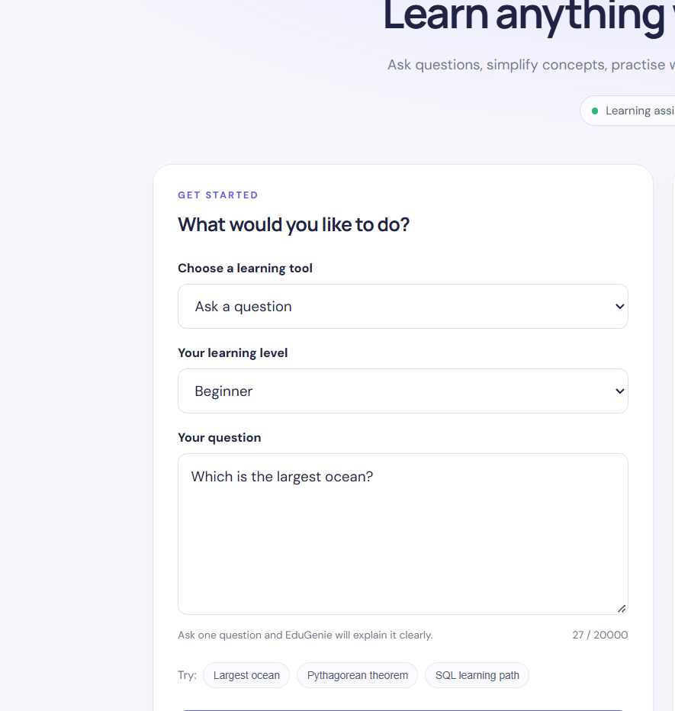
- Explanation of any topic:
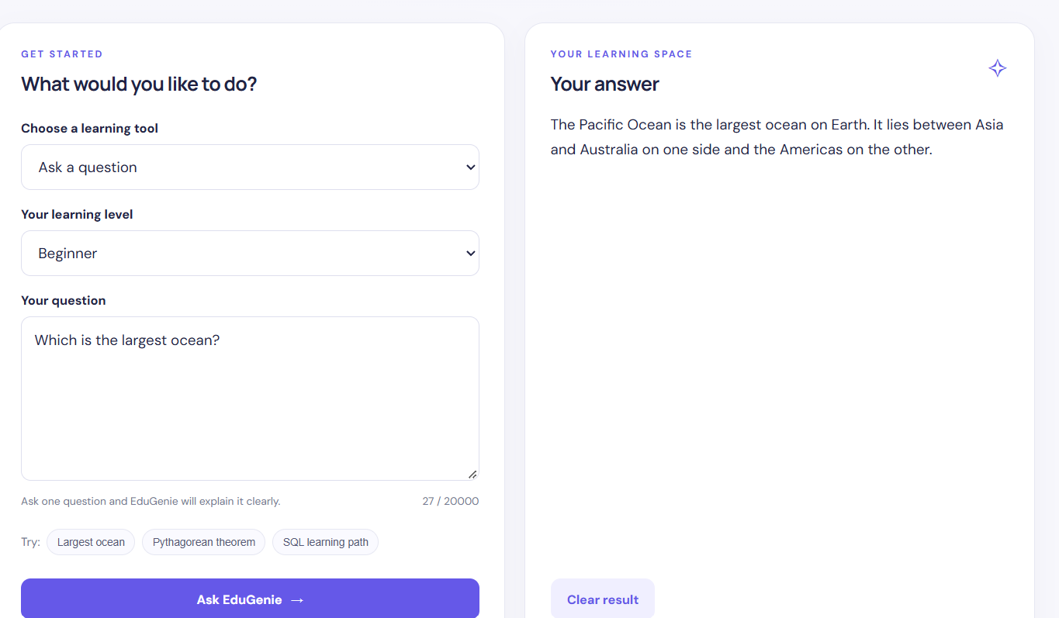
- Summarising long paragraphs:
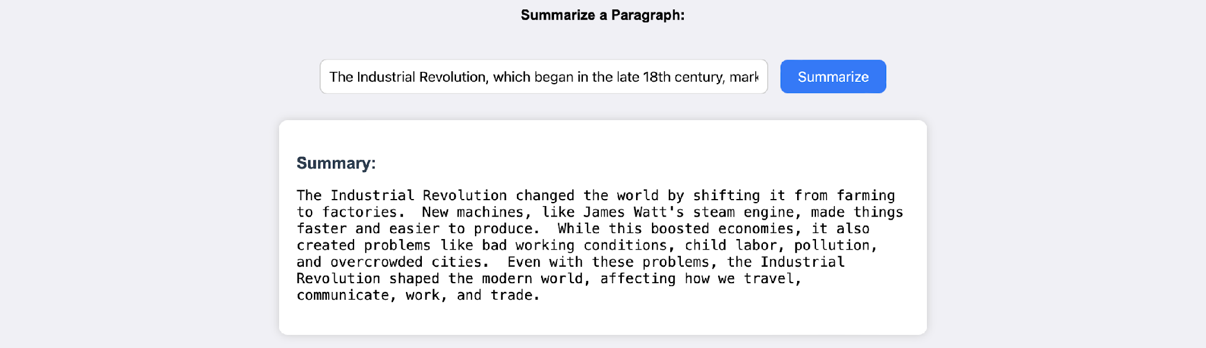

- Generating quizzes:
It generates three questions with 4 options each. It corrects the answer if chosen wrong.

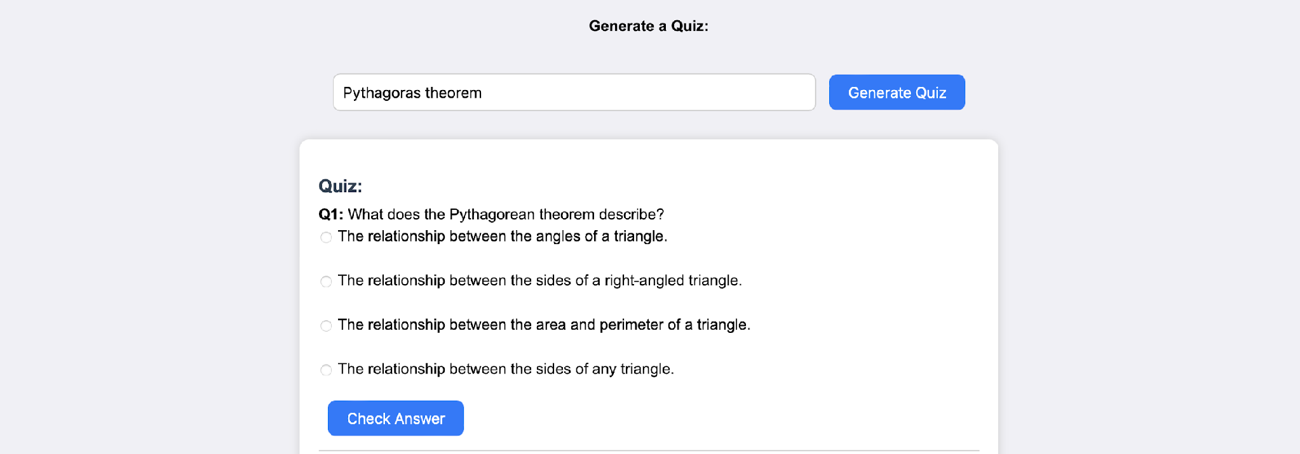
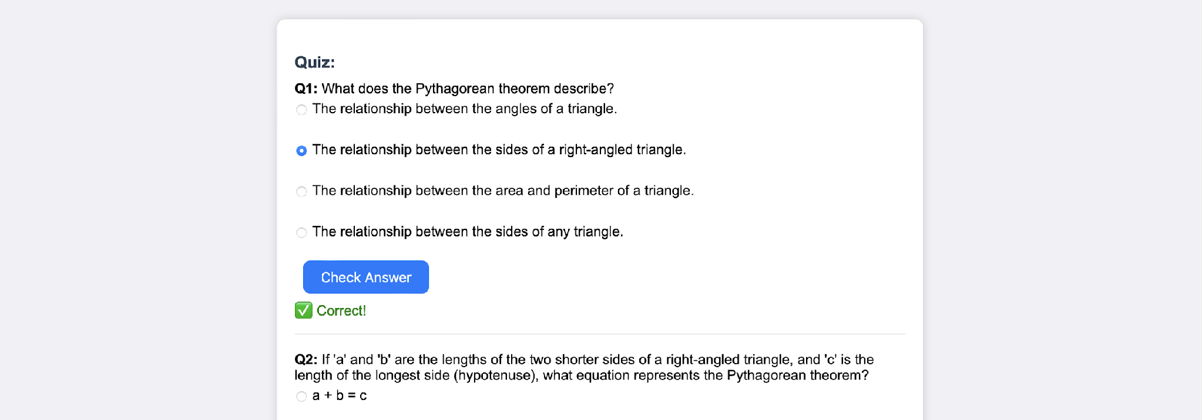
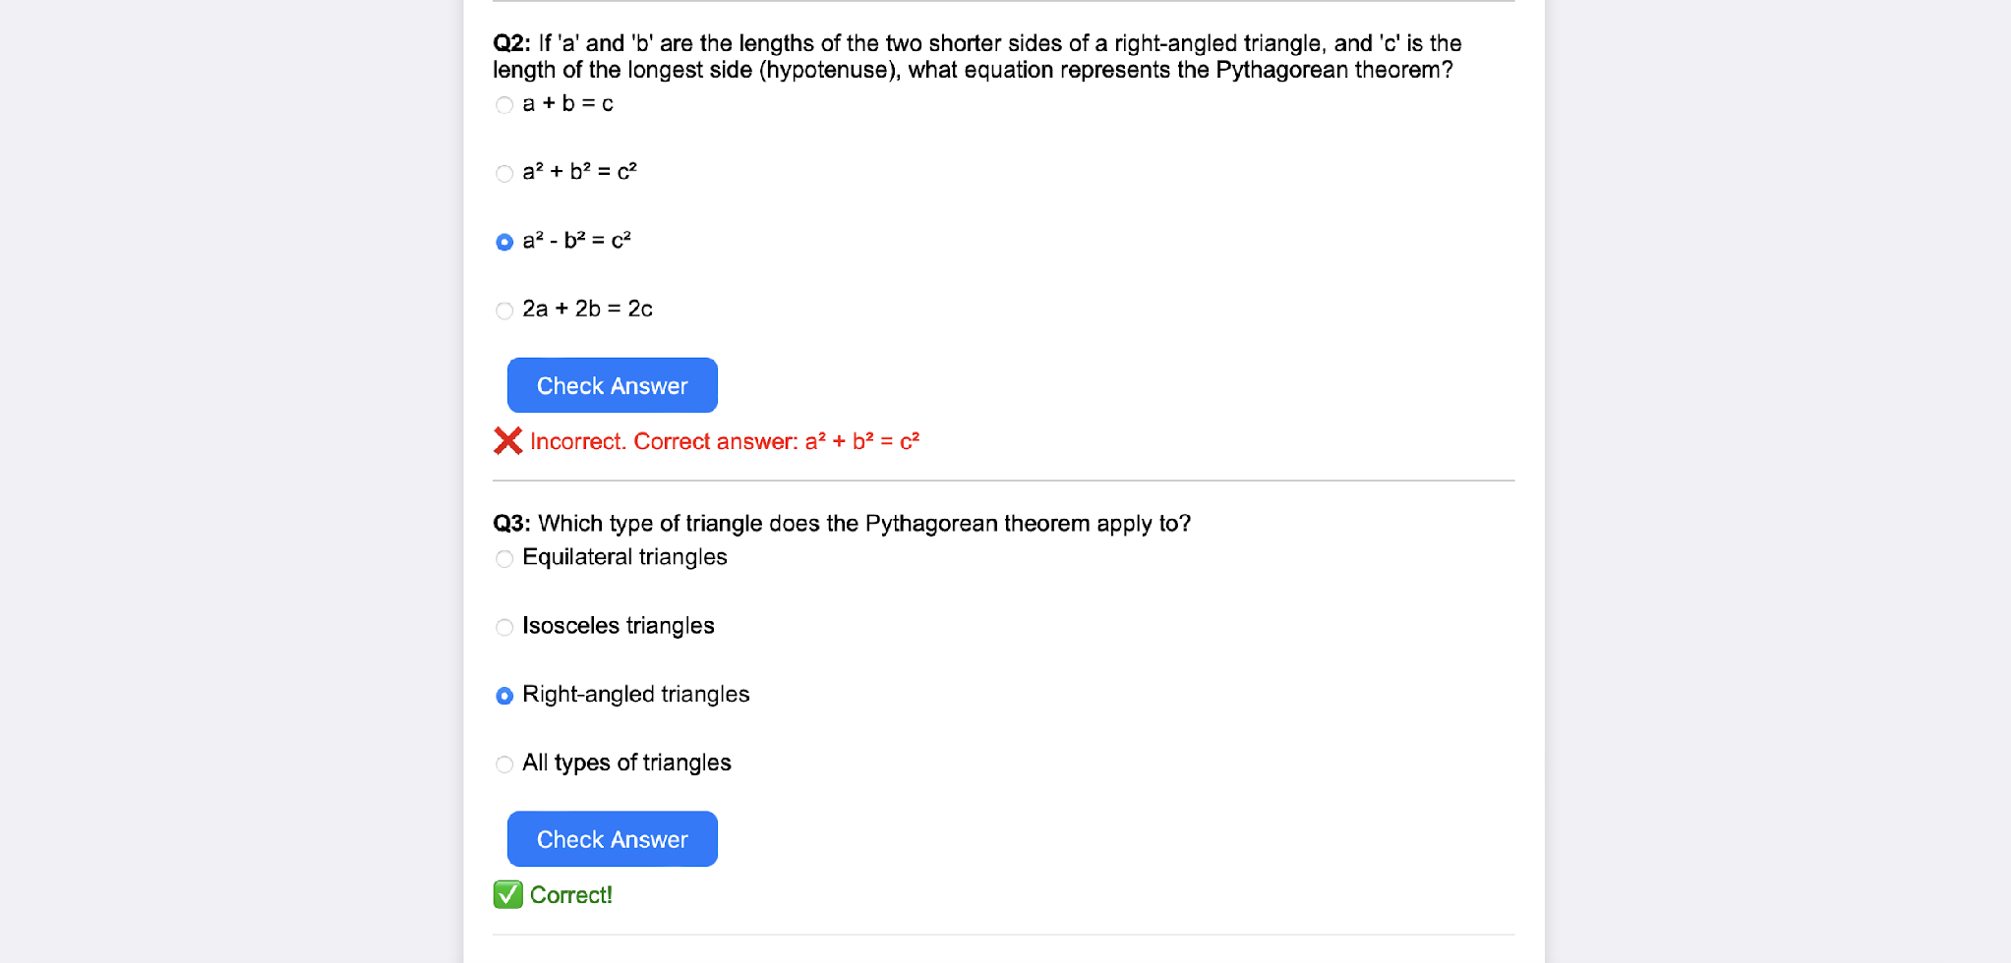

- Guiding with learning recommendations from beginners level to advanced level
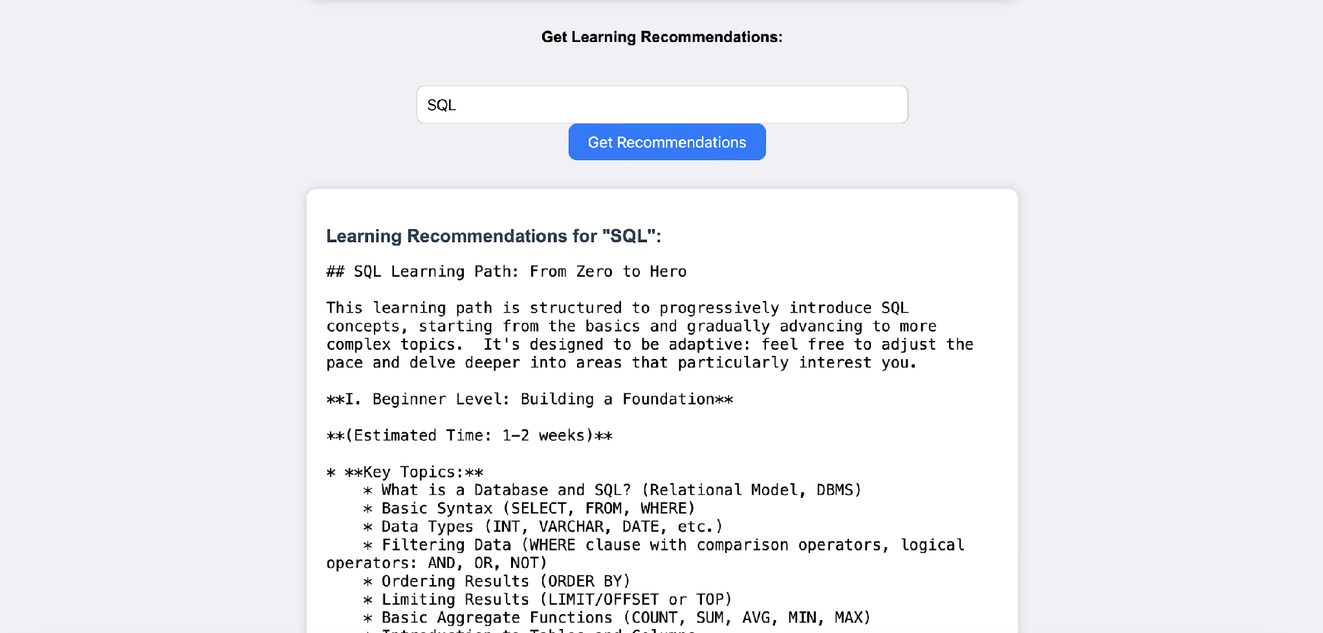
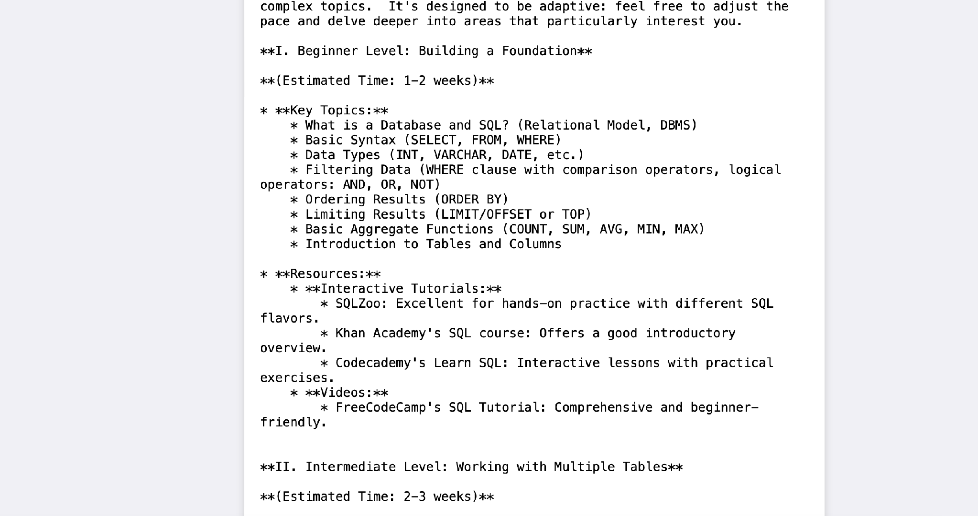
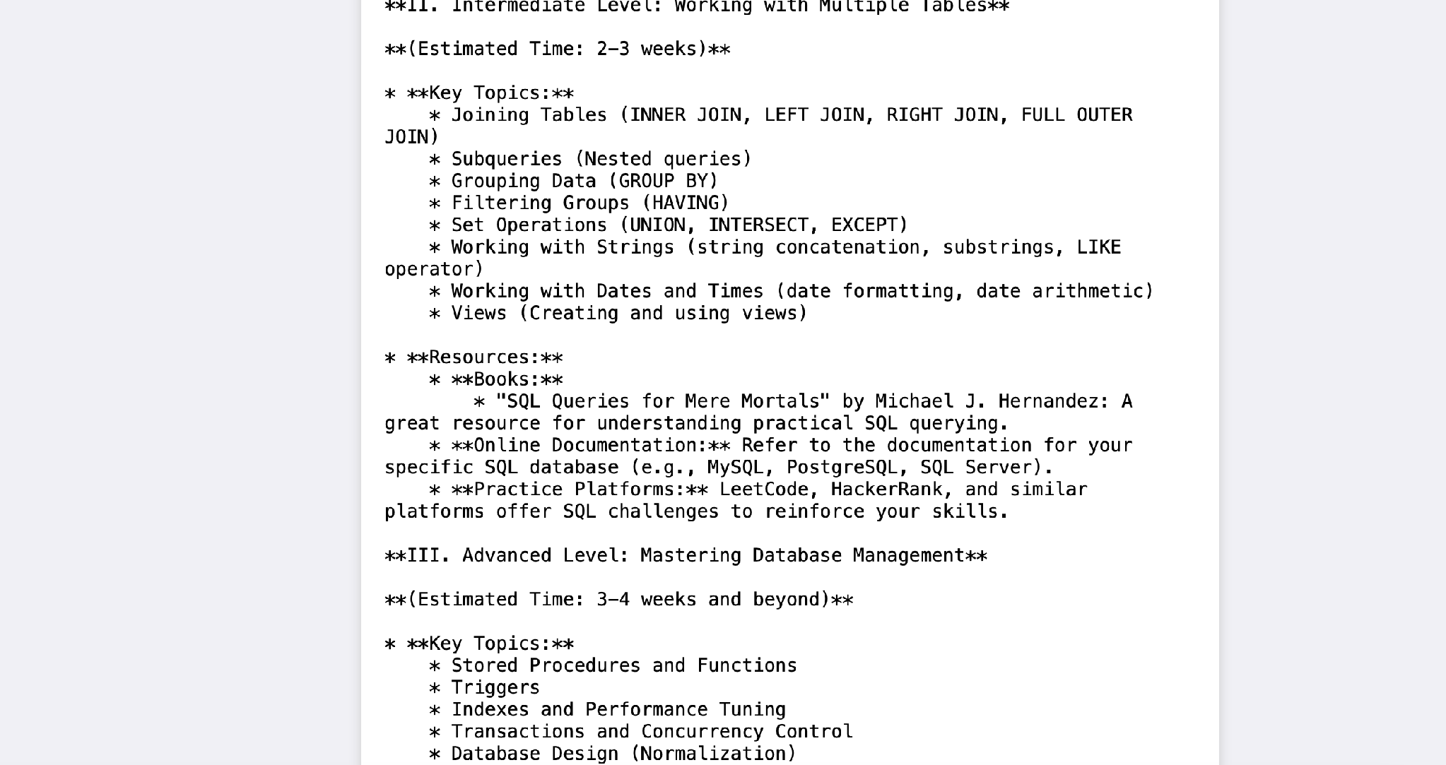
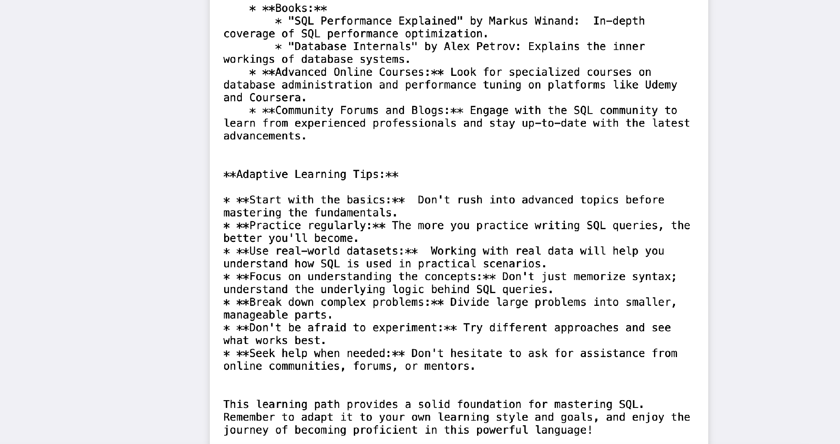
It provides along with details of resources from where to learn and stepwise guidance through-out.

Conclusion
EduGenie is an AI-powered learning assistant that helps students learn in a simple way. It can answer questions, explain topics, create quizzes, summarize text, and provide learning paths.
The project uses Gemini 2.5 Flash for AI responses and a simple web interface for users. During development, we learned about AI integration, prompt engineering, frontend development, and FastAPI.
In the future, EduGenie can be improved with voice support, multilingual learning, mobile applications, progress tracking, and personalized learning.Overall, EduGenie makes learning simple, interactive, and accessible for students.

