NeRF vs Gaussian Splatting: A Comparative Analysis of Neural 3D Reconstruction Techniques on Mobile Video Data
Janani Vaiyapuriappan

Introduction
The goal of this project was to reconstruct a 3D scene of a stack of books and generate novel views using neural radiance fields (NeRF) and Gaussian splatting, with camera poses estimated from a handheld video using COLMAP. The intended pipeline followed the course recommendation to use NeRFStudio’s data-processing tools in conjunction with COLMAP in a cloud GPU notebook environment. Despite substantial effort in implementing and debugging this pipeline, COLMAP failed to produce a valid reconstruction of the captured video, preventing completion of full NeRF and Gaussian splatting training on the custom dataset.

Methods

Data collection
A 1-minute 55-second video of a stack of books was recorded on a smartphone at 1920×1080 resolution and 60 frames per second. The camera was moved around the object to capture multiple viewpoints, but the motion was informal rather than a carefully planned circular trajectory. The video metadata indicated a vertical orientation, a 90‑degree rotation flag, and a high bitrate, which subsequently influenced preprocessing and COLMAP behavior. The video was uploaded to Google Drive and accessed from Google Colab by mounting the Drive filesystem and referencing the file via its `/content/drive/MyDrive/...` path.
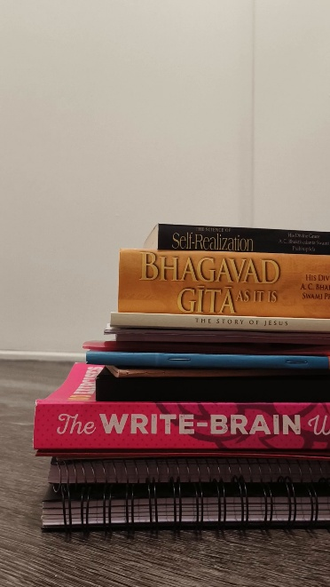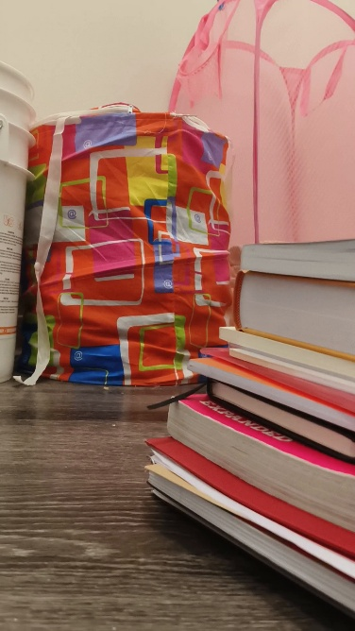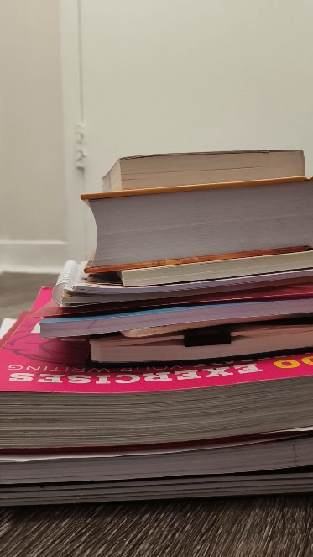
Figure 1 Example extracted frames (Frames 19, 82 and 133) from the 1:55 smartphone video of the stack of books, after temporal downsampling and conversion to PNG at multiple scales

Preprocessing
All experiments were conducted in Google Colab using a GPU runtime when available, with nerfstudio, FFmpeg, and COLMAP installed via `pip` and the Ubuntu package manager. FFmpeg was used to analyze the video, which contained approximately 6921 frames over 1:55 at 60 fps. To reduce computational load, nerfstudio’s `ns-process-data video` interface (and later FFmpeg directly) was used to downsample the video temporally and extract approximately 150–200 evenly spaced frames. These frames were written as PNG images at multiple resolutions into directories named `images`, `images_2`, `images_4`, and `images_8` under a common root such as `data/books_processed` or `data/books_processed_debug2`. This stage consistently succeeded, producing a clean multi‑scale image dataset.

Initial nerfstudio + COLMAP pipeline
The first approach followed the intended high‑level workflow: `ns-process-data video-- data <video>-- output-dir <folder>-- num-frames-target <N>`. This command is designed to convert the video to images, run COLMAP to estimate camera poses, and write a nerfstudio‑ready dataset that includes a `transforms.json` file. After installing nerfstudio, the command initially failed with an error indicating that the `colmap` binary could not be found. Installing COLMAP via the system package manager resolved this issue. Still, subsequent runs produced a Qt “xcb” plugin error: COLMAP’s feature extractor attempted to start a GUI, which is not supported in the headless Colab environment. As a result, `ns-process-data` aborted immediately after the image-extraction stage and did not generate `transforms.json`.

Manual COLMAP reconstruction
To bypass the GUI issue, COLMAP was invoked manually on the extracted frames. A COLMAP database was initialized under `data/books_processed_debug2/colmap/database.db`, and the following steps were run from the command line:
- Feature extraction using `colmap feature_extractor` with the image directory, an OPENCV camera model, and GPU acceleration disabled when necessary to avoid CUDA and Qt‑related errors.
- Exhaustive feature matching using `colmap exhaustive_matcher` on the SIFT features, which completed successfully but took on the order of tens of minutes on the CPU.
- Sparse reconstruction using `colmap mapper` with the database and image directory, writing output to `data/books_processed_debug2/colmap/sparse`.

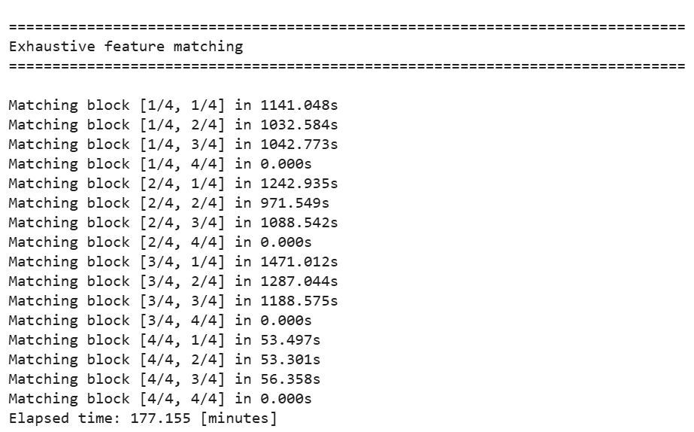
Figure 2 Exhaustive feature matching step executed manually in COLMAP on the extracted frames; this stage was completed successfully on the CPU.
Although feature extraction and matching were completed, the mapper consistently terminated with the message “No good initial image pair found” and did not create any sparse model subdirectory. Repeated runs with different frame subsets and downsampling parameters yielded the same result, indicating that COLMAP could not identify a stable pair of overlapping views for initializing structure‑from‑motion.

Impact on NeRF / Gaussian splatting
Both Nerfstudio’s NeRF pipelines and Gaussian-splatting models require calibrated camera poses, typically obtained from COLMAP reconstructions encoded in a `transforms.json` file. Because the automatic `ns-process-data` route failed due to GUI issues and the manual COLMAP pipeline failed at the mapper stage, no valid `transforms.json` could be produced for the books dataset. Consequently, downstream steps such as `ns-train nerfacto-- data <dataset>` and the corresponding Gaussian splatting training commands could not be executed on this custom data. The project therefore stopped at the structure‑from‑motion stage rather than reaching full neural rendering and novel‑view synthesis.

Challenges
Throughout this project, I encountered significant infrastructure and compatibility challenges that prevented the full NeRF and Gaussian Splatting training pipeline from being completed. The core issue was not with the methodology or the dataset quality, but with the complex software stack required for 3D reconstruction. On Windows, I encountered Python version conflicts (3.14.2 was incompatible with nerfstudio), missing C++ build tools for the fpsample package, and issues with PATH environment variable configuration across multiple tools (ffmpeg, COLMAP). When I transitioned to Kaggle for GPU access, I encountered version incompatibilities between nerfstudio 0.3.4 and COLMAP 3.13, which manifested as parsing errors in the version detection code. Most critically, COLMAP's GUI-dependent architecture (built on Qt) proved incompatible with Kaggle's headless Linux environment. Despite attempts to use offscreen rendering modes, COLMAP consistently failed to initialize its OpenGL context. These issues highlight a broader challenge in modern deep learning: while individual tools (COLMAP, nerfstudio, PyTorch) are mature, their integration creates a fragile dependency chain vulnerable to minor version mismatches and environmental constraints.

Results and Discussion
The main empirical result of this project is negative but informative: given the captured video and constraints of a headless Google Colab environment, COLMAP did not produce a usable reconstruction. Several factors likely contributed to this failure.
The handheld motion around the books did not provide a sufficient baseline and parallax between frames, making it difficult for COLMAP to identify a robust initial image pair. Repetitive textures along book spines may have further confused feature matching and pose estimation.
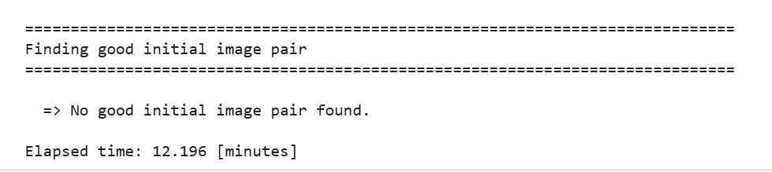
Figure 3 COLMAP sparse reconstruction failing with ‘No good initial image pair found’, indicating that the video did not provide a sufficiently robust pair of overlapping views to initialize structure-from-motion.
The original 60-fps recording produced many highly similar frames, so even after temporal downsampling, the selected images may have lacked the viewpoint diversity typically recommended for successful structure‑from‑motion.
Running COLMAP in Colab introduced additional complications (missing GUI backends, binary availability, and CUDA configuration) that required time‑consuming debugging before any reconstruction could be attempted.
Although the work does not achieve full NeRF or Gaussian-splatting training, it illustrates many of the practical challenges in real‑world neural rendering pipelines. The project implemented: remote data access via mounted Drive, systematic video downsampling and multi‑scale frame extraction, installation and invocation of COLMAP in a headless environment, and detailed inspection of error logs when the mapper failed. These are precisely the “glue” steps that often make or break 3D reconstruction workflows, and they align with the course’s emphasis on understanding both tools and failure modes rather than treating NeRF as a black box.

Conclusion and Future Work
I attempted to reconstruct a 3D scene of a stack of books from a handheld smartphone video using COLMAP for camera pose estimation and NeRFStudio for NeRF and Gaussian splatting. The pipeline successfully extracted a well‑organized multi‑scale image dataset but failed at the COLMAP mapping stage, preventing the creation of `transforms.json` and thereby blocking subsequent neural rendering experiments.

