Question : Detect any loop in the linked list.
Find number of nodes in the linked list.
Find the start point of the linked list.

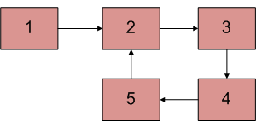

Solutions:
Why is detecting loop of importance??
Find the number of nodes in a linked list.

ii ) Detecting Loop
I. Using hashing

bool detectLoop(struct Node *h)
{
unordered_set<Node *> s;
while (h != NULL)
{
if (s.find(h) != s.end())
return true;
s.insert(h);
h = h->next;
}
return false;
}

II. Using Floyd’s Cycle-Finding Algorithm
int detectloop(struct Node *list)
{
struct Node *slow_p = list, *fast_p = list;
while (slow_p && fast_p && fast_p->next )
{
slow_p = slow_p->next;
fast_p = fast_p->next->next;
if (slow_p == fast_p)
return 1;
}
return 0;
}

iii.) No of nodes in the loop

int countNodes(struct Node *n)
{
int res = 1;
struct Node *temp = n;
while (temp->next != n)
{
res++;
temp = temp->next;
}
return res;
}

iv.) Detect start point of loop

void startOfLoop(struct Node *loop_node, struct Node *head)
{
struct Node *ptr1;
struct Node *ptr2;

ptr1 = head;
while (1)
{
ptr2 = loop_node;
while (ptr2->next != loop_node && ptr2->next != ptr1)
ptr2 = ptr2->next;

if (ptr2->next == ptr1)
break;
}

\\loops starts at --> ptr2
}

