How to check if linked list is palindrome or not?

Problem Statement:
Given a Linked list (consider Singly Linked list), check if it is a Palindrome or not.

Algorithm:
- Find middle element of linked list using slow and fast pointer method .
- Reverse second part of linked list
- Compare first and second part of linked list if it matches then linked list is palindrome.

Java Code:
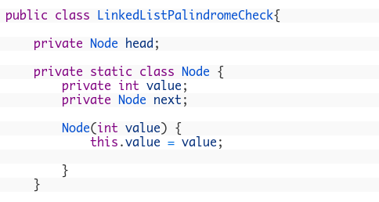

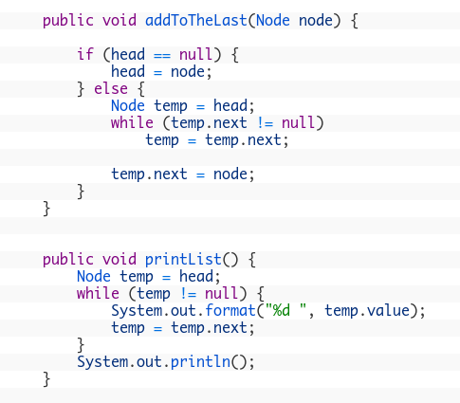

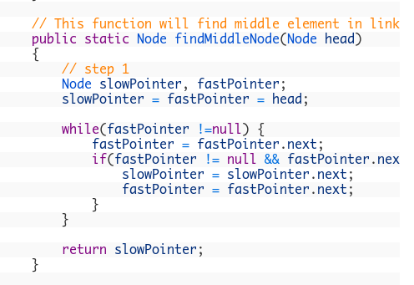

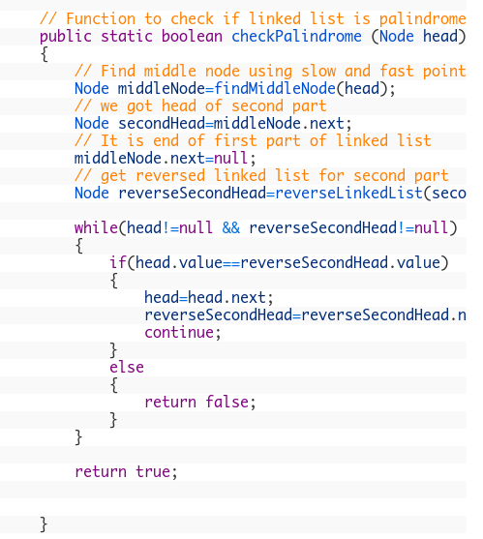

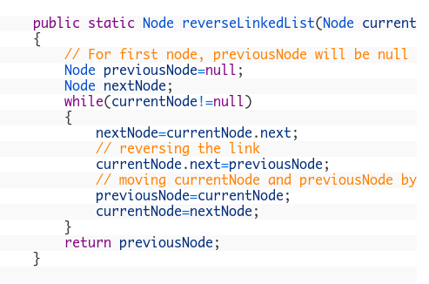
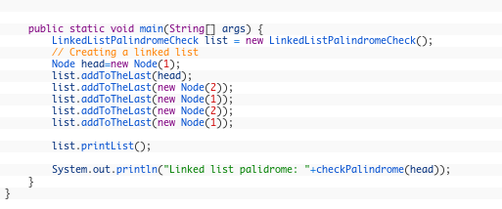

Output:
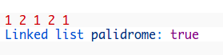

Time Complexity : O(n)

Space Complexity : O(1)

