Problem Statement :

To find Lowest Common Ancestor of a Binary Search Tree

- Lowest Common Ancestor : Lowest common parent of two nodes.
- Binary Search Tree : LeftSubTree < Root < RightSubTree

Approach:

1. Define a class for Node
2. Build the Binary Search Tree
3. Recursively/Iteratively traverse through nodes as follows:

If node is null, return it
If node is greater than A and B, traverse left subtree
If node is lesser than A and B , traverse right subtree.
If above both condition do not satisfy, then node is LCA of A and B

Ways of Solving:

Recursion
Iteration
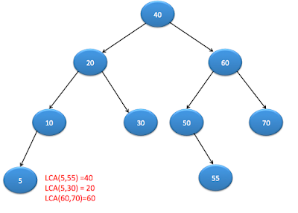

public class BinaryTree {

public static class TreeNode
{
int data;
TreeNode left;
TreeNode right;
TreeNode(int data)
{
this.data=data;
}
}

public static TreeNode lowestCommonAncestorForBinarySearchTree(TreeNode root, TreeNode a, TreeNode b)
{
if(root==null)
return null;;
if(root.data>a.data && root.data > b.data)
{
return lowestCommonAncestorForBinarySearchTree(root.left,a,b);
}
else if(root.data < a.data && root.data < b.data)
{
return lowestCommonAncestorForBinarySearchTree(root.right,a,b);
}

// if you reach at this place, then it is LCA for given two nodes because a and //b are on either side of root.

return root;

}

/*public static TreeNode LCAItr(TreeNode root, TreeNode a, TreeNode b) {
while(root!=null)
{
if(root.data>a.data && root.data > b.data)
{
root=root.left;
}
else if(root.data < a.data && root.data < b.data)
{
root=root.right;
}
else
{
return root;
}
}
return root;
}*/

public static void main(String[] args)
{
BinaryTree bi=new BinaryTree();
TreeNode rootNode=createBinaryTree();
System.out.println("Lowest common ancestor using Recursion is:");
TreeNode node5=new TreeNode(5);
TreeNode node30=new TreeNode(30);
System.out.println(lowestCommonAncestorForBinarySearchTree(rootNode,node5,node30).data);

System.out.println("The tree is:");
print(rootNode);
System.out.println();

//System.out.println("Lowest common ancestor for node 5 and 30 using Iteration:");
//System.out.println(LCAItr(rootNode,node5,node30).data);

}

public static TreeNode createBinaryTree()
{

TreeNode rootNode =new TreeNode(40);

TreeNode node20=new TreeNode(20);
TreeNode node10=new TreeNode(10);
TreeNode node30=new TreeNode(30);
TreeNode node60=new TreeNode(60);
TreeNode node50=new TreeNode(50);
TreeNode node70=new TreeNode(70);
TreeNode node5=new TreeNode(5);
TreeNode node45=new TreeNode(45);
TreeNode node55=new TreeNode(55);

rootNode.left=node20;
rootNode.right=node60;

node20.left=node10;
node20.right=node30;

node60.left=node50;
node60.right=node70;

node10.left=node5;
node50.left=node45;
node50.right=node55;
return rootNode;
}

public static void print(TreeNode rootNode)
{
if(rootNode != null)
{
System.out.print(rootNode.data+" ");
print(rootNode.left);
print(rootNode.right);

}

}
}

