To handle merge conflict,

* git pull origin master

For fatal httprequestexception encountered, update Git for windows

* <https://github.com/git-for-windows/git/releases>

For removing certain folders,

* git rm –r Servers

Oracle – invalid common user or role name

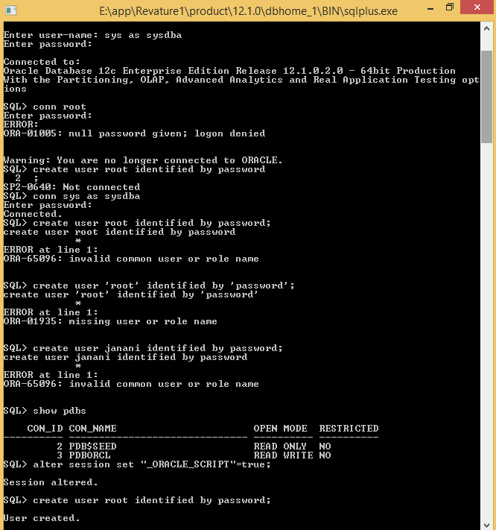

Logon denied

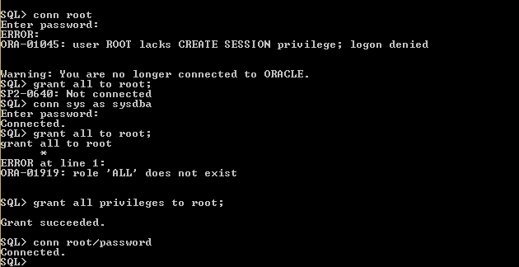

Connect to oracle using Oracle SQL Developer

