NAME OF THE PROJECT : SENTIMENT ANALYSIS FOR MARKETING
PHASE 3
TEAM LEADER
INTRODUCTION:
Preprocessing
Data preprocessing is a data mining technique that involves transforming raw data into an understandable format. Real-world data is often incomplete, inconsistent, and/or lacking in certain behaviors or trends, and is likely to contain many errors. Data preprocessing is a proven method of resolving such issues. Data preprocessing prepares raw data for further processing.

Why preprocessing?
Real-world data are generally:
- Incomplete: lacking attribute values, lacking certain attributes of interest, or containing only aggregate data
- Noisy: containing errors or outliers
- Inconsistent: containing discrepancies in codes or names
Tasks in data preprocessing:
- Data cleaning: fill in missing values, smooth noisy data, identify or remove outliers, and resolve inconsistencies.
- Data integration: using multiple databases, data cubes, or files.
- Data transformation: normalization and aggregation.
- Data reduction: reducing the volume but producing the same or similar analytical results.
- Data discretization: part of data reduction, replacing numerical attributes with nominal ones
- What is Exploratory data analysis?
- In statistics, exploratory data analysis (EDA) is an approach to analyzing data sets to summarize their main characteristics, often with visual methods. A statistical model can be used or not, but primarily EDA is for seeing what the data can tell us beyond the formal modeling or hypothesis testing task.

Data Cleaning
Data cleaning is the process of cleaning / standardising the data to make it ready for analysis. Most of times, there will be discrepancies in the captured data such as incorrect data formats, missing data, errors while capturing the data. This is an important step in any given data science project because the accuracy of the results depends heavily on the data we use.
DATA INTEGRATION
Data integration is the process of combining data from multiple sources into a single view. This can be done using a variety of methods, including:
- Using multiple databases: This involves creating a central database that contains data from all of the source databases. The data can be extracted from the source databases and loaded into the central database using a variety of tools and techniques.
- Using data cubes: Data cubes are a specialized type of database that is designed for analytical purposes. They can be used to store and aggregate data from multiple sources, making it easier to perform complex queries and analysis.
- Using files: Data can also be integrated from multiple files. This can be done by reading the files into a central database or by using a data integration tool to create a virtual view of the data in the files.
The best method for data integration depends on the specific needs of the organization. For example, if the organization needs to integrate data from a large number of different databases, then using a central database may be the best option. If the organization needs to perform complex analytical queries on the data, then using a data cube may be the best option. And if the organization needs to integrate data from a variety of files, then using a file-based data integration tool may be the best option.
Here are some examples of how data integration can be used:
- A retail company can use data integration to combine data from its sales database, inventory database, and customer database. This would allow the company to gain a better understanding of its customers and their buying habits.
- A financial services company can use data integration to combine data from its trading systems, risk management systems, and customer relationship management (CRM) system. This would allow the company to better manage its risks and provide better service to its customers.
- A healthcare organization can use data integration to combine data from its electronic health records (EHR) system, billing system, and patient portal. This would allow the organization to provide better care to its patients and improve its operational efficiency.
Data integration can be a complex and challenging task, but it can also be very rewarding. By integrating data from multiple sources, organizations can gain a deeper understanding of their business, make better decisions, and improve their overall performance.
DATA TRANSFORMATION:
Data transformation is the process of converting raw data into a format that is more suitable for analysis and modeling. This can involve a variety of techniques, including normalization and aggregation.
*Normalization** is the process of scaling the values of a dataset into a common range. This can be done using a variety of methods, such as min-max scaling, standard scaling, and decimal scaling. Normalization is important because it can help to improve the performance of machine learning algorithms and make the results of data analysis more interpretable.
*Aggregation** is the process of combining data at different levels of granularity. For example, you could aggregate data by day, week, month, or year. Aggregation can be used to reduce the size of a dataset, to create new features for machine learning models, or to summarize the data for analysis.
Here are some examples of how normalization and aggregation can be used in data transformation:
* Normalizing the values of a dataset of customer purchase amounts can make it easier to compare the purchase amounts of different customers.
* Aggregating customer purchase data by month can be used to create a new feature called “average monthly purchase amount.” This feature could then be used to train a machine learning model to predict future customer purchases.
* Aggregating customer purchase data by product can be used to create a new feature called “product popularity.” This feature could then be used to identify which products are the most popular among customers.
Normalization and aggregation are just two of the many data transformation techniques that can be used to prepare data for analysis and modeling. By choosing the right data transformation techniques, you can improve the quality of your data and the accuracy of your results.

Here are some additional benefits of using normalization and aggregation in data transformation:
**Improved data quality:** Normalization and aggregation can help to identify and remove errors and inconsistencies in your data.
* **Reduced data size:** Normalization and aggregation can help to reduce the size of your dataset, making it easier to store and process.
* **Improved performance of machine learning algorithms:** Normalization and aggregation can help to improve the performance of machine learning algorithms by making the data more consistent and easier to interpret.
**More interpretable results:** Normalization and aggregation can help to make the results of data analysis more interpretable by summarizing the data in a concise and meaningful way.
PROGRAMS
DATA CLEANING:
linkcode
!pip install tweepy
import numpy as np # linear algebra
import pandas as pd # data processing
import os
import tweepy as tw #for accessing Twitter API

#For Preprocessing
import re # RegEx for removing non-letter characters
import nltk #natural language processing
nltk.download("stopwords")
from nltk.corpus import stopwords
from nltk.stem.porter import *

# For Building the model
from sklearn.model_selection import train_test_split
import tensorflow as tf
import seaborn as sns

#For data visualization
import matplotlib.pyplot as plt
import matplotlib.patches as mpatches
%matplotlib inline

pd.options.plotting.backend = "plotly"
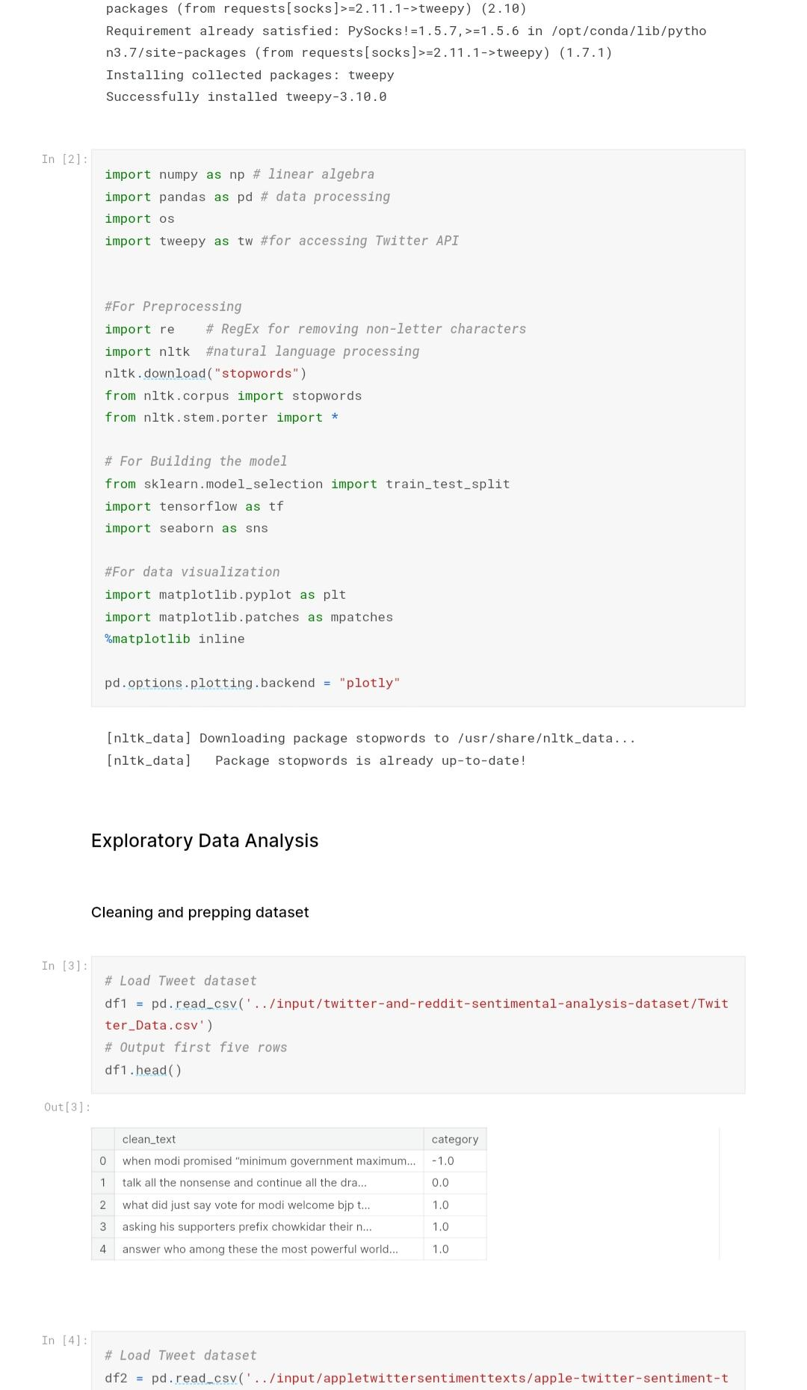

Load Tweet dataset
df1 = pd.read_csv('../input/twitter-and-reddit-sentimental-analysis-dataset/Twitter_Data.csv')
# Output first five rows
df1.head()
Out[3]:
 | clean_text | category
0 | when modi promised “minimum government maximum... | -1.0
1 | talk all the nonsense and continue all the dra... | 0.0
2 | what did just say vote for modi welcome bjp t... | 1.0
3 | asking his supporters prefix chowkidar their n... | 1.0
4 | answer who among these the most powerful world... | 1.0
In [4]:
# Load Tweet dataset
df2 = pd.read_csv('../input/appletwittersentimenttexts/apple-twitter-sentiment-texts.csv')
df2 = df2.rename(columns={'text': 'clean_text', 'sentiment':'category'})
df2['category'] = df2['category'].map({-1: -1.0, 0: 0.0, 1:1.0})
# Output first five rows

df2.head()
Out[4]:
 | clean_text | category
0 | Wow. Yall needa step it up @Apple RT @heynyla:... | -1.0
1 | What Happened To Apple Inc? http://t.co/FJEX... | 0.0
2 | Thank u @apple I can now compile all of the pi... | 1.0
3 | The oddly uplifting story of the Apple co-foun... | 0.0
4 | @apple can i exchange my iphone for a differen... | 0.0
The category column has 3 values:
- 0 Indicating it is a Neutral Sentiment
- 1 Indicating a Postive Sentiment
- -1 Indicating a Negative Sentiment
In [5]:
# Load Tweet dataset
df3 = pd.read_csv('../input/twitterdata/finalSentimentdata2.csv')
df3 = df3.rename(columns={'text': 'clean_text', 'sentiment':'category'})
df3['category'] = df3['category'].map({'sad': -1.0, 'anger': -1.0, 'fear': -1.0, 'joy':1.0})
df3 = df3.drop(['Unnamed: 0'], axis=1)
# Output first five rows
df3.head()
Plotting the distribution of text length for positive sentiment tweets
In [14]:
fig = plt.figure(figsize=(14,7))
df['length'] = df.clean_text.str.split().apply(len)
ax1 = fig.add_subplot(122)
sns.histplot(df[df['category']=='Positive']['length'], ax=ax1,color='green')
describe = df.length[df.category=='Positive'].describe().to_frame().round(2)

ax2 = fig.add_subplot(121)
ax2.axis('off')
font_size = 14
bbox = [0, 0, 1, 1]
table = ax2.table(cellText = describe.values, rowLabels = describe.index, bbox=bbox, colLabels=describe.columns)
table.set_fontsize(font_size)
fig.suptitle('Distribution of text length for positive sentiment tweets.', fontsize=16)

plt.show()

Overview
This script performs EDA and then preprocesses multiple datasets to train a bidirectional LSTM model which is in turn used to predict the sentiments behind tweets fetched in real time using tweepy and classify them as positive negative or neutral.
The model is then integrated with streamlit and deployed as a web-app.
Checkout the web-app: Sententia

Installing and importing dependencies
To fetch tweets from twitter, we need to install the tweepy library. We will be using this package to pull tweets on which our model will make predictions.
In [1]:
!pip install tweepy
Collecting tweepy
Downloading tweepy-3.10.0-py2.py3-none-any.whl (30 kB)
Requirement already satisfied: requests[socks]>=2.11.1 in /opt/conda/lib/python3.7/site-packages (from tweepy) (2.25.1)
Requirement already satisfied: six>=1.10.0 in /opt/conda/lib/python3.7/site-packages (from tweepy) (1.15.0)
Requirement already satisfied: requests-oauthlib>=0.7.0 in /opt/conda/lib/python3.7/site-packages (from tweepy) (1.3.0)
Requirement already satisfied: oauthlib>=3.0.0 in /opt/conda/lib/python3.7/site-packages (from requests-oauthlib>=0.7.0->tweepy) (3.0.1)
Requirement already satisfied: urllib3<1.27,>=1.21.1 in /opt/conda/lib/python3.7/site-packages (from requests[socks]>=2.11.1->tweepy) (1.26.3)
Requirement already satisfied: certifi>=2017.4.17 in /opt/conda/lib/python3.7/site-packages (from requests[socks]>=2.11.1->tweepy) (2020.12.5)
Requirement already satisfied: chardet<5,>=3.0.2 in /opt/conda/lib/python3.7/site-packages (from requests[socks]>=2.11.1->tweepy) (3.0.4)
Requirement already satisfied: idna<3,>=2.5 in /opt/conda/lib/python3.7/site-packages (from requests[socks]>=2.11.1->tweepy) (2.10)
Requirement already satisfied: PySocks!=1.5.7,>=1.5.6 in /opt/conda/lib/python3.7/site-packages (from requests[socks]>=2.11.1->tweepy) (1.7.1)
Installing collected packages: tweepy
Successfully installed tweepy-3.10.0
In [2]:
import numpy as np # linear algebra
import pandas as pd # data processing
import os
import tweepy as tw #for accessing Twitter API

#For Preprocessing
import re # RegEx for removing non-letter characters
import nltk #natural language processing
nltk.download("stopwords")
from nltk.corpus import stopwords
from nltk.stem.porter import *

# For Building the model
from sklearn.model_selection import train_test_split
import tensorflow as tf
import seaborn as sns

#For data visualization
import matplotlib.pyplot as plt
import matplotlib.patches as mpatches
%matplotlib inline

pd.options.plotting.backend = "plotly"
[nltk_data] Downloading package stopwords to /usr/share/nltk_data...
[nltk_data] Package stopwords is already up-to-date!

Exploratory Data Analysis

Cleaning and prepping dataset
In [3]:
# Load Tweet dataset
df1 = pd.read_csv('../input/twitter-and-reddit-sentimental-analysis-dataset/Twitter_Data.csv')
# Output first five rows
df1.head()
Out[3]:
 | clean_text | category
0 | when modi promised “minimum government maximum... | -1.0
1 | talk all the nonsense and continue all the dra... | 0.0
2 | what did just say vote for modi welcome bjp t... | 1.0
3 | asking his supporters prefix chowkidar their n... | 1.0
4 | answer who among these the most powerful world... | 1.0
In [4]:
# Load Tweet dataset
df2 = pd.read_csv('../input/appletwittersentimenttexts/apple-twitter-sentiment-texts.csv')
df2 = df2.rename(columns={'text': 'clean_text', 'sentiment':'category'})
df2['category'] = df2['category'].map({-1: -1.0, 0: 0.0, 1:1.0})
# Output first five rows

df2.head()
Out[4]:
 | clean_text | category
0 | Wow. Yall needa step it up @Apple RT @heynyla:... | -1.0
1 | What Happened To Apple Inc? http://t.co/FJEX... | 0.0
2 | Thank u @apple I can now compile all of the pi... | 1.0
3 | The oddly uplifting story of the Apple co-foun... | 0.0
4 | @apple can i exchange my iphone for a differen... | 0.0
The category column has 3 values:
- 0 Indicating it is a Neutral Sentiment
- 1 Indicating a Postive Sentiment
- -1 Indicating a Negative Sentiment
In [5]:
# Load Tweet dataset
df3 = pd.read_csv('../input/twitterdata/finalSentimentdata2.csv')
df3 = df3.rename(columns={'text': 'clean_text', 'sentiment':'category'})
df3['category'] = df3['category'].map({'sad': -1.0, 'anger': -1.0, 'fear': -1.0, 'joy':1.0})
df3 = df3.drop(['Unnamed: 0'], axis=1)
# Output first five rows
df3.head()
Out[5]:
 | category | clean_text
0 | -1.0 | agree the poor in india are treated badly thei...
1 | 1.0 | if only i could have spent the with this cutie...
2 | 1.0 | will nature conservation remain a priority in ...
3 | -1.0 | coronavirus disappearing in italy show this to...
4 | -1.0 | uk records lowest daily virus death toll since...
In [6]:
# Load Tweet dataset
df4 = pd.read_csv('../input/twitter-airline-sentiment/Tweets.csv')
df4 = df4.rename(columns={'text': 'clean_text', 'airline_sentiment':'category'})
df4['category'] = df4['category'].map({'negative': -1.0, 'neutral': 0.0, 'positive':1.0})
df4 = df4[['category','clean_text']]
# Output first five rows
df4.head()
Out[6]:
 | category | clean_text
0 | 0.0 | @VirginAmerica What @dhepburn said.
1 | 1.0 | @VirginAmerica plus you've added commercials t...
2 | 0.0 | @VirginAmerica I didn't today... Must mean I n...
3 | -1.0 | @VirginAmerica it's really aggressive to blast...
4 | -1.0 | @VirginAmerica and it's a really big bad thing...
In [7]:
df = pd.concat([df1, df2, df3, df4], ignore_index=True)
In [8]:
# Check for missing data
df.isnull().sum()
Out[8]:
clean_text 4
category 7
dtype: int64
In [9]:
# drop missing rows
df.dropna(axis=0, inplace=True)
In [10]:
# dimensionality of the data
df.shape
Out[10]:
(182329, 2)
In [11]:
# Map tweet categories
df['category'] = df['category'].map({-1.0:'Negative', 0.0:'Neutral', 1.0:'Positive'})

# Output first five rows
df.head()
Out[11]:
 | clean_text | category
0 | when modi promised “minimum government maximum... | Negative
1 | talk all the nonsense and continue all the dra... | Neutral
2 | what did just say vote for modi welcome bjp t... | Positive
3 | asking his supporters prefix chowkidar their n... | Positive
4 | answer who among these the most powerful world... | Positive

Exploratory Data Analysis
Data Visualisation-
In [12]:
# The distribution of sentiments
df.groupby('category').count().plot(kind='bar')
30k40k28k32k34k36k38k42k
variableclean_textcategoryvalue
Plotting the distribution of tweet lengths
In [13]:
# Calculate tweet lengths
tweet_len = pd.Series([len(tweet.split()) for tweet in df['clean_text']])

# The distribution of tweet text lengths
tweet_len.plot(kind='box')
444644.54545.546.547
variablevalue
Plotting the distribution of text length for positive sentiment tweets
In [14]:
fig = plt.figure(figsize=(14,7))
df['length'] = df.clean_text.str.split().apply(len)
ax1 = fig.add_subplot(122)
sns.histplot(df[df['category']=='Positive']['length'], ax=ax1,color='green')
describe = df.length[df.category=='Positive'].describe().to_frame().round(2)

ax2 = fig.add_subplot(121)
ax2.axis('off')
font_size = 14
bbox = [0, 0, 1, 1]
table = ax2.table(cellText = describe.values, rowLabels = describe.index, bbox=bbox, colLabels=describe.columns)
table.set_fontsize(font_size)
fig.suptitle('Distribution of text length for positive sentiment tweets.', fontsize=16)

plt.show()
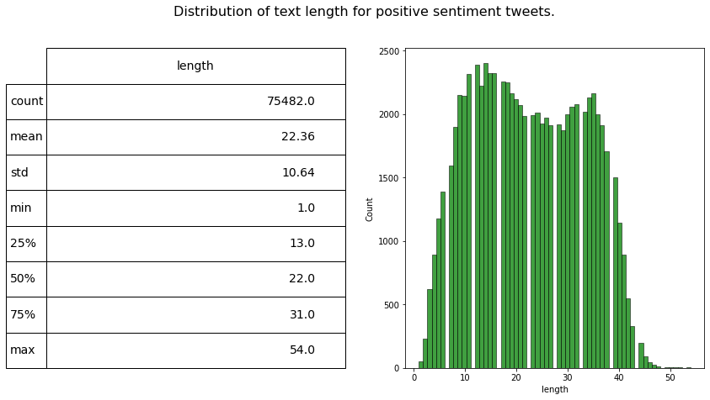

fig = plt.figure(figsize=(14,7))
df['length'] = df.clean_text.str.split().apply(len)
ax1 = fig.add_subplot(122)
sns.histplot(df[df['category']=='Negative']['length'], ax=ax1,color='red')
describe = df.length[df.category=='Negative'].describe().to_frame().round(2)

ax2 = fig.add_subplot(121)
ax2.axis('off')
font_size = 14
bbox = [0, 0, 1, 1]
table = ax2.table(cellText = describe.values, rowLabels = describe.index, bbox=bbox, colLabels=describe.columns)
table.set_fontsize(font_size)
fig.suptitle('Distribution of text length for Negative sentiment tweets.', fontsize=16)

plt.show()
## Visualizing data into wordclouds

from wordcloud import WordCloud, STOPWORDS

def wordcount_gen(df, category):
'''
Generating Word Cloud
inputs:
- df: tweets dataset
- category: Positive/Negative/Neutral
'''
# Combine all tweets
combined_tweets = " ".join([tweet for tweet in df[df.category==category]['clean_text']])

# Initialize wordcloud object
wc = WordCloud(background_color='white',
max_words=50,
stopwords = STOPWORDS)

# Generate and plot wordcloud
plt.figure(figsize=(10,10))
plt.imshow(wc.generate(combined_tweets))
plt.title('{} Sentiment Words'.format(category), fontsize=20)
plt.axis('off')
plt.show()

# Positive tweet words
wordcount_gen(df, 'Positive')

# Negative tweet words
wordcount_gen(df, 'Negative')

# Neutral tweet words
wordcount_gen(df, 'Neutral')
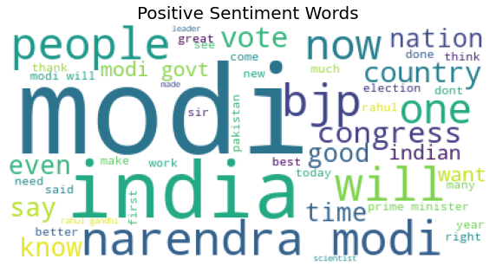
tweet_mode="extended")

l=[]
i=1

for tweet in posts[:10]:
l.append(tweet.full_text)
i=i+1
for j in range (0,9):
print(l[j])
predict_class([l[j]]) #predicting sentiment
print("\n")
ACCURACY: 76%
CONCLUSION:
Sentiment analysis for marketing :
In the phase data pre-processing and loading is exceuted.. I got the final accuracy as percentage of 76% and run time is 103.8s.
RUN TIME : 103.8 s
COLLEGE NAME: PANIMALAR INSTITUTE OF TECHNOLOGY
NM ID: au211521106065
REGISTER NUMBER: 211521106065

