R-PROGRAM
DATASETS – METROPT-3
From a metro train in an operational context, readings from pressure, temperature, motor current, and air intake valves were collected from a compressor's Air Production Unit (APU). This dataset reveals real predictive maintenance challenges encountered in the industry. It can be used for failure predictions, anomaly explanations, and other tasks.
FIELDS IN THE METRO-DATASETS:
Id | Timestamp | TP2 | TP3 | H1 | DV_Pressure | Reservoirs
Oil_Temperature | Motor_Current | COMP | DV_Eletric | Towers | MPG | LPS
Pressure_Switch | Oil_level | Caudal_Impulses

EXPLANATIONS OF THE FIELDS:
- TP2 (bar) – the measure of the pressure on the compressor.
- TP3 (bar) – the measure of the pressure generated at the pneumatic panel.
- H1 (bar) – the measure of the pressure generated due to pressure drop when the discharge of the cyclonic separator filter occurs.
- DV pressure (bar) – the measure of the pressure drop generated when the towers discharge air dryers; a zero reading indicates that the compressor is operating under load.
- Reservoirs (bar) – the measure of the downstream pressure of the reservoirs, which should be close to the pneumatic panel pressure (TP3).
- Motor Current (A) – the measure of the current of one phase of the three-phase motor; it presents values close to 0A - when it turns off, 4A - when working offloaded, 7A - when working under load, and 9A - when it starts working.
- Oil Temperature (ºC) – the measure of the oil temperature on the compressor.
- COMP - the electrical signal of the air intake valve on the compressor; it is active when there is no air intake, indicating that the compressor is either turned off or operating in an offloaded state.
- DV electric – the electrical signal that controls the compressor outlet valve; it is active when the compressor is functioning under load and inactive when the compressor is either off or operating in an offloaded state.
- TOWERS – the electrical signal that defines the tower responsible for drying the air and the tower responsible for draining the humidity removed from the air; when not active, it indicates that tower one is functioning; when active, it indicates that tower two is in operation.
- MPG – the electrical signal responsible for starting the compressor under load by activating the intake valve when the pressure in the air production unit (APU) falls below 8.2 bar; it activates the COMP sensor, which assumes the same behavior as the MPG sensor.
- LPS – the electrical signal that detects and activates when the pressure drops below 7 bars.
- Pressure Switch - the electrical signal that detects the discharge in the air-drying towers.
- Oil Level – the electrical signal that detects the oil level on the compressor; it is active when the oil is below the expected values.
- Caudal Impulse – the electrical signal that counts the pulse outputs generated by the absolute amount of air flowing from the APU to the reservoirs.
Missing Value: No
CLASSIFICATION:
Classification | Accuracy | TP | TN | FP | FN | Sensitivity | Specificity | F-score
Logistic  Regression | 99.99% | 260042 | 54507 | 20 | 4 | 1 | 0.9996 | 1
SVM | 100% | 260042 | 54526 | 1 | 4 | 1 | 1 | 1
Naïve  Bayes | 99.39% | 258125 | 54527 | 0 | 1921 | 0.9926 | 1 | 0.9963

Logistic Regression:
Structure of Datasets:
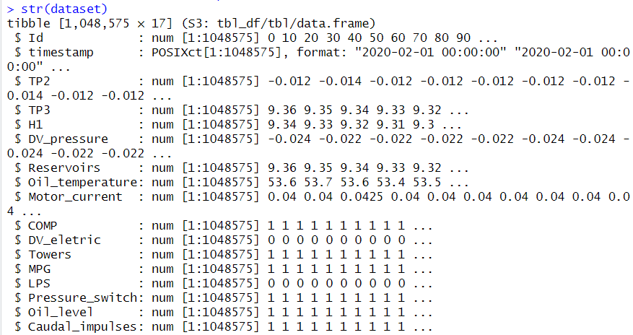
Head Datasets:
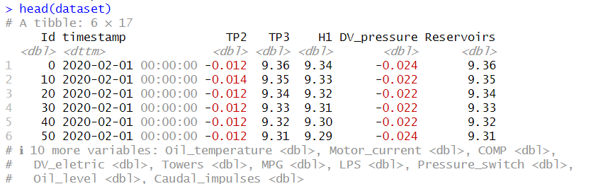
Output:
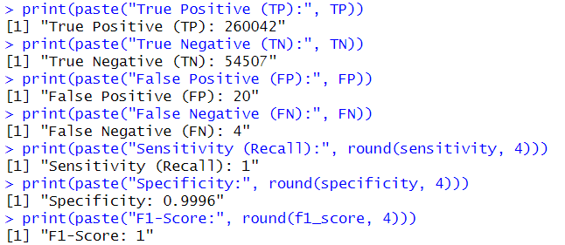
R O C Curve:
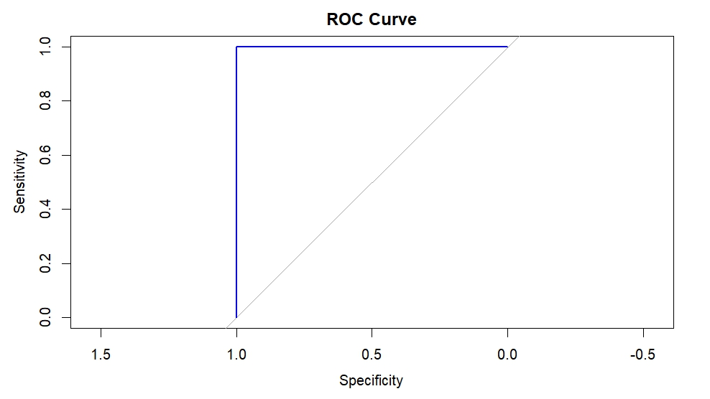
Support Vector Machine:
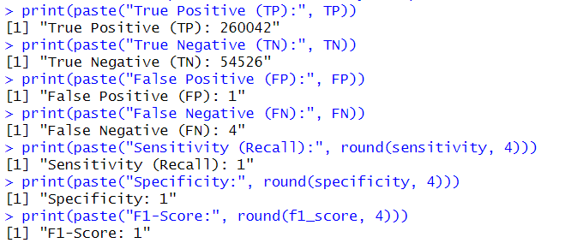
Naïve Bayes:
