LINE CHART EXAMPLES

Simple line chart:
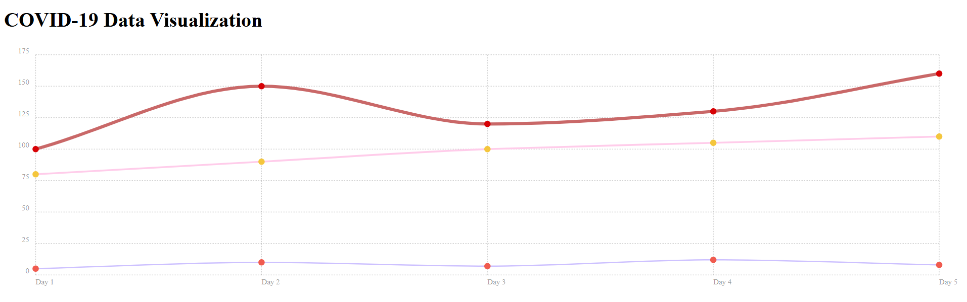
Dashed-line:
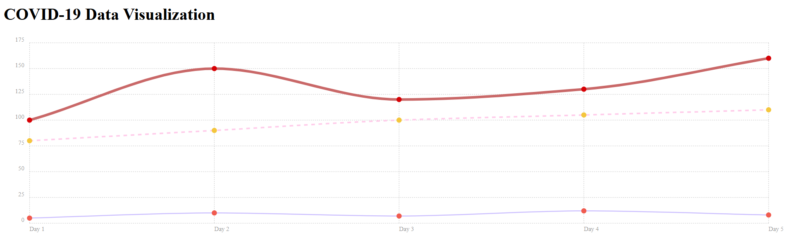
Holes in Data:
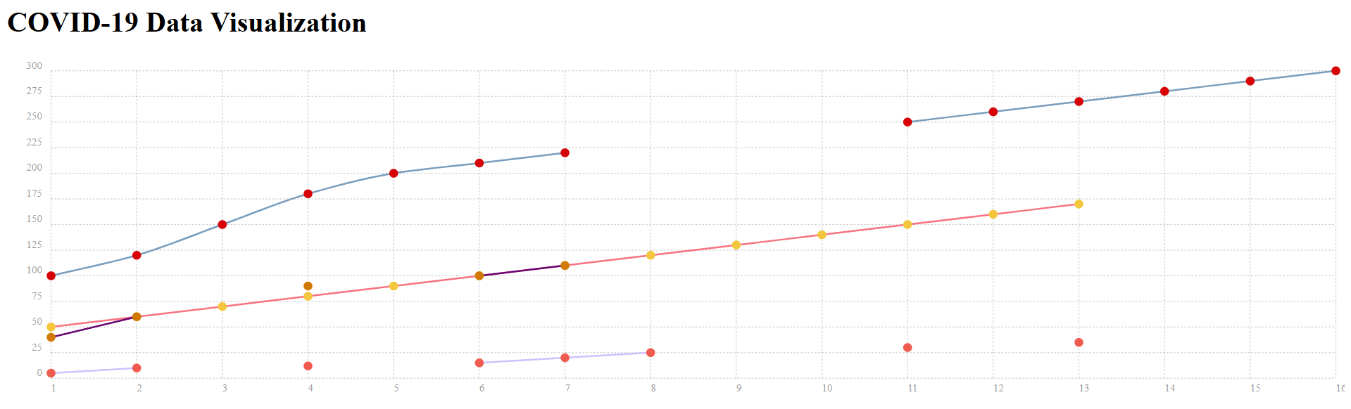

Filled Holes in Data:
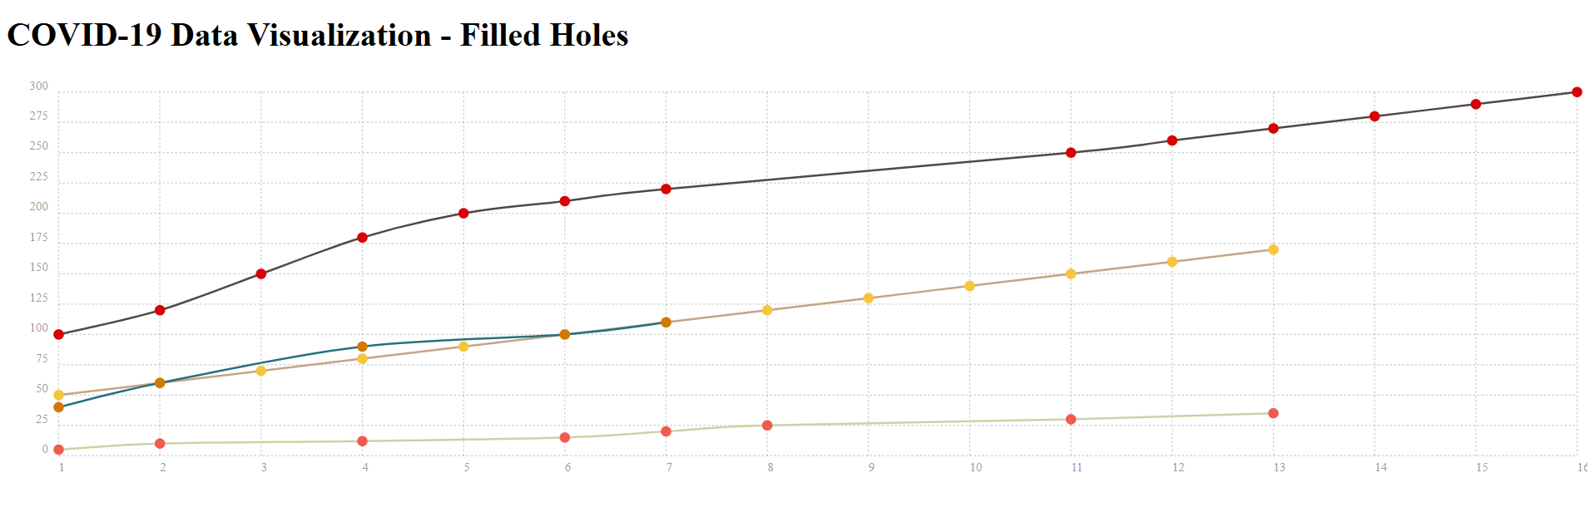
Only whole numbers:
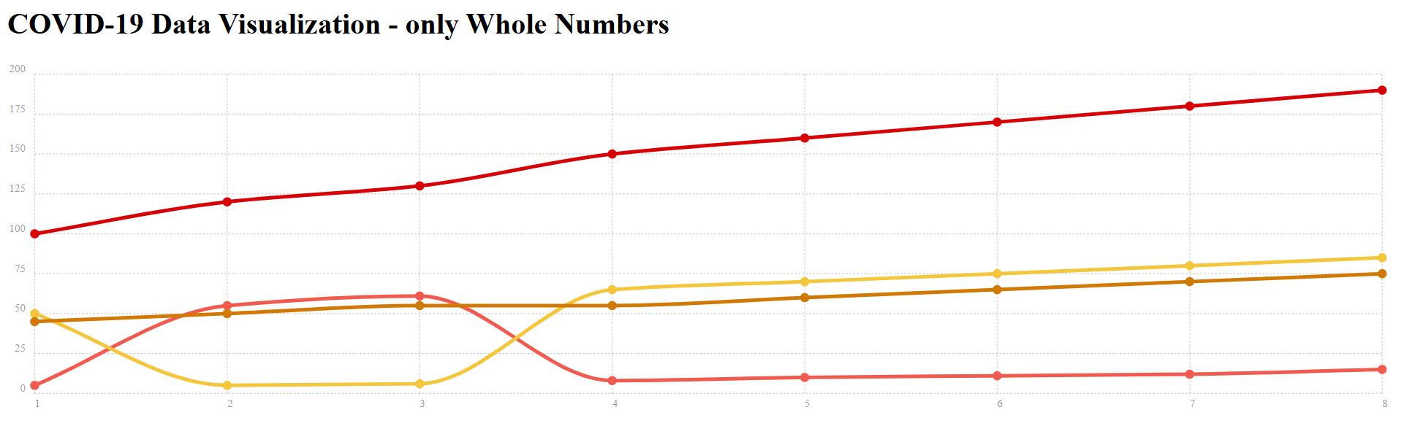
Line Scatter Diagram:
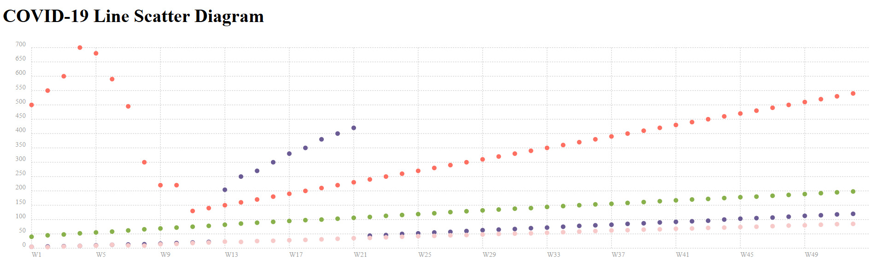
Line with Area Chart:
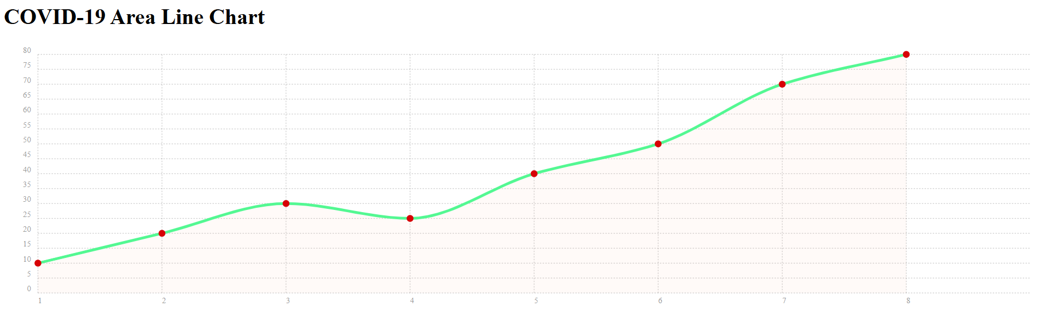
Bipolar line Chart with Area only:
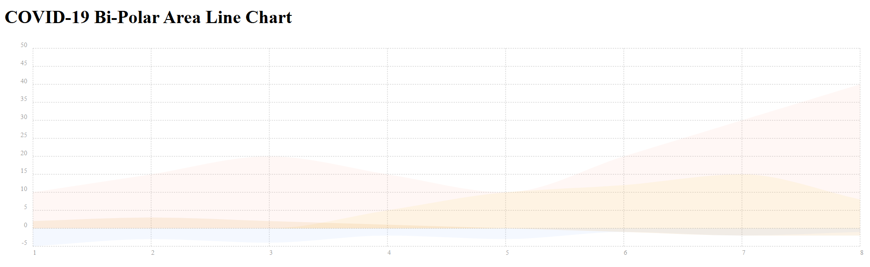

Using events to replace graphics:
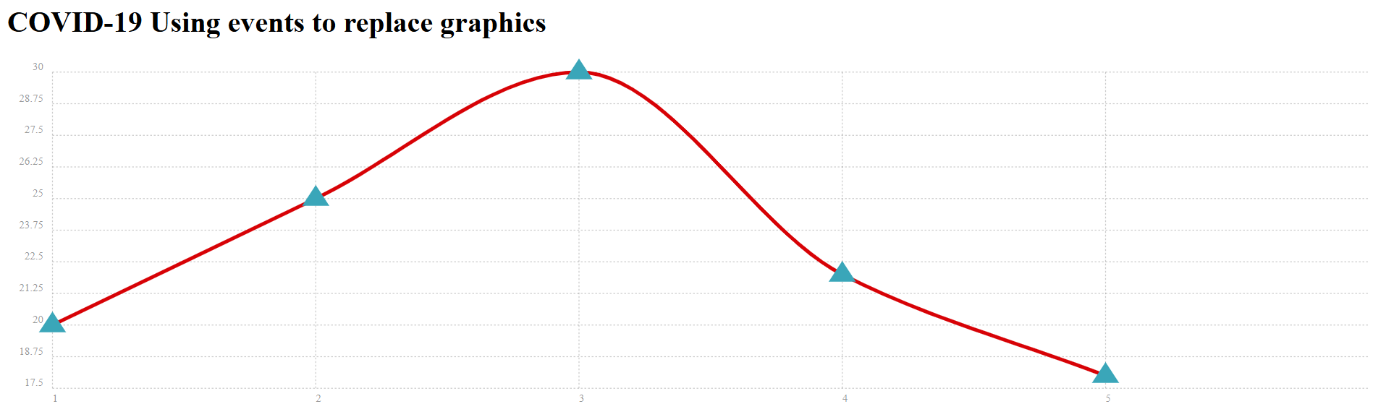
Advanced SMIL Animations:
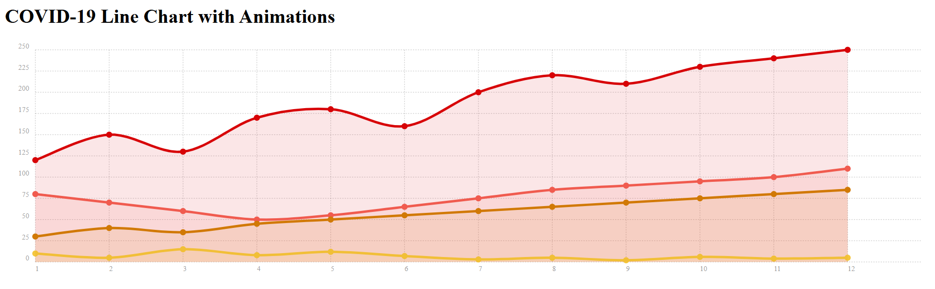

SVG Path animation:
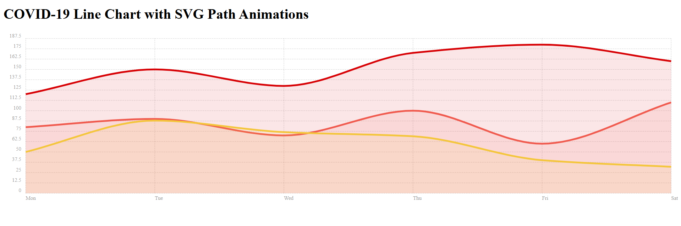
Line Interpolation / Smoothing:
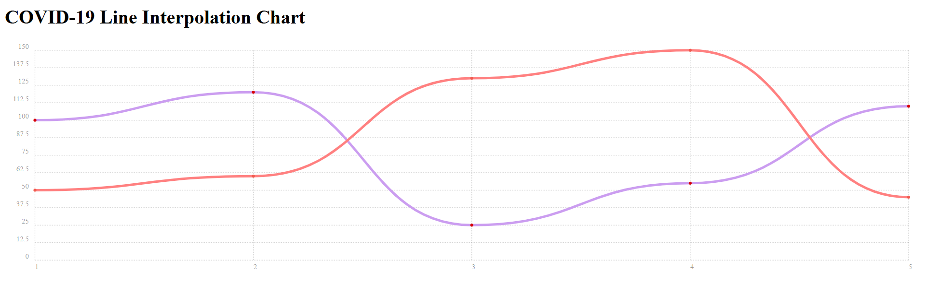
Series Overrides:
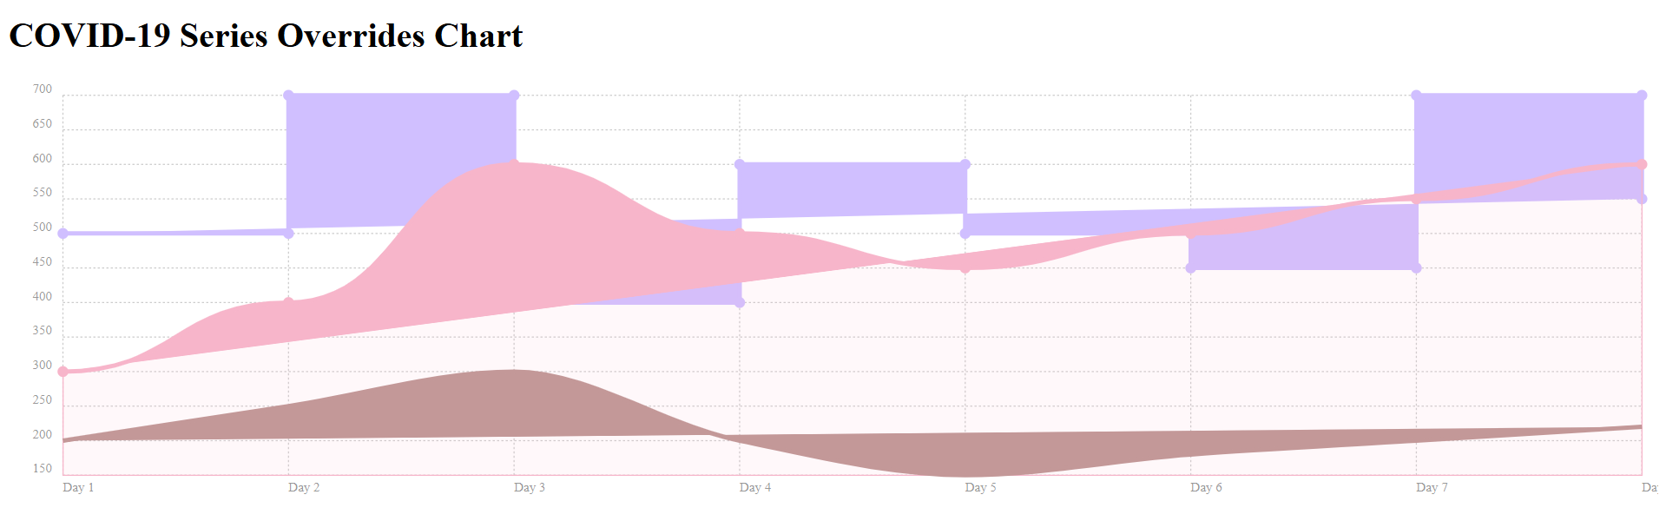

Time Series with Moment.js:
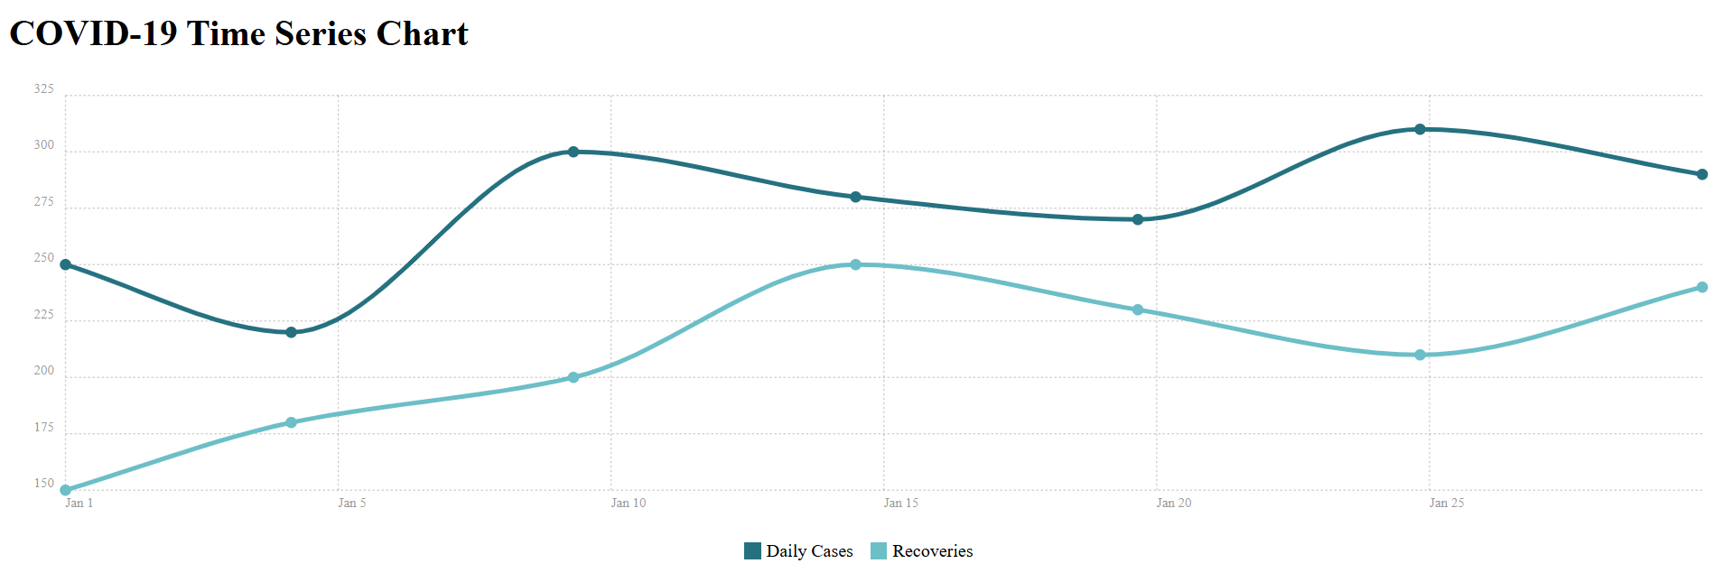
Bar chart examples:
Bi-polar bar chart:
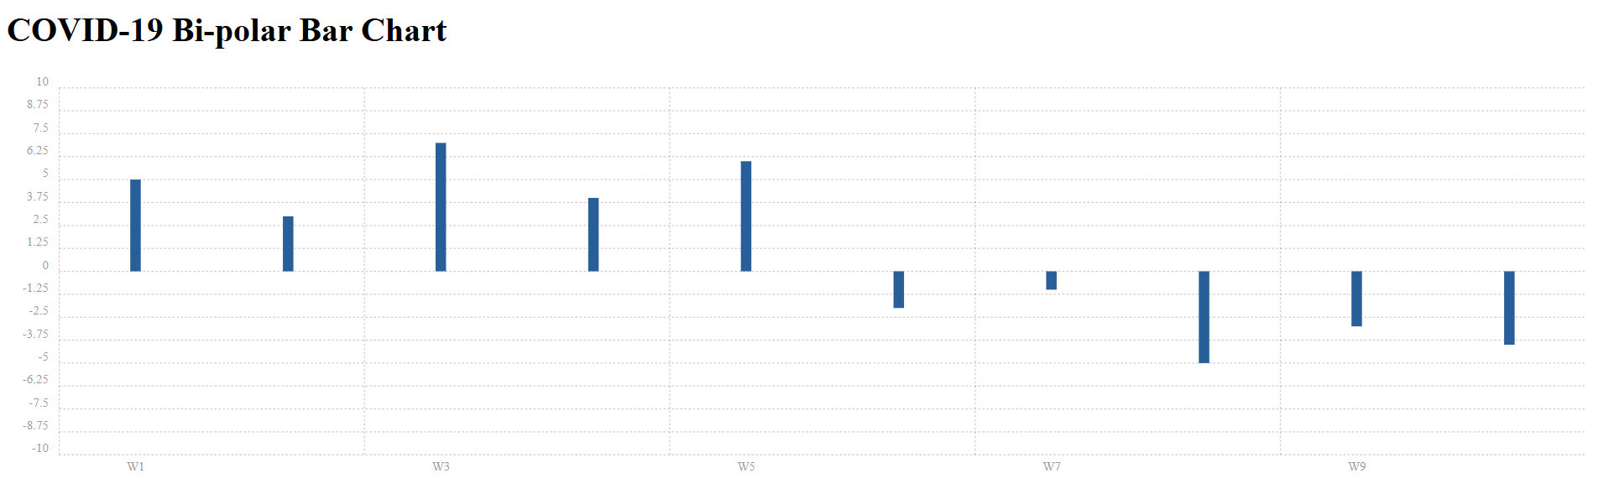
Overlapping bars on mobile:
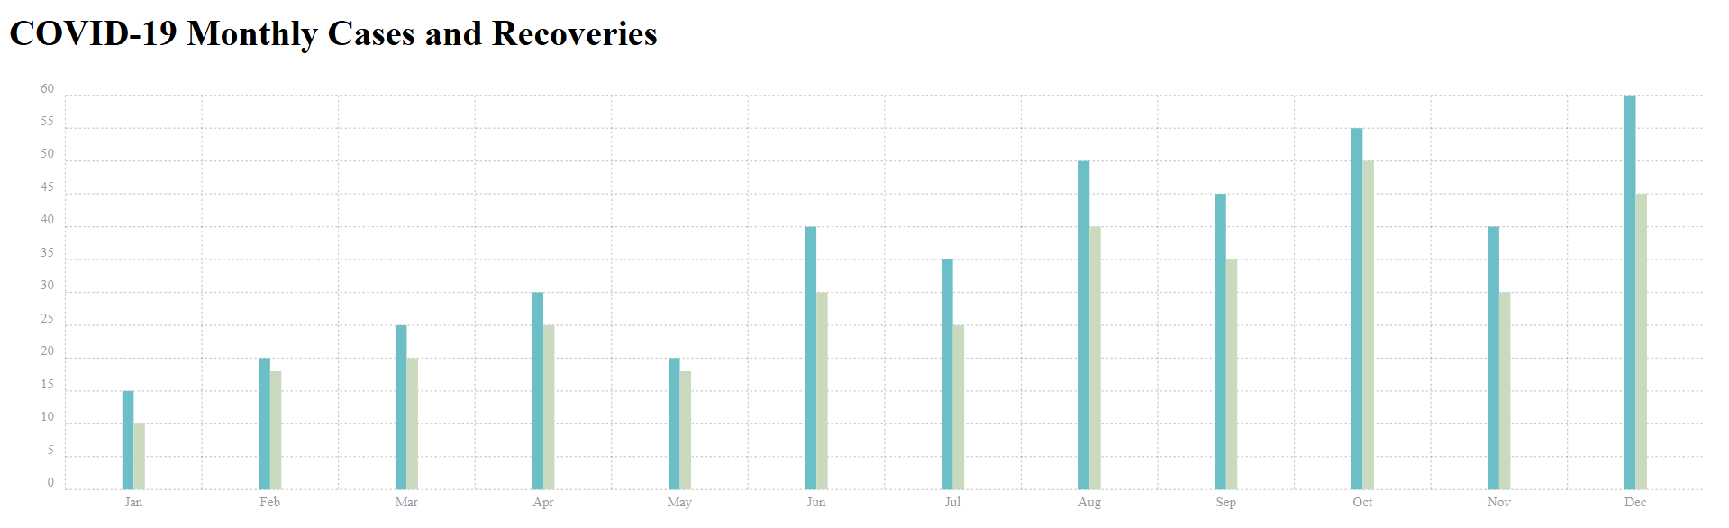

Add peak circles using the draw events:
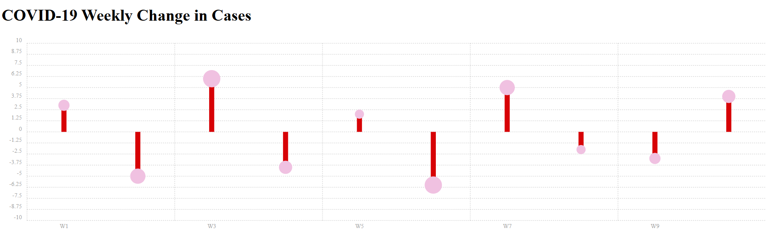
Multi-line labels:
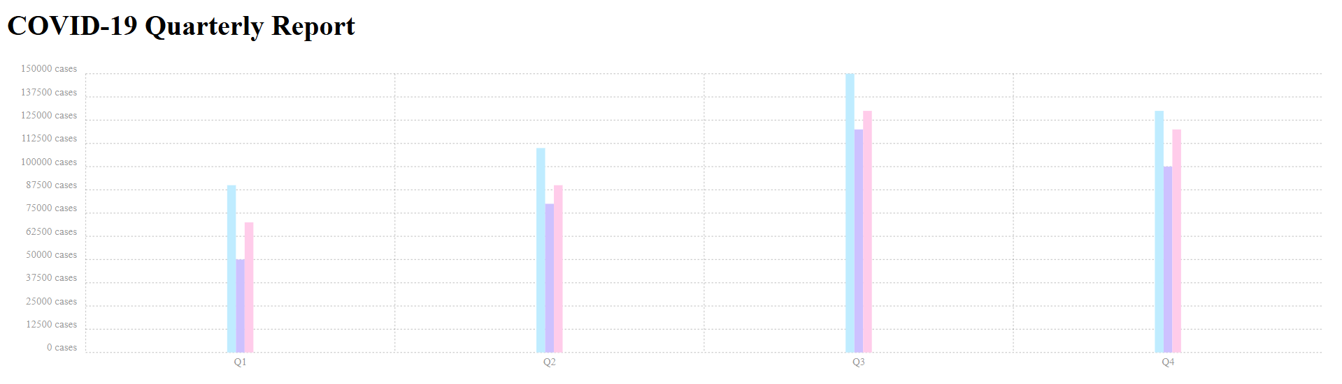
Stacked bar chart:
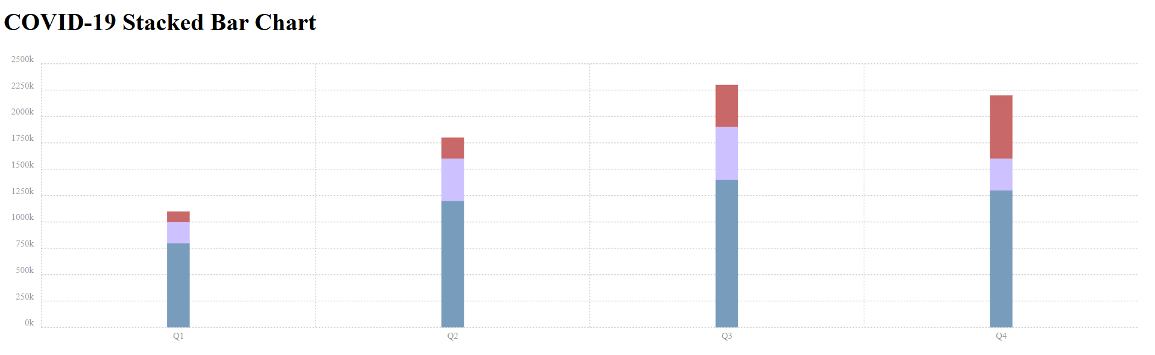
Horizontal bar chart:
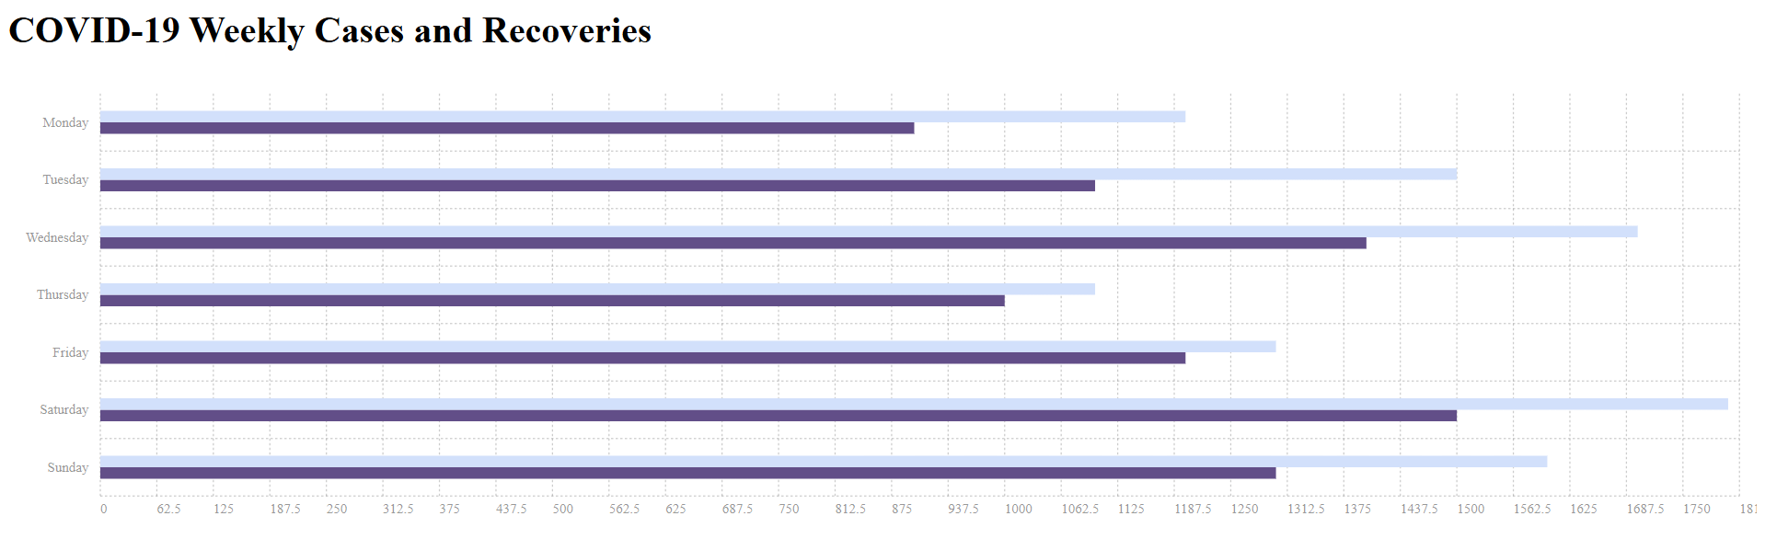

Extreme responsive configuration:
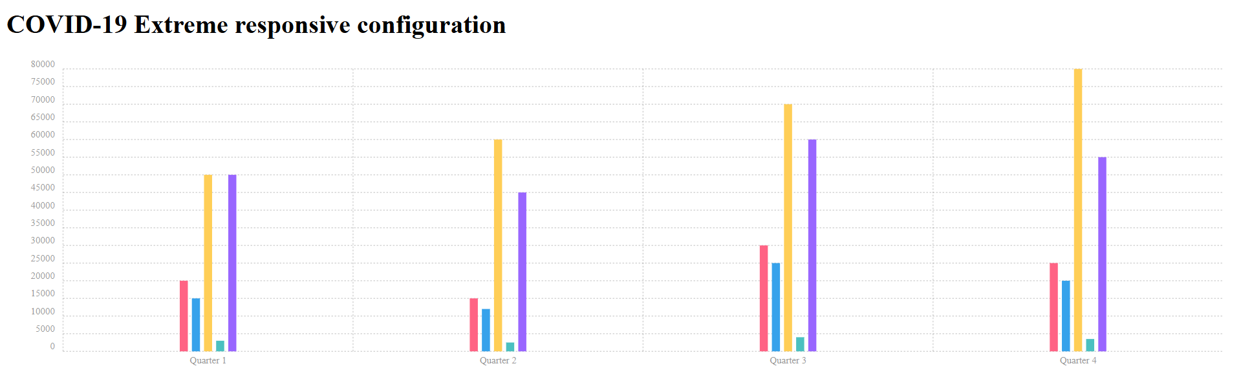
Label placement:
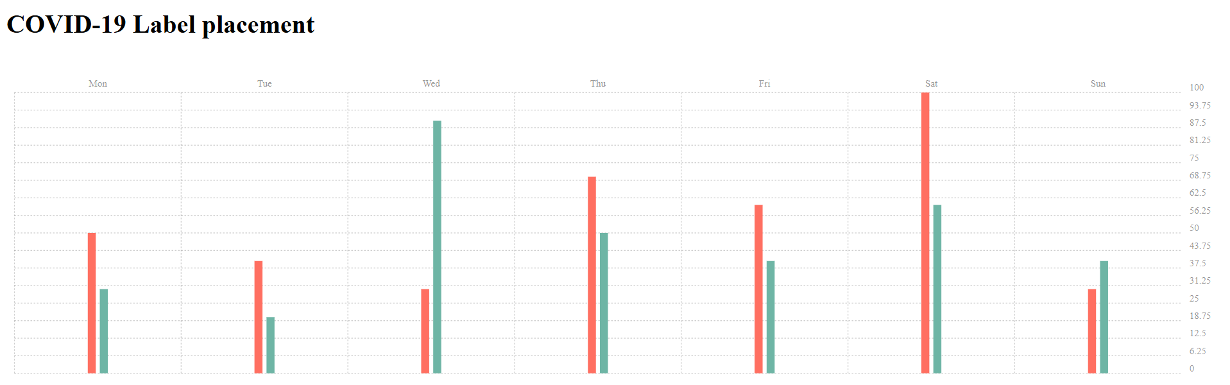
Pie chart examples:
Simple pie chart:
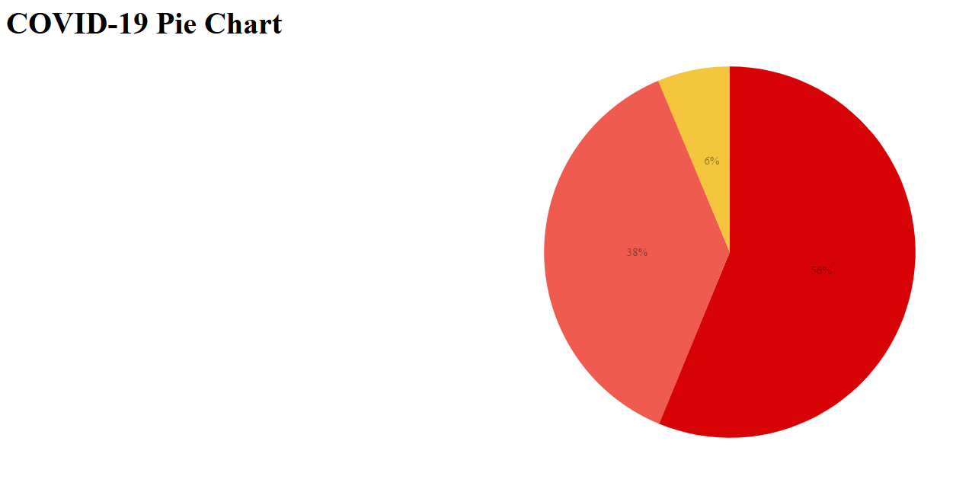

Pie chart with custom labels:
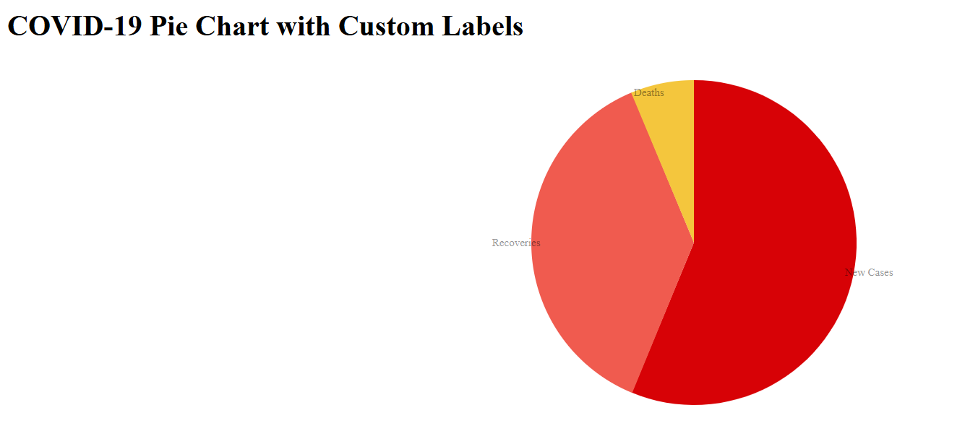
Gauge chart:
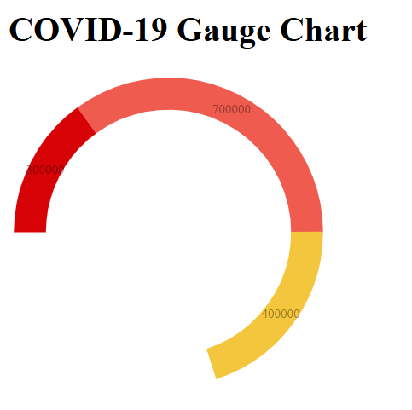
Animating a Donut with Svg.animate:
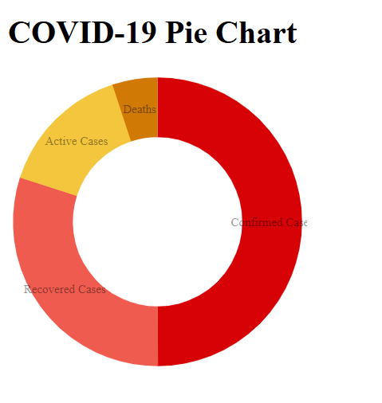

Donut chart using fill rather than stroke:
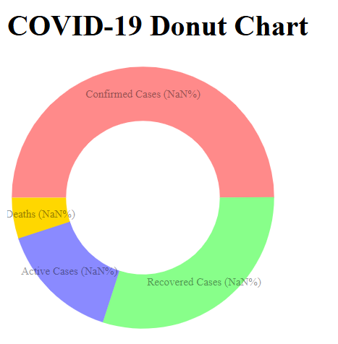
Gauge chart using fill rather than stroke:
