CHAPTER – 1
INTRODUCTION
  - AIM
Global events like the Olympics generate high volumes of online interactions, which can include harmful and offensive language, known as hate speech. Detecting hate speech is a key area within Natural Language Processing (NLP) that aims to identify language targeted at individuals or groups based on race, nationality, or other characteristics. Traditional methods focus on text, but the growing use of emojis adds complexity, as emojis can shift or intensify the sentiment of a message. This is particularly challenging during events like the Olympics, where emojis and text together express both positive and negative emotions.
  - HATE SPEECH DETECTION
This project develops a hate speech detection system that combines text and emoji analysis to monitor social media during the Paris 2024 Olympics. It uses Long Short-Term Memory (LSTM) and a Bidirectional Long Short-Term Memory (BiLSTM) model to capture the context of text-emoji sequences accurately. Developed on Jupyter Notebook, this system is trained on a dataset specific to the Paris Olympics, allowing for effective real-time detection of nuanced hate speech. This approach aims to foster respectful online interactions and can be adapted for future large-scale events.
1.3 ORGANIZATION OF THE REPORT:
The report titled "Hate Speech Detection During the Paris 2024 Olympics Using Text and Emoji Analysis" is structured to systematically present the research and findings. It begins with an Introduction that outlines the aim, background, motivation, and objectives of the study, establishing the context of hate speech detection on social media during significant events like the Olympics. Following this, the Related Work chapter surveys existing literature on hate speech detection, focusing on limitations of current systems and introducing the proposed system that combines text and emoji analysis to enhance detection capabilities. The report then delves into the System Design, detailing the architecture and algorithms utilized, including LSTM and BiLSTM. This is followed by the System Implementation chapter, which elaborates on the methodology, data collection, preprocessing, feature extraction, data splitting, model training, and evaluation metrics. Finally, the report concludes with reflections on the findings, while a comprehensive References section lists all sources cited throughout the document.
CHAPTER – 2
RELATED WORK
2.1 LITERATURE SURVEY
The detection of hate speech and sentiment in social media has seen significant advancements in recent years, with various approaches addressing the challenges posed by real-time and multilingual content. Roy et al. (2024) and Ahmed and Lin (2022) proposed LSTM-based and deep explainable learning models, respectively, to enhance real-time hate speech detection in diverse language settings, providing insight into user sentiment patterns over time. Other works, such as Alsafari et al. (2020) and Al-Hassan and Al-Dossari (2019), tackled regional and linguistic challenges by creating frameworks for Arabic and multilingual hate speech detection, highlighting the necessity for diverse language datasets. Traditional and ensemble methods also played a pivotal role, as seen in Nobata et al. (2016) and Malmasi and Zampieri (2017), who focused on combining lexical and syntactic features to handle abusive language with improved generalization across datasets. Additionally, studies by Burnap and Williams (2015) and Warner and Hirschberg (2012) provided early foundations by integrating machine learning and statistical modeling with practical applications for policy-making in social media.
Emoji and sentiment detection also saw substantial progress, as emojis have become critical for conveying nuanced emotional cues in digital texts. Baziotis et al. (2017) introduced a deep LSTM model with attention mechanisms to detect sentiments, demonstrating the importance of emojis in sentiment analysis. Felbo et al. (2017) utilized millions of emoji occurrences to create a robust model capable of sentiment, emotion, and sarcasm detection, showcasing emoji versatility in detecting implicit meanings. Furthermore, Nayla et al. (2023) leveraged BERT for hate speech detection with emoji-based features, underlining its efficacy in short-text contexts. To address sarcasm and ambiguity in social media, Suttles and Ide (2013) emphasized the complexities of emoji-based sarcasm detection, while Chrismanto et al. (2023) implemented ensemble models for spam detection, combining emoji and textual features for heightened accuracy.
Further advancements in emotion detection and emoji classification through multimodal approaches illustrate the potential of integrating gestures and non-verbal cues with emoji-based methods. For instance, Kumar et al. (2023) and Tare et al. (2023) used CNN models for mood and emoji classification, combining tokenization techniques with machine learning to enhance accuracy in sentiment understanding. Gupta et al. explored emoji prediction from hand gestures, enabling assistive technologies to interpret gestures as emojis. Collectively, these studies underscore the importance of contextual and multimodal approaches for effective hate speech and emoji-based sentiment detection, illustrating the rapid evolution of methods to understand the complex dynamics of online communication.
2.1 EXISTING SYSTEM
Traditional hate speech detection systems predominantly rely on text-based models, focusing on keyword matching, bag-of-words, TF-IDF, and N-gram-based approaches to detect offensive content. Many of these models use machine learning classifiers such as Support Vector Machines (SVM), Naïve Bayes, and even some deep learning techniques like CNNs and RNNs to identify hate speech patterns in text. However, these systems often fail to consider the unique nuances that emojis add to online interactions. Emojis can alter the meaning of a sentence, either intensifying hate speech or, conversely, softening a harsh statement. Most existing systems overlook the complex interactions between text and emoji, resulting in limited accuracy in identifying subtle or disguised hate speech. Moreover, the lack of specialized handling for multilingual and diverse contexts, such as those encountered during global events like the Olympics, reduces their efficacy in accurately identifying hate speech on an international scale.
2.2 PROPOSED SYSTEM
The proposed system aims to bridge the gap by incorporating both text and emoji data for more accurate hate speech detection. Using deep learning techniques like Long Short-Term Memory (LSTM) and Bidirectional LSTM (BiLSTM) networks, the system captures temporal dependencies and context in online conversations, effectively handling the sequential nature of language. This project introduces an enhanced preprocessing pipeline that includes feature extraction modules for word embeddings, emoji embeddings, N-grams, and sentiment analysis to account for sentiment variations conveyed by emojis. By integrating these features, the model is better equipped to recognize hate speech in multilingual and diverse contexts, especially relevant for the Paris 2024 Olympics, where international conversations will be prevalent. The proposed system aims to outperform traditional models in detecting hate speech that incorporates both text and emoji, ensuring a more comprehensive and culturally aware approach to online hate speech mitigation.

CHAPTER- 3
SYSTEM DESIGN

3.1 SYSTEM ARCHITECTURE
This structure overview of the System Architecture of Hate Speech Detection.
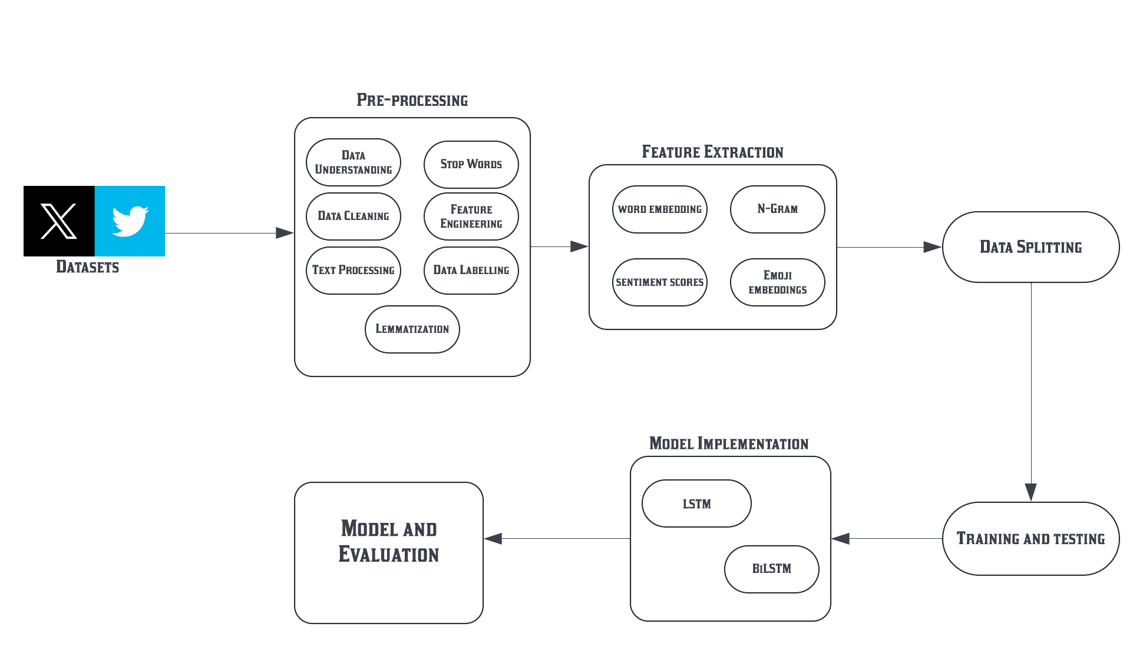

Figure 3.1 System Architecture

3.2 PROPOSED ALGORITHMS
The proposed algorithm for hate speech detection on social media data involves a combination of Long Short-Term Memory(LSTM) and a Bidirectional Long Short-Term Memory (BiLSTM) model. These techniques allow the model to effectively analyze both text and emojis, enabling it to detect hate speech with greater contextual understanding.
3.2.1 LONG SHORT-TERM MEMORY (LSTM)
Overview:
LSTM networks are an advanced type of RNN specifically designed to overcome the limitations of traditional RNNs, especially the issues of vanishing and exploding gradients. LSTMs can capture long-term dependencies in sequences, which is crucial for text data where the meaning of a word or emoji can depend on words that came much earlier in the sequence.
Structure:
Cell State: The "memory" of the network, which carries information across many time steps and can be modified by the network.
Gates: LSTMs use three main gates (input gate, forget gate, and output gate) to regulate the flow of information:
Forget Gate: Decides what information to discard from the cell state.
Input Gate: Determines which information from the current input to add to the cell state.
Output Gate: Controls which information from the cell state to output at the current time step.
In our algorithm, the LSTM processes each word and emoji in a sequence, allowing the model to learn dependencies across sentences. For example, the phrase “dislike 😡 them” might carry a hateful sentiment, where the LSTM can recognize that the emoji strengthens the negative tone. Since the LSTM can maintain context over long sentences, it’s well-suited for identifying the progression of hate speech patterns.
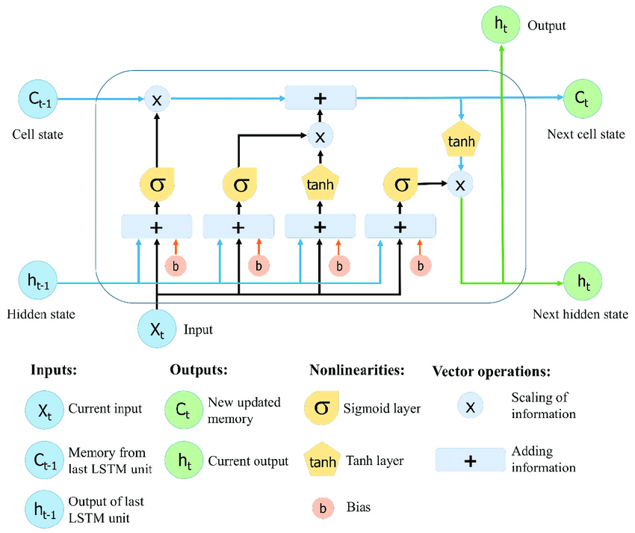
Figure 3.2 LSTM Block Diagram
3.2.2 BILSTM (BIDIRECTIONAL LONG SHORT-TERM MEMORY) MODEL
Overview:
A Bidirectional LSTM is an extension of the LSTM model that processes information in both forward and backward directions, meaning it reads the text sequence twice—once from start to end, and again from end to start. This structure enables the model to capture context from both the past and future words in a sequence, improving its understanding of the full sentence meaning.
Structure:
Forward Layer: Processes the sequence from left to right, similar to a standard LSTM.
Backward Layer: Processes the sequence from right to left, capturing the context that follows each word or emoji.
For hate speech detection, the BiLSTM can be particularly valuable. For instance, in the sentence “They are ruining everything 😤”, a forward-only LSTM may detect a negative sentiment but miss how the phrase might also carry hate speech when the emoji is taken into account with preceding words. A BiLSTM, however, will capture the full context, understanding both how the sequence starts and how it ends. This bidirectional processing is beneficial when handling subtle language patterns and emojis that might change meaning depending on their position.
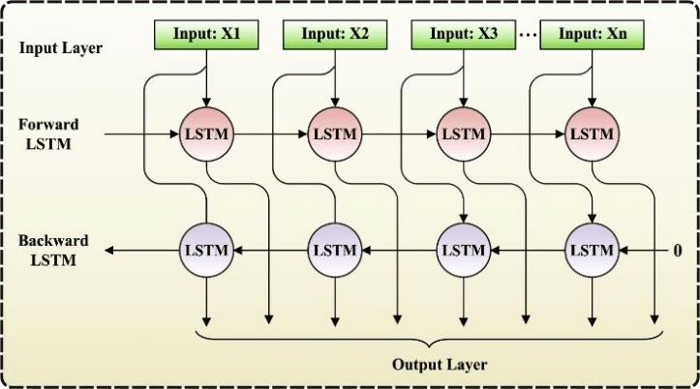
Figure 3.3 BiLSTM Block Diagram
CHAPTER – 4
SYSTEM IMPLEMENTATION
4.1 METHODOLOGY
4.1.1 DATA COLLECTION
Online Sources: The system starts by collecting tweets and other relevant textual data from online sources, which may include social media platforms, forums, or public datasets. The collected data is initially unlabeled and consists of both text and emoji content related to the Paris 2024 Olympics. Since the data is initially unlabeled, it undergoes a manual or semi-automated labeling process to classify it as either "Hate Speech" or "Non-Hate Speech."
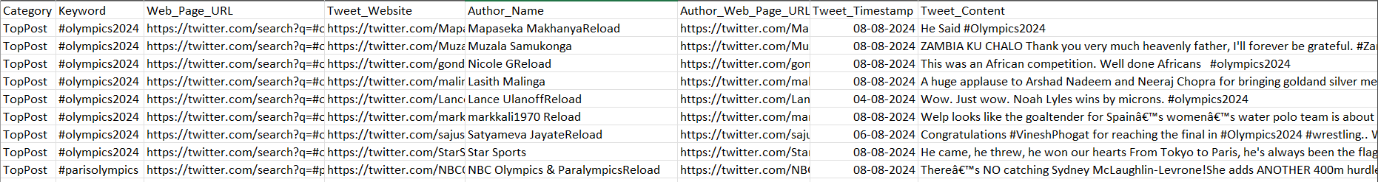
Figure 4.1 Olympics Dataset – 1
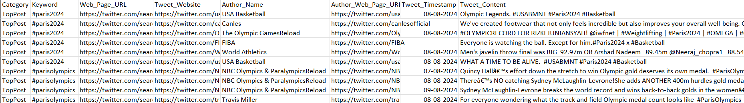
Figure 4.2 Olympics Dataset – 2
4.1.2 DATA PREPROCESSING
Data Understanding: This step involves analyzing the collected dataset to understand its structure, including identifying the number of tweets, the diversity of languages, and the presence of emojis.
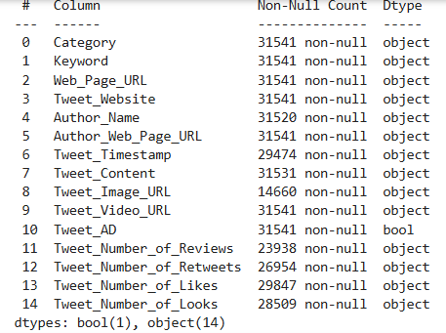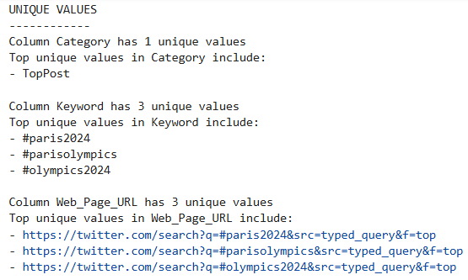
Data Cleaning:
Removing Duplicates: Elimination of duplicate tweets to ensure the integrity of the dataset.
Handling Missing Values: Addressing any missing data by either filling gaps or discarding incomplete entries.
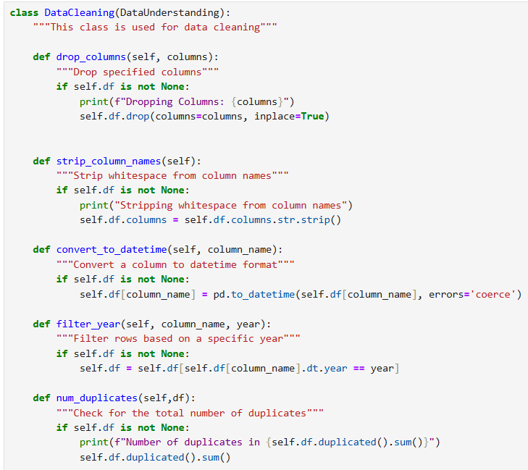
Figure 4.3 Data Cleaning
Text Processing:
Removing ASCII characters: Stripping out any non-ASCII characters to maintain uniformity.
Replacing Emojis: Converting emojis to their textual equivalents to facilitate analysis.
Lemmatization: Reducing words to their base forms to standardize variations of words.
Stop Words Removal: Filtering out common words that do not contribute to the meaning of the text.
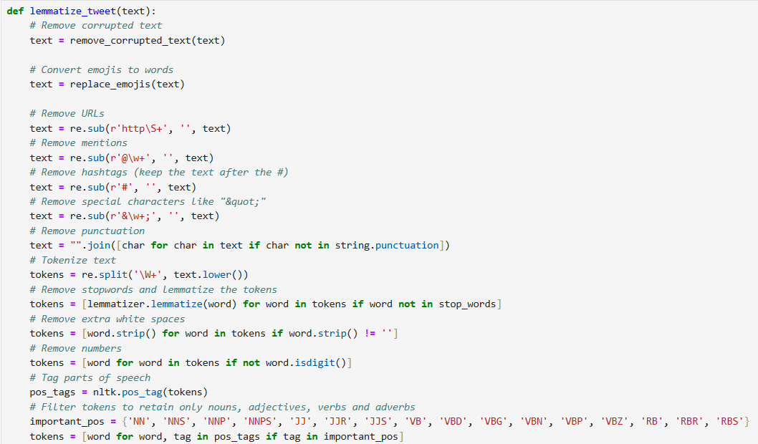
Figure 4.4 Lemmatization
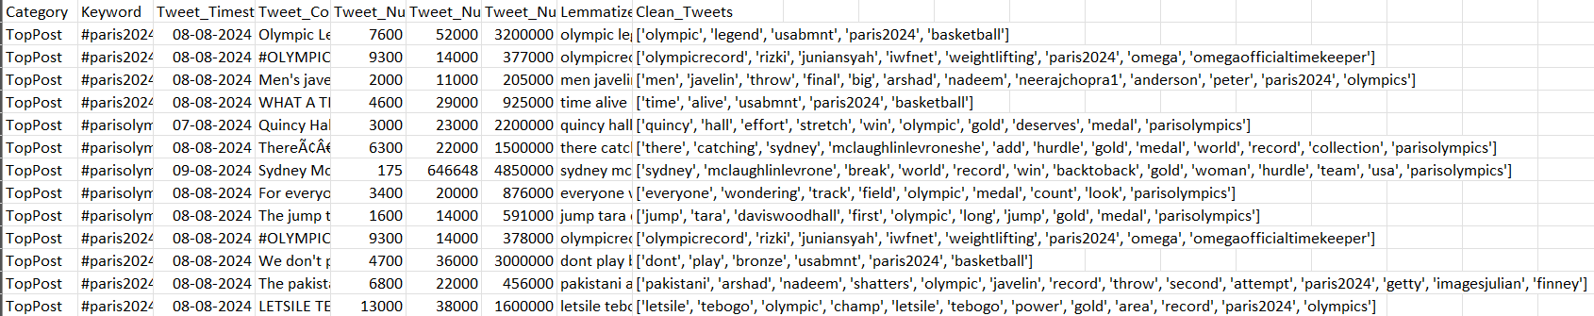
Figure 4.5 Cleaned Tweets
Feature Engineering:
Adding Emojis to Unique Words: Enhancing the dataset by associating relevant emojis with unique words, which aids in context understanding.
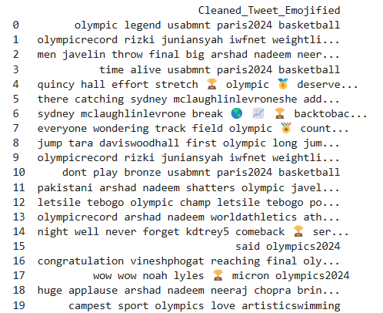
Figure 4.6 Emoji Added

Data Labelling: Manually or semi-automatically label each tweet or text sample as "Hate Speech" or "Non-Hate Speech."
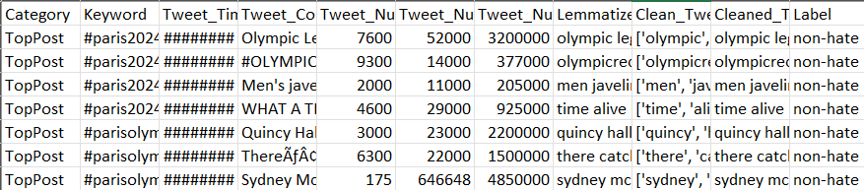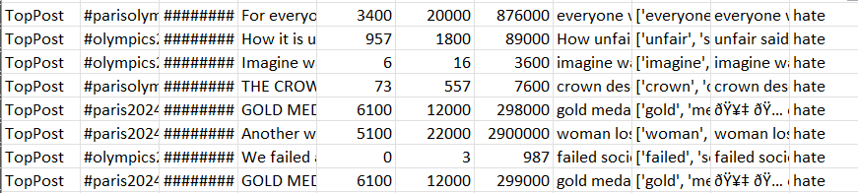
Figure 4.7 Data Labelling
4.1.3 FEATURE EXTRACTION
In this project, we implemented a range of feature extraction techniques to capture both text-based and emoji-based nuances in hate speech, considering the specific nature of social media language.
Word Embeddings: Capture semantic information from the text in tweets, enabling the model to understand the context and meaning of words. We utilized pre-trained GloVe embeddings to convert each word in a tweet into a dense vector representation. Each tweet was tokenized, and individual word vectors were averaged to form a single vector, representing the semantic context of the entire tweet. GloVe embeddings allow for a compact representation of textual data, improving model interpretability by understanding word meanings and relationships.
N-grams:
Identify common word pairs (bigrams) that could indicate hate speech when used in specific combinations. Using the CountVectorizer from Scikit-Learn, we extracted bigrams from the text, creating a feature matrix where each column represented a unique bigram. This feature is especially useful for capturing frequently used hate expressions or sentiments in phrases. The use of bigrams allows the model to capture multi-word expressions that may not be apparent when analyzing individual words, improving accuracy in detecting specific hate speech phrases.
Sentiment Scores:
Measure the overall sentiment of each tweet, as hate speech is often correlated with negative sentiment. TextBlob was used to calculate a sentiment polarity score for each tweet, where the score ranges from -1 (negative) to 1 (positive). This feature serves as an indicator of the emotional tone in tweets. Including sentiment scores helps the model distinguish between neutral or positive messages and those that carry negativity, which could indicate hate speech.
Emoji Embeddings:
Capture the emotional tone and context conveyed through emojis, which are commonly used in tweets to amplify sentiment. Emojis were identified using the emoji library and converted to descriptive text. GloVe embeddings were then used to obtain vector representations of these emojis. Similar to word embeddings, we averaged emoji embeddings to create a single vector for each tweet. Emojis often substitute for words in informal communication, carrying significant emotional content. Representing them as embeddings improves the model’s understanding of non-verbal cues in hate speech.

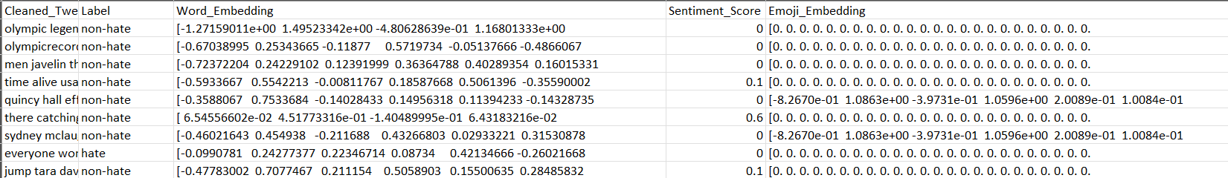
Figure 4.8 Feature Extraction
4.1.4 DATA SPLITTING
The Pre-processed data is split into training, validation, and test sets to ensure the model generalizes well.
Figure 4.9 Data Splitting
4.1.5 MODEL IMPLEMENTATION
The models were implemented using Jupyter Notebook, primarily utilizing TensorFlow and Keras libraries.
LSTM Implementation
Embedding Layer: Initialized using pre-trained word and emoji embeddings, ensuring that the model understands both text and emoji context.
LSTM Layer: The LSTM layer was set up with a hidden size optimized for balancing complexity and performance.
Dense and Output Layers: These layers map the LSTM output to a binary classification of hate speech or non-hate speech.
BiLSTM Implementation
Embedding Layer: Identical to the LSTM implementation, using the same embeddings.
BiLSTM Layer: The BiLSTM layer was implemented to capture both forward and backward contexts, providing a more comprehensive understanding of context.
Dense and Output Layers: Similar to the LSTM model, these layers map the BiLSTM output to the final classification.

Training Setup
Loss Function: Binary Cross-Entropy was used as it’s well-suited for binary classification tasks.
Optimizer: The Adam optimizer was selected for its adaptive learning rate capabilities, ensuring faster convergence.
Hyperparameters: The batch size, learning rate, and dropout rates were optimized through experimentation and cross-validation.
4.1.6 MODEL EVALUATION
To evaluate the performance of our model, we focused on metrics suited to classification tasks, especially for an imbalanced dataset common in hate speech detection.
Confusion Matrix: The confusion matrix provides a breakdown of true positives, true negatives, false positives, and false negatives, helping to understand the model’s strengths and weaknesses.
Precision, Recall, and F1 Score: Precision indicates how many instances predicted as hate speech were actually hate speech. Recall represents the ability to identify all true instances of hate speech. F1 Score is the harmonic mean of precision and recall, providing a balanced measure of accuracy for imbalanced data.
Accuracy: Accuracy is the percentage of correctly classified instances out of all instances. While useful, it can be misleading with imbalanced datasets, hence we also report precision, recall, and F1 scores.

CHAPTER – 5
RESULTS AND DISCUSSION
5.1 RESULTS
This chapter presents the results of the LSTM and BiLSTM models used for hate speech detection in social media text, particularly in discussions surrounding the Paris 2024 Olympics. Each model was trained and evaluated on the dataset, achieving high accuracy and precision in distinguishing hate speech from non-hate speech. The models were evaluated on multiple performance metrics, including accuracy, precision, recall, and F1-score, to determine their effectiveness.
Accuracy:
Model | Training | Testing
LSTM | 98.11% | 98.61%
BiLSTM | 93.88% | 93.92%

Visualization:
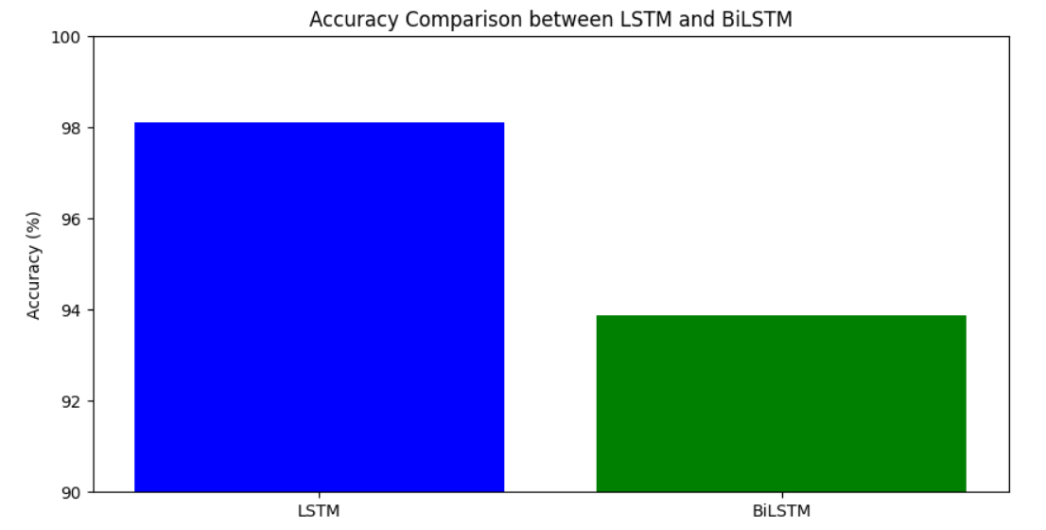
Figure 5.1 Accuracy between LSTM and BiLSTM

Classification Report:
Model |  | Precision | Recall | F1-Score
LSTM | Hate - 0 | 0.98 | 0.85 | 0.91
 | Non-Hate -1 | 0.98 | 1.00 | 0.99
BiLSTM | Hate - 0 | 1.00 | 0.01 | 0.02
 | Non-Hate -1 | 0.94 | 1.00 | 0.97

Confusion Matrix:
Model | True Positive | True Negative | False Positive | False Negative
LSTM | 5530 | 306 | 55 | 2
BiLSTM | 5532 | 2 | 358 | 0

5.2 DISCUSSION
The LSTM model achieved a high training accuracy of 98.11% indicating effective generalization to unseen data. This model handles the classification of both hate and non-hate cases effectively, showing a balanced approach and reliable results across both classes.
In contrast, the BiLSTM model attained a slightly lower training accuracy of 94%. However, it struggled significantly with detecting hate cases, as indicated by low recall in this category. Although it performs well on non-hate cases, the BiLSTM model's failure to capture hate cases adequately limits its utility in hate speech detection.
Overall, the LSTM model’s ability to accurately classify both hate and non-hate cases with higher precision and recall makes it the preferred choice for this task. It handles class imbalance better, ensuring a robust solution for detecting hate speech more reliably than the BiLSTM.

References:
[1] Sanjiban Sekhar Roy; Akash Roy; Pijush Samui; Mostafa Gandomi; Amir H. Gandomi,"Hateful Sentiment Detection in Real-Time Tweets: An LSTM-Based Comparative Approach", in IEEE Transactions on Computational Social Systems ( Volume: 11, Issue: 4, August 2024),pp.5028 - 5037,DOI: 10.1109/TCSS.2023.3260217
[2] U. Ahmed and J. C.-W. Lin, "Deep explainable hate speech active learning on social-media data", IEEE Trans. Computat. Social Syst., Apr. 2022.
[3] Alsafari, S., Sadaoui, S., Mouhoub, M., 2020. “Hate and offensive speech detection on Arabic social media”. Online Soc. Netw. Media 19, 100096.
[4] Al-Hassan A, Al-Dossari H (2019) “Detection of hate speech in social networks: a survey on multilingual corpus.” In: 6th international conference on computer science and information technology, vol 10, pp 10–5121. https:// doi. org/ 10. 5121/ csit. 2019. 90208
[5] Badjatiya, P., Gupta, S., Gupta, M., Varma, V., 2017. “Deep learning for hate speech detection in tweets”. In: Proceedings of the 26th International Conference on World Wide Web Companion. pp. 759–760.
[6] Necva Bölücü,Pelin Canbay., 2021. “Hate Speech and Offensive Content Identification
with Graph Convolutional Networks”.
[7] C. Nobata, J. Tetreault, A. Thomas, Y. Mehdad, Y. Chang, “Abusive language detection in
online user content” In: Proceedings of the 25th international conference on world wide
web, 2016, pp. 145–153.
[8] S. Malmasi, M. Zampieri, “Detecting hate speech in social media”. In: Proceedings of the
International Conference Recent Advances in Natural Language Processing, RANLP 2017,
2017, pp. 467–472.
[9] S. S. Aluru, B. Mathew, P. Saha, A. Mukherjee, “Deep learning models for multilingual hate
speech detection”, arXiv preprint arXiv:2004.06465 (2020).
[10] T. Mandl, S. Modha, G. K. Shahi, H. Madhu, S. Satapara, P. Majumder, J. Schäfer, T. Ranas-inghe, M. Zampieri, D. Nandini, A. K. Jaiswal, Overview of the HASOC subtrack at FIRE 2021: “Hate Speech and Offensive Content Identification in English and Indo-Aryan Languages”, in: Working Notes of FIRE 2021 - Forum for Information Retrieval Evaluation, CEUR, 2021.
[11] C. Baziotis, N. Pelekis, C. Doulkeridis, Datastories at semeval-2017 task 4: “Deep lstmwith attention for message-level and topic-based sentiment analysis”, in: Proceedings of the 11th International Workshop on Semantic Evaluation (SemEval-2017), Association for Computational Linguistics, Vancouver, Canada, 2017, pp. 747–754.
[12] Adine Nayla; Casi Setianingsih; Burhanuddin Dirgantoro “Hate Speech Detection on Twitter Using BERT Algorithm”, 2023 International Conference on Computer Science, Information Technology and Engineering (ICCoSITE), 10.1109/ICCoSITE57641.2023.10127831, 23 May 2023.
[13] R. D. King and G. M. Sutton, "High times for hate crimes: Explaining the temporal clustering of hate-motivated offending", Criminology, vol. 51, pp. 871-894, 2013.
[14] P. Burnap and M. L. Williams, "Cyber hate speech on twitter: An application of machine classification and statistical modeling for policy and decision making", Policy Internet, vol. 7, no. 2, pp. 223-242, Jun. 2015.
[15] W. Warner and J. Hirschberg, "Detecting hate speech on the world wide Web", Proc. 2nd Workshop Lang. Social Media, pp. 19-26, Jun. 2012.
[16] Barath Kumar V; Sooryash J; Sriram B; Sushmita V; Sabitha B; Magudapathi P “Human Emotion Detection to Emoji Display Using Machine Learning”, 2023 2nd International Conference on Advancements in Electrical, Electronics, Communication, Computing and Automation (ICAECA), 10.1109/ICAECA56562.2023.10201174, 07 August 2023.
[17] T. Praveen, S. S. Reddy, T. V. K. Reddy, N. S. Reddy and S. N. Chandrashekhar, “EMOJI CREATION WITH FACIAL EMOTION DETECTION USING CNN”.
[18] S. Srivastava, P. Gupta and P. Kumar, "Emotion recognition based emoji retrieval using deep learning", 2021 5th International Conference on Trends in Electronics and Informatics (ICOEI), pp. 1182-1186, 2021, June.
[19] Antonius Rachmat Chrismanto; Anny Kartika Sari; Yohanes Suyanto, “Enhancing Spam Comment Detection on Social Media With Emoji Feature and Post-Comment Pairs Approach Using Ensemble Methods of Machine Learning”, IEEE Access ( Volume: 11), 10.1109/ACCESS.2023.3299853, 2169-3536, 28 July 2023.

[20] M. Purver and S. Battersby, "Experimenting with emoticons in task-oriented dialogue", Proceedings of the 13th Annual Meeting of the Special Interest Group on Discourse and Dialogue, pp. 146-154, 2012.
[21] B. Felbo, A. Mislove, A. Søgaard, I. Rahwan and S. Lehmann, "Using millions of emoji occurrences to learn any-domain representations for detecting sentiment emotion and sarcasm", arXiv preprint arXiv:1708.00524, 2017.
[22] J. Suttles and N. Ide, "Emoticon-based detection of sarcasm in Twitter", Proceedings of the 2nd Workshop on Language in Social Media, pp. 1-10, 2013.
[23] Sushil Dalavi; Tanvesh Nivelkar; Sarvesh Patil; Aadesh Sawant; Pankaj Vanwari, “Enhancing Hate Speech Detection through Emoji-based Classification using Bi-LSTM and GloVe Embeddings”, 2023 6th International Conference on Advances in Science and Technology (ICAST), 10.1109/ICAST59062.2023.10455077, 04 March 2024.
[24] B. Felbo, A. Mislove, A. Søgaard, I. Rahwan and S. Lehmann, "Using millions of emoji occurrences to learn any-domain representations for detecting sentiment emotion and sarcasm", arXiv preprint arXiv:1708.00524, 2017.
[25] Kuldeep Vayadande; Ubed Shaikh; Rajan Ner; Sanket Patil; Omkar Nimase; Tejas Shinde, “Mood Detection and Emoji Classification using Tokenization and Convolutional Neural Network”, 2023 7th International Conference on Intelligent Computing and Control Systems (ICICCS), 10.1109/ICICCS56967.2023.10142472, 08 June 2023.
[26] Sanskar S Tare; Madhav J Patil; Adnan Alam; P. Swarnalatha, “Hand-Gesture Based Emoji Identification and Chat Integration”, 2023 5th International Conference on Inventive Research in Computing Applications (ICIRCA), 10.1109/ICIRCA57980.2023.10220739, 28 August 2023.
[27] J. Gupta, S. Goel, S. Varshney, M. S. Dhall and M. N. Gupta, Hand Gesture Recognition for Emoji Prediction.
[28] C. H. Goh and N. Kulathuramaiyer, "Developing an indigenous cultural values based emoji messaging system: A socio-technical systems innovation approach", 12th ACM Conference on Web Science Companion, pp. 32-36, July 2020.
[29] D. Tandyonomanu, "Emoji: representations of nonverbal symbols in communication technology", IOP Conference series: materials science and engineering, vol. 288, no. 1, pp. 012052, 2018.

