Docker, Kubernetes & Amazon EKS
Complete Beginner Learning Notes — Questions, Answers, Diagrams & Examples
Purpose: A reusable reference for the concepts discussed so far, organized from basic definitions to the end-to-end EKS workflow. Keep adding future questions and answers to this document as the learning continues.

Contents
1. Big-picture architecture
2. Core terms: server, EC2, worker node, Docker, image, container, Pod, Kubernetes and EKS
3. ECS vs EKS
4. End-to-end workflow
5. Where Pod creation logic lives
6. Example Deployment YAML, explained line by line
7. Labels and selectors: what app: my-app means
8. What Kubernetes automates—and what you configure
9. Common misunderstandings corrected
10. Commands and a learning checklist
11. Connection to Jenkins, Terraform and a React Native app

1. Big-picture architecture
A typical EKS deployment packages an application as an image, stores that image in a registry such as Amazon ECR, and tells Kubernetes how the workload should run. EKS provides a managed Kubernetes control plane. Pods run on available compute, often EC2 worker nodes. A load balancer may route user traffic to the application.
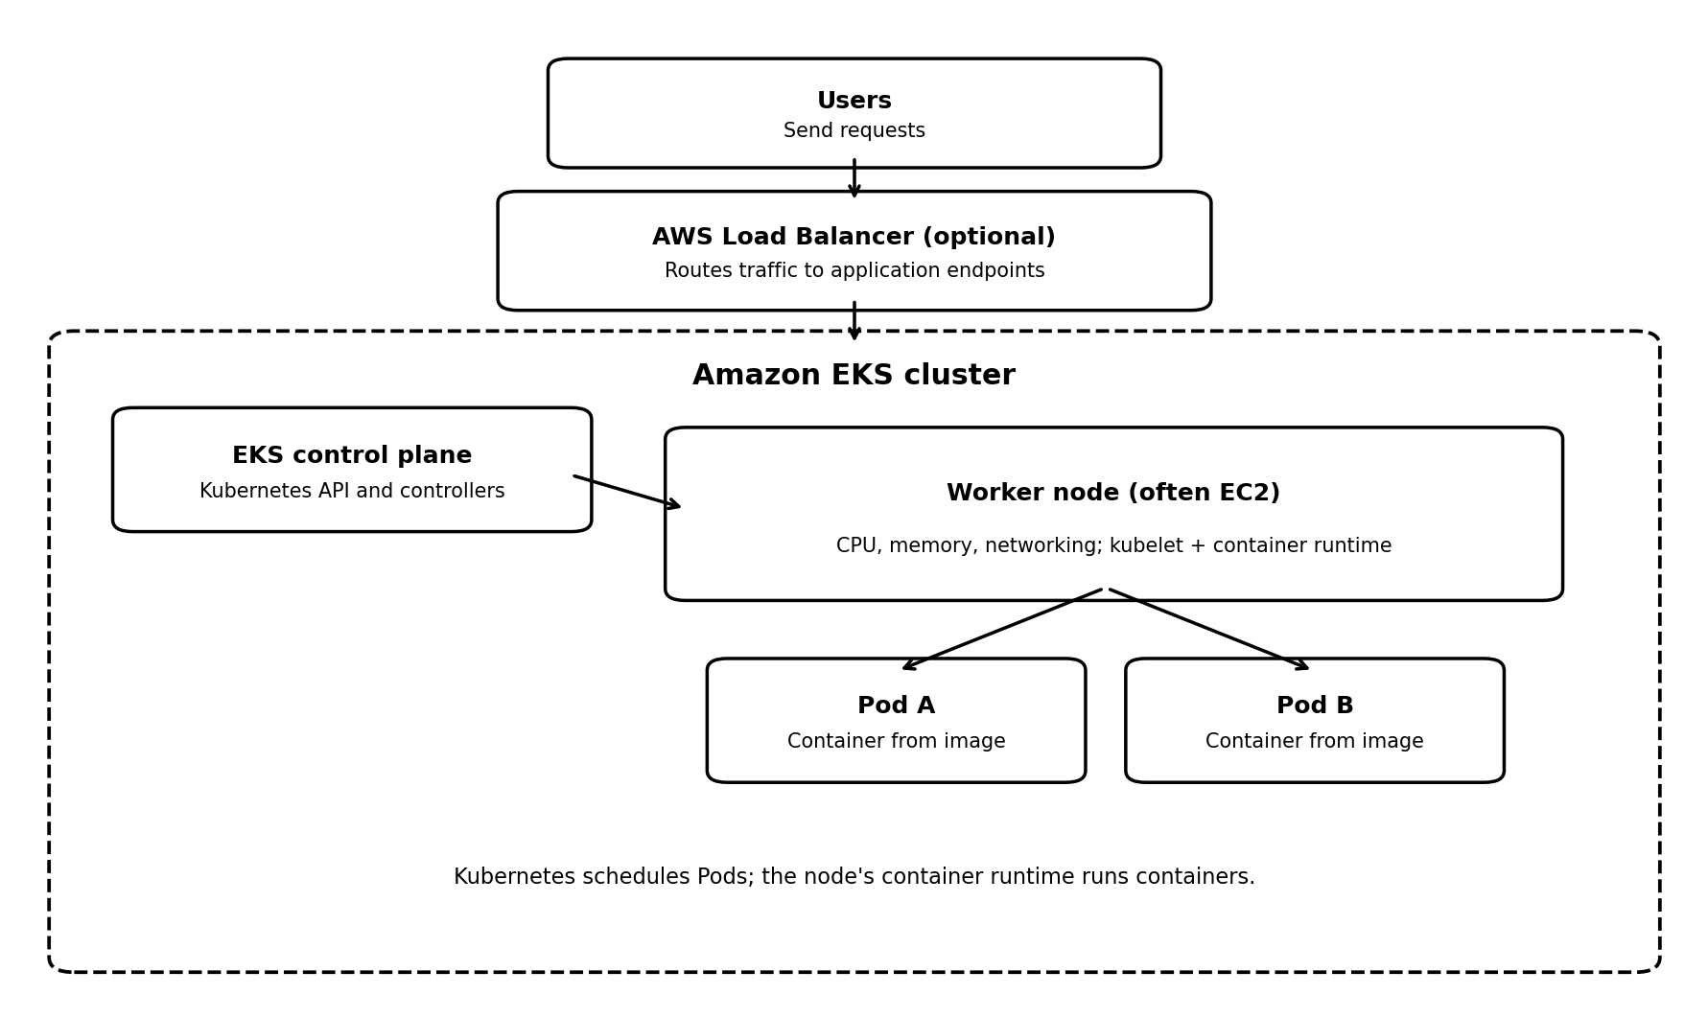
Figure 1. Simplified EKS architecture. Actual networking, traffic routing, and compute options vary by setup.
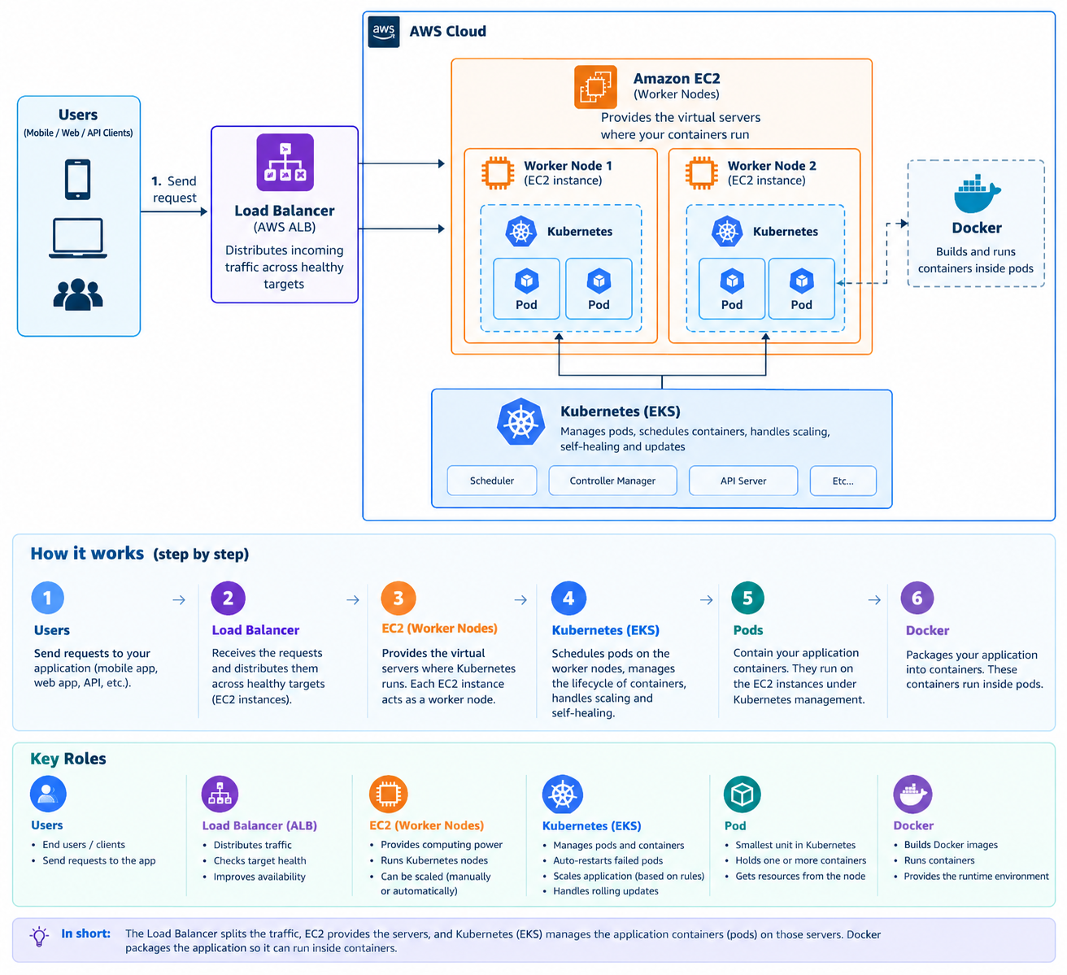

2. Core terms
- Server: A computer that provides compute resources and runs software. It can be physical or virtual.
- EC2 instance: An AWS virtual server. It can act as an EKS worker node when configured for that purpose.
- Worker node: A machine that provides CPU, memory, networking, and runtime services for Pods. In EKS it is often an EC2 instance, though other compute options exist.
- Docker image: A packaged template for an application and its runtime dependencies. An image is not running by itself.
- Container: A running instance of an image.
- Pod: Kubernetes' smallest deployable unit. It usually contains one application container, but can contain more.
- Deployment: A Kubernetes resource that describes a desired number of Pod replicas and manages replacements and rollouts.
- Kubernetes: A container-orchestration system that schedules workloads and helps maintain their declared desired state.
- Amazon EKS: AWS's managed Kubernetes service. AWS manages the Kubernetes control plane; the user still configures workloads, networking, permissions, and compute choices.
- Amazon ECR: A registry for storing container images so compute environments can pull them.
- Load balancer: Routes incoming traffic to appropriate healthy application endpoints when configured. It does not build images or manage Pod replica counts.
- Container runtime: Software on the worker node that runs containers. Modern EKS nodes commonly use containerd; Docker Engine is not normally installed separately just to run EKS Pods.

3. ECS vs EKS
Amazon ECS and Amazon EKS are alternative AWS container-orchestration services. For a given workload, you normally choose ECS or EKS to orchestrate it rather than having both manage the same containers.
ECS: AWS-native orchestration using ECS tasks and services; compute can be EC2 or Fargate.
EKS: managed Kubernetes; Kubernetes uses Pods and resources such as Deployments and Services; compute can include EC2 worker nodes and supported Fargate configurations.
Learn Docker fundamentals first, then understand ECS and EKS as different orchestration options.

4. End-to-end workflow
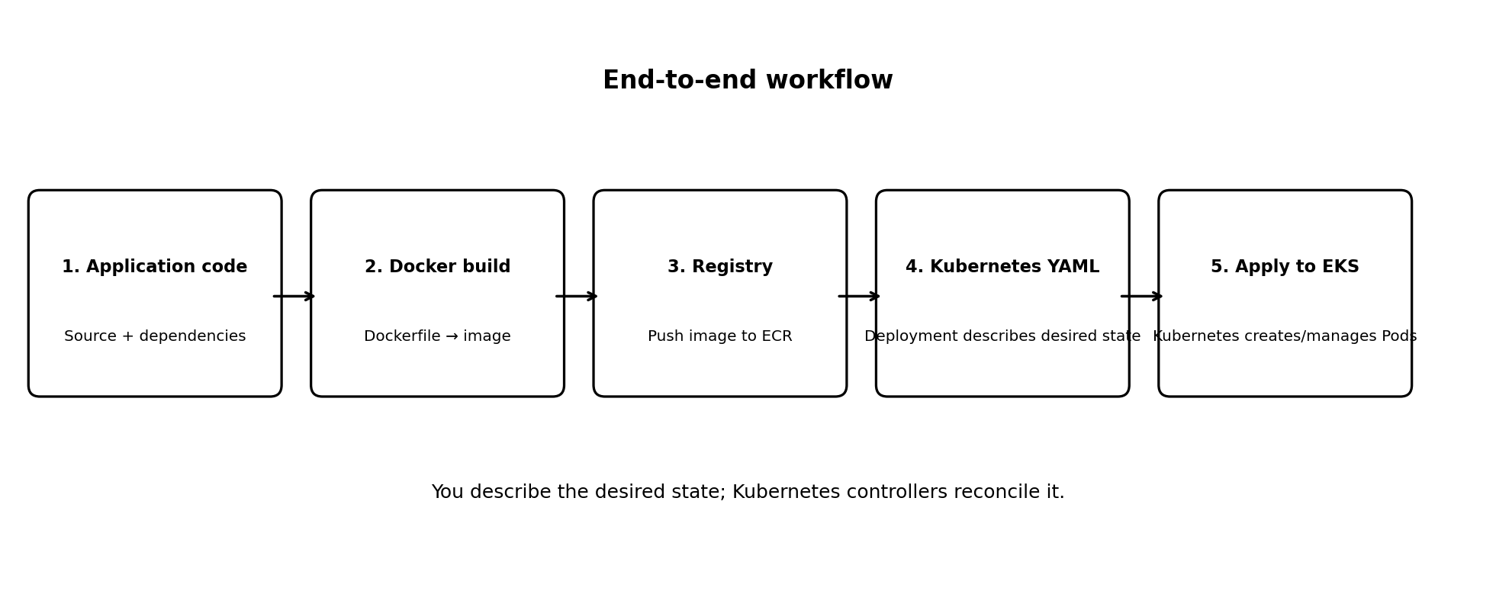
Figure 2. From application source to running Pods.
- Write the application and define its dependencies.
- Create a Dockerfile and build an image with Docker tooling.
- Push the image to a registry accessible to the cluster, commonly Amazon ECR.
- Write Kubernetes YAML, commonly a Deployment, to describe the desired application state.
- Configure kubectl access to the intended EKS cluster.
- Run kubectl apply -f deployment.yaml.
- Kubernetes controllers create and maintain Pods; the scheduler places them on suitable available nodes; the node runtime runs the containers.

5. Where does Pod creation logic live?
You do not write the internal Pod-creation algorithm. You declare what you want in Kubernetes YAML. For a typical application, you define a Deployment. Kubernetes' Deployment/ReplicaSet controllers work to maintain the requested Pod count; the scheduler chooses a suitable node; the node's kubelet and container runtime coordinate running the containers.
A standalone Pod manifest is possible, but a Deployment is usually preferred for an application that needs replicas, replacement, and rollout management.

6. Example Deployment YAML
apiVersion: apps/v1
kind: Deployment
metadata:
name: my-app
spec:
replicas: 2
selector:
matchLabels:
app: my-app
template:
metadata:
labels:
app: my-app
spec:
containers:
- name: my-container
image: 123456789012.dkr.ecr.ap-south-1.amazonaws.com/my-app:latest
ports:
- containerPort: 3000
This is an example only. Replace the account ID, region, repository, tag, and port with values for your application. The image must exist and the cluster nodes must have permission/network access to pull it.

7. Explain the important YAML fields
- apiVersion: apps/v1 — API group/version for the Deployment resource.
- kind: Deployment — Tells Kubernetes the resource type to create.
- metadata.name: my-app — The Deployment resource's name.
- replicas: 2 — The desired count is two Pods. Kubernetes works to maintain that count.
- template — The blueprint used to create each Pod.
- template.metadata.labels.app: my-app — Adds the label app=my-app to each Pod made from this template.
- selector.matchLabels.app: my-app — Tells the Deployment which Pods it manages. It must match the template labels.
- containers.name — A name for the container within the Pod.
- containers.image — The registry/repository/image tag Kubernetes should run.
- containerPort: 3000 — Documents the port the app listens on inside the container; it does not publish the app to the internet by itself.

8. What does app: my-app mean?
my-app is a sample label value, not a special Kubernetes keyword. You can use a meaningful value such as vitalweave-api. A label is a key-value tag: the key is app and the value is my-app.
Kubernetes uses labels to identify and group resources. The Deployment selector uses the label to find the Pods it manages. In this example, selector.matchLabels.app and template.metadata.labels.app must both be my-app.
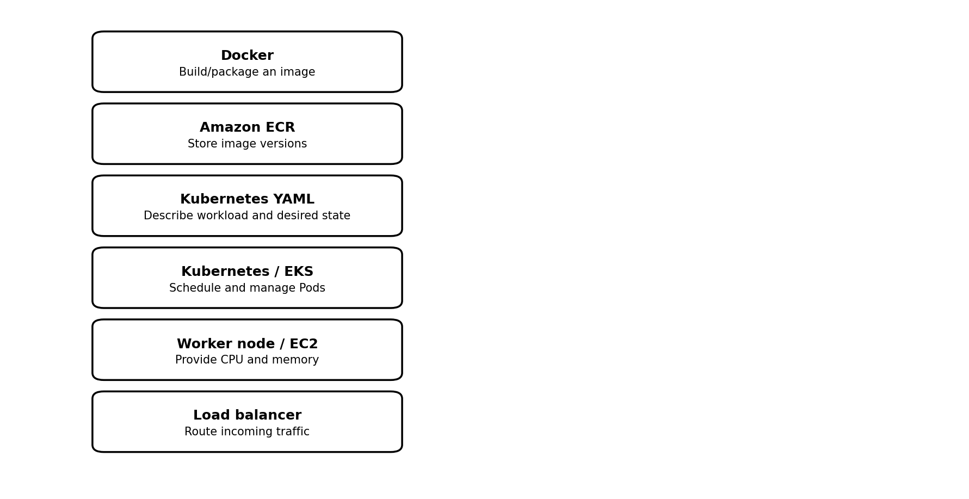
Figure 3. Responsibility summary for the main components.

9. What is automated, and what must be configured?
Capability | How it works
Pod replacement / self-healing | With a Deployment, Kubernetes works to restore the desired Pod count when a Pod is deleted or fails. Container restarts are also handled by node-level components according to Pod policy.
Pod autoscaling | Not automatically enabled just by creating EKS. Configure HPA, metrics, resource requests and policies as needed.
Worker-node scaling | Separate from Pod scaling. Configure managed node-group scaling, Cluster Autoscaler, or Karpenter as appropriate.
Traffic routing | Configure Services and, when needed, an Ingress or AWS load-balancer integration/controller.
Rolling deployments | A Deployment can roll out new versions using updated image references and configured rollout settings.

10. Common misunderstandings corrected
- An image is not a running container. A container is an instance created from an image.
- You normally do not manually create a container and then place it into a Pod. You specify the image in the Pod template; Kubernetes and the node runtime create/run the container.
- The Deployment YAML describes the desired workload; Kubernetes performs Pod creation and reconciliation.
- A worker node is a server, not a Pod. Pods are scheduled onto worker nodes.
- EKS manages the Kubernetes control plane, but you still configure worker capacity, workload YAML, IAM permissions, networking, registry access, and autoscaling features as needed.
- Modern EKS nodes usually use containerd as the container runtime; Docker Engine is not required on each node just because your image was built using Docker.
- A load balancer routes traffic. It does not replace EKS/Kubernetes and does not itself create or scale application Pods.
- Pod scaling and EC2 worker-node scaling are two different layers.
- EC2 is common, but not the only possible compute choice for EKS.
- containerPort alone does not expose an application publicly; networking resources such as Service and ingress/load-balancer configuration may be required.

11. Useful commands
# Apply the Deployment configuration
kubectl apply -f deployment.yaml
# List Deployments
kubectl get deployments
# List Pods
kubectl get pods
# Show worker nodes
kubectl get nodes
# Inspect Deployment details and events
kubectl describe deployment my-app
# Read logs from a Pod (replace the Pod name)
kubectl logs <pod-name>
These commands require kubectl to be installed and configured for the correct cluster. The placeholder <pod-name> should be replaced with a real Pod name.

12. Connection to Jenkins, Terraform, and React Native
Terraform can provision infrastructure such as networking, EKS, node groups, and related AWS resources. Jenkins can automate testing, building an image, pushing it to ECR, and applying a deployment through an approved pipeline. Kubernetes/EKS then manages the deployed Pods.
For a React Native mobile app, the app itself is normally built as an Android APK/AAB for installation, rather than deployed as a Docker container. A backend API or a web service is a more typical candidate for Docker and EKS.
An end-to-end mental model: Terraform provisions infrastructure → Jenkins automates the pipeline → Docker builds an image → ECR stores it → Kubernetes YAML describes the workload → EKS/Kubernetes manages Pods → worker nodes run the containers → a load balancer routes traffic when configured.

13. Beginner learning checklist
☐ Explain the difference between an image and a container.
☐ Explain what a Pod and a Deployment are.
☐ Identify the image field in a Deployment YAML.
☐ Explain why selector.matchLabels must match template.metadata.labels.
☐ Describe the roles of ECR, EKS, worker nodes, and a load balancer.
☐ Apply a Deployment to a practice cluster and inspect Pods and logs.
☐ Understand that HPA and worker-node autoscaling need additional configuration.
☐ Connect Docker, Kubernetes, Jenkins, and Terraform in one CI/CD workflow.

