Regression and Optimization (Multi Linear and Polynomial regression)
SCENARIO 1: Multilinear Regression - Predicting Student’s Academic Performance:
Actual vs Predicted scores:
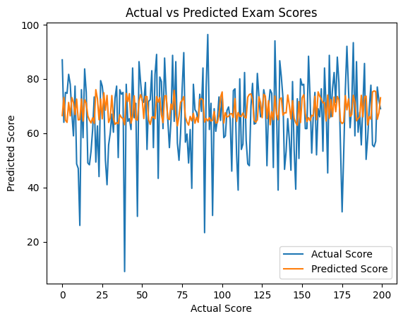
Feature Influence on Exam score:
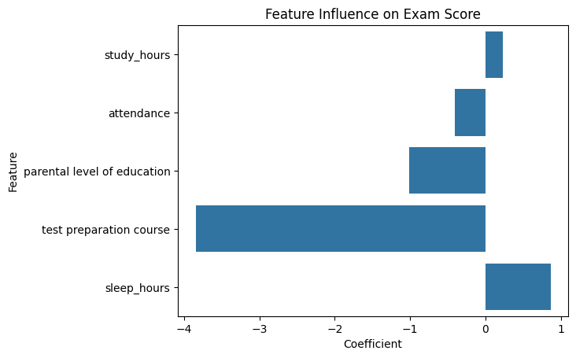
Residual Distribution:
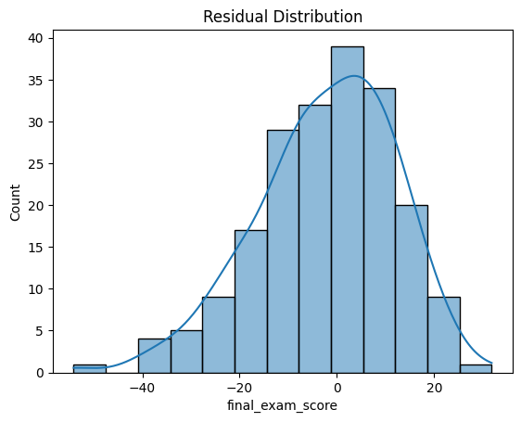

SCENARIO 2: Polynomial Regression - Predicting Vehicle Fuel Efficiency:
Polynomial Curve Fitting for Different Degrees:

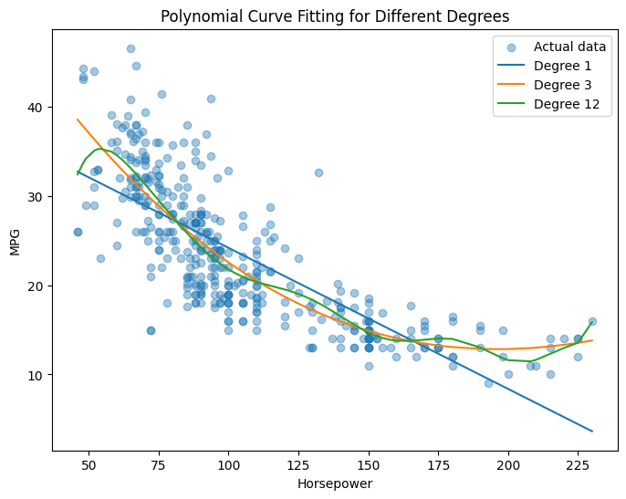

Training vs Testing Error Comparison:

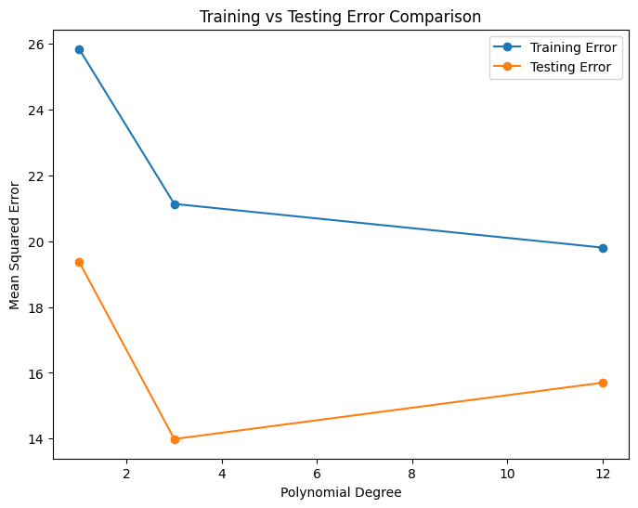

Underfitting and Overfitting Demonstration:

