Clustering using K-Means and Gaussian Mixture Models (GMM)
SCENARIO 1 – CLUSTERING USING K-MEANS:
Elbow Method:
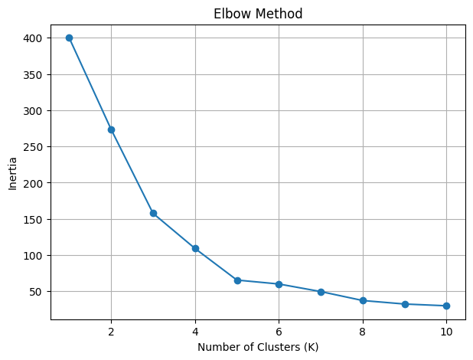
Silhouette scores for different K:
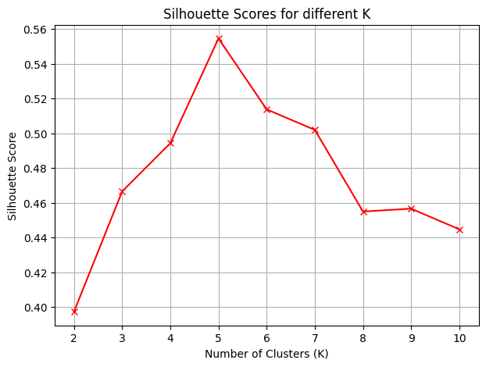
Customer Segments – Centroids(K=5):
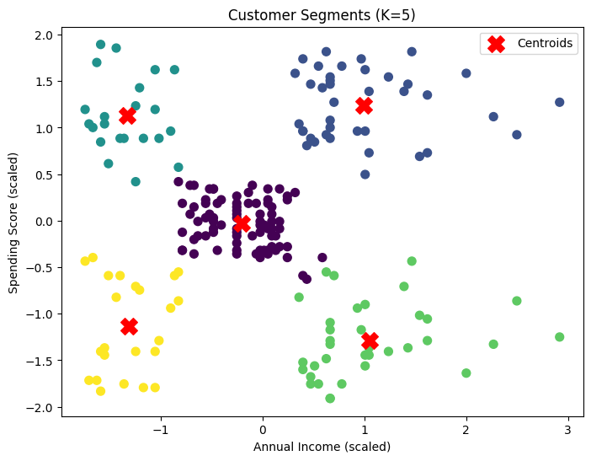
Random Initialization:
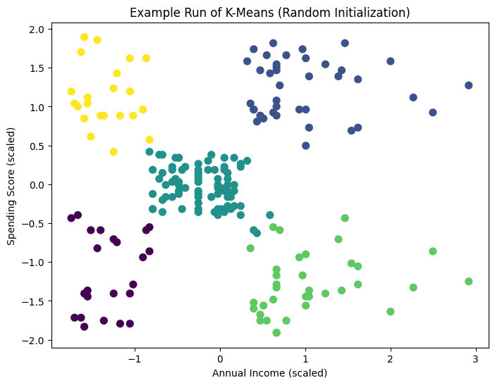
SCENARIO 2 – CLUSTERING USING GMM:
GMM model selection using AIC and BIC:
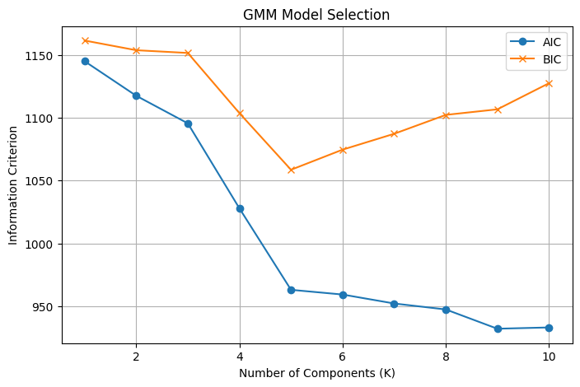
GMM clustering:
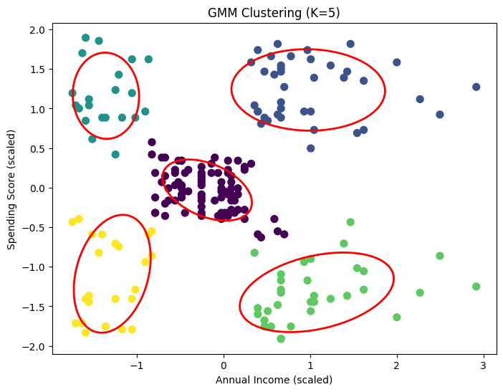
Comparison between K-means and GMM clusters:
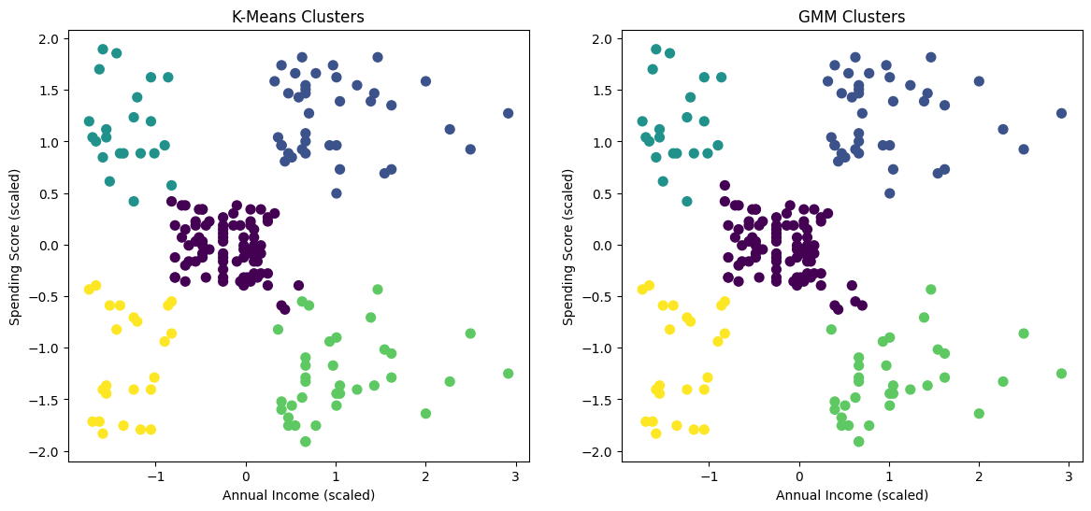
GMM cluster probability distribution:
