Recommendation systems using Matrix Factorization
(SVD & NMF)
SCENARIO 1 – MATRIX FACTORIZATION USING SVD:
Effect of K on error:
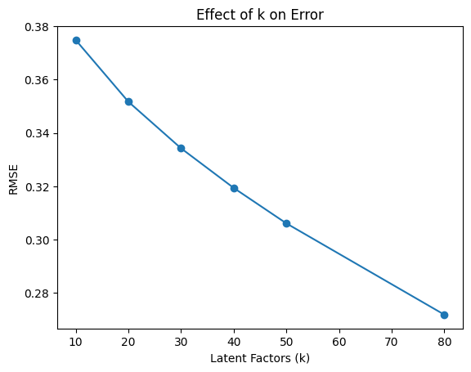
Actual vs Predicted Ratings:
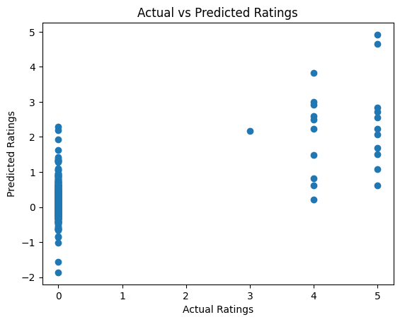
Original User Item matrix:

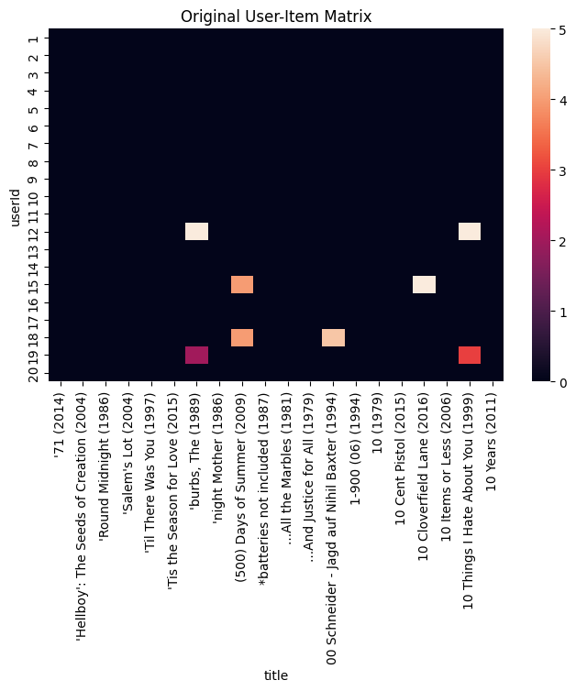

Reconstructed matrix:

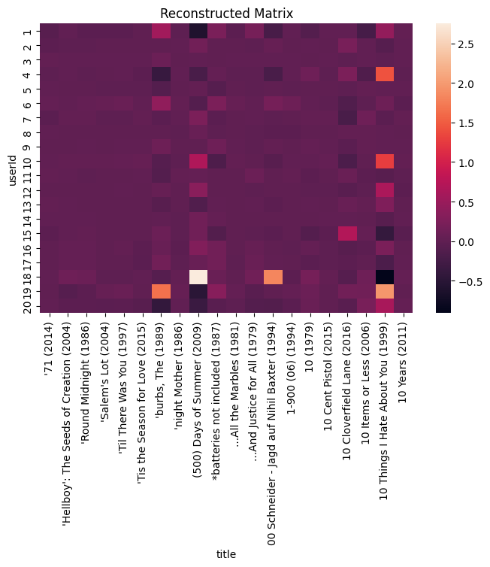

Top recommended movies for users:
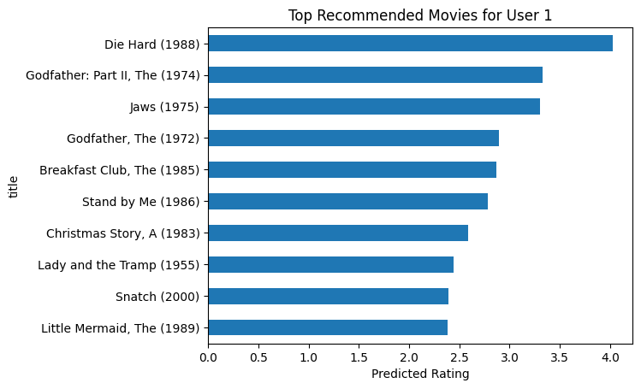

SCENARIO 2 – MATRIX FACTORIZATION USING NMF:
User feature matrix (W):
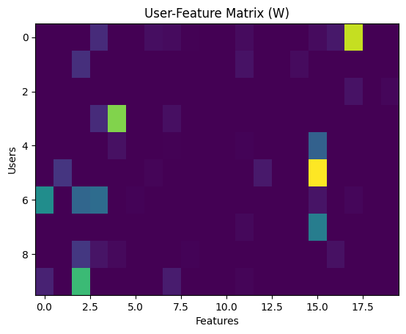
Top recommendations:
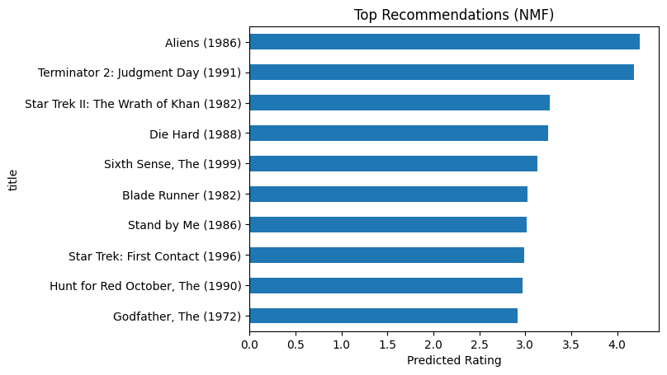

Original matrix:
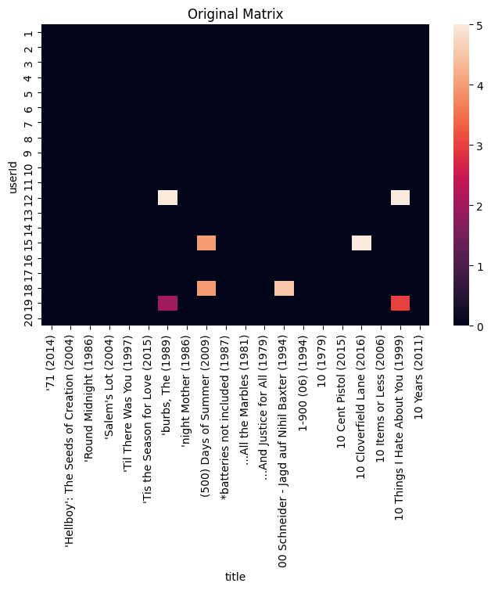

Reconstructed matrix:
