Regression and Optimization (Linear and Logistic regression)
Scenario 1: Predicting Ocean water temperature

Actual vs Predicted water temperature:

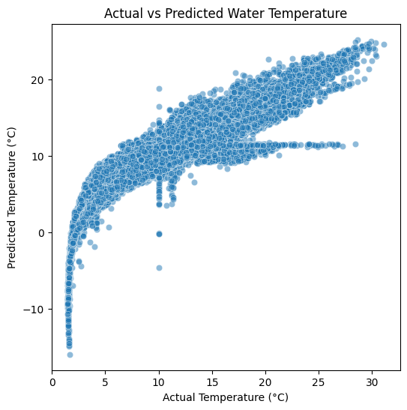
Residual Error Distribution:

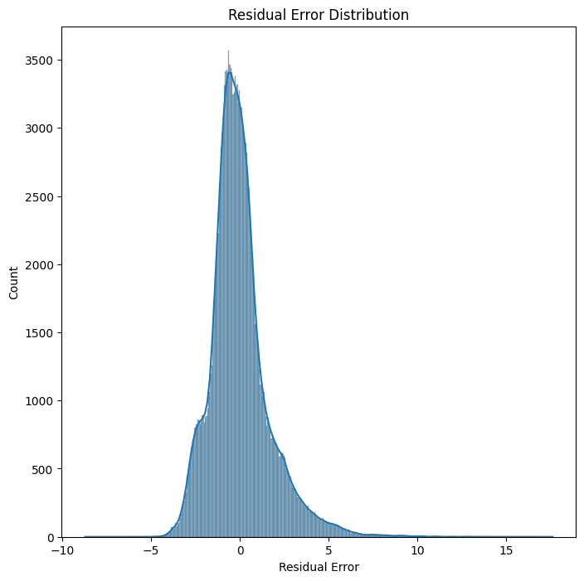

Feature Correlation Heatmap:

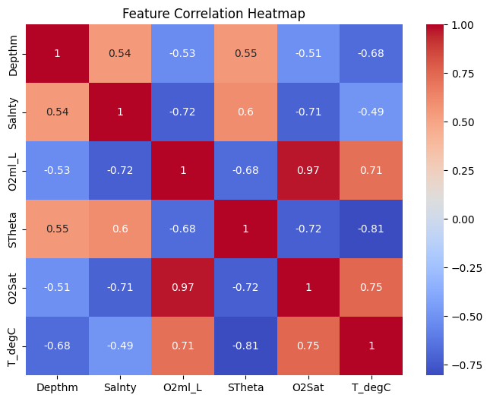

Scenario 2: Predicting whether LIC price stock is increasing or decreasing

Confusion Matrix:
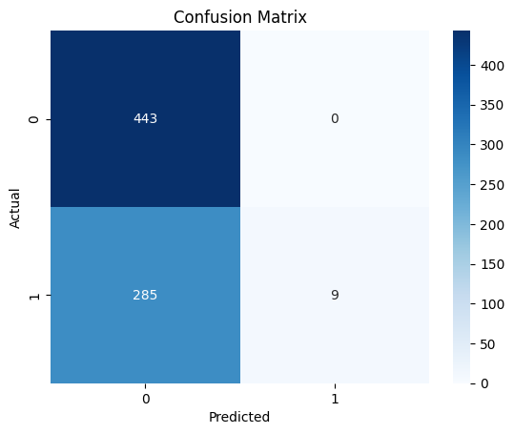

ROC Curve:

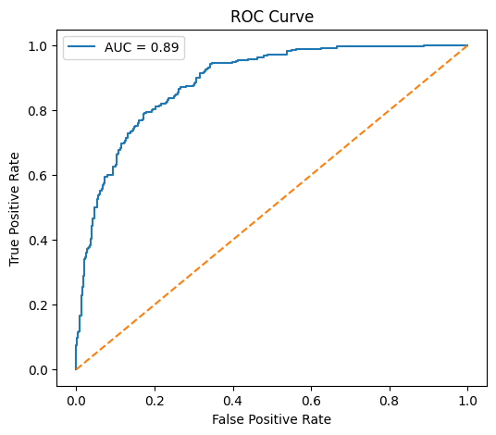

Feature Importance:

