Association Rule Learning (Apriori Algorithm) and
Dimensionality Reduction (PCA)
Scenario 1: ASSOCIATION RULE MINING USING APRIORI ALGORITHM

Top frequent itemsets:
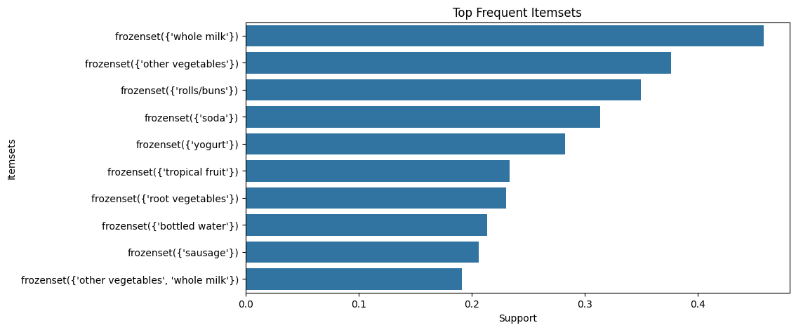
Support vs confidence:
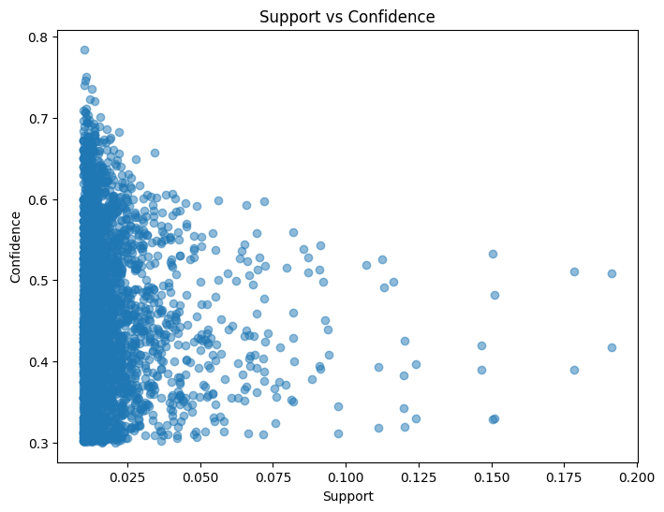
Lift distribution:
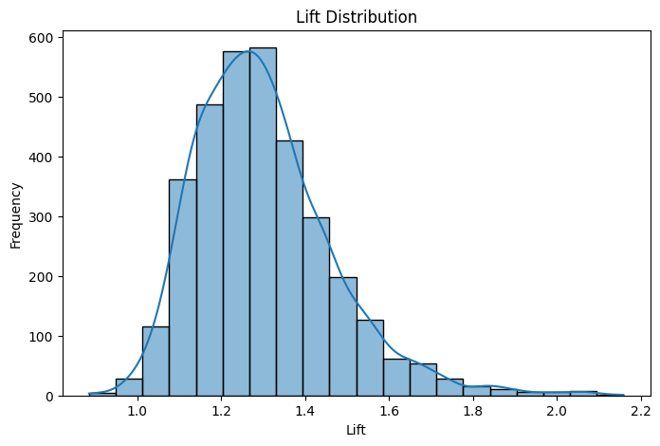
Association rule network:
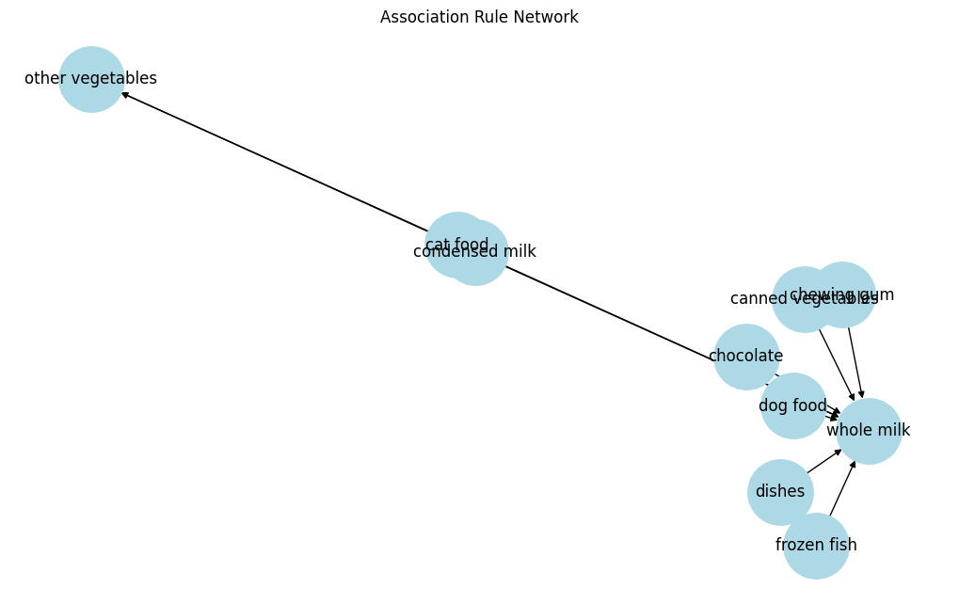

Effect of support threshold:
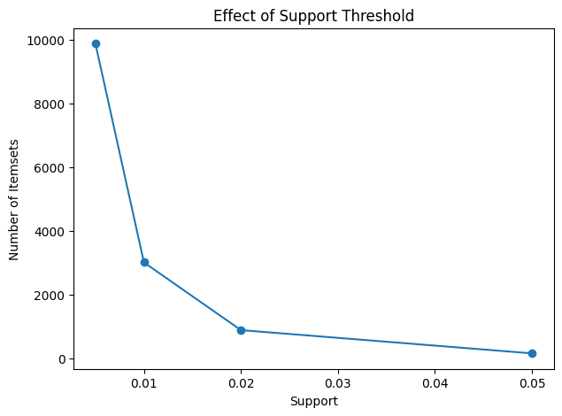
Effect of confidence threshold:
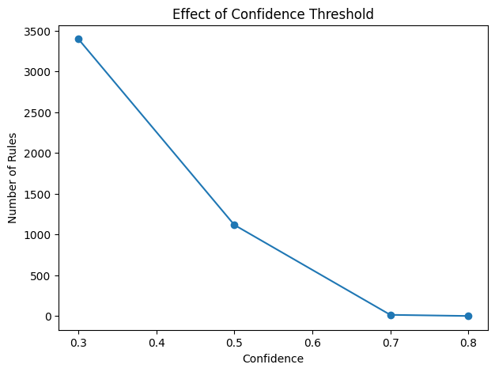
SCENARIO 2 – DIMENSIONALITY REDUCTION USING PCA

Scree plot:
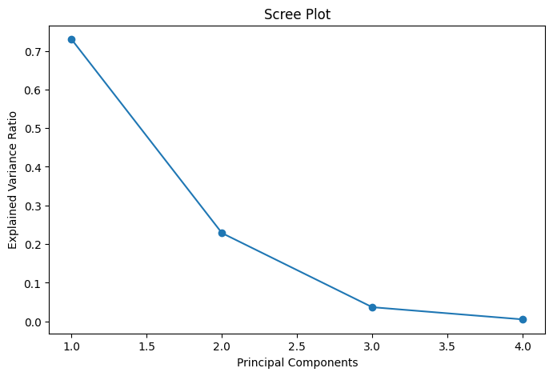
Cumulative explained variance:
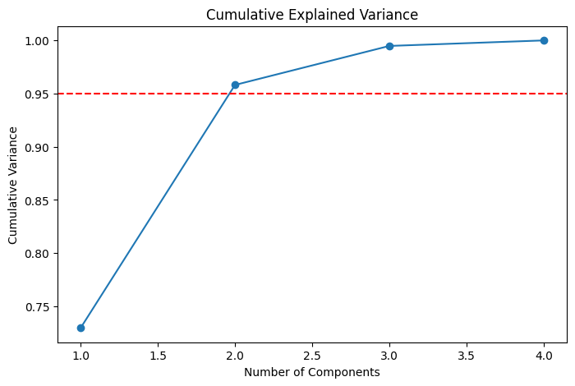

PCA 2D projection:
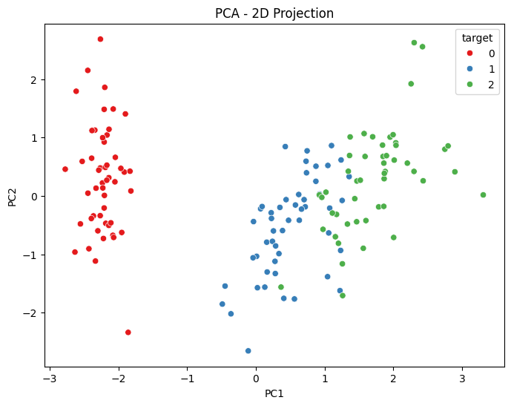
PCA 3D Visualization:
