Recommendation System Using Collaborative Filtering Techniques
SCENARIO 1: USER-BASED COLLABORATIVE FILTERING:
User – Item matrix heatmap:
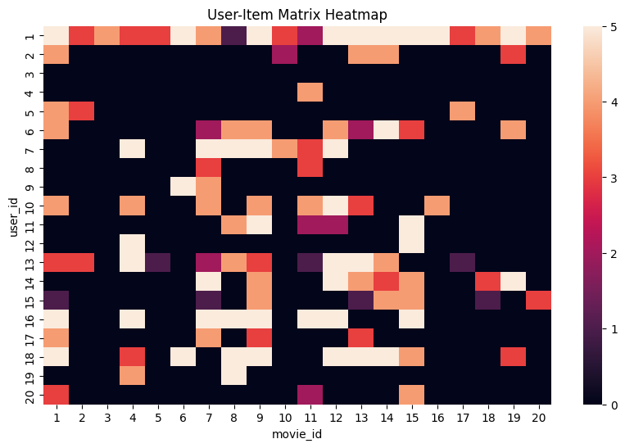
User similarity matrix heatmap:
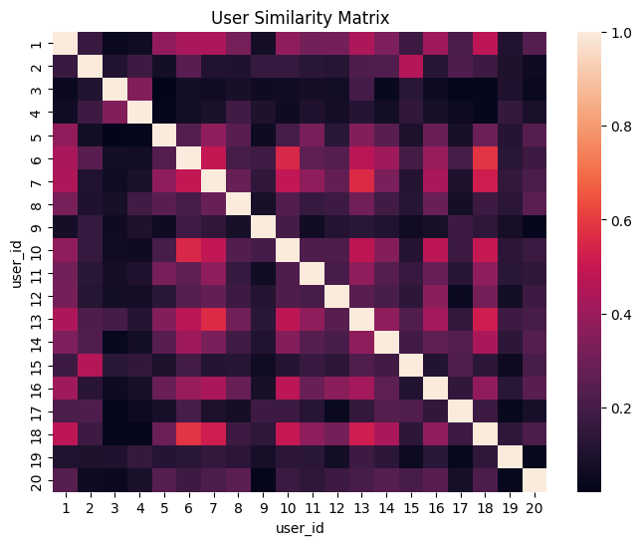
Top recommended movies:
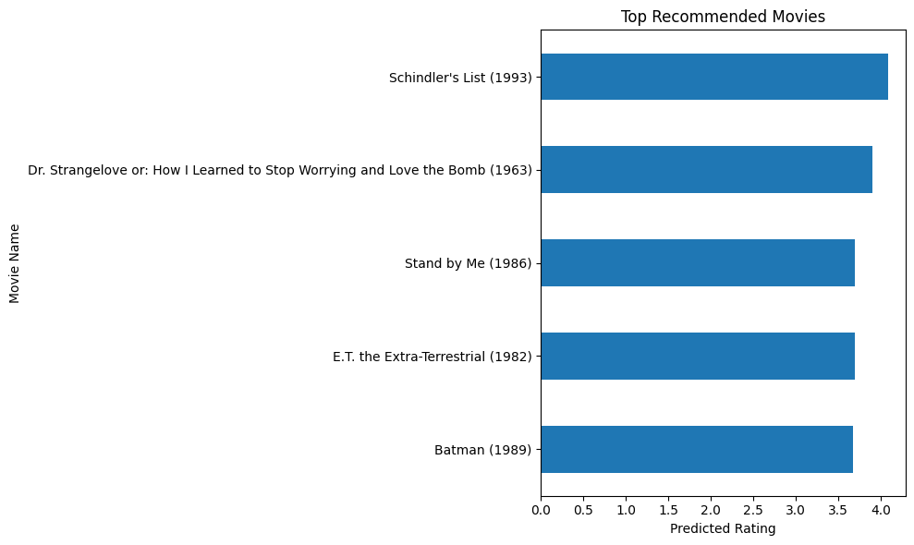

SCENARIO 2: ITEM-BASED COLLABORATIVE FILTERING:
Item similarity matrix:
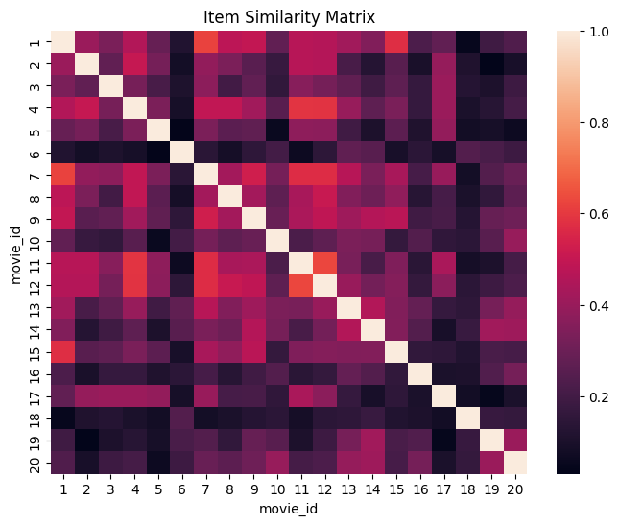
Top similar movies:
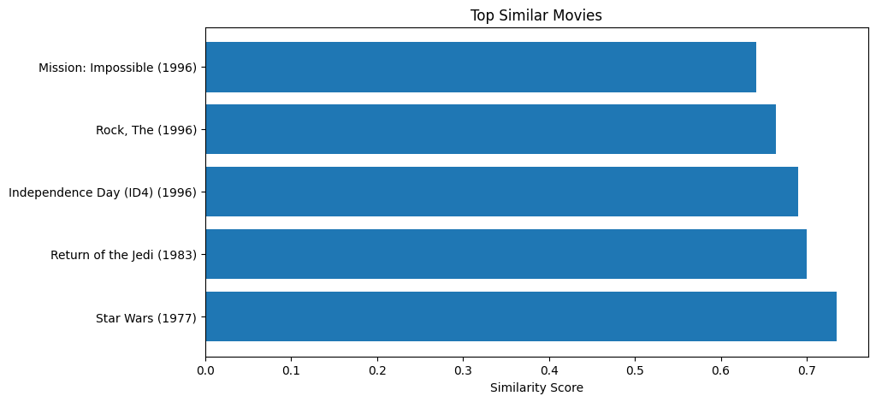

Recommended movies:
