Ensemble Learning & Class Imbalance Handling (SMOTE)
BAGGING:
Accuracy comparison using Bar graph:
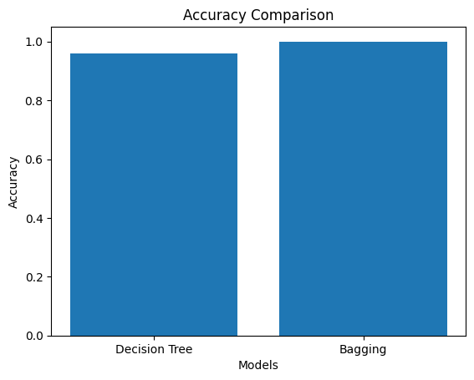
Confusion Matrix:
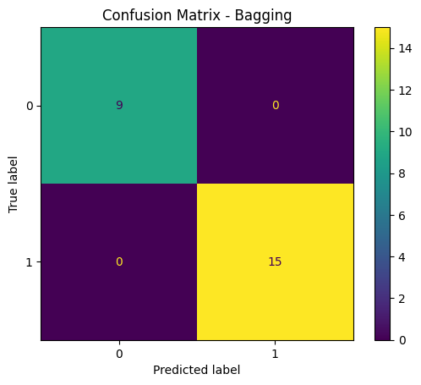
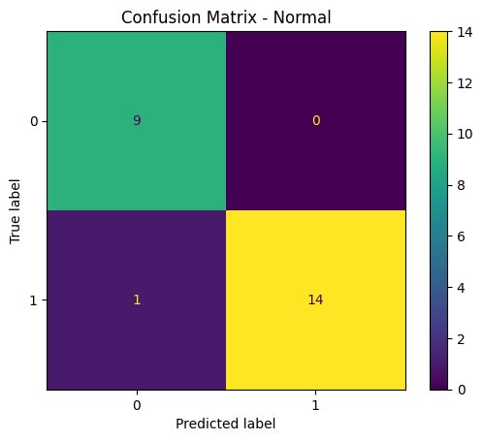
BOOSTING: ADABOOST, GRADIENT BOOSTING:
ROC Curve:
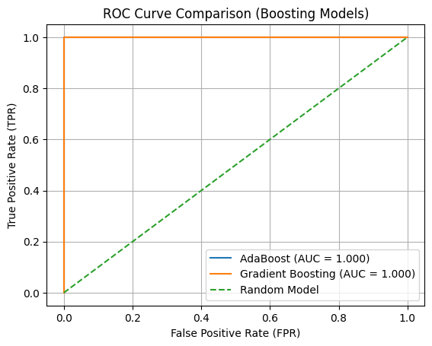

Feature importance plot:
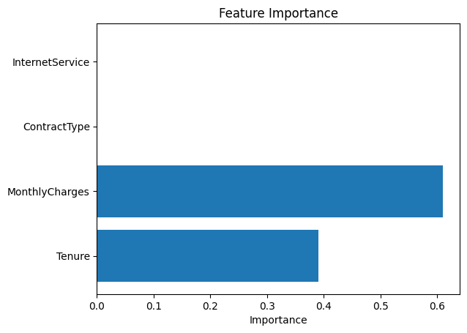
RANDOM FOREST:
Feature importance plot:
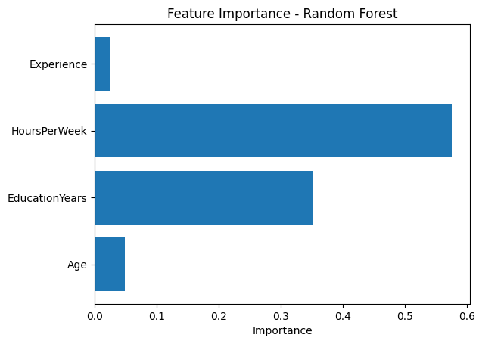
Accuracy vs Number of Trees graph:
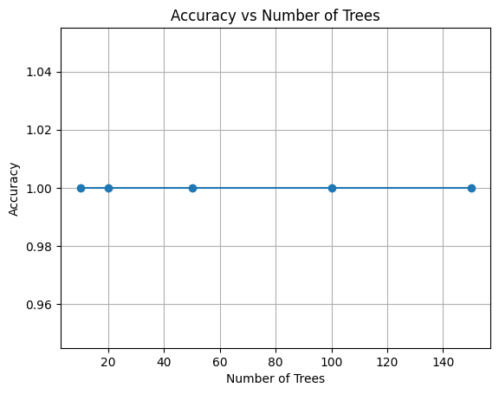
STACKING:
Model Comparison Bar Chart:
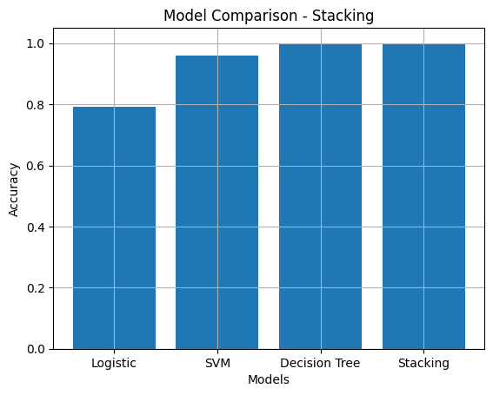
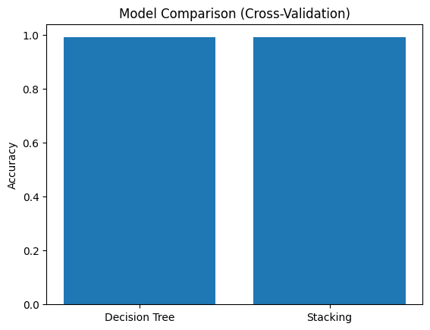
SMOTE:
Class Distribution – Before SMOTE:
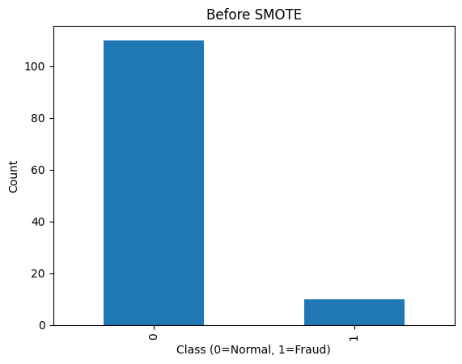

Class Distribution - After SMOTE:
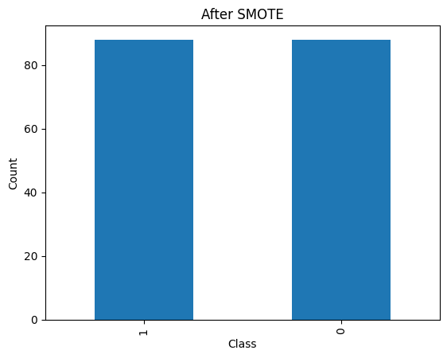
Precision – Recall curve:
