**Traffic management**

Traffic management is the process of controlling and regulating the flow of vehicles, pedestrians, and other forms of transportation in a given area to ensure safety, efficiency, and mobility. It is a crucial aspect of urban planning and transportation engineering. Effective traffic management helps reduce congestion, minimize accidents, and improve the overall transportation system. Here are some key aspects and strategies related to traffic management:

1. Traffic Control Devices: This includes traffic signals, stop signs, yield signs, speed limit signs, and other road signs and signals that guide and regulate traffic.
2. Traffic Signals: Traffic lights are used at intersections to control the movement of vehicles and pedestrians, ensuring a safe and orderly flow of traffic. They are often synchronized to optimize traffic flow.
3. Traffic Laws and Regulations: Laws and regulations, such as speed limits and rules of the road, are enforced by law enforcement agencies to maintain order on the roads.
4. Road Design and Engineering: The design of road networks, including the layout of intersections, lanes, and the placement of traffic control devices, plays a crucial role in traffic management.
5. Public Transportation: Effective public transportation systems can reduce the number of private vehicles on the road, thus easing traffic congestion.
6. Parking Management: Proper parking regulations and facilities help ensure that parked vehicles do not obstruct traffic flow.
7. Traffic Calming: Techniques like speed bumps, chicanes, and narrowed roadways are used to slow down traffic in residential areas and school zones.
8. Intelligent Transportation Systems (ITS): ITS uses technology, such as traffic cameras, sensors, and dynamic message signs, to collect and disseminate traffic information and manage congestion.
9. Traffic Management Centers: These are centralized facilities that monitor traffic conditions and coordinate responses to accidents, road closures, and other disruptions.
10. Congestion Pricing: Some cities implement pricing schemes to charge vehicles for using congested areas during peak times, thereby reducing congestion.
11. Public Awareness and Education: Educating drivers and pedestrians about safe and responsible behavior on the road is an essential component of traffic management.
12. Alternative Transportation Options: Promoting cycling, walking, carpooling, and ridesharing can reduce the number of single-occupancy vehicles on the road.
13. Emergency Response and Incident Management: Swift responses to accidents and incidents, including clearing the road quickly, are vital for traffic management.
14. Environmental Considerations: Managing traffic to reduce emissions and promote eco-friendly transportation options is becoming increasingly important in the face of environmental concerns.
15. Future Trends: The integration of autonomous vehicles and smart city technologies is expected to have a significant impact on traffic management in the future.

Effective traffic management is critical for reducing traffic-related injuries and fatalities, improving air quality, and ensuring the efficient movement of people and goods. It requires a combination of infrastructure planning, technology, regulation, and public cooperation to be successful.

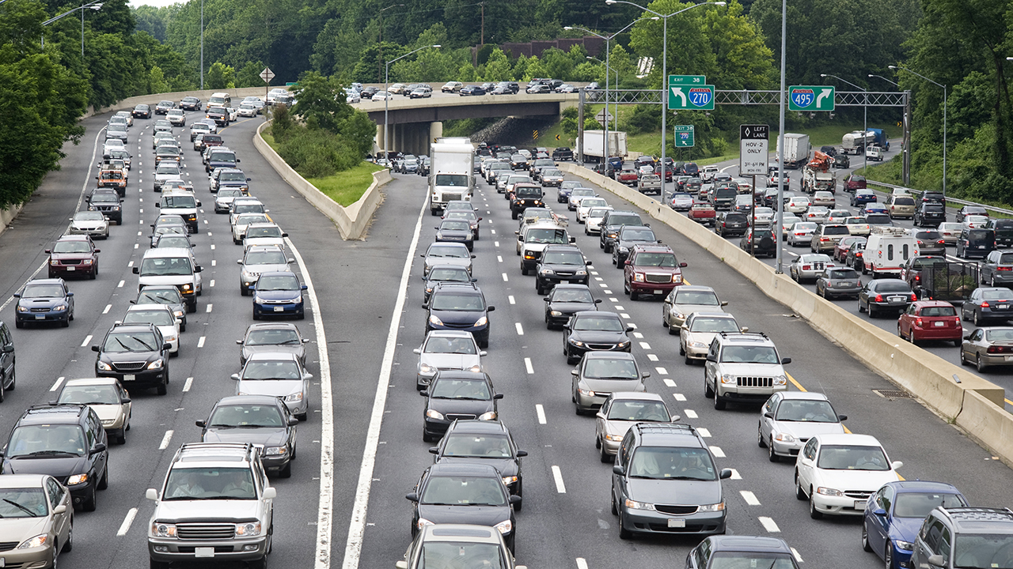

**Innovation:**

Innovations in traffic management are crucial for addressing the growing challenges of urban congestion, road safety, and environmental concerns. Here are some notable innovations in traffic management:

1. **Connected and Autonomous Vehicles (CAVs)**: Self-driving cars and vehicles that can communicate with each other and with infrastructure can potentially optimize traffic flow, reduce accidents, and improve efficiency.
2. **Intelligent Transportation Systems (ITS)**: Advanced sensors, cameras, and data analytics are used to monitor traffic conditions and manage congestion in real-time. This includes adaptive traffic signal control systems that adjust signal timings based on traffic conditions.
3. **Traffic Apps and Navigation Services**: Smartphone apps like Waze and Google Maps provide real-time traffic information, alternative routes, and navigation assistance, helping drivers avoid congestion.
4. **Big Data and Predictive Analytics**: Data analysis and machine learning algorithms are used to predict traffic patterns and suggest optimal routes for drivers.
5. **Traffic Management Software**: Advanced software platforms are used to coordinate and manage traffic in real-time, helping to reduce congestion and improve traffic flow.
6. **Smart Traffic Lights**: Adaptive traffic signal systems use real-time data to adjust signal timing, reducing wait times and congestion at intersections.
7. **Electric Vehicle (EV) Charging Infrastructure**: The integration of EV charging stations into traffic management systems supports sustainable transportation and reduces emissions.
8. **Micro-Mobility Solutions**: Shared e-scooters and bikes, often available through mobile apps, offer eco-friendly and convenient alternatives to cars for short trips in urban areas.
9. **Mobility as a Service (MaaS)**: MaaS platforms allow users to plan, book, and pay for various transportation modes (public transit, ridesharing, car rentals) through a single app, promoting seamless and efficient travel.
10. **Traffic-Responsive Signage**: Dynamic message signs that provide real-time information about traffic conditions and detours, helping drivers make informed decisions.
11. **Crowdsourced Data**: Gathering data from users' smartphones to create real-time traffic maps and share information about accidents, road closures, and congestion.
12. **Blockchain for Traffic Management**: Blockchain technology can be used for secure and transparent management of traffic data, including congestion pricing and toll collection.
13. **Drones for Traffic Monitoring**: Unmanned aerial vehicles can be used for traffic monitoring, incident management, and surveying road conditions.
14. **Augmented Reality (AR) for Navigation**: AR navigation apps provide drivers with real-time information about the road, navigation instructions, and nearby points of interest.
15. **Environmental Initiatives**: Implementing traffic management strategies that prioritize environmental sustainability, such as carpool lanes, low-emission zones, and pedestrian-friendly urban planning.
16. **Public-Private Partnerships**: Collaborations between governments and private companies are driving innovation in areas like ridesharing, autonomous vehicles, and EV infrastructure.

These innovations aim to improve traffic management, reduce congestion, enhance safety, and promote sustainable transportation options. The integration of technology, data analytics, and collaboration between public and private sectors is essential for effective traffic management in the modern age.

**Seven innovative ideas to reduce traffic congestion with smart city tech**

* Adaptive traffic signals. ...
* V2I smart corridors. ...
* Autonomous vehicle technology. ...
* Real-time traffic feedback. ...
* Tracking pedestrian traffic. ...
* Carsharing and multi-modal solutions. ...
* Replacing vehicles with drones.

