1. Using the python PIP command create a “requirements.txt” file from the terminal/ command –prompt of your system?

Command: **pip freeze > requirements.txt**

Screenshot:

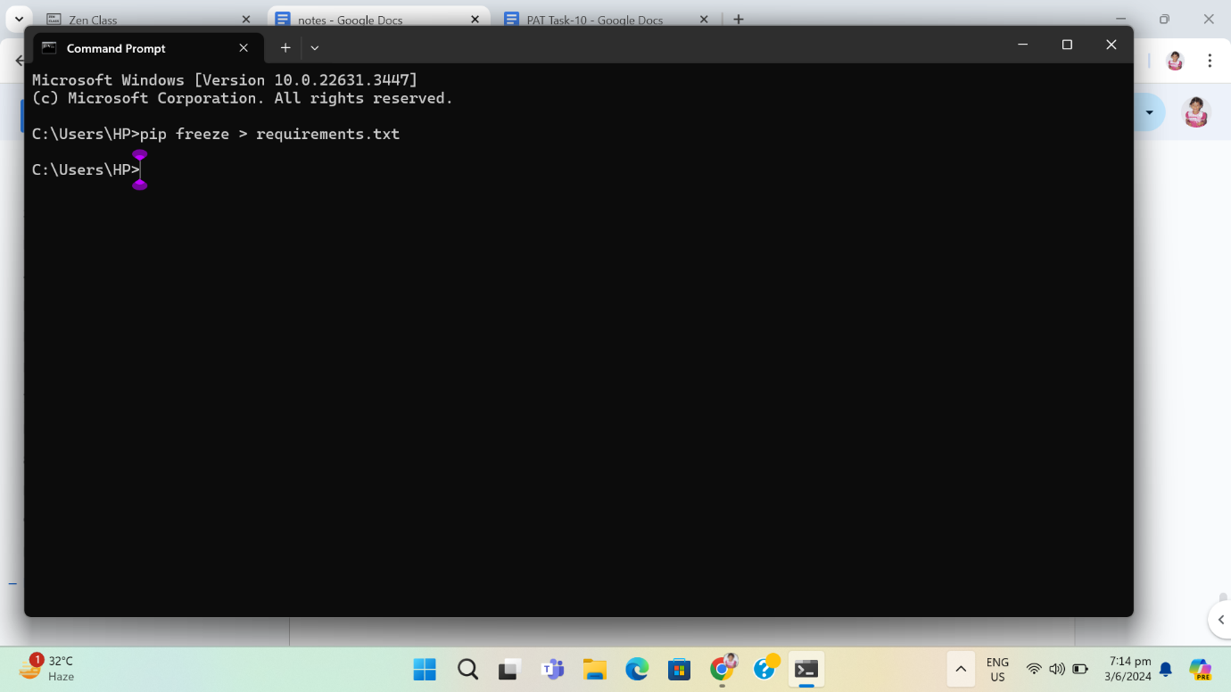

Screen shot of the “requirements.txt” file which is created in my respective directory.

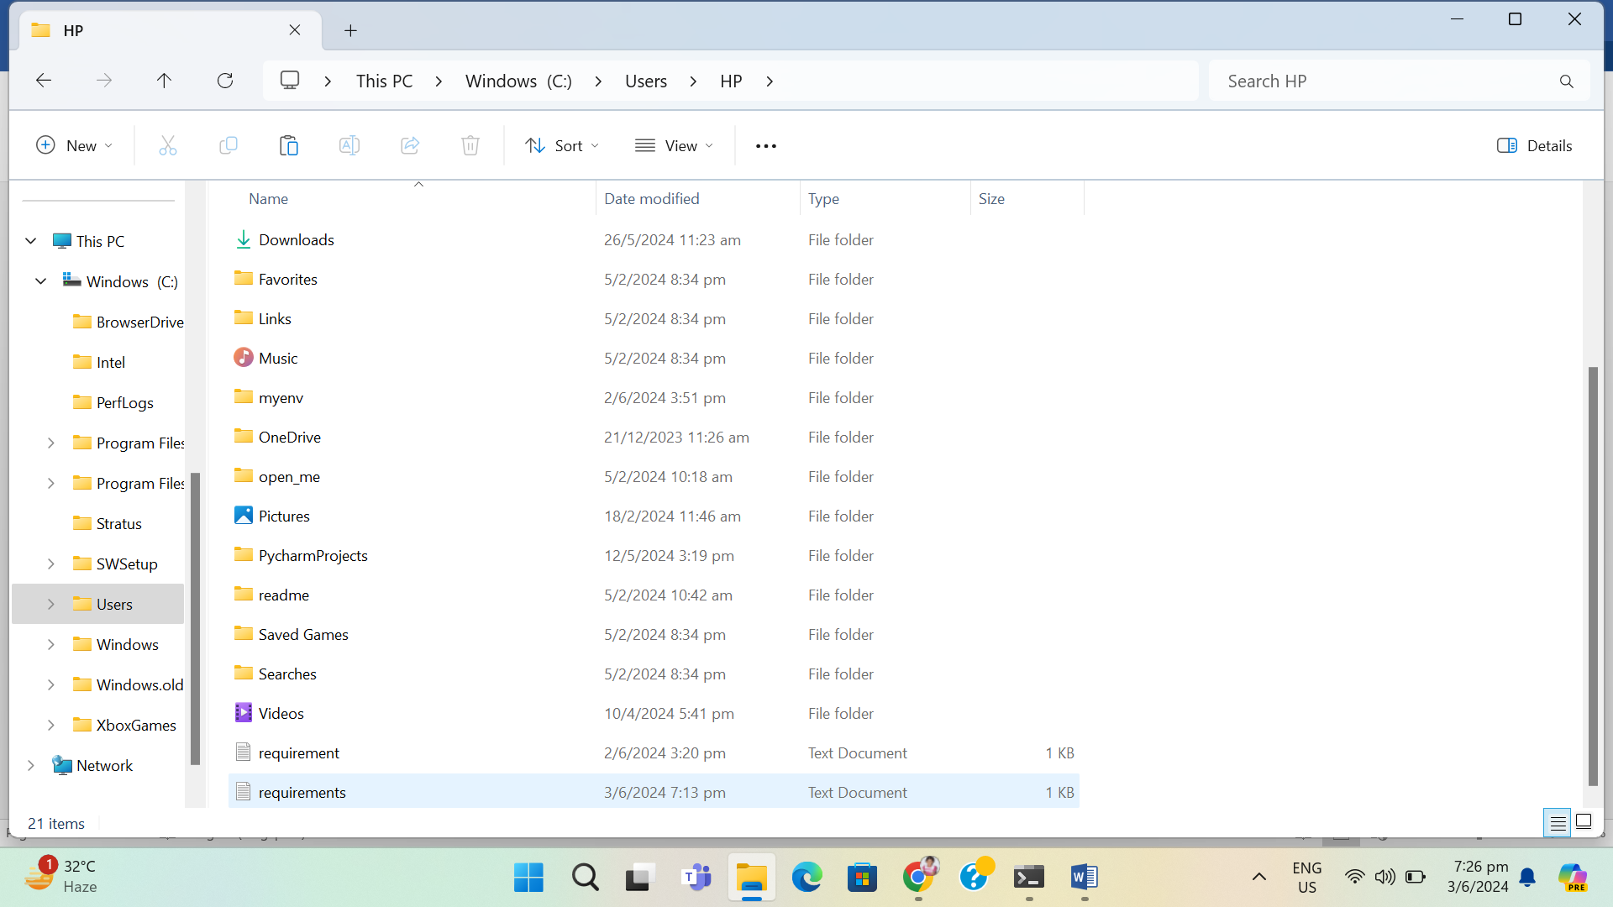

1. Using the pip command install the Flask module <2.0 into your system?

Command: pip install "Flask<2.0"

Screenshot:

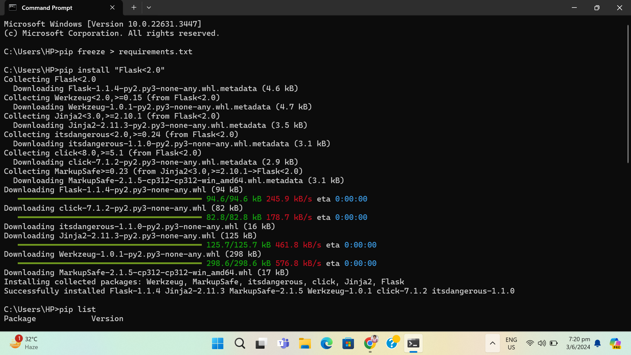

Screen shot of pip list:

