**CODEKATA** – Completed **55** questions

|  |  |
| --- | --- |
| Topics | Total Questions Completed |
| Input/Output | 10 |
| Absolute Beginner | 15 |
| Array | 3 |
| Mathematics | 7 |
| Strings | 5 |
| Basics | 15 |
| Total Questions completed | 55 |

Screen Shot

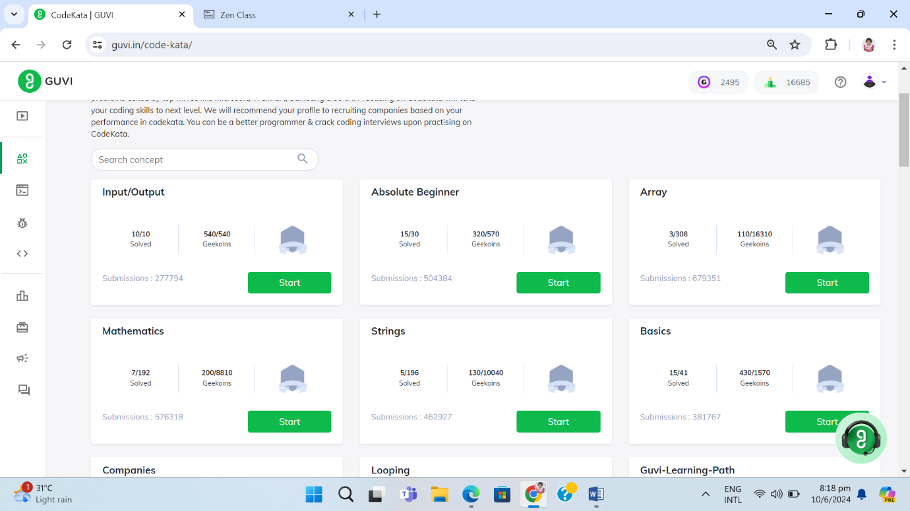

**WEBEKATA** – Completed **55** questions

In HTML – completed **53**

In CSS **–** completed **1**

