Does Quitting Smoking Cause Weight Gain, and for Whom?
A causal machine learning analysis of NHEFS along the eight-step pipeline
Background document to the presentation
Jananthan Uthayakumar · MSE Data Science, HSLU · September 2026
Audience of the presentation: the prevention unit of a Swiss health insurer that plans a smoking-cessation programme with optional weight coaching.

1. Executive summary
Main idea. Quitting smoking causes about 3.4 kg of additional weight gain over 11 years (95% CI 2.5 to 4.3 kg), and we find no reliable evidence that this effect differs between types of smokers. Weight support therefore belongs in the standard offer for all quitters, not in a targeted programme.

- The raw comparison is misleading. Quitters gained 2.5 kg more than continuing smokers, but they were older and smoked less at baseline. Adjusting for these differences shows that the raw comparison understates the effect by about a quarter.
- The adjusted number is robust. Five estimators agree (3.3 to 3.5 kg), inverse probability weighting reproduces the published estimate of Hernán & Robins (3.4 kg), all five robustness checks pass, and an unmeasured confounder would need about nine times the strength of age to erase the effect.
- The effect is not reliably different between smokers. Neither smoking intensity, age, sex nor baseline weight shifts the effect in a statistically reliable way (calibration test, RATE and best linear projection). A semi-synthetic check shows that the design would have detected strong heterogeneity, so any real differences are smaller than that.
Implication. About 0.3 kg per year is modest compared with the health benefits of quitting. The programme should offer weight support to everyone and not invest in a targeting model.

2. Context and decision
Situation. Quitting is the single most effective step a smoker can take for their health, and the insurer plans a cessation programme.
Complication. Fear of weight gain keeps many smokers from quitting, the budget for coaching is limited, and raw data are misleading because people who quit differ systematically from people who continue.
Question. How much weight gain does quitting actually cause, and should weight support be offered to everyone or targeted at specific groups?
Structure of this document. Sections 3 to 10 follow the eight steps of the causal machine learning pipeline from the lecture: Steps 1 to 4 identify the effect before any model is fitted, Steps 5 to 8 estimate and interrogate it. Limitations, reproducibility and additional figures follow at the end.

3. Step 1: Research question and data

3.1 Research question
- Primary (ATE): By how many kilograms does quitting smoking change weight over roughly 11 years, compared with continuing to smoke?
- Secondary (CATE): Is the effect larger for some smokers than for others, for example heavy versus light smokers?

3.2 Target trial
The ideal experiment would randomly assign smokers in 1971 to quitting or to continuing and measure weight change in 1982. NHEFS is its observational counterpart: participants decided themselves whether to quit, which creates confounding, and the timing and method of quitting were not controlled.

3.3 Data
NHEFS (NHANES I Epidemiologic Follow-up Study, National Center for Health Statistics / CDC) combines a baseline examination in 1971 to 1975 with a follow-up in 1982. We use the subset of 1,629 cigarette smokers aged 25 to 74 curated by Hernán & Robins (2020), loaded through the Python package causallib. The nine confounders are loaded without automatic feature engineering so that all encoding decisions are made explicitly in the models.
Table 1. Variables and their roles.
Variable | Role | Description
qsmk | Treatment W | Quit smoking between baseline and 1982 (1 = yes)
wt82_71 | Outcome Y | Weight change 1971 to 1982 (kg)
age | Confounder | Age in 1971 (years)
sex | Confounder | 0 = male, 1 = female
race | Confounder | 0 = white, 1 = black or other
education | Confounder | Five levels, from 8th grade or less to college or more
smokeintensity | Confounder | Cigarettes per day in 1971
smokeyrs | Confounder | Years of smoking
exercise | Confounder | Recreational exercise in 1971: much, moderate, little or none
active | Confounder | Daily activity in 1971: very active, moderate, inactive
wt71 | Confounder | Weight in 1971 (kg)

3.4 Sample and missing outcomes
Table 2. Sample flow and censoring by group.
 | Quit | Continued | Total
Full cohort | 428 | 1,201 | 1,629
Missing 1982 weight (censored) | 25 (5.8%) | 38 (3.2%) | 63 (3.9%)
Analysis sample | 403 | 1,163 | 1,566
Mean weight change (kg) | +4.53 | +1.98

Censoring is plausibly informative: quitters are censored almost twice as often, censored people are older (50.3 vs. 43.7 years) and heavier (76.6 vs. 70.8 kg), and the adjusted odds ratio of censoring for quitters is 1.68 (p = 0.072). Decision: the main analysis uses the 1,566 complete cases, as in Hernán & Robins; inverse probability weighting for censoring is reported as a robustness check (Section 9.5).

4. Step 2: Causal structure
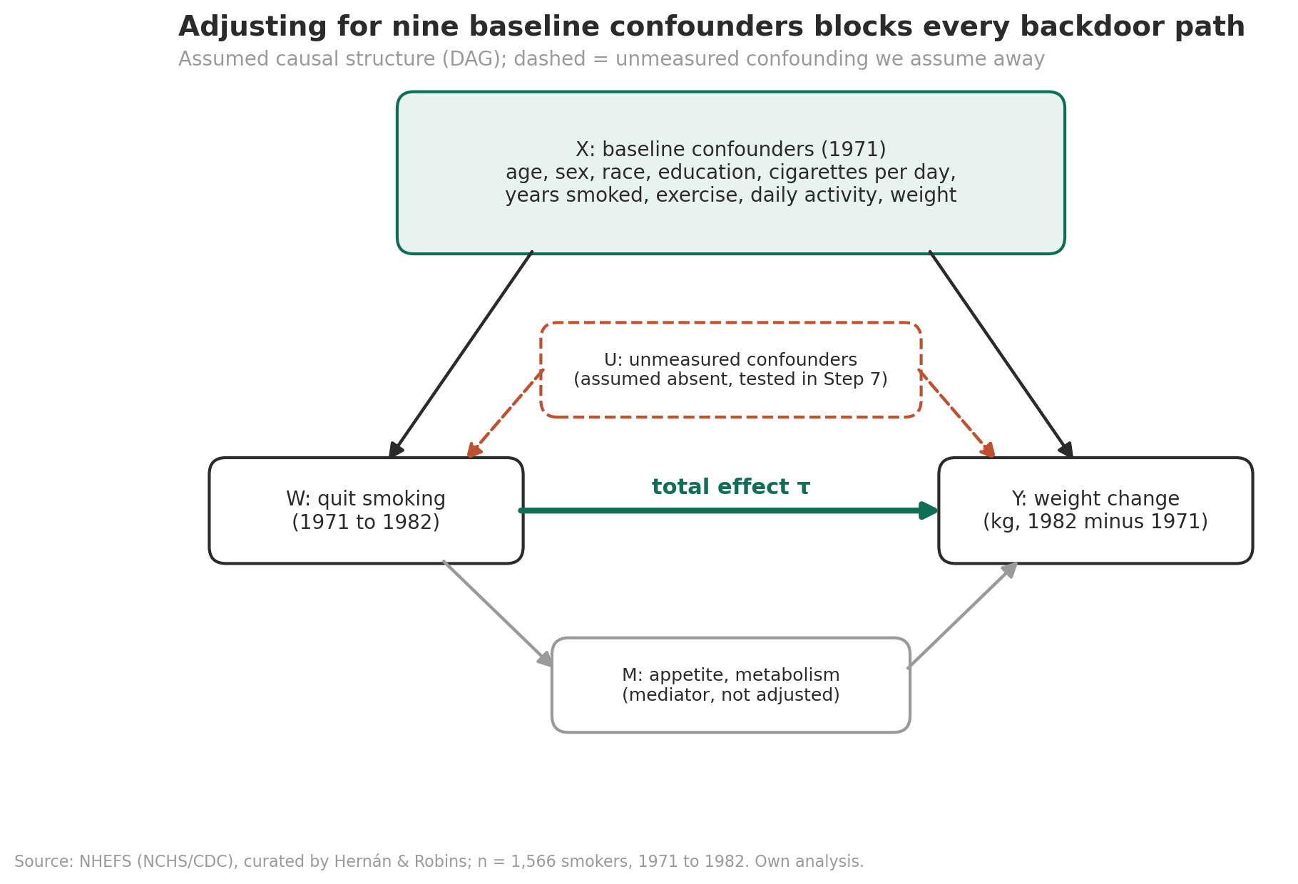
Figure 1. Assumed causal structure. The nine baseline confounders X affect both quitting W and weight change Y; appetite and metabolism M mediate part of the effect; unmeasured confounders U are assumed absent and stress-tested in Section 9.4.
The DAG is an assumption, not something learned from the data. It distinguishes three kinds of paths between W and Y: causal paths (W → Y and W → M → Y), which we want to keep; backdoor paths through the confounders (W ← X → Y), which must be blocked; and paths through unmeasured variables (W ← U → Y), which cannot be blocked and are only assumed away.
Table 3. Why each baseline variable is a confounder.
Confounder | Plausible effect on quitting (W) | Plausible effect on weight change (Y)
Age | Older smokers are more health-motivated to quit | Weight trajectories change with age
Sex | Quitting rates differ by sex | Sex-specific weight dynamics
Race | Social context of smoking and quitting | Differences in weight trajectories
Education | Education predicts quitting | Education predicts diet and activity
Cigarettes per day | Light smokers quit more easily | Nicotine dose affects metabolism and appetite
Years smoked | Long-term smokers find quitting harder | Long smoking history, different weight dynamics
Exercise, daily activity | Healthier lifestyle, more likely to quit | Physical activity affects weight change
Weight 1971 | Weight concerns may deter quitting | Baseline weight affects later gain (regression to the mean)

Mediators such as appetite and metabolic rate are part of the effect of interest (the total effect) and are therefore not adjusted for; adjusting for them would remove part of the effect (overadjustment).
Backdoor check. A programmatic check of the backdoor criterion (d-separation with networkx) returns True for the assumed DAG, False if an unmeasured confounder U exists (condition ii fails), and False if the mediator M is added to the adjustment set (condition i fails, M is a descendant of W). Because all nine confounders were measured in 1971, before anyone quit, none of them can be a descendant of W: temporal precedence guarantees condition i by design.

5. Step 3: Causal estimand
- Primary: ATE = E[Y(1) − Y(0)] among the 1,566 smokers, the average additional weight change if everyone quit versus if nobody quit. The insurer's programme addresses smokers in general, not only those who happened to quit.
- Secondary: CATE τ(x) = E[Y(1) − Y(0) | X = x], the average effect for people with characteristics x. It is an average for people like x, not the individual effect of one person, which is not identified.
- Fallback: ATT = E[Y(1) − Y(0) | W = 1], to be used only if overlap failed (Section 6.2).
All effects are measured in kilograms over the follow-up period (about 11 years) and are total effects.

6. Step 4: Identifying assumptions
Under three assumptions the ATE equals the adjustment formula τ = E_X[ E[Y | W = 1, X] − E[Y | W = 0, X] ], which can be estimated from observed data.

6.1 SUTVA (argued)
- Consistency: quitting is a compound treatment (timing, method, relapses). Y(1) therefore refers to quitting as it occurred in this cohort.
- No interference: one person's quitting does not change another person's weight. Plausible in a population sample; couples who quit together are a possible exception.

6.2 Positivity (tested)
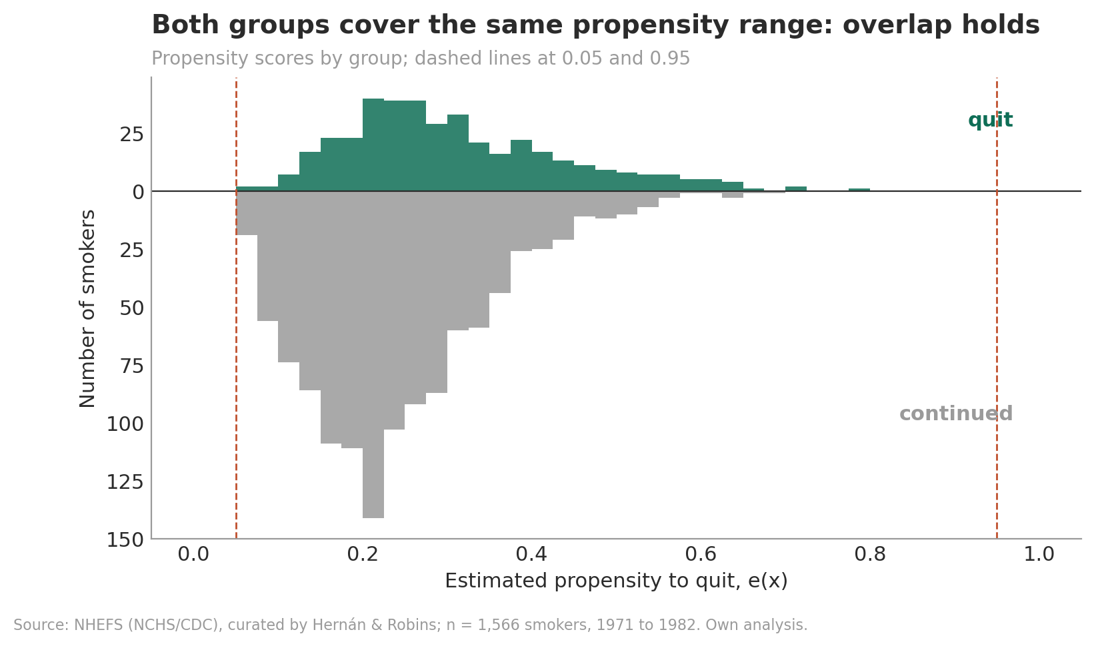
Figure 2. Estimated propensity to quit by group (logistic model with the Hernán & Robins specification). Both groups cover the same range.
Propensity scores range from 0.05 to 0.78, and no one falls outside [0.05, 0.95]. Decision: the ATE remains the estimand; no trimming is needed.

6.3 Unconfoundedness (argued, supported by balance)
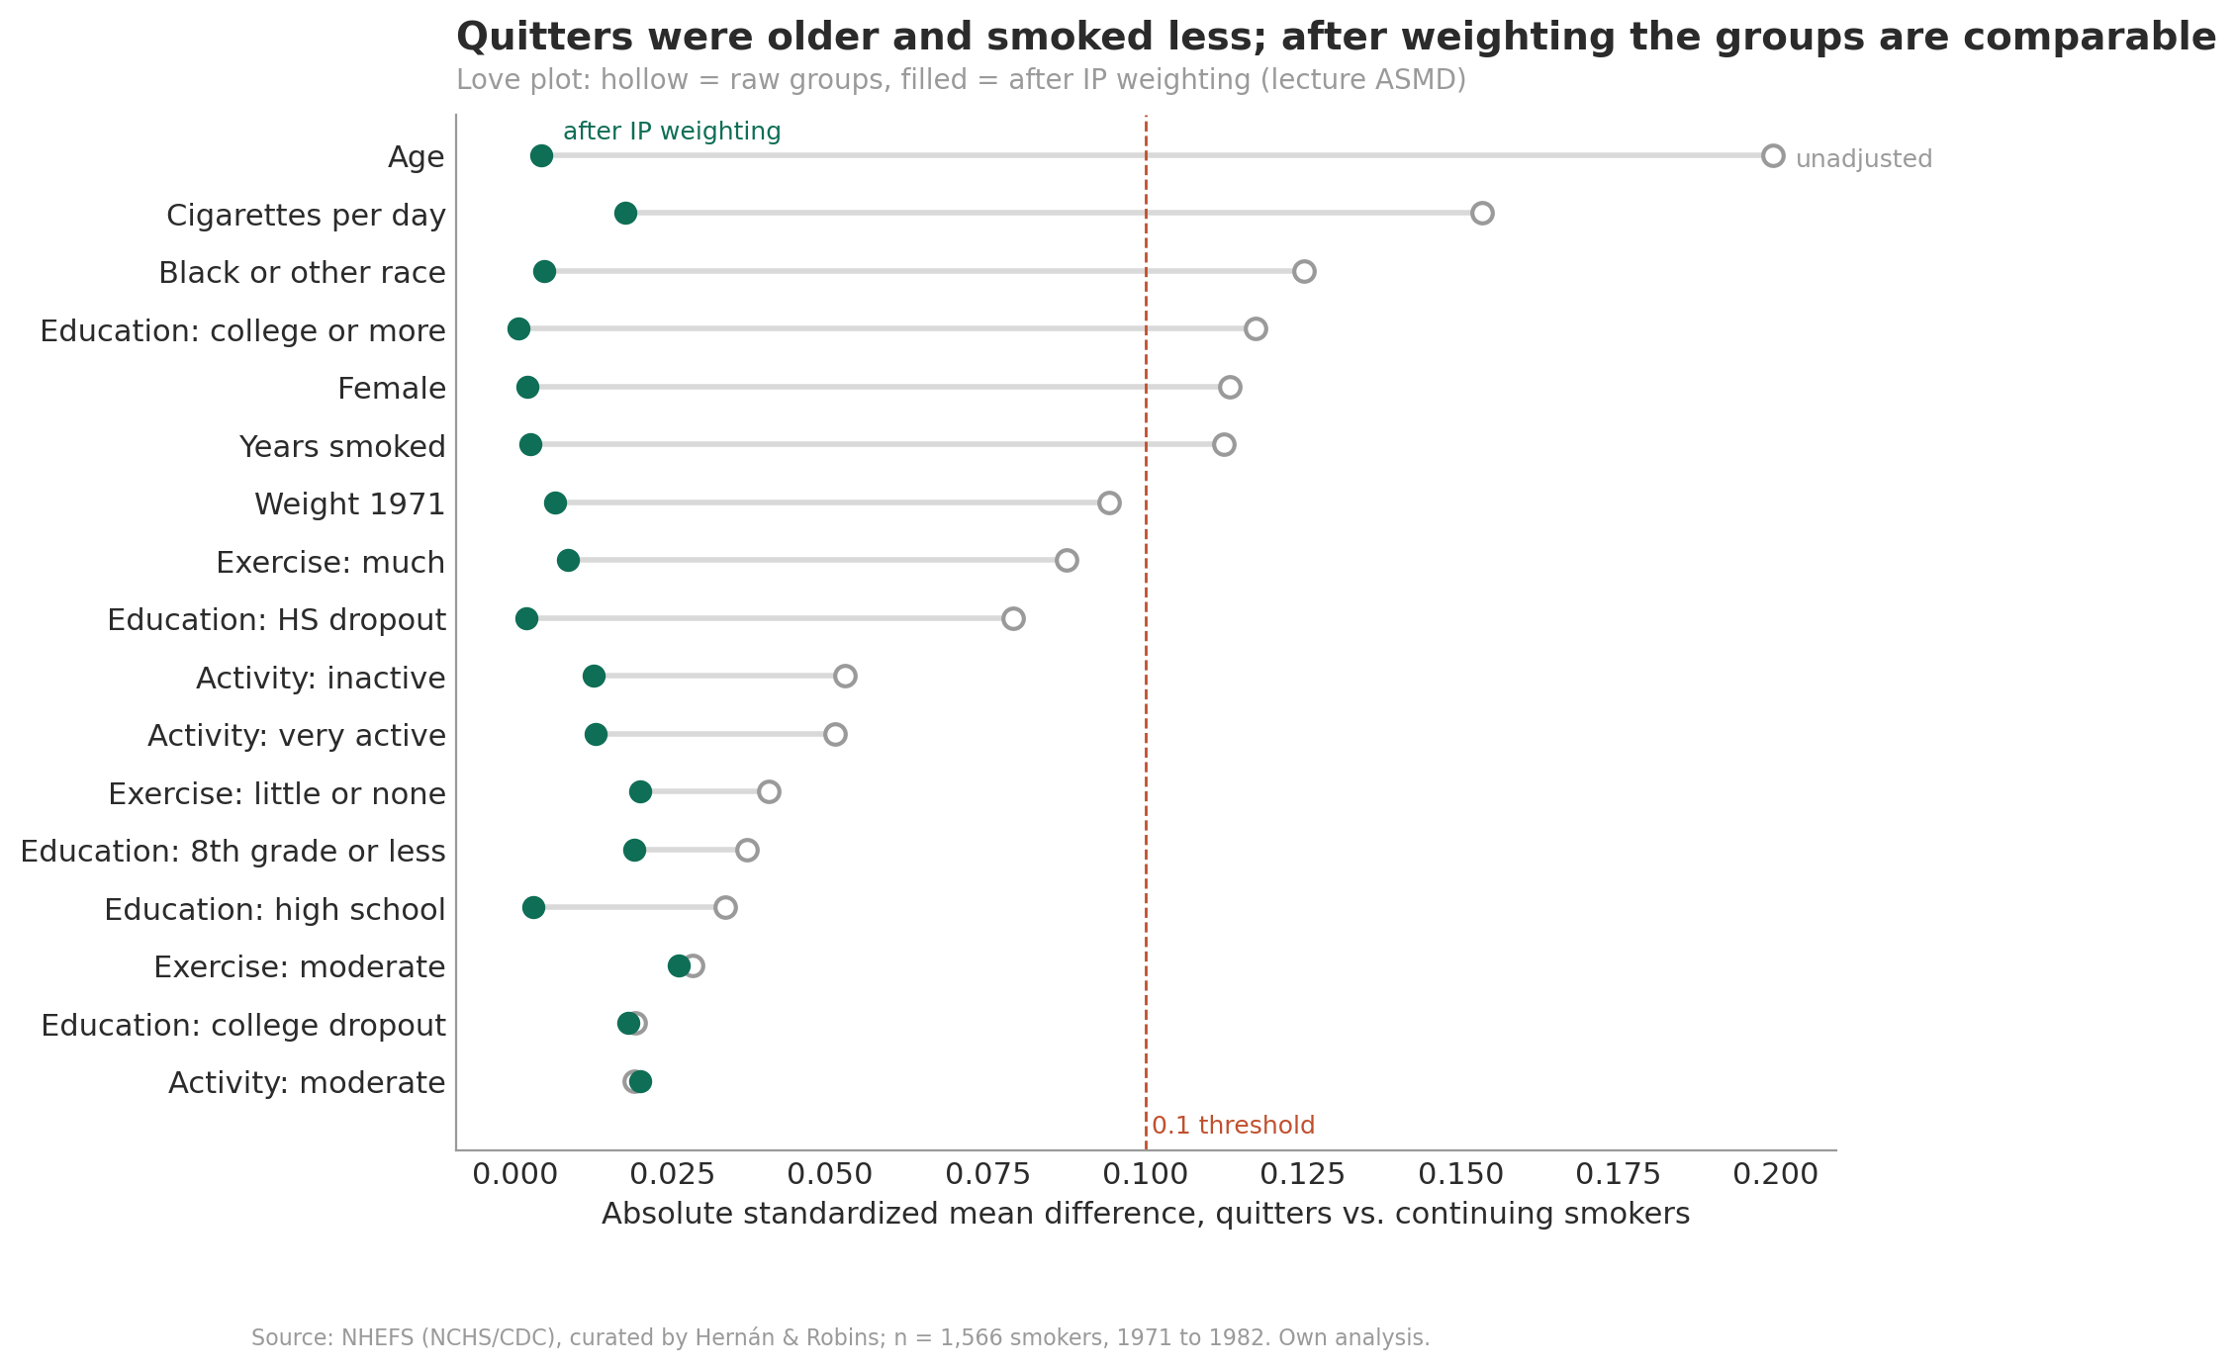
Figure 3. Covariate balance before (hollow) and after (filled) stabilized inverse probability weighting.
Before weighting, quitters differ most in age (ASMD 0.20) and cigarettes per day (0.15); after weighting, every ASMD is below 0.03. The stabilized weights have mean 0.999 and range 0.33 to 4.30, so no single person dominates. The ASMD follows the lecture definition |mean₁ − mean₀| / √(s₁² + s₀²); common software divides by √((s₁² + s₀²)/2), which gives values larger by a factor √2. Balance shows that the weights work for the measured confounders; unconfoundedness with respect to unmeasured ones cannot be tested and is addressed by the sensitivity analysis in Section 9.4.

7. Step 5: Fitting the method

7.1 Nuisance models
The causal forest needs two nuisance functions: m(x) = E[Y | X = x] and e(x) = P(W = 1 | X = x). As in the lecture, both come from honest regression forests with out-of-bag predictions (cross-fitting for free). For comparison, parametric models with the Hernán & Robins specification were fitted with 5-fold cross-fitting.
Table 4. Out-of-sample quality of the nuisance models.
Nuisance models | m(x): R² | e(x): AUC | e(x): Brier score | e(x): range
Regression forests (out-of-bag) | 0.074 | 0.612 | 0.186 | 0.12 to 0.47
Parametric (5-fold cross-fit) | 0.085 | 0.632 | 0.183 | 0.05 to 0.80

Both fits are weak: weight change is hard to predict and quitting is only mildly predictable from X, which is good for overlap. Weak nuisances do not threaten identification; they make estimates noisier. The forests are used inside the causal forest (lecture workflow); the parametric models enter the estimator ladder, so the ladder also shows robustness to the nuisance choice.

7.2 Causal forest
The causal forest (econml.grf, the Python counterpart of R's grf) is a forest-localized Robinson regression of Y − m(X) on W − e(X): honest trees, 2,000 trees, out-of-bag predictions. The leaf size was selected by the R-loss (Nie & Wager 2021) over the grid 5, 10, 20, 40 (R-loss 55.417, 55.358, 55.399, 55.459); min_samples_leaf = 10 was selected. Its doubly robust ATE is 3.38 kg (95% CI 2.46 to 4.30).

7.3 Estimator ladder
Table 5. ATE estimates along the estimator ladder (kg over 1971 to 1982).
Estimator | Estimate | SE | 95% CI
Difference in means (naive) | 2.54 | 0.49 | 1.59 to 3.50
Direct: outcome model (standardization) | 3.52 | 0.49 | 2.57 to 4.47
IPW: treatment model (stabilized weights) | 3.44 | 0.53 | 2.41 to 4.47
AIPW: parametric nuisances, cross-fit | 3.26 | 0.51 | 2.27 to 4.26
AIPW: causal forest (forest nuisances) | 3.38 | 0.47 | 2.46 to 4.30

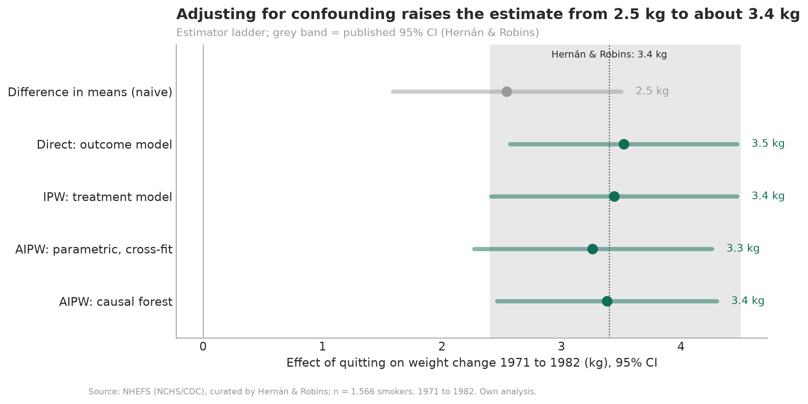
Figure 4. Estimator ladder with 95% confidence intervals; the grey band is the published 95% CI of Hernán & Robins (2020).
Validation. IPW reproduces the published estimate of Hernán & Robins (3.4 kg, 95% CI 2.4 to 4.5), and the direct estimator matches their standardization result (3.5 kg). Direction of the bias. The naive estimate is too low: quitters were older and heavier at baseline, characteristics associated with smaller weight gain regardless of quitting, so the raw comparison hides part of the effect. Confounding can bias in either direction.

8. Step 6: Evaluating heterogeneity
A histogram of the forest's predictions τ(x) is not evidence of heterogeneity: every prediction carries noise, so predictions vary even when the true effect is identical for everyone. Three honest checks follow.

8.1 Calibration test and revise loop
The calibration test regresses Y − m(X) on the mean forest prediction and the differential forest prediction. The coefficient α ≈ 1 means the average effect is well calibrated; β significantly greater than 0 is omnibus evidence that heterogeneity exists.
Table 6. Calibration test across leaf sizes (revise loop; selected forest in bold).
min_samples_leaf | R-loss | α (mean) | β (differential) | p (β > 0)
5 | 55.417 | 0.99 | 0.44 | 0.135
10 | 55.358 | 1.00 | 0.54 | 0.141
20 | 55.399 | 1.00 | 0.39 | 0.294
40 | 55.459 | 1.00 | −0.65 | 0.705

For the selected forest, α = 1.00 (95% CI 0.72 to 1.27) and β = 0.54 (95% CI −0.45 to 1.53, one-sided p = 0.14). β is not significant for any leaf size: the average effect is well calibrated, but heterogeneity cannot be distinguished from noise.

8.2 Predicted versus confirmed effects
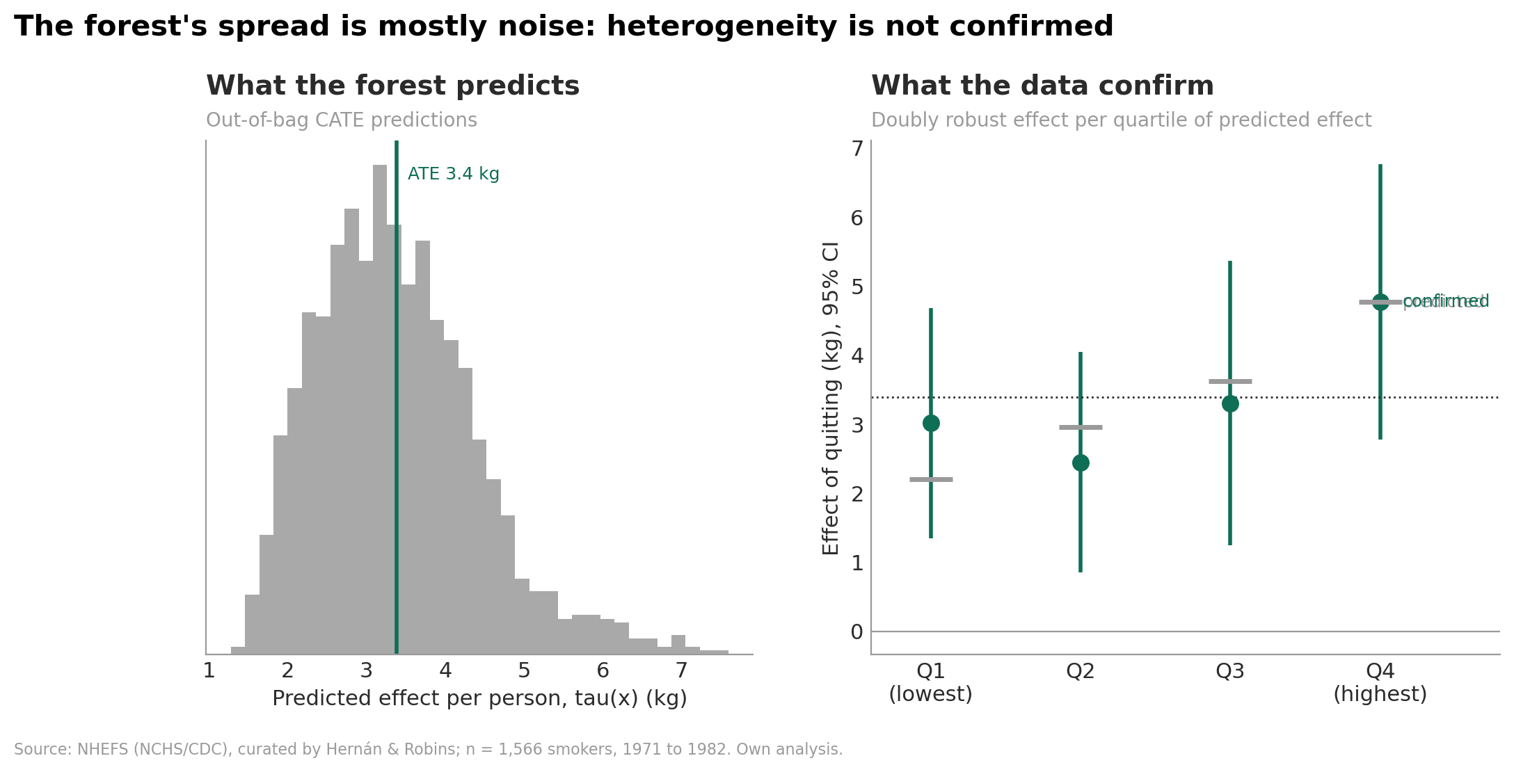
Figure 5. Left: out-of-bag CATE predictions. Right: doubly robust effect estimates per quartile of the predicted effect (grey bars: predictions).
The confirmed effects by quartile of the prediction are 3.01, 2.45, 3.30 and 4.77 kg. They do not rise monotonically, and the difference between the highest and the lowest quartile (1.76 kg, 95% CI −0.84 to 4.36) is not significant.

8.3 Rank-weighted average treatment effect (RATE)
With the split-and-score approach, a prioritization rule is learned on one half of the data and evaluated on the other. The causal forest ranking yields a RATE (AUTOC) of 0.29 kg (95% CI −1.38 to 1.97), the simple rule "cigarettes per day" 0.63 kg (95% CI −1.14 to 2.39). Neither rule identifies smokers with a reliably larger effect. The split halves the sample, which limits power (see Figure A4).
Verdict: the data cannot confirm heterogeneity. This is a result, not a failure, and Section 9.3 quantifies how large heterogeneity would have to be to be detected.

9. Step 7: Robustness
Table 7. Robustness scorecard.
Check | Idea | Result | Passed
Placebo treatment | Replace W by a random permutation (20 refits) | Mean placebo effect +0.06 kg; real effect outside all placebo effects (p = 0.048) | Yes
Random common cause | Add a pure-noise covariate (5 refits) | Largest shift 0.10 kg (threshold 0.23 kg) | Yes
Semi-synthetic outcome | Real X and W, synthetic Y with known effect | Bias +0.08 kg, CI coverage 100% | Yes
Unmeasured confounding | Omitted-variable-bias bounds (Cinelli & Hazlett) | Robustness value 18%; U needs about 9 times the strength of age | Yes
Missing outcomes | Inverse probability weighting for censoring | 3.50 kg with vs. 3.44 kg without censoring weights | Yes

9.1 Placebo treatment
With a randomly permuted treatment, the pipeline estimates effects around zero (mean +0.06 kg, SD 0.52 kg), and the real effect lies outside all 20 placebo effects. The permutation p-value of 0.048 is the smallest attainable with 20 refits (1/21). A failure here would have sent the analysis back to Step 4 (feedback loop).

9.2 Random common cause
Adding a pure-noise covariate shifts the ATE by at most 0.10 kg. The noise variable nevertheless ranks second of ten in the forest's split importance in all five refits, which confirms that split importance is not evidence of effect heterogeneity.

9.3 Semi-synthetic outcome: bias and power
The real covariates and the real, confounded treatment were kept, and the outcome was replaced by a synthetic one with a known effect and the real noise level (five replicates per scenario).
- No heterogeneity (true effect 3.40 kg for everyone): naive 2.78 kg, pipeline 3.48 kg, CI coverage 5 of 5, no false heterogeneity alarms (0 of 5).
- Strong heterogeneity (2 kg more per 10 cigarettes/day, true ATE 4.11 kg): pipeline 4.03 kg, heterogeneity detected in 5 of 5 replicates, estimated slope 1.93 vs. true 2.00 kg per 10 cigarettes.
The pipeline removes the confounding bias of the naive comparison and detects strong heterogeneity. Real heterogeneity, if present, is therefore smaller than about 2 kg per 10 cigarettes/day.

9.4 Sensitivity to unmeasured confounding
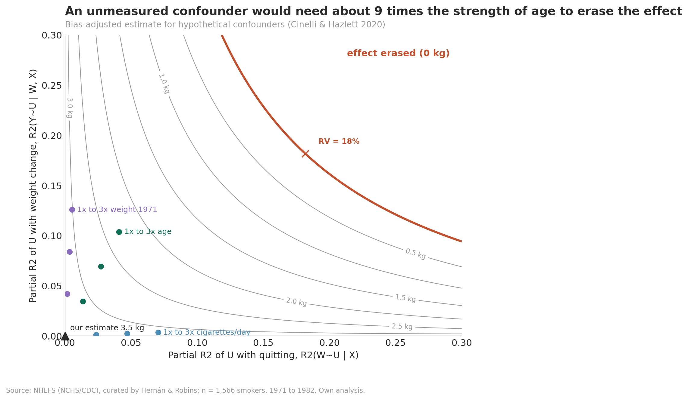
Figure 6. Bias-adjusted estimate for hypothetical unmeasured confounders U, described by their partial R² with quitting and with weight change; benchmarks at one to three times the strength of observed covariates.
On the linear adjustment estimate (3.46 kg, SE 0.44), the robustness value is 18.2%: a confounder explaining 18.2% of the residual variance of both quitting and weight change would erase the effect; 14.0% would make it insignificant. A confounder as strong as age reduces the estimate to 3.09 kg (95% CI 2.24 to 3.94), one three times as strong as age to 2.32 kg (1.49 to 3.15). To erase the effect, U would need about 9 times the strength of age, 23 times that of baseline weight or 24.5 times that of smoking intensity.

9.5 Missing outcomes
Weighting the uncensored by the inverse probability of remaining uncensored, given treatment and covariates, reconstructs the full cohort of 1,629 and yields 3.50 kg (95% CI 2.47 to 4.53), as reported by Hernán & Robins. The complete-case analysis (3.44 kg) is therefore not materially affected by censoring.

10. Step 8: Interpretation
Because the calibration test did not confirm heterogeneity, the following results are exploratory descriptions, not findings.

10.1 Best linear projection
Table 8. Best linear projection of the doubly robust scores (covariates centred; intercept = ATE for an average smoker).
Term | Coefficient (kg) | 95% CI | p
Intercept | 3.38 | 2.46 to 4.31 | <0.001
Cigarettes per day (per 10) | 0.38 | −0.47 to 1.24 | 0.380
Age (per 10 years) | 0.06 | −0.69 to 0.82 | 0.868
Weight 1971 (per 10 kg) | 0.16 | −0.69 to 1.00 | 0.715
Female | 0.22 | −1.99 to 2.44 | 0.844

10.2 Partial dependence
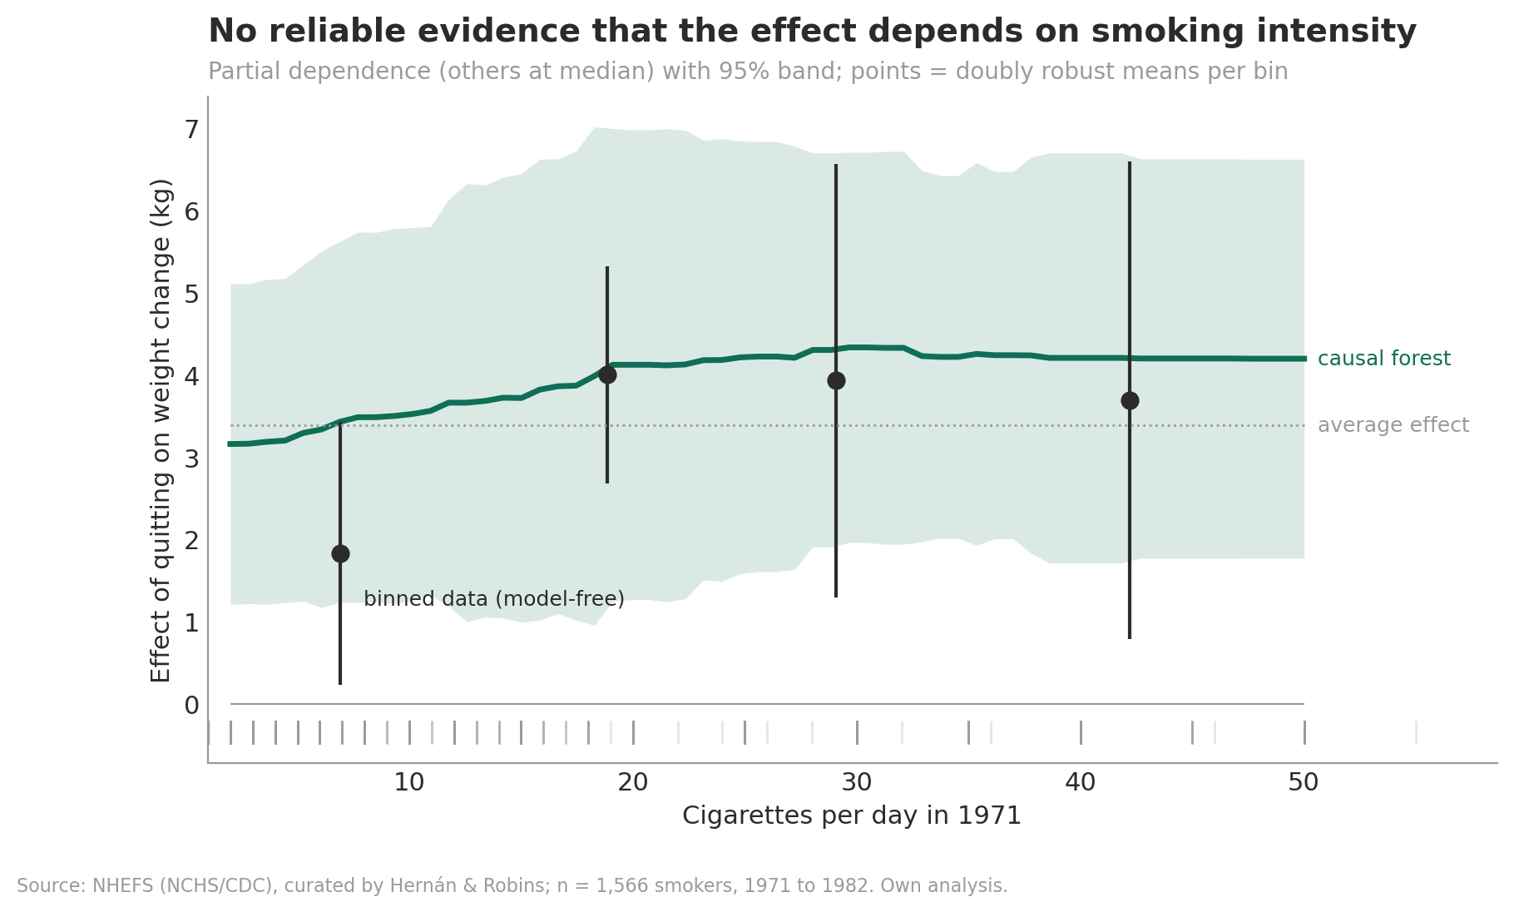
Figure 7. Partial dependence of the effect on cigarettes per day (other covariates at their median) with 95% band; points are model-free doubly robust means per bin.
The forest's curve rises slightly from about 3.2 to 4.2 kg with smoking intensity, the same direction as the outcome model with a quit × intensity interaction in Hernán & Robins (about 2.8 kg at 5 and 4.4 kg at 40 cigarettes per day), which is not statistically significant in our replication either. The model-free bins (1.83, 4.00, 3.93 and 3.69 kg for up to 10, 11 to 20, 21 to 30 and more than 30 cigarettes) have wide, overlapping intervals. Age shows no systematic pattern either (Figure A7).

10.3 Illustrative profiles
The estimated effect for people like a light smoker (woman, 30, 5 cigarettes per day) is 2.56 kg (1.12 to 3.99), for a median smoker 4.12 kg (1.27 to 6.98), and for a heavy smoker (man, 50, 40 cigarettes per day) 2.62 kg (1.20 to 4.04). The intervals overlap; the profiles cannot be told apart (Figure A8).

10.4 Implications for the audience
- Standard offer: plan weight support as a component for all quitters. The expected additional gain is about 3.4 kg over 11 years, roughly 0.3 kg per year.
- No targeting model: smoking intensity, age, sex and baseline weight provide no reliable basis for targeting.
- Communication: present the number in context. A modest weight gain is small compared with the health benefits of quitting, which helps to reduce the fear that keeps smokers from quitting.
- Next step: validate with current Swiss data, for example from programme monitoring, because transporting a US cohort from 1971 to 1982 to today is an assumption.

11. Limitations
- Unconfoundedness is untestable. It is supported by the DAG and bounded by the sensitivity analysis (robustness value 18%, about 9 times the strength of age), but not proven.
- Compound treatment. Timing, method and relapses of quitting are unknown, so consistency holds only approximately.
- Missing outcomes. Censoring was informative, but inverse probability weighting for censoring barely changes the result.
- Self-reported smoking. Treatment and smoking-related confounders are self-reported and subject to measurement error.
- Transportability. The data describe US smokers from 1971 to 1982; products, diets and populations differ today.
- Limited power for heterogeneity. With 1,566 people and a noisy outcome, a null CATE result means "not detectable", not "identical for everyone" (quantified in Section 9.3).
- Total effect. The estimate includes mediated pathways such as appetite and metabolism and says nothing about the mechanism.
- ASMD definition. The lecture formula differs by a factor √2 from common software; the 0.1 threshold must be read accordingly.

12. Reproducibility
- Code: nhefs_causal_ml_pipeline.ipynb; run with Restart Kernel and Run All (a few minutes).
- Randomness: one seed (42) for all forests, splits, permutations and bootstraps.
- Software: causallib (data), econml.grf (regression and causal forests), statsmodels, scikit-learn, networkx, matplotlib; tested with econml 0.17 and scikit-learn 1.9. Forest-based values may differ slightly with other versions; parametric values are deterministic.
- Outputs: figures in figures/, key numbers in results/ (JSON and CSV), including an automatically generated executive summary.

Appendix A. Additional figures
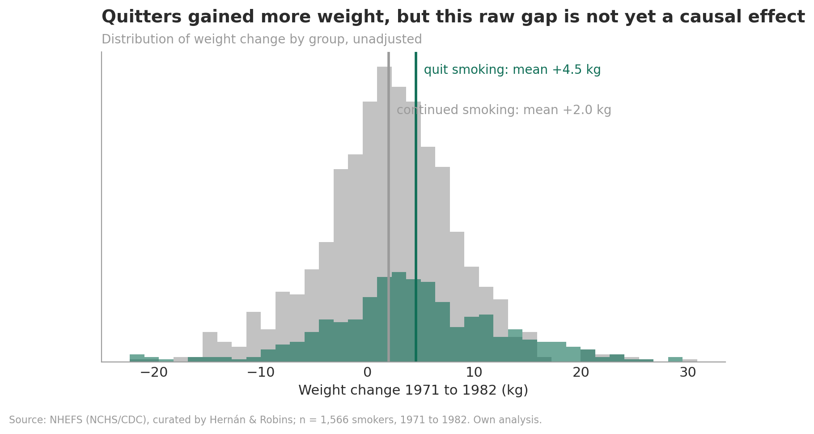
Figure A1. Distribution of weight change by group (unadjusted).
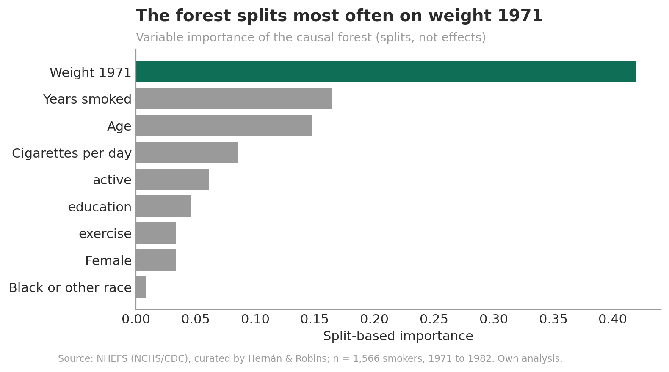
Figure A2. Split-based variable importance of the causal forest (splits, not effects).
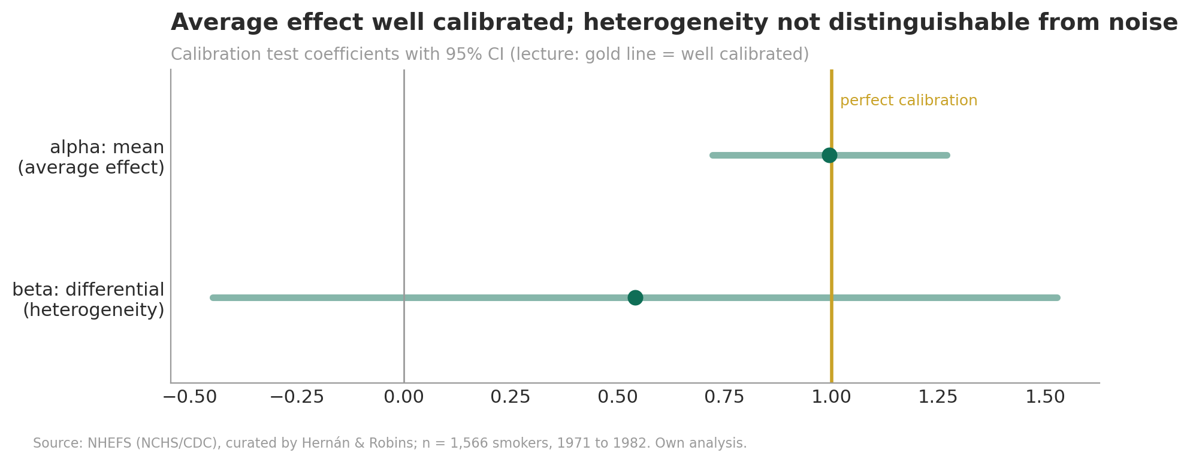
Figure A3. Calibration test coefficients with 95% CI.
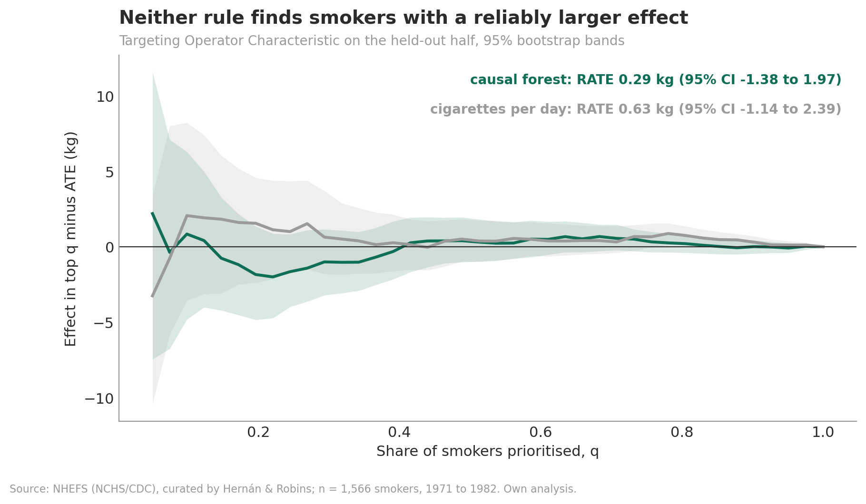
Figure A4. Targeting operator characteristic on the held-out half for both prioritization rules.
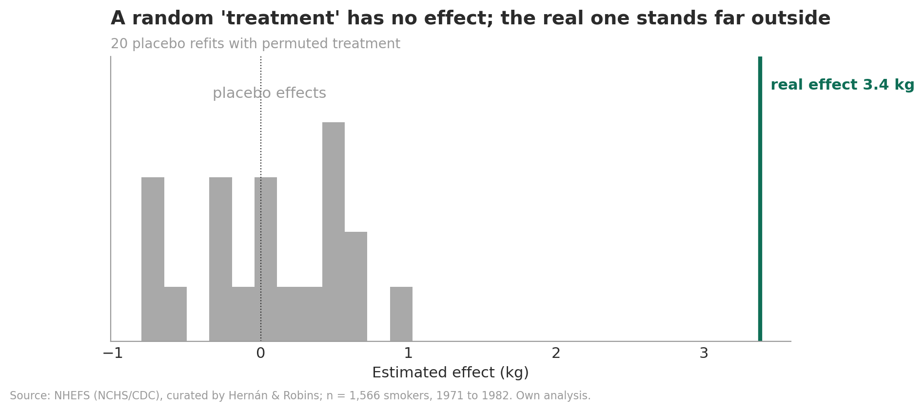
Figure A5. Placebo effects from 20 refits with permuted treatment, compared with the real effect.
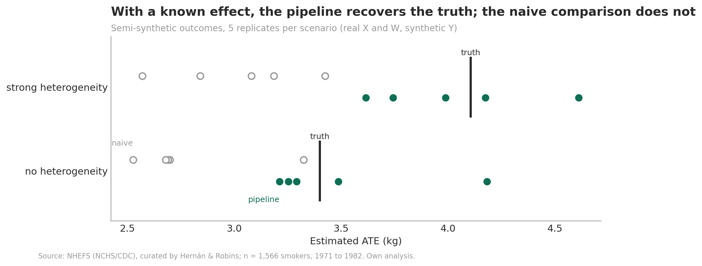
Figure A6. Semi-synthetic validation: naive and pipeline estimates against the known truth.
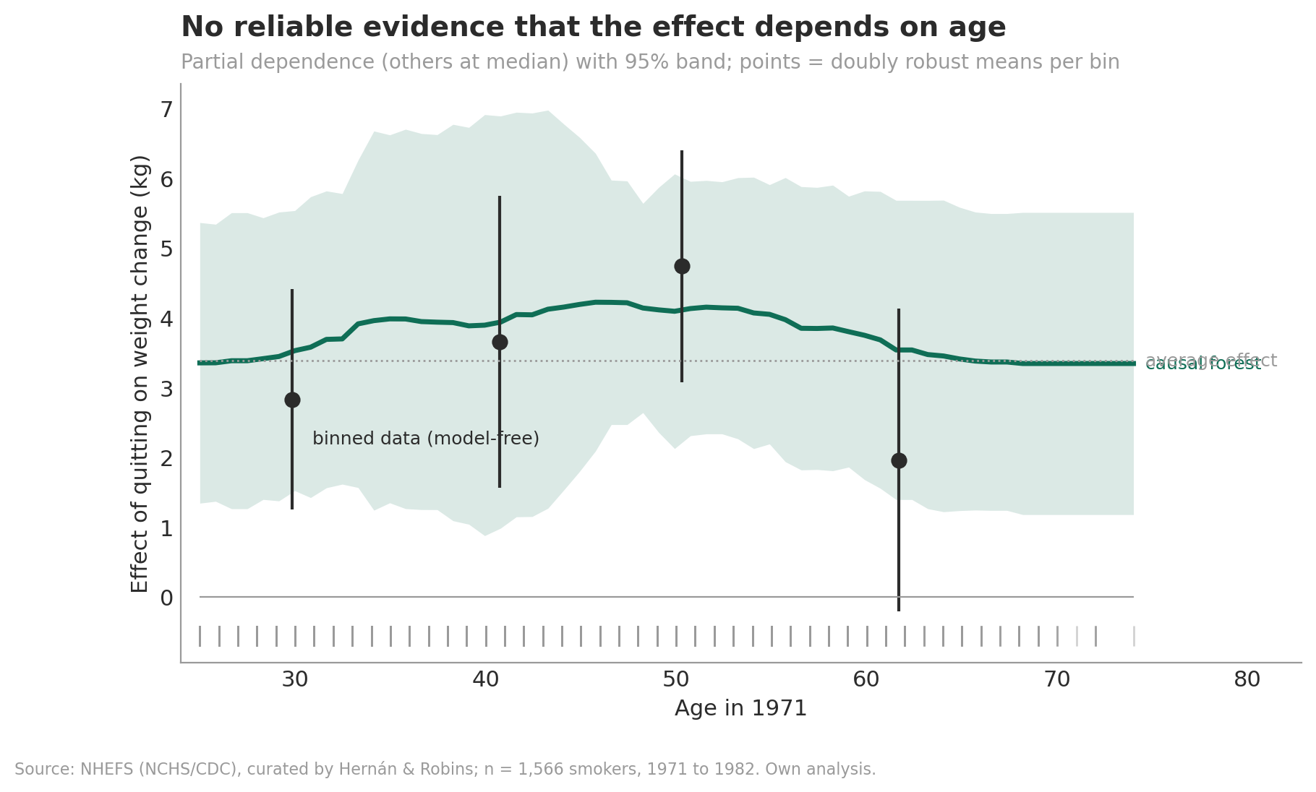
Figure A7. Partial dependence of the effect on age.
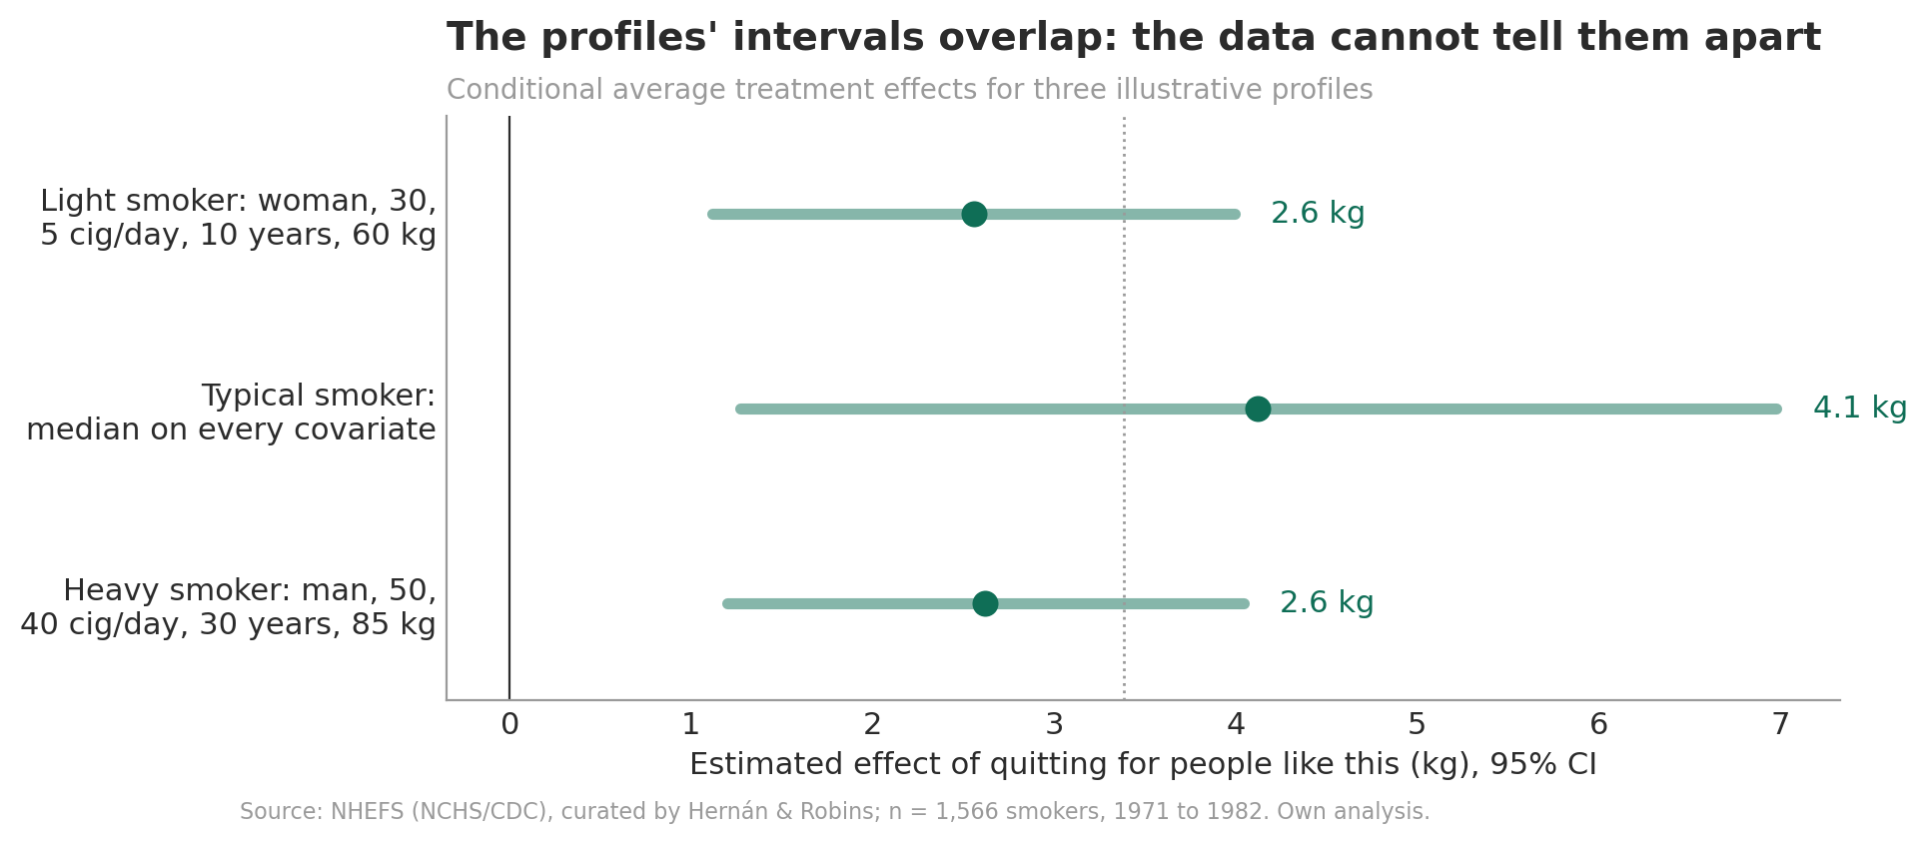
Figure A8. Conditional average treatment effects for three illustrative profiles.
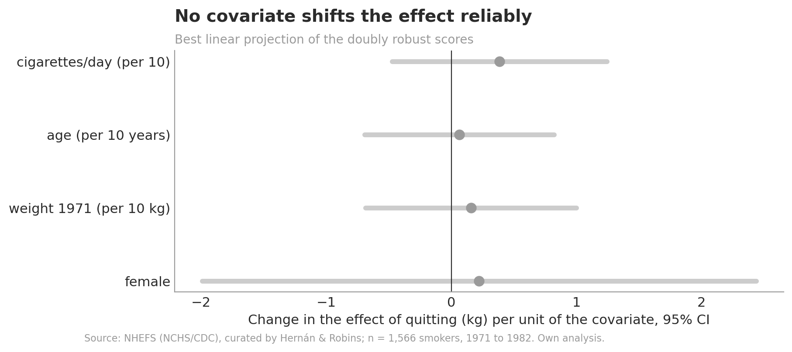
Figure A9. Best linear projection of the doubly robust scores.

References
Athey, S., Tibshirani, J., & Wager, S. (2019). Generalized random forests. Annals of Statistics, 47(2), 1148-1178.
Athey, S., & Wager, S. (2019). Estimating treatment effects with causal forests: An application. Observational Studies, 5, 37-51.
Chernozhukov, V., Chetverikov, D., Demirer, M., Duflo, E., Hansen, C., Newey, W., & Robins, J. (2018). Double/debiased machine learning for treatment and structural parameters. The Econometrics Journal, 21(1), C1-C68.
Cinelli, C., & Hazlett, C. (2020). Making sense of sensitivity: Extending omitted variable bias. Journal of the Royal Statistical Society Series B, 82(1), 39-67.
Hernán, M. A., & Robins, J. M. (2020). Causal Inference: What If. Boca Raton: Chapman & Hall/CRC.
Knaflic, C. N. (2015). Storytelling with Data. Hoboken: Wiley.
Minto, B. (2009). The Pyramid Principle: Logic in Writing and Thinking (3rd ed.). Harlow: Pearson.
Nie, X., & Wager, S. (2021). Quasi-oracle estimation of heterogeneous treatment effects. Biometrika, 108(2), 299-319.
Rosenbaum, P. R., & Rubin, D. B. (1983). The central role of the propensity score in observational studies for causal effects. Biometrika, 70(1), 41-55.
Yadlowsky, S., Fleming, S., Shah, N., Brunskill, E., & Wager, S. (2021). Evaluating treatment prioritization rules via rank-weighted average treatment effects. arXiv:2111.07966.

