Write a program to check whether input string is accepted by given DFA or not.

Intro:

- The language accepted by finite automata can be easily described by simple expressions called Regular Expressions. It is the most effective way to represent any language. Example : (a+b)*aba(a+b)*

- The languages accepted by some regular expression are referred to as Regular languages.

- Deterministic Finite Automaton (DFA)

In DFA, for each input symbol, one can determine the state to which the machine will move. Hence, it is called **Deterministic Automaton**. As it has a finite number of states, the machine is called **Deterministic Finite Machine** or **Deterministic Finite Automaton.**

Code:

# Re = (a+b)*abb

def takeTT():

    totalSym = list(input("Symbols: ").split())

    totalStates = int(input("How many states: "))

    acceptedState = list(map(int,input("Accepted state numbers :").split()))

    temp = totalStates

    tt = []

    print(f'Enter T.T. values by rows for column {totalSym}')

    while temp > 0:

        tt.append(list(map(int,input().split())))

        temp -= 1

    print(tt)

    return tt, totalSym, acceptedState

def takeAndCheck_Strings(TT,symbols,accStates):

    #take strings to check

    strList = []

    userString = ''

    print("RE: (a+b)*abb")

    while userString != 'null':

        userString = input()

        strList.append(userString)

    #check using TT

    for string in strList[:-1]:

        state = 0

        for ch in string:

            prevState = state

            symIndex = symbols.index(ch)

            state = TT[state][symIndex]

            print(prevState,"->",state)

        if state in accStates:

            print(string,"is Accepted")

        else:

            print(string,"is not Accepted")

transTable, Symbols, accState = takeTT()

takeAndCheck_Strings(transTable,Symbols,accState)

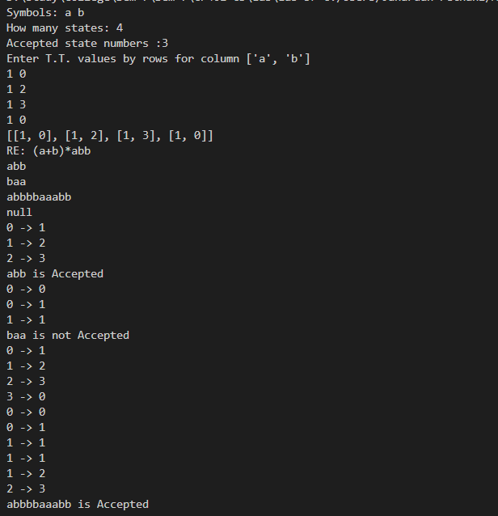Output: