**Program 1:** WAP in C++ to read random value of 100 elements in array. Find mean, mod, median, range, variance, Standard aviation.

Code:

#include<iostream>

#include<stdlib.h>

#include<ctime>

#include <bits/stdc++.h>

using namespace std;

int main()

{

srand((unsigned) time(0));

int array[100];

for(int i=0;i<100;i++)

{

array[i]=(rand() % 100) + 1;

// cout<<i<<": "<<array[i]<<endl;

}

sort(array,array+100);

for(int i=0;i<100;i++)

{

cout<<i+1<<": "<<array[i]<<"\t";

}

//Mean------------------------------------------

float mean = 0;

float sum = 0;

for(int i=0;i<100;i++)

{

sum += array[i];

}

mean = sum/100;

//Median----------------------------------------

int n1 = array[50];

int n2 = array[51];

float median = (n1+n2)/2;

//mode------------------------------------------

int maxi = array[99] + 1;

int count[maxi];

// cout<<"max="<<maxi;

for (int i = 0; i < maxi; i++)

count[i] = 0;

for (int i = 0; i < 100; i++)

count[array[i]]++;

int mode = 0;

int k = count[0];

for (int i = 0; i < maxi; i++)

{

if (count[i] > k)

{

k = count[i];

mode = i;

}

}

//range-----------------------------------------

maxi = array[99];

int mini = array[0];

int range = maxi - mini;

//S.Deviation-------------------------------------

float SD = 0.0;

for(int i = 0; i < 100; ++i)

SD += pow(array[i] - mean, 2);

float variance = SD;

SD = sqrt(SD/100);

//-------------------------

cout<<"\n\nmean= "<<mean<<endl;

cout<<"median= "<<median<<endl;

cout<<"mode= "<<mode<<endl;

cout<<"variance= "<<variance<<endl;

cout<<"SD= "<<SD;

return 0;

}

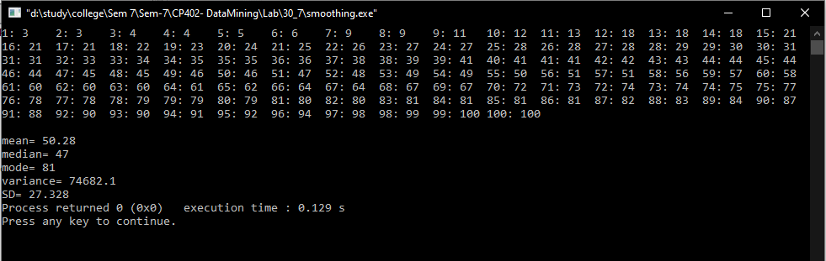Output: