Program: ZJANA_BILLINGITEM_OOPS

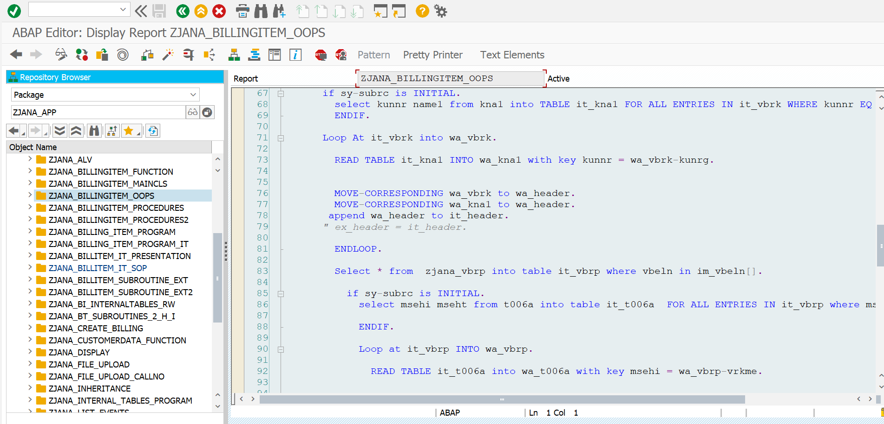

*\*&---------------------------------------------------------------------\**  
*\*& Report ZJANA_BILLINGITEM_OOPS*  
*\*&---------------------------------------------------------------------\**  
*\*&*  
*\*&---------------------------------------------------------------------\**  
REPORT zjana_billingitem_oops.  
DATA p_vbeln TYPE zjana_vbrk-vbeln.  
SELECT-OPTIONS s_vbeln FOR p_vbeln.  
  
CLASS BillingItem_oops DEFINITION.  
 PUBLIC SECTION.  
  
  
 METHODS get_data IMPORTING im_vbeln TYPE zjana_t_range.  
  
  
 Methods display_Result.  
  
  
 PRIVATE SECTION.  
 DATA it_header TYPE zjana_t_header.  
 DATA wa_header LIKE LINE OF it_header.  
  
 DATA it_item TYPE zjana_t_item.  
 DATA wa_item LIKE LINE OF it_item.  
  
  
 TYPES:BEGIN OF ty_kna1,  
 kunnr TYPE kna1-kunnr,  
 name1 TYPE kna1-name1,  
 END OF ty_kna1.  
  
 DATA: it_vbrk TYPE TABLE OF zjana_vbrk,  
 wa_vbrk LIKE LINE OF it_vbrk.  
 DATA: it_kna1 TYPE TABLE OF ty_kna1,  
 wa_kna1 LIKE LINE OF it_kna1.  
  
 TYPES: BEGIN OF ty_t006a,  
 msehi TYPE t006a-msehi,  
 mseht TYPE t006a-mseht,  
 END OF ty_t006a.  
  
  
  
 DATA: it_vbrp TYPE TABLE OF zjana_vbrp,  
 wa_vbrp LIKE LINE OF it_vbrp.  
 DATA: it_t006a TYPE STANDARD TABLE OF ty_t006a,  
 wa_t006a LIKE LINE OF it_t006a.  
  
  
ENDCLASS.  
*\**  
*\*SELECTION-SCREEN BEGIN OF BLOCK b1 WITH FRAME TITLE text-001.*  
*\* SELECT-OPTIONS s_vbeln FOR p_vbeln MEMORY ID vbe.*  
*\**  
*\*SELECTION-SCREEN END OF BLOCK b1.*  
  
  
CLASS billingitem_oops IMPLEMENTATION.  
  
  
  
 METHOD get_data.  
  
 select * FROM zjana_vbrk into table it_vbrk where vbeln in im_vbeln[].  
  
 if sy-subrc is INITIAL.  
 select kunnr name1 from kna1 into TABLE it_kna1 FOR ALL ENTRIES IN it_vbrk WHERE kunnr EQ it_vbrk-kunrg.  
 ENDIF.  
  
 Loop At it_vbrk into wa_vbrk.  
  
 READ TABLE it_kna1 INTO wa_kna1 with key kunnr = wa_vbrk-kunrg.  
  
  
 MOVE-CORRESPONDING wa_vbrk to wa_header.  
 MOVE-CORRESPONDING wa_kna1 to wa_header.  
 append wa_header to it_header.  
 *" ex_header = it_header.*  
  
 ENDLOOP.  
  
 Select * from zjana_vbrp into table it_vbrp where vbeln in im_vbeln[].  
  
 if sy-subrc is INITIAL.  
 select msehi mseht from t006a into table it_t006a FOR ALL ENTRIES IN it_vbrp where msehi = it_vbrp-vrkme.  
  
 ENDIF.  
  
 Loop at it_vbrp INTO wa_vbrp.  
  
 READ TABLE it_t006a into wa_t006a with key msehi = wa_vbrp-vrkme.  
  
  
 MOVE-CORRESPONDING wa_vbrp to wa_item.  
 MOVE-CORRESPONDING wa_t006a to wa_item.  
  
  
 APPEND wa_item to it_item.  
 *" ex_item = it_item.*  
  
 ENDLOOP.  
  
  
  
 ENDMETHOD.  
  
 METHOD display_Result.  
  
 Sort it_item by vbeln.  
  
 Loop At it_item INTO wa_item.  
  
 AT NEW vbeln.  
 READ TABLE it_header into wa_header with key vbeln = wa_vbrp-vbeln.  
  
 Write: /'DocumentNo:',wa_header-vbeln.  
 Write:/'payer name:',wa_header-name1.  
 write:/'Date:',wa_header-fkdat.  
 write:/'net value:',wa_header-netwr.  
 WRITE : /5 'Item',  
 20 'Material',  
 50 'Quantity',  
 60 'UoM',  
 90 'Net Value'.  
 ENDAT.  
  
  
  
 WRITE : /5 wa_item-posnr,  
 20 wa_item-matnr,  
 40 wa_item-fkimg,  
 60 wa_item-mseht,  
 80 wa_item-netwr.  
  
  
 ENDLOOP.  
  
 ENDMETHOD.  
  
  
ENDCLASS.  
  
DATA O_billingItem_OOPS type REF TO billingitem_oops.  
  
  
START-OF-SELECTION.  
create OBJECT o_billingitem_oops.  
  
o_billingitem_oops->get_data(  
EXPORTING im_vbeln = s_vbeln[]  
).  
  
o_billingItem_oops->display_Result( ).

**RESULT:**

