Program: ZJANA_BILLITEM_SUBROUTINE_EXT2

ZJANA_BT_SUBROUTINES_2_H_I

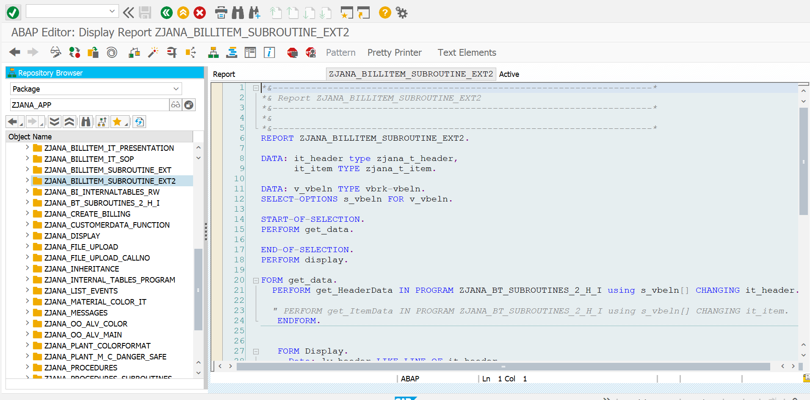

*\*&---------------------------------------------------------------------\**  
*\*& Report ZJANA_BILLITEM_SUBROUTINE_EXT2*  
*\*&---------------------------------------------------------------------\**  
*\*&*  
*\*&---------------------------------------------------------------------\**  
REPORT ZJANA_BILLITEM_SUBROUTINE_EXT2.  
  
DATA: it_header type zjana_t_header,  
 it_item TYPE zjana_t_item.  
  
DATA: v_vbeln TYPE vbrk-vbeln.  
SELECT-OPTIONS s_vbeln FOR v_vbeln.  
  
START-OF-SELECTION.  
PERFORM get_data.  
  
END-OF-SELECTION.  
PERFORM display.  
  
FORM get_data.  
 PERFORM get_HeaderData IN PROGRAM ZJANA_BT_SUBROUTINES_2_H_I using s_vbeln[] CHANGING it_header.  
  
 *" PERFORM get_ItemData IN PROGRAM ZJANA_BT_SUBROUTINES_2_H_I using s_vbeln[] CHANGING it_item.*  
 ENDFORM.  
  
  
 FORM Display.  
 Data: lw_header LIKE LINE OF it_header,  
 lw_item LIKE LINE OF it_item.  
  
 SORT it_item by vbeln posnr.  
  
 LOOP AT it_item INTO lw_item.  
  
 AT NEW vbeln.  
 Read TABLE it_header INTO lw_header with KEY vbeln = lw_item-vbeln.  
  
 WRITE : / 'Doc No:', lw_header-vbeln,  
 / 'Payer:', lw_header-name1,  
 / 'Date:', lw_header-fkdat,  
 / 'Net Value:', lw_header-netwr.  
 SKIP.  
 WRITE : /5 'Item',  
 20 'Material',  
 50 'Quantity',  
 60 'UoM',  
 90 'Net Value'.  
  
 ENDAT.  
  
 WRITE : /5 lw_item-posnr,  
 20 lw_item-matnr,  
 40 lw_item-fkimg,  
 60 lw_item-mseht,  
 80 lw_item-netwr.  
 ENDLOOP.  
 ENDFORM.

*\*&---------------------------------------------------------------------\**  
*\*& Report ZJANA_BT_SUBROUTINES_2_H_I*  
*\*&---------------------------------------------------------------------\**  
*\*&*  
*\*&---------------------------------------------------------------------\**  
REPORT zjana_bt_subroutines_2_h_i.  
  
TYPES tr_vbeln TYPE RANGE OF vbrk-vbeln.  
  
Types p_vbeln type vbrk-vbeln.  
  
  
  
  
  
FORM get_HeaderData USING r_vbeln TYPE tr_vbeln CHANGING p_it_header TYPE zjana_t_header.  
  
 TYPES: BEGIN OF ty_kna1,  
 kunnr TYPE kna1-kunnr,  
 name1 TYPE kna1-name1,  
 END OF ty_kna1.  
 DATA: lt_vbrk TYPE TABLE OF zjana_vbrk,  
 lw_vbrk LIKE LINE OF lt_vbrk.  
 DATA: lt_kna1 TYPE STANDARD TABLE OF ty_kna1,  
 lw_kna1 LIKE LINE OF lt_kna1.  
  
 DATA lw_header LIKE LINE OF p_it_header.  
  
 TYPES: BEGIN OF ty_t006a,  
 msehi TYPE t006a-msehi,  
 mseht TYPE t006a-mseht,  
 END OF ty_t006a.  
  
 DATA: lt_vbrp TYPE TABLE OF zjana_vbrp,  
 lw_vbrp LIKE LINE OF lt_vbrp.  
 DATA: lt_t006a TYPE TABLE OF ty_t006a,  
 lw_t006a LIKE LINE OF lt_t006a.  
 DATA: it_item TYPE zjana_t_item.  
 DATA lw_item LIKE LINE OF it_item.  
  
 SELECT * FROM zjana_vbrk INTO TABLE lt_vbrk WHERE vbeln IN r_vbeln.  
  
 IF sy-subrc IS INITIAL.  
 SELECT kunnr name1 FROM kna1 INTO TABLE lt_kna1 FOR ALL ENTRIES IN lt_vbrk WHERE kunnr EQ lt_vbrk-kunrg.  
 ENDIF.  
  
  
 *"SORT lt_vbrp BY vbeln.*  
 LOOP AT lt_vbrk INTO lw_vbrk.  
 READ TABLE lt_kna1 INTO lw_kna1 WITH KEY kunnr = lw_vbrk-kunrg.  
  
 MOVE-CORRESPONDING lw_vbrk TO lw_header.  
 MOVE-CORRESPONDING lw_kna1 TO lw_header.  
 APPEND lw_header TO p_it_header.  
 *"HIDE lw_vbrk-vbeln.*  
 CLEAR lw_header.  
  
  
 ENDLOOP.  
 CLEAR lw_header.  
ENDFORM.  
  
  
  
  
  
  
FORM get_ItemData USING p_p_vbeln type p_vbeln CHANGING p_it_item type zjana_t_item.  
  
 TYPES: BEGIN OF ty_t006a,  
 msehi TYPE t006a-msehi,  
 mseht TYPE t006a-mseht,  
 END OF ty_t006a.  
  
 Data: lt_vbrp type table of zjana_vbrp,  
 lw_vbrp LIKE LINE OF lt_vbrp.  
 Data: lt_t006a type table of ty_t006a,  
 lw_t006a LIKE LINE OF lt_t006a.  
 DATA: it_item type zjana_t_item.  
Data lw_item LIKE LINE OF p_it_item.  
  
  
 IF sy-subrc = 0.  
  
SELECT * from zjana_vbrp INTO table lt_vbrp where vbeln EQ p_p_vbeln.  
 if sy-subrc is INITIAL.  
 SELECT msehi mseht from t006a into table lt_t006a FOR ALL ENTRIES IN lt_vbrp where msehi EQ lt_vbrp-vrkme.  
 ENDIF.  
  
 LOOP At lt_vbrp INTO lw_vbrp.  
  
 READ TABLE lt_t006a into lw_t006a WITH KEY msehi = lw_vbrp-vrkme.  
  
 MOVE-CORRESPONDING lw_vbrp to lw_item.  
 MOVE-CORRESPONDING lw_t006a to lw_item.  
 AppEND lw_item to p_it_item.  
 clear lw_item.  
 ENDLOOP.  
endif.  
  
ENDFORM.

