REPORT: ZJANA_OO_ALV_COLOR

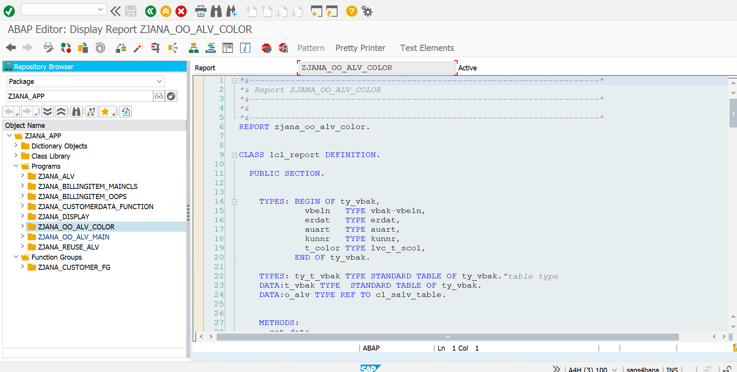

*\*&---------------------------------------------------------------------\**  
*\*& Report ZJANA_OO_ALV_COLOR*  
*\*&---------------------------------------------------------------------\**  
*\*&*  
*\*&---------------------------------------------------------------------\**  
REPORT zjana_oo_alv_color.  
  
  
CLASS lcl_report DEFINITION.  
  
 PUBLIC SECTION.  
  
  
 TYPES: BEGIN OF ty_vbak,  
 vbeln TYPE vbak-vbeln,  
 erdat TYPE erdat,  
 auart TYPE auart,  
 kunnr TYPE kunnr,  
 t_color TYPE lvc_t_scol,  
 END OF ty_vbak.  
  
 TYPES: ty_t_vbak TYPE STANDARD TABLE OF ty_vbak.*"table type*  
 DATA:t_vbak TYPE STANDARD TABLE OF ty_vbak.  
 DATA:o_alv TYPE REF TO cl_salv_table.  
  
  
 METHODS:  
 get_data,  
 generate_output.  
  
  
 PRIVATE SECTION.  
 METHODS:  
 set_pf_status  
  
 CHANGING  
 co_alv TYPE REF TO cl_salv_table.  
 METHODS:  
 set_colors  
 CHANGING  
  
 co_alv TYPE REF TO cl_salv_table  
 ct_vbak TYPE ty_t_vbak.  
  
  
  
ENDCLASS.  
  
  
  
  
  
  
  
CLASS lcl_report IMPLEMENTATION.  
  
 METHOD get_data.  
 SELECT vbeln erdat auart kunnr INTO CORRESPONDING FIELDS OF TABLE t_vbak FROM vbak UP TO 20 ROWS.  
 ENDMETHOD.  
  
  
 METHOD generate_output.  
 DATA:lx_msg TYPE REF TO cx_salv_msg  
 .  
 TRY.  
 cl_salv_table=>factory(  
*\* EXPORTING*  
*\* list_display = if_salv_c_bool_sap=>false " ALV Displayed in List Mode*  
*\* r_container = " Abstract Container for GUI Controls*  
*\* container_name =*  
 IMPORTING  
 r_salv_table = o_alv *" Basis Class Simple ALV Tables*  
 CHANGING  
 t_table = t_vbak  
 ).  
 CATCH cx_salv_msg. *" ALV: General Error Class with Message*  
  
  
  
  
  
  
 ENDTRY.  
  
 CALL METHOD set_pf_status  
 CHANGING  
 co_alv = o_alv.  
  
  
  
  
 CALL METHOD set_colors  
 CHANGING  
 co_alv = o_alv  
 ct_vbak = t_vbak.  
 o_alv->display( ).  
  
  
  
 ENDMETHOD.  
  
 METHOD set_pf_status.  
 DATA: lo_functions TYPE REF TO cl_salv_functions_list.  
  
 lo_functions = co_alv->get_functions( ).  
  
 lo_functions->set_default( abap_true ).  
  
 ENDMETHOD.  
 METHOD set_colors.  
 DATA: lo_cols_tab TYPE REF TO cl_salv_columns_table,  
 lo_col_tab TYPE REF TO cl_salv_column_table,  
 ls_color TYPE lvc_s_colo.  
  
  
 lo_cols_tab = co_alv->get_columns( ).  
  
 INCLUDE <color>.  
 TRY.  
 lo_col_tab ?= lo_cols_tab->get_column( 'ERDAT' ).  
 ls_color-col = col_total.  
 lo_col_tab->set_color( ls_color ).  
 CATCH cx_salv_not_found.  
 ENDTRY.  
 DATA: lt_s_color TYPE lvc_t_scol,  
 ls_s_color TYPE lvc_s_scol,  
 la_vbak LIKE LINE OF ct_vbak,  
 l_count TYPE i.  
  
  
 LOOP AT ct_vbak INTO la_vbak.  
 l_count = l_count + 1.  
  
 CASE l_count.  
 WHEN 3.  
 ls_s_color-fname ='AUART'.  
 ls_s_color-color-col = col_negative.  
 ls_s_color-color-int = 0.  
 ls_s_color-color-inv = 0.  
  
 APPEND ls_s_color TO lt_s_color.  
  
 CLEAR ls_s_color.  
  
 WHEN 5.  
 ls_s_color-color-col = col_positive.  
 ls_s_color-color-int = 0.  
 ls_s_color-color-inv = 0.  
  
 APPEND ls_s_color TO lt_s_color.  
 CLEAR ls_s_color.  
 ENDCASE.  
 la_vbak-t_color = lt_s_color.  
 MODIFY ct_vbak FROM la_vbak.  
 CLEAR la_vbak.  
 CLEAR lt_s_color.  
 ENDLOOP.  
  
  
 TRY.  
 lo_cols_tab->set_color_column( 'T_color' ).  
  
  
 CATCH CX_SALV_data_error.  
  
 ENDTRY.  
  
  
  
 ENDMETHOD.  
  
ENDCLASS.  
  
  
  
START-OF-SELECTION.  
 DATA:lo_report TYPE REF TO lcl_report.  
  
  
  
 CREATE OBJECT lo_report.  
 lo_report->get_data( ).  
 lo_report->generate_output( ).

