Program: ZJANA__BILING_DOC_EVENTS

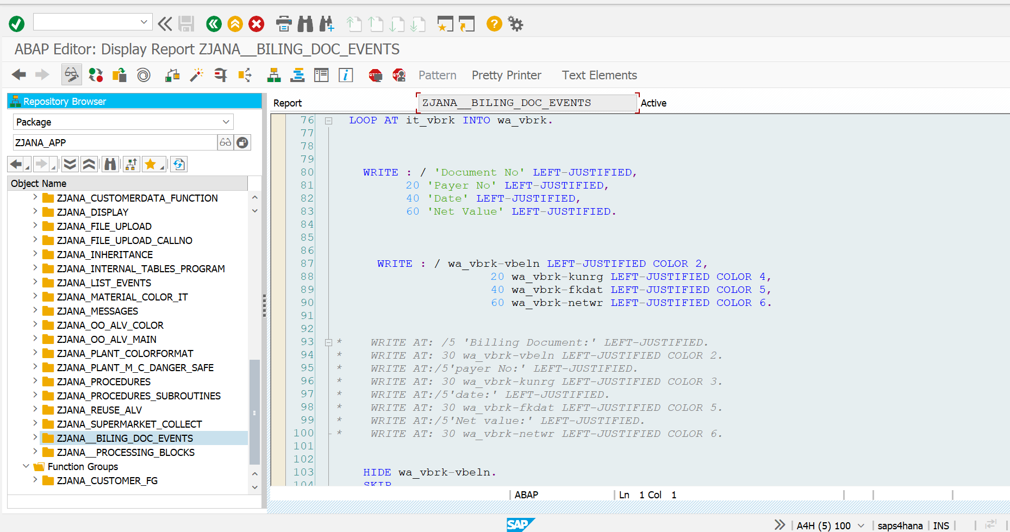

*\*&---------------------------------------------------------------------\**  
*\*& Report ZJANA__BILING_DOC_EVENTS*  
*\*&---------------------------------------------------------------------\**  
*\*&*  
*\*&---------------------------------------------------------------------\**  
*\*1.Find out to print the Footer if the page is Incompleted*  
*\**  
*\*2. Find out the how the AT line Selectiona and AT USER works.*  
*\**  
*\*33.Click on the Doc No then it has to show the Iteam Description.*  
*\**  
*\*4.Use all the Events in the single program and debug.*  
  
*"\*\*\*\*\*\*\*\*\*\*\*\*\*\*\*\*\*\*\*\*\*\*\*\*\*\*\*\*\*\*\*\*\*\*\*\*\*\*\*\*\*\*\*\*\*\*\*\*\*\*\*\*\*\*\*\*\*\*\*\*\*\*\*\*\*\*\*\*\*\*\*\*\*\*\*\*\*\*\**  
*\*1. Program Constructor Event*  
*\* LOAD-OF-PROGRAM*  
*\**  
*\**  
*\**  
*\*2. Reporting Events (Executable Type Program)*  
*\* INITIALIZATION*  
*\* START-OF-SELECTION*  
*\* END-OF-SELECTION*  
*\**  
*\**  
*\**  
*\*3. SELECTION SCREEN EVENTS*  
*\* AT SELECTION-SCREEN OUTPUT.*  
*\* AT SELECTION-SCREEN*  
*\* AT SELECTION-SCREEN ON field*  
*\* AT SELECTION-SCREEN ON block*  
*\* AT SELECTION-SCREEN ON HELP-REQUEST*  
*\* AT SELECTION-SCREEN ON VALUE-REQUEST*  
*\**  
*\**  
*\**  
*\*4.LIST EVENTS*  
*\* TOP-OF-PAGE*  
*\* END-OF-PAGE*  
*\* AT LINE-SELECTION*  
*\* AT USER-COMMAND*  
  
REPORT zjana__biling_doc_events LINE-COUNT 10(1).  
*" Data Objects*  
DATA : it_vbrk TYPE TABLE OF ZJANA_VBRk,  
 wa_vbrk LIKE LINE OF it_vbrk.  
DATA : it_vbrp TYPE TABLE OF zjana_vbrp,  
 wa_vbrp LIKE LINE OF it_vbrp.  
*"provide the selection screen for the user.*  
DATA p_vbeln TYPE zjana_vbrk-vbeln.  
SELECT-OPTIONS s_vbeln FOR p_vbeln.  
  
  
  
TYPES: BEGIN OF ty_makt,  
 matnr TYPE makt-matnr,  
 maktx TYPE makt-maktx,  
 END OF ty_makt.  
DATA: it_makt TYPE TABLE OF ty_makt,  
 wa_makt LIKE LINE OF it_makt.  
  
  
START-OF-SELECTION.  
 SELECT * FROM zjana_vbrk INTO TABLE it_vbrk WHERE vbeln IN s_vbeln.  
 SELECT * FROM zjana_vbrp INTO TABLE it_vbrp WHERE vbeln IN s_vbeln.  
  
  
END-OF-SELECTION.  
  
DATA : v_endPrint TYPE i VALUE 0.  
  
 SORT it_vbrp BY vbeln.  
  
  
  
 LOOP AT it_vbrk INTO wa_vbrk.  
  
  
  
 WRITE : / 'Document No' LEFT-JUSTIFIED,  
 20 'Payer No' LEFT-JUSTIFIED,  
 40 'Date' LEFT-JUSTIFIED,  
 60 'Net Value' LEFT-JUSTIFIED.  
  
  
  
 WRITE : / wa_vbrk-vbeln LEFT-JUSTIFIED COLOR 2,  
 20 wa_vbrk-kunrg LEFT-JUSTIFIED COLOR 4,  
 40 wa_vbrk-fkdat LEFT-JUSTIFIED COLOR 5,  
 60 wa_vbrk-netwr LEFT-JUSTIFIED COLOR 6.  
  
  
*\* WRITE AT: /5 'Billing Document:' LEFT-JUSTIFIED.*  
*\* WRITE AT: 30 wa_vbrk-vbeln LEFT-JUSTIFIED COLOR 2.*  
*\* WRITE AT:/5'payer No:' LEFT-JUSTIFIED.*  
*\* WRITE AT: 30 wa_vbrk-kunrg LEFT-JUSTIFIED COLOR 3.*  
*\* WRITE AT:/5'date:' LEFT-JUSTIFIED.*  
*\* WRITE AT: 30 wa_vbrk-fkdat LEFT-JUSTIFIED COLOR 5.*  
*\* WRITE AT:/5'Net value:' LEFT-JUSTIFIED.*  
*\* WRITE AT: 30 wa_vbrk-netwr LEFT-JUSTIFIED COLOR 6.*  
  
  
 HIDE wa_vbrk-vbeln.  
 SKIP.  
 CLEAR wa_vbrk.  
  
 ENDLOOP.  
 CLEAR wa_vbrk.  
  
 SKIP.  
  
AT LINE-SELECTION.  
 *"Read LINE sy-lilli.*  
 IF sy-subrc = 0.  
 SELECT * FROM zjana_vbrp INTO TABLE it_vbrp WHERE vbeln EQ wa_vbrk-vbeln.  
  
 WRITE AT:/5 'Item No',  
 20 'Material No',  
 40 'Qunatity',  
 60 'UOM',  
 80 'Net Value'.  
 LOOP AT it_vbrp INTO wa_vbrp.  
  
 WRITE AT:/5 wa_vbrp-posnr LEFT-JUSTIFIED,  
 20 wa_vbrp-matnr LEFT-JUSTIFIED,  
 40 wa_vbrp-fkimg LEFT-JUSTIFIED,  
 60 wa_vbrp-vrkme LEFT-JUSTIFIED,  
 80 wa_vbrp-netwr LEFT-JUSTIFIED.  
 AT END OF vbeln.  
 SUM.  
 WRITE: /60 'TOTAL NET VALUE:', wa_vbrp-netwr LEFT-JUSTIFIED COLOR 7.  
 ENDAT.  
 AT LAST.  
 *" the code here will be excuted in the last loop pass*  
 WRITE: /'END OF REPORT'.  
 ENDAT.  
  
 *"WRITE: sy-linct, sy-linno.*  
 ENDLOOP.  
  
  
 ENDIF.  
  
TOP-OF-PAGE.  
 WRITE 'UST GLOBAL'.  
 ULINE.  
  
RESERVE v_endPrint lines.  
  
  
END-OF-PAGE.  
  
 *"RESERVE 10 Lines.*  
 WRITE /'this is electronic genereated'.  
 ULINE.  
  
AT USER-COMMAND.  
 CASE sy-ucomm.  
 WHEN 'PDF'.  
 WHEN 'EXCEL'.  
  
 WHEN OTHERS.  
 ENDCASE.  
  
  
  
  
 *"output the data*  
 SET PF-STATUS 'LIST'.

