TravelMemory – AWS Deployment Evidence
Editable report built from screenshots actually uploaded in this conversation
Evidence note: All images in this report are original screenshots supplied by you. They have not been recreated as mockups. Image resolution is limited by the uploaded copies available in this conversation.

1. Project summary
TravelMemory is the MERN-stack application discussed in this deployment work. The AWS setup included frontend and backend EC2 instances, Application Load Balancers, target groups, security groups, and a MongoDB Atlas database.
AWS region recorded in the project discussion: US East (N. Virginia), us-east-1.

2. Resource inventory
Role | Instance name | Instance ID | Recorded private IP
Frontend | frontend-master3 | i-0e1e9d882b83025c6 | 172.31.28.50
Backend | backend-master2 | i-09d31dbea45a9ce09 | 172.31.42.142
Backend | backend-2 | i-0eca7791e1a3a9cd7 | 172.31.32.170
Recorded load balancer/target group names: travelmemory-frontend-alb, travelmemory-frontend-tg, travelmemory-backend-alb, travelmemory-backend-tg. Backend target port: 3001.

3. Actual screenshots
The following pages contain the original screenshots selected from the uploaded material. Captions describe the visible area at a high level and do not claim a resource is healthy unless that is clearly shown.

Screenshot 01: TravelMemory browser application showing trip cards
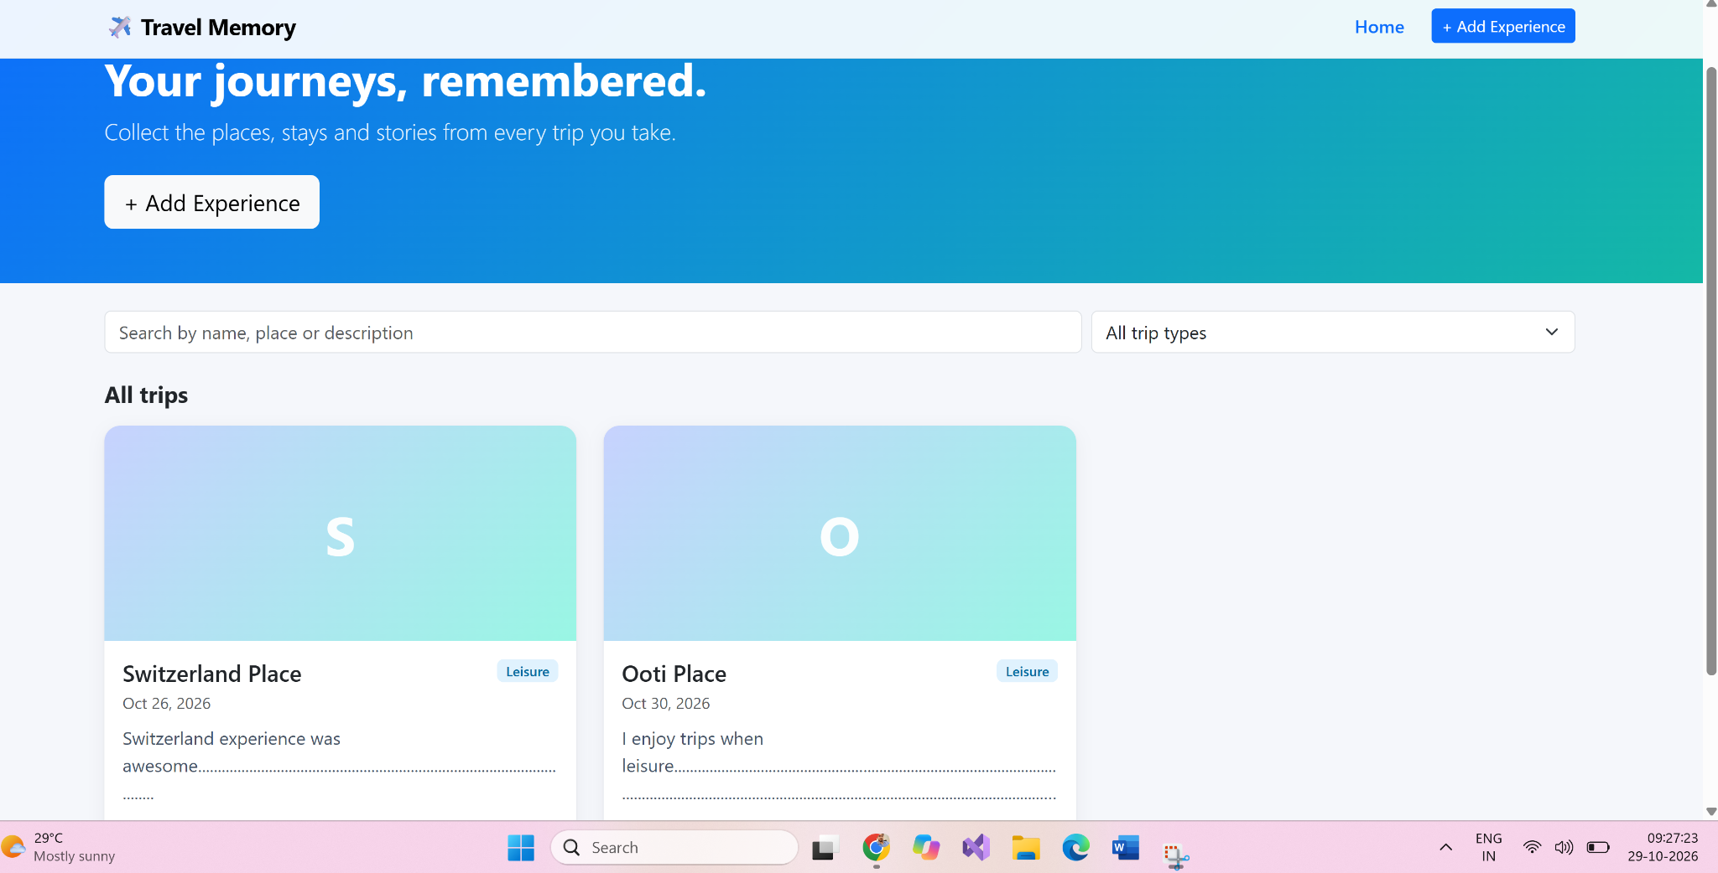
Original uploaded file: 01_image(20261029-035739).png

Screenshot 02: Backend terminal showing MongoDB connection and server startup
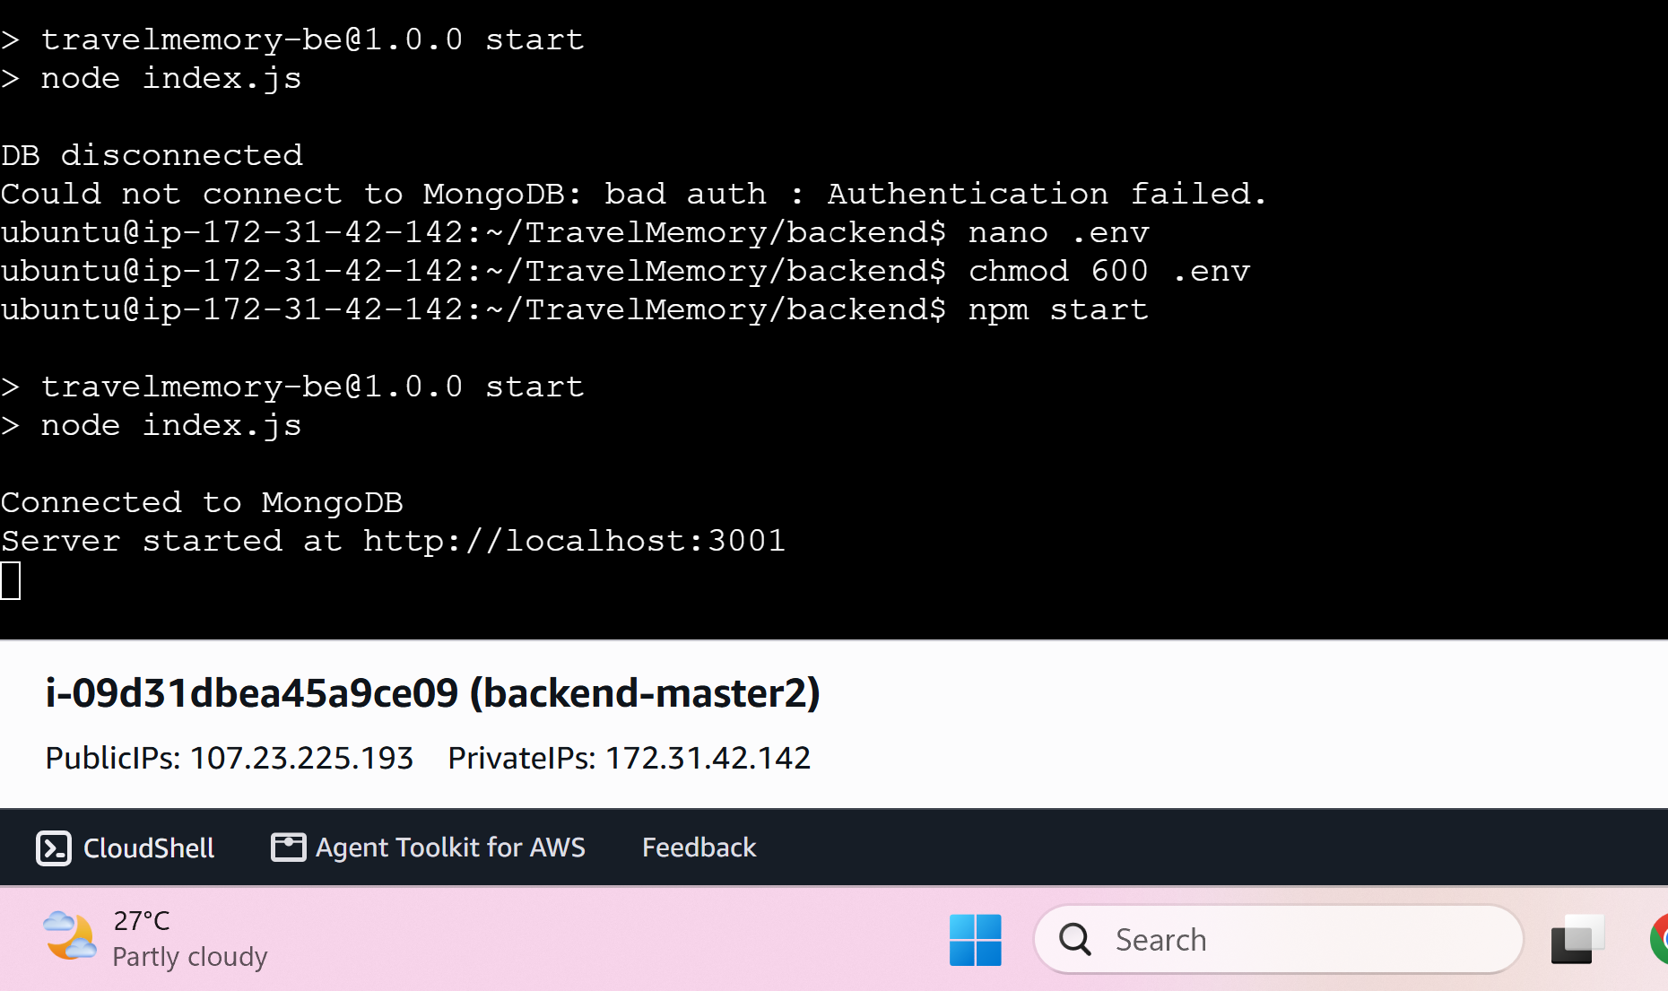
Original uploaded file: 02_image(20261027-205454).png

Screenshot 03: AWS EC2 Load Balancers console listing
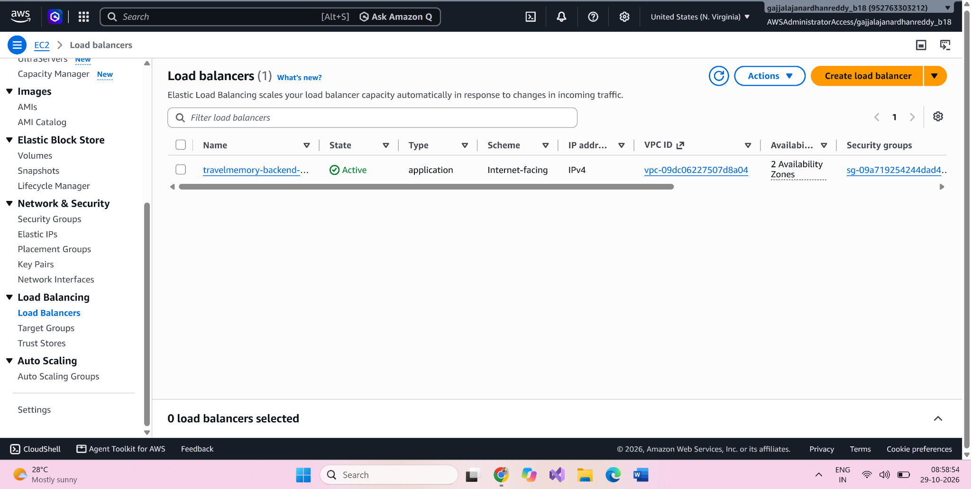
Original uploaded file: 03_image(20261029-032912).png

Screenshot 04: AWS security group inbound rules
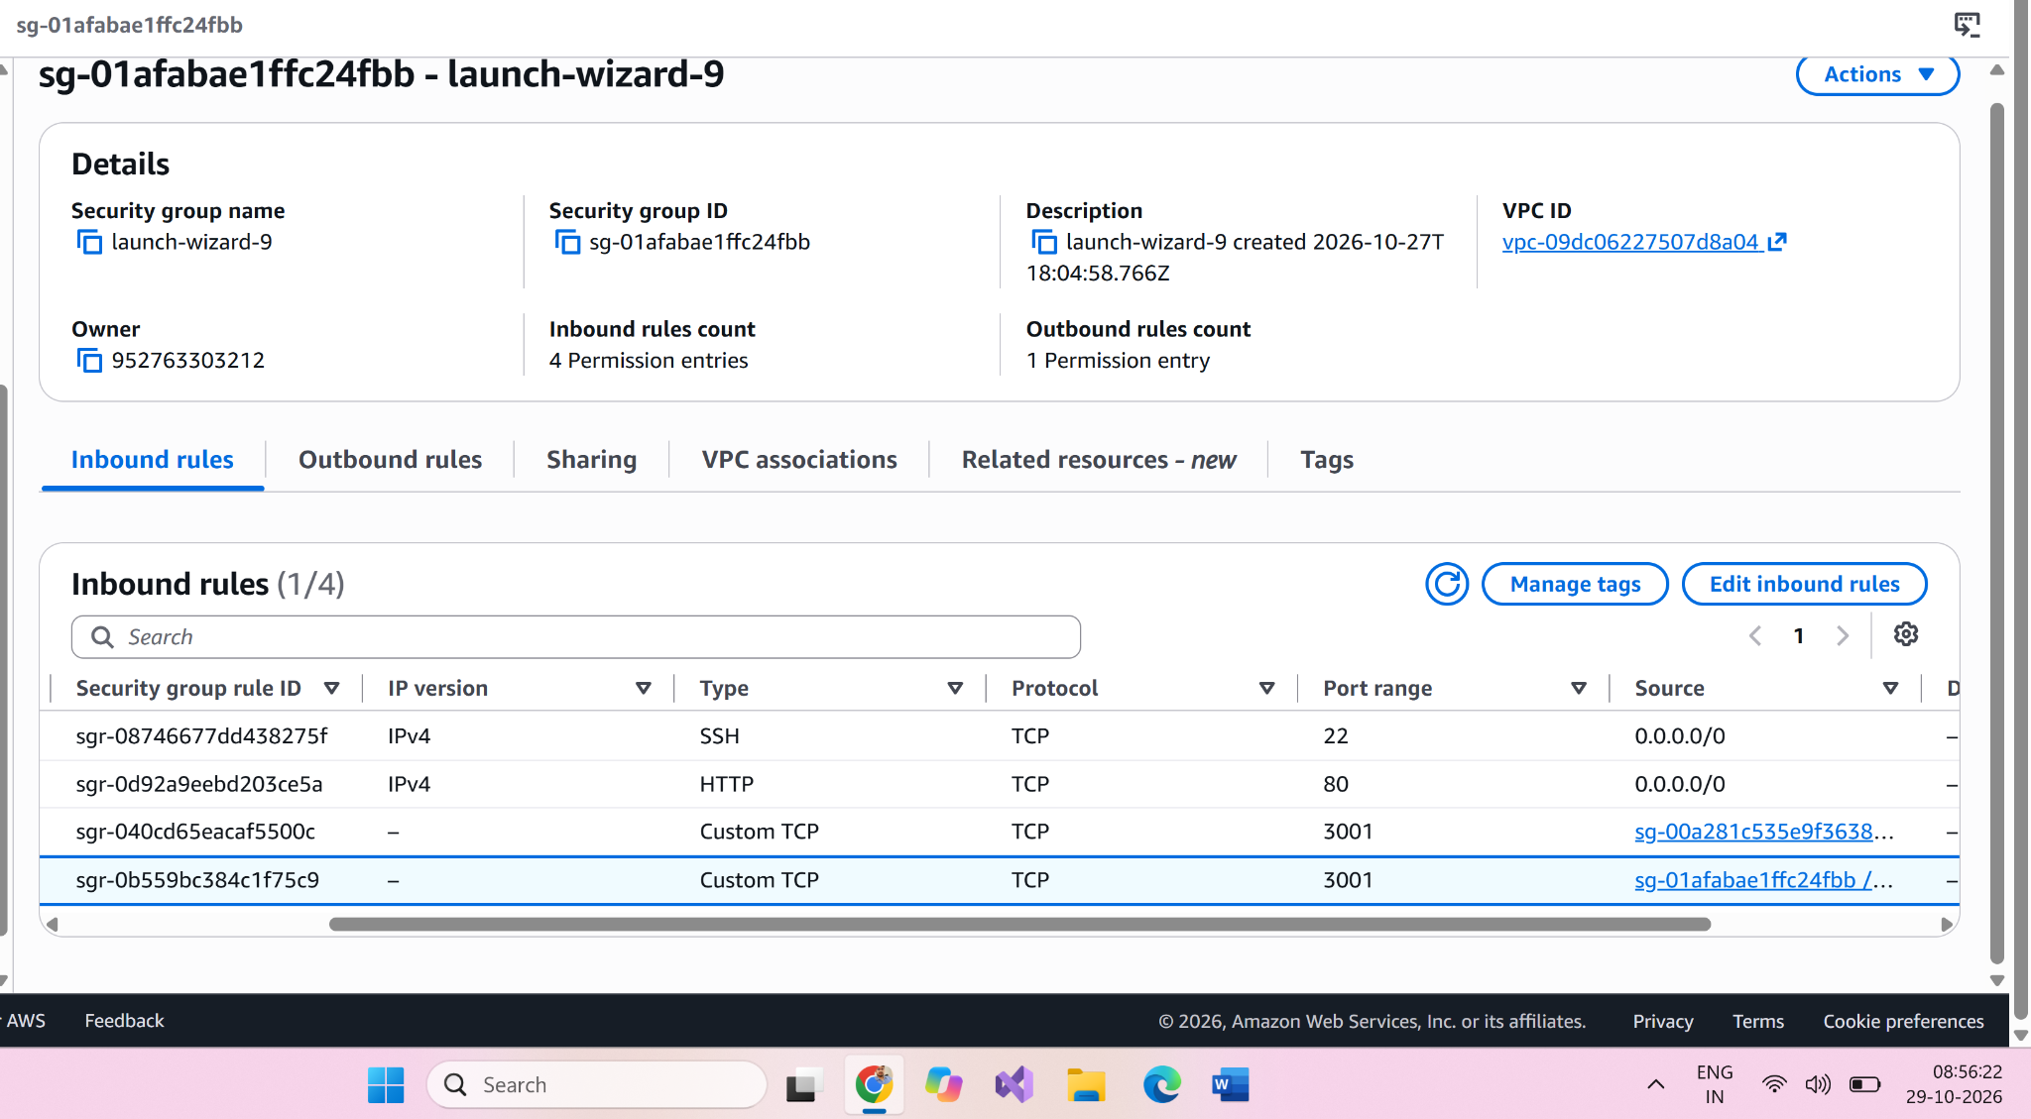
Original uploaded file: 04_image(20261029-032644).png

Screenshot 05: AWS security groups console
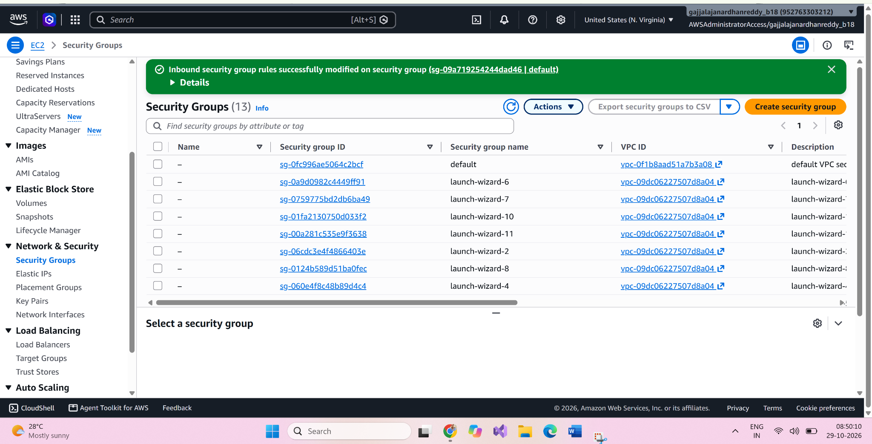
Original uploaded file: 05_image(20261029-032021).png

Screenshot 06: AWS console project/dashboard view
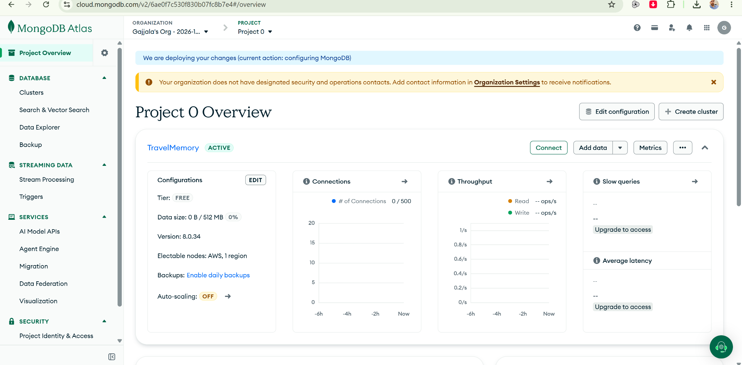
Original uploaded file: 06_image(5).png

Screenshot 07: AWS load balancer or target group configuration view
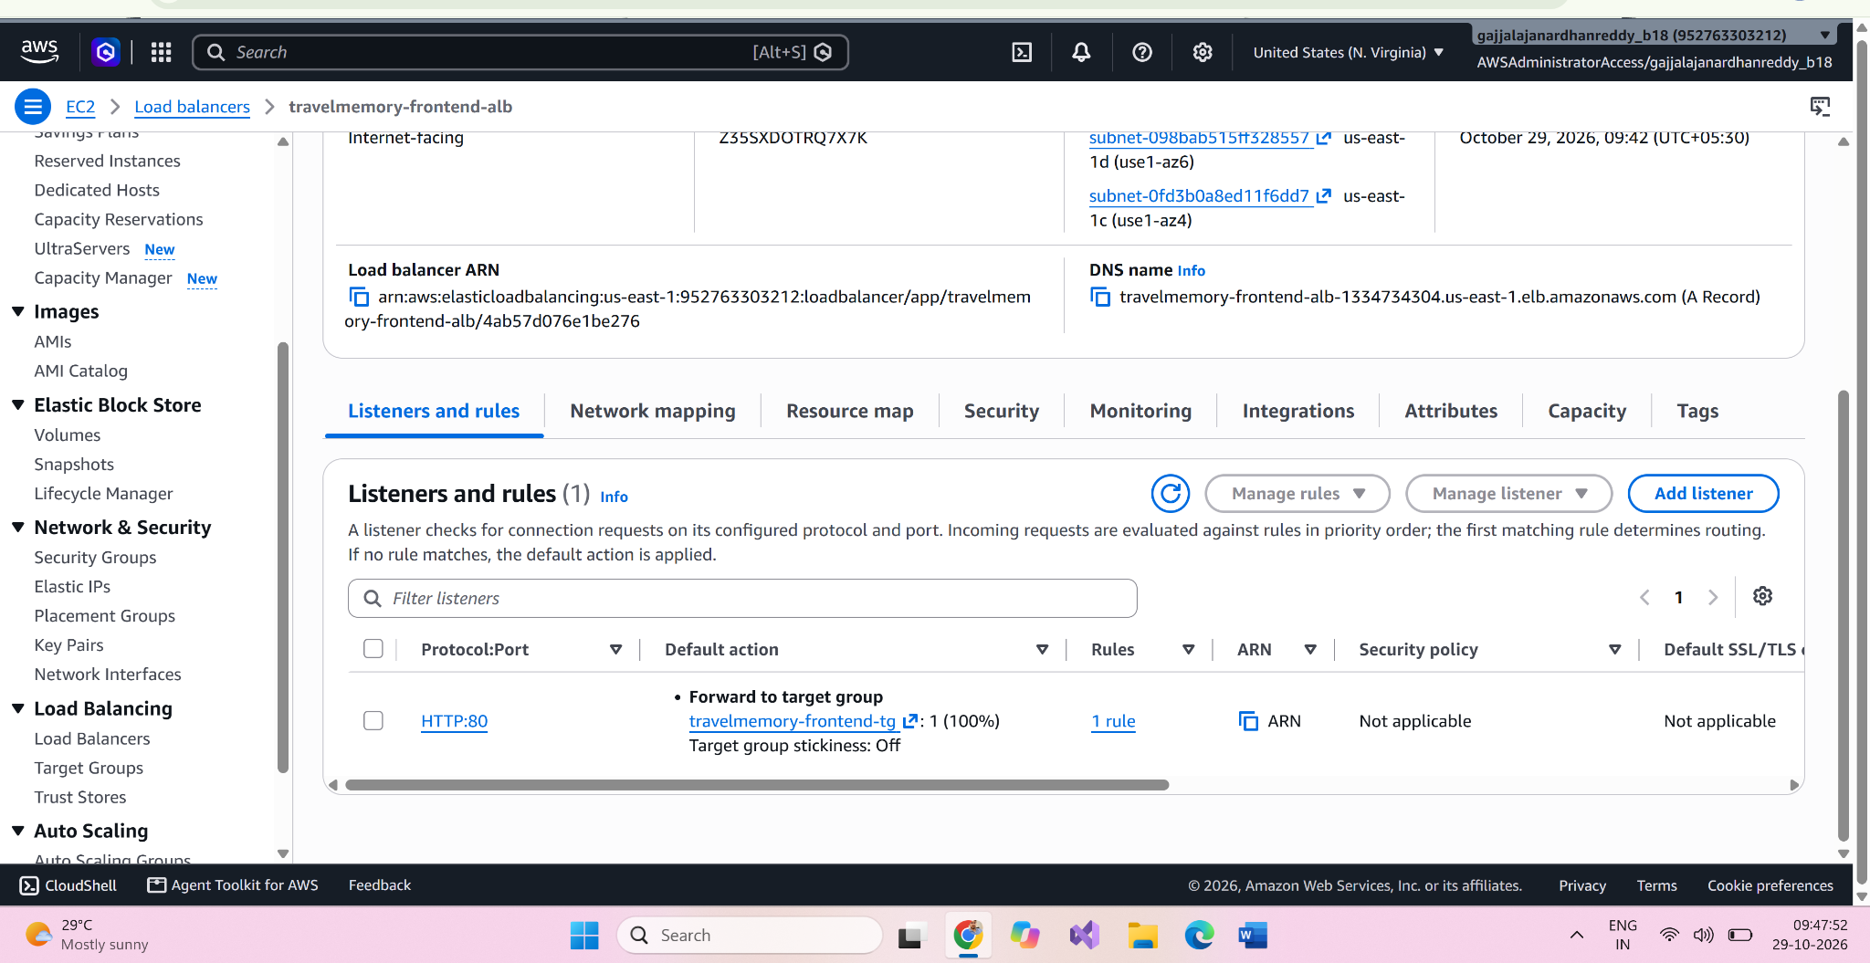
Original uploaded file: 07_image(20261029-041813).png

Screenshot 08: AWS load balancer or target group configuration view
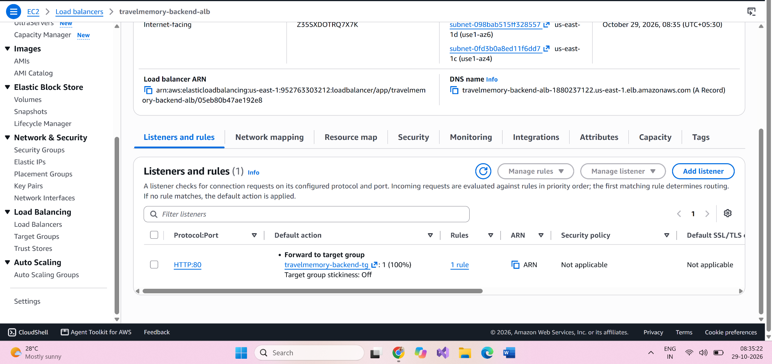
Original uploaded file: 08_image(20261029-030533).png

Screenshot 09: AWS launch template configuration
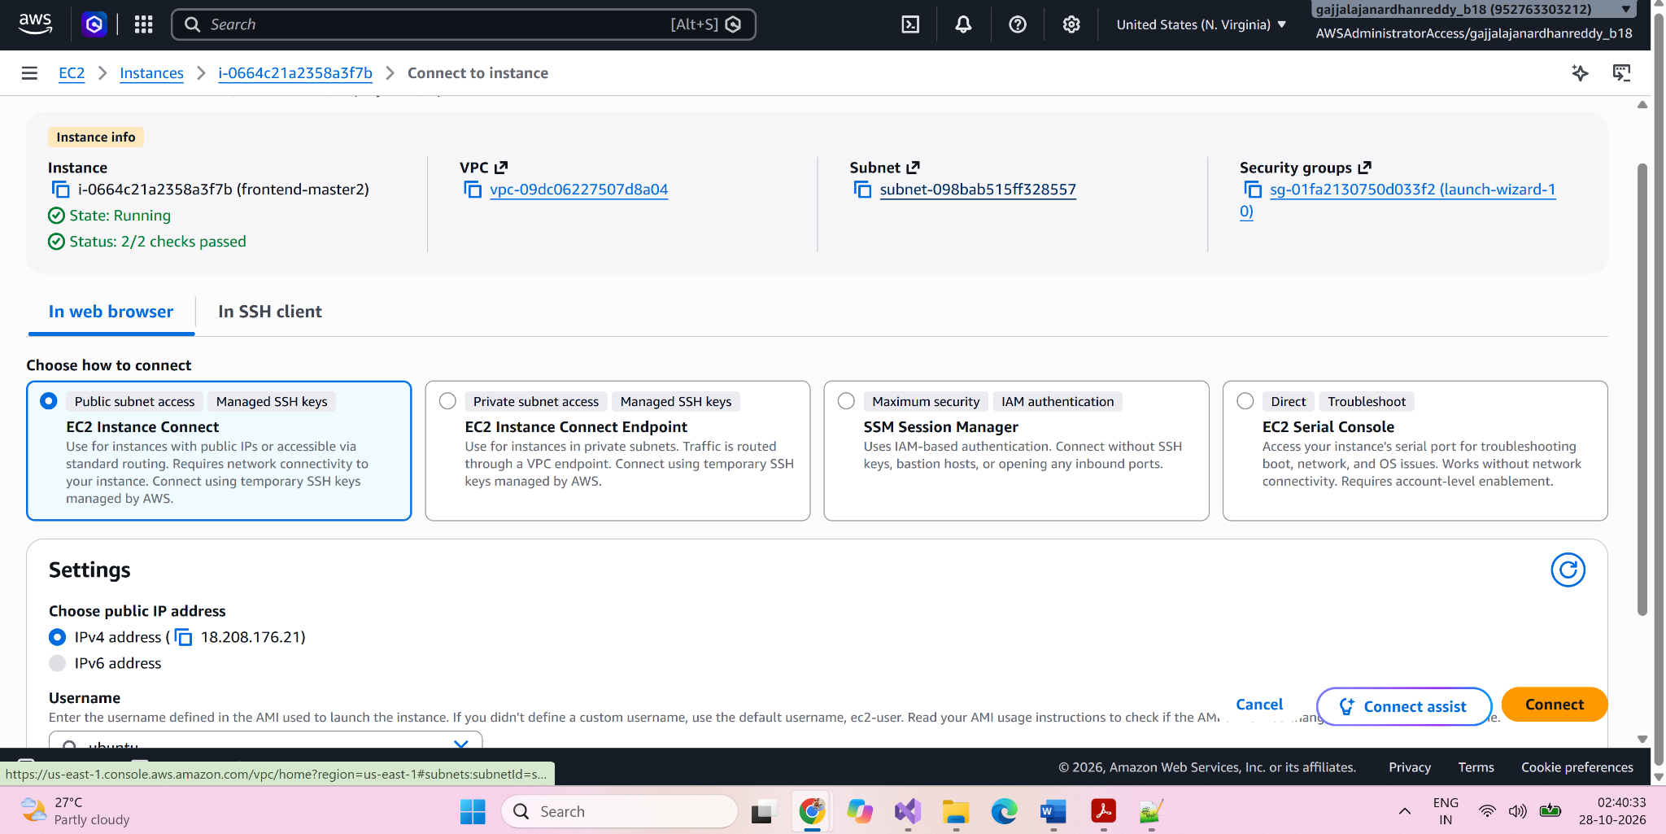
Original uploaded file: 09_image(20261027-211050).png

Screenshot 10: AWS monitoring metrics view
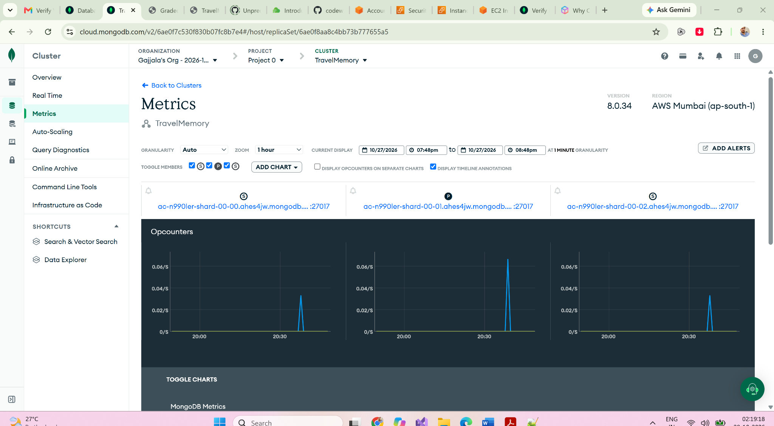
Original uploaded file: 10_image(20261027-204930).png

Screenshot 11: AWS resource configuration view
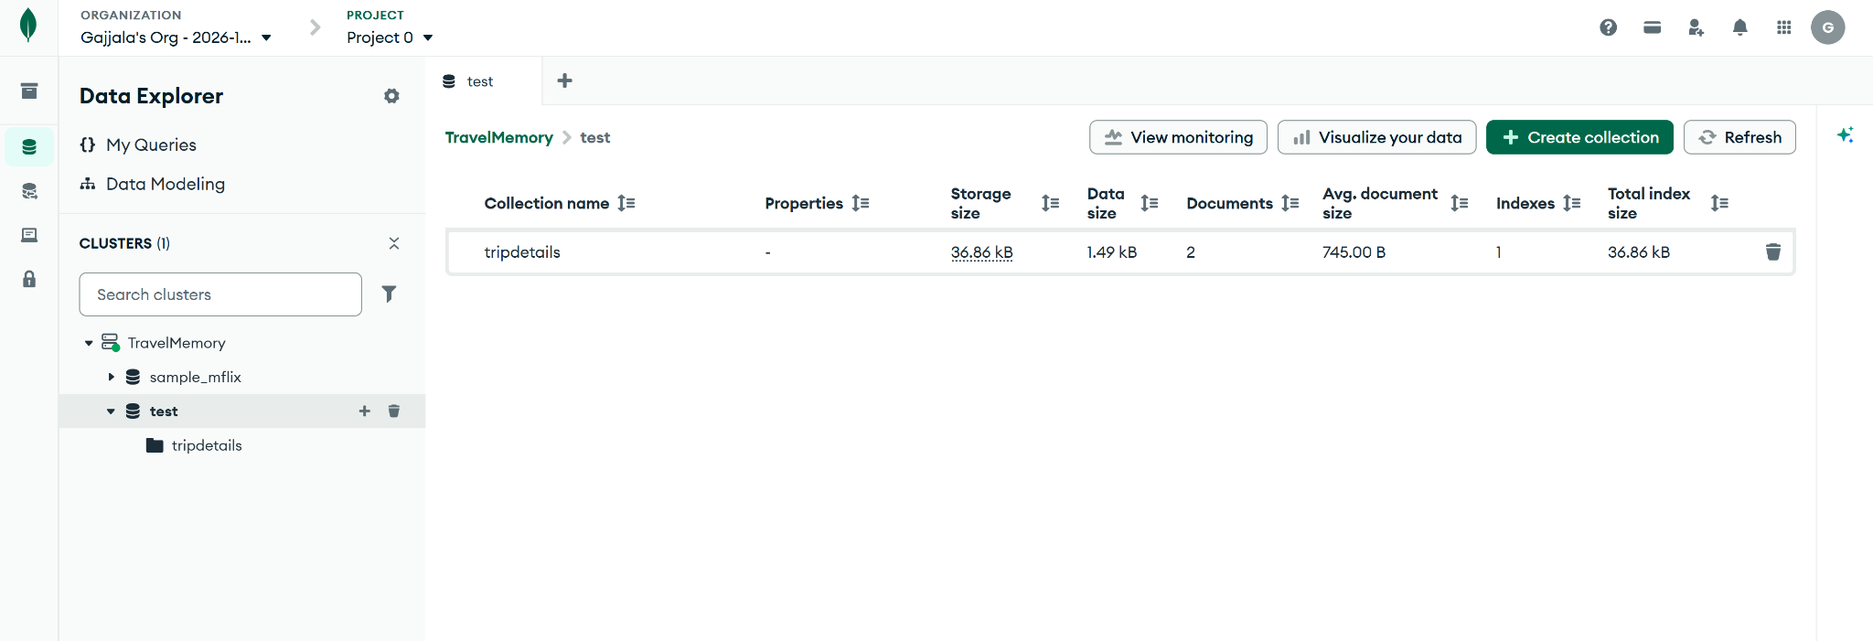
Original uploaded file: 11_image(20261029-050615).png

Screenshot 12: AWS networking route configuration view
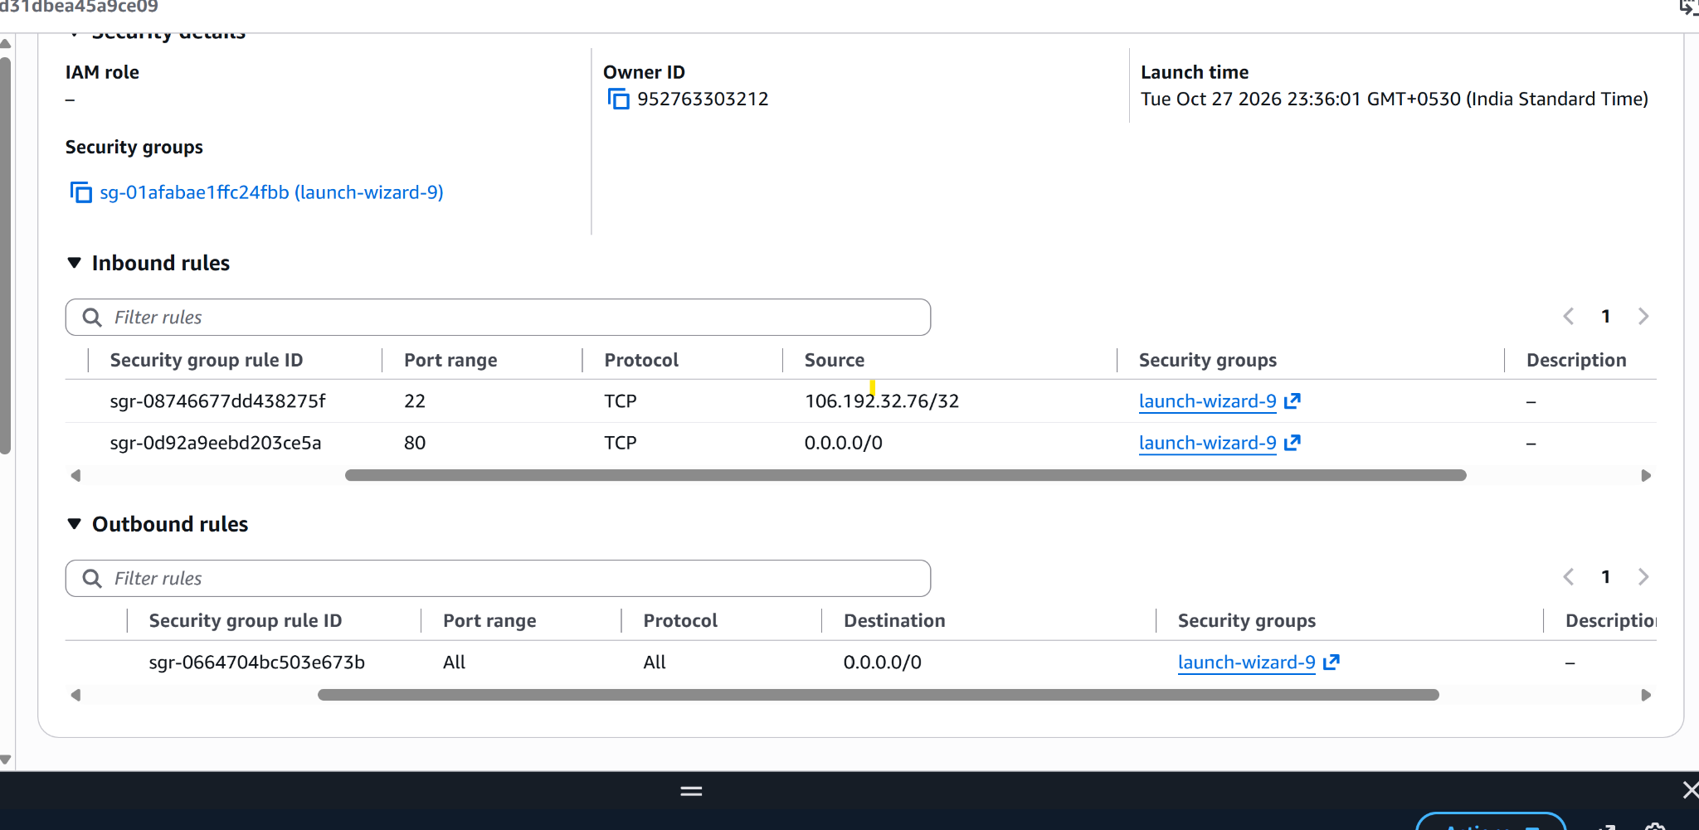
Original uploaded file: 12_image(1).png

4. Validation and handover checklist
- Verify both backend EC2 instances are running.
- Run systemctl status travelmemory-backend on each backend.
- Run curl -i http://localhost:3001/trip on each backend and confirm HTTP 200.
- Confirm current backend egress IP addresses are allowed in MongoDB Atlas Network Access.
- Confirm both backend targets are healthy in travelmemory-backend-tg.
- Confirm the frontend target is healthy in travelmemory-frontend-tg.
- Open the frontend ALB DNS name and verify the live TravelMemory application.
- Added fresh, full-resolution screenshots of the final healthy target groups and working.

