RR Peer Assessment 1

Jana

Wednesday, November 11, 2015

library("ggplot2")

## Warning: package 'ggplot2' was built under R version 3.1.3

data <- read.table('activity.csv',sep = ",",header = TRUE, na.strings ="NA",  
 colClasses = c('integer','Date','factor'))  
new.data <- na.omit(data)  
total.steps <- tapply(new.data$steps, new.data$date, FUN = sum)  
plot1 <- ggplot(new.data, aes(date, steps)) + geom_bar(stat = "identity",binwidth = .5) +  
 labs(title = "Histogram of Total Number of Steps Taken Each Day",x = "Date", y = "Total Number of Steps")  
print(plot1)

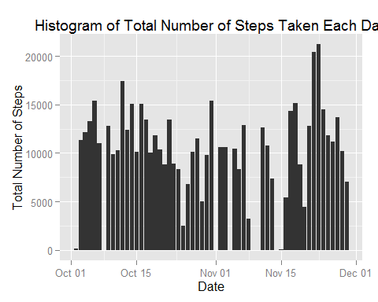

mean(total.steps)

## [1] 10766.19

median(total.steps)

## [1] 10765

averages <- aggregate(new.data$steps, list(interval = as.numeric(as.character(new.data$interval))), FUN = "mean")  
names(averages)[2] <- "Avg.Steps"  
  
plot2 <- ggplot(averages, aes(interval, Avg.Steps)) + geom_line(color = "green", size = 0.7) + labs(title = "Time Series Plot of the 5-minute Intervals", x = "5-minute intervals", y = "Average Number of Steps Taken")  
print(plot2)

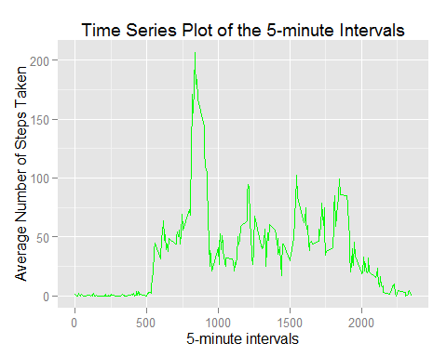

averages[averages$Avg.Steps == max(averages$Avg.Steps),]

## interval Avg.Steps  
## 104 835 206.1698

sum(!complete.cases(data))

## [1] 2304

impData <- data   
for (i in 1:nrow(impData)) {  
 if (is.na(impData$steps[i])) {  
 impData$steps[i] <- averages[which(impData$interval[i] == averages$interval), ]$Avg.Steps  
 }  
}  
sum(!complete.cases(impData))

## [1] 0

plot3 <- ggplot(impData, aes(date, steps)) + geom_bar(stat = "identity",binwidth = .5) +  
 labs(title = "Histogram of Total Number of Steps Taken Each Day (Imputed Data)",x = "Date", y = "Total Number of Steps")  
print(plot3)

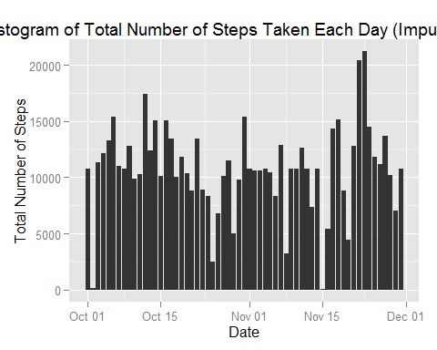

total.steps.impute <- tapply(impData$steps, impData$date, FUN = sum)  
mean(total.steps.impute)

## [1] 10766.19

median(total.steps.impute)

## [1] 10766.19

impData$weekdays <- factor(format(impData$date, "%A"))  
levels(impData$weekdays)

## [1] "Friday" "Monday" "Saturday" "Sunday" "Thursday" "Tuesday"   
## [7] "Wednesday"

levels(impData$weekdays) <- list(weekday = c("Monday", "Tuesday",  
 "Wednesday",   
 "Thursday", "Friday"),  
 weekend = c("Saturday", "Sunday"))  
levels(impData$weekdays)

## [1] "weekday" "weekend"

table(impData$weekdays)

##   
## weekday weekend   
## 12960 4608

new.averages <- aggregate(impData$steps,   
 list(interval = as.numeric(as.character(impData$interval)),   
 weekdays = impData$weekdays),  
 FUN = "mean")  
names(new.averages)[3] <- "meanOfSteps"  
library(lattice)

## Warning: package 'lattice' was built under R version 3.1.3

plot4 <- xyplot(new.averages$meanOfSteps ~ new.averages$interval | new.averages$weekdays,   
 layout = c(1, 2), type = "l",   
 xlab = "Interval", ylab = "Number of steps")  
print(plot4)

