PROJECT REPORT
CAMPUS FEES MANAGEMENT SYSTEM
Submitted in partial fulfillment for the requirement
[UNIVERSITY NAME]
For the award of the degree
[DEGREE NAME]
Submitted by
Name: [Your Name] Register No: [Register Number]
Under the guidance of
[Guide Name], [Guide Qualification]
[Designation], Department of [Department Name]
DEPARTMENT OF [DEPARTMENT NAME]
[COLLEGE NAME]
(Affiliated to [UNIVERSITY NAME])
[College Address]
[MONTH YEAR]

[COLLEGE NAME]
[College Address]
DEPARTMENT OF [DEPARTMENT NAME]

BONAFIDE CERTIFICATE
This is to certify that the project titled "CAMPUS FEES MANAGEMENT SYSTEM" is a bonafide work done by [Your Name] ([Register Number]) and submitted to the Department of [Department Name], [College Name], in partial fulfillment of the requirements for the award of the degree of [Degree Name] under [University Name].
[Guide Name] [HOD Name]
Guide, Department of [Department Name] Head of the Department
Submitted for the Viva-Voce Examination held on ______________
Internal Examiner External Examiner

ACKNOWLEDGEMENT
First and foremost, I thank the Almighty for the blessings, health, and strength that made it possible for me to complete this project successfully.
I express my sincere gratitude to our honourable Principal, [Principal Name], [College Name], for the kind encouragement given to undertake this project.
I am deeply thankful to [HOD Name], Head of the Department of [Department Name], for the valuable support extended throughout the completion of this project.
I wish to express my heartfelt thanks to my guide, [Guide Name], [Department Name], for the valuable guidance, suggestions, and constant encouragement given at every stage of this project.
I am grateful to [College Name] for granting permission to carry out this project.
Last but not the least, I would like to thank my parents and friends for their constant support and encouragement.
[Your Name]

CONTENTS

CHAPTER I: INTRODUCTION ABOUT THE PROJECT

1.1 Campus Fees Management System
A Campus Fees Management System is a web-based application that helps an educational institution record, track, and manage student fee payments in a structured and secure manner. It replaces manual registers and spreadsheets with a centralised digital system accessible to administrators, teachers, and students through role-based logins.

1.2 Definition of Campus Fees Management System
The Campus Fees Management System developed in this project is a full-stack web application built using React on the frontend and Node.js with Express and MongoDB on the backend. It allows an Administrator to create student and teacher accounts and manage fee records, allows a Teacher to view the fee status of students in their assigned department, and allows a Student to log in and view their own fee status, dues, and downloadable fee reports.

1.3 Objective
- To maintain accurate, centralised records of student fee dues and payments.
- To provide role-based access so that Admins, Teachers, and Students each see only what is relevant to them.
- To secure student and staff login credentials using password hashing and token-based authentication.
- To reduce the manual effort and errors involved in paper-based or spreadsheet-based fee tracking.
- To let students independently check their fee status and download a PDF report at any time.

1.4 Project Description
The system is built on a MERN-style stack: a React (Vite) single-page application styled with Tailwind CSS on the client side, and a Node.js/Express REST API backed by MongoDB (via Mongoose) on the server side. Authentication is implemented using JSON Web Tokens (JWT), and passwords are stored only as bcrypt hashes, never in plain text.
Three roles are supported. The Admin can add students and teachers (each with their own login), browse students by course, add and update fee records, and manage the overall system. The Teacher can log in and view the fee status of students belonging to their own assigned department only. The Student can log in with a login ID, view their profile and fee overview, and download a PDF fee report generated on the server using PDFKit.

CHAPTER II: SYSTEM ANALYSIS

2.1 Existing System
In most small institutions, student fee records are maintained manually in registers or in disconnected spreadsheet files. Every fee collection, due date, or concession has to be recorded and cross-checked by hand. This existing approach has several drawbacks:
- Fee records are scattered across registers or files kept by different staff members.
- There is no easy way for a student to check their own due amount without visiting the office.
- Manual entry is error-prone and time-consuming, especially during admission or exam season.
- There is no built-in security — anyone with physical or file access can view or alter records.
- Generating a consolidated report (e.g., pending dues by department) requires manual aggregation.

2.2 Proposed System
The proposed Campus Fees Management System digitises this entire workflow. It stores every student, teacher, and fee record in a single MongoDB database accessed only through an authenticated REST API. Advantages of the proposed system include:
- A single source of truth for student, teacher, and fee data.
- Role-based dashboards — Admin, Teacher, and Student each see only the data relevant to them.
- Secure login with hashed passwords and JWT-based session tokens with a 7-day expiry.
- Instant, self-service visibility for students into their own dues, without depending on office hours.
- One-click PDF fee reports and invoices generated directly by the server.
- A responsive interface that works on both desktop and mobile browsers.

2.3 System Requirements
Functional Requirements:
- Admin can create, list, update, and delete student records, and create and list teacher records.
- Admin can add fee records against a student and mark fees as paid.
- Teacher can view fee records for students in their own department only.
- Student can log in, view their profile overview, view fee status, and download a PDF report.
- The system must authenticate every protected request and reject an incorrect or expired token.
Non-Functional Requirements:
- Security — passwords hashed with bcrypt; protected routes verified via JWT middleware.
- Usability — a clean, responsive UI built with React and Tailwind CSS.
- Maintainability — a modular Express route structure separated by resource (auth, students, teachers, fees).
- Portability — runs on any machine with Node.js and MongoDB installed, locally or on a cloud host.

CHAPTER III: SYSTEM REQUIREMENT SPECIFICATION

3.1 Hardware Specification
Component | Minimum Requirement
Processor | Dual-core 2 GHz or above
RAM | 4 GB (8 GB recommended)
Hard Disk | 500 MB free space for the application and dependencies
Display | 1024 x 768 resolution or higher
Network | Internet/Intranet connection to reach the MongoDB server

3.2 Software Specification
Component | Specification
Operating System | Windows / Linux / macOS
Runtime | Node.js (v18 or later)
Database | MongoDB (local instance or MongoDB Atlas)
Frontend Build Tool | Vite
Browser | Any modern browser — Chrome, Firefox, Edge

3.3 About the Software
The project depends on the following key packages, as declared in the project's own package.json files:
Backend Package | Purpose
express | Minimal HTTP server framework used to expose the REST API.
mongoose | Object Data Modelling (ODM) library used to define schemas and talk to MongoDB.
mongodb | Official MongoDB driver used underneath Mongoose.
jsonwebtoken | Creates and verifies the JWT access tokens issued at login.
bcryptjs | Hashes user passwords before they are stored, and verifies them at login.
cors | Enables cross-origin requests from the React frontend to the API.
dotenv | Loads configuration (Mongo URL, JWT secret, admin credentials) from a .env file.
pdfkit | Generates the downloadable PDF fee/invoice reports on the server.

Frontend Package | Purpose
react / react-dom | Core UI library used to build the single-page application.
react-router-dom | Client-side routing between login, admin, teacher, and student views.
axios | HTTP client used to call the backend REST API.
lucide-react | Icon set used throughout the interface (role icons, eye-toggle, logout, etc.).
tailwindcss | Utility-first CSS framework used for all styling.
vite | Development server and production bundler for the React app.

CHAPTER IV: SYSTEM DESIGN

4.1 Architectural Diagram
The application follows a three-layer architecture: a React client layer, a Node.js/Express API layer guarded by JWT authentication middleware, and a MongoDB data layer accessed through Mongoose models.
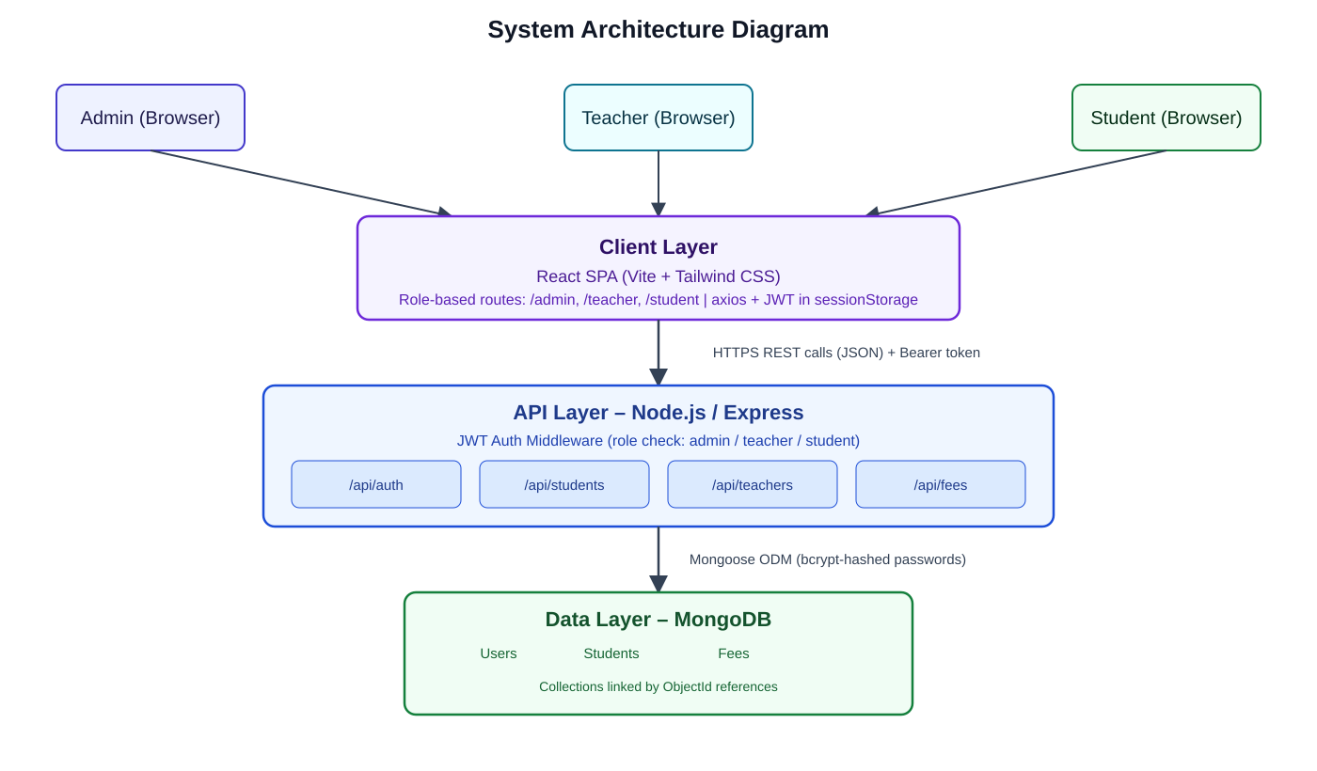
Fig 4.1: System Architecture Diagram

4.2 Data Flow Diagram
The Level-1 Data Flow Diagram below shows how Admin, Teacher, and Student actors interact with the system's core processes, and how each process reads from or writes to the Users, Students, and Fees data stores.
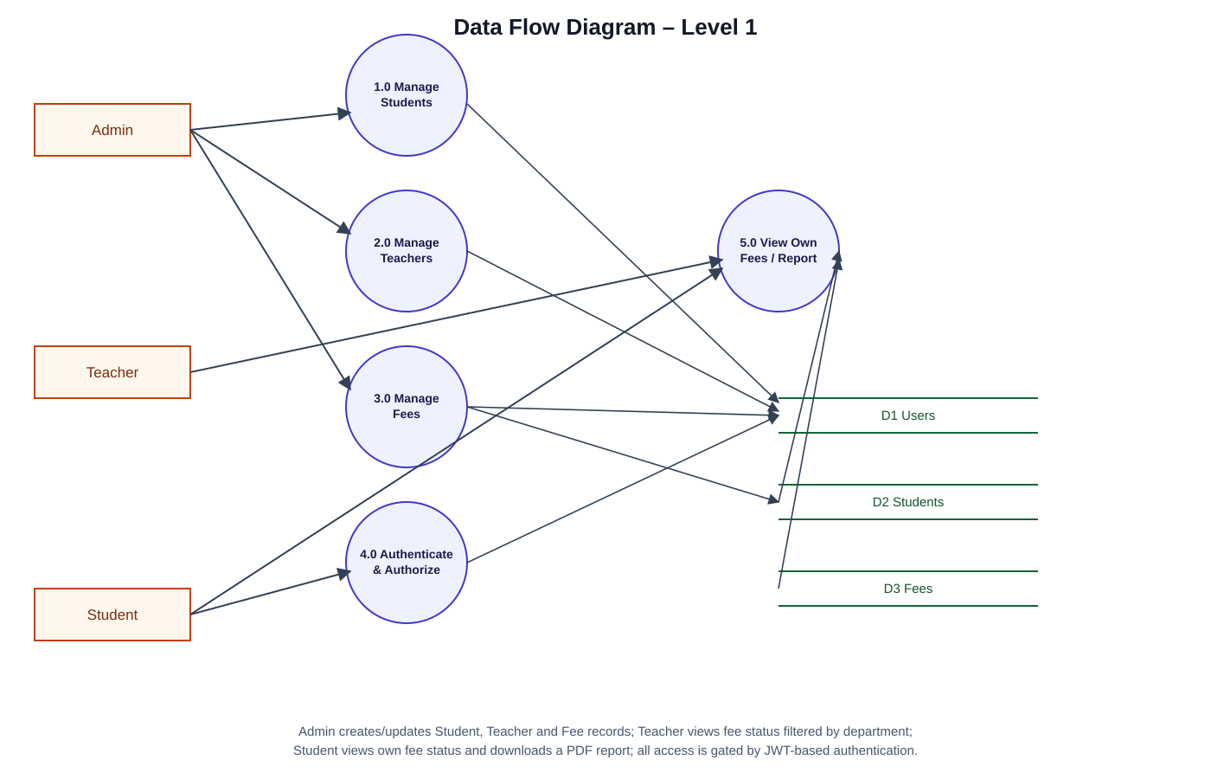
Fig 4.2: Data Flow Diagram (Level 1)

4.3 ER Diagram
The Entity-Relationship Diagram below is derived directly from the three Mongoose schemas used in the backend (User, Student, and Fee). A User with role "student" is linked one-to-one with a Student profile; a Student can have many Fee records.
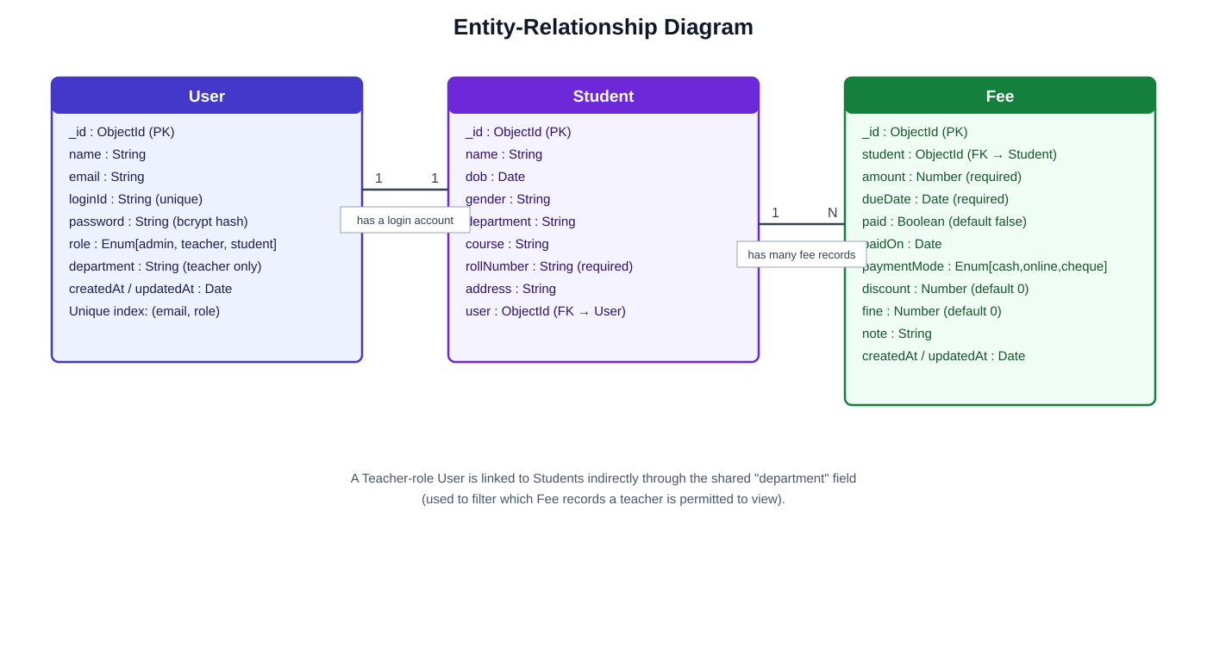
Fig 4.3: Entity-Relationship Diagram

4.4 Project Specification
The application is organised into the following functional modules/pages:
- Login — single page with Admin / Teacher / Student tabs, role-aware fields, and a show/hide password toggle.
- Admin Dashboard — summary cards (total students, pending fees, amount collected) and quick links.
- Admin — Add Student — creates a student record together with a student login (Login ID + password).
- Admin — Students List — students grouped by course, with search by name or roll number.
- Admin — Add Teacher — creates a teacher login and assigns the department they can view fees for.
- Admin — Student Profile (Overview / Fees / Report) — drill-down into one student's details, fee list, and PDF report.
- Teacher — Fees — fee status table filtered to the teacher's own assigned department.
- Student — Overview / Fees / Report — the student's own read-only profile, fee status, and PDF report download.

4.5 Table Design
Table: User
Field Name | Type | Description
_id | ObjectId | Primary key, auto-generated by MongoDB.
name | String | Full name of the admin, teacher, or student.
email | String | Login email — used by Admin and Teacher roles.
loginId | String (unique) | Login identifier used by Student role.
password | String | bcrypt-hashed password (never stored as plain text).
role | Enum | One of: admin, teacher, student.
department | String | Department assigned to a teacher account (teacher role only).
createdAt / updatedAt | Date | Automatic timestamps.

Table: Student
Field Name | Type | Description
_id | ObjectId | Primary key, auto-generated by MongoDB.
name | String | Student's full name.
dob | Date | Date of birth.
gender | String | Gender of the student.
department | String | Department the student belongs to.
course | String | Course/programme the student is enrolled in.
rollNumber | String | Required unique roll number used for lookup/search.
address | String | Residential address.
user | ObjectId (ref: User) | Link to the student's own login account.
createdAt / updatedAt | Date | Automatic timestamps.

Table: Fee
Field Name | Type | Description
_id | ObjectId | Primary key, auto-generated by MongoDB.
student | ObjectId (ref: Student) | The student this fee record belongs to.
amount | Number | Fee amount due.
dueDate | Date | Date by which the fee is due.
paid | Boolean | Whether the fee has been paid (default false).
paidOn | Date | Date the fee was marked paid.
paymentMode | Enum | One of: cash, online, cheque (default cash).
discount | Number | Scholarship/concession amount (default 0).
fine | Number | Late-payment fine amount (default 0).
note | String | Optional free-text note.
createdAt / updatedAt | Date | Automatic timestamps.

CHAPTER V: TESTING AND MAINTENANCE

5.1 Testing
Testing was carried out manually at each stage of development to verify that every role-specific flow behaved correctly end-to-end — from the login screen down to the underlying API response and database state. Each new feature (for example, the password show/hide toggle, or the fixed sidebar layout) was checked in the browser after being built, and the production build was run to catch any compile-time errors before considering a change complete.

5.2 Type of Testing
- Unit-level checks — verifying individual pieces such as password hashing, JWT signing/verification, and Mongoose schema validation behave as expected.
- Integration testing — verifying that a full request (e.g. POST /api/students) correctly creates both a Student document and its linked User login document.
- Manual / User Acceptance Testing (UAT) — walking through each role's screens (Admin, Teacher, Student) in the browser to confirm the UI matches the intended behaviour.
- Regression checks — re-running the production build (vite build) after every change to catch broken imports or syntax errors early.
- Security testing — confirming that protected API routes reject requests without a valid JWT, and that a Teacher cannot view another department's fee records.

CHAPTER VI: SAMPLE INPUT / OUTPUT
This chapter presents representative input screens (the Add Student and Add Teacher forms, shown fully in Chapter VII) together with real source code excerpts that implement the core logic behind the system's most important flows: default admin bootstrap, authentication, protected-route authorisation, student creation, and the password show/hide control on the client.

6. Sample Source Code
backend/server.js — creates a default Admin user on server startup if one does not already exist
async function createDefaultAdmin() {
const email = process.env.ADMIN_EMAIL || "admin@1.com";
const password = process.env.ADMIN_PASSWORD || "123456";

const adminExists = await User.findOne({ email, role: "admin" });

if (!adminExists) {
const hashed = await bcrypt.hash(password, 10);
await User.create({
name: "School Principal",
email,
password: hashed,
role: "admin"
});
console.log("Default Admin Created");
}
}

backend/middleware/auth.js — verifies the JWT and enforces role-based access on protected routes
module.exports = (roles = []) => {
if (typeof roles === 'string') roles = [roles];

return (req, res, next) => {
const token = req.headers['authorization']?.split(' ')[1];

if (!token) return res.status(401).json({ message: 'No token provided' });

try {
const payload = jwt.verify(token, process.env.JWT_SECRET);
req.user = payload;

if (roles.length && !roles.includes(payload.role)) {
return res.status(403).json({ message: 'Access denied' });
}

next();
} catch (err) {
return res.status(401).json({ message: 'Invalid token' });
}
};
};

backend/routes/auth.js — POST /auth/login: verifies credentials and issues a signed JWT
const ok = await bcrypt.compare(password, user.password);
if (!ok) return res.status(400).json({ message: "Invalid credentials" });

const token = jwt.sign(
{ id: user._id, role: user.role },
process.env.JWT_SECRET,
{ expiresIn: "7d" }
);

return res.json({
token,
user: {
id: user._id.toString(),
role: user.role,
name: user.name,
email: user.email || null,
loginId: user.loginId || null,
studentId,
department: user.department || null,
}
});

backend/routes/students.js — POST /: creates a Student record together with its linked login (Admin only)
router.post("/", auth(["admin"]), async (req, res) => {
const {
name, dob, gender, department, course,
address, rollNumber, loginId, studentPassword,
} = req.body;

if (!name || !department || !course || !rollNumber) {
return res.status(400).json({ message: "Missing required student fields" });
}
if (await User.findOne({ loginId })) {
return res.status(400).json({ message: "Student loginId already exists" });
}

const student = new Student({ name, dob, gender, department, course, address, rollNumber });

const studentUser = await User.create({
name, loginId,
password: await bcrypt.hash(studentPassword, 10),
role: "student",
});
student.user = studentUser._id;
await student.save();

res.json({ message: "Student added successfully", student, credentials: { loginId, studentPassword } });
});

frontend/src/components/ui.jsx — shared Input component with the password show/hide eye toggle
export function Input({ label, wrapperClassName, className = "", icon: Icon, type, ...props }) {
const [showPassword, setShowPassword] = useState(false);
const isPassword = type === "password";
const inputType = isPassword && showPassword ? "text" : type;

return (
<Field label={label} className={wrapperClassName}>
<div className="relative">
{Icon && <Icon className="... absolute left-3 ..." />}
<input type={inputType} className={`${inputStyles} ...`} {...props} />
{isPassword && (
<button type="button" onClick={() => setShowPassword((p) => !p)} tabIndex={-1}>
{showPassword ? <EyeOff className="h-4 w-4" /> : <Eye className="h-4 w-4" />}
</button>
)}
</div>
</Field>
);
}

frontend/src/pages/auth/Login.jsx — submit handler: builds the login payload per role and redirects on success
const submit = async (e) => {
e.preventDefault();
setError(""); setLoading(true);
try {
let body = {};
if (mode === "admin" || mode === "teacher") {
body = { email, password, role: mode };
} else if (mode === "student") {
body = { loginId: email, password };
}

const { data } = await api.post("/auth/login", body);
sessionStorage.setItem("token", data.token);
sessionStorage.setItem("user", JSON.stringify(data.user));

let dest = "/";
if (data.user.role === "admin") dest = "/admin/dashboard";
else if (data.user.role === "teacher") dest = "/teacher/fees";
else if (data.user.role === "student" && data.user.studentId)
dest = `/student/${data.user.studentId}/overview`;

window.location.href = dest;
} finally { setLoading(false); }
};

CHAPTER VII: SCREEN LAYOUT
This chapter presents screenshots of the working application, walking through the Login screen, the Admin flows, the Teacher flow, and the Student flow, in the order a real user would encounter them.
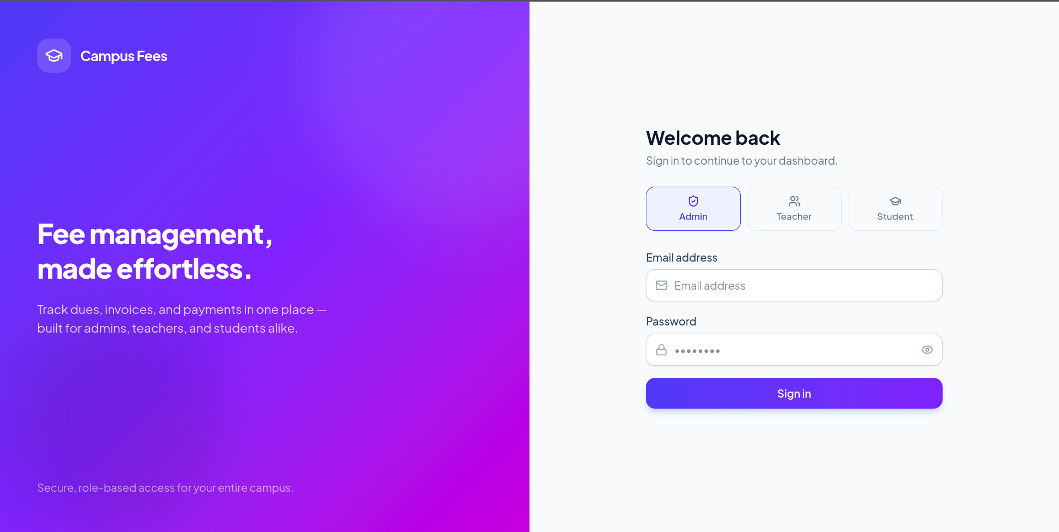
Fig 7.1: Login Page — Admin tab selected
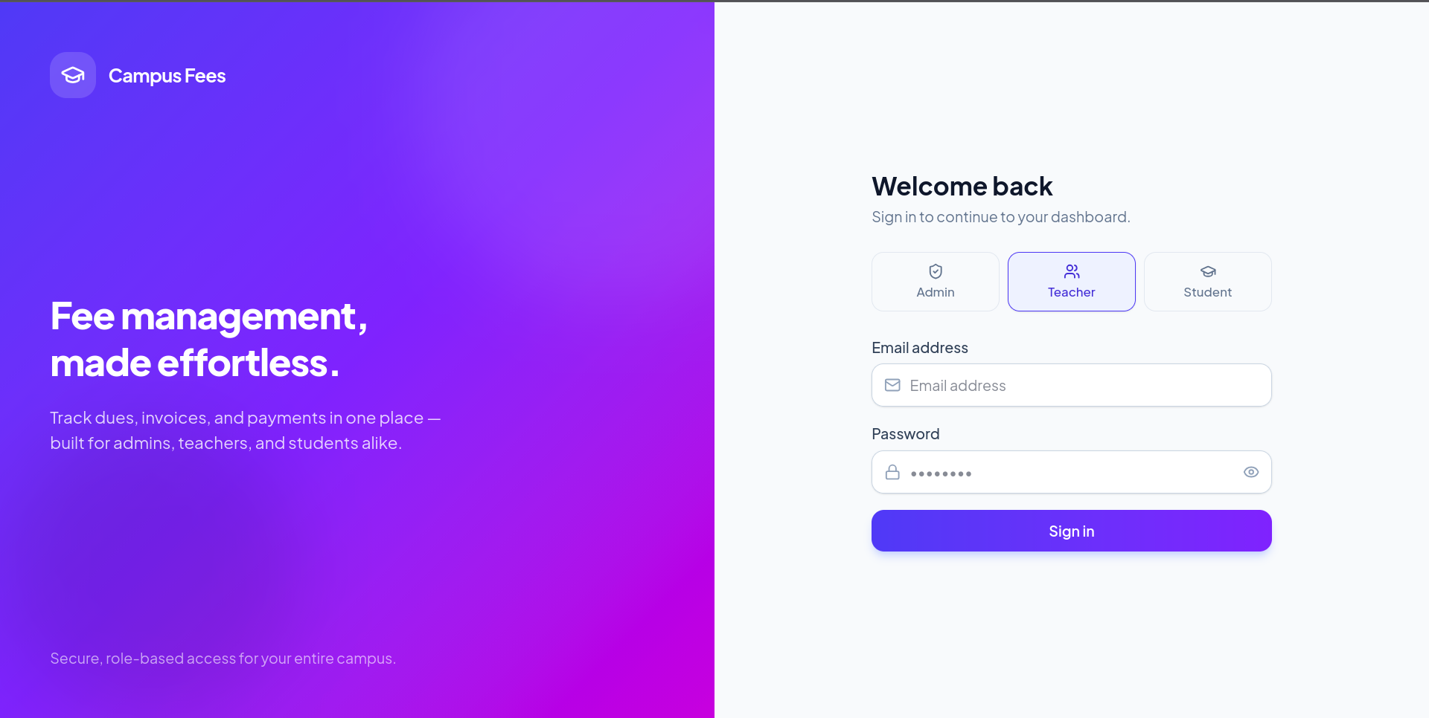
Fig 7.2: Login Page — Teacher tab selected
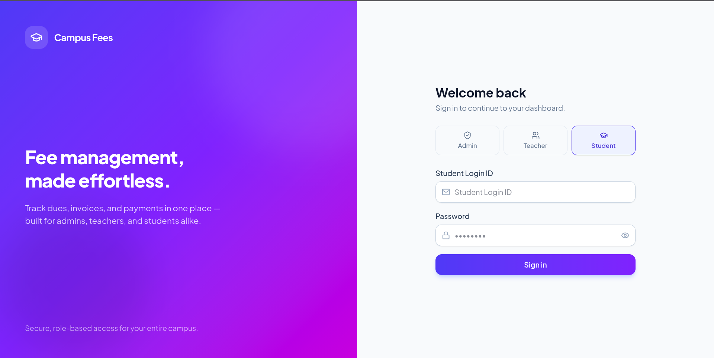
Fig 7.3: Login Page — Student tab selected (Login ID field, password eye-toggle visible)
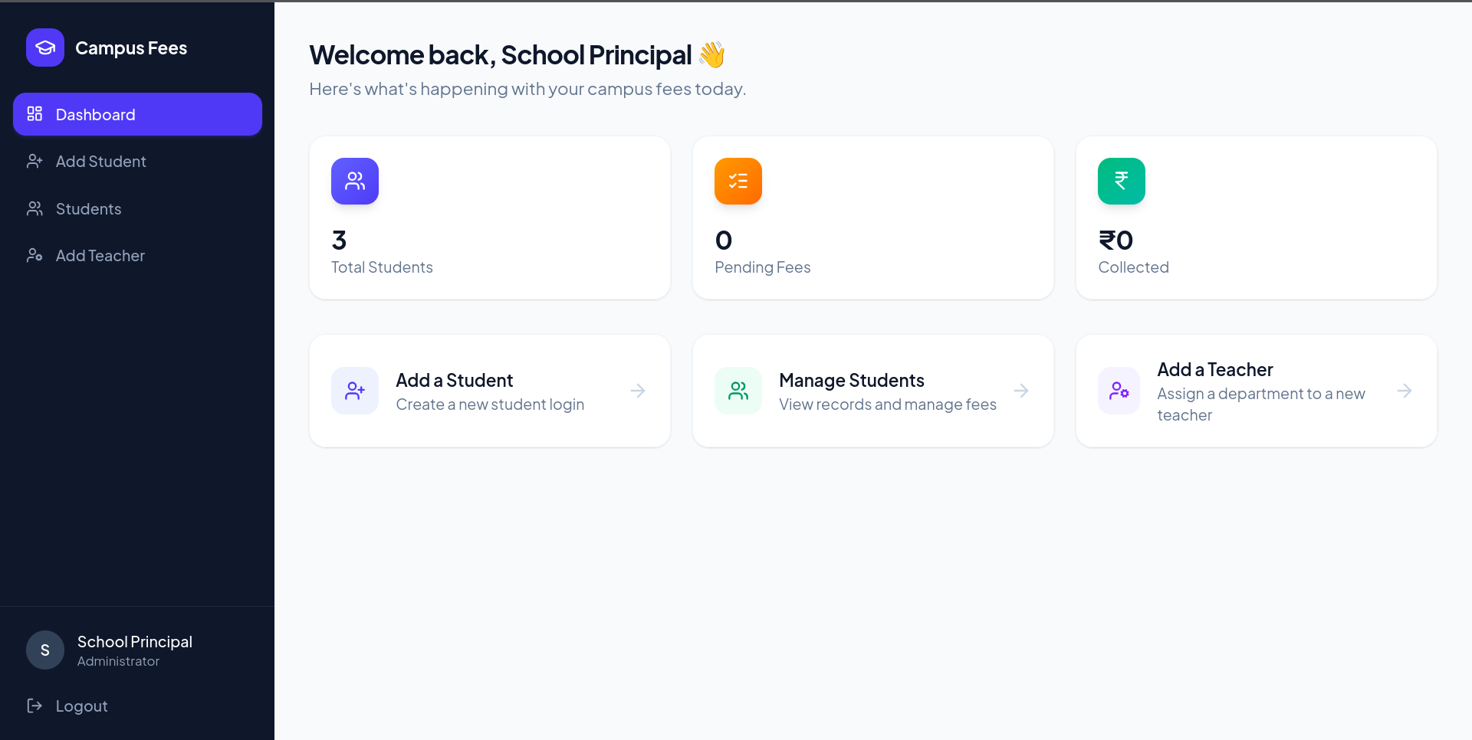
Fig 7.4: Admin Dashboard — summary cards and quick links, fixed sidebar with Logout
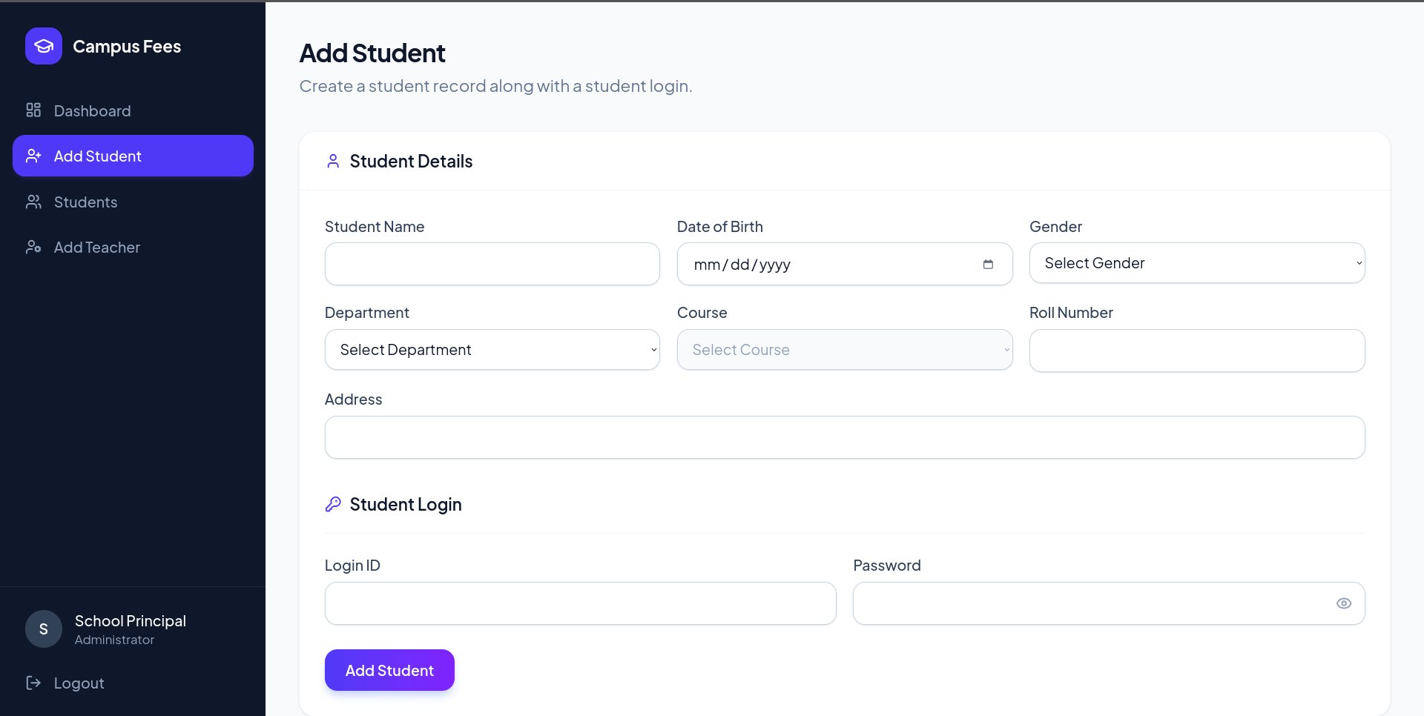
Fig 7.5: Admin Panel — Add Student form
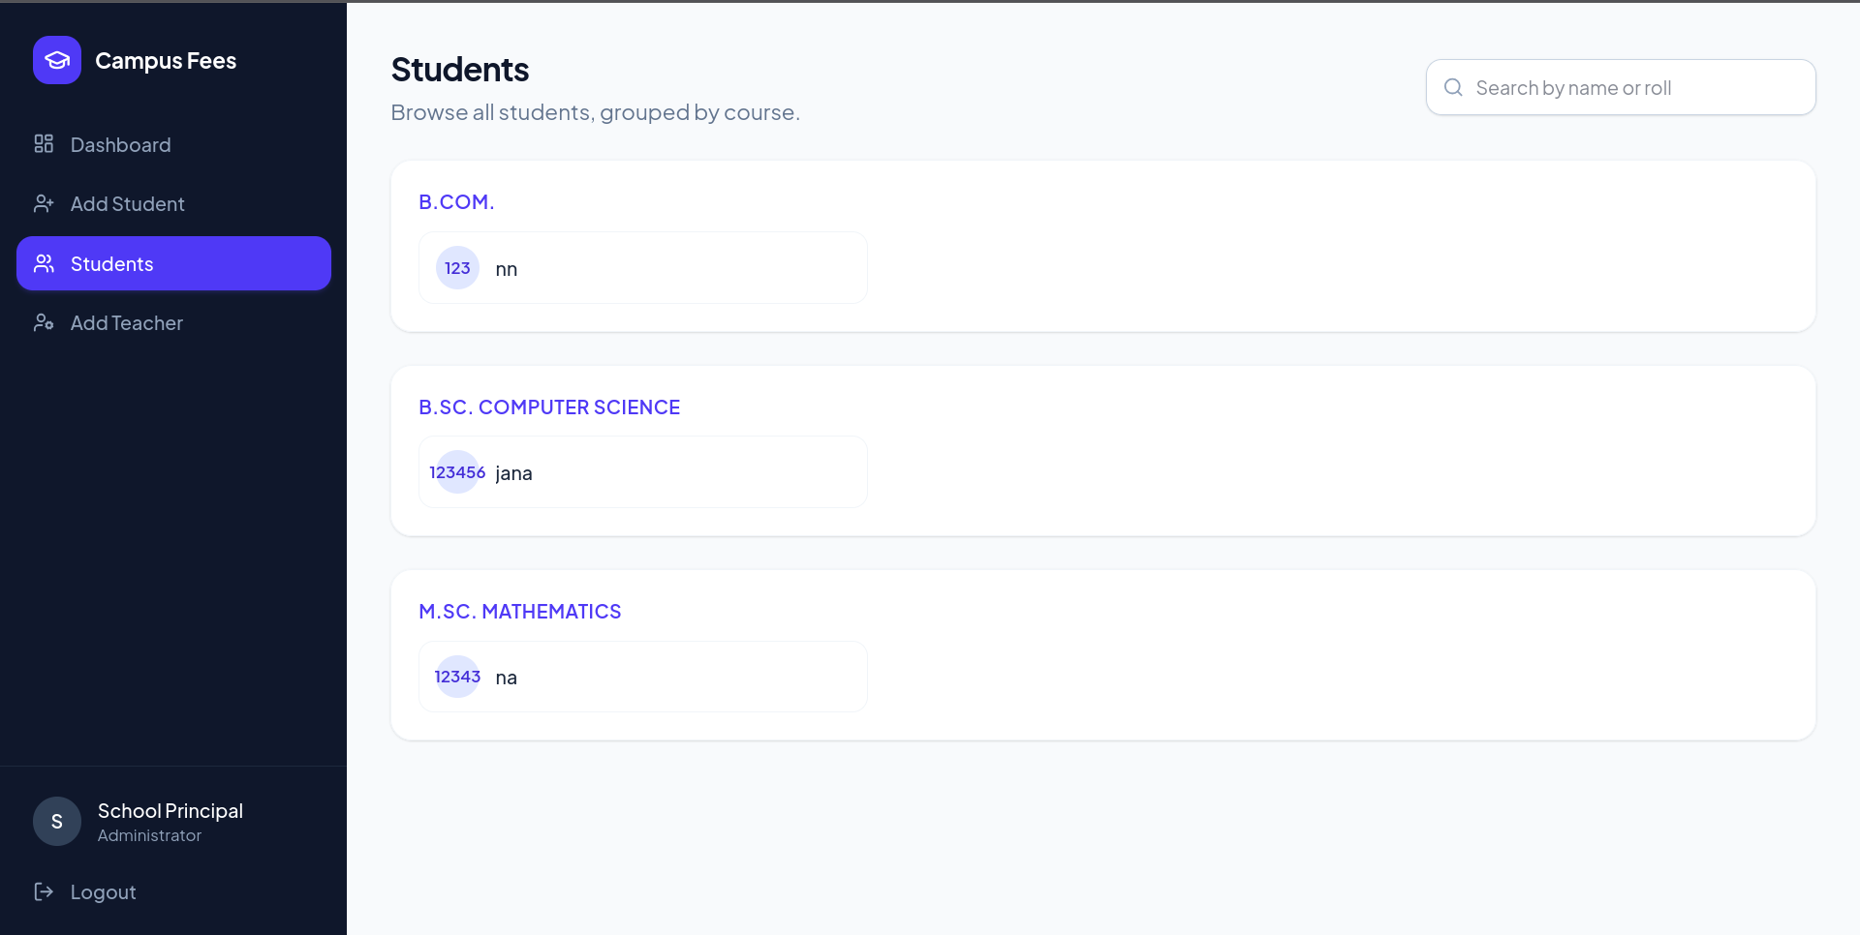
Fig 7.6: Admin Panel — Students List, grouped by course
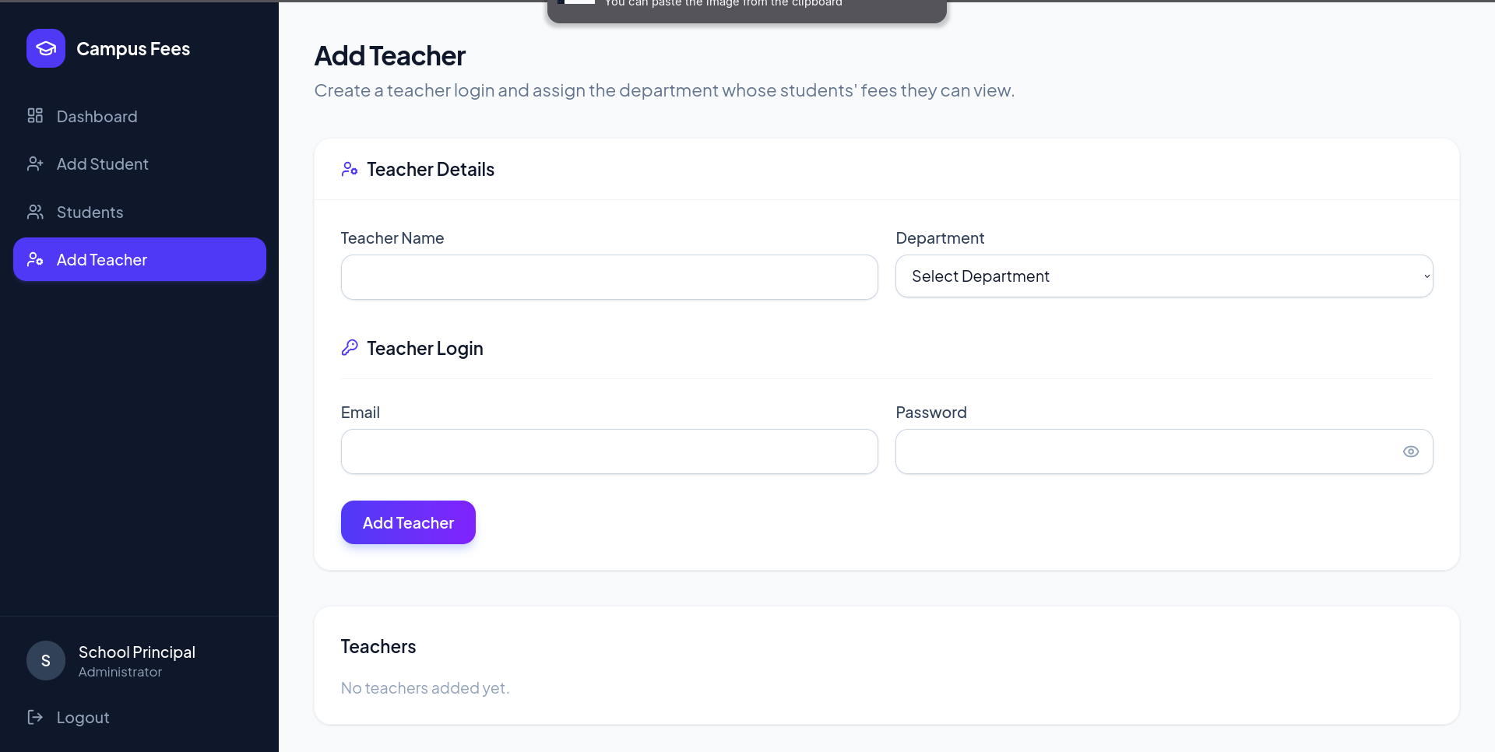
Fig 7.7: Admin Panel — Add Teacher form
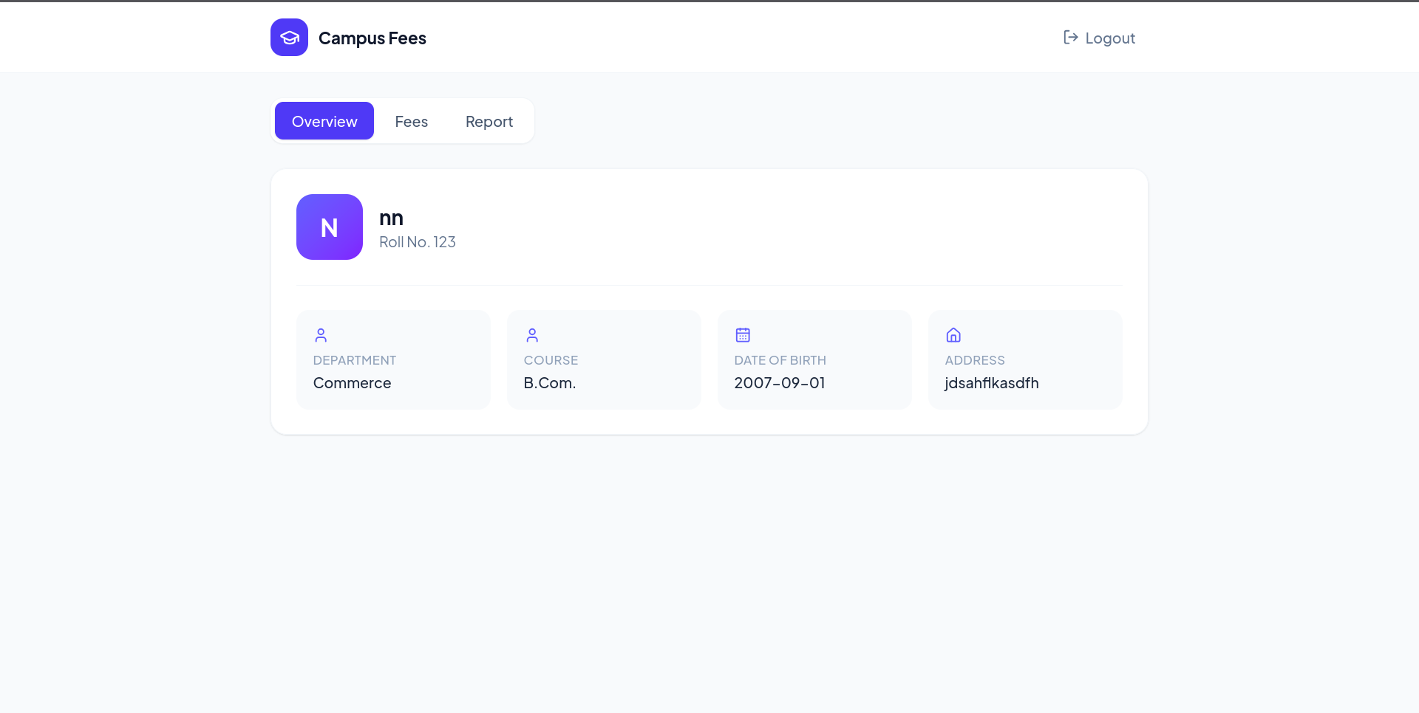
Fig 7.8: Student Profile — Overview tab
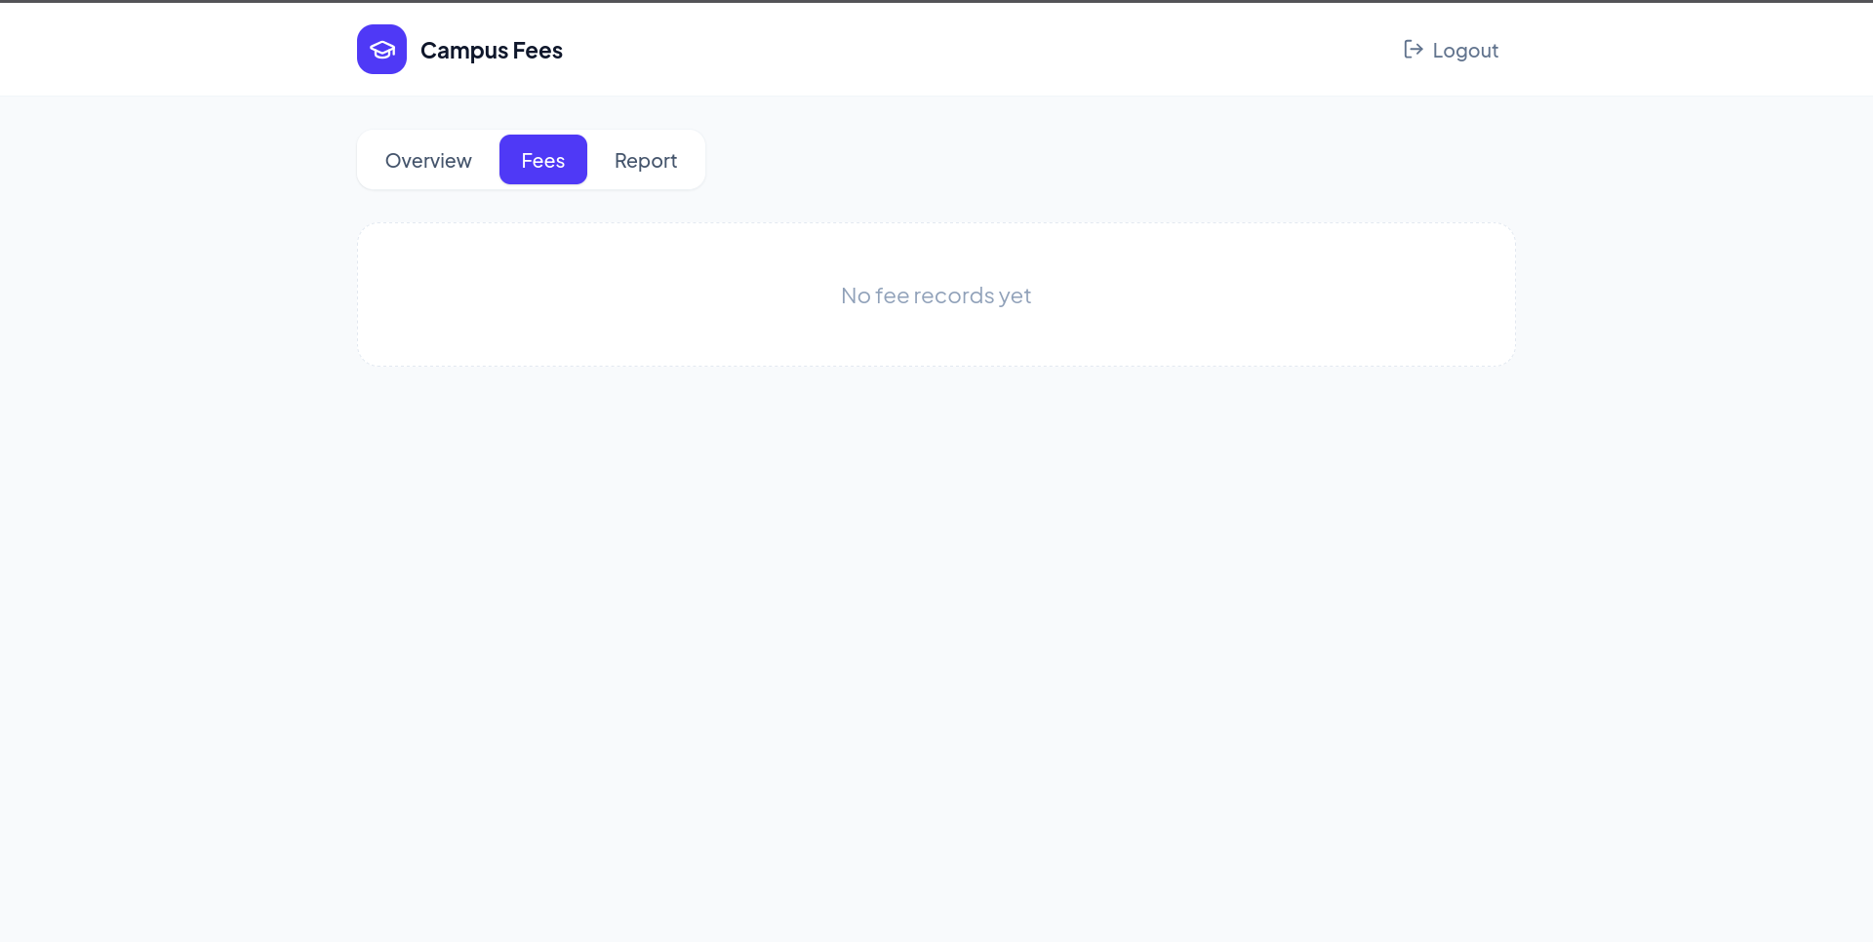
Fig 7.9: Student Profile — Fees tab
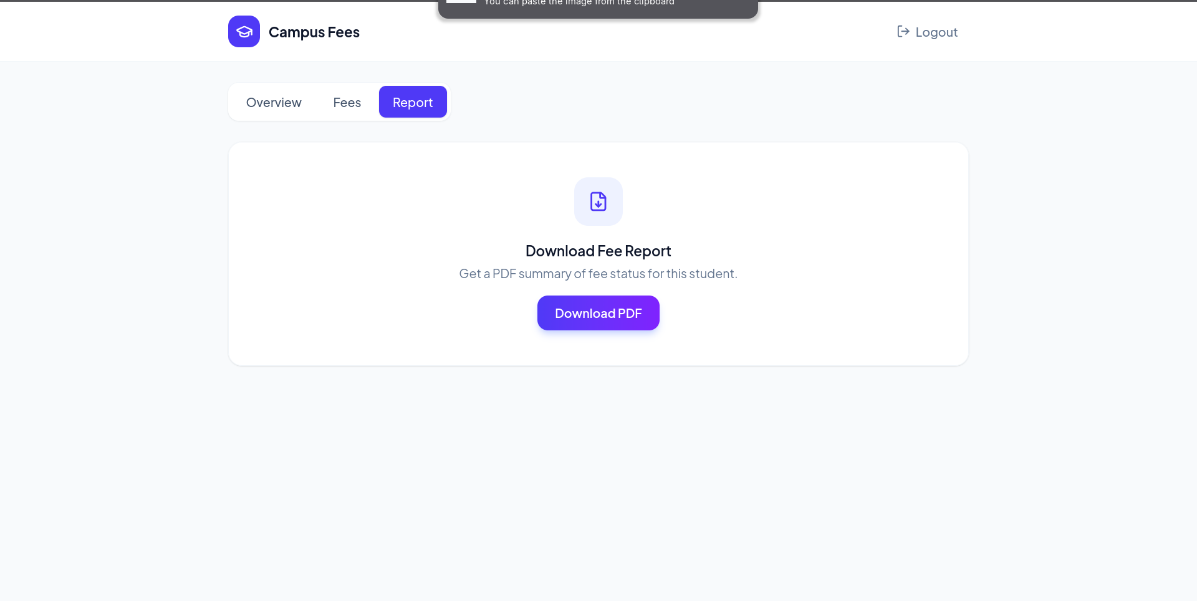
Fig 7.10: Student Profile — Report tab (Download Fee Report as PDF)
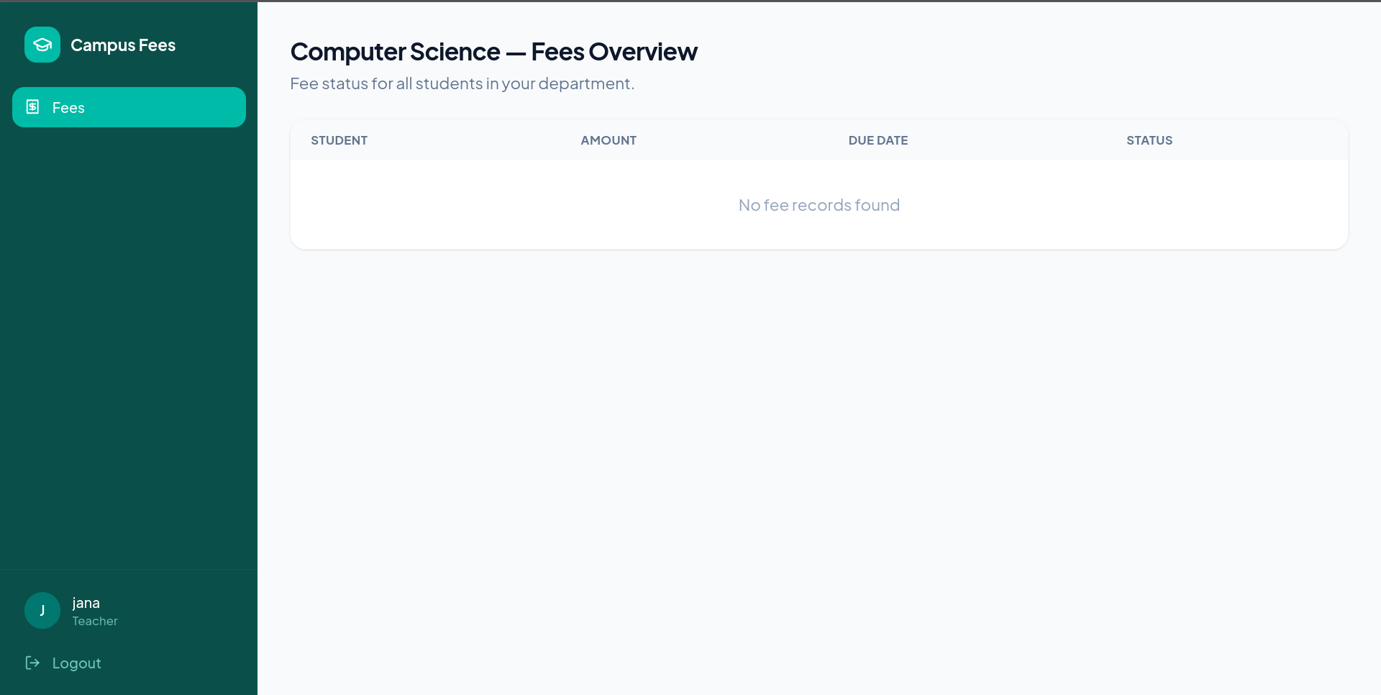
Fig 7.11: Teacher Panel — Fees Overview, filtered to the teacher's own department

CHAPTER VIII: FUTURE ENHANCEMENT
- Online payment gateway integration (Razorpay/Stripe) so students can pay dues directly through the portal instead of only viewing them.
- Automated email/SMS reminders to students as a fee due date approaches or passes.
- A richer analytics dashboard for the Admin — department-wise collection trends, defaulter lists, and monthly summaries.
- Downloadable, professionally formatted fee receipts (beyond the current basic PDF) with institution letterhead and digital signature.
- Support for multiple institutions/campuses within a single deployment (multi-tenant architecture).
- An audit trail/history log of who created, edited, or marked each fee record as paid.

CHAPTER IX: CONCLUSION
The Campus Fees Management System successfully replaces a manual, error-prone fee-tracking process with a secure, role-based web application. Using React, Node.js/Express, and MongoDB, the system allows an Administrator to manage students, teachers, and fee records; a Teacher to monitor fee status within their own department; and a Student to independently check dues and download a fee report at any time. Authentication is protected end-to-end with hashed passwords and JWT-based session tokens. The project demonstrates a practical, full-stack solution to a real administrative problem faced by educational institutions, and leaves clear room for future enhancement such as online payments and automated reminders.

APPENDIX

A.1 Backend Dependencies (package.json)
- express ^4.18.2
- mongoose ^7.0.0
- mongodb ^7.0.0
- jsonwebtoken ^9.0.0
- bcryptjs ^2.4.3
- cors ^2.8.5
- dotenv ^16.0.0
- pdfkit ^0.17.2
- nodemon ^2.0.22 (dev dependency)

A.2 Frontend Dependencies (package.json)
- react ^18.2.0 / react-dom ^18.2.0
- react-router-dom ^6.14.1
- axios ^1.4.0
- lucide-react ^1.43.0
- tailwindcss ^4.3.3 (dev dependency)
- vite ^5.0.0 / @vitejs/plugin-react ^4.0.0 (dev dependencies)

