Project Report
LEARNING MANAGEMENT SYSTEM (LMS PORTAL)

Submitted in partial fulfillment for the requirement
MOTHER TERESA WOMEN'S UNIVERSITY
For the award of the degree
BACHELOR OF COMMERCE WITH COMPUTER APPLICATION

Submitted by
Name: Register No:
D. JANANI (23242ER012)
C. KRISHA (23242ER015)
R. NESHA (23242ER020)

Under the guidance of
Ms. Kaviya M.Com CA., B.Ed., DCA
Assistant Professor, Department of Commerce

POST GRADUATE DEPARTMENT OF COMMERCE
THIRAVIUM COLLEGE OF ARTS AND SCIENCE FOR WOMEN
(Affiliated to Mother Teresa Women's University, Kodaikanal)
Run by TRINTY Trust
Mount Jerusalem, Periyakulam Road, Kailaspatty – 625605

NOVEMBER 2025

THIRAVIUM COLLEGE OF ARTS AND SCIENCE FOR WOMEN
PERIYAKULAM KAILASPATTY – 625605
DEPARTMENT OF COMMERCE
BONAFIDE CERTIFICATE
This is to certify that the project on "LEARNING MANAGEMENT SYSTEM (LMS PORTAL)" is a Bonafide work done by the students D. JANANI, C. KRISHA, R. NESHA of class III B.COM (CA) and submitted to Department of Commerce, Thiravium College of Arts and Science for Women, Periyakulam, in partial fulfillment of the requirements for the award of the Degree of Under Graduate of Commerce With Computer Application Under Mother Teresa Women's University, Kodaikanal.

T. Sivanesan M.Com., M.Phil.,  The Head of the Department  Department of Commerce  Thiravium College of Arts and Science for Women, Periyakulam. | Ms. K. Kaviya M.Com(CA)., B.Ed., DCA  Assistant Professor  Department of Commerce  Thiravium College of Arts and Science for Women, Periyakulam.

Internal Examiner External Examiner

ACKNOWLEDGEMENT
First and foremost, we remember with gratitude the blessings of the Almighty who has given us the health and necessary skill to complete this project.
We convey our heartiest thanks to our honourable Principal Dr. R. ANANTHA BABU M.A., MPhil., Ph.D., of Thiravium College of Arts and Science for Women, Kailasapatti, for her kind encouragement to undertake this project.
We wish to express our sincere thanks to MR. T. SIVANESAN M.COM., MPhil., DCM., PCP., the Head and Assistant Professor, Department of Commerce, Thiravium College of Arts and Science for Women, Kailasapatti, for his valuable support in the completion of this project.
Our sincere thanks go to our guide Ms. K. KAVIYA M.COM CA., B.Ed., DCA., Assistant Professor, Department of Commerce, Thiravium College of Arts and Science for Women, Kailasapatti, who gave valuable guidance, suggestions and great support at each and every step of this project.
We are grateful to THIRAVIUM COLLEGE OF ARTS AND SCIENCE FOR WOMEN, KAILASAPATTI, for granting permission to do this project.
Last but not least, we would like to express our gratitude to our beloved parents for their continuous blessings and encouragement.

D. JANANI
C. KRISHA
R. NESHA

TABLE OF CONTENTS
NAME | CHAPTER | CONTENTS | PAGE NO
 | CHAPTER I | INTRODUCTION ABOUT THE PROJECT
 |  | 1.1 Learning Management System
 |  | 1.2 Definition of LMS Portal
 |  | 1.3 Objective
 |  | 1.4 Project Description
 | CHAPTER II | SYSTEM ANALYSIS
 |  | 2.1 Existing System
 |  | 2.2 Proposed System
 |  | 2.3 System Requirements
 | CHAPTER III | SYSTEM REQUIREMENT SPECIFICATION
 |  | 3.1 Hardware Specification
 |  | 3.2 Software Specification
 |  | 3.3 About the Software (Tech Stack)
 | CHAPTER IV | SYSTEM DESIGN
 |  | 4.1 Architectural Diagram
 |  | 4.2 Data Flow Diagram
 |  | 4.3 ER Diagram
 |  | 4.4 Project Specification
 |  | 4.5 Database Schema
 | CHAPTER V | TESTING AND MAINTENANCE
 |  | 5.1 Testing Overview
 |  | 5.2 Types of Testing
 | CHAPTER VI | SAMPLE SOURCE CODE
 | CHAPTER VII | SCREEN LAYOUT / OUTPUT
 | CHAPTER VIII | FUTURE ENHANCEMENT
 | CHAPTER IX | CONCLUSION
 | APPENDIX | BIBLIOGRAPHY

CHAPTER – I
1. INTRODUCTION ABOUT THE PROJECT
1.1 Learning Management System
In the modern era of digital education, managing learning resources, students, instructors, and course content efficiently is a critical challenge for educational institutions and corporate training organizations. Traditional, manual methods of course administration—scattered spreadsheets, physical registers, and untracked email communication—are proving insufficient to meet the demands of a fast-paced learning environment.
A Learning Management System (LMS) is a comprehensive web-based platform that provides the infrastructure for the delivery, tracking, and management of online learning and training programs. It enables students to enroll in courses, track their learning progress, and purchase educational content, while providing instructors with tools to create, publish, and manage courses. Administrators can oversee the entire ecosystem through a centralized dashboard.
This project, LMS Portal (also known as LMSLearn), aims to develop a full-stack, role-based web application that serves as a modern, scalable learning management system. It supports three key user roles: Admin, Instructor, and Student, each with a dedicated, purpose-built interface.
1.2 Definition of Learning Management System
A Learning Management System (LMS) is a software platform or web application designed to create, manage, deliver, and track educational content and training programs. It allows organizations and educators to publish structured courses consisting of video lectures, quizzes, and supplementary materials, while enabling learners to access these resources securely, track their own progress, and obtain certifications upon completion.
The LMS Portal project implements a full-stack LMS featuring JWT-based authentication, Stripe payment integration for course purchases, Cloudinary for media storage, and a React-based frontend with a Node.js/Express backend connected to a MongoDB database.
1.3 Objective
To design and implement a secure, scalable, and user-friendly full-stack web-based Learning Management System that allows students to enroll in and complete courses online, while enabling instructors to create and manage course content and administrators to oversee all platform activity.
Scope:
- Allow users to register and log in securely using JWT-based authentication.
- Provide role-based interfaces for Admin, Instructor, and Student users.
- Enable Instructors to create courses with multi-lecture video content hosted on Cloudinary.
- Allow Students to browse, purchase (via Stripe), and complete courses.
- Include a real-time course progress tracker for students.
- Maintain an Admin dashboard for platform-wide oversight: users, courses, and orders.
- Generate revenue analytics for instructors via a dedicated dashboard.
- Ensure data security, integrity, and proper role-based access control (RBAC).
Key Users:
- Students/Learners – Browse, purchase, and complete courses.
- Instructors – Create, publish, and manage courses; view revenue analytics.
- Admin – Oversee the entire platform: manage users, courses, and orders.
Benefits:
- Centralized, scalable platform for online learning.
- Secure payment processing through Stripe.
- Cloud-based media management via Cloudinary.
- Real-time progress tracking for students.
- Role-based dashboards for better user experience.
- Data-driven analytics for instructors and administrators.
1.4 Project Description – LMS Portal
The LMS Portal is a MERN stack (MongoDB, Express.js, React.js, Node.js) web application developed to serve as a complete online learning platform. The system supports three distinct user roles and provides each with a specialized experience:
Student Module: Students can register, browse all available courses categorized by topic, view detailed course information, purchase courses via Stripe payment gateway, and track their video-lecture completion progress through an interactive course player.
Instructor Module: Instructors can register as instructors during signup, create and publish multi-lecture courses with images and videos uploaded to Cloudinary, view their student enrollment stats, and track total revenue from their courses.
Admin Module: The admin panel provides full control over the platform, including the ability to manage all users (view, change roles, delete), manage all published courses, and view all completed orders with payment details.

CHAPTER – II
2. SYSTEM ANALYSIS
2.1 Existing System
In traditional educational environments, learning management is handled manually or through basic tools that are disconnected from one another:
- Course materials are distributed via physical handouts, email attachments, or basic file-sharing services.
- Student enrollment is tracked using spreadsheets or paper registers.
- There is no centralized system to monitor course completion or student progress.
- Payments for courses are handled manually through cash or basic bank transfers.
- Communication between instructors and students relies on unstructured email or messaging platforms.
Drawbacks of the Existing System:
- Time-consuming and administratively inefficient.
- No real-time progress tracking for students or instructors.
- Lack of scalability – cannot handle growing numbers of users simultaneously.
- Absence of a unified platform leads to fragmented data and poor user experience.
- No secure payment gateway for course purchases.
- Difficult to generate analytics or performance reports.
2.2 Proposed System
The proposed LMS Portal is a full-stack, cloud-enabled, role-based web application that addresses all the deficiencies of the existing system. It provides a unified platform for course creation, enrollment, delivery, and administration:
- Secure JWT-based user authentication with role-based access control.
- Instructor-facing course builder with Cloudinary media upload integration.
- Student-facing course marketplace with Stripe payment gateway.
- Real-time video-lecture progress tracking with percentage completion.
- Admin dashboard for platform-wide user, course, and order management.
- Fully responsive React.js frontend with TailwindCSS and shadcn/ui components.
Advantages of the Proposed System:
- Centralized, secure, and scalable cloud-based platform.
- Automated payment processing with Stripe eliminates manual transactions.
- Rich media support via Cloudinary for video and image assets.
- Real-time progress tracking improves student engagement.
- Role-based dashboards for a tailored experience per user type.
- Easy-to-use, modern interface built with React.js and TailwindCSS.
2.3 System Requirements
a. Functional Requirements
Student Module:
- Register and log in securely.
- Browse and search courses by category.
- Purchase courses via Stripe payment.
- View course details and video lectures.
- Track course completion progress.
- Manage profile and view enrolled courses.
Instructor Module:
- Register as an instructor.
- Create, edit, and publish courses.
- Upload course images and lecture videos to Cloudinary.
- View student enrollment statistics.
- Track total revenue from published courses.
Admin Module:
- View all registered users.
- Change user roles or delete accounts.
- View all courses published on the platform.
- Delete inappropriate courses.
- View all orders and payment records.
b. Non-Functional Requirements
- Usability: Clean, responsive interface using TailwindCSS and shadcn/ui.
- Reliability: RESTful API backend with proper error handling and validation.
- Security: JWT tokens, bcrypt password hashing, and role-based middleware.
- Performance: Optimized React frontend with lazy loading and Vite bundler.
- Scalability: MongoDB Atlas supports horizontal scaling for large datasets.

CHAPTER – III
3. SYSTEM REQUIREMENT SPECIFICATION
3.1 Hardware Specification
Hardware Component | Specification
Processor | Intel Core i3 / i5 or higher
RAM | Minimum 4 GB (Recommended 8 GB)
Hard Disk | Minimum 20 GB free space
Monitor | 15" LED/LCD Colour Display
Keyboard | Standard Multimedia Keyboard
Mouse | Optical Mouse

3.2 Software Specification
Software Component | Specification
Operating System | Windows 10 / Ubuntu 20.04+
Frontend Framework | React.js 18 with Vite
Backend Framework | Node.js with Express.js
Database | MongoDB (MongoDB Atlas)
Styling | TailwindCSS + shadcn/ui
Browser | Google Chrome / Mozilla Firefox
Version Control | Git & GitHub

3.3 About the Software (Tech Stack)
3.3.1 Frontend – React.js
React.js is an open-source JavaScript library developed by Meta (Facebook) for building fast, declarative, and component-based user interfaces. In this project, the frontend is built with React 18 and bundled using Vite, which provides extremely fast development server startup and optimized production builds.
Key libraries used include React Router DOM for client-side navigation, Axios for REST API communication, Framer Motion for animations, and Lucide React for icons. UI components are built using the shadcn/ui component library layered on top of Radix UI primitives, with TailwindCSS for utility-first styling.
3.3.2 Backend – Node.js & Express.js
Node.js is a server-side JavaScript runtime built on Chrome's V8 engine. Express.js is a minimal web application framework for Node.js that provides robust routing, middleware support, and HTTP utilities. In LMS Portal, Express.js handles all REST API endpoints, authentication middleware, and payment webhook processing.
3.3.3 Database – MongoDB
MongoDB is a NoSQL document-oriented database that stores data in flexible, JSON-like BSON documents. It is used in this project via Mongoose ODM (Object Document Mapper) to define schemas for Users, Courses, Lectures, Orders, and Course Progress. MongoDB Atlas provides cloud hosting with built-in replication and security.
3.3.4 Authentication – JWT & Bcrypt
JSON Web Tokens (JWT) are used for stateless authentication. Upon login, the server signs a token containing the user's ID and role. This token is sent in HTTP-only cookies and validated by middleware on every protected route. Passwords are hashed using bcryptjs before storage, ensuring they are never stored in plain text.
3.3.5 Payment Gateway – Stripe
Stripe is a PCI-compliant payment processing platform. Students can purchase courses by creating a Stripe Checkout Session. Upon successful payment, a webhook event confirms the transaction and automatically enrolls the student in the purchased course.
3.3.6 Media Storage – Cloudinary
Cloudinary is a cloud-based media management service used for storing and serving course images and video lectures. When instructors upload media files, they are streamed to Cloudinary and the returned URL is stored in MongoDB. This offloads media bandwidth from the application server.
3.3.7 TailwindCSS & shadcn/ui
TailwindCSS is a utility-first CSS framework that enables rapid UI development through composable class names. shadcn/ui is a collection of accessible, re-usable components built on Radix UI, providing components like buttons, cards, dialogs, tabs, and forms used throughout the application.

CHAPTER – IV
4. SYSTEM DESIGN
4.1 Architectural Diagram
The LMS Portal follows a three-tier client-server architecture separating the Presentation Layer (React frontend), the Business Logic Layer (Node.js/Express API), and the Data Layer (MongoDB). External services — Cloudinary and Stripe — are integrated at the API layer.
┌─────────────────────────────────────────────────────────────────┐
│ PRESENTATION LAYER │
│ React.js + Vite + TailwindCSS + shadcn/ui │
│ ┌──────────┐ ┌──────────────┐ ┌───────────────────────────┐ │
│ │ Student │ │ Instructor │ │ Admin Panel │ │
│ │ View │ │ View │ │ Overview | Users | ... │ │
│ └──────────┘ └──────────────┘ └───────────────────────────┘ │
└─────────────────────────┬───────────────────────────────────────┘
│ REST API (HTTP / JSON)
▼
┌─────────────────────────────────────────────────────────────────┐
│ BUSINESS LOGIC LAYER │
│ Node.js + Express.js API Server │
│ ┌─────────────┐ ┌──────────────┐ ┌─────────────────────────┐ │
│ │ Auth Routes │ │Course Routes │ │ Order / Payment Routes │ │
│ │ /auth/* │ │ /courses/* │ │ /order/* │ │
│ └─────────────┘ └──────────────┘ └─────────────────────────┘ │
│ ┌────────────────────────────────────────────────────────────┐ │
│ │ Middleware: JWT Authentication | Role-Based Authorization │ │
│ └────────────────────────────────────────────────────────────┘ │
└──────────┬─────────────────────┬────────────────────────────────┘
│ │
▼ ▼
┌──────────────────┐ ┌──────────────────────────────────────────┐
│ DATA LAYER │ │ EXTERNAL SERVICES │
│ MongoDB Atlas │ │ ┌────────────┐ ┌────────────────────┐ │
│ (Mongoose ODM) │ │ │ Cloudinary │ │ Stripe Payment │ │
│ - User │ │ │ (Images + │ │ Gateway │ │
│ - Course │ │ │ Videos) │ │ (Checkout + │ │
│ - Order │ │ └────────────┘ │ Webhook) │ │
│ - CourseProgress│ │ └────────────────────┘ │
└──────────────────┘ └──────────────────────────────────────────┘
4.2 Data Flow Diagram (DFD)
Level 0 – Context Diagram
The Context DFD shows the LMS Portal system as a single process interacting with three external entities: Student, Instructor, and Admin. All data flows pass through the central system.
[Student] ──── login / enroll / watch ────► [LMS PORTAL SYSTEM] ◄──── manage users/courses ──── [Admin]
│
create / manage courses
│
[Instructor]
Level 1 – Detailed DFD
Student ──► [1.0 Authentication] ──► JWT Token ──► Session Cookie
Student ──► [2.0 Course Browsing] ──► Course List (MongoDB)
Student ──► [3.0 Payment Processing] ──► Stripe API ──► Order Record (MongoDB)
Student ──► [4.0 Course Progress] ──► Progress Data (MongoDB)

Instructor ──► [1.0 Authentication] ──► JWT Token
Instructor ──► [5.0 Course Creation] ──► Media Upload (Cloudinary) ──► Course Record (MongoDB)
Instructor ──► [6.0 Revenue Dashboard] ──► Order Aggregation (MongoDB)

Admin ──► [1.0 Authentication] ──► JWT Token (Admin Role)
Admin ──► [7.0 User Management] ──► User Records (MongoDB)
Admin ──► [8.0 Platform Overview] ──► Aggregated Stats (MongoDB)
4.3 Entity-Relationship (ER) Diagram
The following ER diagram illustrates the relationships between the core data entities in the LMS Portal database:
┌──────────┐ enrolls in ┌────────────┐
│ User │─────────────────────► │ Order │
│──────────│ │────────────│
│ _id (PK) │ │ _id (PK) │
│ userName │ │ userId(FK) │
│ userEmail│ ┌──────────────────│courseId(FK)│
│ password │ │ │ amount │
│ role │ │ │ paymentId │
└──────────┘ │ └────────────┘
│ │
creates │ belongs to
│ │
▼ ▼
┌──────────┐ ┌──────────────┐ ┌─────────────────┐
│ Course │──►│ Lecture │ │ CourseProgress │
│──────────│ │──────────────│ │─────────────────│
│ _id (PK) │ │ _id (PK) │ │ _id (PK) │
│instructor│ │courseId (FK)│ │ userId (FK) │
│ Id (FK) │ │ title │ │ courseId (FK) │
│ title │ │ videoUrl │ │ lecturesProgress │
│ pricing │ │ freePreview │ │ completed │
│ category │ │ public_id │ └─────────────────┘
│ image │ └──────────────┘
└──────────┘
4.4 Project Specification
Specification | Detail
Project Name | LMS Portal (LMSLearn)
Project Type | Full-Stack MERN Web Application
Frontend | React.js 18 + Vite + TailwindCSS + shadcn/ui
Backend | Node.js + Express.js
Database | MongoDB (via Mongoose ODM)
Authentication | JWT (JSON Web Tokens) + Bcrypt
Payment Gateway | Stripe Checkout
Media Storage | Cloudinary (Images & Videos)
Deployment | Localhost (Dev) / Cloud (Production)

4.5 Database Schema (MongoDB Collections)
The LMS Portal uses MongoDB with the following primary collections managed via Mongoose schemas:
4.5.1 User Schema
const UserSchema = new mongoose.Schema({
userName : { type: String, required: true },
userEmail : { type: String, required: true, unique: true },
password : { type: String, required: true },
role : { type: String, enum: ['user', 'instructor', 'admin'], default: 'user' },
}, { timestamps: true });
4.5.2 Course Schema
const CourseSchema = new mongoose.Schema({
instructorId : { type: String, required: true },
instructorName : { type: String, required: true },
title : { type: String, required: true },
category : { type: String, required: true },
level : { type: String, enum: ['beginner', 'intermediate', 'advanced'] },
primaryLanguage : String,
subtitle : String,
description : String,
image : String,
pricing : { type: Number, required: true },
isPublished : { type: Boolean, default: false },
lectures : [LectureSchema],
students : [{ studentId: String, studentName: String, studentEmail: String }],
}, { timestamps: true });
4.5.3 Order Schema
const OrderSchema = new mongoose.Schema({
userId : { type: String, required: true },
userName : String,
userEmail : String,
orderStatus : { type: String, enum: ['pending', 'confirmed'], default: 'pending' },
paymentMethod : String,
paymentStatus : String,
orderDate : Date,
paymentId : String,
payerId : String,
instructorId : String,
instructorName : String,
courseImage : String,
courseTitle : String,
courseId : String,
coursePricing : String,
}, { timestamps: true });
4.5.4 Course Progress Schema
const CourseProgressSchema = new mongoose.Schema({
userId : String,
courseId : String,
completed: Boolean,
lecturesProgress: [{
lectureId : String,
viewed : Boolean,
}],
});

CHAPTER – V
5. TESTING AND MAINTENANCE
5.1 Testing Overview
Testing is a critical phase of the software development lifecycle. For the LMS Portal, a combination of manual and functional testing strategies were employed to ensure each module functions correctly, securely, and as expected across all three user roles.
Testing was conducted at the unit level (individual API endpoints), integration level (frontend-backend communication), and system level (full user workflow from registration to course completion).
5.2 Types of Testing
5.2.1 Unit Testing
Individual backend API routes were tested using REST clients to verify that each endpoint returns the correct HTTP status codes, response structures, and data. JWT middleware was tested to confirm that protected routes reject unauthenticated requests.
Test Case | Module | Expected Result | Status
TC-01 | POST /auth/register | Returns 200 with success message | Pass
TC-02 | POST /auth/login | Returns JWT token in cookie | Pass
TC-03 | GET /courses | Returns list of published courses | Pass
TC-04 | POST /order/create | Creates Stripe Checkout session | Pass
TC-05 | GET /admin/users | Returns all users (Admin only) | Pass

5.2.2 Integration Testing
Integration testing verified that the React frontend correctly communicates with the Express.js API, and that responses are properly rendered in the UI. Axios interceptors were tested to ensure authorization tokens are attached to all API requests.
5.2.3 User Acceptance Testing (UAT)
Test Case | User Role | Scenario | Result
UAT-01 | Student | Student registers and logs in | Pass
UAT-02 | Student | Student browses and purchases a course | Pass
UAT-03 | Student | Student watches a lecture and marks progress | Pass
UAT-04 | Instructor | Instructor creates and publishes a course | Pass
UAT-05 | Instructor | Instructor views revenue dashboard | Pass
UAT-06 | Admin | Admin manages users and views orders | Pass

5.2.4 Security Testing
Security testing focused on verifying role-based access control, JWT validation, and Stripe webhook signature verification:
- Attempted to access admin routes without a valid JWT token – returned 401 Unauthorized.
- Attempted to access instructor routes with a student token – returned 403 Forbidden.
- Verified that passwords are stored as bcrypt hashes in MongoDB.
- Verified that Stripe webhook events are validated using the signing secret.

CHAPTER – VI
6. SAMPLE SOURCE CODE
6.1 Backend – Authentication Controller
// backend/controllers/auth-controller/index.js
const bcrypt = require('bcryptjs');
const jwt = require('jsonwebtoken');
const User = require('../../models/User');

async function registerUser(req, res) {
const { userName, userEmail, password, role } = req.body;
const existingUser = await User.findOne({ $or: [{ userEmail }, { userName }] });
if (existingUser) {
return res.status(400).json({ success: false, message: 'User already exists.' });
}
const hashPassword = await bcrypt.hash(password, 10);
const newUser = new User({ userName, userEmail, password: hashPassword, role });
await newUser.save();
return res.status(201).json({ success: true, message: 'User registered successfully.' });
}

async function loginUser(req, res) {
const { userEmail, password } = req.body;
const checkUser = await User.findOne({ userEmail });
if (!checkUser || !(await bcrypt.compare(password, checkUser.password))) {
return res.status(401).json({ success: false, message: 'Invalid credentials.' });
}
const accessToken = jwt.sign(
{ _id: checkUser._id, userName: checkUser.userName, role: checkUser.role },
process.env.JWT_SECRET, { expiresIn: '120m' }
);
res.cookie('access_token', accessToken, { httpOnly: true, secure: false });
return res.status(200).json({ success: true, data: { accessToken, user: { ... } } });
}

module.exports = { registerUser, loginUser };
6.2 Backend – Course Creation Controller
// backend/controllers/instructor-controller/course-controller/index.js
const Course = require('../../../models/Course');

async function addNewCourse(req, res) {
const courseData = req.body;
const newCourse = new Course({ ...courseData, students: [] });
const savedCourse = await newCourse.save();
if (savedCourse) {
return res.status(201).json({ success: true, data: savedCourse });
}
return res.status(500).json({ success: false, message: 'Error adding course.' });
}

async function updateCourseByID(req, res) {
const { id } = req.params;
const updatedCourseData = req.body;
const updatedCourse = await Course.findByIdAndUpdate(id, updatedCourseData, { new: true });
if (!updatedCourse) {
return res.status(404).json({ success: false, message: 'Course not found.' });
}
return res.status(200).json({ success: true, data: updatedCourse });
}
6.3 Backend – Payment Controller (Stripe)
// backend/controllers/student-controller/order-controller/index.js
const stripe = require('stripe')(process.env.STRIPE_SECRET_KEY);
const Order = require('../../../models/Order');
const Course = require('../../../models/Course');

async function createOrder(req, res) {
const { userId, userName, userEmail, courseId, courseTitle, coursePricing } = req.body;
const session = await stripe.checkout.sessions.create({
payment_method_types: ['card'],
line_items: [{
price_data: {
currency: 'usd',
product_data: { name: courseTitle },
unit_amount: Math.round(coursePricing * 100),
},
quantity: 1,
}],
mode: 'payment',
success_url: `${process.env.CLIENT_URL}/payment-return?session_id={CHECKOUT_SESSION_ID}`,
cancel_url: `${process.env.CLIENT_URL}/payment-cancel`,
metadata: { userId, courseId },
});
const newOrder = new Order({ userId, userName, userEmail, courseId,
courseTitle, coursePricing, paymentMethod: 'stripe', orderStatus: 'pending' });
await newOrder.save();
return res.status(201).json({ success: true, data: { sessionId: session.id, url: session.url } });
}
6.4 Frontend – Admin Dashboard Page (React)
// frontend/src/pages/admin/index.jsx
import { useContext, useState } from 'react';
import { AuthContext } from '@/context/auth-context';
import { Button } from '@/components/ui/button';
import { BarChart3, Book, LogOut, ShieldCheck, ShoppingCart, Users } from 'lucide-react';

function AdminDashboardPage() {
const [activeTab, setActiveTab] = useState('overview');
const { auth, resetCredentials } = useContext(AuthContext);

const menuItems = [
{ icon: BarChart3, label: 'Overview', value: 'overview', component: <AdminOverview /> },
{ icon: Users, label: 'Users', value: 'users', component: <AdminUsers /> },
{ icon: Book, label: 'Courses', value: 'courses', component: <AdminCourses /> },
{ icon: ShoppingCart, label: 'Orders', value: 'orders', component: <AdminOrders /> },
];

function handleLogout() { resetCredentials(); sessionStorage.clear(); }

return (
<div className="flex h-full min-h-screen bg-secondary/50">
<aside className="hidden w-64 flex-col border-r bg-card md:flex">
<div className="flex flex-1 flex-col p-4">
<div className="mb-6 flex items-center gap-2 px-2">
<ShieldCheck className="h-6 w-6 text-primary" />
<h2 className="text-lg font-extrabold">Admin Panel</h2>
</div>
<nav className="space-y-1">
{menuItems.map(item => (
<Button key={item.value} variant={activeTab === item.value ? 'secondary' : 'ghost'}
className="w-full justify-start" onClick={() => setActiveTab(item.value)}>
<item.icon className="mr-2 h-4 w-4" /> {item.label}
</Button>
))}
</nav>
<div className="mt-auto border-t pt-4">
<Button variant="ghost" className="w-full justify-start" onClick={handleLogout}>
<LogOut className="mr-2 h-4 w-4" /> Logout
</Button>
</div>
</div>
</aside>
{/* Main content area */}
</div>
);
}
6.5 Frontend – Auth Context (React)
// frontend/src/context/auth-context/index.jsx
import { createContext, useState } from 'react';
import axios from 'axios';

export const AuthContext = createContext(null);

export default function AuthProvider({ children }) {
const [auth, setAuth] = useState({ authenticate: false, user: null });

async function handleLoginUser(event) {
event.preventDefault();
const response = await axios.post(
`${import.meta.env.VITE_BACKEND_URL}/auth/login`,
signInFormData, { withCredentials: true }
);
if (response.data.success) {
setAuth({ authenticate: true, user: response.data.data.user });
}
}

function resetCredentials() {
setAuth({ authenticate: false, user: null });
}

return (
<AuthContext.Provider value={{ auth, handleLoginUser, resetCredentials, ... }}>
{children}
</AuthContext.Provider>
);
}
6.6 Frontend – Student Home Page (React)
// frontend/src/pages/student/home/index.jsx
import { Button } from '@/components/ui/button';
import { useNavigate } from 'react-router-dom';
import { courseCategories } from '@/config';

function StudentHomePage() {
const navigate = useNavigate();

return (
<div className="min-h-screen bg-background">
{/* Hero Section */}
<section className="bg-gradient-to-br from-[#392f41] via-[#6f636d] to-[#95898e] text-white">
<div className="mx-auto flex max-w-7xl items-center px-4 py-16 lg:px-8">
<div className="lg:w-1/2">
<p className="mb-3 text-sm font-semibold uppercase text-[#ccc3d0]">
Learn without limits
</p>
<h1 className="mb-5 text-4xl font-extrabold md:text-5xl">
Skills that move your career forward
</h1>
<Button size="lg" onClick={() => navigate('/courses')}
className="bg-[#ebe7df] text-[#392f41] hover:bg-[#ccc3d0]">
Explore Courses
</Button>
</div>
<div className="lg:w-1/2">
<img src="/banner.png" className="w-full rounded-xl shadow-2xl" />
</div>
</div>
</section>

{/* Category Filters */}
<section className="mx-auto max-w-7xl px-4 py-12">
<h2 className="text-2xl font-bold mb-6">Browse by category</h2>
<div className="flex flex-wrap gap-3">
{courseCategories.map(cat => (
<button key={cat.id} onClick={() => navigate('/courses')}
className="rounded-full border bg-card px-4 py-2 text-sm hover:border-primary">
{cat.label}
</button>
))}
</div>
</section>
</div>
);
}

CHAPTER – VII
7. SCREEN LAYOUT / OUTPUT
This chapter presents the actual output screenshots of the LMS Portal application, covering all major pages and views across the three user roles: Student, Instructor, and Admin.
7.1 Authentication Pages
7.1.1 Sign In Page
The Sign In page features a split-screen layout. The left panel displays the LMSLearn branding with a dark plum-to-mauve gradient. The right panel contains a card with email and password input fields and a Sign In button.
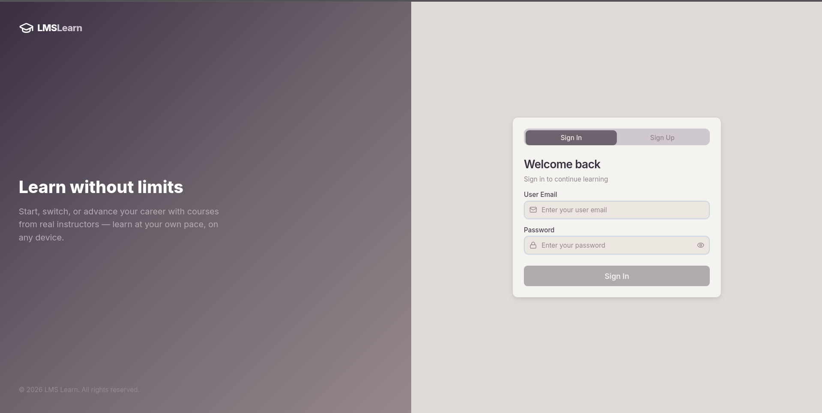
Figure 7.1 – Sign In Page
7.1.2 Sign Up Page
The Sign Up page allows new users to create an account. Users must select their role (Student or Instructor) before entering their name, email, and password. The role selection uses an animated card toggle.
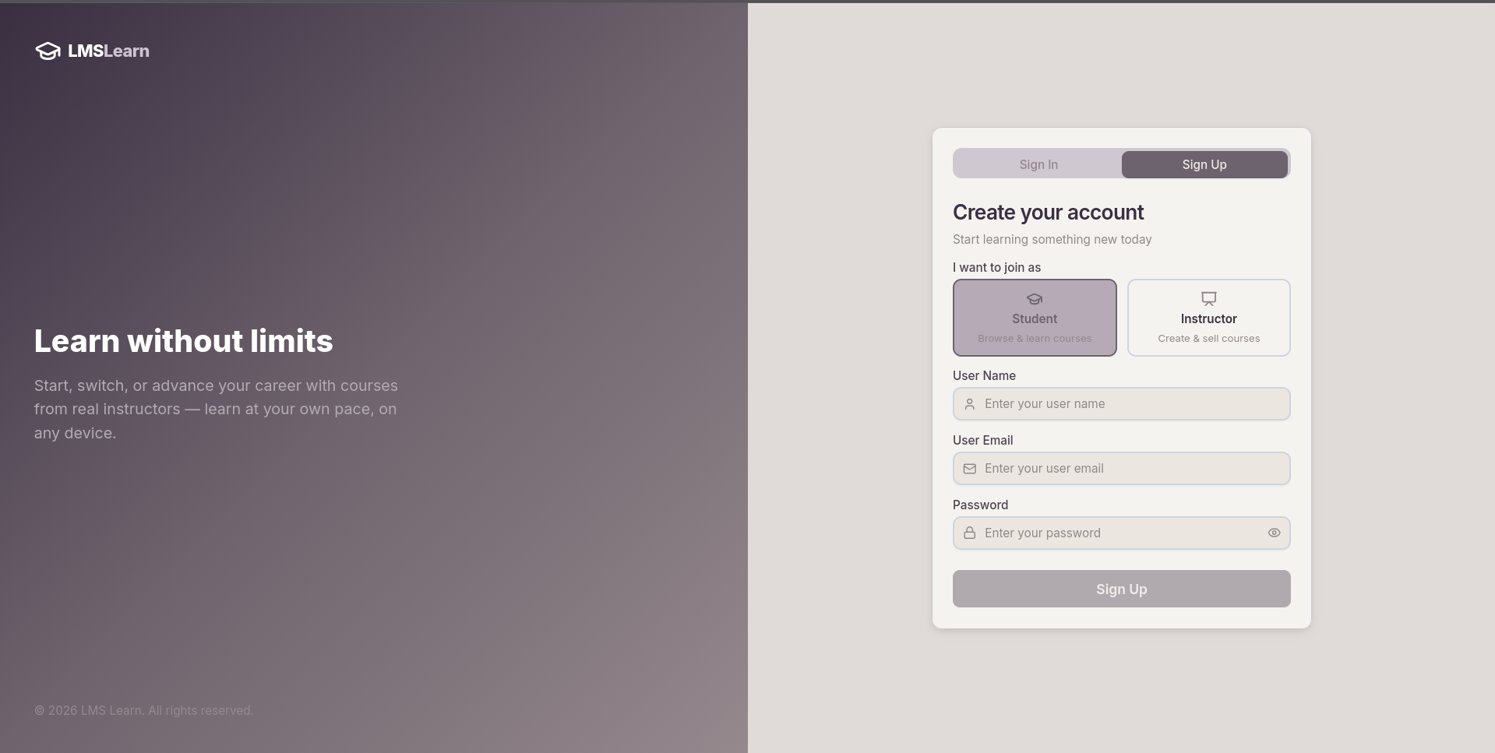
Figure 7.2 – Sign Up Page
7.2 Admin Panel Pages
7.2.1 Admin Overview Dashboard
The Admin Overview page displays key platform statistics across six metric cards: Total Users, Students, Instructors, Total Courses, Total Enrollments, and Total Revenue. The sidebar shows navigation links with the Logout button pinned at the bottom.
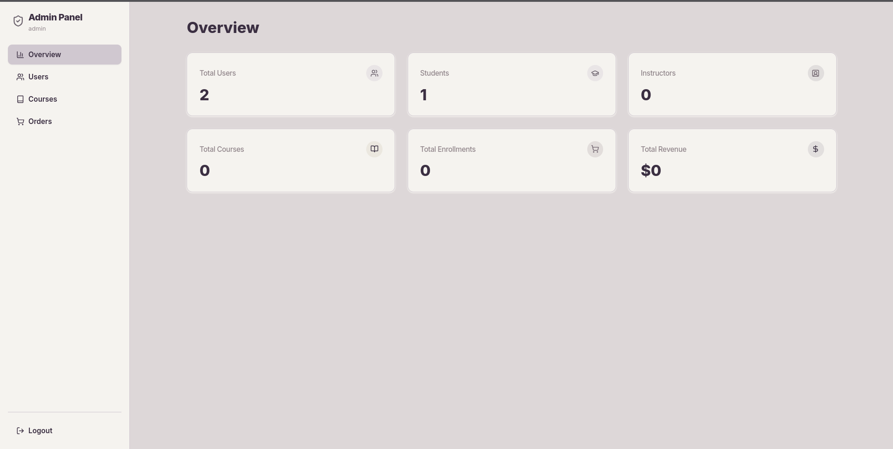
Figure 7.3 – Admin Panel – Overview Dashboard
7.2.2 Admin Users Management
The Users page lists all registered users with their Name, Email, and Role. Admins can change a user's role using a dropdown selector and delete users using the trash icon. The current admin user is indicated with a '(you)' badge.
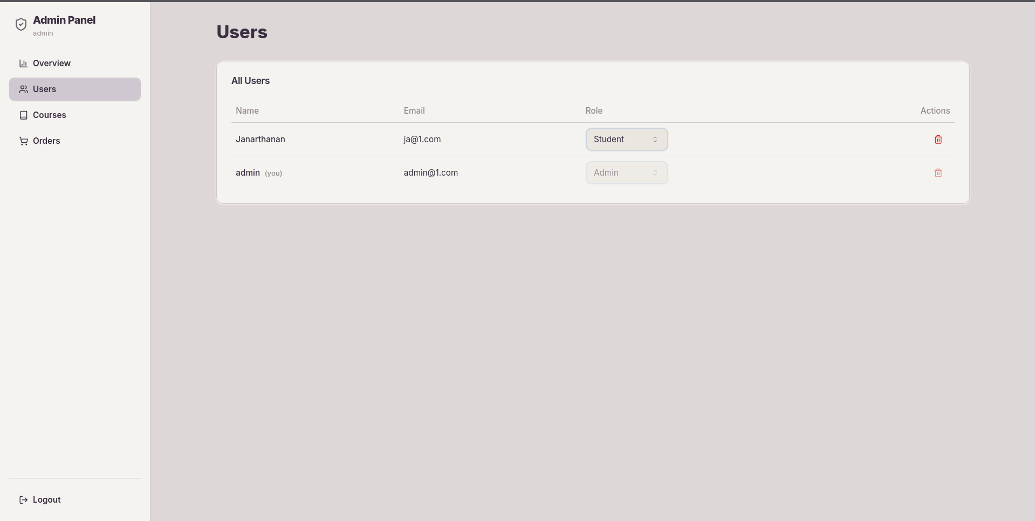
Figure 7.4 – Admin Panel – Users Management
7.2.3 Admin Courses Management
The Courses page shows all courses published on the platform in a table with columns for Course, Instructor, Students enrolled, Revenue generated, and Action controls for deletion.
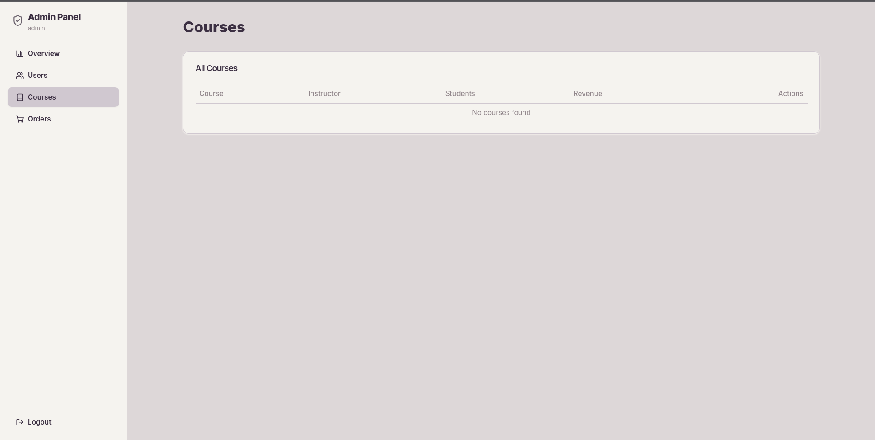
Figure 7.5 – Admin Panel – Courses Management
7.2.4 Admin Orders Management
The Orders page lists all completed course purchases with Course, Student, Amount, Payment method, Order ID, and Date columns, providing full transaction visibility to the admin.
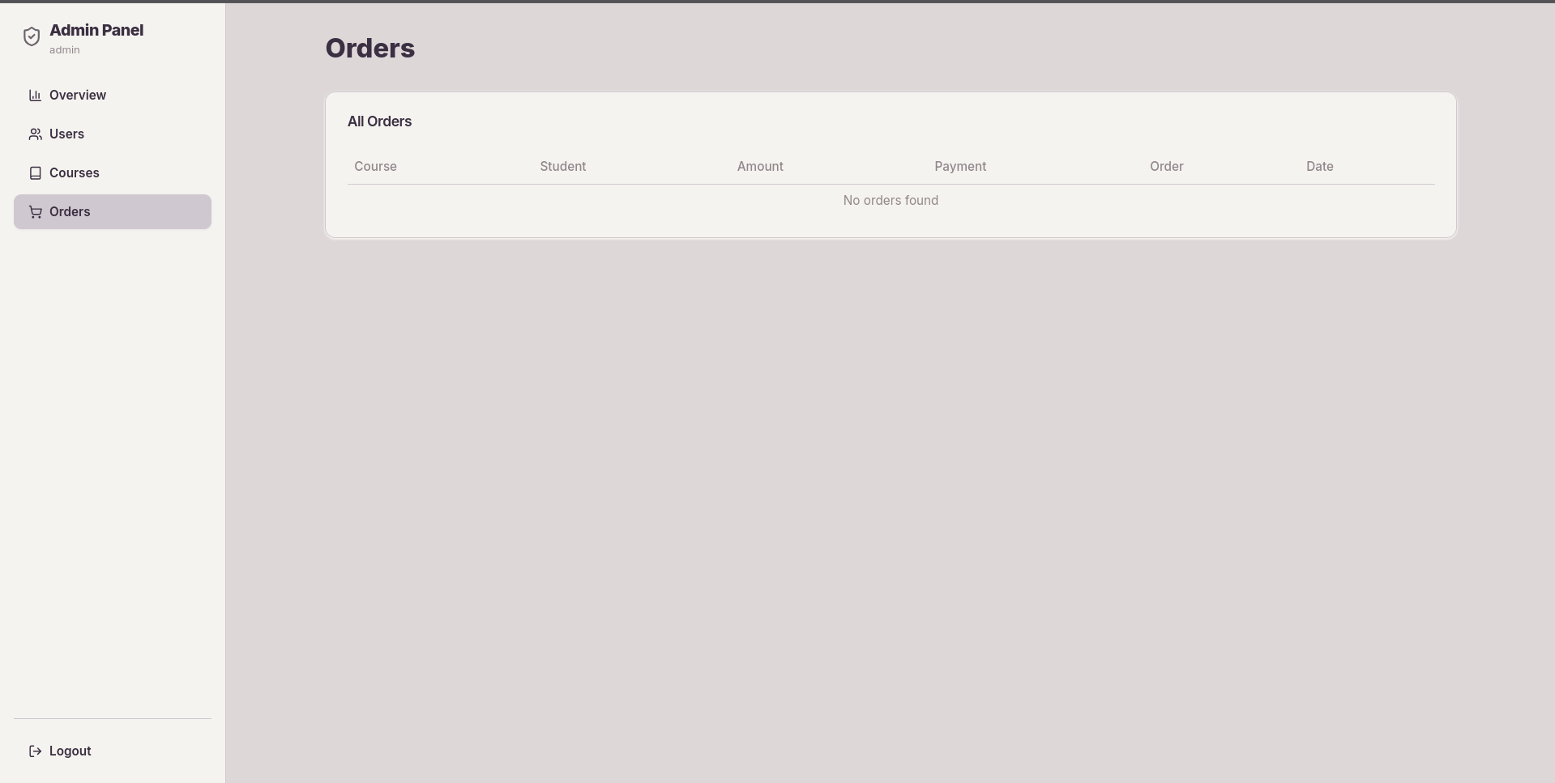
Figure 7.6 – Admin Panel – Orders Management
7.3 Student View Pages
7.3.1 Student Home Page
The Student Home page features a hero banner with the course exploration CTA, a Browse by Category section with pill-shaped category filters, and a Featured Courses grid below. The top navbar provides access to Explore Courses, My Learning, Profile, and Sign Out.
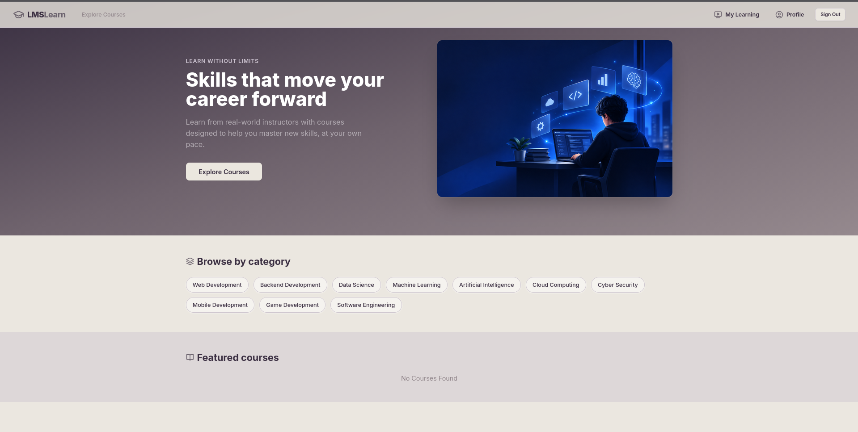
Figure 7.7 – Student Home Page
7.3.2 Student My Courses Page
The My Courses page shows all courses the student has purchased. When no courses are purchased, a friendly empty-state message is displayed.
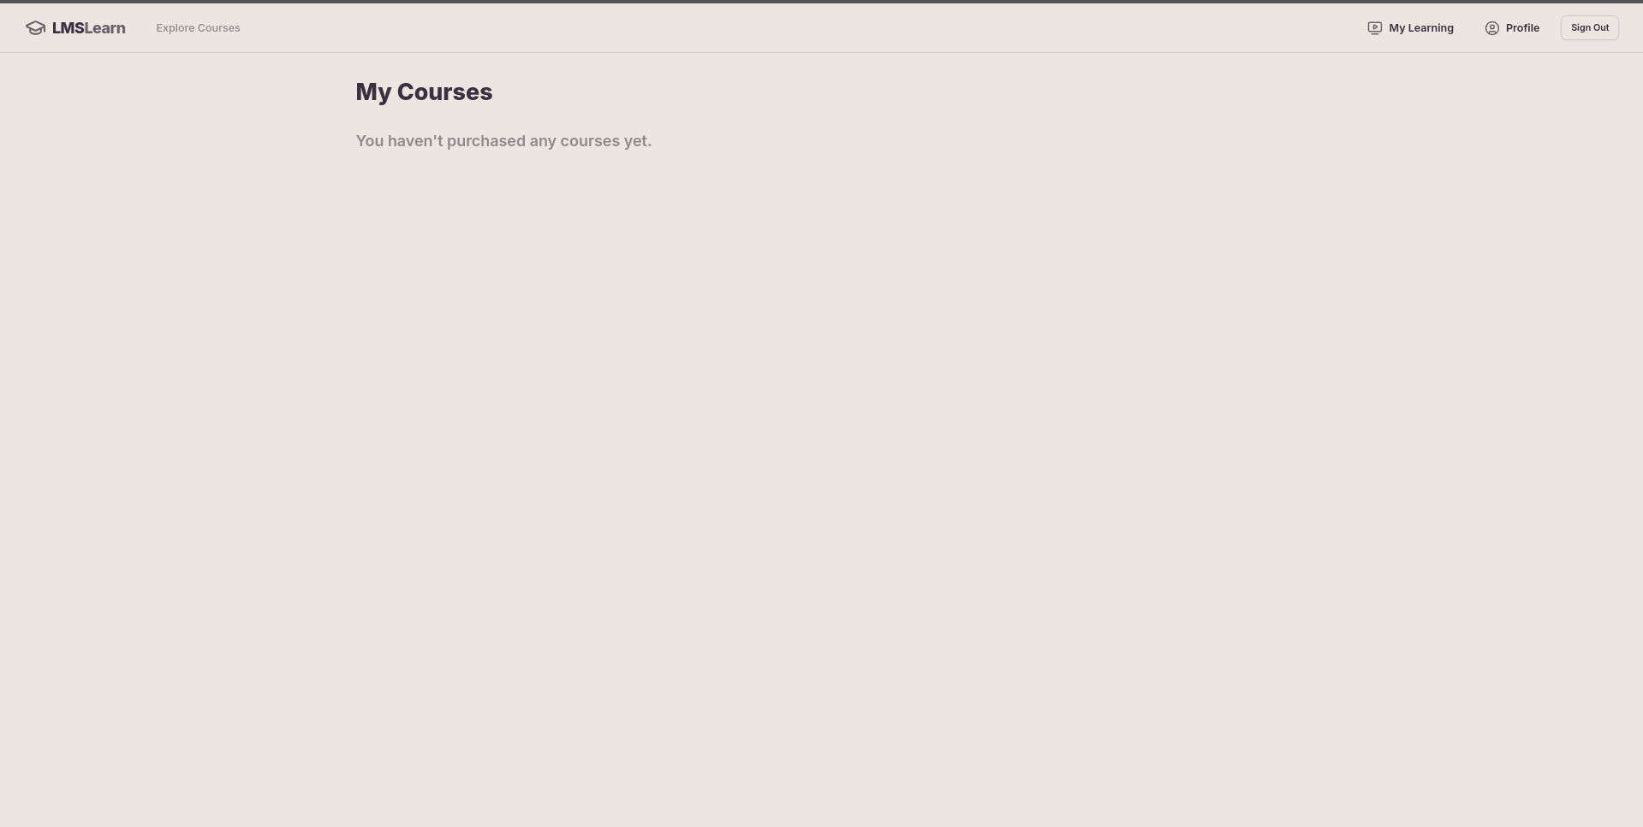
Figure 7.8 – Student My Courses Page
7.3.3 Student Profile Page
The Profile page shows the student's avatar (initial-based), username, email, role badge, number of enrolled courses, and member since date. Tab sections provide Account Details, Security, and My Courses views.
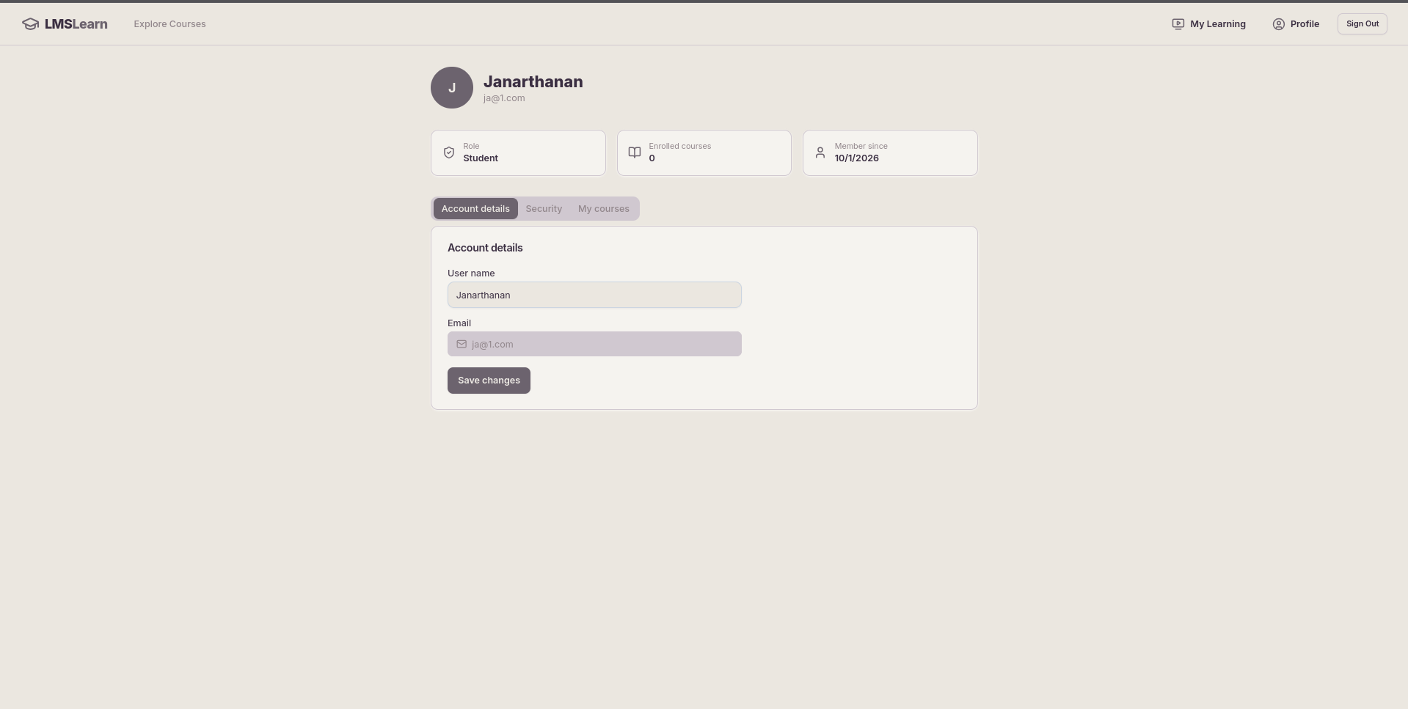
Figure 7.9 – Student Profile Page
7.4 Instructor View Pages
7.4.1 Instructor Dashboard
The Instructor Dashboard displays Total Students enrolled and Total Revenue earned in metric cards, followed by a Students List table showing Course Name, Student Name, and Student Email for each enrollment.
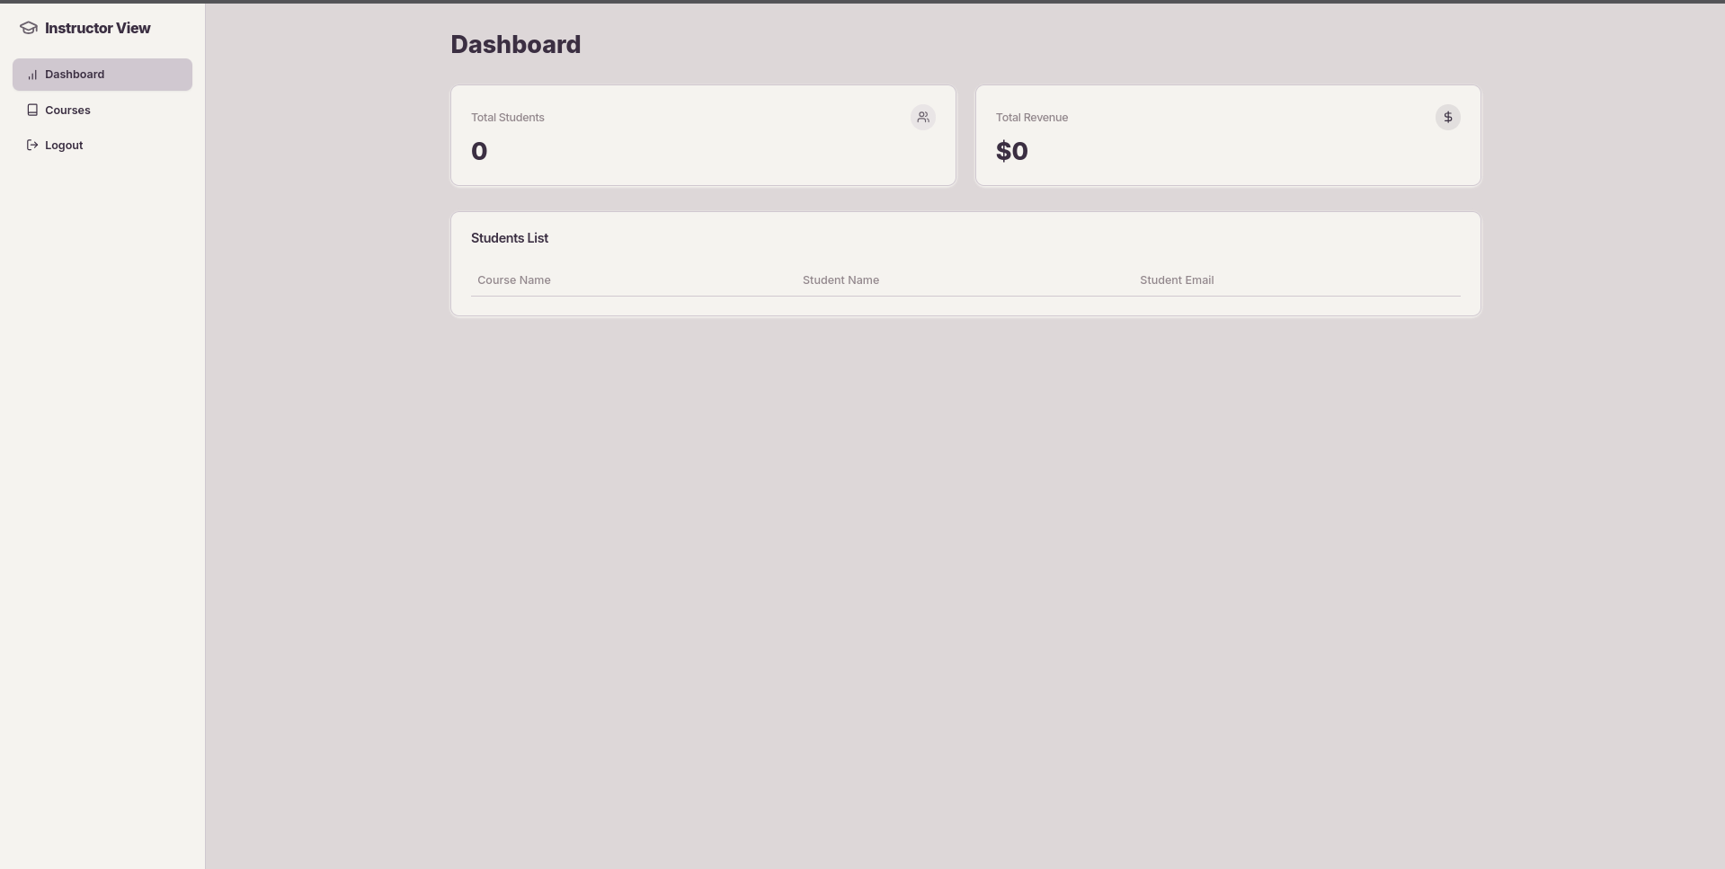
Figure 7.10 – Instructor Dashboard
7.4.2 Instructor Courses Page
The Instructor Courses page lists all courses created by the instructor in a table with columns for Course, Students, Revenue, and Actions. A 'Create New Course' button in the top-right allows adding new courses.
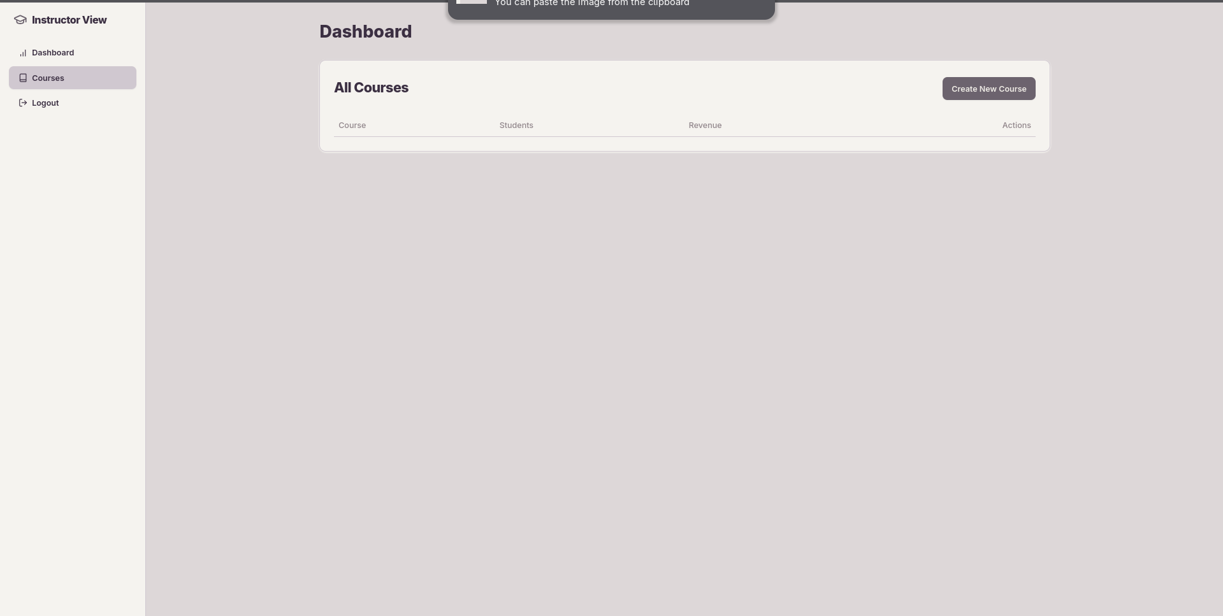
Figure 7.11 – Instructor Courses Page

CHAPTER – VIII
8. FUTURE ENHANCEMENT
1. Mobile Application Integration
A dedicated mobile application can be developed for Android and iOS platforms using React Native, allowing students to access courses, track progress, and receive notifications directly from their smartphones. Offline video downloads for on-the-go learning would be a key feature.
2. AI-Based Course Recommendation
Implementing machine learning algorithms to analyze student browsing and completion patterns, then recommend personalized courses based on their interests, learning history, and goals. This would significantly improve course discovery and student engagement.
3. Live Class Integration
Adding real-time virtual classroom support using WebRTC or third-party services like Zoom SDK or Jitsi, allowing instructors to conduct live sessions, Q&A, and interactive workshops directly within the LMS platform.
4. Discussion Forums and Peer Learning
Implementing course-specific discussion boards where students can ask questions, share resources, and collaborate with peers and instructors, fostering a community-driven learning experience.
5. Certificate Generation
Upon completing a course (100% lecture completion), students can automatically receive a digitally signed PDF certificate with a QR code verification link, providing tangible proof of their learning achievement.
6. Advanced Analytics Dashboard
Providing instructors and admins with detailed analytics charts — enrollment trends, completion rates, revenue over time, and popular categories — using data visualization libraries like Recharts or Chart.js.
7. Multi-Language Support
Adding internationalization (i18n) support to serve a global audience by providing the platform interface in multiple languages, in addition to the existing primary language filter for courses.
8. Quiz and Assessment Module
Enabling instructors to add quizzes, assignments, and assessments to their courses. Student scores would be recorded and displayed in the progress tracker, providing a more structured learning experience.

CHAPTER – IX
9. CONCLUSION
The Learning Management System (LMS Portal) is a comprehensive, efficient, and modern web-based platform designed to streamline the process of creating, managing, delivering, and tracking online courses. The system successfully bridges the gap between instructors who create educational content and students who seek to advance their skills in a structured, online environment.
By leveraging the MERN stack (MongoDB, Express.js, React.js, Node.js) alongside industry-standard services such as Stripe for payments, Cloudinary for media management, and JWT for secure authentication, the LMS Portal provides a production-ready foundation for online learning.
The role-based architecture ensures that each user type — Student, Instructor, and Admin — receives a tailored interface with precisely the tools they need. Students benefit from an intuitive course marketplace with real-time progress tracking. Instructors are empowered with a course builder and revenue dashboard. Administrators maintain full platform oversight through a dedicated management panel.
The TailwindCSS-based UI with the warm mauve-plum color palette delivers a visually cohesive and accessible experience. The implementation of Stripe's secure payment gateway ensures that financial transactions are handled reliably and compliantly.
The future enhancements outlined in Chapter VIII — including mobile applications, AI recommendations, live classes, certificates, and advanced analytics — position the LMS Portal as a scalable platform capable of growing from a college project into a fully-fledged commercial learning management system.
In conclusion, the LMS Portal serves as a reliable, scalable, and user-centric digital platform for online education. It not only demonstrates the practical application of full-stack web development technologies but also addresses real-world challenges in the domain of e-learning, laying the groundwork for future innovation in educational technology.

BIBLIOGRAPHY / APPENDIX
References
1. React Documentation. (2024). React – The library for web and native user interfaces. https://react.dev
2. Node.js Foundation. (2024). Node.js Documentation. https://nodejs.org/en/docs
3. Express.js. (2024). Express – Fast, unopinionated, minimalist web framework for Node.js. https://expressjs.com
4. MongoDB, Inc. (2024). MongoDB Documentation. https://www.mongodb.com/docs
5. Mongoose. (2024). Mongoose – Elegant MongoDB object modeling for Node.js. https://mongoosejs.com
6. Stripe, Inc. (2024). Stripe API Reference. https://stripe.com/docs/api
7. Cloudinary. (2024). Cloudinary Documentation – Image and Video Upload. https://cloudinary.com/documentation
8. Tailwind Labs. (2024). TailwindCSS Documentation. https://tailwindcss.com/docs
9. shadcn. (2024). shadcn/ui – Beautifully designed components. https://ui.shadcn.com
10. JWT.io. (2024). JSON Web Tokens Introduction. https://jwt.io/introduction
11. MDN Web Docs. (2024). JavaScript Reference. https://developer.mozilla.org
12. Vite. (2024). Vite – Next Generation Frontend Tooling. https://vitejs.dev
Abbreviations
Abbreviation | Full Form
LMS | Learning Management System
MERN | MongoDB, Express.js, React.js, Node.js
JWT | JSON Web Token
API | Application Programming Interface
REST | Representational State Transfer
CRUD | Create, Read, Update, Delete
UI | User Interface
UX | User Experience
CSS | Cascading Style Sheets
ODM | Object Document Mapper

