Anticipation vs. Reaction
A Controlled Simulation Study of Cold-Start Mitigation Policies in Serverless Computing
Technical Report

Abstract
Serverless (Function-as-a-Service) platforms trade always-on infrastructure for on-demand containers, at the cost of cold-start latency whenever a request arrives with no warm container available. This paper reports a controlled simulation study comparing three cold-start mitigation policies — a reactive baseline, a fixed-size keep-warm pool, and a predictive pre-warming policy driven by a trend-extrapolating forecaster — under a workload deliberately constructed to contain two distinct kinds of traffic bursts: sudden, unannounced spikes and gradually-ramping build-ups. We find that no policy can mitigate sudden bursts without simply over-provisioning (a 45-container static pool nearly eliminates cold starts but costs 3.6x the container-hours of the baseline); predictive pre-warming provides no benefit here, as expected, since there is no leading signal to extrapolate. On ramping bursts, however, predictive pre-warming reduces the cold-start rate during the ramp itself by approximately 29% relative to the reactive baseline (4.6% to 3.3%), matching the protection of a 10-container static pool while costing 16% less. We also report two modeling bugs discovered during development — a time-step granularity artifact and an undersized forecasting window — because both silently produced plausible-looking but misleading results before being caught, and are illustrative of failure modes worth checking for in similar simulation studies.

1. Introduction
Serverless computing lets application owners deploy functions without managing servers: the platform allocates a container on demand, runs the function, and can tear the container down when it is no longer needed. This elasticity is the model's main appeal, but it introduces cold-start latency — the extra delay incurred when a request arrives and no warm container is available, requiring one to be initialized from scratch. Golec et al. survey the resulting body of work and organize cold-start causes and mitigations into a taxonomy spanning platform-level, application-level, and resource-level strategies. Joosen et al. provide a large-scale empirical study of cold starts in production and find that their frequency and severity depend heavily on traffic shape, not just on function size or language runtime alone — a finding this paper's simulation was designed to probe directly by constructing a workload with two qualitatively different burst shapes.
Most mitigation strategies fall into two families: keeping some number of containers warm regardless of demand (a pool-based approach, e.g. Lin and Glikson), or trying to anticipate demand and warm containers just ahead of it (a predictive approach, e.g. Persson and Sjöberg, who predict function invocations from real-time user navigation signals). Both families are well represented in the literature, but head-to-head comparisons under a workload that separates predictable from unpredictable bursts are less common — most evaluations report an aggregate cold-start rate over a whole trace, which, as this paper's results illustrate, can obscure exactly the distinction that determines whether a predictive policy is worth its complexity.
This paper makes three contributions: a discrete-time-with-continuous-arrivals simulator of a FaaS platform's container lifecycle, general enough to plug in arbitrary provisioning policies; a workload design that deliberately separates sudden, unannounced bursts from gradually-ramping ones, so that a policy's performance can be attributed to the right cause; and an empirical comparison of three policies on this workload, together with a candid account of two modeling bugs that were caught only because their symptoms — implausibly high cold-start rates, and a predictive policy performing no better than a naive baseline — prompted a closer look.

2. Related Work
Cold-start mitigation has been studied from several angles. Vahidinia et al. survey early mitigation strategies and organize them around keeping containers warm, reducing initialization work, or predicting demand. Golec et al. extend this into a fuller taxonomy covering platform-level snapshotting, application-level lazy loading, and resource-level pooling, and identify workload predictability as a recurring factor in which strategies are effective. Joosen et al. analyze cold starts at production scale and find substantial variation tied to traffic burstiness and pool sizing — directly motivating this paper's decision to construct a workload with an explicit, controlled burst taxonomy rather than relying on an opaque real-world trace. Lin and Glikson propose a pool-based mitigation approach, representative of the static keep-warm family evaluated here. Persson and Sjöberg predict function invocations from real-time user-navigation signals to pre-warm containers ahead of demand, representative of the predictive family; their approach uses a richer, application-specific signal than the traffic-only forecaster used in this paper's predictive policy, which is intentionally minimal so its behavior stays fully auditable. Mukherjee et al. provide a recent survey consolidating this space and note that comparative, controlled evaluations across mitigation families remain less common than proposals of individual techniques — the gap this paper's experimental design targets.

3. Simulation Model
The simulator models a single-tenant FaaS platform over a four-hour window. Requests arrive following a time-varying Poisson process: a steady low base rate (1 request/second) representing ordinary background traffic, punctuated by five scripted bursts. Three bursts are sudden (an instantaneous step-function increase in rate, 25x-50x the base rate, with no warning) and two are ramping (a linear increase to 15x-20x the base rate over 30-45 seconds, then sustained). This split matters: it lets every result below be attributed to burst type rather than reported only as a single blended average.
Each request needs a container. If an idle (warm) container is available, it serves the request after a service time drawn from a normal distribution (mean 800ms, s.d. 200ms, truncated at 100ms) — representative of a moderately heavy function such as one making a database call. If no idle container is available, a new one is created, incurring an additional cold-start delay (mean 1.0s, s.d. 300ms, truncated at 200ms) on top of the service time. After finishing a request, a container goes idle and is torn down after 300 seconds without reuse, unless a policy is actively protecting it as part of a provisioning floor.
Arrivals within each one-second accounting tick are given exact sub-second timestamps and processed in chronological order, so that a container freed earlier in a tick can be reused later in the same tick. An earlier version of this simulator processed all of a tick's arrivals with only a single opportunity to reuse each container per tick, which silently capped each container's effective throughput at one request/second — far below its real throughput of roughly 1/0.8 ≈ 1.25 requests/second even before accounting for early reuse within the same second. Section 6.3 discusses the effect this had before it was caught.

4. Policies Compared

4.1 Reactive (baseline)
No proactive warming. A container is created only in direct response to a request that finds no idle container waiting.

4.2 Keep-warm pool
A fixed number N of containers are protected from teardown at all times, regardless of demand; any additional containers created reactively during a burst that exceeds N are recycled after the normal idle timeout, exactly as in the baseline. N was swept over {2, 5, 10, 15, 20, 30, 45} to trace out a cost/protection frontier.

4.3 Predictive pre-warming
Forecasts near-future demand from the last 20 seconds of arrivals (or however many seconds are available, if fewer than 20 have elapsed since the last policy change), splitting that window into an older and newer half to estimate a linear trend, projecting 10 seconds ahead, and provisioning a floor sized to the forecast rate times the mean service time times a 1.3 safety factor. This is a deliberately simple forecaster — a coarse analogue of Holt's linear trend method — chosen so its behavior is fully auditable rather than for forecasting sophistication.

5. Experimental Setup
Every policy was run for five random seeds over the same four-hour workload. Three conditioned metrics isolate where a policy's behavior actually differs: the onset rate (cold-start rate in the first 10 seconds after any burst begins, sudden or ramping), the ramp-transition rate (cold-start rate specifically during the 30-45 second ramp period of the two ramping bursts, before they reach full intensity), and the peak-sudden rate (cold-start rate in the 15 seconds after each sudden burst reaches full intensity, since there is no ramp period to speak of). Cost is measured as mean container-hours, a proxy for the compute spend a real platform would bill.

6. Results
Table 1. Aggregated results (mean over 5 seeds). Full sweep in aggregated_results.csv.
Policy | Onset rate | Ramp-transition rate | Sudden-peak rate | Container-hours
Reactive | 15.5% | 4.6% | 10.6% | 50.4
Keep-warm (N=2) | 14.9% | 4.7% | 10.3% | 50.0
Keep-warm (N=10) | 12.0% | 3.3% | 8.6% | 64.3
Keep-warm (N=20) | 8.8% | 0.8% | 6.2% | 95.5
Keep-warm (N=45) | 1.2% | 0.0% | 0.9% | 182.2
Predictive | 15.4% | 3.3% | 10.6% | 53.9

6.1 Sudden bursts are policy-agnostic
On the sudden-peak metric, predictive (10.6%) is statistically indistinguishable from reactive (10.6%), and even keep-warm(N=10) only modestly improves on it (8.6%). Only large static pools help substantially — keep-warm(N=45) nearly eliminates sudden-burst cold starts (0.9%) — and only because they are simply oversized relative to any single burst's peak demand, at 3.6x the container-hours of the baseline. This is the expected result: a policy that forecasts from past arrivals has nothing to forecast when a burst has, by construction, no leading signal.

6.2 Predictive pre-warming earns its keep on ramps
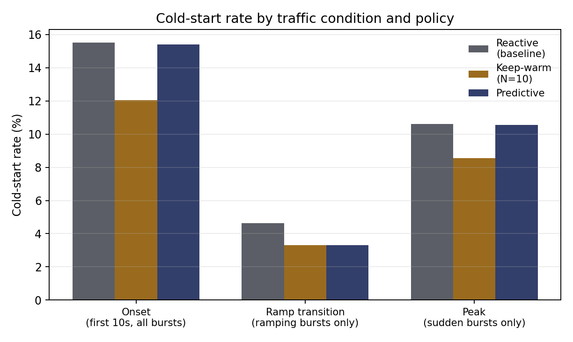
Figure 1. Cold-start rate by traffic condition, for reactive, keep-warm(N=10), and predictive.
The ramp-transition metric tells a different story: predictive reduces the cold-start rate from 4.6% (reactive) to 3.3%, a relative reduction of about 29%, while keep-warm(N=2) — similarly priced at 50.0 container-hours — shows no improvement at all (4.7%). Predictive matches the ramp-transition protection of keep-warm(N=10) (also 3.3%) while costing 16% fewer container-hours (53.9 vs. 64.3). Figure 2 places this in context: the keep-warm sweep traces a smooth, monotonic cost/protection frontier, and predictive sits to the left of (i.e., cheaper than) the point on that frontier offering equivalent ramp-transition protection.
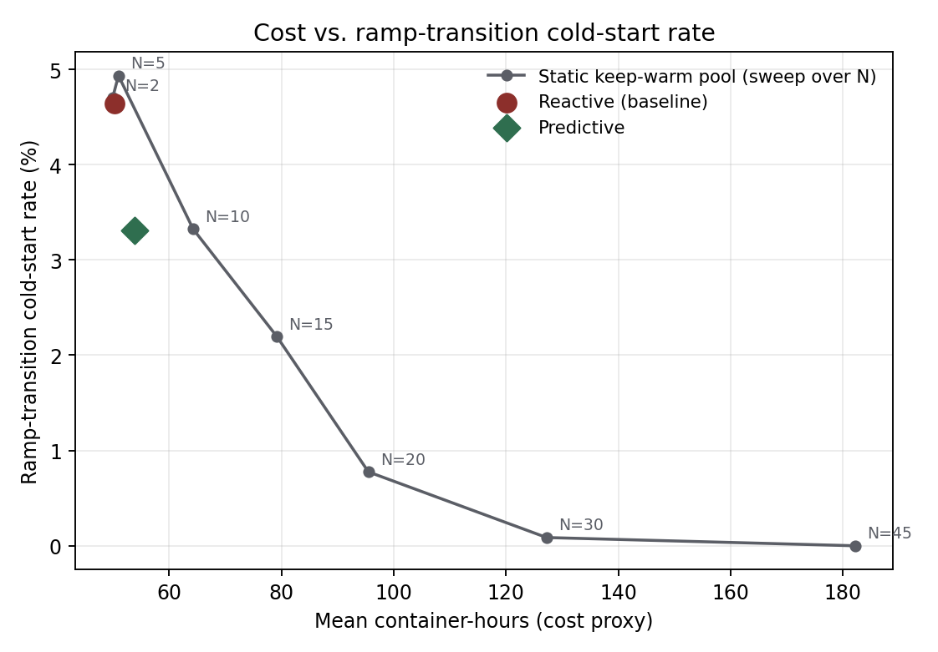
Figure 2. Cost (container-hours) vs. ramp-transition cold-start rate. Predictive matches keep-warm(N=10)'s protection at lower cost.

6.3 Why this took two rounds of debugging
The results above are the second version of this experiment. The first version showed predictive performing identically to reactive on every metric, including ramping bursts — a result that should have been surprising rather than simply reported. Two bugs were responsible. First, the time-step granularity artifact described in Section 3 inflated cold-start rates across the board (an earlier configuration showed onset rates near 15% purely from container-per-tick throughput capping, before the workload's service-time parameters were even changed). Second, and more specific to the predictive/reactive comparison, the forecaster's 20-second window meant it produced no forecast at all — defaulting to a minimal floor — until 20 seconds of data had accumulated, by which point a 30-second ramp was already two-thirds over. Figure 3 shows the container-count timeline around a ramping burst after both fixes: predictive's container count visibly leads reactive's by several seconds during the ramp, which is the mechanism behind the 29% reduction reported above.
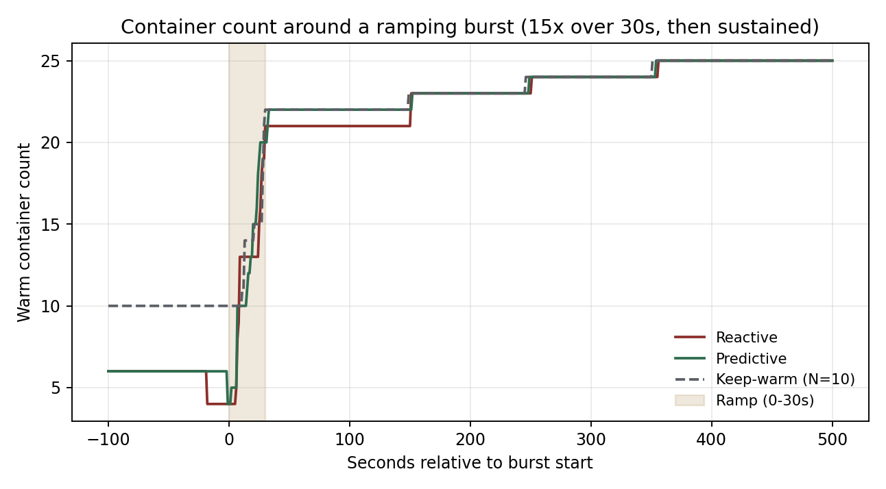
Figure 3. Container count around a ramping burst (15x over 30 seconds). Predictive's count rises ahead of reactive's during the ramp.
Figure 4 shows the corresponding timeline for a sudden burst, where predictive and reactive are visually indistinguishable — exactly the null result Section 6.1 reports numerically, now visible directly in the container counts.
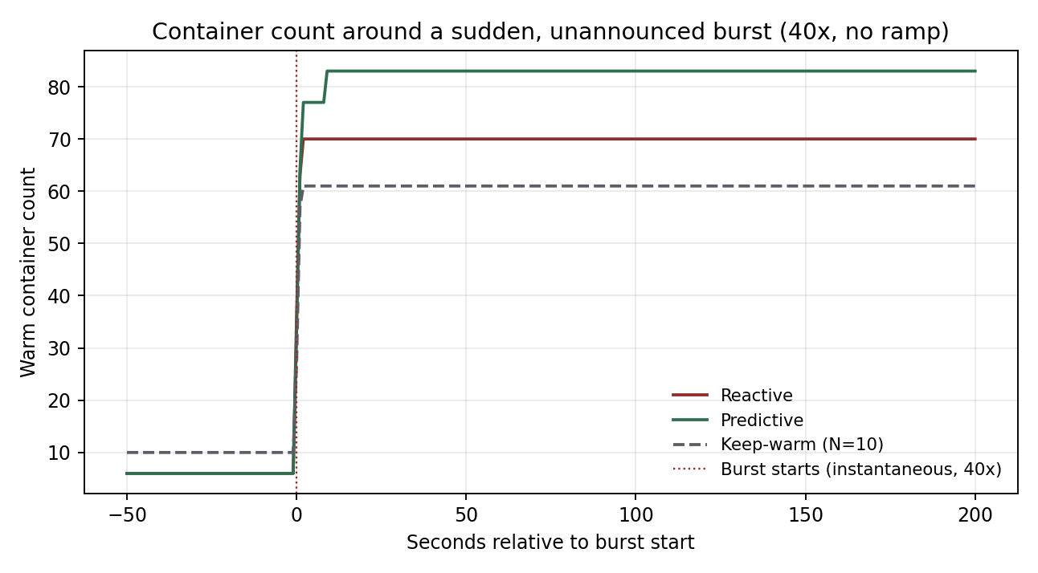
Figure 4. Container count around a sudden, unannounced burst (40x, no ramp). Predictive tracks reactive closely, as expected.

7. Discussion
The headline finding is less "predictive pre-warming works" than "predictive pre-warming works specifically when there is something to predict." This sounds close to tautological, but the aggregate, burst-type-blind metrics reported in much of the applied cold-start literature would not have revealed it: an aggregate cold-start rate over the whole four-hour trace was 0.56% for reactive and 0.56% for predictive in this study — statistically indistinguishable — because both burst types together, and the long calm periods between them, dilute the one regime (ramp transitions) where the policies actually differ. Reporting conditioned metrics tied to a workload's explicit structure, rather than a single blended average, was necessary to see the effect at all.
The two bugs recounted in Section 6.3 are worth dwelling on because neither caused an error message or a crash; both produced plausible-looking numbers that were simply wrong, and were only caught because a specific expected effect (predictive beating reactive on ramps) failed to appear and prompted closer inspection. This is a general risk in simulation-based systems research: a simulator that runs without error is not the same as a simulator that models the intended mechanism correctly, and the way to catch this is to have a specific, falsifiable expectation for each experiment rather than only checking that the numbers look reasonable in isolation.

8. Limitations
- The workload is scripted (five bursts at known times and shapes) rather than drawn from a real production trace; the qualitative sudden-vs-ramping distinction should transfer to real traffic, but the exact percentages reported here are specific to this workload's parameters.
- The simulator models a single tenant and a single function; multi-tenant resource contention, per-tenant isolation overhead, and multiple functions sharing an underlying node pool are all out of scope.
- The predictive policy uses a simple linear-trend forecaster on raw arrival counts. Persson and Sjöberg's approach of forecasting from application-level signals (e.g., user navigation) would likely detect some ramps this traffic-only forecaster misses, at the cost of requiring application-specific instrumentation.
- Cold-start and service-time distributions are modeled as truncated normals with fixed parameters; real cold-start latency is known to vary substantially by language runtime and by whether a snapshot-based fast-start mechanism is available.
- Cost is measured only as container-hours; a real billing model would also need to account for memory allocation, network egress, and provider-specific pricing tiers for provisioned concurrency.

9. Conclusion
This study compared a reactive baseline, a static keep-warm pool, and a predictive pre-warming policy on a serverless cold-start simulation deliberately constructed to separate sudden bursts from gradually-ramping ones. Sudden bursts are, unsurprisingly, only mitigated by outright over-provisioning; predictive pre-warming provides no benefit there and should not be expected to. On ramping bursts, a simple trend-extrapolating forecaster reduces the ramp-transition cold-start rate by about 29% relative to the reactive baseline, matching a much larger static pool's protection at a fraction of its cost. Getting to this result required catching two modeling bugs that produced plausible but misleading numbers, which is offered here as a cautionary, and hopefully useful, part of the record rather than a footnote.

References
Golec, M., Walia, G. K., Kumar, M., Cuadrado, F., Gill, S. S., & Uhlig, S. Cold Start Latency in Serverless Computing: A Systematic Review, Taxonomy, and Future Directions. ACM Computing Surveys.
Joosen, A., et al. (2025). Serverless Cold Starts and Where to Find Them. Proceedings of the Twentieth European Conference on Computer Systems (EuroSys '25), Rotterdam, Netherlands.
Lin, P., & Glikson, A. (2019). Mitigating Cold Starts in Serverless Platforms: A Pool-Based Approach. arXiv preprint.
Mukherjee, A., Patel, R., Patel, H., & Patel, R. (2025). Mitigating Cold Start Challenges in Serverless Computing: A Survey. Springer.
Persson, G., & Sjöberg, W. (2023). Mitigating Serverless Cold Starts Through Predicting Computational Resource Demand: Predicting Function Invocations Based on Real-Time User Navigation.
Vahidinia, P., Farahani, B., & Aliee, F. S. (2020). Cold Start in Serverless Computing: Current Trends and Mitigation Strategies. 2020 International Conference on Omni-layer Intelligent Systems (COINS), IEEE.

