.NET Framework using C# (MCAE0402) – Class Assignment

MASTER OF COMPUTER APPLICATION
Department of Computer Engineering & Applications

Session- 2025 – 26
Practical File

SubjectName & Code:

Course: Semester: Section:
Class Roll No: University Roll No:
.NET FrameworkusingC#

2484200082
(MCAE 0402)

Submitted To Submitted By

Dr. Sachendra SinghChauhan (Assistant Professor)
Janavi Agrawal

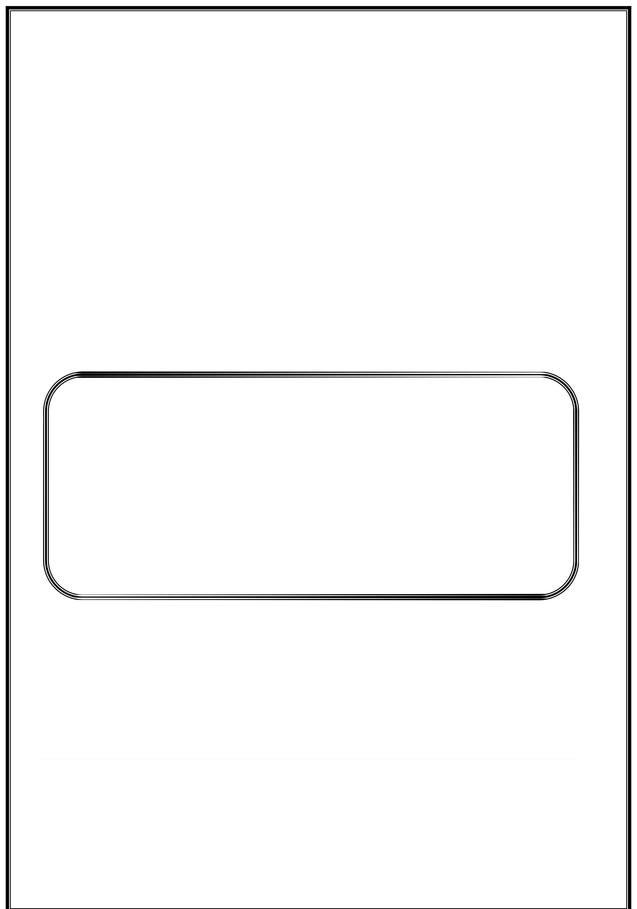

1| Page

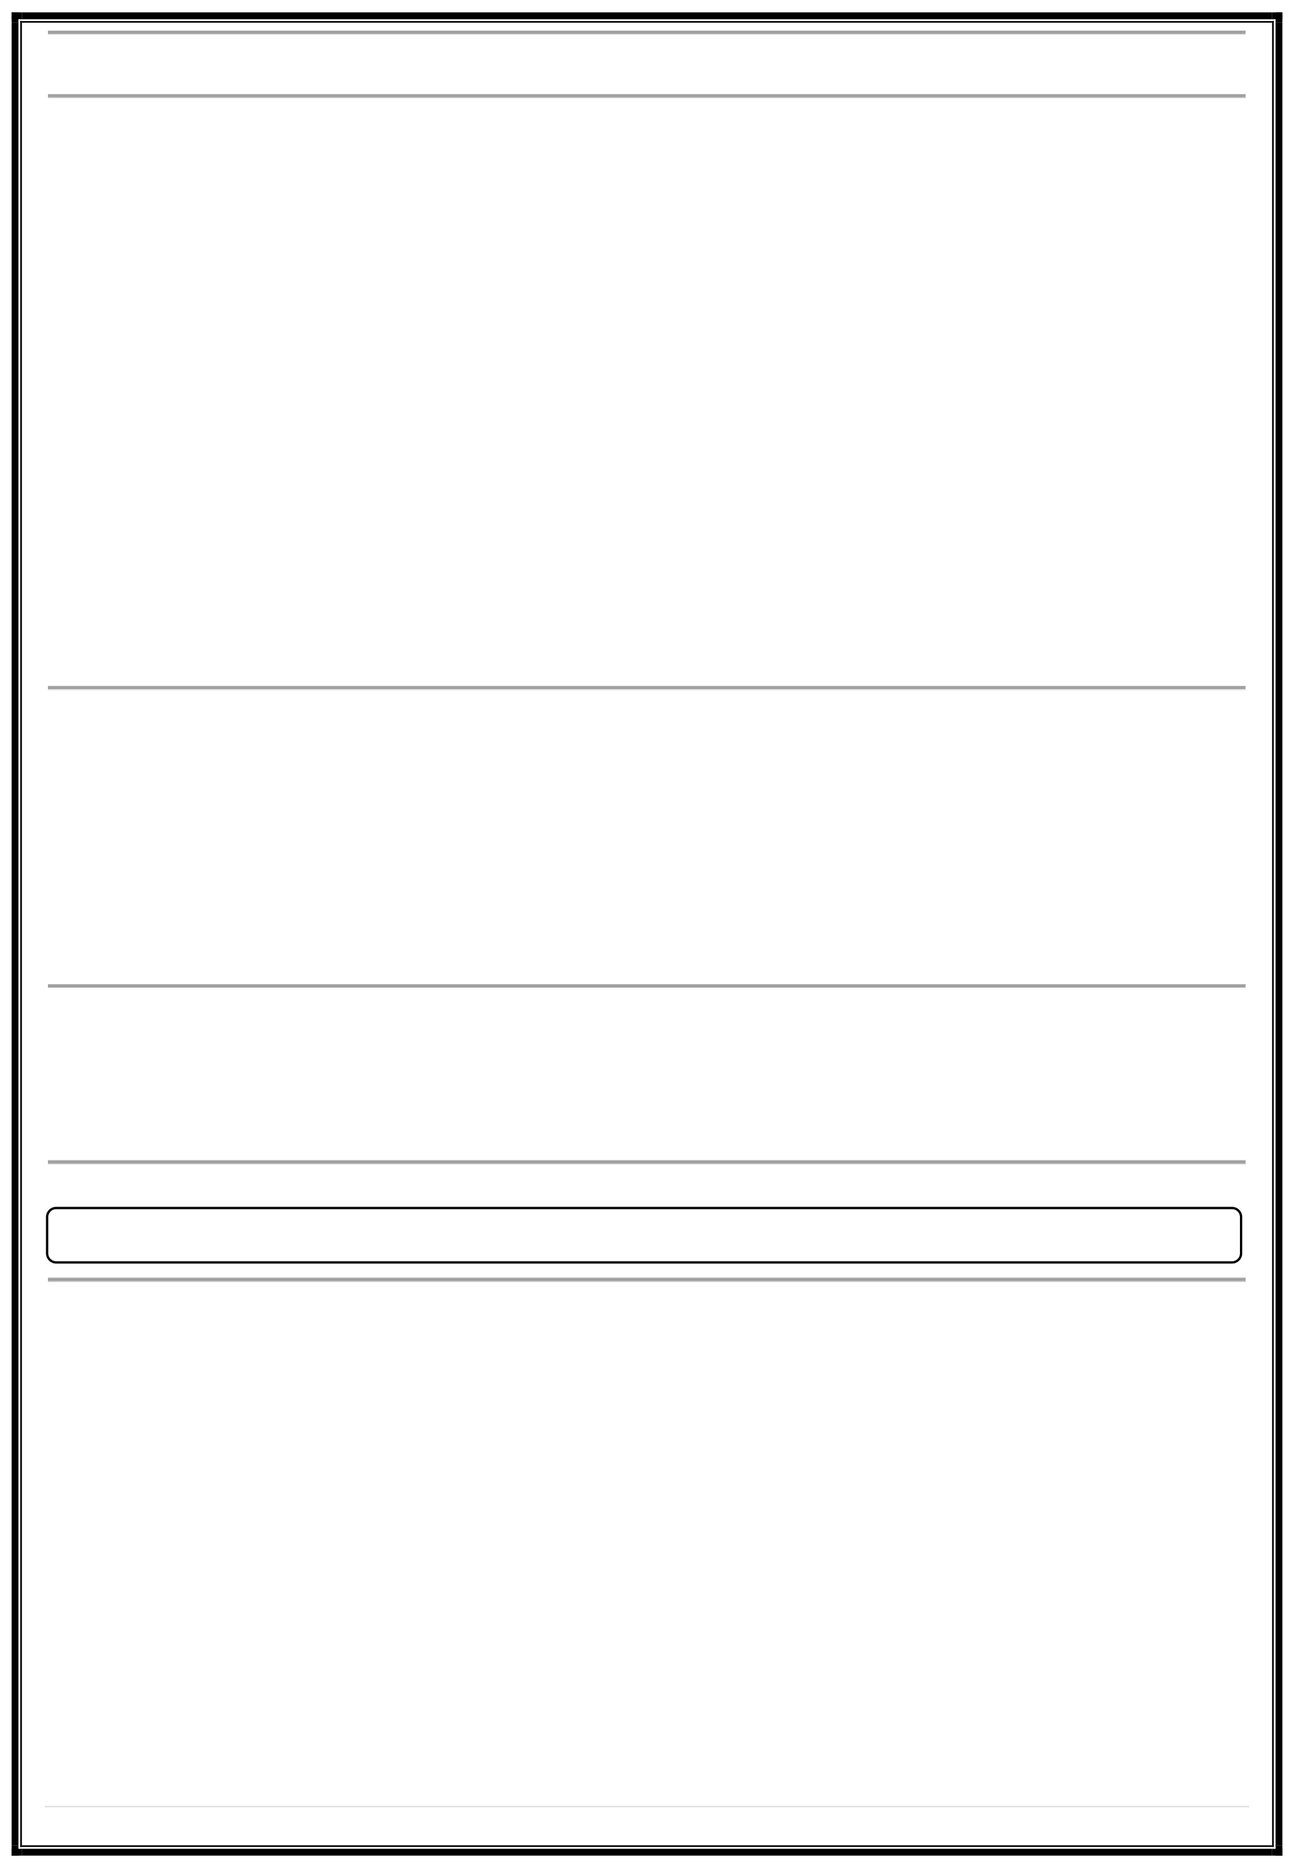
.NET Framework using C# (MCAE0402) – Class Assignment Question 1:
Imagine you are explaining the .NET Framework architecture to a colleague unfamiliar with the framework. How would you break down the architecture and its components, such as the CLR, FCL, and the application domains? Provide a structured explanation.
Answer:

iTshapeo.NwEerTfuFlsroafmtweawreoprlkataforrcmhitedcetvuerleopedbyMicrosoft. Itprovidesaconsistent environment for developingandrunning applicationswrittenin differentprogramming languagessuchasC#, VB.NET, or F#.

Itmainly consists of three corecomponents:
- Common Language Runtime (CLR):
  - The CLR is like the engine ofthe.NETFramework.
  - Itprovides crucial servicessuchas:
    - Memory management (allocatingandfreeing memory automatically)
    - Garbage collection
    - Exception handling
    - Security management
  - Italso convertsthe Intermediate Language (IL) code (produced by the compiler) into native machine code
using the Just-In-Time (JIT)compiler.
ThinkofCLRastheheart of .NET — it runs your program efficiently and safely.

- Framework Class Library (FCL):
  - The FCL is a large collectionof pre-built, reusable classes and functions.
  - Itcontains classes for:
    - File handling (System.IO)
    - Database operations (System.Data)
    - Collections (System.Collections)
    - Networking (System.Net)
    - User interfaces (System.Windows.Forms)
It savestime—youdon’thavetowritecommonfunctionalitiesfromscratch.

- Application Domains:
  - An Application Domain (AppDomain) is an isolated environment where .NET applications run.
  - It provides isolation betweenapplications.
  - If one applicationcrashes,others arenot affected.
  - CLR manages these application domains internally.

Overall Architecture Flow:
C# Code → Compiler → Intermediate Language (IL) → CLR (JIT) → Executes using FCL

Question 2:
In a team meeting, you are asked to explain key .NET Framework runtime concepts like the Common Language Runtime (CLR), Common Type System (CTS), and Common Language Specification (CLS). How would you present these to ensure clarity and relevance to the team's work?
Answer:
Thesethreeconcepts — mCulLtipRle, lCanTgSu,aagnesd. CLS —formthefoundationofhow.NETrunscodeconsistentlyacross
- Common Language Runtime (CLR):
  - rAMucantnstaimsgtehesetehneveirxoencumtieonntof all .NET opfr.oNgEraTm. s.
  - Responsibilities include:

    - Memory management
    - Type safety
    - Security
    - Garbage collection
    - Thread management

2| Page

.NET Framework using C# (MCAE0402) – Class Assignment

Example: When you run a C# program, CLR takes care of converting IL code to native code and running it on the system.
- Common Type System (CTS):
  - Defines howdata typesare declared and used in the .NET environment.
  - Ensures all .NET languages (C#, VB.NET, F#) use the same type definitions.
Example:
  - int in C# and Integer in VB.NET are treated as the same type (System.Int32) because of CTS.
  - This allows seamless data sharing between different .NET languages.

- Common Language Specification (CLS):
  - A set of rules that all.NET languages must follow for interoperability.
  - Ensures thatcode writtenin one.NET language can be used in another.
Example:
If your C# code uses an unsigned integer (uint), it might not be CLS-compliant since VB.NET doesn’t support unsigned types.

Summary Table:

Concept Meaning Purpose

CLR CTS CLS
Common Language Runtime Common Type System
Common Language Specification
Executes code, manages memory & errors Ensures consistent data types
Enables multi-language compatibility

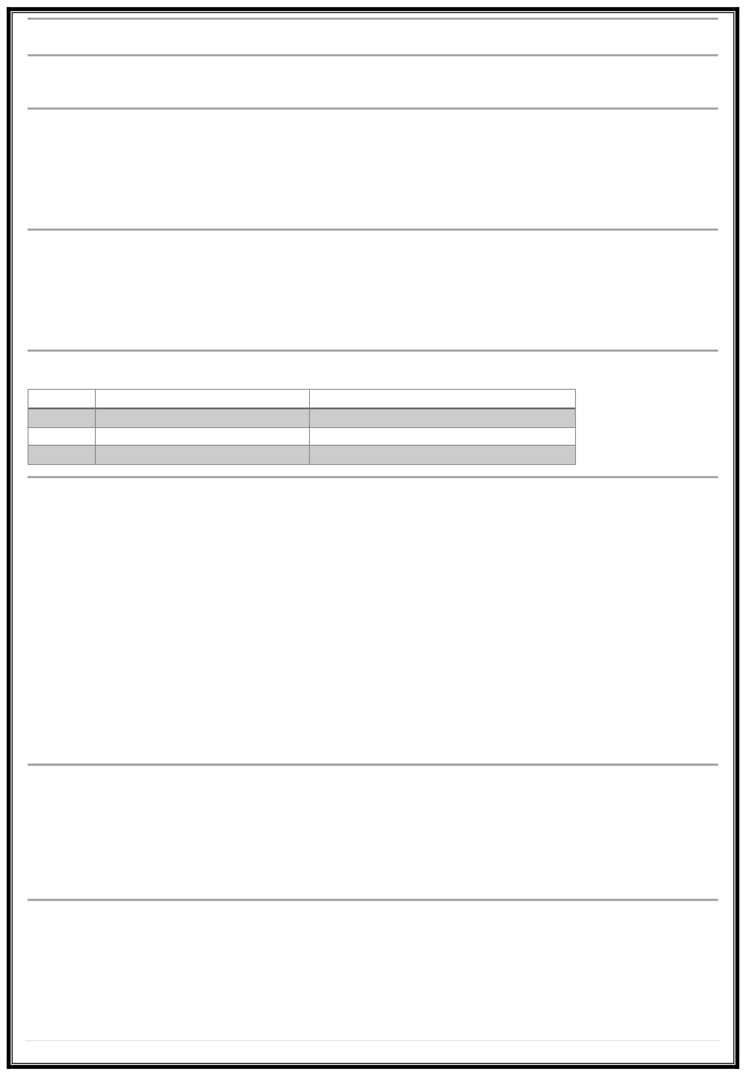
Question 3:
You are developing a large-scale application and need to explain to a junior developer how assemblies are used in .NET Framework to organize and deploy the application. Provide an explanation of assemblies and include an example scenario where multiple assemblies are used.
Answer:
An Assembly is the basic building block of a .NET application. It is a compiled code library used for deployment, versioning, and security.
Key Points:
  - An assembly can be:
    - .exe file → executable program
    - .dll file → reusable library
  - Each assembly contains:
    - IL code (compiled code)
    - Metadata (information about the code)
    - Manifest (details like version, culture, references)
    - Resources (images, text files, etc.)

Types of Assemblies:
- Private Assembly:
  - Usedbyasingleapplication.
  - Storedinthesamefolder as theexecutable.
- Shared Assembly:
  - Canbeusedbymultiple applications.
  - Stored in the Global Assembly Cache (GAC).
Example Scenario:
Supposeyou build an e-commerce application. You can organize like this:
- UI.dll → Contains user interface classes.
- BusinessLogic.dll → Contains calculations and validation.
- DataAccess.dll → Handles database connectivity.
These assemblies can be independently developed and maintained, making the system modular and easy to update.

3| Page

.NET Framework using C# (MCAE0402) – Class Assignment Question 4:
In your project, you notice a developer struggling to organize classes and methods properly. How would you explain the concept of namespaces in .NET Framework and demonstrate how they are used to avoid naming conflicts in large projects?
Answer:
A Namespace in .NET is a logical grouping of related classes, interfaces, and methods. It helps organize code and prevents naming conflicts.
Why Use Namespaces:

- Avoids confusion when differentparts ofaprojectusethesameclassnames.
- Makes large projects easier to manage.
- Provides structure and clarity.

ExampleWithout Namespace:

classEmployee
{ }
public void Display() => Console.WriteLine("From HR Department"); classEmployee
{ }

public void Display() => Console.WriteLine("From Sales Department");

Thiswill cause a naming conflict Example With Namespace:
namespace HR
{
because both classes have the same name.

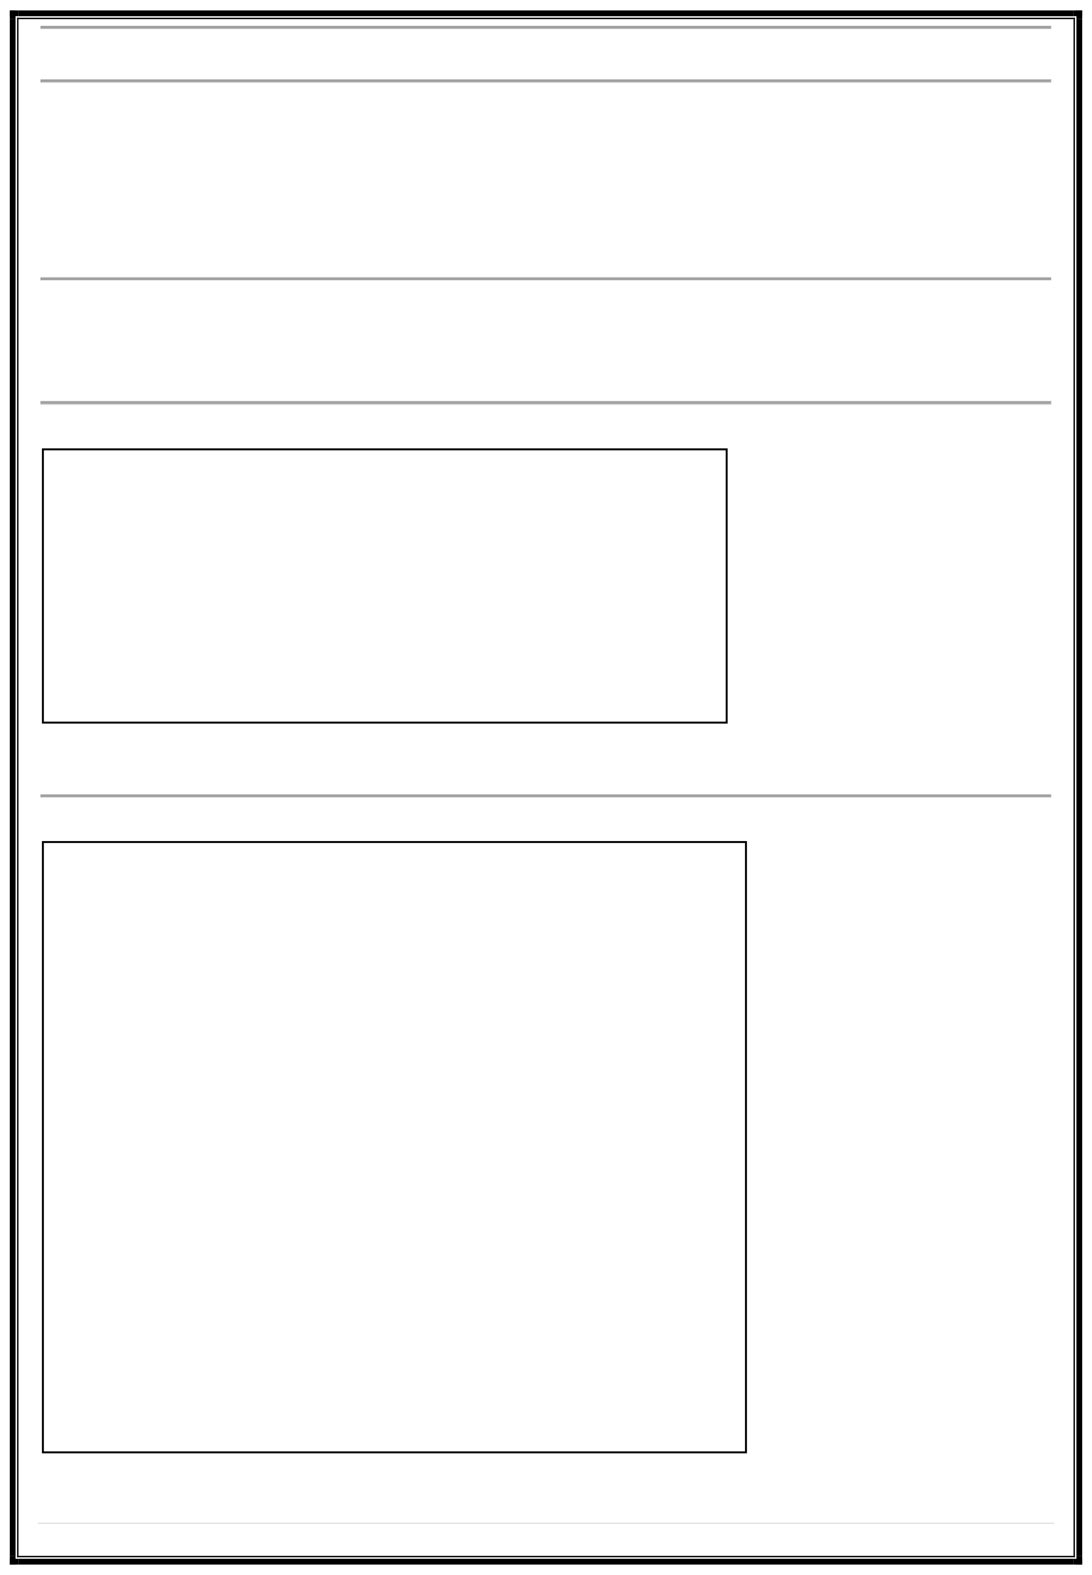
class Employee
{ }
public void Display() => Console.WriteLine("HR Employee");

}
namespace Sales
{
class Employee
{ }
public void Display() => Console.WriteLine("Sales Employee");

}
class Program
{
static void Main()
{
HR.Employee e1 = new HR.Employee(); Sales.Employee e2 = new Sales.Employee(); e1.Display(); e2.Display();

}
}

4| Page

.NET Framework using C# (MCAE0402) – Class Assignment

Output: HR Employee
Sales Employee
Explanation:
Using namespaces keeps similarly named classes separate and avoids conflicts.

Question 5:
During a code review, a developer confuses primitive types with reference types in their application. How would you explain the difference between primitive types and reference types?
Answer:
InC#,datatypesaredividedinto twocategories:
- Store actual data directly inthememory.
- Primitive (Valustea)cTkympeesm:ory.
  - Stored in
  - When assigned to another variable,acopy ofthevalueismade.
Examples:

int,float,char, bool, struct
Exianmt pale:= 5; int b = a; b = 10; Console.WriteLine(a); // Output: 5

Each variable holds its own value.

- ReferenceTypes:
  - Storea reference (address) to the actual data in memory.
  - Storedin heap memory.
  - Whenassigned to another variable, both point to the same object.
Examples: class,array,string,object Example:
classTest{public int x; }
Testt1=newTest(); t1.x =5;
Testt2=t1;//t2points to same object t2.x =10;
Console.WriteLine(t1.x); // Output: 10
Explanation:

Forvalue types,each variable is independent. For reference types, variables share the same memory reference.
Question 6:
While refactoring a piece of C# code, you notice both value types and reference types are being used incorrectly. Explain the difference between value types and reference types in C#, and provide examples to clarify their behaviour in memory.
Answer:
In C#, value types and reference types differ mainly in how and where they are stored in memory.
Value Types
  - Store actual data inthe stack memory.

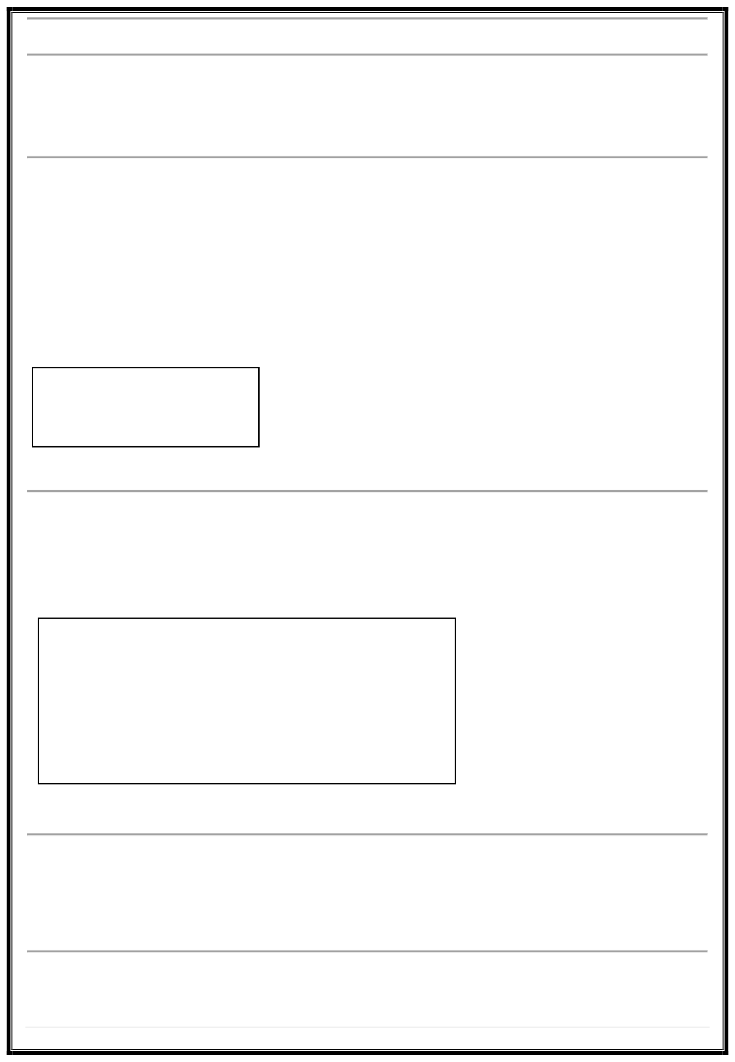

5| Page
When assigned to anothervariable,a copyofthedataiscreated. Changing one variable doesn’t affect the other.

.NET Framework using C# (MCAE0402) – Class Assignment

Examples: int,float, double, bool, struct
Example Code:
int x = 10;
int y = x; // copyof x y = 20;
Console.WriteLine($"x = {x}, y = {y}");
Output:
x = 10, y = 20

Reference Types
  - Store the address (reference) of the data in heap memory.
  - When assigned, both variables refer to the same memorylocation.
  - Changing one affects the other.
Examples: class, array, string, object
Example Code:
class Demo { public int num; }
Demo d1 = new Demo(); d1.num = 5;
Demo d2 = d1; // d2 refers to same object d2.num = 10;

Summary:

Type
Value Type Reference Type
Question 7:
Stored In Stack Heap
Holds
Actual data Address of object
Behavior Independent copy Shared reference

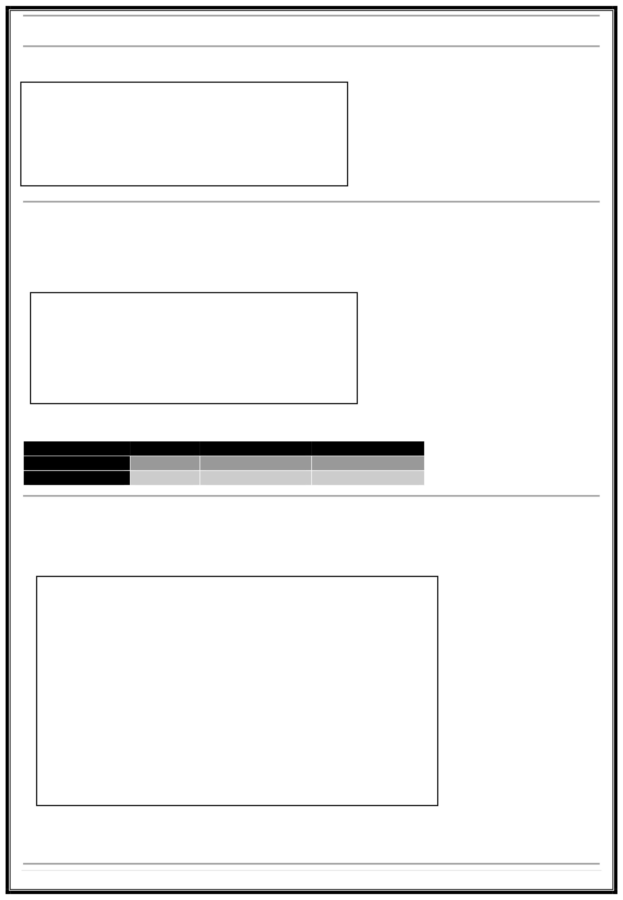
You are tasked with creating a method that demonstrates both implicit and explicit type conversions. Write a program in C# that converts an int to a double implicitly and a double to an int explicitly, explaining each step in your code.
Answer:
using System;
class ConversionExample
{
static void Main()
{
int num = 10;
double implicitDouble = num; // Implicit conversion (int → double) Console.WriteLine("Implicit Conversion: int to double = " +
implicitDouble);

double val = 9.78;
int explicitInt = (int)val; // Explicit conversion (double → int) Console.WriteLine("Explicit Conversion: double to int = " + explicitInt);
}
}

Explanation:
  - Implicit Conversion: Happens automatically when no data loss occurs (e.g., smaller → larger type).
  - Explicit Conversion: Requires casting because data might be lost (e.g., 9.78 becomes 9).

6| Page

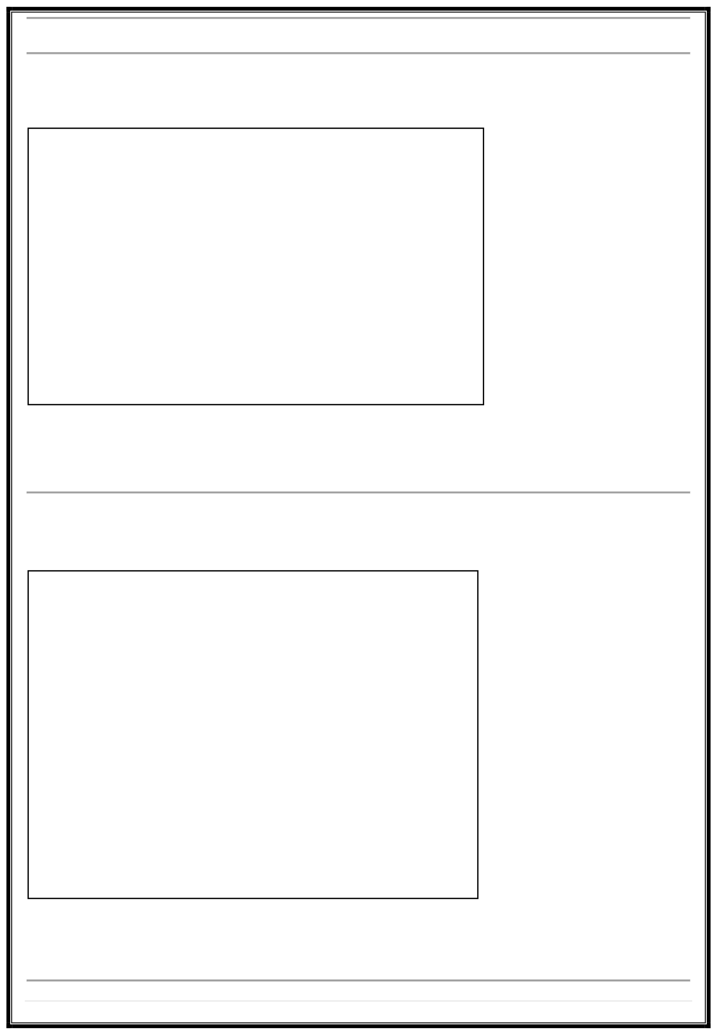
.NET Framework using C# (MCAE0402) – Class Assignment

Question 8:
A junior developer asks for help writing a program to determine whether a number is positive, negative, or zero.Use if-else statements to write this program in C#, and explain the logic behind the code.
Answer:
usingSystem; classCheckNumber
{
staticvoid Main()
{
Console.Write("Enter a number: ");
intnum = Convert.ToInt32(Console.ReadLine()); if(num > 0)
Console.WriteLine("The number is Positive"); elseif (num < 0)
Console.WriteLine("The number is Negative"); else
Console.WriteLine("The number is Zero");
}
}

Explanation:
  - The ifchecks if number > 0. else
  - ifchecks if number < 0. If neither,
  - the number must be 0.

Question 9:
Use a switch-case construct to explain how it works in C#. Illustrate the use of this construct by writing a program that takes a number (1–5) and prints the corresponding weekday.
Answer:
usingSystem; classWeekdays
{
staticvoid Main()
{
Console.Write("Enter a number (1–5): "); intday = Convert.ToInt32(Console.ReadLine());
switch (day)
{
case 1: Console.WriteLine("Monday"); break; case 2: Console.WriteLine("Tuesday"); break; case 3: Console.WriteLine("Wednesday"); break; case 4: Console.WriteLine("Thursday"); break; case 5: Console.WriteLine("Friday"); break; default: Console.WriteLine("Invalid day!"); break;
}
}
}

Explanation:
  - Theswitch checks the value of day and jumps to the matching case.
  - breakstops further execution.
  - defaulthandles invalid input.

7| Page

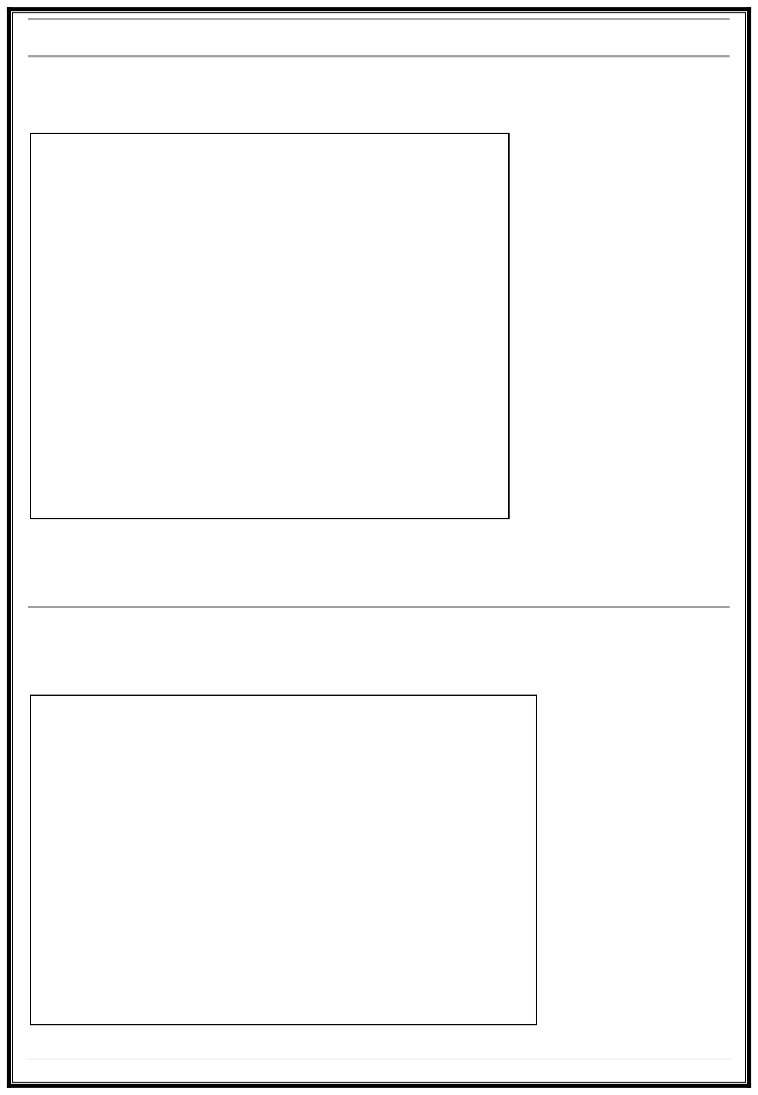
.NET Framework using C# (MCAE0402) – Class Assignment

Question 10:
Demonstrate how to use nested if-else and switch-case statements together by writing a program that checks a number and prints whether it is even/odd and whether it falls into specific ranges (e.g., 0–10, 11–20).
Answer:
usingSystem; classEvenOddRange
{
staticvoid Main()
{
Console.Write("Enter a number: ");
intnum = Convert.ToInt32(Console.ReadLine()); if(num % 2 == 0)
Console.WriteLine("Even Number"); else
Console.WriteLine("Odd Number");
switch (num)
{
case <= 10: Console.WriteLine("Range: 0–10"); break;
case <= 20: Console.WriteLine("Range: 11–20"); break; default: Console.WriteLine("Range: Above 20"); break;
}
}
}

Explanation:
  - The if-else checks even/odd using modulus %.
  - The switch checks number range.

Question 11:
Writea programthatprintsthe Fibonacci series using a for loop in C#. Provide a detailed explanation of your approach.
Answer:

using System;
class FibonacciSeries
{
static void Main()
{
int n = 7; inta=0,b=1,c;
Console.Write(a+""+b + " "); for (int i = 2; i < n; i++)
{
c=a+b; Console.Write(c+""); a=b;
b=c;
}
}
}

8| Page

.NET Framework using C# (MCAE0402) – Class Assignment

Explanation:
  - Startswith0 and 1.
  - Nextnumber = sum of previous two.
  - for loop repeats the calculation until n terms are printed.

Question 12:
Explain the key differences between while and do-while loops, and provide examples of each where one might be more appropriate than the other.
Answer:
Loop Condition Checked Executes at least once? Example Use

while
do-while Example:
Before the body After the body
No Yes
When unsure if loop should run When loop must run at least once

int i = 5; while(i<5)
Console.WriteLine("While Loop"); // won’t run
do
{
Console.WriteLine("Do-While Loop"); // runs once
}while(i< 5);

Question 13:
Write a program in C# that uses nested loops to generate a pyramid pattern of stars (*). Explain how the loops work together to produce the pattern.
Answer:

using System; class StarPattern
{
static void Main()
{
int rows = 5;
for(inti=1;i<=rows; i++)
{
for(intj=i;j<rows; j++) Console.Write(" ");

for(intk=1;k<= (2 * i - 1); k++) Console.Write("*");

Console.WriteLine();
}
}
}

Explanation:

  - The outer loop controls rows.
  - The first inner loop prints spaces.
  - The second
Together, they create a pyramid shape.

inner

loop prints

stars.

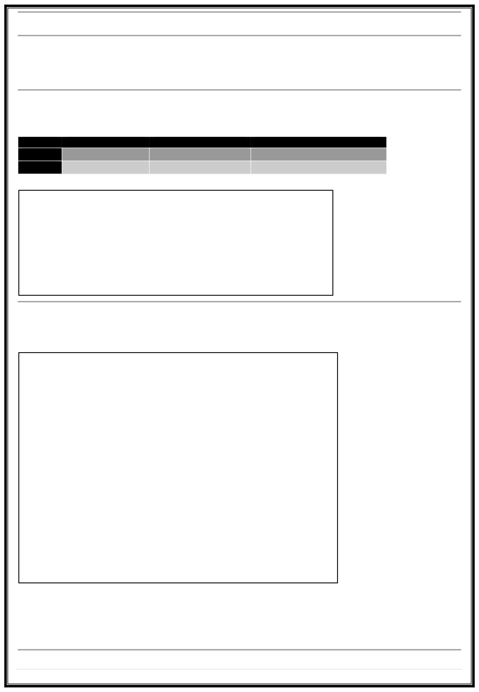

9| Page

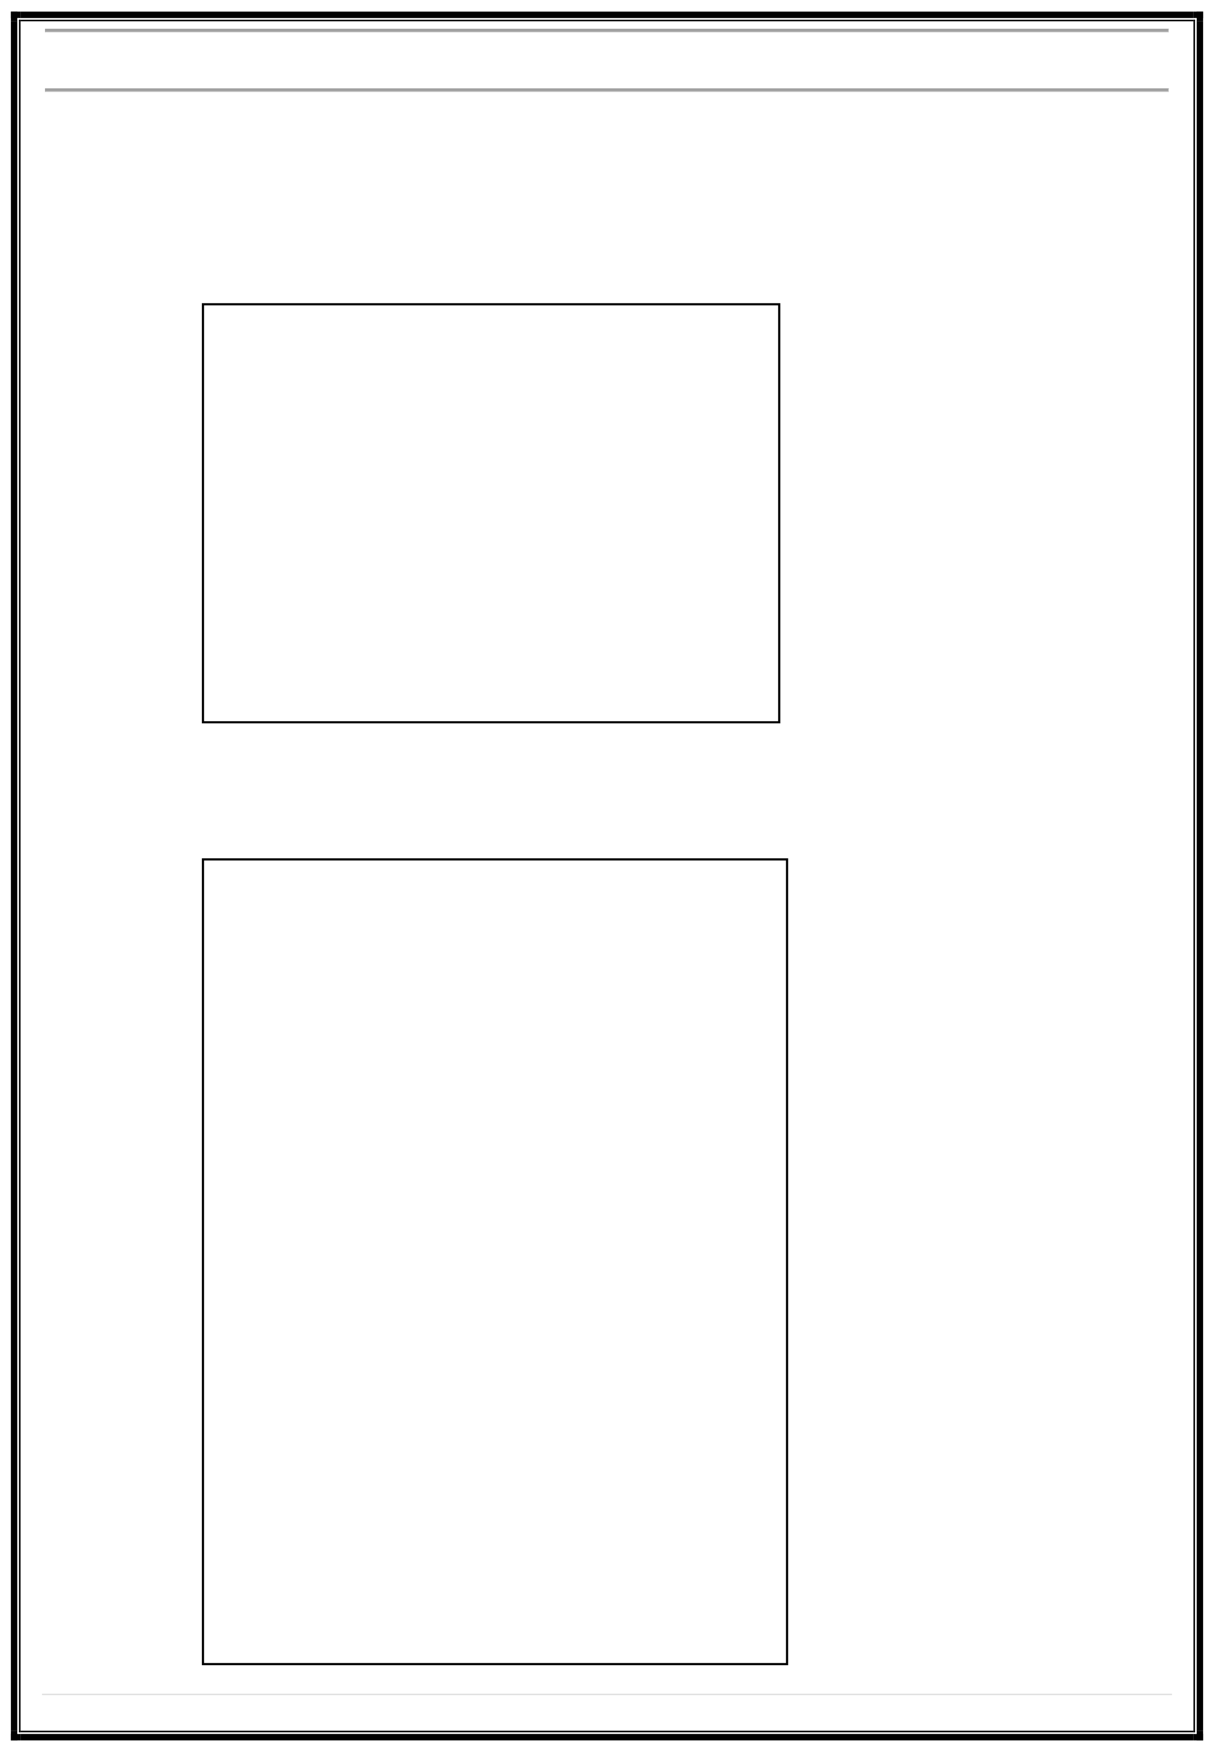
.NET Framework using C# (MCAE0402) – Class Assignment

Question 14:
Define Encapsulation, Inheritance, Polymorphism, and Abstraction, and provide real-world examples of each in C#.
Answer:
- Encapsulation:
  - Hidinginternaldatausingaccessmodifiers.
  - Example:

using System;
class Account
{
private double balance; // data hidden public void Deposit(double amount)
{ }
publailcandcoeub+l=e aGmetoBuanlta;nce()
{ }

return balance;
}
Real-world: ATM hides internal balance calculations.
- Inheritance:
  - Allows one class to derive from another.
  - Example:

using System; class Vehicle
{
public void Start()
{ }
Console.WriteLine("Vehicle started");
}
class Car : Vehicle
{
public void Drive()
{ }
Console.WriteLine("Car is driving");

}
class Program
{
static void Main()
{
Car c = new Car(); c.Start(); // from Vehicle c.Drive(); // from Car
}
}

10 | Page

.NET Framework using C# (MCAE0402) – Class Assignment

Real-world: Car inherits general features of a vehicle.
- Polymorphism:
  - Same method behaves differently in derived classes.
  - Example:

usingSystem;
classShape
{
public virtual void Draw() { }
}
classCircle : Shape
{
public override void Draw()
{ }
Console.WriteLine("Drawing Circle");

}
classProgram
{
static void Main()
{

}
}

- Abstraction:
Shape s = new Circle();
s.Draw(); // Output: Drawing Circle

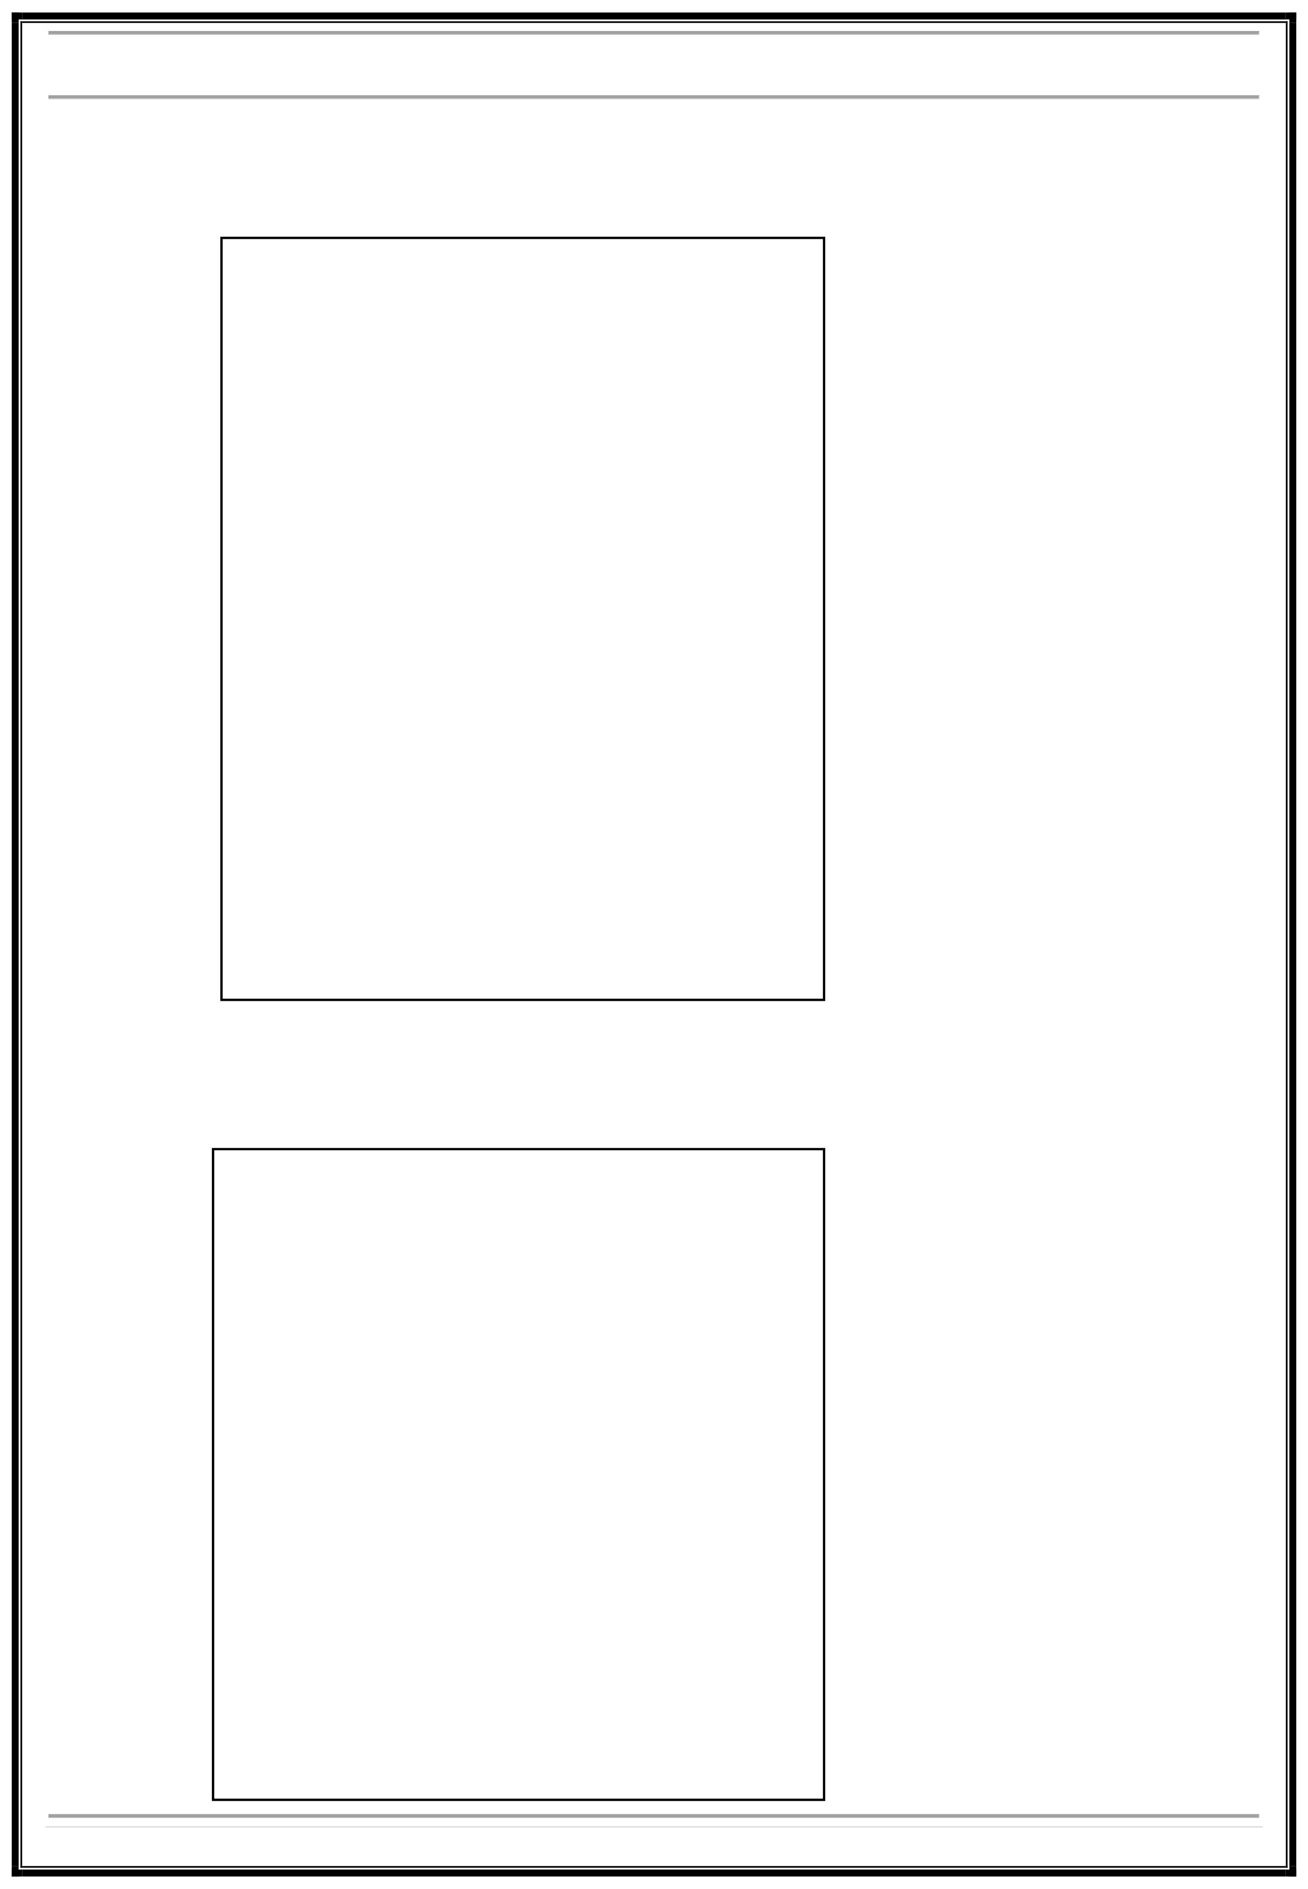
- Showsonly essential features, hides complex details.
- Example:

usingSystem;
abstract class Animal
{
public abstract void Sound();
}
classDog : Animal
{
public override void Sound()
{
Console.WriteLine("Bark");
}
}
classProgram
{
static void Main()
{
Animal a = new Dog(); a.Sound(); // Output: Bark
}
}

11 | Page

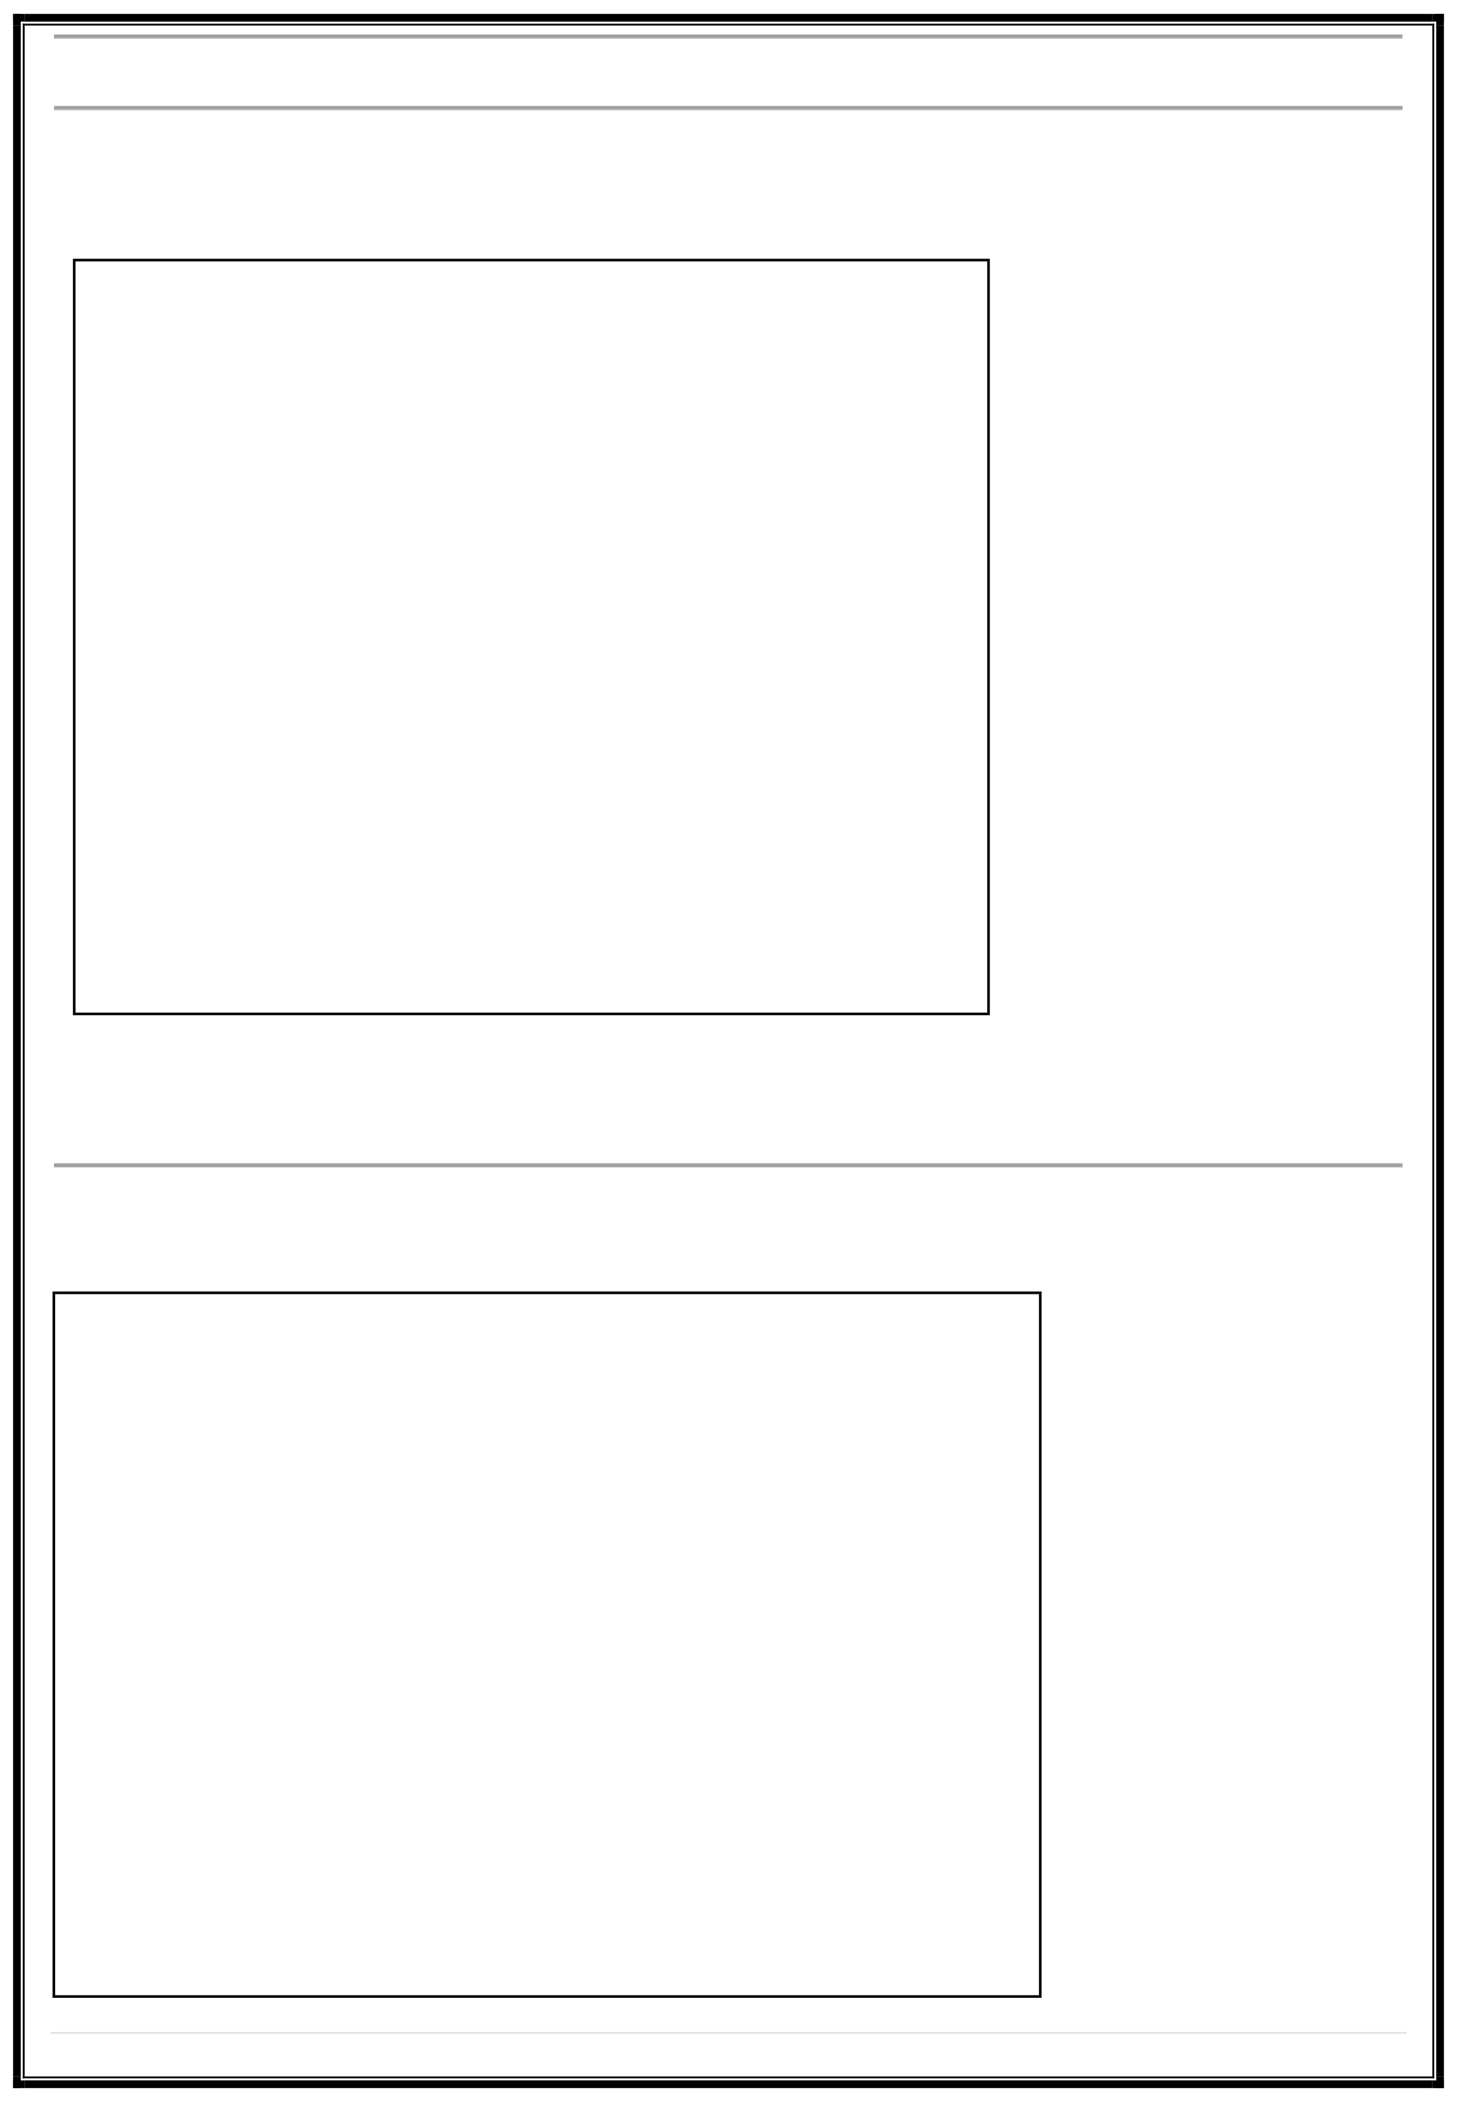
.NET Framework using C# (MCAE0402) – Class Assignment

Question 15:
Write a C# program that includes both a constructor and a destructor, explaining the lifecycle of an object from creation to destruction.
Answer:
usingSystem; classDemo
{
public Demo()
{ }
Console.WriteLine("Constructor called: Object created");
~Demo()
{ }

Console.WriteLine("Destructor called: Object destroyed");

}
classProgram
{
static void Main()
{ }
Demo d = new Demo();

}

Explanation:
- The constructor initializes the object.
- The destructor runs automatically when the object is destroyed (usually by garbage collector).

Question 16:
Explain public, private, protected, and internal access modifiers, and demonstrate their use in a small C# class. Answer:

using System;
class AccessExample
{
public void PublicMethod() { Console.WriteLine("Public"); } private void PrivateMethod() { Console.WriteLine("Private"); }
protected void ProtectedMethod() { Console.WriteLine("Protected"); } internal void InternalMethod() { Console.WriteLine("Internal"); }
}
class Program
{
static void Main()
{
AccessExample obj = new AccessExample(); obj.PublicMethod(); // Accessible
obj.InternalMethod(); // Accessible within same assembly
}
}

12 | Page

.NET Framework using C# (MCAE0402) – Class Assignment

Explanation: Modifier public private protected internal

Accessible From
Anywhere Same class
Same + derived class Same assembly

Example Use Utility methods Encapsulated logic Base class features Shared internal code

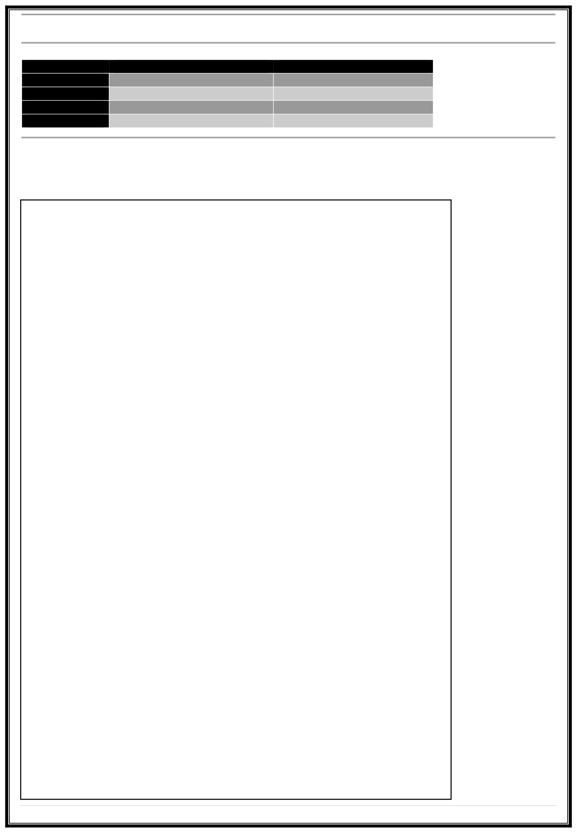
Question 17:
Write a program where a Vehicle class is inherited by a Car class and a Bike class, each with their own unique methods. Demonstrate how inheritance allows code reuse.
Answer:
using System;
// Base class class Vehicle
{
public void Start()
{ }
Console.WriteLine("Vehicle Starting...");
}
// Derived class Car class Car : Vehicle
{
public void Drive()
{ }
Console.WriteLine("Car Driving...");

}
// Derived class Bike class Bike : Vehicle
{
public void Ride()
{ }
Console.WriteLine("Bike Riding...");
}
// Main Program class Program
{
static void Main()
{
// Car object CarmyCar=newCar();
myCar.Start();//Inherited from Vehicle myCar.Drive();//Car-specific
// Bike object BikemyBike=new Bike();
myBike.Start();//Inherited from Vehicle
myBike.Ride();//Bike-specific
}
}
13| Page

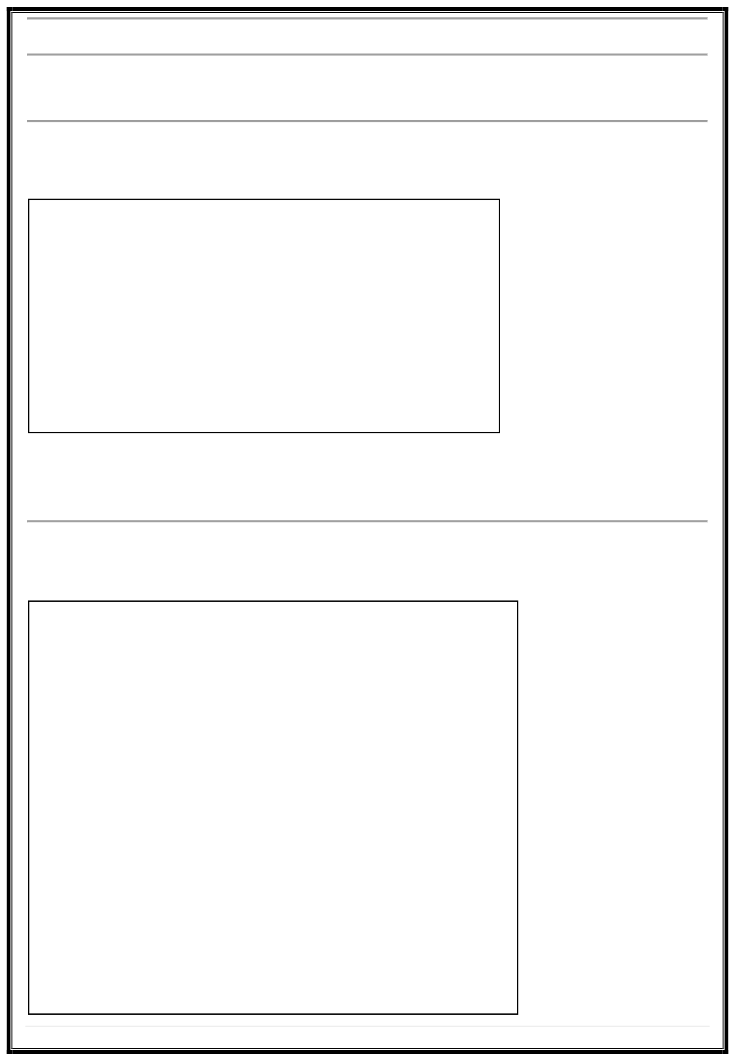
.NET Framework using C# (MCAE0402) – Class Assignment

Explanation:
- Car and Bike reuse the Start() method from Vehicle.
- Demonstrates code reusability and inheritance.

Question 18:
Explain how the try-catch-finally blocks work in C# with an example of catching and handling an arithmetic exception, and how finally is always executed.
Answer:
try
{
int x = 10, y = 0; int result = x / y;
} catch (DivideByZeroException ex) { } finally { }

Console.WriteLine("Error: Cannot divide by zero.");

Console.WriteLine("Finally block executed.");

Explanation:
- Codeintry may cause an error.
- catchhandles that error gracefully.
- finallyalways runs, whether an error occurs or not — often used to release resources.

Question 19:
Write a C# program that demonstrates exception handling by throwing and catching a custom exception, explaining why custom exceptions are beneficial.
Answer:
usingSystem; classInvalidMarksException : Exception {
}
clapsusPbrliocgIrnavmalidMarksException(string message) : base(message) { }
{

staticvoid Main()
{
intmarks = -10;
try
{
if(marks < 0 || marks > 100)
throw new InvalidMarksException("Marks must be between 0 and
100!");
}
catch(InvalidMarksException e)
{ }
Console.WriteLine(e.Message);
}
}

14 | Page

.NET Framework using C# (MCAE0402) – Class Assignment

Explanation:
- Customexceptions make errors specific and meaningful.
- Insteadofageneric error, theprogramexplainswhatwent wrong (e.g., invalid marks).
Question 20:
Explain how proper exception handling improves an application’s robustness. Answer:
Properexceptionhandling ensuresthataprogramcangracefully respond tounexpected errors instead of crashing.
Itseparatesnormalcode fromerror-handling code, making the program easier to read and maintain.
Benefits:
- Prevents crashes: Theprogram can catch errors and continue running safely.
- Improves user experience: Users see clear error messages instead of confusing crashes.
- Easier debugging: Developers can log detailed error information.

- Resource management:
released.
Using finally ensures resources like files or database connections are always

- Reliable software: Example in C#:
Programs become more stable and robust under different scenarios.

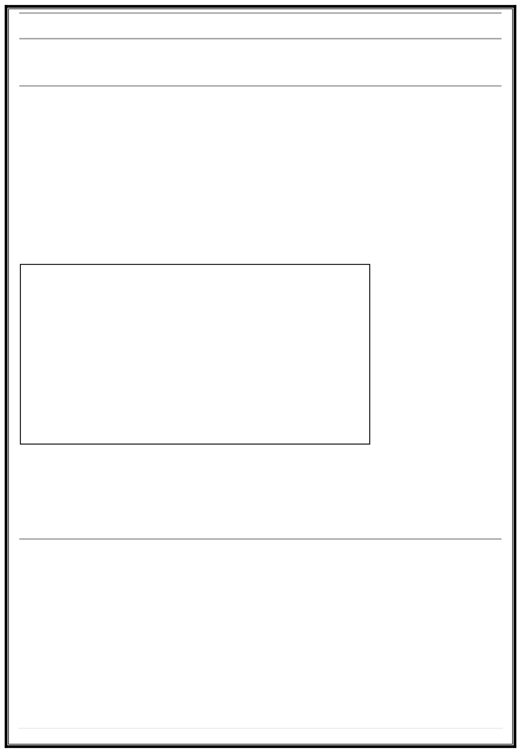
try
{
int x = 10, y = 0;
int result = x / y; // Will cause DivideByZeroException
}
catch (DivideByZeroException ex)
{
Console.WriteLine("Error: Cannot divide by zero!");
}
finally
{ }
Console.WriteLine("This block always executes.");

Explanation:
- Theprogram catches the error instead of crashing.
- finally ensures cleanup or final messages.
- Users see a friendly message and the program continues safely.
Summary: Well-handled exceptions turn potential crashes into controlled, recoverable situations, making the application more stable and reliable.

15 | Page

