.NET Framework using C# (MCAE0402) – Class Assignment

MASTER OF COMPUTER APPLICATION

Department of Computer Engineering & Applications

Session- 2025 – 26

Subject Name & Code: Course:
Semester: Section:
Class Roll No: University Roll No:
.NET Framework using C# (MCAE0402) MCA
3rd A 21
2484200082

Submitted To Submitted By


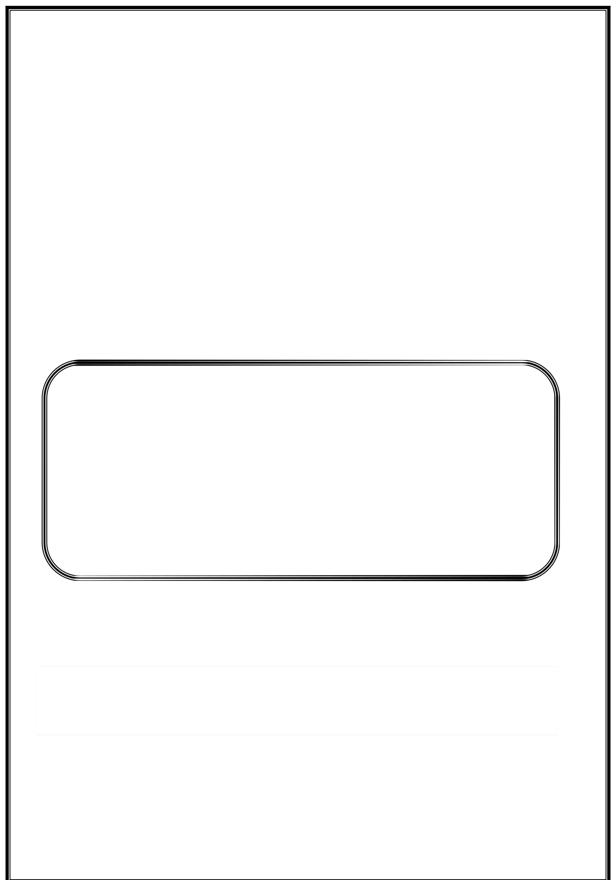
Dr. Sachendra Singh Chauhan (Assistant Professor)
Janavi Agrawal

Assignment 2 - .NET Framework using C#
- Explain the key differences between Windows services and Web services in C#. Windows Services are long-running background applications that start automatically when the system boots. They don’t require user interaction and are mainly used for system-level tasks such as logging, file monitoring, or scheduled tasks.

Web Services, on the other hand, are network-based services that allow communication between applications over the Internet using standard protocols like HTTP and SOAP. They are mainly used to share data and functionality between distributed systems.

Differences:
| Feature | Windows Service | Web Service |
| | | |
| Execution | Runs in background on Windows OS | Hosted on a web server |
| User Interface | No UI | Can be accessed via browser or client |
| Communication | Local machine | Over HTTP/SOAP |
| Usage | System-level automation | Application integration |

Describe the Windows service and explain the purpose of OnStart and OnStop methods.
A Windows Service is a special type of application that runs continuously in the background. It is managed by the Service Control Manager (SCM) and can start automatically when the computer boots up.

  - OnStart(): Executed when the service starts. It initializes resources and starts the main operation.
  - OnStop(): Executed when the service stops. It releases resources and performs cleanup.

Example: If a service logs data to a file every hour, OnStart() starts the timer, and OnStop() stops it and closes the file.

Create a basic Windows service that logs the current date and time to a text file. Include the steps to install and start the service.
Steps:
- Open Visual Studio → Create new Windows Service Project.
- In Service1.cs, write:

protected override void OnStart(string[] args)
{
File.AppendAllText(@"C:\log.txt", "Service started: " + DateTime.Now + "\n"); timer = new Timer(WriteTime, null, 0, 60000);
}
private void WriteTime(object state)
{
File.AppendAllText(@"C:\log.txt", "Time: " + DateTime.Now + "\n");
}
protected override void OnStop()
{
File.AppendAllText(@"C:\log.txt", "Service stopped: " + DateTime.Now + "\n");
}

- Build project → Run “installutil MyService.exe”.
- Open Services.msc → Start the service.

Design a website to consume a SOAP-based Web service and display the result in a TextBox.
Example: Currency Conversion

Steps:
- Create ASP.NET Web Application.
- Add Service Reference → Enter SOAP service URL.
- Add TextBox and Button in Default.aspx.
- Write this code in Default.aspx.cs:

protected void btnConvert_Click(object sender, EventArgs e)
{
CurrencyService.ServiceSoapClient client = new CurrencyService.ServiceSoapClient();
double result = client.ConvertUSDToINR(Convert.ToDouble(txtUSD.Text)); txtINR.Text = result.ToString("F2");
}

What are attributes in C#? Explain their purpose and provide an example of a custom attribute.
Attributes in C# provide metadata that can be retrieved at runtime using reflection. They describe additional information about program elements.

Example:

[AttributeUsage(AttributeTargets.Class)] public class AuthorAttribute : Attribute
{
public string Name { get; set; } public double Version { get; set; }
public AuthorAttribute(string name, double version)
{
Name = name; Version = version;
}
}
[Author("Jaya", 1.0)]
public class SampleClass { }

Explain the use of the Obsolete attribute in C#. What is its impact during compilation?
The Obsolete attribute marks a program element as outdated.

Example:
[Obsolete("Use NewMethod instead", true)]

If true → Compile-time error.
If false → Compile-time warning.

Impact: Helps developers migrate from old APIs to newer ones safely.

Write a program in C# to create a custom attribute Author with properties like Name and Version.
[AttributeUsage(AttributeTargets.Class)] public class AuthorAttribute : Attribute
{
public string Name { get; set; } public double Version { get; set; }

public AuthorAttribute(string name, double version)
{
Name = name; Version = version;
}
}

[Author("Jaya Sharma", 1.2)] public class Demo
{
public void Display()
{
Console.WriteLine("Author Attribute Example");
}
}

What is an assembly in C#? Explain the difference between private and shared assemblies.
An assembly is the compiled output of a .NET application (.exe or .dll).

Private Assembly: Used by one application, stored locally.
Shared Assembly: Used by multiple applications, stored in the Global Assembly Cache (GAC).

Differences:
| Feature | Private Assembly | Shared Assembly |
| | | |
| Scope | Single Application | Multiple Applications |
| Location | App Folder | GAC |
| Naming | Normal | Strong name required |

Describe the structure of an assembly. Highlight the role of the manifest and metadata.
Structure:
- Manifest – Contains assembly identity and references.
- Metadata – Describes types and members.
- MSIL Code – Intermediate code.
- Resources – Images, icons, etc.

Role:
  - Manifest: Helps .NET locate and load correct version.
  - Metadata: Enables reflection and type safety.

Explain the steps to create a shared assembly and register it in the Global Assembly Cache (GAC).
Steps:
- Create Class Library project.
- Generate Strong Name: sn -k keypair.snk
- Add in AssemblyInfo.cs: [assembly: AssemblyKeyFile("keypair.snk")]

- Build project → .dll file created.
- Register in GAC: gacutil -i MyLibrary.dll
- Verify: gacutil -l MyLibrary

Create a class library in C# and compile it as a DLL. Demonstrate its use in a console application.
MathLibrary.cs: namespace MathLibrary
{
public class Calculator
{
public int Add(int a, int b)
{
return a + b;
}
}
}

Console App: using MathLibrary; class Program
{
static void Main()
{
Calculator calc = new Calculator(); Console.WriteLine("Sum: " + calc.Add(10, 20));
}
}

How would you use ADO.NET to fetch employee records from SQL Server and display them in a DataGridView?
SqlConnection con = new SqlConnection("connection string");
SqlDataAdapter da = new SqlDataAdapter("SELECT * FROM Employees", con); DataTable dt = new DataTable();
da.Fill(dt); dataGridView1.DataSource = dt;

How to enable offline functionality using DataSet and DataTable in ADO.NET?
DataSet stores data in memory and can be used offline.

SqlDataAdapter da = new SqlDataAdapter("SELECT * FROM Employees", con); SqlCommandBuilder cb = new SqlCommandBuilder(da);

DataSet ds = new DataSet(); da.Fill(ds, "Employees");

ds.Tables["Employees"].Rows[0]["Name"] = "Jaya"; da.Update(ds, "Employees");

How would you implement parameterized queries in ADO.NET to prevent SQL Injection?
SqlCommand cmd = new SqlCommand("SELECT * FROM Employees WHERE ID=@ID", con);
cmd.Parameters.AddWithValue("@ID", txtID.Text); SqlDataAdapter da = new SqlDataAdapter(cmd); DataTable dt = new DataTable();
da.Fill(dt); dataGridView1.DataSource = dt;

Inventory Management System — Using DataSet and DataReader
- Use DataSet to display and edit product data.
SqlDataAdapter da = new SqlDataAdapter("SELECT * FROM Products", con); DataSet ds = new DataSet();
da.Fill(ds, "Products");
dataGridView1.DataSource = ds.Tables["Products"];

- Use DataReader for summary data.
SqlCommand cmd = new SqlCommand("SELECT COUNT(*), SUM(Price) FROM Products", con);
SqlDataReader dr = cmd.ExecuteReader(); if (dr.Read())
Console.WriteLine("Count: " + dr[0] + " Total Value: " + dr[1]);

