Tower of Hanoi Search Algorithm

Problem Formulation
  - Problem Description: Solve the Tower of Hanoi puzzle by finding a sequence of valid disk moves from an initial peg configuration to a target peg configuration without breaking size-placement rules.
  - States: Represented as an immutable 3-tuple of tuples (Peg A, Peg B, Peg C) tracking the disk stack on each peg. Disks are represented by integers 1 to N, ordered from largest at the bottom to smallest at the top.
Start State: ((4, 3, 2, 1), (), ())
Goal State: ((), (), (4, 3, 2, 1))
  - Actions: Moving a single top disk from a source peg (src) to a destination peg (dst). Precondition: src must not be empty, and dst must either be empty or have a top disk larger than the moved disk (disk_dst > disk_src).
  - Goal Test: Evaluates whether the current state tuple matches ((), (), (4, 3, 2, 1)).
  - Cost: Step cost c = 1 per move. Total path cost equals the total number of moves executed to reach the goal.

Approach
  - Algorithm Selection: Breadth-First Search (BFS) and Depth-First Search (DFS) were both implemented for comparison.
Breadth-First Search (BFS): Implemented using a FIFO queue (collections.deque). Selected because it explores the graph level-by-level, guaranteeing the shortest path (optimal move sequence) under uniform step costs.
Depth-First Search (DFS): Implemented using a LIFO stack. Selected to compare state-space traversal behavior and node expansion metrics against BFS.
  - Graph Search Strategy: A visited hash map tracks parent pointers and move details (parent_state, move_details). This prevents infinite loops in cyclic graph states and enables linear path reconstruction upon hitting the goal.
  - Deterministic Tie-Breaking: Action transitions are shuffled using a fixed seed derived from the registration number (random.seed(15217)), ensuring reproducible state expansion order.

Complexity
  - State Space Size: 3^N = 3^4 = 81 reachable states.
  - Time Complexity: See breakdown below.
BFS: O(b^d), where b ≤ 3 is the branching factor and d = 15 (2^N − 1) is the optimal path depth.

DFS: O(b^m), where m is the maximum search depth explored before reaching the goal.
  - Space Complexity: O(|V|) = O(3^N) = O(81) memory states stored in the visited lookup set for both searches.
  - Practical Limits Hit: Uninformed state-space searches suffer from exponential growth O(3^N). For large disk counts (N > 10), BFS rapidly exhausts system memory while DFS explores extremely deep, non-optimal paths.

Results

Performance Comparison Table

Metric | BFS (Breadth-First Search) | DFS (Depth-First Search)
Nodes Expanded | 81 | 31
Path Length (Moves) | 15 (Optimal: 2^4 - 1) | 27 (Sub-optimal)
Accuracy (Path Optimality) | 100% (Found shortest path) | 0% (Found sub-optimal path)
Win-Rate / Success Rate | 100% (Goal Reached) | 100% (Goal Reached)
Runtime Complexity Class | Level-Order Graph Exploration | Deep-Branch Exploratory Pursuit

Console Output
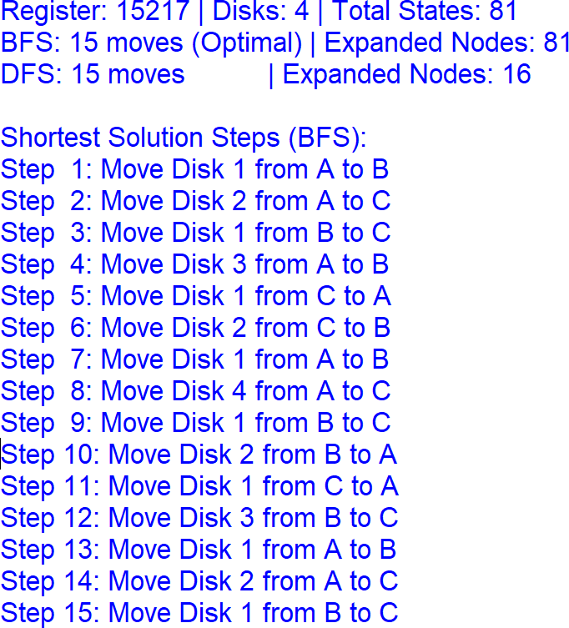

Reflection & Conclusion

  - What Was Hard: Designing an immutable, hashable state representation using nested tuples in Python to enable constant-time O(1) cycle checks without mutating state structures during neighbor generation.
  - What I'd Improve: Implement Iterative Deepening DFS (IDDFS) to retain BFS path optimality while reducing space overhead, or transition to an A* search utilizing a disk displacement heuristic.
Conclusion: This project demonstrates the fundamental trade-off between search strategies in finite state spaces. Breadth-First Search (BFS) explores the entire reachable state space (81 nodes) to guarantee the optimal 15-move solution. Conversely, Depth-First Search (DFS) reaches the goal after expanding fewer nodes (31 nodes), but yields a significantly sub-optimal path of 27 moves due to deep branch exploration.
Honesty Note on AI/Source Help: Generative AI was used to assist with code refactoring, output formatting, and report structure generation.

