NMON is short for Nigel's Performance Monitor and is available on AIX, Solaris (With Sarmon), Linux and ARM Systems.

NMON Splunk App has been designed to massively collect, convert, index and analyse NMON Metrics Data, providing an Enterprise class Application.

* AIX / Linux / Solaris hosts can Collect (local or Forwarders) / Convert / Index / Analyse.
* Mac OS X and Windows hosts can Collect (Forwarders only) Convert / Index / Analyse.

NMON Performance does Global / Summary Analysis per Host, Analysis per type of metric (CPU usage, Memory, I/O...), Predictive, Comparison Analysis, Inventory Collect and Analysis, and more.

Link to the last main release youtube video presentation: <https://www.youtube.com/watch?v=yHlo0idH3is>

[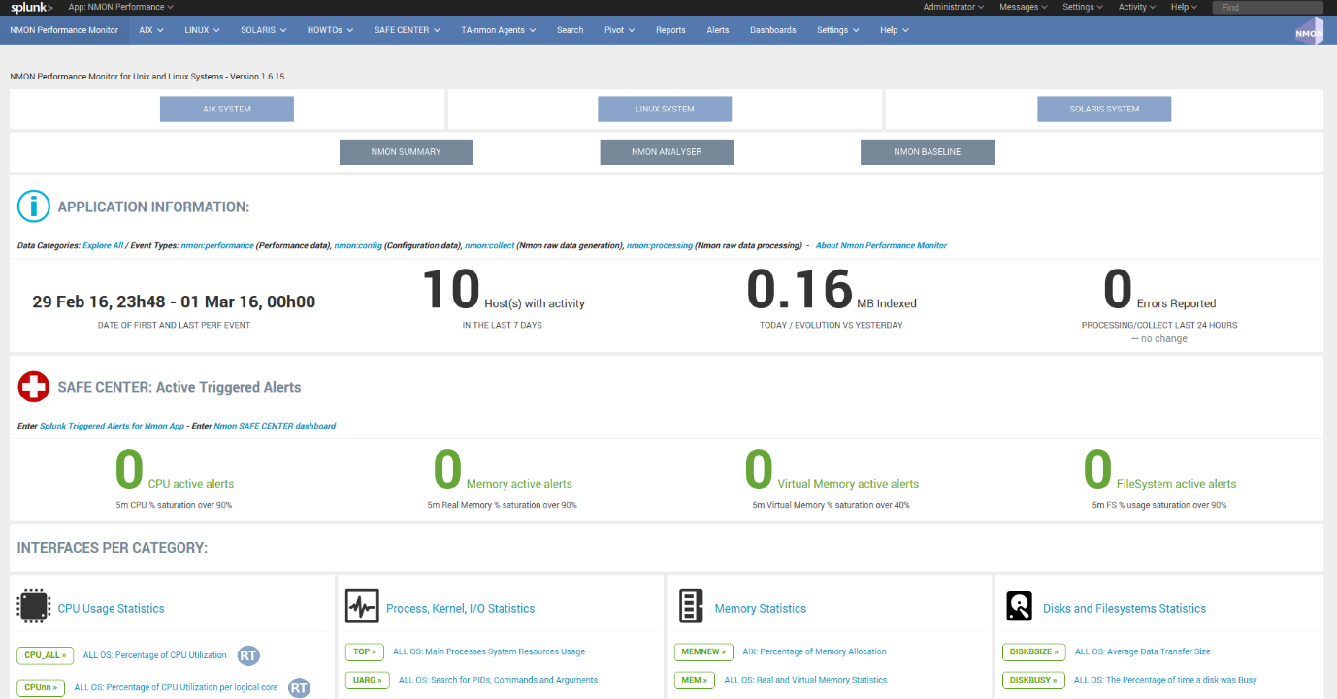](https://github.com/guilhemmarchand/nmon-for-splunk/blob/master/docs/img/screen001.png)

[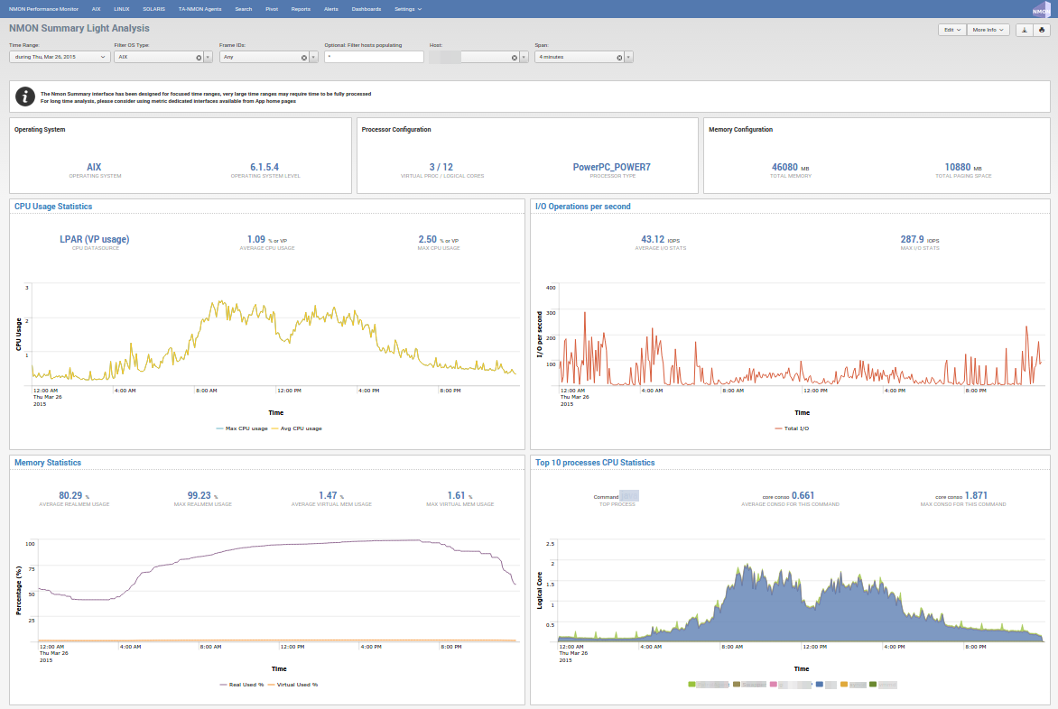](https://github.com/guilhemmarchand/nmon-for-splunk/blob/master/docs/img/screen002.png)

[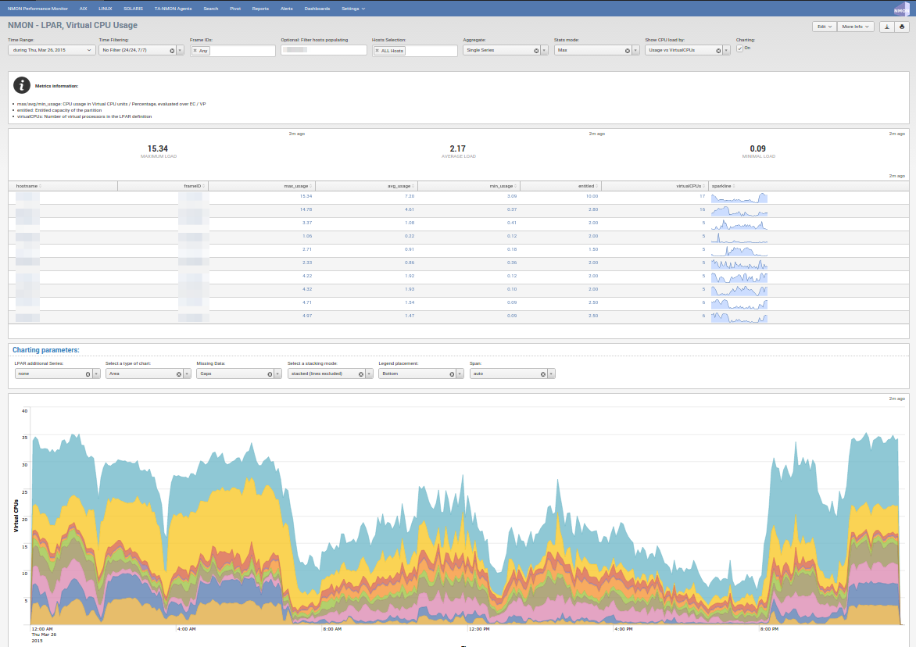](https://github.com/guilhemmarchand/nmon-for-splunk/blob/master/docs/img/screen003.png)

[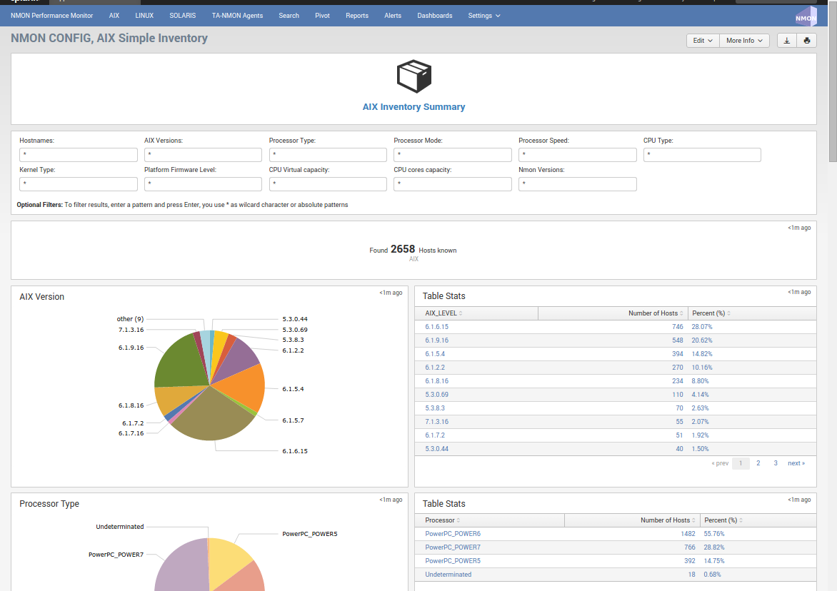](https://github.com/guilhemmarchand/nmon-for-splunk/blob/master/docs/img/screen004.png)

[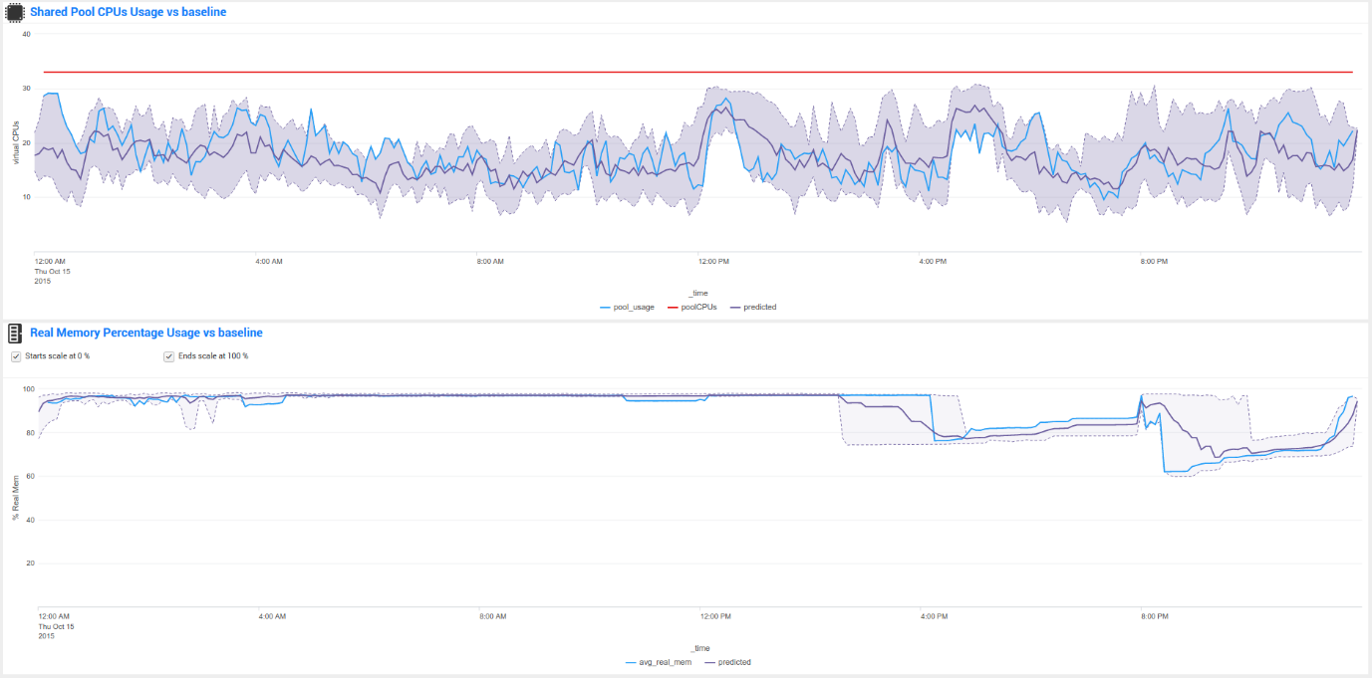](https://github.com/guilhemmarchand/nmon-for-splunk/blob/master/docs/img/screen005.png)