Proxy means when server don’t know client, and reverse proxy means when client doesn’t know server.

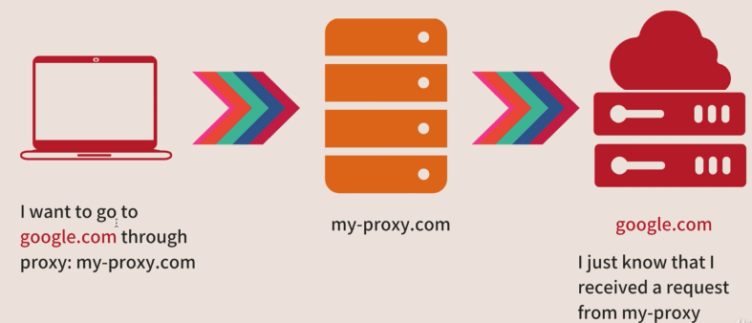

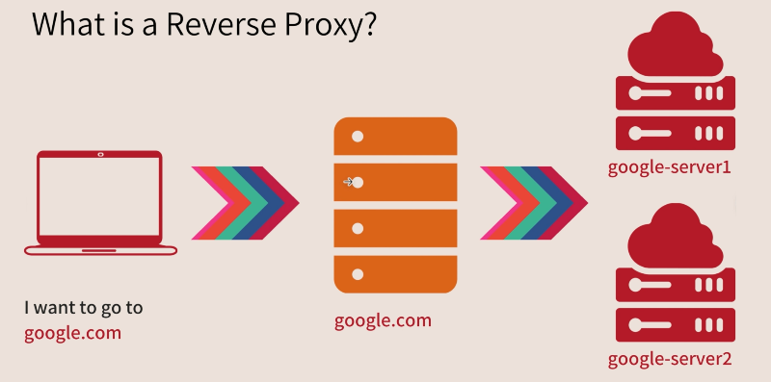

Feature of reverse proxy

