Lab: <https://killercoda.com/>

You can authenticate yourself with below methods, but we suggest you to go with google authentication.

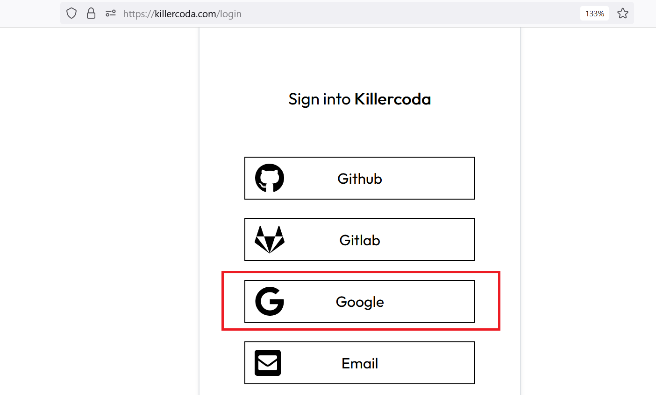

Now, you have all listed lab for DevOps-

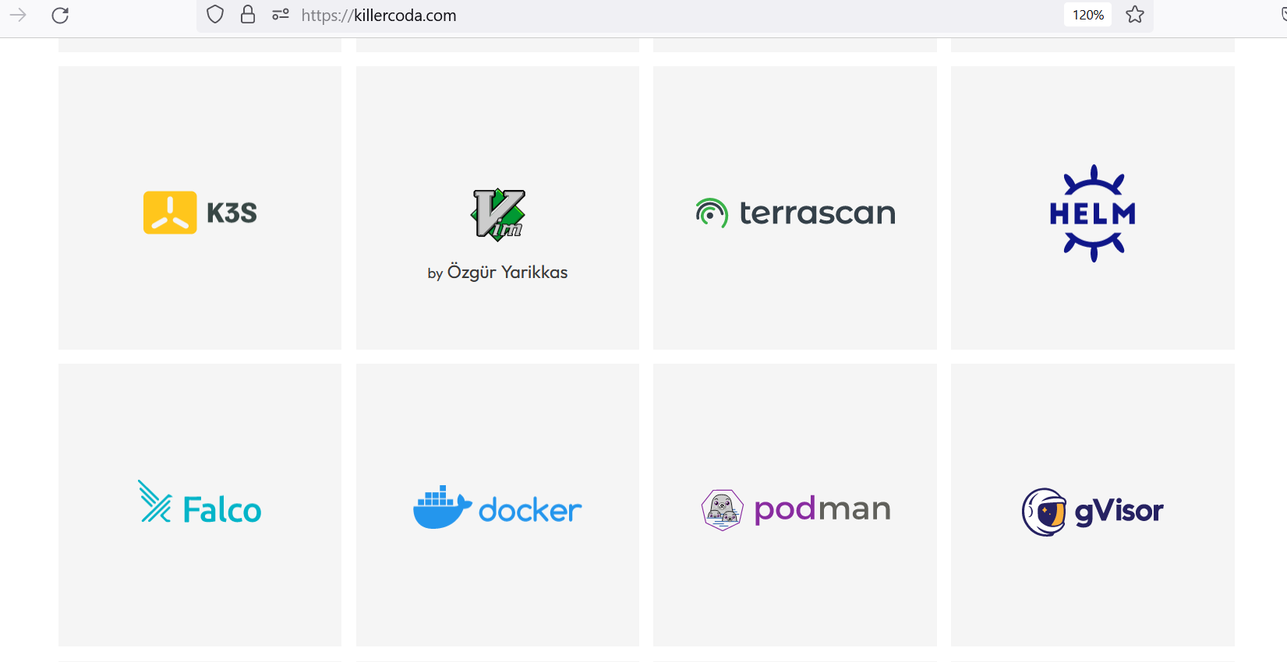

Even you have empty Linux box:

<https://killercoda.com/playgrounds>