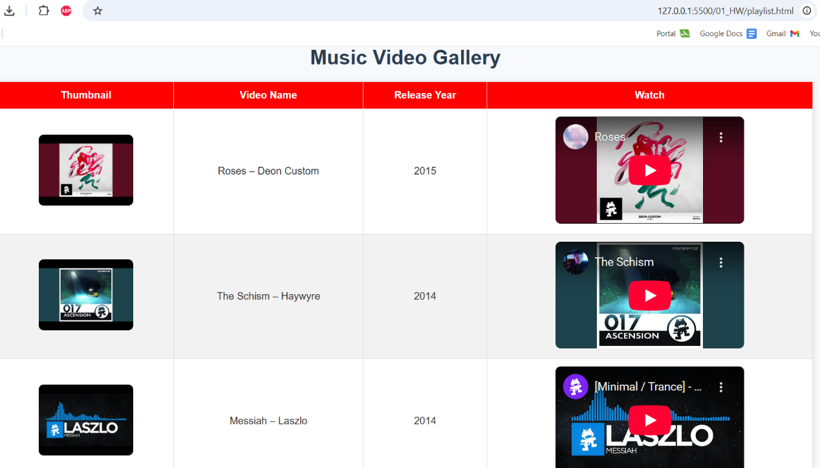 | Added playlist html and design  https://github.com/Janbayhat/WebDevCourse_HW/commit/0d30c0fa8dbfdb38276f2bf5a1f3b919e47dabd7
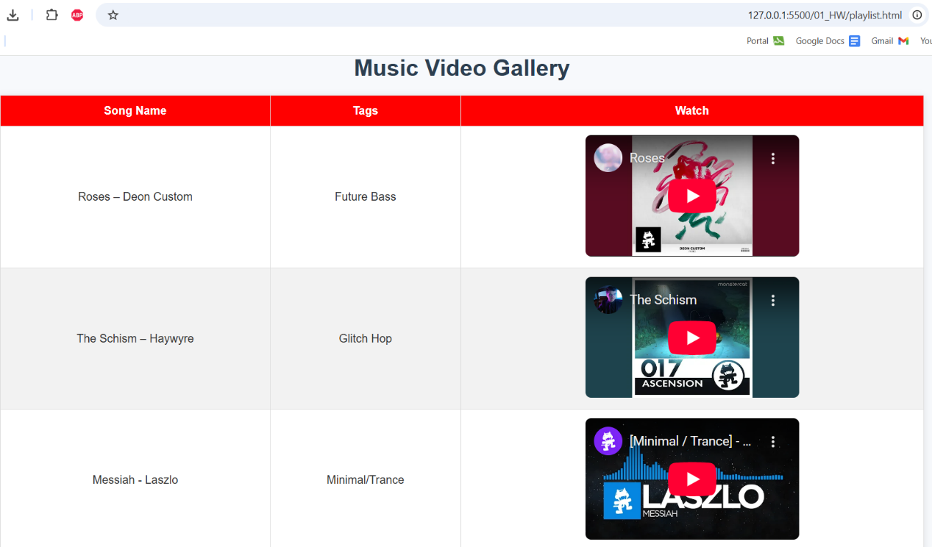 | Added screenshot 2  https://github.com/Janbayhat/WebDevCourse_HW/commit/20f5c8b40b0be28856603c52fbe2fbd12de11edd
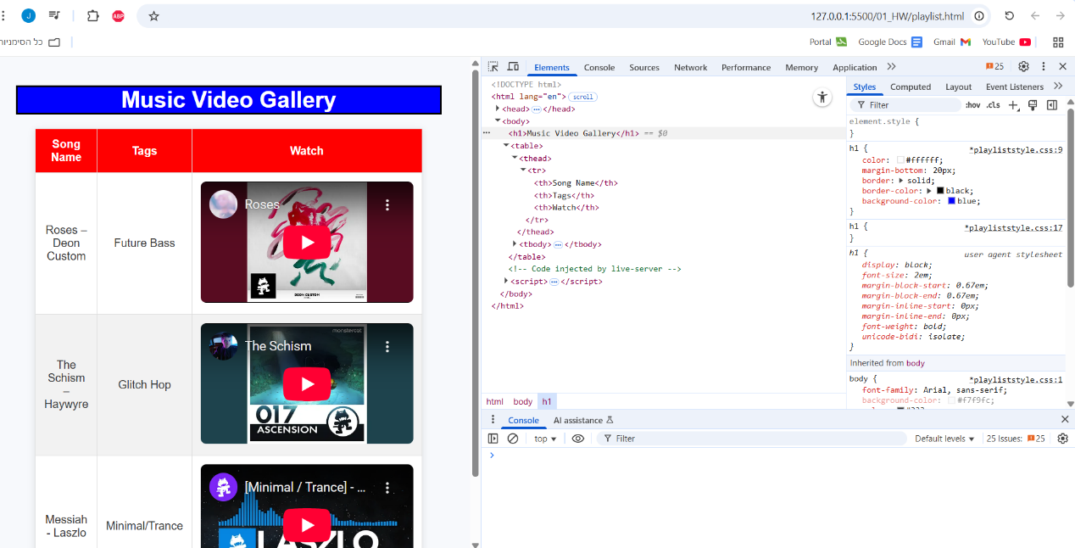 | Added screenshot 3,4 and blue coloring  https://github.com/Janbayhat/WebDevCourse_HW/commit/fb953da771db5dee673bca6de621adb28fce3fca
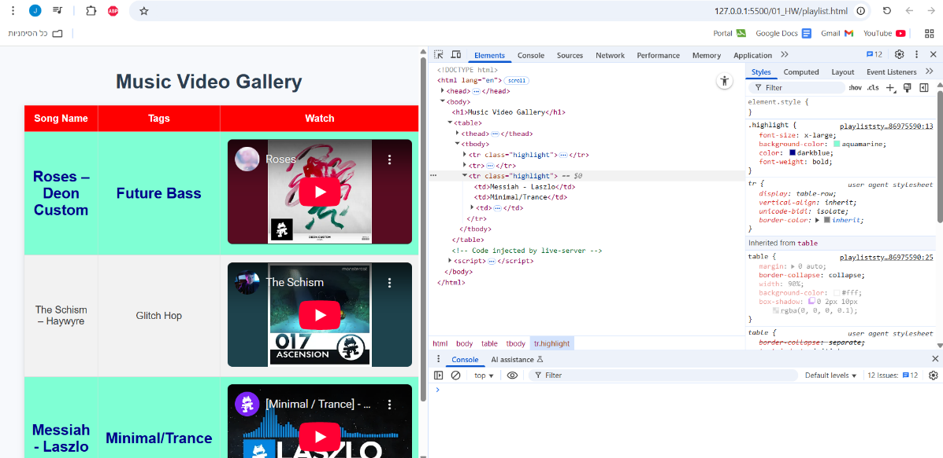 | Added screenshot 3,4 and blue coloring  https://github.com/Janbayhat/WebDevCourse_HW/commit/fb953da771db5dee673bca6de621adb28fce3fca
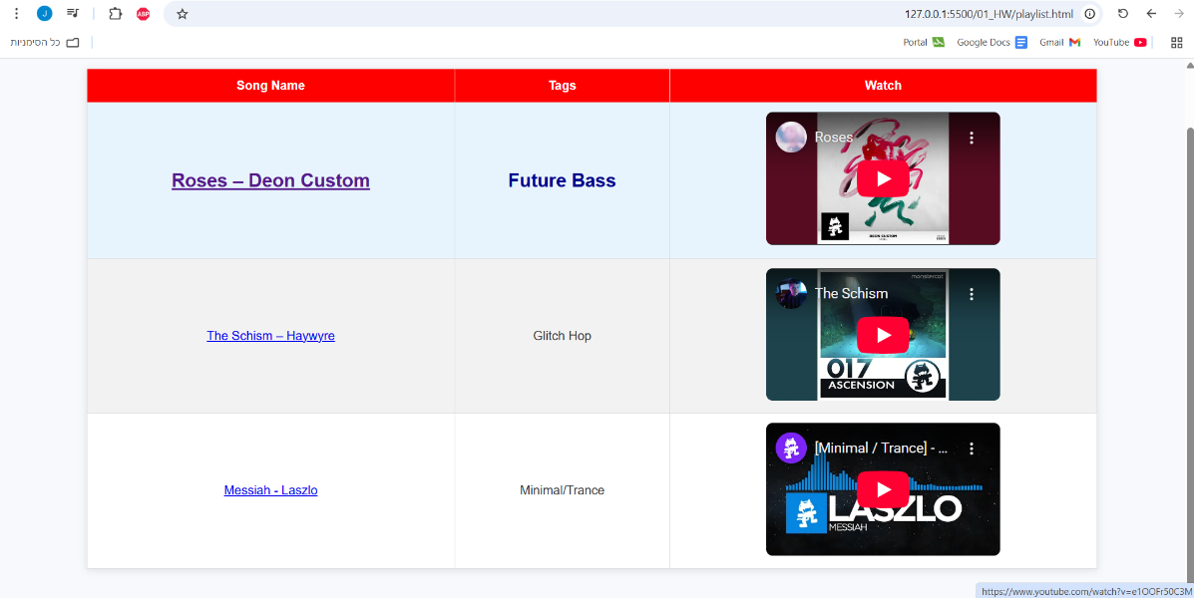 | Added hyperlinks  https://github.com/Janbayhat/WebDevCourse_HW/commit/113b1c61a5da96e6840030c81fbd0021525efbce
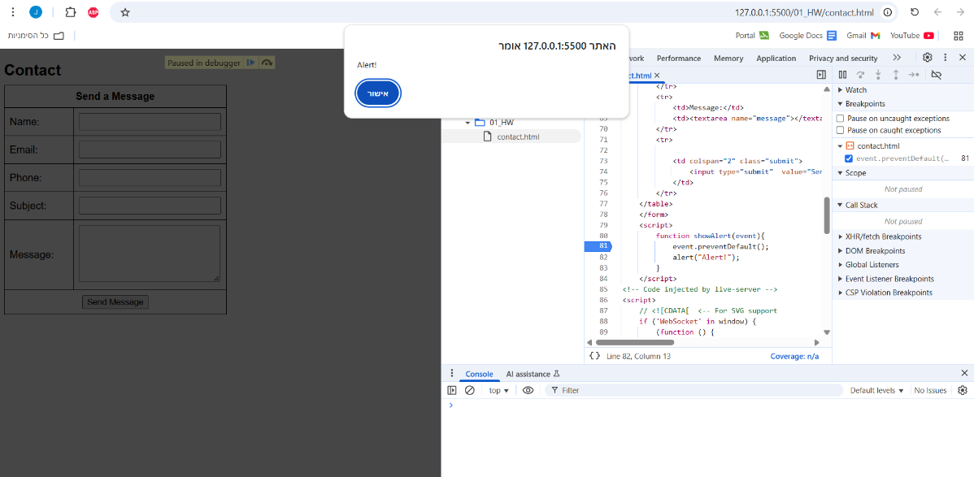 | Added and designed contact page  https://github.com/Janbayhat/WebDevCourse_HW/commit/290e6688ff311bbe207ae4bcd4ebcd285271aa41
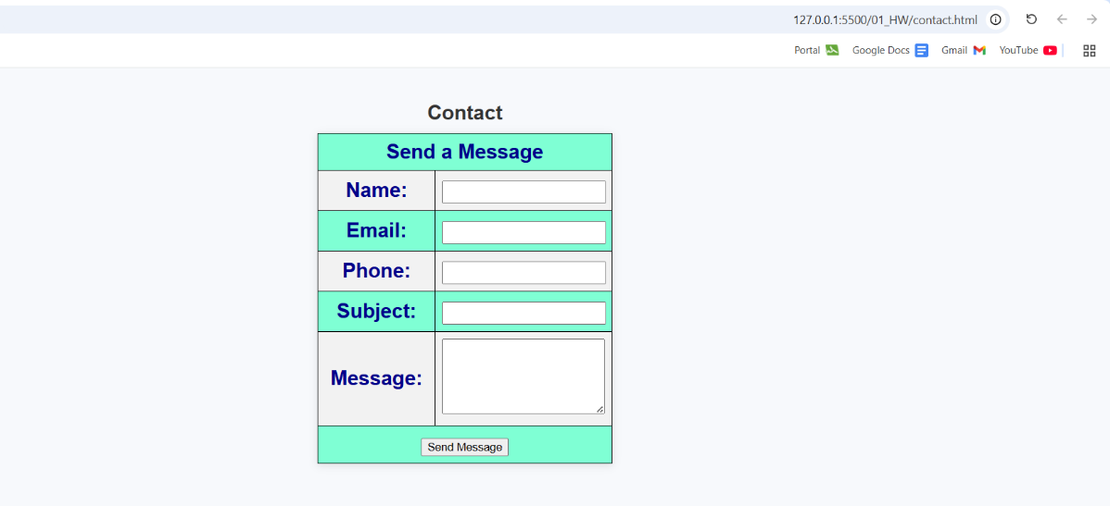 | Added and designed contact page
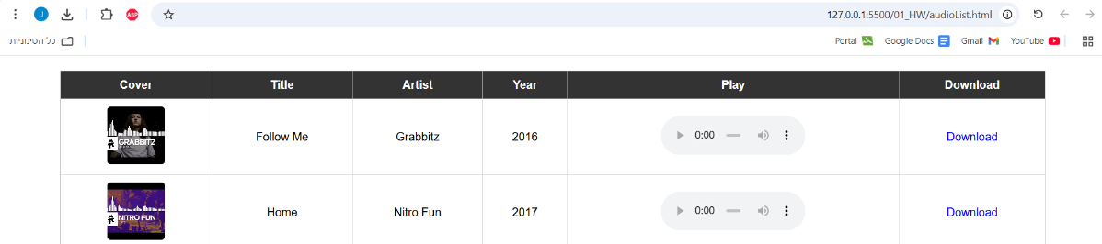 | Added mp3 player  https://github.com/Janbayhat/WebDevCourse_HW/commit/81d95a9451026b4bac621d51294b241b5a63a441
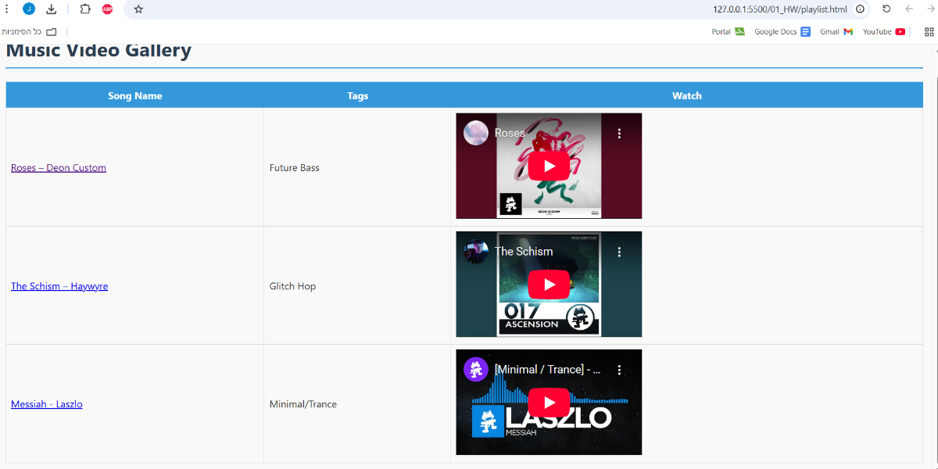
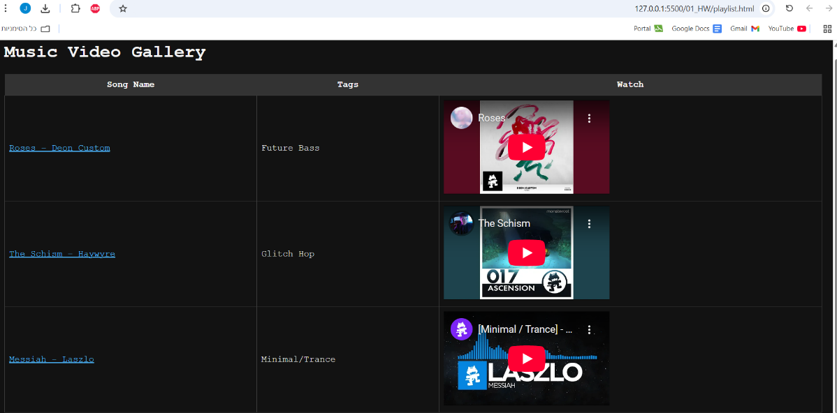
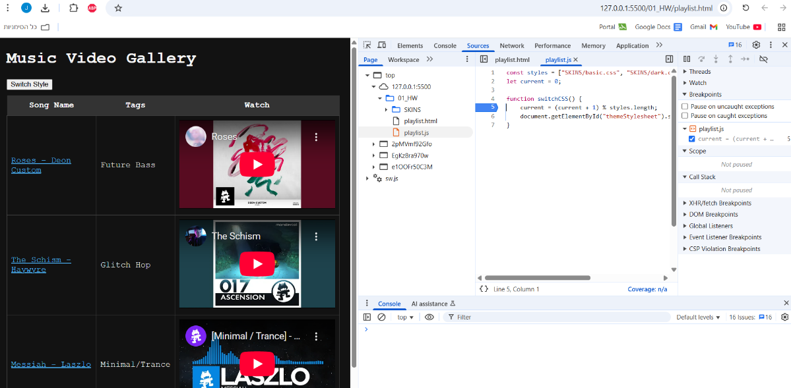 | Added skin button  https://github.com/Janbayhat/WebDevCourse_HW/commit/14934df2f068ae3a80b57373115ddc7f6028898d

