Raspbian
- configured Raspbian: /IMAGE/5inch_HDMI_Raspbian .img
- Install at yourself Raspbian
Display
change config.txt as follow:
pi@raspberrypi ~ $sudo nano /boot/config.txt
# uncomment if hdmi display is not detected and composite is being output
hdmi_force_hotplug=1

# uncomment to force a specific HDMI mode (here we are forcing 800x480!)
hdmi_group=2
hdmi_mode=1
hdmi_mode=87
hdmi_cvt 800 480 60 6 0 0 0

start_file=start_x.elf
fixup_file=fixup_x.elf
#gpu_mem=128

After reboot, it will display OK
Touch
Copy \software\RPI_TOUCH_HDMI_5.0_RASPBIAN.tar.gz to your Pi（though Net or
USB）.
pi@raspberrypi ~ $tar xvf 5inch_HDMI_LCD.tar.gz
pi@raspberrypi ~ $cd 5inch_HDMI_LCD/
pi@raspberrypi ~ $sudo ./5inch_HDMI_LCD
after reboot, the touch will be work
Touch calibrate
pi@raspberrypi ~ $cd 5inch_HDMI_LCD/
pi@raspberrypi ~ $su pi
pi@raspberrypi ~ $DISPLAY=:0.0 xinput_calibrator
After calibrate, you will get
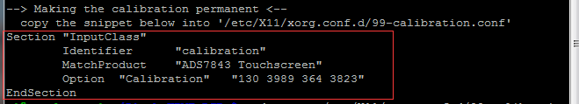
On LXTerminal:
pi@raspberrypi ~ $sudo mkdir /etc/X11/xorg.conf.d
pi@raspberrypi ~ $sudo nano /etc/X11/xorg.conf.d/99-calibration.conf

past what you get just now
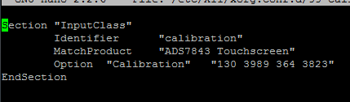
pi@raspberrypi ~ $pi@raspberrypi ~ $sudo reboot
Pidora
- configured Ridora: /IMAGE/5inch_HDMI_PIDORA.img
- Install at yourself Raspbian
Display
change config.txt as follow:
pi@raspberrypi ~ $sudo nano /boot/config.txt
# uncomment if hdmi display is not detected and composite is being output
hdmi_force_hotplug=1
# uncomment to force a specific HDMI mode (here we are forcing 800x480!)
hdmi_group=2
hdmi_mode=1
hdmi_mode=87
hdmi_cvt 800 480 60 6 0 0 0
start_file=start_x.elf
fixup_file=fixup_x.elf
#gpu_mem=128
Touch
Copy \software\RPI_TOUCH_HDMI_5.0_RASPBIAN.tar.gz to your Pi（though Net or
USB）
pi@raspberrypi ~ $tar xvf 5inch_HDMI_LCD.tar.gz
pi@raspberrypi ~ $cd 5inch_HDMI_LCD/
pi@raspberrypi ~ $sudo ./5inch_HDMI_LCD
after reboot, the touch will be work
Touch calibrate
pi@raspberrypi ~ $sudo yum install xinput_calibrator
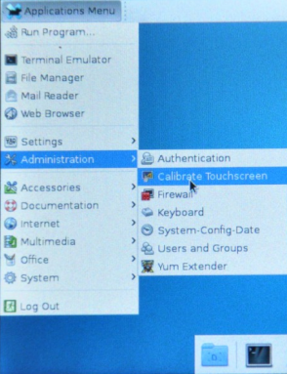
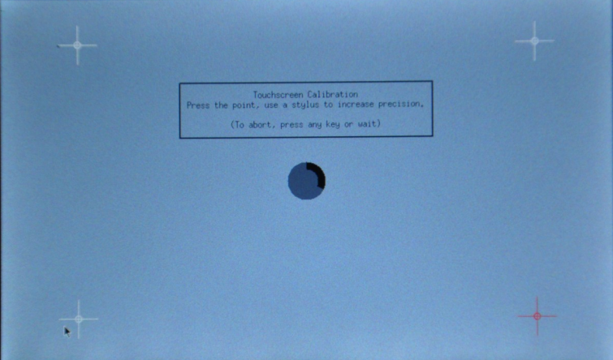
After calibrating, you will get the following codes
xinput set-int-prop "ADS7843 Touchscreen" "Evdev Axis Calibration" 32 125 4001 378 3821
Copy it to /etc/profile
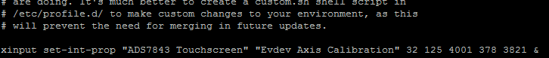
Save and exit , After reboot,it will work
Raspbmc
Configured OS: /IMAGE/ 5inch_HDMI__Raspbian_XBMC.img
(The official version is not supported, only use the version we offer)

