UNIVERSITY OF ZAGREB
FACULTY OF ELECTRICAL ENGINEERING AND COMPUTING

MASTER THESIS no. 705
EVOLUTIONARY COMPUTING OPTIMIZATION OF NEURAL NETWORK FOR TUMOR DETECTION IN BRAIN MR IMAGES
JAN ĐURINEC

Zagreb, January 2025.
Diplomski rad predaje se u elektroničkoj verziji u pdf obliku.
Izgled naslovnice (sadržaj na prednjoj strani korica) prikazan je na prvoj stranici ovog dokumenta.
Prilikom oblikovanja rada držite se redoslijeda: nakon naslovnice slijedi prva stranica istovjetna naslovnoj, zadatak diplomskog rada koji ste preuzeli elektronički, prazna stranica (ili stranica sa zahvalom) te potom cjelokupni sadržaj rada. Redoslijed stranica okvirno je prikazan na slici.
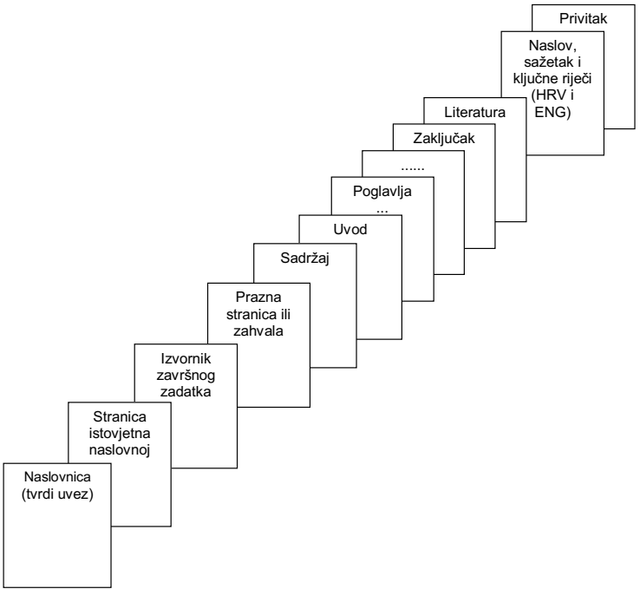

Student predaje samo pdf verziju rada preko FERweb-a.
Ova stranica treba biti:
ILI prazna stranica
ILI stranica sa zahvalom (po želji studenta; zahvala nije obvezna).

Content table
- Introduction
  - Brain tumor MRI
  - Machine learning
  - Convolutional neural networks
  - Evolutionary computing
- Related work: evolutionary computing in DL
- Brain tumor detection
  - Short summary
  - Chosen dataset and its transformation
  - CNN structure
  - Proposed model for brain tumor detection
  - Model comparison
- Evolutionary computing in brain tumor detection
  - Hyperparameter tunning
    - Moth Flame Optimization
    - Non-linear Levy Chaotic MFO
    - Particle Swarm optimization
  - Image segmentation
    - …
  - CNNs loss function optimization
  - Proposed optimized model for brain tumor detection
  - Model comparison
- Conclusion

Introduction
In the recent years, the global hype surrounding Artificial Intelligence (AI) and machine learning (ML) has spurred across a variety of fields, from healthcare to autonomous vehicles. As these technologies evolve, they continue to demonstrate their potential to transform industries and improve our daily lives. One example of such is the realm of medial image analysis, where with the help of AI brain tumors can be easily detected in brain MRI scans. However, the complexity and high dimensionality of medical data pose significant challenges, making it difficult for traditional algorithms to achieve optimal results. Brain MRI scans are often large, containing vast amounts of information, and the tumors themselves may vary in size, shape, and location. This variability makes it difficult to identify tumors using conventional image processing techniques, which may struggle to account for the wide range of possible tumor characteristics. This is where evolutionary computing, a branch of AI inspired by biological evolution and nature behaviors, comes into the action. Evolutionary computing offers a unique approach to solving optimization problems. By mimicking the way nature evolves organisms to adapt and survive, evolutionary algorithms can explore large, complex solution spaces and find optimal or near-optimal solutions in a more efficient manner. In this thesis, the application of evolutionary computing algorithms was explored to optimize the process of brain tumor detection, with the focus on image segmentation as a step to simplify and extract most valuable features from the MRI scans and optimization of convolutional neural networks. In the context of brain tumor detection, evolutionary algorithms can be employed to optimize three main aspects: the preprocessing step for network’s input images, the selection of optimal network hyperparameters, and the minimization of the network’s loss function. All of these actions are necessary to improve the network’s performance and accuracy. In summary, the aim of this thesis is to provide a comprehensive introduction to evolutionary computing, followed by a detailed survey of the latest state-of-the-art applications to brain tumor detection and classification.

The primary objective is to implement evolutionary computing optimized neural network for brain tumor detection and to implement and explore evolutionary computing techniques for brain MR image segmentation, serving as a preprocessing step for network’s input. Furthermore, the thesis aims to explore several optimization algorithms and compare their performance on publicly available dataset with brain MR images containing various types of tumors. This work is organized as follows: … (TODO ?)

Brain tumor MRI
There are many ways and techniques of creating a detailed brain images, it’s structure and functionality. Some of the most famous imaging techniques are:
- Magnetic resonance imaging (MRI) – non-invasive method which creates the image using magnetic fields and radio waves
- Functional magnetic resonance imaging (fMRI) – subcategory of MRI, it measures the brain’s blood flow and creates an image on top of that
- Computed tomography (CT) – uses the X-rays to create an image, barely used because of dangerous X-rays exposure
- Positron emission tomography (PET) – uses the small sample of radioactive material which is injected into the bloodstream
Like in the field of machine learning, there is no best method to create an optimal image of a brain in general. It depends on a specific task and health condition of a subject. Some of the most used features regarding brain tumor detection and classification problem are volume of a tumor, tumor texture, subject’s age, subject’s sex and so on. Based on those extracted features, machine learning models are able to learn the characteristics of specific tumor types and generalize based on new, never seen sample. From definition [1], tumors are abnormal growth of cells that can form in any part of the body. They occur when cells begin to divide uncontrollably. Tumors can be benign, non-cancerous and generally they do not spread, or malignant, meaning they are cancerous and have the potential to invade nearby tissues or spread to other parts of the body Error: Reference source not found. Because of their nature, especially for malignant tumors, early detection is crucial for further diagnosis and successful treatment. There are many types of brain tumors, and the dataset used in this work, which will be further explained in the dataset section, contains only three types: pituitary tumors, glioma tumors and meningioma tumors. Normal brain tissues are composed of gray matter, white matter, and cerebrospinal fluid (CSF). Tumor cell characteristics, including irregular shapes, heterogeneous intensity distributions, variability in tumor location, and the presence of imaging artifacts, significantly impact the diagnostic process. Tumor heterogeneity refers to the distinct morphological and phenotypic variations observed among tumor cells, such as differences in cellular structure, gene expression profiles, metabolic activity, motility, proliferation rates, and metastatic potential [5]. This heterogeneity poses substantial challenges in the design and implementation of effective treatment strategies. Studies conducted by the National Brain Tumor Foundation (NBTF) indicate that brain tumors are a leading cause of mortality worldwide, with their incidence having more than tripled over the past three decades [4]. This dramatic increase highlights the urgent need for advanced and reliable detection or classification techniques, which are essential for early diagnosis, precise treatment planning, and ultimately improving outcomes for the many patients impacted by this condition.

In this work, only the MRI samples will be used. Since MRI is one of the most used techniques for brain imaging due to its non-invasive nature and high resolution. Those images can provide critical information about the structure of the brain, which is crucial for detecting abnormalities or classification of tumors. MRI scans can be performed using various sequences, each designed to highlight specific tissue properties. The two most common sequences are T1-weighted images and T2-weighted images.

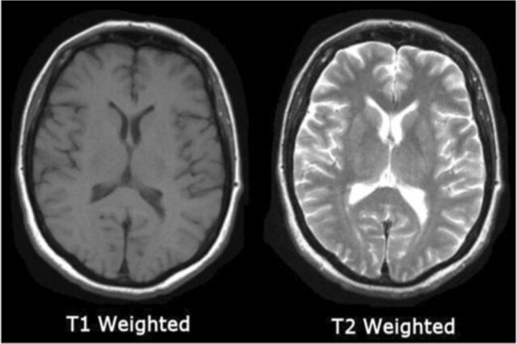
Figure 1.1. T-1 and T-2 weighted MR image comparison
[5]

T1-weighted images are often used to assess the overall structure of the brain and identify abnormalities such as tumors or lesions. Cerebrospinal fluid has dark appearance and white matter has bright appearance as we can see on the figure above (Figure 1.1.). On the other hand, T2-weighted images have cerebrospinal fluid appearing bright and white matter appearing dark. They are often used for detecting areas of edema, inflammation or pathological changes [6]. MRI data can be acquired in either two-dimensional (2D) slices or three-dimensional (3D) volumes. While 2D imaging involves capturing individual slices of the brain, 3D imaging collects data across an entire volume, allowing for more detailed and isotropic analysis. In research and clinical applications, 3D MRIs are often preferred because they enable more precise segmentation, registration, and volumetric measurements. And for the processing MRI data, there are significant computational challenges such as high dimensionality (single 3D MRI scan can contain hundreds of slices) or preprocessing complexity (noise reduction, normalization…). In this work, only 2D MRI scans were utilized due to computational limitations of the available hardware. Processing 3D volumetric MRI data requires significantly more memory and computational power, which exceeds the capacity of the system used in this work. The 2D approach, while less detailed than 3D analysis, allows for effective processing and analysis within these constraints.

Machine learning
In general, machine learning (ML) is divided into supervised, unsupervised and semi-supervised (reinforcement) machine learning (Figure 1.2.). The first category is supervised learning, where models are trained on labeled data. In this case, each input is paired with a corresponding output, allowing the model to learn the relationship between them. The primary goal of supervised learning is to predict the output for new, unseen inputs. It is commonly used for tasks such as classification, where the model predicts discrete categories, and regression, where the model predicts continuous values. Examples include predicting the type of brain tumor from MRI scans or estimating the age of a subject based on brain imaging data. Another category is unsupervised learning, which deals with unlabeled data. In this approach, the model identifies patterns, structures, or relationships within the data without explicit guidance. The main goal of unsupervised learning is to discover hidden patterns or groupings in the data. This is particularly useful for clustering, where similar data points are grouped together, or for dimensionality reduction, which reduces the number of features while retaining significant information. For example, clustering techniques could be used to group MRI scans based on texture or intensity, while dimensionality reduction methods like principal component analysis can simplify complex datasets. Reinforcement learning represents a different approach, where an agent learns to make decisions by interacting with an environment. The agent receives feedback in the form of rewards or penalties and optimizes its actions over time to maximize cumulative rewards. This type of learning is widely used in robotics, game-playing AI, and autonomous systems, where sequential decision-making is critical [7].

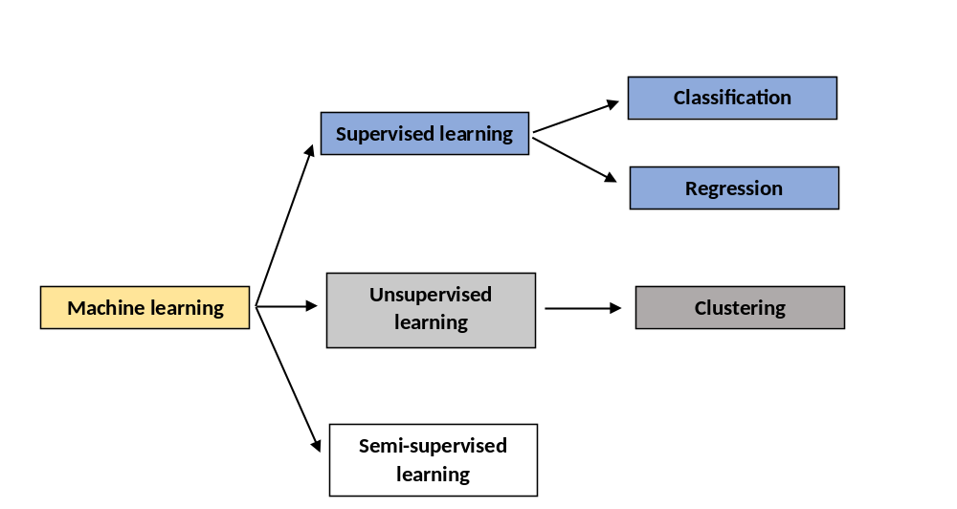Figure 1.2. Division of ML methods

In this work, focus is going to be on supervised learning. Hence, other branches of machine learning will not be further explained. Brain tumor detection, in this case, is a binary classification problem. On the output of a model, there are only two classes: tumor is detected and tumor is not detected. As it is mentioned above, the main difference between supervised and unsupervised approach is whether labeled data is available for the learning process or not. Some of the most common classification algorithms are:

- Logistic regression: Despite its name, it’s a classification algorithm. It predicts the probability of a data point belonging to the specific class using a logistic function.
- Decision trees: These algorithms split data into subsets based on feature values, creating a trees of decision. They are very easy to interpret.
- Support vector machines (SVM): The algorithm finds the hyperplane that optimally separates classes in the feature space. It is very effective in high-dimensional space and for data with clear margins of separation.
- Neural networks: Inspired by biological neural systems, they are a powerful tool for complex problems but require significant computational resources.
- Random forest: An ensemble method that combines decision trees to improve classification accuracy and reduce overfitting.
- Naïve bayes: Based on Bayes’ theorem, this algorithm assumes feature independence. Works well for text classification problems.
There are several different machine learning classification algorithms which are not mentioned above, because they are either a combination of the algorithms above, their generalization, or it has been shown that they do not perform well in practice. Furthermore, it is important to mention that there is no the best classification algorithm. Each one of them depends on the computational resources and the input data, and based on data they can perform better than the other ones. In order to find out the best possible machine learning model for some specific input data, it is necessary to try various different models and compare their results. Choosing the best possible ML model is often a matter of experience and domain knowledge, as understanding the characteristic of the data and the problem is crucial for selecting the most appropriate algorithm. Usually, in practice, small subsets of the data can be used to train and evaluate different models, allowing for a quick comparison of their performance. This approach, often referred to as model benchmarking, helps in identifying optimal candidates without the need to invest excessive computational resources upfront. Once the best-performing models are identified on the smaller subset, they can be further fine-tuned and validated on the full dataset. Fine-tuning is a process of finding the optimal hyperparameters for the specified ML model. For example, finding the optimal number of decision trees in the random forest algorithm.

Convolutional neural networks
One of the biggest aspects of this work are convolutional neural networks (CNNs), which have revolutionized the field of machine learning, particularly in the realm of image processing and computer vision. In order to fully grasp the significance and work behind CNNs, understanding the fundamentals of neural networks and the process of convolution is essential. Some of the first learning algorithms we recognize today were designed as computational representations of biological learning—essentially, models of how learning occurs or could occur in the brain. As a result, deep learning has often been referred to as artificial neural networks (ANNs) [8]. These models consist of layers of interconnected “neurons” that process input data, mimicking how biological neurons transmit an process signals. They are connected by weighted links. Each connection between neurons represents a synapse, and the weight associated with each link determines the strength of the connection. As a result, the network is able to adapt to the data it processes because network’s weights are adjusted during the learning process (Figure 1.3.)
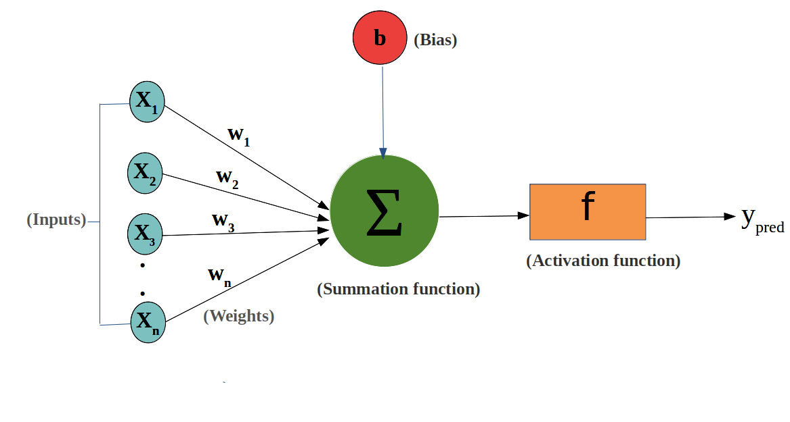
Figure 1.3. Components of the basic artificial neuron [10]

A neural network (NN) is organized into three types of layers: the input layer, hidden layers, and output layer (Figure 1.4.). The input layer receives the raw data, which is then processed through one or more hidden layers. Each neuron in these hidden layers applies a mathematical function, known as an activation function, to the incoming signals. The most common activation functions include the sigmoid, hyperbolic tangent (tanh), and Rectified Linear Unit (ReLU). The processed data then passes to the output layer, which produces the network's final predictions or decisions.

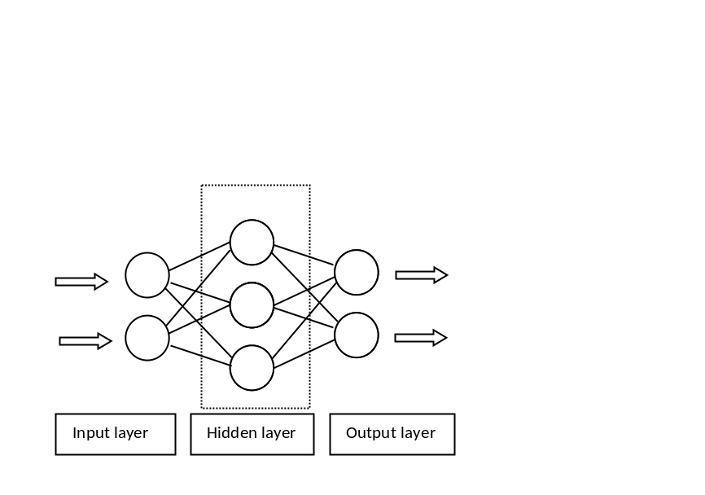
Figure 1.4. Structure of NN

In machine learning, every algorithm is composed of three essential components: the model, the loss function, and the optimization process. These components work together to enable the algorithm to learn from data – train, and generate predictions - predict. Training involves adjusting the weights of the network to minimize the difference between the predicted output and the actual target. This is typically done using a supervised learning algorithm, where the network is provided with input-output pairs, and the goal is to reduce the error between predicted and true outputs. The error is usually measured using a loss function, such as mean squared error (MSE), and the network updates its weights through a process called backpropagation. Backpropagation computes the gradient of the loss function with respect to each weight and adjusts the weights in the direction that reduces the error, using an optimization algorithm like gradient descent. Müller [9] emphasizes that one of the challenges in neural network training is avoiding overfitting, which occurs when a model becomes too complex and performs well on training data but poorly on unseen data. Regularization techniques, such as dropout layers or L2 regularization, are often employed to mitigate the issue of overfitting and help the network generalize better to new data. On the other hand, underfitting occurs when a model is too simple, or to shallow. For example, linear model cannot successfully solve a problem, regression or classification, of an input data where the relationship of the features is non-linear. A field of machine learning that observes a deep neural networks – ones with many hidden layers, is called deep learning. These networks have been instrumental in achieving breakthroughs in complex tasks such as object detection, language translation, and medical diagnosis.

Convolutional neural networks are a type of classical multi-layer feedforward neural networks consisting of an input layer, hidden layer, and output layer. The output of each neuron is a feature map, while kernels are used instead of weights. (Figure 1.5.)

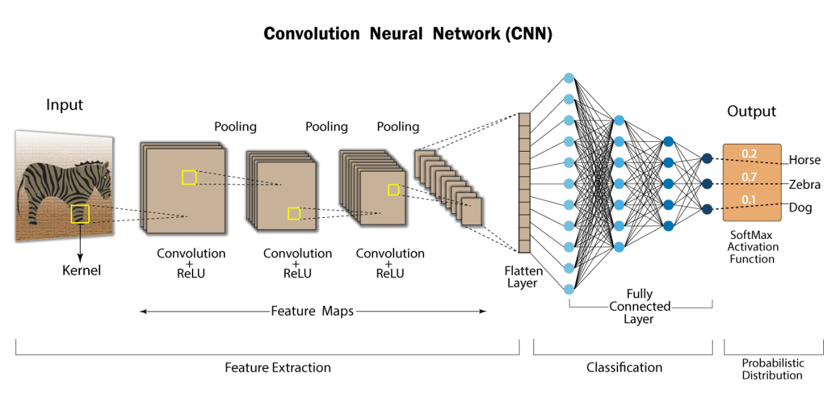
Figure 1.5. Typical CNN architecture Error: Reference source not found

CNNs are particularly suitable for classification, segmentation, and regression of image-based inputs. The most common architecture consists of convolution layers, pooling layers, and at the end, a few fully connected layers. The term “convolutional” comes from the concept of convolution, whose mathematical definition is: an operation on two functions that produces a third function which expresses how the shape of one alters the other. In the context of machine learning, convolution occurs between the input feature map and the kernels. In CNNs, convolution is a crucial step in feature extraction. Early convolution layers can detect simple features such as edges and textures, while deeper layers can detect more complex patterns such as shapes, objects, or even faces. Other type of layers, besides convolutional or fully connected layers are pooling layers. Pooling layers reduce the resolution of the feature maps and increase the spatial invariance of the neural network. There are several types of pooling, with max pooling being the most common. A flatten layer, the one between the last pooling layer and the first fully connected layer (Figure 1.5.), has a purpose to transform multi-dimensional input into a one-dimensional vector. This is necessary because fully connected layers except a one-dimensional input. There are also layers such as dropout layer, and batch normalization layer which are used to prevent overfitting and stabilize a training process. The main advantage of convolutional neural networks over fully connected networks is the smaller number of input nodes, equivalence to small shifts in the image, fewer connections, and they cannot easily learn noise from the input data.

Evolutionary computing
Metaheuristics are advanced problem-solving techniques used to find solutions for complex optimization problems that are hard to solve using exact methods. These algorithms are designed to explore large solution spaces efficiently and to provide robust, approximate solutions to a wide range of optimization challenges. They often draw inspiration from natural phenomena or human problem-solving strategies, and their adaptability and ability to escape local optima make them effective for real-world applications. Optimization methods can be divided into two categories: exact methods and heuristic methods (Figure 1.6.). Exact methods, such as dynamic programming, A start, linear programming, guarantee the optimal solution with a lack of scalability for large or complex problems. These methods are computationally expensive. On the other hand, heuristic or approximate methods, including metaheuristics, provide approximate solutions without guaranteeing optimality. They are mostly used when a problem is too complex or good-enough solution is acceptable taking into the account computational costs and computational time. Heuristic methods are designed to explore the solution space more efficiently by applying simple rules. 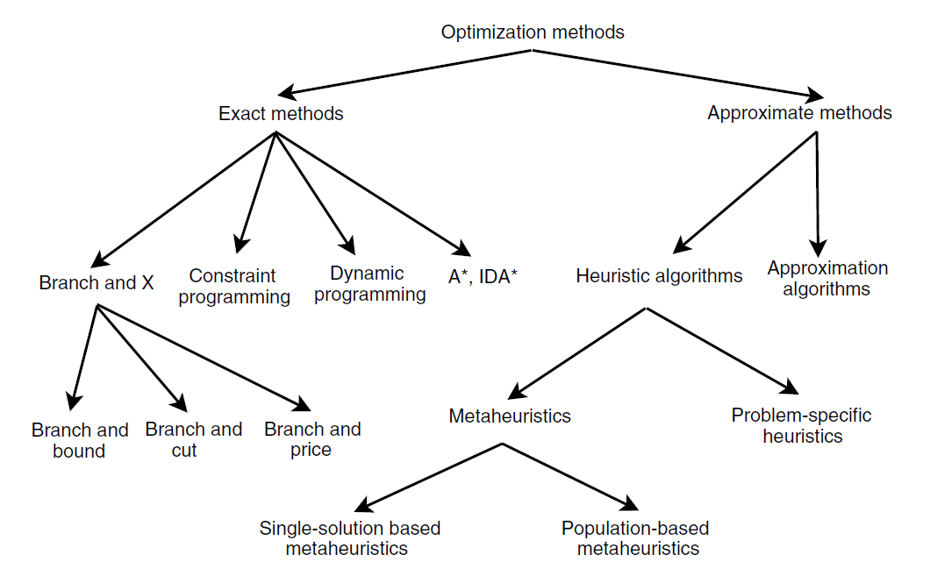
Figure 1.6. Classic optimization methods [11]

Evolutionary computing (EC), a subset of metaheuristics – population-based metaheuristics, is particularly influential, built on top of the principles of biological evolution. It uses mechanisms such as selection, mutation, and recombination to evolve a population of candidate solutions over successive generations. This approach includes popular algorithms like Genetic Algorithms (GA), Genetic Programming (GP), Simulated Annealing (SA), Particle Swarm Optimization (PSO), Ant Colony Optimization (ACO), which simulate the process of natural selection and survival of the fittest to progressively improve solution quality. The flexibility of metaheuristics, and how they can be implemented across diverse fields from engineering and logistics to artificial intelligence has grown in the past years [11]. Overall, metaheuristic and evolutionary computing provide powerful tools for tackling large-scale, complex optimization tasks where traditional exact methods are not viable. On the figure below (Figure 1.7.) the obvious peek in deep learning and evolutionary computing publications from 2008 to 2018 can be seen.

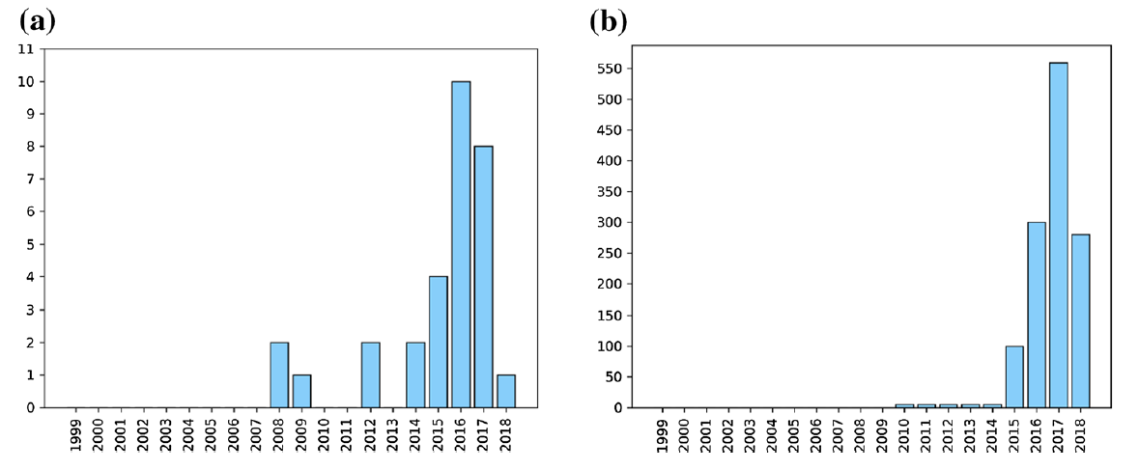
Figure 1.7. Histograms for deep learning and evolutionary computation publications according to the web of science based on related keywords: a total publications by year and b number of citations by year [12]

In the past decade, several evolutionary approaches have been proposed to solve learning problems, and these approaches have displayed remarkably good performance compared to the traditional learning methods that usually require human intervention and expertise. Traditional gradient-based methods for training multilayer neural networks are prone to problems like getting stuck in local optima and can be computationally expensive, particularly when dealing with large training datasets. As a result, training neural networks with multiple hidden layers has not been widely explored for various applications until recently. This shift in interest is due to the development of adaptive stochastic variants of the gradient descent method – a method to find the minimum in models complex loss function. Additionally, metaheuristics can be used to optimize neural network parameters (such as determining the number of hidden layers for a specific task) and improve prediction accuracy. Notably, in recent years, there has been growing interest among core machine learning researchers in using evolutionary computing algorithms for DL. As mentioned above, the main objective of EC algorithms is to improve the efficiency of computations that can assist in solving the challenging computational problems. The initial population explores the search space randomly, then the algorithm evaluates the obtained solutions to select some of them for the further step (best ones, random ones…). The new population is built as a better version of the first population (performing operations such as mutation, selection…). The previous population is often referred as parents to the current one. EC algorithm performs a combination of exploration – investigating new areas of the search space and exploitation – refining and improving the current best solution. After some iterations, algorithm converges to good-enough, near-optimal solution. The balance between exploration and exploitation is critical. If exploitation dominates, the algorithm might converge too quickly to a local optimum. If exploration is too strong, the algorithm might not focus enough on promising areas and fail to refine solutions effectively. The right balance can reduce the risk of getting stuck in a local optimum.

Related work: evolutionary computing in DL
As one of the main objectives of this work was to provide comprehensive introduction to evolutionary computing and a detailed survey of the latest state-of-the-art applications to brain tumor detection, the following section will analyze and discuss the various approaches, methodologies, and results from recent papers, thesis and similar works. It is essential to categorize these approaches, as EC can be applied in various ways, such as tuning the hyperparameters of CNNs, serving as a loss function within the network, or being utilized in the segmentation process of input images. Also, some of the approaches will be analyzed, described into the details and developed in the following sections.

As highlighted by Yao Error: Reference source not found, learning and adaptation are two essential aspects of the ability to adapt and learn, which have evolved over time in various species. The selection of parameters, weights, and the appropriate architecture of an ANN are considered crucial challenges. Evolutionary Computing (EC) can be applied at various stages of an ANN's development, such as during training, weight optimization, and the design of learning rules. Numerous approaches in the literature have been proposed to tackle the optimization problem of fine-tuning the architecture and parameters of ANNs. Leung et al Error: Reference source not found proposed GA to optimize the network structure and learning for a specific application by an ANN. Later, EC has been used to adjust the number of nodes, layers or even polynomial type. The appliance of EA in CNNs has been introduced by Cheung and Sable in 2011. Error: Reference source not found, where they used stochastic diagonal Levenberg-Marquardt method to accelerate the convergence of training while reducing the cost of fitness evaluation. Fujino et al. Error: Reference source not found used a GA to optimize the hyper-parameters of a CNN. Typically, those parameters can be number of iterations, learning rate, momentum rate, number of filters, shape of a filter, max pooling sizes. Aside from finding the best parameters, Khalifa et al. Error: Reference source not found used PSO to optimize the connection weights of the last classification layer of a seven layer CNN architecture for handwritten digit classification and reported better results over a normal CNN that uses stochastic gradient decent (SGD) for all layers. Another example of using PSO algorithm can be found in study by Zhang et al. Error: Reference source not found, where they explored a novel computer-aided diagnosis system for detecting pathological brains in MRI scans. The authors combined wavelet entropy for feature extraction and hybridization of biogeography-based optimization and PSO for training a NN. The proposed system achieved 99.49% accuracy on the large dataset which includes 11 types of pathological conditions, such as glioma, Alzheimer’s disease, and Huntington’s disease. The proposed system outperformed 14 state-of-the-art CAD systems in accuracy. The following study by Dehkordi A. et al. Error: Reference source not found introduced enhanced CNN architecture optimized using Nonlinear Levy Chaotic Moth-Flame Optimization (NLCMFO) for brain tumor detection and classification. The performance of the proposed model was validated using the BRATS 2015 dataset, achieving superior accuracy (97,4%) and f1 score (96,6%) compared to state-of-the-art methods. The model was also benchmarked against PSO, MFO, Salp Swarm Algorithm (SSA), Whale Optimization Algorithm (WOA) and Gray Wolf Optimizer (GWO) algorithms. As shown in the figure below (Figure 2.1.), the NLCMFO algorithm achieved superior performance compared to other methods in nearly every objective space. Overall, the authors concluded that metaheuristic optimization overcomes premature convergence and improves convergence speed through the combination of chaotic maps and levy flight theorem. The study above will be mentioned once again in the following sections. The study by Mahesh K. and Renjit J. [20] provides a critical survey of evolutionary intelligence and other segmentation techniques for recognizing brain tumors from MRI images. It reviews various evolutionary computing and optimization algorithms used in brain tumor recognition, alongside traditional approaches like thresholding, region-based techniques, clustering, and model-based techniques. In the study, authors used GA for tumor segmentation after preprocessing via Discrete Walvet Transform (DWT) and PSO to enhance tumor classification on BRATS dataset.
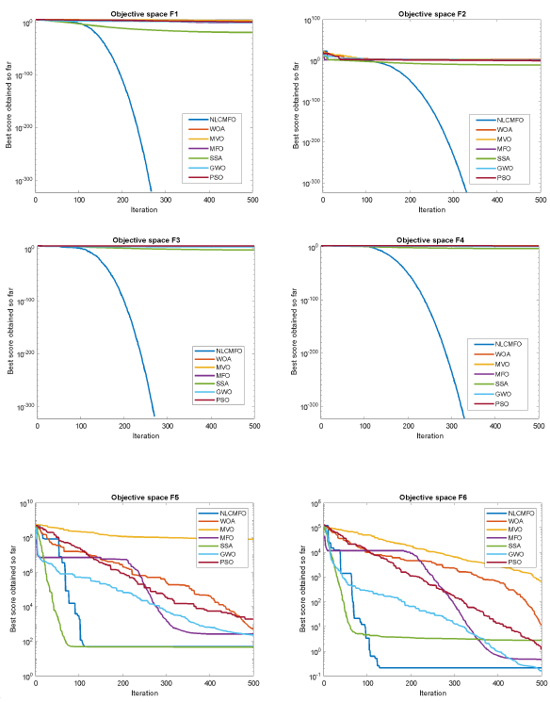
Figure 2.1. NCLMFO versus other approaches convergence analysis [19]

Brain tumor detection
Brain tumor detection is … mention how 2D images are used because of comp power and limited resources…how the process was iterative, how is it usually to build a CNN, why the focus was only on detection, mention previous works.

Short summary
Short summary of the 3rd section, explain the dataset, the chosen CNN aritecture, explain the proposed model for detection and show comparison with different models

Brain tumor detection - dataset

Brain tumor detection - CNN architecture

Proposed model for brain tumor detection

Model comparison

Evolutionary computing in brain tumor detection
Why evolutionary comp, how the idea has been born, …

Study 1 – hyperparameter tunning

Study 2 – input image segmentation

Study 3 – CNNs loss function optimization

Conclusion
Max 1 page
Results were better by …, future work, future of EC…

- Future Directions:
- Extend the approach to 3D CNN architectures for volumetric brain image analysis.
- Incorporate advanced optimization methods to handle larger and more diverse datasets.
- Explore real-time applications and deployment in clinical settings for brain tumor detection.

Literature
- Mayo Clinic, Brain tumor overview (2024, December), link: https://www.mayoclinic.org/diseases-conditions/brain-tumor/symptoms-causes/syc-20350084; accessed 21. December 2024.
- Judas M., Kostovic I., Temelji neuroznanosti, Zagreb (1997)
- Chang H., Valentino D.J., Duckwiler G.R., Toga A.W., Segmentation of brain MR images using a charged fluid model, IEEE (2007)
- El-Dahshan et al., Computer-aided diagnosis of human brain tumor through MRI: A survey and a new algorithm, ScienceDirect (2014, February), DOI: https://doi.org/10.1016/j.eswa.2014.01.021
- Lloyd-Jones G., Radiology masterclass – MRI interpretation (2017, September). Link: https://www.radiologymasterclass.co.uk/tutorials/mri/mri_scan; accessed 21. December 2024.
- Sajedi H., Pardakhti N., Age prediction based on brain MRI image: A survey, Springer (2019, July), DOI: https://doi.org/10.1007/s10916-019-1401-7
- Wiering M., Otterlo M., Reinforcement learning, Springer (2012)
- Goodfellow I., Bengio Y., Courville A., Deep learning, MIT Press (2016)
- Muller B. et al., Neural networks: An introduction, Springer (1991)
- Towards data science, what’s the role of weights and bias in a neural network? (2020, July), link: https://towardsdatascience.com/whats-the-role-of-weights-and-bias-in-a-neural-network-4cf7e9888a0f ; accessed 26. December 2024.
- El-Ghazali T., Metaheuristics – From design to implementation, John Wiley & Sons (2009)
- Darwish A. et al., A survey of swarm and evolutionary computing approaches for deep learning, Springer (2019, June), DOI: https://doi.org/10.1007/s10462-019-09719-2
- Yao X, Evolving artificial neural networks, IEEE (1999, September), DOI: 10.1109/5.784219
- Leung F. et al., Tuning of the structure and parameters of a neural network using an improved genetic algorithm, IEEE (2002, August), DOI: 10.1109/IECON.2001.976448
- Cheung B., Sable C., Hybrid evolution of convolutional networks, IEEE (2011, December), DOI: 10.1109/ICMLA.2011.73
- Fujino S., Mori N., Matsumoto K., Deep convolutional networks for human sketches by means of the evolutionary deep learning, IEEE (2017, August), DOI: 10.1109/IFSA-SCIS.2017.8023302
- Khalifa M. et al., Particle swarm optimization for deep learning of convolution neural network, IEEE (2018, February), DOI: 10.1109/SCCSIT.2017.8293059
- Zhang Y. et al., Pathological brain detection in MRI scanning by wavelet entropy and hybridization of biogeography-based optimization and particle swarm optimization, Springer (2015, November), DOI: https://doi.org/10.1186/s40064-015-1523-4
- Dehkordi A., Hashemi M., Neshat M., Mirjalili A., Sadiq A., Brain tumor detection and classification using a new evolutionary CNN, SSRN (2022, December), DOI: http://dx.doi.org/10.2139/ssrn.4292650
- Mahesh, K., Renjit A., Evolutionary intelligence for brain tumor recognition from MRI images: a critical study and review. Springer (2018, June), DOI: https://doi.org/10.1007/s12065-018-0156-2
- …
- …
- …
- …
- …
- …

Sažetak
Naslov, sažetak, ključne riječi (na hrvatskom jeziku)
Sažetak opisuje sadržaj rada, prepričan u stotinjak riječi.

Summary
Title, summary, keywords (na engleskom jeziku)

Abbreviations
ATM Asynchronous Transfer Mode
ISDN Integrated Services Digital Network
# TODO

