CAPSTONE PROJECT
DATABASE DESIGN DOCUMENT
Student / Group Template
Project Title | StudyFlow: A Web-Based Study Planner for CTU Students
Group Members | Dewald Van Jaarsveldt (team lead), Aneesah Rehman, Riaan Jacobs, Jandre Van Zyl, Omphemetse Dikeledi
Module | Software Engineering 2 (SPM622)
Lecturer / Supervisor | ________________________________________
Week / Stage | ________________________________________
Submission Date | ________________________________________

Database Purpose
The StudyFlow database must reliably store, per private student account, the profile and daily study budgets of that student, the subjects they are registered for, the recurring weekly class sessions of each subject within an active date range, the assessments attached to each subject with their deadlines and progress states, and the study blocks planned against those assessments. It must guarantee that no user can read or modify another user's data, preserve historical records through archive/restore and cancellation instead of deletion, and enforce field-level validation and uniqueness rules (such as one subject code per owner, including archived subjects) at the point of write.

Entity-Relationship Diagram
Figure 1 shows the logical model. The user profile owns four independent entity sets. Subjects are referenced by class slots and assessments through subjectId; assessments are referenced by study blocks through assessmentId; and the subjectCodes collection acts as a uniqueness claim register that reserves each subject code at most once per owner.
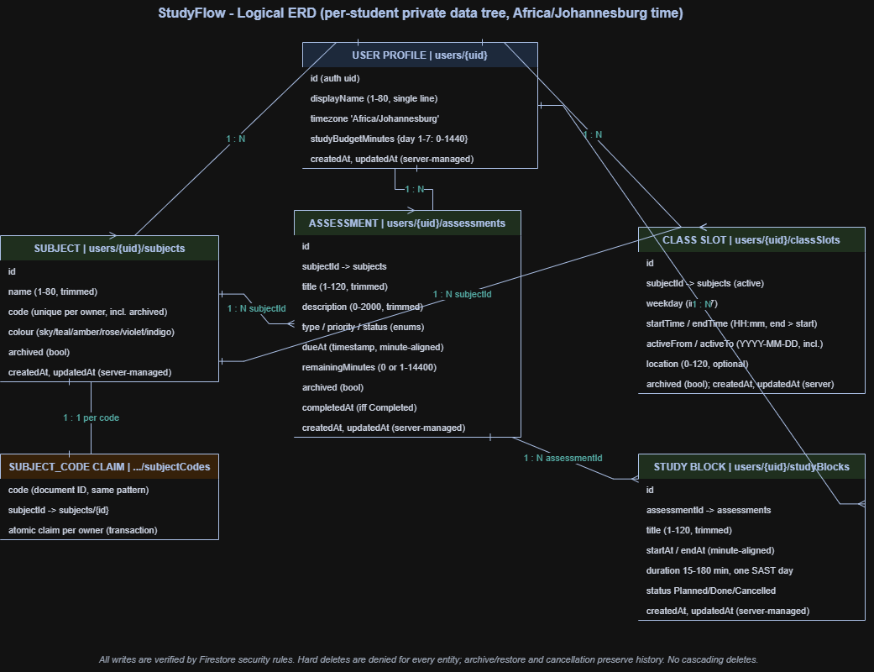
Figure 1: Logical ERD of the StudyFlow data model.
Cardinalities:
Relationship | Cardinality | Reference mechanism
User profile - Subject | 1 : N | Subcollection nesting under users/{uid}/subjects
User profile - Class slot | 1 : N | Subcollection nesting under users/{uid}/classSlots
User profile - Assessment | 1 : N | Subcollection nesting under users/{uid}/assessments
User profile - Study block | 1 : N | Subcollection nesting under users/{uid}/studyBlocks
Subject - Class slot | 1 : N | subjectId field; validated active on create/change
Subject - Assessment | 1 : N | subjectId field; validated active on create/change
Assessment - Study block | 1 : N | assessmentId field; validated active/incomplete on create/change
Subject code claim - Subject | 1 : 1 per code | subjectCodes/{CODE}.subjectId; atomic transaction

Data Dictionary
The dictionary records every persisted field with its type, requirement and constraints as enforced by the security rules. All documents carry server-managed createdAt (immutable, set at creation) and updatedAt (set to request.time on every accepted write). No other fields are accepted: each rule uses exact hasAll/hasOnly key checks, so unknown or forged fields cause rejection. Identifiers marked "auto" are Firestore snapshot IDs, never user-editable fields.
Table 1: User profile (users/{uid}).
Field | Type | Required | Constraints and rules
id | string (uid) | auto | Authentication identifier; document ID
displayName | string | yes | 1-80 characters; trimmed single line
timezone | string | yes | Fixed value "Africa/Johannesburg" in v1
studyBudgetMinutes | map<string,int> | yes | Exactly keys "1"-"7" (ISO weekdays); each integer 0-1440 minutes
createdAt | timestamp | yes | Equals request.time at creation; immutable afterwards
updatedAt | timestamp | yes | Equals request.time on every update; >= createdAt

Table 2: Subject (users/{uid}/subjects/{id}).
Field | Type | Required | Constraints and rules
id | string | auto | Stable snapshot ID; survives renames and archiving
name | string | yes | 1-80 characters; trimmed single line
code | string | yes | Pattern ^[A-Z0-9][A-Z0-9_-]{0,19}$ (uppercase); unique per owner including archived subjects via claims
colour | enum string | yes | One of: sky, teal, amber, rose, violet, indigo
archived | boolean | yes | Archive/restore lifecycle; archived subjects keep history and references
createdAt / updatedAt | timestamp | yes | Server-managed as above

Table 3: Subject code claim (users/{uid}/subjectCodes/{CODE}).
Field | Type | Required | Constraints and rules
CODE (document ID) | string | auto | Same pattern as subject.code
subjectId | string | yes | Must reference an existing owned subject whose code equals the claim
(document semantics) |  |  | Created in the same transaction as the subject (getAfter check); deleted only when the subject no longer holds that code; list and update denied

Table 4: Class slot (users/{uid}/classSlots/{id}).
Field | Type | Required | Constraints and rules
id | string | auto | Stable snapshot ID
subjectId | string (reference) | yes | Existing own subject; required active for new or changed references; unchanged archived parent retained
weekday | integer | yes | 1-7 (ISO weekday, Monday=1)
startTime | string HH:mm | yes | 24-hour pattern ^([01][0-9]|2[0-3]):[0-5][0-9]$
endTime | string HH:mm | yes | Same pattern; strictly later than startTime (same day)
activeFrom | string YYYY-MM-DD | yes | Real calendar date 2000-2099 incl. leap days; inclusive
activeTo | string YYYY-MM-DD | yes | Real calendar date; >= activeFrom; inclusive
location | string | no (0-120) | Trimmed single line; empty allowed
archived | boolean | yes | Archive/restore lifecycle
createdAt / updatedAt | timestamp | yes | Server-managed as above

Table 5: Assessment (users/{uid}/assessments/{id}).
Field | Type | Required | Constraints and rules
id | string | auto | Stable snapshot ID
subjectId | string (reference) | yes | Existing own subject; active required for new/changed; unchanged archived parent retained
title | string | yes | 1-120 characters; trimmed single line
type | enum string | yes | Assignment, Test, Exam or Project
description | string | no (0-2000) | Trimmed; at most 2000 characters
dueAt | timestamp | yes | Minute-aligned (seconds and nanos zero); year (SAST) within 2000-2099
priority | enum string | yes | High, Medium or Low
status | enum string | yes | To Do, In Progress or Completed
remainingMinutes | integer | yes | 1-14400 while not Completed; exactly 0 when Completed
completedAt | timestamp or null | yes | Null unless Completed; set to request.time on completion, preserved on later edits, cleared on reopening (which requires positive remainingMinutes)
archived | boolean | yes | Archive/restore lifecycle; history retained
createdAt / updatedAt | timestamp | yes | Server-managed as above

Table 6: Study block (users/{uid}/studyBlocks/{id}).
Field | Type | Required | Constraints and rules
id | string | auto | Stable snapshot ID
assessmentId | string (reference) | yes | Existing own assessment; new/changed references require an incomplete, unarchived assessment whose subject is also active; unchanged completed/archived parent retained
title | string | yes | 1-120 characters; trimmed single line
startAt | timestamp | yes | Minute-aligned; SAST year 2000-2099
endAt | timestamp | yes | Minute-aligned; duration 15-180 minutes; same SAST calendar day as startAt
status | enum string | yes | Planned, Done or Cancelled; Done requires startAt at or before server time
createdAt / updatedAt | timestamp | yes | Server-managed as above

Normalisation
The logical model is kept close to third normal form: each fact type lives in exactly one entity (subjects, their recurring class sessions, assessments and blocks are separate sets linked by stable identifiers), and no non-key field duplicates a fact stored elsewhere. Two deliberate deviations from a strictly relational layout exist. First, the daily study budget is embedded in the profile document as a fixed seven-key map rather than a separate collection: it is small, always read with the profile, and its shape is fixed, so embedding removes a join the client would otherwise perform on every dashboard load. Second, the subjectCodes collection is an intentionally duplicated index that exists purely to make a uniqueness constraint enforceable in a document database.
Compared with a relational database, Firestore trades server-side joins, declarative foreign keys and ad-hoc SQL for hierarchical scoping, real-time listeners and rules-based validation that match this application's access pattern: every read and write is scoped to one signed-in student's subtree. Cross-entity queries that a relational database would answer with joins (for example, the combined weekly agenda) are computed in the application layer from the four per-user collections, which is feasible because no student's dataset exceeds a few hundred documents.

Security and Integrity
Firestore does not provide declarative foreign keys, unique constraints or server-side joins, so the equivalent integrity is enforced inside the security rules (firebase/firestore.rules) and service transactions, rejecting the invalid writes covered by the documented rules and tests:
Per-user isolation: every planner rule is guarded by an owns(uid) check binding the document path to request.auth.uid, and a catch-all rule denies all other access. Profile listing and account deletion are explicitly disabled.
Exact schemas: hasAll/hasOnly key checks plus per-field type and pattern validation reject missing, extra or forged fields on every create and update.
Referential integrity: subject and assessment references are validated with get()/getAfter() lookups inside the same write; new or changed references must point at an active (and for blocks, incomplete) parent, while unchanged references to archived or completed parents remain valid so history is preserved.
Uniqueness: subject codes are unique per owner, including archived subjects, through subjectCodes claim documents created atomically in the same transaction as the subject.
Lifecycle integrity: completion requires zero remaining minutes and a server completedAt; reopening requires a positive estimate and clears completedAt; Done blocks cannot start in the future; createdAt is immutable and updatedAt is always request.time.
No destructive operations: delete is denied for every collection; subjects, classes and assessments are archived and restored, and blocks are cancelled. Parent archiving never cascades.
Backups and sensitive data: the evaluated system runs entirely on local Firebase emulators with disposable data and no personal or payment information; accounts use synthetic credentials. The rules and index configuration are version-controlled with the source code, which serves as the recoverable record of the database definition.

SQL Scripts
The implemented database is the Firestore model described in this document, so the project-specific schema artifacts stored in the repository are firebase/firestore.rules (every validation, uniqueness and access rule cited above), firebase/firestore.indexes.json (currently empty: all queries are single-collection, per-user reads or client-side merges, so no composite index is required), and the authoritative document shapes in src/shared/types/planner.ts. No seed script exists by design: accounts are registered manually with synthetic credentials and backend data is disposable in the local emulator environment.
The relational database_schema_template.sql supplied in the course pack (folder 05) is treated as a generic example only and does not reflect the implemented database. Whether the Firestore rules/index configuration plus this data dictionary satisfy the course's schema-script requirement is being confirmed with the supervisor by the team lead; this document states the implemented design and does not assume that acceptance.

Release alignment - 28 October 2026
This contributor draft describes the original core planner. The final application also includes CTU branding and source imports, onboarding, a study timer with private recorded sessions, and a private grade book. The default npm run dev uses the real Firebase backend from a local website; automated npm test uses disposable local emulators. Hosting is unpublished. Earlier emulator-only and excluded-timer/branding descriptions are superseded by this addendum.
The original ERD remains the core planner diagram. The complete current collection inventory, relationships, access controls, source-to-planner lifecycle and limitations are recorded in docs/design/Release_Data_and_Scope_2026-10-28.md. Use that addendum when assembling the final dissertation. Git stores rules and source code, not a backup of private cloud records. No paid backups are configured.

