Suffering from Success: Relief, Yield, and Retention in Security Assistance
September 21, 2026

Abstract
Security assistance can improve a force while support is available without showing how much capability the partner can reproduce after external service stops. This article separates relief, whether assistance improves a limiting service; yield, how much whole-force capability follows; and retention, how much remains after support ends. I evaluate this framework in the Pineland agent-based model using a frozen 2,808-world Stage-4 campaign, a 1,472-world coordinated-development extension, matched no-aid controls, and a prospectively frozen post-review demand-clamp test. At +30 days, 26 of 120 treated Phase-Map cells show supported capability above matched no aid but post-withdrawal capability below no aid; 30 improve in both branches and 51 are below no aid in both. Frozen-telemetry decomposition associates terminal logistics-coverage gaps with both indigenous service and the supported operating requirement. A direct demand clamp passes its manipulation check but does not identify requirement expansion as the cause of those gaps because the fresh-seed normal arms reproduce positive capability effects but no coverage penalty to attenuate. Constraint displacement is better identified: command and force-generation bottlenecks migrate frequently but produce little system yield and do not explain the strongest retention penalties. Developmental assistance improves partner-owned service but lies on a capability-retention-cost frontier rather than uniformly dominating substitution. The contribution is therefore a diagnostic production framework for showing why local assistance success, whole-force performance, dependence on continuing support, and post-support retention need not coincide. # 1. Introduction
Security assistance is often assessed through outcomes that are related but not identical. Did the donor fix the targeted military problem? Did the force become more capable? Could the partner reproduce that capability after external support stopped? Existing research explains disappointing assistance outcomes through provider-recipient interest misalignment, weak institutions, limited leverage, fragmented security sectors, poor absorptive capacity, fragile elite formations, and dependence on external resources (Biddle 2017; Biddle et al. 2018; Metz 2023; Matisek 2018; Knowles and Matisek 2019; Harkness 2022; Sandnes 2024). Recent work also treats security assistance as a relational practice that can reshape authority, alignment, and dependency rather than merely transfer technical inputs (Rolandsen et al. 2021, 2026).
This article addresses a narrower production problem. Even when assistance changes the military function it targets, three outcomes can diverge. Relief concerns the targeted constraint. Yield concerns whole-force capability. Retention concerns what remains after the donor’s additional service stops. Treating these as one outcome obscures both successful and unsuccessful assistance. A program can fix a training bottleneck without raising whole-force performance because logistics binds next. It can raise supported performance without creating a retained gain because the operating requirement grows faster than indigenous sustainment. It can also improve both supported and retained capability.
The underlying ideas are not individually new. Theory of Constraints expects relief of one bottleneck to expose another (Watson et al. 2007). Hirschman’s unbalanced-growth logic treats expansion in one activity as a source of new complementary shortages (Hirschman 1958). Foreign-aid research shows that donor-financed activity can increase claims on scarce recurrent or administrative resources (Roodman 2006; Arimoto and Kono 2009). Security-assistance scholarship has long distinguished current performance from sustainability and independent capacity. The contribution here is to translate those insights into a military-production framework that separates outcomes first and then assigns distinct empirical tests to candidate explanations for their divergence.
The first is requirement expansion. Assistance can enable a force to sustain more personnel, movement, patrols, combat, or command activity. Those operations generate service requirements. If the requirement for a complementary indigenous service grows faster than indigenous production, the partner’s coverage of the supported operating requirement falls even if indigenous service itself increases. This is a numerator-denominator mechanism. It does not require the binding service to change.
The second is constraint displacement. Assistance can successfully improve the service that currently limits the force, only for another service to become binding. Once that happens, further improvement of the relieved service can have little whole-system return. This is a bottleneck mechanism. It explains relief without yield, but it does not by itself imply a retention penalty.
These mechanisms imply a stricter empirical standard than the original manuscript used. Comparing continued support with withdrawal after a common period of support identifies a dependency gap, but it does not establish that support improved capability relative to no aid. The revised analysis therefore distinguishes the supported effect relative to a matched zero-support trajectory, the retained effect after withdrawal relative to the same benchmark, and the gap between continued support and withdrawal. A strong success-without-retention case requires supported capability above no aid and post-withdrawal capability below no aid.
I evaluate the framework using Pineland, a partially observed agent-based model that represents military personnel, formations, readiness, logistics, command, external support, force generation, governance, armed organizations, and territorial competition. Stage 4 contains 2,808 prospectively frozen production worlds across a Phase Map, a targeted bottleneck-displacement module, and a substitution-versus-development module. Stage 5 adds 1,472 separately frozen worlds testing coordinated indigenous development. Post-review analyses use only frozen telemetry for matched no-aid comparisons and service-demand decomposition, while a separately frozen demand-clamp experiment tests whether requirement expansion actually mediates the terminal coverage gap.
The revised evidence is more qualified than the original branch-contrast headline. At +30 days, 26 of 120 treated Phase-Map cells meet the strict pattern of positive supported capability relative to no aid and negative retained capability after withdrawal. Thirty cells improve relative to no aid in both branches, 51 are below no aid in both branches, one is negative under support but positive after withdrawal, and 12 are neutral on at least one contrast. Thus support-induced dependence is a meaningful regime in the model, not its universal outcome.
The mechanism evidence also separates, but asymmetrically. Among worlds with negative terminal logistics coverage, the continued-support branch usually faces a larger logistics requirement, and descriptive standardization attributes a larger share of the mean coverage gap to demand than to indigenous-service decline. The prospectively frozen clamp test, however, does not causally validate that interpretation. Its demand manipulation succeeds, but the fresh-seed normal arms reproduce positive capability effects without reproducing any indigenous-coverage branch gap, leaving no retention penalty to attenuate. Requirement expansion therefore remains a plausible production dynamic supported descriptively, not an identified cause of the Stage-4 retention pattern. By contrast, the Migration module directly shows that command and force-generation constraints are readily displaced while logistics is persistent. Force-generation relief can change the binding service while producing essentially no composite-capability gain. Constraint displacement therefore explains relief without yield, not the terminal retention penalty.
The treatment-mode results add a further qualification. Developmental logistics assistance produces much more partner-owned logistics service and much better terminal coverage than substitution, but it is somewhat more expensive in the model and does not uniformly dominate on near-term capability. Assistance design therefore lies on a capability-retention-cost frontier. Stage 5 likewise finds a small number of positive equal-dose complementarities, but its intended near-tie structure becomes logistics-bound before the main comparison. The fixed-budget breadth result consequently applies to the realized single-bottleneck regimes rather than cleanly testing the intended near-tie hypothesis.
The paper makes three contributions. First, it provides a minimal production model separating supported capability, retained capability, service coverage, and the dependency gap. Second, it demonstrates why requirement growth and constraint displacement require different empirical tests and reports both supportive and failed tests rather than inferring mechanism from outcome patterns alone. Third, it offers a measurement framework for evaluating security assistance through relief, yield, retention, service demand, indigenous production, and cost rather than treating supported performance as a proxy for autonomous capacity.
The scope is limited. Pineland is a synthetic laboratory, not a forecasting system. Numerical effects are model outcomes, not estimates for Afghanistan, Iraq, Mali, Colombia, or any other historical force. Historical cases are used only as structured external validation, with rival political explanations preserved rather than treated as noise.

2. Security Assistance, Dependence, and the Missing Production Dynamic

2.1 Interest misalignment and influence
A major strand of security-force-assistance research treats poor outcomes as an agency problem. Biddle, Macdonald, and Baker argue that U.S. efforts frequently encounter systematic interest misalignment with recipients, which limits the military effectiveness achievable through small-footprint assistance (Biddle 2017; Biddle et al. 2018). Metz develops a related account centered on influence. Recipient leaders may have political incentives to preserve military practices that external advisers seek to reform, while U.S. organizations often prefer teaching and persuasion to more coercive forms of conditionality (Metz 2023).
This work explains why recipients may fail to adopt reforms even when donors possess technical expertise. It also guards against an overly technocratic interpretation of military weakness. A partner force can remain ineffective because the political system that produces it rewards behaviors that donors regard as pathologies. The present article accepts that insight. It asks a different question: conditional on assistance actually improving a targeted military function, what happens to the production structure of the partner force afterward?

2.2 Fragile forces, weak institutions, and dependence
A second literature emphasizes the fragility of forces built without corresponding political and institutional foundations. Matisek describes externally constructed but brittle militaries as “Faberge Egg” forces whose apparent capability can collapse when external support is removed (Matisek 2018). Knowles and Matisek similarly argue that technical assistance cannot substitute for political settlement and local ownership in weak states (Knowles and Matisek 2019). Harkness shows that concentrating assistance in enclave units can create effective pockets of force while generating political and institutional consequences for the broader security system (Harkness 2022). Sandnes conceptualizes the G5 Sahel Joint Force’s relationship with external actors as asymmetric interdependence and emphasizes the difficulty of reaching an autonomous endpoint under such a relationship (Sandnes 2024).
Security-assistance scholarship also already treats independence or sustainability as a distinct outcome from current battlefield performance. Karlin includes the ability to sustain a partner military without continuing U.S. support in the outcome concept for successful military building (Karlin 2018). Reynolds similarly proposes an explicit Security Autonomy Index for assessing whether recipient institutions can internalize and sustain security models (Reynolds 2025). These works occupy important conceptual ground that the present article does not claim as new. The contribution must therefore lie in the production mechanisms separating supported from retained capability, not in noticing that such divergence can exist.
Policy and evaluation literatures make a related point in the language of absorptive capacity and sustainment. RAND research on defense institution building stresses the organizational and institutional foundations required to convert external assistance into durable partner capability (McNerney et al. 2016). Earlier RAND work on building partnership capacity likewise emphasizes that assistance effectiveness depends on context, recipient capacity, and the type of capability being built rather than the transfer of resources alone (Paul et al. 2013). GAO’s review of Section 333 train-and-equip proposals found that 42 of 46 reviewed proposals did not fully document sustainment, absorptive capacity, or measurable objectives (U.S. Government Accountability Office 2023). These literatures make it clear that durable capacity cannot be inferred from equipment delivery or tactical proficiency.
An adjacent state-capacity literature sharpens the same warning. Pritchett, Woolcock, and Andrews describe premature load bearing as a condition in which organizations are asked to perform functions beyond the capabilities they have actually developed (Pritchett et al. 2013). Andrews, Pritchett, and Woolcock develop that argument into a broader account of capability traps and problem-driven institution building (Andrews et al. 2017). The present theory is narrower and more mechanistic. It asks how successful assistance can itself alter the service requirements placed on a military organization, and how the identity of the binding production constraint changes as a result. In that sense, support- enabled demand is not merely an external burden placed on a weak organization; it can be an endogenous consequence of prior success.
The contribution here is therefore not the claim that assistance can create dependency. That point is well established. The narrower problem is how to separate current supported performance from retained capability while identifying whether a gap arises because operating requirements expand, because indigenous production changes, or because a different complementary service becomes binding.
It is also useful to separate three forms of dependence that are often collapsed into one label. Operational dependence means that a specified military output cannot be generated without continuing foreign service or input provision. Institutional dependence means that external provision weakens or displaces the development of indigenous organizations. Relational dependence means that reliance on an external actor creates asymmetric bargaining power. The production framework here is fundamentally operational. Requirement expansion and constraint displacement can coexist with the institutional and relational forms, but neither mechanism logically requires them.

2.3 Bottlenecks, recurrent costs, and complementary production
The closest general antecedent is the Theory of Constraints. In that tradition, system throughput is governed by the active constraint; improving a nonconstraint yields little whole-system benefit, while successful elevation of the current constraint eventually causes another to become limiting (Watson et al. 2007). That logic is almost an abstract statement of constraint migration. It should therefore be treated as a theoretical foundation rather than claimed as an original discovery.
Hirschman’s unbalanced-growth framework provides a second close precedent. Expansion in one sector creates shortages, pressures, and inducements for complementary investment elsewhere (Hirschman 1958). The key similarity is endogeneity: the next shortage is generated or made salient by successful expansion in the first activity. The difference is that Hirschman’s mechanism is normally developmental and economy-wide, whereas the present argument focuses on selective foreign substitution inside a military production system and on the possibility that observed performance rises faster than indigenous reproduction.
Foreign-aid research comes closer still to the support-induced demand problem. Roodman models donor aid and scarce recipient-side resources as complementary inputs and shows how project proliferation can overload the local resources needed to administer assistance (Roodman 2006). Arimoto and Kono model donor-financed investment that generates recurrent-cost obligations which the recipient must supply if project benefits are to persist (Arimoto and Kono 2009). Morss’s earlier work on donor and project proliferation similarly emphasizes the burden placed on scarce recipient administrative capacity (Morss 1984). These are direct precedents for the proposition that an external input can increase the requirement for a scarce indigenous complement.
The military contribution is narrower. The relevant complement need not be a recurrent cost attached directly to the donated asset. Assistance to one service can enable a broader change in operating scale or complexity whose demands spill onto a different service. More reliable command can make larger formations usable. More force generation can increase logistics and replacement demand. More mobility can increase maintenance, fuel, communications, medical evacuation, and distribution requirements. The object of interest is therefore a changing constraint set in which the service that limits the whole force is itself endogenous to successful intervention.
This point is consistent with mature theories of complementarity. Kremer’s O-ring model shows why weak performance in one indispensable task can sharply reduce the return to excellence elsewhere (Kremer 1993), and organizational complementarity research shows how returns to one practice can depend on the presence of others (Milgrom and Roberts 1990), while military effectiveness research has long treated armed forces as complex organizations whose aggregate performance cannot be inferred from isolated attributes (Millett et al. 1986). Biddle’s force-employment account similarly demonstrates that material inputs do not map mechanically into military capability because their effect depends on how forces employ them (Biddle 2004). Military logistics scholarship likewise demonstrates that movement and sustainment can delimit operational possibility (Creveld 2004). The paper therefore makes no generic claim that militaries are systems, that logistics matters, or that nonbinding improvements can have low system returns.
Absorptive capacity is adjacent but distinct. In its classic organizational form, absorptive capacity concerns the ability to recognize, assimilate, and exploit external knowledge (Cohen and Levinthal 1990). A partner can display high absorptive capacity in an assisted subsystem and still fail to reproduce the larger military system that successful absorption makes possible. The most diagnostic cases for the present theory are therefore not failed absorption, but successful first-stage absorption followed by insufficient indigenous production in another complementary service.
Aid-dependence research also offers a competing route to superficially similar outcomes. High external financing can weaken accountability, distort incentives, or inhibit long-run institution building (Knack 2001; BrÃ¤utigam and Knack 2004; Moss et al. 2006). Those mechanisms can also produce high supported output and weak post-support retention. The empirical burden here is to show a different production sequence: assistance changes supported operations and service requirements, indigenous production may fail to keep pace, and local constraint relief may or may not translate into whole-system yield.

2.4 From static capacity to endogenous production dynamics
Military capability is jointly produced: personnel, logistics, command, and force generation are complements, so improving one function need not increase whole-force output. Assistance can also change the system it evaluates by enabling more personnel, movement, coordination, or operations, which can alter service requirements and the identity of the binding constraint. The narrow contribution is therefore a measurement framework that places supported capability, retained capability, service requirements, indigenous production, and changing constraints in one production system while keeping candidate mechanisms empirically separable.

3. Theory

3.1 A minimal complementary-production model
Consider a military system that requires services indexed by (j). An operation of scale or complexity (x) requires (r_j(x)) units of service (j). Indigenous production is (I_j) and external provision is (E_j). Supported feasible capability and independently reproducible capability are
[ C^{S}=x r_j(x)I_j+E_j j, ]
and
[ C^{A}=x r_j(x)I_j j. ]
For the useful special case (r_j(x)=a_jx), these reduce to
[ C^{S}=_j, C^{A}=_j. ]
The result is elementary but important. A force can possess a high supported capability and a much lower independently reproducible capability at the same point in time. The gap (C^{S-C}A) is therefore a production property, not a claim that indigenous capability has necessarily been destroyed.
The empirical analysis also records indigenous coverage of an observed service requirement. For any active service with demand (D_j>0),
[ q_j^I=, q_j^S=. ]
The structural coverage coordinate is (q^I=_j q_j^I), and the observed binding service is (B=_j q_j^I). Coverage is deliberately kept distinct from absolute capability. A lower (I/D) ratio can reflect lower indigenous service, a larger requirement, or both. It should not be described as indigenous capability loss without decomposing its numerator and denominator.

3.2 Relief, yield, and retention
Security-assistance performance is decomposed into three outcomes.
Relief asks whether an intervention improves or removes the service that was limiting the system. Yield asks how much whole-force capability the intervention produces. Retention asks how much of that capability remains after the additional external service stops.
These quantities can be represented against a common no-aid benchmark. Let (C_h^0) be capability at horizon (h) under matched no aid, (C_h^{ON}) capability with continued support after the split, and (C_h^{OFF}) capability after the same supported prehistory followed by withdrawal. Then
[ S_h=C_h^{{ON}-C_h}0 ]
is the supported effect,
[ R_h=C_h^{{OFF}-C_h}0 ]
is the retained effect, and
[ G_h=C_h^{{ON}-C_h}{OFF}=S_h-R_h ]
is the dependency gap between continued support and withdrawal. A strong success-without-retention case requires (S_h>0) and (R_h<0). This is a stricter condition than simply observing (C_h^{{ON}>C_h}{OFF}), because the latter can arise when withdrawal harms a force that was not outperforming the matched no-aid trajectory.
The three-part framework also separates two system dynamics that the original draft treated as one. Requirement expansion can create yield without retention. Constraint displacement can create relief without much yield. Neither mechanism logically requires the other.

3.3 Requirement expansion and indigenous coverage
Suppose assistance allows the force to operate at a higher supported scale (C^S). Service demand may then rise with that operating scale. Write the requirement for service (j) as (D_j=g_j(C^S)), with (g_j’). Indigenous coverage is
[ q_j^{I=\frac{I_j}{g_j(C}S)}. ]
For positive values, the change in log coverage decomposes exactly as
[ q_j^I=I_j-D_j. ]
Coverage therefore falls whenever proportional growth in the service requirement exceeds proportional growth in indigenous service. This can occur even when (I_j) increases in absolute terms. It can also occur while the same service remains binding throughout. Requirement expansion is therefore a distinct mechanism from bottleneck migration.
Proposition 1, Requirement Expansion. Conditional on an assistance-induced increase in operating requirements, indigenous coverage of service (j) falls when (D_j) grows faster than (I_j).
Proposition 2, Supported-Retained Divergence. Assistance can generate a positive supported effect (S_h) while producing a smaller or negative retained effect (R_h) when the supported system depends on service production that the partner does not reproduce after withdrawal.

3.4 Constraint displacement and system yield
Requirement expansion is not the only reason local improvement can fail to translate into system performance. In the linear special case, suppose service (k) is the unique supported bottleneck. Increasing external service (E_k) raises (C^S) only until
[ = _{jk}. ]
Beyond that threshold, another service binds and the marginal system return to additional service (k) is zero unless the new constraint is also relieved. This is constraint displacement. It is the standard bottleneck logic applied to a partner force whose service levels can be altered selectively by external assistance.
The distance between the lowest and second-lowest service coverage levels can describe the initial spacing of constraints, but it does not determine realized yield once assistance changes operations and demand. The paper therefore treats static headroom as a descriptive diagnostic rather than a causal predictor.
Proposition 3, Constraint Displacement. Assistance that relieves a binding service can shift the limiting constraint to another service; once displaced, additional improvement of the relieved service can have little or no whole-system yield.
This proposition does not predict a retention penalty. Migration can accompany positive, zero, or negative retained outcomes.

3.5 Substitution, development, and coordinated growth
Direct substitution increases (E_j). Developmental assistance seeks to raise (I_j). Development at a persistently binding service can therefore improve indigenous coverage, but it need not dominate substitution on near-term capability or modeled donor cost. The relevant policy object is a frontier among supported capability, retained capability, indigenous service, time, and cost, not a single ranking of assistance modes.
If several services are genuinely near binding, coordinated development may generate technical complementarity. For two services, the equal-dose factorial interaction is
[ I_{AB}=Q_{AB}-Q_A-Q_B+Q_0, ]
where (Q) is the prespecified terminal system coordinate. A positive interaction identifies complementarity on that outcome. A different question is whether spreading a fixed total developmental dose across services beats concentrating it on the best single channel. The latter requires a valid near-tie manipulation and cannot be inferred from complementarity alone.
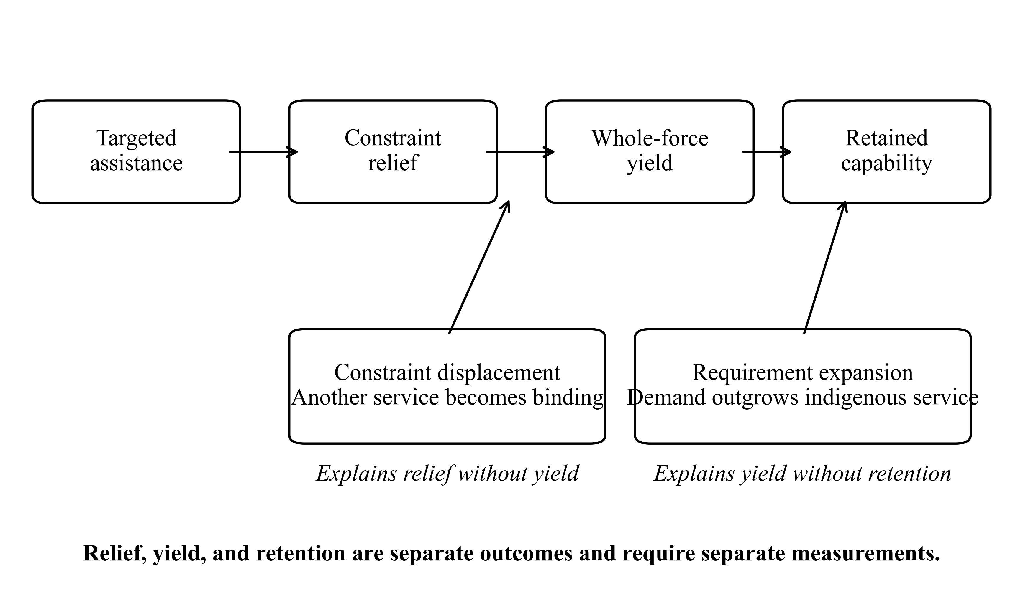
Figure 1. Security assistance can separate relief, yield, and retention. Requirement expansion affects the transition from supported yield to retained capability when service demand grows faster than indigenous production. Constraint displacement affects the transition from local relief to system yield when another complementary service becomes binding.

3.6 Empirical implications
The two mechanisms imply different observable patterns. Requirement expansion is supported when the continued-support branch generates a larger service requirement than its matched withdrawal branch and clamping that excess demand attenuates the terminal coverage gap. Constraint displacement is supported when the targeted service ceases to bind but system yield remains limited by a different service. Neither pattern is sufficient evidence for the other.
The framework is weakened if continued support does not enlarge relevant requirements, if clamping the requirement leaves the coverage gap unchanged, or if the reportedly displaced service remains the marginal determinant of whole-system output. These tests are reported separately rather than combining them into a single migration-mediated theory of dependence.

4. Research Design

4.1 Why use a synthetic experiment?
The central quantities in the theory are difficult to identify directly in historical data. Donor service, indigenous service, latent demand, and the counterfactual state of the same force after withdrawal are rarely observed at the same temporal and functional resolution. Historical forces also select into assistance nonrandomly, donor packages change with battlefield conditions, and the withdrawal of support is usually endogenous to political events.
Pineland is used here as a causal laboratory rather than a forecasting system. The model makes service flows explicit, permits exact cloning at withdrawal, and allows one component of external support to be removed while preserving the rest of the simulated state and random streams. This provides causal leverage over mechanisms that are difficult to isolate observationally. It does not by itself provide empirical estimates for real-world cases.

4.2 Pineland partner-force architecture
Pineland is a partially observed agent-based model of insurgency, counterinsurgency, political order, logistics, information, mobility, and foreign assistance. The complete model is documented using the ODD structure for agent-based model reporting (Grimm et al. 2020) in the replication materials. The present paper uses a narrower partner-force layer with three service channels: force generation, logistics, and command. Each channel records demand, indigenous service, and removable external service in like-for-like units.
Channel | Demand | Indigenous service | External service
Force generation | military losses during the measurement window | indigenous training graduates | externally enabled incremental graduates
Logistics | military logistics demanded | indigenous logistics delivered | external logistics delivered
Command | command opportunities multiplied by a fixed 0.5 service requirement per opportunity | indigenous command service | supported command service above the indigenous amount
The structural coverage coordinate is computed only for channels with positive demand. A zero-demand channel is inactive rather than assigned an arbitrary coverage value. The binding service is the active channel with the lowest indigenous service-to-demand ratio.
Logistics demand is endogenous to the simulated force. It accumulates through presence consumption, movement, patrol activity, and combat supply requirements. Force generation demand is realized military loss. Command demand is generated by command opportunities. Assistance can therefore alter service requirements indirectly by changing personnel survival, readiness, movement, patrols, combat, and other operational states. The demand side of the coverage ratio is not an exogenous treatment label.
Whole-force capability is measured separately from service coverage. Let (g), (p), (f), (c), and (r) denote government-control retention, military-personnel retention, operational-formation survival, geographic coverage retention, and operational-readiness retention, each bounded to ([0,1]) relative to the split-time reference state. The primary composite is
[ C=(gpfcr)^{1/5}. ]
Thus a reported capability difference of 0.02 is a two-hundredths difference on a unit-scale geometric retention index, not a two-percent estimate of historical combat effectiveness. An earlier four-component version excluding readiness is retained in telemetry for audit but is not the paper’s primary capability coordinate.
Developmental assistance alters partner-owned productive capacity on a weekly cadence. Direct substitution instead supplies removable external service. The specific treatment coefficients and all model parameters used in production are reported in the archived contracts and parameter table. The formal adapter is also checked against a small Lean specification for nonnegativity and service feasibility. That verification establishes implementation consistency, not the empirical validity of the model.
At simulated day 120, each Stage-4 world is cloned into continued-support and withdrawal branches. The branches are identical at the split. The withdrawal branch removes the designated external continuation while preserving indigenous formations, personnel, accumulated developmental capacity, stocks, governance state, topology, and random streams. Outcomes are measured 7, 30, 90, 180, and 360 days after the split.

4.3 Integrated Stage-4 design
The experiment contains 234 cells and 2,808 production worlds, with 12 seeds per cell.
Module | Cells | Seeds per cell | Worlds | Purpose
Phase Map | 140 | 12 | 1,680 | Vary starting structure, indigenous capacity, and direct support intensity
Bottleneck Migration | 52 | 12 | 624 | Target observed and nominal constraints and track persistent migration
Substitution vs Development | 42 | 12 | 504 | Compare no aid, direct substitution, indigenous development, and hybrid assistance
Total | 234 | 12 | 2,808 | Integrated test of phenomenon, dynamics, and mechanism
Table 1. Integrated Stage-4 experimental design. Each production world uses one frozen seed within a prospectively frozen cell. The three modules separate branch divergence, constraint displacement, and the assistance-architecture contrast between substitution and indigenous development.
The Phase Map crosses four starting structural families with five indigenous capacity levels and seven direct-support intensities from 0 to 2 times the balanced service package. The Migration module contains force-generation, logistics, command, balanced-targeted, and no-support conditions across three treatment intensities. The treatment target is evaluated against the observed pre-withdrawal bottleneck, not assumed to be correct because of the nominal cell label.
The mechanism module varies force-generation, logistics, and command weakness; moderate and severe starting conditions; treatment mode; and low or high intensity. Direct substitution provides external service. Developmental assistance increases partner-owned productive capacity on a fixed treatment cadence. Hybrid assistance combines both. Development accumulated before withdrawal remains in the withdrawal branch, while future donor-funded development stops.

4.4 Estimands and uncertainty
The original Stage-4 estimands were frozen before production. The early branch contrast is continued support minus withdrawal in composite capability at +30 days. The terminal structural contrast is continued support minus withdrawal in capped indigenous coverage at +360 days. The original analysis called the joint pattern of a positive early branch contrast and a negative terminal coverage contrast an autonomy trap. The revised analysis retains those results as frozen branch contrasts but does not equate them with net benefit over no aid.
Two post-completion analyses were added after external review and are labeled as such throughout. First, each treated Phase-Map world is matched by structure, capacity, seed, and horizon to its zero-support control. This yields the supported effect (S_h), retained effect (R_h), and dependency gap (G_h) defined in Section 3.2. Second, the terminal coverage contrast is decomposed into indigenous-service and demand components. For worlds in which logistics binds in both terminal branches, two standardized quantities are also reported: continued-support indigenous service evaluated at withdrawal-branch demand, and withdrawal-branch indigenous service evaluated at continued-support demand. These standardizations are descriptive counterfactual calculations, not runtime interventions.
The revised paper therefore distinguishes three classes of evidence: frozen Stage-4 estimands, explicitly labeled post-completion diagnostics from frozen telemetry, and a separately frozen post-review mechanism ablation that directly intervenes on logistics demand.
Cell summaries report means, medians, 10th and 90th percentiles, and directional seed fractions because prior experiments showed material heavy-tail behavior. Bootstrap intervals are retained as descriptive stability summaries, not as population-sampling significance tests. No world is removed as an outlier and no primary result is winsorized. The revised text emphasizes effect sizes, directions, and robustness across conditions rather than treating the number of simulation seeds as inferential sample size.
For the mechanism experiment, development-minus-substitution and hybrid-minus-substitution contrasts use matched seed indices within the same target, severity, and intensity condition. These are common-random-number contrasts, not exact cloned counterfactuals across treatment modes because the pre-withdrawal treatment histories differ.

4.5 Reproducibility and production integrity
The production simulator, contracts, and selected runtime artifacts were locked under a cryptographic freeze before production. Engineering calibration used a disjoint seed namespace from the production experiment. All 2,808 production worlds completed. An independent final audit re-hashed every primary and trajectory shard and verified exact logical-task coverage, row counts, filenames, production commit, freeze hash, and contract hash. The audit found zero missing task IDs, zero duplicate task IDs, and zero integrity errors.
Postprocessing repairs were isolated from production. Exact commits, artifact hashes, seed namespaces, task ledgers, and reproduction commands are reported in the online replication appendix rather than in the substantive argument.

4.6 Proposition-to-test correspondence
The revised theory assigns different tests to the two mechanisms. The Phase Map establishes branch divergence and supplies the frozen telemetry for the post-review supply-demand decomposition. A separate prospectively frozen demand-clamp experiment directly tests Proposition 1 by preventing the continued-support branch from generating a larger logistics requirement than its matched withdrawal branch. The no-aid controls in the Phase Map identify the supported effect, retained effect, and dependency gap in Proposition 2.
The Migration module tests Proposition 3. Its purpose is not to explain the coverage penalty. It asks whether successful relief displaces the binding service and whether such displacement is associated with material system yield. The substitution-versus-development module then shows how local indigenous production, system capability, terminal coverage, and modeled donor cost move together under different assistance architectures.
This mapping is intentionally asymmetric. Requirement expansion can reduce coverage without migration, and migration can occur without a negative terminal coverage effect. The empirical analysis treats those possibilities as competing observations rather than forcing them into one causal chain.

4.7 Prospectively frozen coordinated-development extension
The completed Stage-4 findings raise an additional question that was not part of the original preregistration: can several complementary indigenous capacities be developed together so that the whole production frontier moves outward rather than one bottleneck simply replacing another? Because this question emerged after Stage-4 results were known, it was treated as a separate prospective extension rather than retrofitted into the original design.
Stage 5 contains 92 cells and 16 matched seeds per cell, for 1,472 production worlds. It tests all nonempty combinations of indigenous force-generation, logistics, and command development across four nominal starting structures: one force-generation bottleneck, one logistics bottleneck, one command bottleneck, and a low-capacity near-tie structure in which all three service multipliers begin at the same level. Two developmental intensities are used.
The design deliberately separates two questions. Under equal total effort, a fixed normalized developmental dose is divided across the active channels. This tests whether breadth itself improves allocation efficiency. Under equal channel dose, each active service receives the full single-channel dose. Multi-channel arms therefore use more total effort, allowing direct estimation of pairwise and three-way factorial interactions without interpreting raw outcome differences as cost efficiency.
The primary endpoint is capped indigenous whole-system feasibility on the SUPPORT_OFF branch at +360 days. All arms receive the same 120-day developmental prehistory. At the split, additional donor-driven development stops while the indigenous productive capacity accumulated during the prehistory remains. The prospectively frozen analyses therefore estimate retained coverage and capability gains, pairwise and three-way factorial interactions, equal-total-effort breadth premiums, and bottleneck dynamics.
The Stage-5 protocol, contract, analysis code, and inherited scientific foundation were prospectively frozen before any Stage-5 production outcome was observed. The campaign completed all 1,472 worlds. Exact source commits, hashes, and execution provenance are reported in the replication appendix.
A manipulation check is essential for interpretation. The nominal multiplier structures do not always remain the observed formal bottleneck after the common 120-day developmental prehistory. At the split, logistics is the observed bottleneck in all 368 nominal force-generation-constrained worlds, all 368 logistics-constrained worlds, and 365 of 368 nominal near-tie worlds. The nominal command-constrained structure preserves command as the split-point bottleneck in 100 of 368 worlds and logistics in the remainder. Stage-5 structure labels are therefore reported as nominal design factors, not as validated observed bottleneck identities. This weakens any causal interpretation of the intended near-tie scope-condition test while leaving the paired treatment contrasts themselves intact.

5. Results

5.1 Supported effect, retained effect, and dependency gap are different quantities
The original frozen Stage-4 analysis compared continued support with withdrawal after both branches had already experienced 120 days of support. Under that branch contrast, 106 of 120 treated cells had a positive mean +30-day capability gap and 96 of those 106 had lower +360-day indigenous coverage under continued support. That result remains correct for its frozen branch estimand. It does not, however, establish that continued support improved capability relative to no aid.
The post-review control-matched analysis uses the 20 zero-support cells to make that distinction explicit. At +30 days, the 120 treated cells divide as follows:
Supported effect vs no aid | Retained effect after withdrawal vs no aid | Cells
Positive | Negative | 26
Positive | Positive | 30
Negative | Negative | 51
Negative | Positive | 1
At least one effect within the epsilon-neutral band |  | 12
The strong success-without-retention pattern therefore appears in 26 of 120 treated cells at +30 days, not in 96 of 106 cells. The latter count describes a different quantity: whether continued support outperforms withdrawal after a common supported prehistory.
The mean decomposition reinforces the distinction. Across all treated worlds at +30 days, continued support is only +0.00036 above the matched no-aid trajectory on the unit-scale composite-capability index, while the withdrawal branch is -0.02378 below no aid. Their mean dependency gap is +0.02414. At +360 days, the corresponding means are -0.00326, -0.02443, and +0.02118. Thus a positive continued-support-minus-withdrawal contrast can coexist with little or no net supported advantage over no aid because part of the gap reflects deterioration after withdrawal.
This result changes the interpretation of the Phase Map. It identifies a set of genuine success-without-retention cases, a set in which both supported and retained capability improve, and a large set in which neither branch beats the matched no-aid benchmark. The paper therefore treats the three quantities separately rather than calling every positive branch gap a successful program.
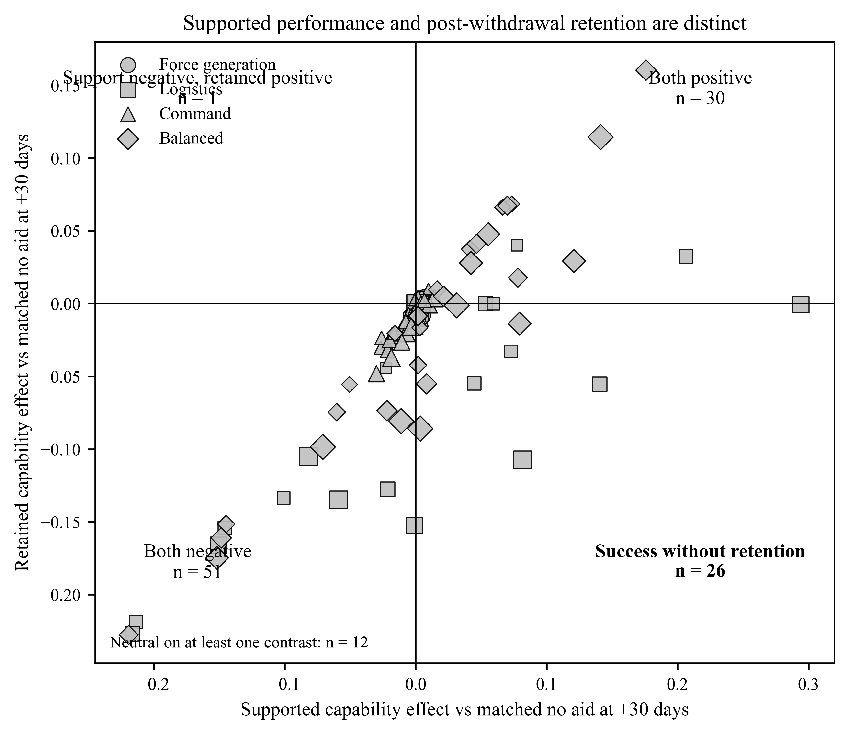
Figure 2. Supported capability relative to matched no aid versus retained capability after withdrawal relative to matched no aid at +30 days. Each point is a treated Phase-Map cell. Marker shape identifies the nominal starting structure and marker size increases with support intensity.

5.2 The terminal coverage gap is produced by both indigenous service and demand
The endogenous denominator of the coverage ratio is substantively important. Among 1,189 treated Phase-Map worlds with a negative +360-day indigenous- coverage branch contrast, 1,174 end with the same binding service in both branches, almost entirely logistics. Within those same-terminal worlds, 95.9 percent have higher logistics demand under continued support, whereas 19.8 percent have lower indigenous logistics delivery. Both lower indigenous service and higher demand occur in 15.8 percent.
For worlds with positive quantities, the exact decomposition
[ q = I-D ]
gives a mean indigenous-service term of -0.0733 and a mean demand term of +0.0820, producing a mean log coverage gap of approximately -0.1553. In other words, requirement expansion contributes slightly more than indigenous-service decline to the average log gap in this subset.
A second descriptive standardization puts the two components back onto the capped coverage scale. Among the 823 worlds that both improve composite capability at +30 days relative to withdrawal and have lower terminal logistics coverage, the observed mean coverage contrast is -0.0823. Evaluating the continued-support indigenous service against withdrawal-branch demand leaves a mean production-only contrast of -0.0301. Holding indigenous service at the withdrawal level while imposing the continued-support requirement produces a mean demand-only contrast of -0.0534. Because the capped ratio is nonlinear, these terms are not perfectly additive, but the comparison shows that most of the average gap in this subset is associated with the larger operating requirement rather than with lower indigenous service alone.
These calculations are post-completion diagnostics, not the direct mechanism experiment. A separately frozen demand-clamp ablation reported below intervenes on the simulated requirement itself.
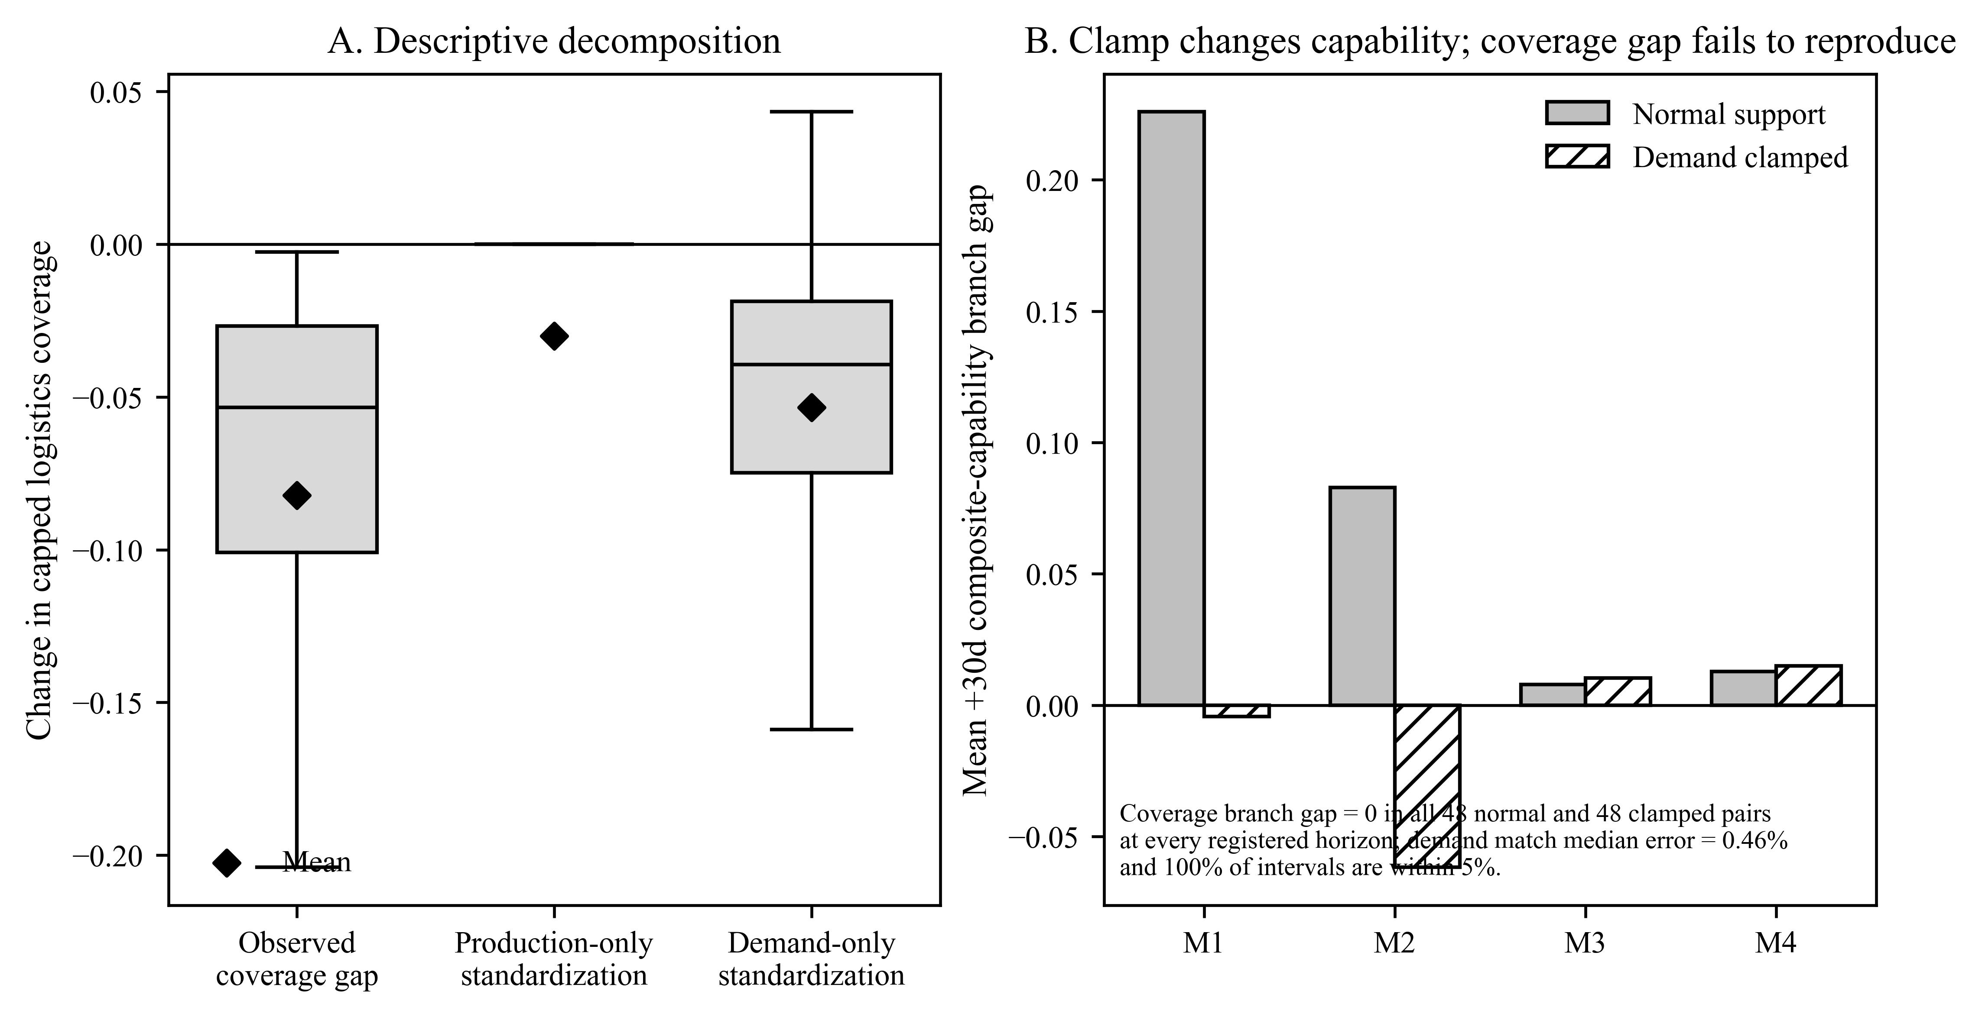
Figure 3. Requirement-expansion evidence. Panel A decomposes the terminal logistics-coverage gap in worlds with positive +30-day branch capability and negative +360-day coverage. Panel B reports the separately frozen prospective demand-clamp test and its effect on +30-day composite capability.

5.3 The prospective demand clamp does not identify the retention mechanism
The post-review ablation directly intervenes on the demand side of the proposed requirement-expansion mechanism. Four Phase-Map cells were selected before the new outcomes were observed. On their original Stage-4 seeds, their mean +360-day coverage branch effects were approximately -0.106, -0.105, -0.106, and -0.134. The ablation reruns those exact cell parameters under a fresh seed namespace, with paired normal and demand-clamped arms across 48 matched seeds.
The manipulation itself succeeds. Across 2,640 post-split telemetry intervals, the median relative mismatch between clamped supported-branch logistics demand and the paired withdrawal requirement is 0.46 percent, the 95th percentile is 1.30 percent, the maximum is 2.05 percent, and every interval lies within the precommitted 5 percent tolerance.
The primary outcome, however, fails its replication prerequisite. In all 48 fresh-seed normal worlds, the capped indigenous-coverage branch gap is exactly zero at +7, +30, +90, +180, and +360 days. The demand-clamped worlds are also zero at every registered horizon. There is therefore no normal-arm retention penalty for the clamp to attenuate. The precommitted +360-day attenuation estimate is exactly zero, but that value cannot be interpreted as evidence that requirement expansion is causally irrelevant to the Stage-4 penalty.
The failure is specific to the retention outcome rather than to the assistance effect generally. The fresh-seed normal arms retain positive mean +30-day composite-capability branch effects in all four scenarios, approximately +0.226, +0.083, +0.008, and +0.013. Clamping logistics demand materially changes that capability effect, reducing the pooled branch contrast by about 0.093 at +30 days, 0.212 at +90, 0.213 at +180, and 0.147 at +360. Thus the demand intervention is operationally consequential, but it does not identify the cause of a coverage gap that is absent in the fresh-seed normal arm.
This result narrows the paper’s mechanism claim. The frozen Stage-4 telemetry remains descriptively consistent with requirement expansion, but the prospective ablation does not establish requirement expansion as the mediator of the retention pattern. It also reveals a seed-domain transport problem for the selected coverage effects that future experiments must treat as a first-order robustness question.

5.4 Supported capability advantages evolve over time
The +30-day horizon also understates the temporal structure of the branch gap. Among the 1,064 Phase-Map worlds with a positive continued-support-minus- withdrawal capability contrast at +30 days, the mean gap is +0.0106 at day 7, +0.0335 at day 30, +0.0395 at day 90, +0.0340 at day 180, and +0.0298 at day 360. The fraction of those worlds with a positive branch gap declines from 100 percent at day 30 to 63.1 percent at one year.
That trajectory is evidence that continued support can maintain capability relative to withdrawal for extended periods. It should not be confused with a net treatment effect over no aid. Across all treated cells, mean supported capability relative to the matched no-aid control is +0.00782 at day 7, +0.00036 at day 30, -0.01005 at day 90, -0.00768 at day 180, and -0.00326 at day 360. The synthetic experiment therefore contains strong positive cases, neutral cases, and harmful cases rather than one uniformly successful support regime.
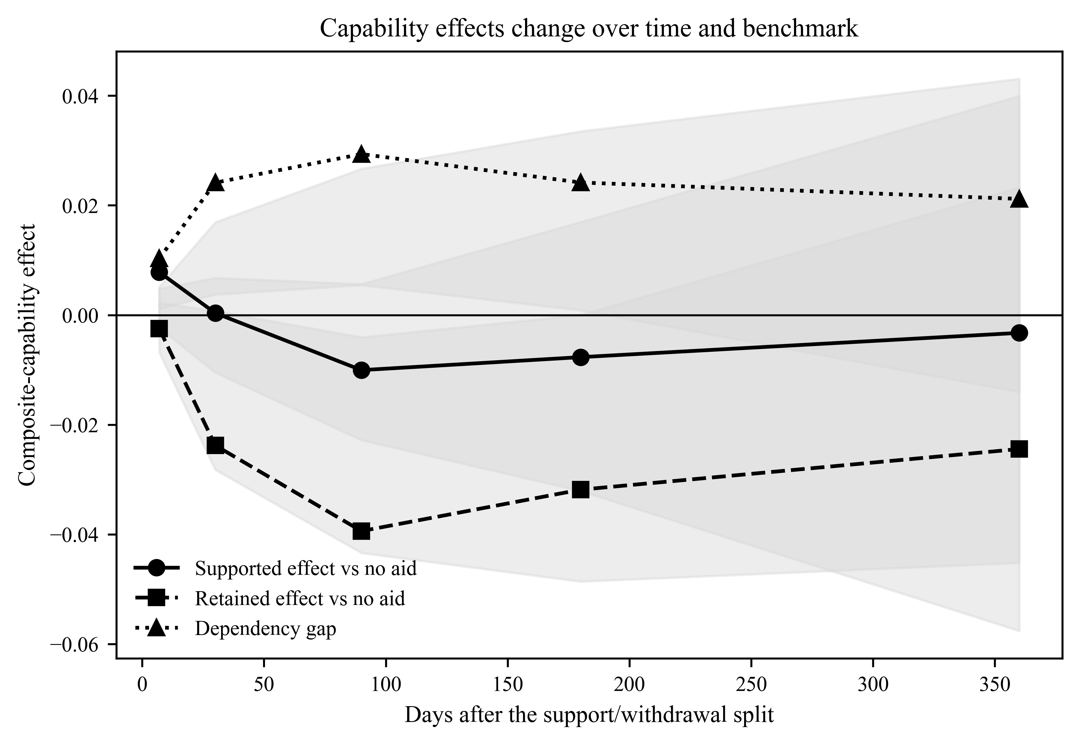
Figure 4. Mean supported effect relative to no aid, retained effect after withdrawal relative to no aid, and the dependency gap across all treated Phase-Map cells at each registered horizon. Shaded bands show the interquartile range across cells.

5.5 Nominal weakness is a poor proxy for the observed bottleneck
The Phase Map also shows why static labels are inadequate. As nominal force-generation capacity rises, the observed bottleneck frequently shifts to logistics before treatment. At the 0.60 force-generation multiplier, all 84 sampled worlds across support conditions were already logistics-bottlenecked. Balanced systems likewise became increasingly logistics-bound as overall capacity increased, reaching 84 of 84 logistics bottlenecks at balanced capacity 1.0.
Command-constrained systems remained command-bound over lower capacity levels, but at command capacity 0.70, 61 of 84 worlds were logistics-bottlenecked and only 23 remained command-bottlenecked. These patterns establish an important measurement point: the target named in an assistance program or experimental design need not be the service that actually limits the system.

5.6 Constraint displacement explains low yield, not the terminal coverage penalty
The dedicated Migration module shows that bottleneck displacement is real, but it does not mediate the terminal coverage penalty. Among worlds where the treatment target matched the observed pre-withdrawal bottleneck, command and force generation behave very differently from logistics.
When command assistance matched an observed command bottleneck, all 38 worlds experienced persistent migration; median detected migration time was seven days, and logistics was the modal post-support bottleneck in all 38. When force- generation assistance matched an observed force-generation bottleneck, all 46 worlds migrated persistently; median detected migration time was again seven days, and logistics was the modal post-support bottleneck in all 46.
Matched logistics cases produced the opposite result: none of 85 worlds migrated persistently. Continued logistics support improved +30-day capability on average by approximately +0.0170, while the terminal indigenous- coverage branch contrast was approximately -0.2215.
The key finding is the separation between migration and the coverage gap. Matched command relief migrates in 38 of 38 worlds and has a mean +360-day coverage effect of +0.0555. Matched force-generation relief migrates in 46 of 46 worlds and has a mean terminal effect of zero at reported precision. Matched logistics relief migrates in 0 of 85 worlds and has the large negative terminal effect, -0.2215. The full Phase Map shows the same direction: among worlds with a positive +30-day branch capability effect, migrated worlds have a less negative mean terminal coverage contrast than non-migrated worlds.
Migration therefore cannot be the cause of the coverage penalty in these experiments. What it does identify is relief without yield. Matched force- generation assistance changes which service binds in all 46 worlds while its mean +30-day composite-capability effect is approximately +0.00000021. Command relief also migrates universally but yields only +0.00354 on average. Logistics support produces the largest +30-day branch gain, about +0.01699, despite no persistent migration.
Observed-matched target | Persistent migration | Mean +30d capability effect | Mean +360d indigenous-coverage effect
Command | 38/38 | +0.00354 | +0.0555
Force generation | 46/46 | approximately 0.00000021 | 0.0000
Logistics | 0/85 | +0.01699 | -0.2215
Table 2. Relief, migration, system yield, and terminal indigenous coverage in observed-matched Migration worlds. The weighted means are a post-completion descriptive synthesis of frozen cell summaries. They were not themselves a prospectively frozen primary estimand.
The result supports a narrower role for constraint displacement than the original manuscript proposed. Moving from one bottleneck to another shows that the targeted constraint was structurally displaced. It does not explain the supported-retained gap. Relief, yield, constraint identity, and retention must therefore be reported separately.

5.7 Substitution and development lie on a capability-retention-cost frontier
The Substitution versus Development module should not be read as a cost-equated horse race. Development is modeled as partner-owned capacity growth, whereas substitution provides removable external service, and the donor-cost schedules are different. The useful comparison is therefore a frontier among early capability, terminal indigenous coverage, local production, and modeled cost.
For moderate logistics weakness at intensity 0.5, development improves terminal indigenous coverage relative to substitution by approximately +0.1316, with a 95 percent bootstrap interval of +0.1245 to +0.1398. At moderate weakness and intensity 1.0, the contrast is approximately +0.1853 [0.1236, 0.2398]. At severe weakness and intensity 0.5, it is approximately +0.2542 [0.2388, 0.2687]. At severe weakness and intensity 1.0, it reaches approximately +0.4328 [0.4169, 0.4516].
Across logistics-targeted cells, development has a less negative mean terminal coverage effect than substitution and increases indigenous logistics service substantially, but it is also slightly more expensive on the model’s donor-cost ledger and does not dominate on early capability in every condition. Averaged over the logistics-targeted cells, the mean +30-day capability effects are approximately +0.038 for development, +0.070 for hybrid assistance, and +0.047 for substitution. The corresponding mean +360-day coverage effects are -0.033, -0.129, and -0.284, while modeled cumulative donor costs are approximately 3.32, 3.28, and 3.24 million units.
The indigenous-production mechanism is also visible directly. Relative to substitution, developmental logistics generates approximately +172,859 to +1,249,115 additional units of indigenous cumulative logistics service across the tested conditions. Capped indigenous coverage of cumulative logistics demand improves by approximately +0.114 to +0.411.
Development is therefore not simply another route to the same supported capability, but neither is it a free improvement. It changes who produces the service and moves the modeled capability-retention-cost frontier.
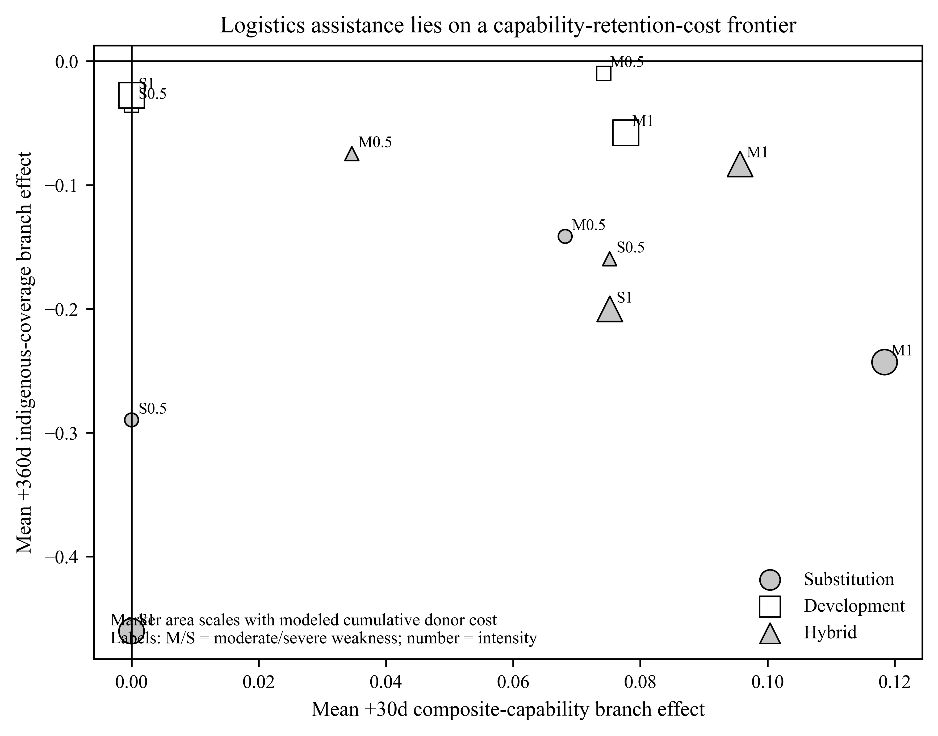
Figure 5. Logistics-targeted assistance on the capability-retention-cost frontier. Horizontal position is the mean +30-day capability branch effect, vertical position is the mean +360-day indigenous-coverage branch effect, and marker area scales with modeled cumulative donor cost.

5.8 Local development does not guarantee system yield
Force generation provides a clean test of Proposition 5. Developmental force-generation assistance produces large indigenous gains relative to direct substitution. The matched development-minus-substitution contrasts in cumulative indigenous force-generation output range from approximately +121 to +674 across the four severity and intensity conditions, with narrow bootstrap intervals.
Yet the corresponding whole-system terminal-coverage contrast is exactly zero in all four cells. By +360 days, every force-generation-targeted world in the mechanism experiment is logistics-bottlenecked. The intervention succeeds in the subsystem it targets, but the targeted subsystem no longer limits the system.
Command development generates the same logic in a less uniform form. It raises indigenous command service and coverage, but command-development worlds migrate away from command as the binding constraint, overwhelmingly toward logistics. In the moderate-weakness, high-intensity condition, development produces a terminal system-coverage contrast of approximately -0.132 relative to substitution, with a bootstrap interval of about -0.231 to -0.046, despite improving the indigenous command subsystem.
The result should not be read as evidence that command development is generally harmful. It shows that improving a nonbinding or transient capacity can have a low system return. Once another service binds, further improvements in the relieved subsystem cannot raise whole-system feasibility by themselves.

5.9 Integrated evidence: separate outcomes and uneven mechanism evidence
The revised evidence no longer supports a single migration-mediated retention mechanism, and it does not support equally strong claims about the two candidate production dynamics. Constraint displacement is directly demonstrated and helps explain why successful local relief can produce little whole-system yield. Requirement expansion is descriptively consistent with the Stage-4 supply-demand decomposition, but the prospective clamp test fails to reproduce a normal-arm coverage penalty and therefore does not identify requirement expansion as its cause.
Result | Estimate | Status
+30d cells with supported capability above no aid and retained capability below no aid | 26/120 | Post-completion matched-control diagnostic
+30d cells with both supported and retained capability above no aid | 30/120 | Post-completion matched-control diagnostic
Same-terminal coverage-penalty worlds with higher continued-support logistics demand | 95.9% of 1,174 | Post-completion telemetry decomposition
Mean standardized coverage effect in +30d-effective logistics-penalty worlds | observed -0.0823; production-only -0.0301; demand-only -0.0534 | Post-completion diagnostic
Fresh-seed normal worlds reproducing a nonzero coverage branch gap in the demand-clamp test | 0/48 at every registered horizon | Post-review prospectively frozen replication failure
Demand-clamp manipulation intervals within 5% of paired withdrawal demand | 2,640/2,640 | Post-review prospectively frozen manipulation check
Observed-matched command migration | 38/38 | Frozen Stage-4 Migration module
Observed-matched force-generation migration | 46/46 | Frozen Stage-4 Migration module
Observed-matched logistics migration | 0/85 | Frozen Stage-4 Migration module
Force-generation development minus substitution on terminal system coverage | 0 in all four cells | Frozen Stage-4 mechanism module
Table 3. Headline evidence after separating outcomes from mechanism claims. The matched-control and supply-demand decompositions were added after external review and are labeled post-completion diagnostics. The demand-clamp rows come from a separately frozen post-review experiment and show both a successful manipulation and a failed retention-outcome replication.
The constraint-displacement result is also highly insensitive to replacing the hard minimum coverage coordinate with smooth service aggregators in the Migration module. Across the 169 worlds in which the assistance target matched the observed pre-withdrawal bottleneck, the sign of the +360-day coverage effect agrees between the hard-minimum measure and each of the arithmetic, geometric, and harmonic smooth measures in 167 worlds, or 98.8 percent. The two discordant worlds are one command-targeted world and one logistics-targeted world.
Observed-matched target | Worlds | Hard minimum vs arithmetic | Hard minimum vs geometric | Hard minimum vs harmonic
Command | 38 | 37/38, 97.4% | 37/38, 97.4% | 37/38, 97.4%
Force generation | 46 | 46/46, 100% | 46/46, 100% | 46/46, 100%
Logistics | 85 | 84/85, 98.8% | 84/85, 98.8% | 84/85, 98.8%
Total | 169 | 167/169, 98.8% | 167/169, 98.8% | 167/169, 98.8%
Table 4. Sign robustness of terminal-coverage effects to smooth feasibility aggregation in observed-matched Migration worlds. This check is specific to the Migration evidence package and should not be read as a robustness result for every Phase-Map or mechanism-module estimand.

5.10 Stage 5 identifies selective complementarity but does not validate the intended near-tie allocation test
Stage 5 separates equal-channel-dose technical complementarity from fixed-budget allocation efficiency. Its intended scope-condition manipulation fails: 365 of 368 nominal near-tie worlds are logistics-bound by the split, so most fixed- effort comparisons occur in realized single-bottleneck regimes. In those regimes, none of 32 breadth comparisons has an interval entirely above zero and 21 have intervals entirely below zero. This shows that spreading a fixed dose can be costly when one service already dominates, not that breadth would fail under a genuine near-tie.
Equal-channel-dose results show narrower complementarity. Two high-intensity pairwise interactions in the nominal near-tie design are positive, about +0.025 for force generation plus logistics and +0.172 for logistics plus command, while the corresponding three-way interaction is negative. Multiplicity, outcome ceiling effects, and the failed near-tie manipulation limit stronger inference. The conditional allocation question for a verified multi-constraint near-tie therefore remains open.

5.11 Supplemental robustness
Alternative service aggregators, the adversarial structural sidecar, complete Stage-5 contrasts, and distributional diagnostics are reported in the supplementary appendix. The sidecar establishes only that all three service channels can be terminal under adversarial structures; it is not treated as a global sensitivity analysis.

6. Discussion

6.1 Separate outcomes, uneven mechanism identification
The revised evidence changes the causal interpretation of the paper. The original manuscript treated constraint migration as the mechanism linking successful relief to lower indigenous coverage. The data do not support that claim. Migration is common when command or force generation is targeted, but the strongest terminal coverage penalties occur where logistics remains binding. In the Phase Map, migrated worlds with a positive early branch capability gap have a less negative mean terminal coverage contrast than non-migrated worlds. Constraint displacement is therefore not the mediator of the retention penalty.
What survives is more useful because it is more specific. The framework identifies two separate production problems, but the experiments identify them with different strength. Requirement expansion concerns the scale of service demand relative to indigenous production. The Stage-4 telemetry is consistent with that process, but the fresh-seed demand-clamp test does not reproduce the coverage penalty required to test mediation. Constraint displacement concerns the marginal value of improving one complementary service after another becomes limiting and is directly observed in the Migration module. It can produce relief without material whole-force yield and without any negative retention effect.
This distinction connects security-assistance research to established theories without claiming novelty for generic bottleneck logic or donor dependence. Operations management already expects changing constraints (Watson et al. 2007). Development economics already treats expansion as a source of new complementary requirements (Hirschman 1958). Aid research already recognizes recurrent-cost and absorptive-capacity problems (Roodman 2006; Arimoto and Kono 2009). The contribution is a military-production formulation that places supported capability, retained capability, service demand, indigenous production, and changing constraints in the same analytic framework, while making explicit what evidence would actually identify each proposed mechanism.

6.2 Why the no-aid benchmark matters
The distinction between a dependency gap and a net treatment effect is substantively important. If continued support outperforms withdrawal after 120 days of prior support, the donor is supplying something the withdrawal branch no longer has. That difference may represent valuable ongoing support. It may also reflect deterioration caused by the removal of an externally supported operating system. Without a matched no-aid benchmark, those possibilities cannot be separated.
The Phase Map demonstrates the point. The original frozen branch contrast classified 106 treated cells as having a positive mean +30-day continued-support advantage over withdrawal. The stricter no-aid comparison finds only 26 cells in which supported capability is above no aid while post-withdrawal capability is below no aid. Thirty cells are above no aid in both branches. Fifty-one are below no aid in both. A useful evaluation framework must therefore report at least three quantities: the supported effect relative to no aid, the retained effect relative to no aid, and the gap between continued support and withdrawal.
This also clarifies the meaning of the phrase Suffering from Success. It is not a description of every assistance program in the model. It denotes a conditional regime in which support produces a real capability gain but the supported system is not reproduced after withdrawal. The regime is analytically important precisely because it can be distinguished from simple program failure.

6.3 Requirement expansion remains a candidate retention mechanism
The post-completion telemetry analysis shows why the indigenous-coverage coordinate must be decomposed. In same-terminal logistics worlds with a negative coverage contrast, the continued-support branch usually faces higher logistics demand, while a smaller share also has lower indigenous delivery. On the log scale, both components matter, and requirement growth contributes slightly more to the average gap than indigenous-service decline. The standardized capped-coverage calculation points in the same direction. These are descriptive decompositions of realized Stage-4 trajectories, not causal mediation estimates.
The prospective demand-clamp experiment was intended to provide the stronger test and does not do so. Its manipulation check passes, and clamping logistics demand materially changes composite capability, especially in the M1 and M2 scenarios. But the fresh-seed normal arms reproduce no indigenous-coverage branch gap at any registered horizon. Because the outcome to be mediated is absent before the clamp is applied, the zero attenuation estimate cannot distinguish “requirement expansion does not matter” from “this fresh-seed ensemble did not enter the Stage-4 retention regime.” The direct experiment therefore leaves requirement expansion unconfirmed as a retention mechanism and exposes a new seed-domain robustness problem for the coverage result.
That result does not imply that demand should be held fixed in substantive policy. A larger requirement can be the consequence of more activity, more surviving formations, more territory, or other real operational gains. The point is diagnostic. A falling service-to-demand ratio is not equivalent to destroyed indigenous capacity. It can instead mean that the force has grown into a larger sustainment problem. The policy question then becomes whether indigenous production can catch up with the supported operating requirement, not merely whether the ratio fell.
This is why the paper reports absolute capability alongside coverage and why the final interpretation does not equate a decomposed association with mechanism identification. A donor can improve supported capability, leave indigenous service unchanged or higher, and still create a larger post-support shortfall if the new operating system requires more service than the partner can produce alone. The Stage-4 telemetry contains that pattern, but the prospective fresh-seed test shows that it is not automatically portable across simulated worlds. Conversely, a coverage decline with no supported capability gain is not a success-induced retention problem. It is simply a poor outcome.

6.4 Constraint displacement is mainly a yield problem
The Migration module gives bottleneck logic a different role. Command and force-generation constraints are easy to displace in the tested parameter region. Force-generation relief is the cleanest example: 46 of 46 observed-matched worlds migrate, yet the average +30-day composite-capability effect is essentially zero. The system changes, but the force barely improves because another service is already limiting.
This is the practical value of tracking constraint identity. Assistance can report a successful local output, such as more trained personnel or better command performance, while whole-force output remains flat. A program manager looking only at the treated subsystem would record progress. A system-level evaluation would ask whether the intervention changed the limiting service and whether any capability gain followed.
Static headroom is only a partial diagnostic for this problem. The post-completion reconstruction does not show a monotonic relationship between initial coverage spacing and realized yield. Once operations, losses, movement, stocks, and service demand respond endogenously, the initial distance between the first and second constraints is not a sufficient predictor. For applied use, direct measurement of the current constraint and the realized system response is more defensible than a simple headroom rule.

6.5 Assistance modes lie on a frontier
The substitution-versus-development results also become clearer under the revised framework. Developmental logistics assistance produces more indigenous service and much better terminal coverage than substitution, but it is not uniformly superior on early capability and it carries a somewhat higher modeled donor cost. The relevant comparison is therefore not “development good, substitution bad.” It is a frontier among immediate supported performance, retained capability, indigenous service production, cost, and time.
This matters because real assistance programs face different objectives. A donor trying to prevent an immediate battlefield collapse may rationally value rapid substitution. A donor trying to reduce long-run external dependence should care more about partner-owned production. The model cannot assign the political value of those objectives. It can make the tradeoff visible and prevent one outcome from being mislabeled as another.
The force-generation result adds a systems warning. Development can succeed locally and still have zero whole-system return when a different service binds. Capacity building should therefore be evaluated both at the targeted subsystem and at the force level.

6.6 Coordinated development remains an open allocation problem
Stage 5 does not provide the clean near-tie test originally intended because its nominal near-tie worlds become logistics-bound before the main comparison. The fixed-effort results are still informative about the realized single-bottleneck regimes: spreading a fixed dose across several services rarely beats concentrating it in the best included channel. But that result should not be generalized to genuinely co-binding systems.
The equal-dose factorial results offer narrower evidence that technical complementarities can exist. A small number of pairwise interactions are positive, including one materially large logistics-command interaction. Those interactions do not imply that broad allocation is efficient under a fixed budget, and multiplicity and ceiling effects limit strong claims. A future experiment should create and verify true near-ties at the treatment split before testing whether breadth becomes advantageous as the number of binding constraints increases.

6.7 What a security-assistance evaluation should measure
The results suggest a practical diagnostic sequence rather than a universal prescription:
- Identify the service actually limiting whole-force performance, not only the service named in the program design.
- Measure the local treatment effect on that service.
- Measure the whole-force capability effect relative to a credible no-aid benchmark where possible.
- Track how the intervention changes service requirements as well as indigenous production.
- After support changes, measure retained capability relative to the same benchmark.
- Record whether another service becomes limiting and whether that displacement materially changes system yield.
- Compare assistance architectures on capability, retention, time, and cost rather than one metric alone.
This framework is compatible with political explanations rather than a substitute for them. Recipient incentives determine whether capacity investments are adopted and maintained. Patronage, corruption, command politics, coalition dynamics, and donor leverage shape both indigenous production and the operating requirement. The production model isolates one set of mechanisms conditional on those political processes. It should be combined with, not used to displace, agency and institutional analysis.

7. External Validity and Historical Validation
The synthetic experiments are designed to establish internal causal logic under explicit model assumptions. External validity requires a different evidentiary strategy. Historical validation should therefore test observable implications of the mechanism rather than search for cases that merely resemble the model.
The historical unit of analysis is an assistance episode by military-service constraint by time. For each episode, the protocol asks whether seven observable implications can be identified: the initial limiting service, the assistance directed at it, improvement in the targeted function, expansion or change in the operating requirement, migration or persistence of the limiting constraint, the degree of indigenous replacement, and the response to a support reduction or withdrawal shock. The purpose is process validation. Historical evidence can show that the proposed sequence exists outside the model and can identify important scope conditions. It cannot convert the synthetic treatment effects into empirical causal estimates.
The protocol froze four cases before systematic coding: Afghanistan, Iraq, Mali, and Colombia. They are selected for theoretical variation rather than because all four are expected to support the argument.
Case | Intended evidentiary role | Main question for the theory
Afghanistan | High-support, high-substitution episode with a major withdrawal shock | Can supported sophistication outrun indigenous replacement even when the externally supplied function remains the core constraint?
Iraq | Force-generation and institutional expansion under heavy external assistance | Does improvement in force generation reveal sustainment or logistics as a subsequent system constraint?
Mali | Politically fragmented, multi-provider and difficult case | Does the production mechanism survive where political fragmentation and provider diversity complicate a clean constraint sequence?
Colombia | Comparatively durable long-run development case | Can indigenous institutions and sustainment grow fast enough for capability gains to become retained rather than externally reproduced?
Source-audited coding under that frozen protocol produces meaningful variation. Afghanistan provides strong evidence of persistent external substitution in aviation maintenance and logistics rather than a clean migration away from the original constraint. SIGAR found that the Afghan Air Force remained heavily dependent on contractor maintenance and that the broader ANDSF had failed to become independent and self-sustaining before the 2021 withdrawal shock (Special Inspector General for Afghanistan Reconstruction 2022, 2023). Iraq provides a clearer sequential case. By late 2006, DOD reported hundreds of thousands of trained and equipped Iraqi personnel, while GAO identified logistics and sustainment as a serious shortcoming and documented lagging national and regional support institutions (U.S. Government Accountability Office 2007b, 2007c, 2007a). A later Department of Defense Inspector General lessons-learned review likewise emphasized the need to develop logistics and sustainment concurrently with operational forces rather than treating support capacity as a downstream problem (Department of Defense Inspector General 2015).
Mali is a harder and less supportive case. RAND’s field research found that EUTM-trained GTIAs improved basic soldier skills, but logistics, maintenance, command, and coordinated operations remained major limits (Shurkin et al. 2017). Marsh and Rolandsen further show how multiple, weakly coordinated assistance providers can fragment recipient-force cohesion, supplying a political-organizational rival to a production-constraint explanation (Marsh and Rolandsen 2021). Those weaknesses were already present during the assistance effort, so the evidence is better interpreted as local-system divergence than as a clean case in which assistance caused a new bottleneck to emerge. Colombia provides the strongest positive retention case. U.S. assistance initially supplied contractor pilots, mechanics, maintenance, logistics, and training to an aviation system that Colombia could not yet sustain independently. Over a long phased transition, Colombian personnel and institutions assumed progressively more responsibility; GAO later reported that Colombia had taken over full maintenance and operations for the Army aviation program, while also noting slower nationalization in a related helicopter training center (U.S. Government Accountability Office 2008, 2013, 2018).
Case | Audited constraint sequence | Indigenous replacement | Support-change evidence | Strongest rival explanation | Audited theory fit
Afghanistan | Aviation maintenance/logistics remained limiting beneath external substitution | Negative or incomplete | Abrupt contractor and U.S. support reduction followed by severe degradation | Political collapse, morale and leadership failure, corruption, strategy, and Taliban adaptation | Strong for substitution/retention; partial for discrete constraint displacement
Iraq | Rapid force generation followed by lagging logistics and sustainment | Incomplete in coded 2005-2008 episode | No clean withdrawal shock in coded episode | Sectarian politics, militia penetration, absenteeism, command problems, corruption, and intelligence weakness | Strongest sequential-constraint analogue, with major political confounding
Mali | Basic unit skills improved while pre-existing logistics, maintenance, and C2 weaknesses remained | Mixed | No clean support shock in coded 2013-2015 episode | Political fragmentation, provider fragmentation, command weakness, and institutional instability | Partial; strongest for local-system divergence
Colombia | Externally enabled aviation expansion initially outran pilots, mechanics, maintenance, and logistics, followed by phased nationalization | Positive and substantial over time | Phased transfer rather than abrupt withdrawal | Stronger institutions, fiscal capacity, political commitment, long duration, and continued external partnership | Strong positive retention case; partial for discrete constraint displacement
Table 5. Source-audited historical process evidence under the frozen external- validation protocol. The table is a structured plausibility and process test, not a causal estimate of security-assistance effects. The source audit preserves mixed and adverse evidence rather than upgrading ambiguous cases to full support.
This case set allows the historical exercise to test more than simple similarity. Afghanistan can support the substitution and replacement mechanism even if constraint migration is weak. Iraq provides a stronger opportunity to observe sequential constraint change. Mali is useful precisely because rival political explanations may dominate. Colombia provides a positive case in which the theory should be able to accommodate sustained indigenous development rather than predicting dependency everywhere.
Evidence is ranked in a frozen source hierarchy: oversight and audit material; contemporaneous official or declassified records; peer-reviewed research with primary evidence; major research institutions; and high-quality journalism. Every episode must also record the strongest plausible rival explanation. Political leadership, corruption, force design, morale, sectarian or factional control, donor strategy, adversary adaptation, and changes in the threat are not treated as residual noise. If they explain an episode better than the proposed production sequence, the case should count against the scope of the mechanism.
The historical test therefore has three possible outcomes. Process support occurs when the initial constraint, targeted relief, demand change, subsequent constraint, and indigenous replacement pattern appear in the expected order. Partial support occurs when only part of that sequence is observable, such as persistent substitution without clear migration. Disconfirmation occurs when the targeted function improves but neither demand, the binding constraint, nor retention behaves as the mechanism predicts, or when an identified rival account better explains the sequence.
Because the Stage-4 synthetic results were already known and the researcher had broad prior familiarity with these cases, the historical exercise is described as structured external validation rather than an untouched confirmatory test. Its coding protocol, case set, source hierarchy, and disconfirming-evidence rule were frozen before systematic case coding. The source-audited case table reports supportive, mixed, and adverse evidence rather than selecting only episodes that fit the model.

8. Limitations
First, Pineland is a synthetic model. The numerical effects reported here are consequences of a specified simulated production system, not empirical treatment effects or historical threshold estimates. The model is useful for mechanism isolation because states can be cloned and assistance components manipulated independently. That same control limits direct external validity.
Second, indigenous coverage is a ratio with an endogenous denominator. The revised paper treats this as a substantive object rather than a hidden assumption, but the ratio still depends on how service demand is represented. The no-aid capability comparison and supply-demand decomposition reduce the risk of mistaking denominator growth for destroyed indigenous capacity. The prospective demand clamp does not validate the denominator mechanism: although the manipulation succeeds, its fresh-seed normal arms do not reproduce the Stage-4 coverage penalty. The simulated demand functions therefore remain a model assumption whose empirical relevance must be established outside this experiment.
Third, the structural coordinate assumes strong complementarity among force generation, logistics, and command. Smooth arithmetic, geometric, and harmonic alternatives show that many Stage-4 sign results are not unique to a hard minimum, but the model still imposes a limited set of military-production relationships. A richer model could allow more substitution among services or additional channels such as maintenance specialization, intelligence, finance, or officer quality.
Fourth, composite capability is itself a modeled construct. It is the geometric mean of five unit-scale retention components: government control, military personnel, operational formations, geographic coverage, and readiness. This measure makes whole-force performance transparent and bounded, but it is not a validated empirical index of combat effectiveness. The paper therefore reports component and service-level results alongside the composite rather than treating one number as ground truth.
Fifth, the no-aid benchmark is a matched simulation trajectory, not an observational estimate. Matching by structure, capacity, seed, and horizon provides a clean model counterfactual, but it does not reproduce the selection processes that determine which historical partners receive assistance. The distinction between supported effect, retained effect, and dependency gap is analytically useful even where a real-world no-aid counterfactual cannot be estimated cleanly.
Sixth, several important revised analyses are post-completion diagnostics. The matched no-aid comparison, supply-demand decomposition, five-horizon synthesis, migration-yield comparison, and capability-retention-cost framing were developed after the Stage-4 production campaign and after external review. They use frozen telemetry and are labeled as exploratory or post-completion rather than retroactively described as prospectively frozen. The demand-clamp experiment is different: its contract, analysis rules, seeds, and code were frozen before its own production outcomes were observed. That stronger design produced an adverse robustness result: the four source cells had negative mean coverage effects on the original Stage-4 seeds, but all 48 fresh-seed normal worlds had zero coverage branch effect at every registered horizon. This seed-domain non-reproduction limits generalization of the Stage-4 retention surface and prevents the clamp experiment from identifying mediation.
Seventh, assistance architectures are stylized. Development changes partner-owned production on a specified cadence, while substitution supplies removable external service. Real institutional development is politically contested, path dependent, and often much slower. The modeled donor-cost ledger is useful for internal tradeoffs but is not a dollar estimate and should not be used for empirical cost-effectiveness rankings.
Eighth, Stage 5 does not cleanly test its intended scope condition. Its nominal near-tie worlds become almost uniformly logistics-bound before the main treatment comparison. The paired factorial contrasts remain valid for the realized states, but the claim that breadth should become more efficient under a verified multi-constraint near-tie remains unresolved.
Ninth, the structural sidecar rejects only a literal hard-coding claim. It demonstrates that command, force generation, and logistics can each be terminal under adversarial structures, but the intended migration paths do not occur. It is not a global sensitivity analysis of the Stage-4 logistics attractor.
Tenth, the historical case analysis is structured external validation rather than causal confirmation. Afghanistan, Iraq, Mali, and Colombia contain political, organizational, strategic, and adversarial dynamics that the synthetic production model does not identify separately. The historical coding therefore preserves rival explanations and mixed evidence rather than treating resemblance to a simulated mechanism as proof.
Finally, the framework concerns production conditional on political decisions. Recipient incentives, command politics, corruption, patronage, donor leverage, coalition management, and adversary adaptation can determine whether a technically feasible development path is ever pursued. Relief, yield, requirement expansion, constraint displacement, and retention are therefore complements to political analysis, not substitutes for it.

9. Conclusion
Security assistance should not be evaluated with a single question such as whether a program “worked.” The more useful questions are whether it relieved the intended constraint, how much whole-force capability followed, how the operating requirement changed, and how much capability remained after external service stopped.
The revised Pineland evidence shows why those questions must be separated. Continued support often outperforms withdrawal after a shared period of assistance, but that dependency gap is not the same as a net gain over no aid. At +30 days, 26 of 120 treated Phase-Map cells show the strict success-without-retention pattern of supported capability above matched no aid and post-withdrawal capability below matched no aid. Thirty cells improve relative to no aid in both branches, while 51 are below no aid in both. Dependence is therefore a meaningful modeled regime, not the universal result of direct support.
The mechanism evidence is also more specific than the original manuscript claimed. In the Stage-4 telemetry, terminal logistics-coverage gaps reflect both indigenous service and the scale of the operating requirement. Descriptive standardization attributes a larger share of the average gap to requirement differences than to lower indigenous delivery. That pattern is consistent with requirement expansion, but the prospective demand-clamp test does not causally confirm it. The clamp matches the withdrawal requirement closely and materially changes capability, yet its fresh-seed normal arms reproduce no coverage penalty at any horizon. Requirement expansion therefore remains a plausible interpretation of the Stage-4 trajectories rather than an identified cause of the retention gap.
Constraint displacement is a separate dynamic. Targeted command and force-generation assistance frequently changes which service binds, yet those migrations are associated with little whole-force yield and do not explain the strongest retention penalties. Force-generation relief can therefore be locally successful while producing almost no composite-capability gain. The policy lesson is not that moving bottlenecks are inherently harmful. It is that local relief, whole-system yield, and retention are different outcomes.
Assistance architecture adds another tradeoff. Development can build partner-owned service and substantially improve terminal coverage relative to substitution, but it need not maximize immediate capability and it is not costless in the model. Stage 5 further shows that technical complementarity does not automatically imply that a fixed developmental budget should be spread broadly, especially when one service is already the realized bottleneck. The untested case that now matters most is a verified multi-constraint near-tie.
The paper’s contribution is therefore narrower and stronger than the claim that “support builds dependence.” It provides a production framework for distinguishing supported effects, retained effects, dependency gaps, and successful local relief that merely shifts the limiting constraint. It also shows why mechanism claims require tests beyond outcome decomposition and why those tests can fail even when the original pattern looks persuasive. The practical implication is straightforward: measure absolute supported capability, retained capability, service demand, indigenous service production, the current binding constraint, and cost separately. A force that performs well with the donor and a force that can reproduce that performance without the donor are not the same outcome, and assistance evaluation should not treat them as if they were.

Data, Code, and Reproducibility
The Pineland repository contains the model source, frozen experiment contracts, analysis code, compact evidence tables, figure-generation code, and integrity validators needed to reproduce the manuscript results. Stage 4 completed 2,808 production worlds, Stage 5 completed 1,472, and the post-review demand-clamp experiment completed 96 worlds under a separately frozen contract and fresh seed namespace. Each production campaign records task-level source and contract provenance, and the tracked compact evidence is regenerated from immutable raw shards before final manuscript validation. Exact commit identifiers, artifact hashes, cluster commands, and file-level provenance are reported in the supplementary reproducibility appendix rather than in the substantive article.

Disclosure
The author designed and developed the Pineland simulation and conducted the analysis described here. The historical-validation exercise was conducted after the synthetic Stage-4 results were observed and is therefore labeled as external validation rather than prospective confirmation. The manuscript makes no claim that synthetic numerical thresholds are empirical estimates for any historical security force. The relief-yield-retention framing and the weighted cross-target yield comparison were developed after Stage-4 completion and are labeled as post-completion synthesis. The coordinated-development Stage-5 experiment was motivated by those completed results but prospectively frozen before any Stage-5 production outcome was observed. The post-review demand-clamp experiment was likewise prospectively frozen before its production outcomes; its failed fresh-seed coverage replication and zero precommitted attenuation are reported without redesigning the experiment around the result.
Andrews, Matt, Lant Pritchett, and Michael Woolcock. 2017. Building State Capability: Evidence, Analysis, Action. Oxford University Press. https://doi.org/10.1093/acprof:oso/9780198747482.001.0001.
Arimoto, Yutaka, and Hisaki Kono. 2009. “Foreign Aid and Recurrent Cost: Donor Competition, Aid Proliferation, and Budget Support.” Review of Development Economics 13 (2): 276–87. https://doi.org/10.1111/j.1467-9361.2008.00486.x.
Biddle, Stephen. 2004. Military Power: Explaining Victory and Defeat in Modern Battle. Princeton University Press. https://doi.org/10.2307/j.ctt7s19h.
Biddle, Stephen. 2017. “Building Security Forces and Stabilizing Nations: The Problem of Agency.” Daedalus 146 (4): 126–38. https://doi.org/10.1162/DAED_a_00464.
Biddle, Stephen, Julia Macdonald, and Ryan Baker. 2018. “Small Footprint, Small Payoff: The Military Effectiveness of Security Force Assistance.” Journal of Strategic Studies 41 (1-2): 89–142. https://doi.org/10.1080/01402390.2017.1307745.
BrÃ¤utigam, Deborah A., and Stephen Knack. 2004. “Foreign Aid, Institutions, and Governance in Sub-Saharan Africa.” Economic Development and Cultural Change 52 (2): 255–85. https://doi.org/10.1086/380592.
Cohen, Wesley M., and Daniel A. Levinthal. 1990. “Absorptive Capacity: A New Perspective on Learning and Innovation.” Administrative Science Quarterly 35 (1): 128–52. https://doi.org/10.2307/2393553.
Creveld, Martin van. 2004. Supplying War: Logistics from Wallenstein to Patton. 2nd ed. Cambridge University Press.
Department of Defense Inspector General. 2015. Summary of Lessons Learned: DoD IG Assessment Oversight of Train, Advise, Assist, and Equip Operations by u.s. And Coalition Forces in Iraq and Afghanistan. DODIG-2015-093. Department of Defense Inspector General.
Grimm, Volker, Steven F. Railsback, Christian E. Vincenot, et al. 2020. “The ODD Protocol for Describing Agent-Based and Other Simulation Models: A Second Update to Improve Clarity, Replication, and Structural Realism.” Journal of Artificial Societies and Social Simulation 23 (2): 7. https://doi.org/10.18564/jasss.4259.
Harkness, Kristen A. 2022. “Security Force Assistance to Cameroon: How Building Enclave Units Deepens Autocracy.” International Affairs 98 (6): 2099–117. https://doi.org/10.1093/ia/iiac215.
Hirschman, Albert O. 1958. The Strategy of Economic Development. Yale University Press.
Karlin, Mara E. 2018. Building Militaries in Fragile States: Challenges for the United States. University of Pennsylvania Press.
Knack, Stephen. 2001. “Aid Dependence and the Quality of Governance: Cross-Country Empirical Tests.” Southern Economic Journal 68 (2): 310–29. https://doi.org/10.1002/j.2325-8012.2001.tb00421.x.
Knowles, Emily, and Jahara Matisek. 2019. “Western Security Force Assistance in Weak States: Time for a Peacebuilding Approach.” The RUSI Journal 164 (3): 10–21. https://doi.org/10.1080/03071847.2019.1643258.
Kremer, Michael. 1993. “The o-Ring Theory of Economic Development.” The Quarterly Journal of Economics 108 (3): 551–75. https://doi.org/10.2307/2118400.
Marsh, Nicholas, and Øystein H. Rolandsen. 2021. “Fragmented We Fall: Security Sector Cohesion and the Impact of Foreign Security Force Assistance in Mali.” Journal of Intervention and Statebuilding 15 (5): 614–29. https://doi.org/10.1080/17502977.2021.1988226.
Matisek, Jahara. 2018. “The Crisis of American Military Assistance: Strategic Dithering and Faberge Egg Armies.” Defense & Security Analysis 34 (3): 267–90. https://doi.org/10.1080/14751798.2018.1500757.
McNerney, Michael J., Stuart E. Johnson, Stephanie Pezard, et al. 2016. Defense Institution Building in Africa: An Assessment. RR-1232-OSD. RAND Corporation. https://doi.org/10.7249/RR1232.
Metz, Rachel Tecott. 2023. “The Cult of the Persuasive: Why u.s. Security Assistance Fails.” International Security 47 (3): 95–135. https://doi.org/10.1162/isec_a_00453.
Milgrom, Paul, and John Roberts. 1990. “The Economics of Modern Manufacturing: Technology, Strategy, and Organization.” American Economic Review 80 (3): 511–28.
Millett, Allan R., Williamson Murray, and Kenneth H. Watman. 1986. “The Effectiveness of Military Organizations.” International Security 11 (1): 37–71. https://doi.org/10.2307/2538875.
Morss, Elliott R. 1984. “Institutional Destruction Resulting from Donor and Project Proliferation in Sub-Saharan African Countries.” World Development 12 (4): 465–70. https://doi.org/10.1016/0305-750X(84)90024-X.
Moss, Todd, Gunilla Pettersson, and Nicolas van de Walle. 2006. An Aid-Institutions Paradox? A Review Essay on Aid Dependency and State Building in Sub-Saharan Africa. Working Paper 74. Center for Global Development.
Paul, Christopher, Colin P. Clarke, Beth Grill, et al. 2013. What Works Best When Building Partnership Capacity and Under What Circumstances? MG-1253/1-OSD. RAND Corporation.
Pritchett, Lant, Michael Woolcock, and Matt Andrews. 2013. “Looking Like a State: Techniques of Persistent Failure in State Capability for Implementation.” The Journal of Development Studies 49 (1): 1–18. https://doi.org/10.1080/00220388.2012.709614.
Reynolds, Phil W. 2025. “Strategic Fit: Application of World Governance Indicators to u.s. Security Assistance.” Defense & Security Analysis, ahead of print. https://doi.org/10.1080/14751798.2025.2596533.
Rolandsen, Oystein H., Maggie Dwyer, and William Reno. 2021. “Security Force Assistance to Fragile States: A Framework of Analysis.” Journal of Intervention and Statebuilding 15 (5): 563–79. https://doi.org/10.1080/17502977.2021.1988224.
Rolandsen, Oystein H., Ursula C. Schroder, Simone Tholens, et al. 2026. “Security Assistance and the Crisis of the Liberal International Order.” International Studies Review 28 (2): viag003. https://doi.org/10.1093/isr/viag003.
Roodman, David. 2006. Aid Project Proliferation and Absorptive Capacity. Working Paper 75. Center for Global Development.
Sandnes, Marie. 2024. “The Effect of Asymmetric Interdependence on the Outcomes of Military Cooperation in the Sahel.” Cooperation and Conflict 59 (3): 405–24. https://doi.org/10.1177/00108367231184717.
Shurkin, Michael, Stephanie Pezard, and S. Rebecca Zimmerman. 2017. Mali’s Next Battle: Improving Counterterrorism Capabilities. RR-1241-OSD. RAND Corporation.
Special Inspector General for Afghanistan Reconstruction. 2022. Afghan Air Forces: DOD Has Taken Steps to Develop Afghan Aviation Capability but Continued u.s. Support Is Needed to Sustain Forces. SIGAR-21-14-AR. Special Inspector General for Afghanistan Reconstruction.
Special Inspector General for Afghanistan Reconstruction. 2023. Why the Afghan Security Forces Collapsed. SIGAR-23-16-IP. Special Inspector General for Afghanistan Reconstruction.
U.S. Government Accountability Office. 2007a. Operation Iraqi Freedom: DOD Assessment of Iraqi Security Forces’ Units as Independent Not Clear Because ISF Support Capabilities Are Not Fully Developed. GAO-08-143R. U.S. Government Accountability Office.
U.S. Government Accountability Office. 2007b. Operation Iraqi Freedom: Preliminary Observations on Iraqi Security Forces’ Logistical Capabilities. GAO-07-582T. U.S. Government Accountability Office.
U.S. Government Accountability Office. 2007c. Operation Iraqi Freedom: Preliminary Observations on Iraqi Security Forces’ Logistics and Command and Control Capabilities. GAO-07-503R. U.S. Government Accountability Office.
U.S. Government Accountability Office. 2008. Plan Colombia: Drug Reduction Goals Were Not Fully Met, but Security Has Improved; u.s. Agencies Need More Detailed Plans for Reducing Assistance. GAO-09-71. U.S. Government Accountability Office.
U.S. Government Accountability Office. 2013. Building Partner Capacity: DOD Is Meeting Most Targets for Colombia’s Regional Helicopter Training Center but Should Track Graduates. GAO-13-674. U.S. Government Accountability Office.
U.S. Government Accountability Office. 2018. Colombia: U.s. Counternarcotics Assistance Achieved Some Positive Results, but State Needs to Review the Overall u.s. Approach. GAO-19-106. U.S. Government Accountability Office.
U.S. Government Accountability Office. 2023. Building Partner Capacity: DOD and State Should Strengthen Planning for Train and Equip Projects. GAO-23-105842. U.S. Government Accountability Office.
Watson, Kevin J., John H. Blackstone, and Stanley C. Gardiner. 2007. “The Evolution of a Management Philosophy: The Theory of Constraints.” Journal of Operations Management 25 (2): 387–402. https://doi.org/10.1016/j.jom.2006.04.004.

