For figure in each page, axis X stands for accuracy, axis Y stands for threshold

Accelerometer for the left figure, orientation for the right one

The first row demonstrates the result using DBADP Len Window= 15 Len Filter=5

Threshold range(0,30) incremented by 0.2

The second row demonstrates the result using DBADH Len Window=5 Len Filter=30

Threshold range for Accelerometer(0,3) incremented by 0.05

Threshold range for Orientation(0,300) incremented by 2

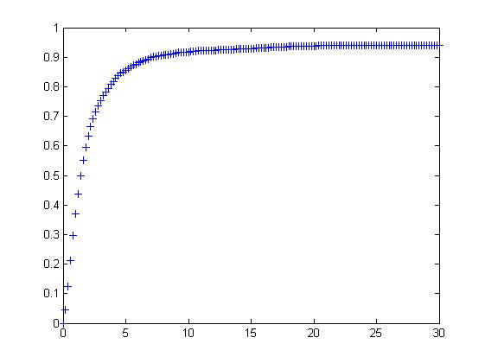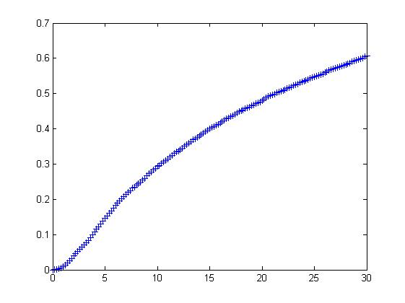

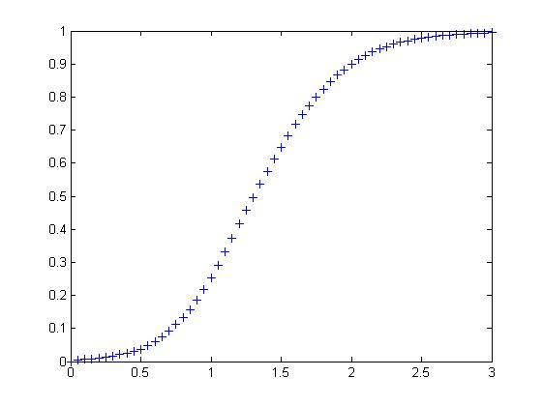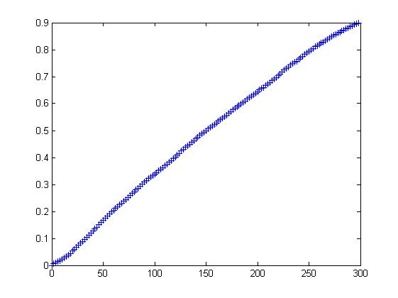

Exp1: all in the same group

accuracy approaches 1 if threshold approaches infinity

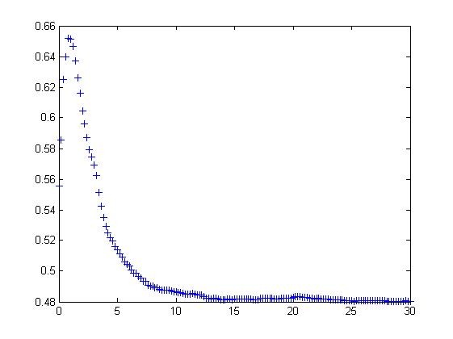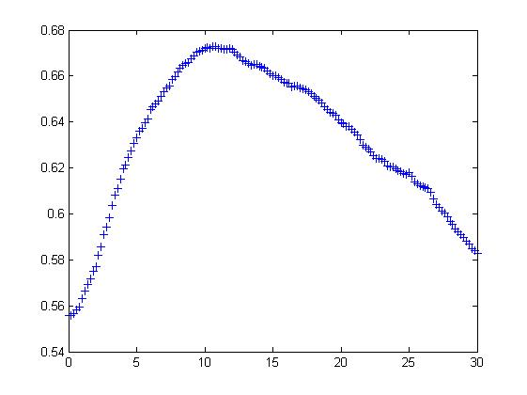

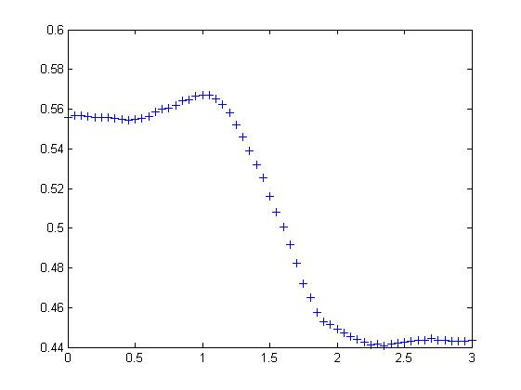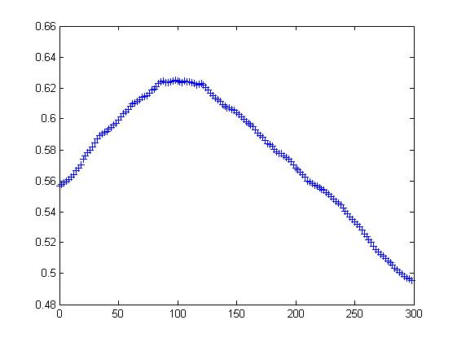

Exp2: (1,2,3,4,5) (6,7,9,10,11)

DBADP:

For Accelerometer: Achieve highest accuracy 0.65 if threshold=1.0

For Orientation: Achieve highest accuracy 0.67 if threshold=11

DBADH:

For Accelerometer: Achieve highest accuracy 0.57 if threshold=1.0

For Orientation: Achieve highest accuracy 0.63 if threshold=100

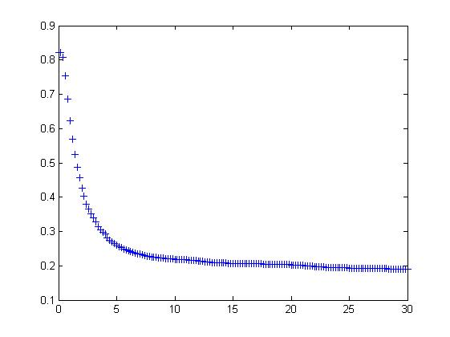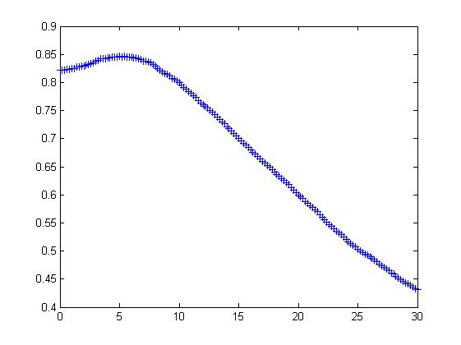

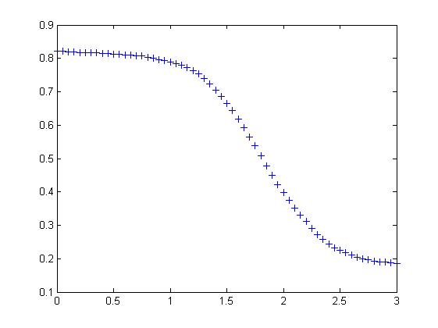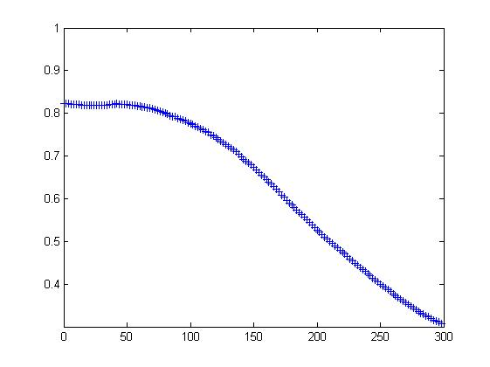

Exp3: (1,2,3) (4,5,6) (7,9) (10,11)

DBADP:

For Accelerometer: Achieve highest accuracy 0.82f threshold=0.2

For Orientation: Achieve highest accuracy 0.85 if threshold=5

DBADH:

For Accelerometer: Achieve highest accuracy 0.82 if threshold=0

For Orientation: Achieve highest accuracy 0.82 if threshold=50

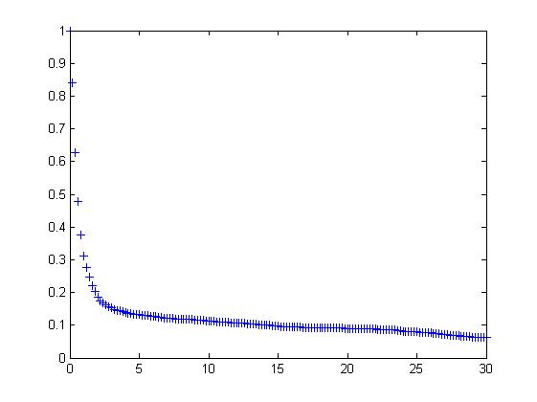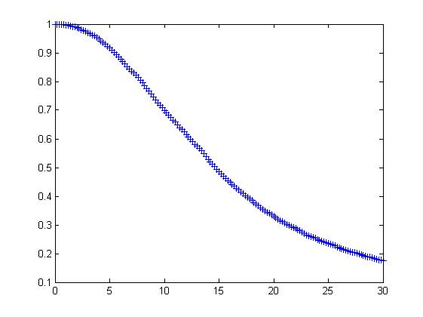

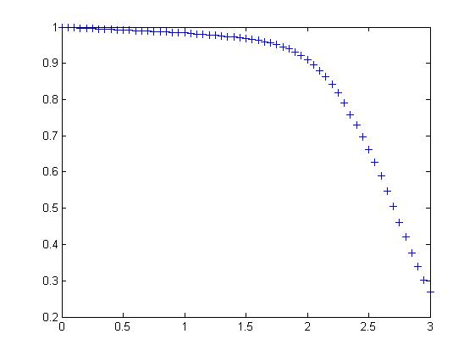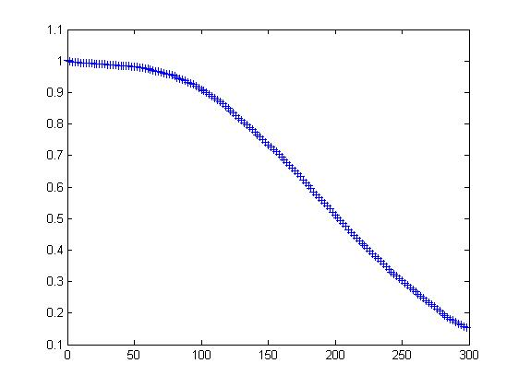

Exp4:Each individual forms a group

Accuracy decreases as threshold grows. Initially 100%

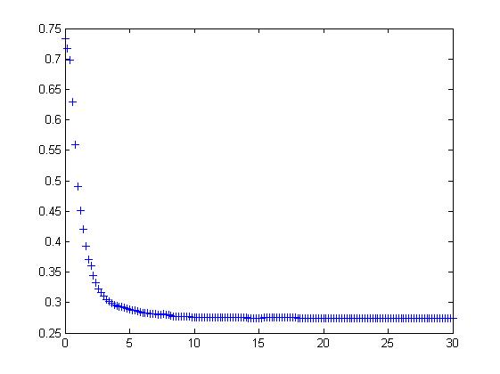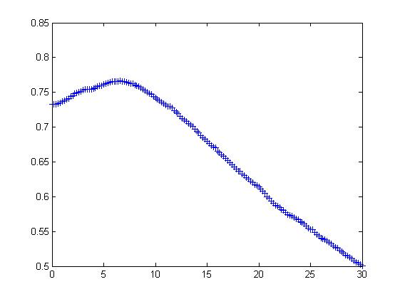

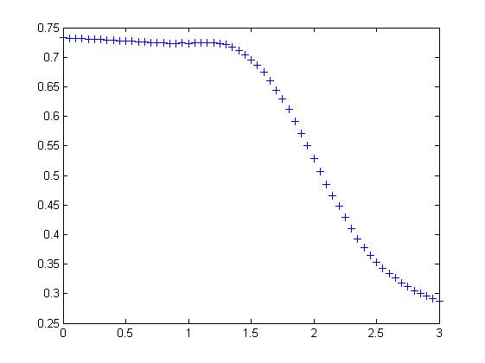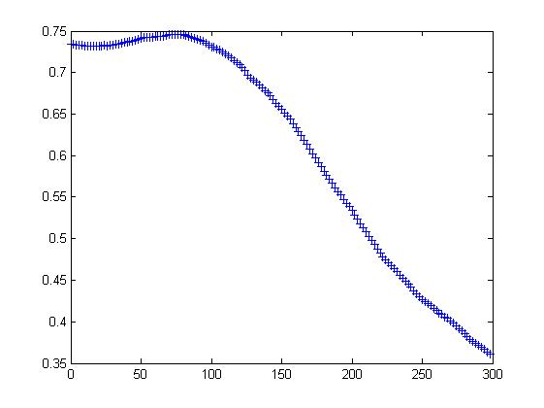

Exp5: (1,2,3,5) (4,6,7) (9,10,11)

DBADP:

For Accelerometer: Achieve highest accuracy 0.74 hreshold=0

For Orientation: Achieve highest accuracy 0.76 ifthreshold=7

DBADH:

For Accelerometer: Achieve highest accuracy 0.74 if threshold=0

For Orientation: Achieve highest accuracy 0.75 if threshold=80

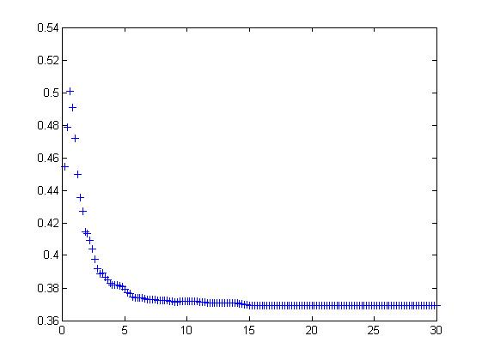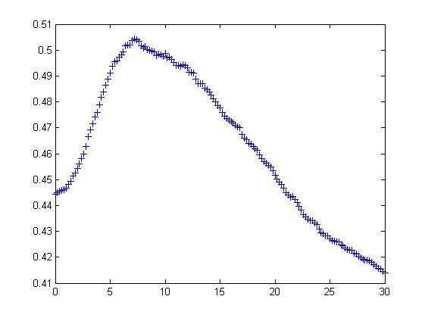

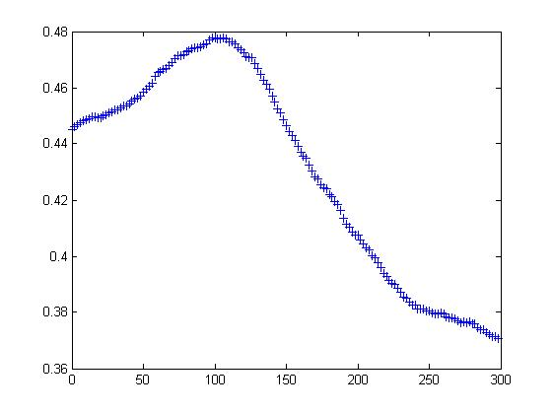

Exp6 (1,2,3,4,5,6)(7,9,10,11)

DBADP:

For Accelerometer: Achieve highest accuracy 0.5 if threshold=0.8

For Orientation: Achieve highest accuracy 0.5 if threshold=7

DBADH:

For Accelerometer: Achieve highest accuracy 0.5 if threshold=1

For Orientation: Achieve highest accuracy 0.48 if threshold=100