**Vonmises图像及分布对比（参数分别为mean,m,Im）**

**以下是用DBAD中的第三次实验的每个用户方向数据的34个窗口（随机选择）得到的冯米塞斯概率分布。**

Exp3: (1,2,3) (4,5,6) (7,9) (10,11)

DBADP:

For Accelerometer: Achieve highest accuracy 0.82f threshold=0.2

For Orientation: Achieve highest accuracy 0.85 if threshold=5

**用户1窗口34分布对比（2.9018525992894295,2.743695636079612,24.982427042641387）**

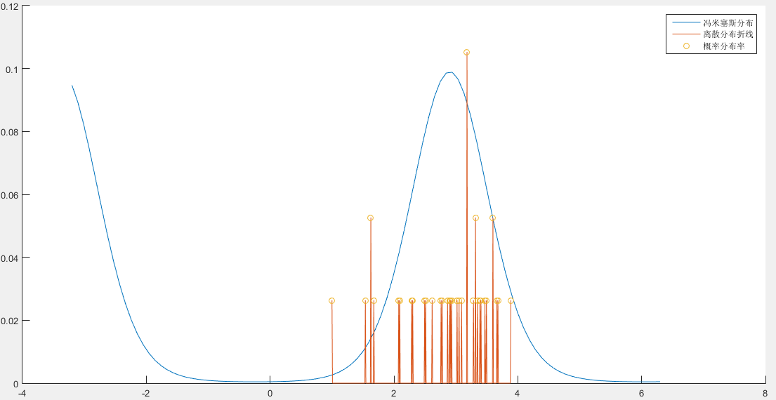

**用户2窗口34分布对比（1.6243032597755598,2.1711817785326577,16.17735827349417）**

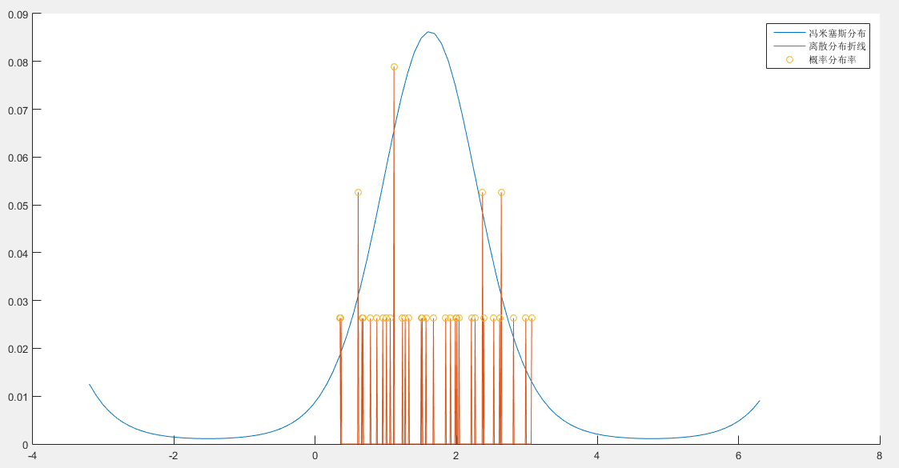

**用户3窗口34分布对比（2.3689254049519235,3.162056728864012,35.001183524626896）**

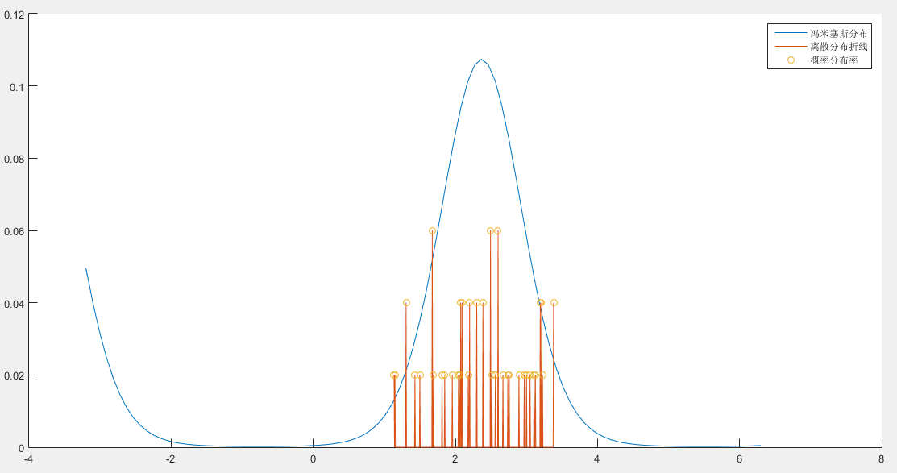

**用户4窗口34分布对比（1.7090676454990348,5.457434298335415,258.13844837573686）**

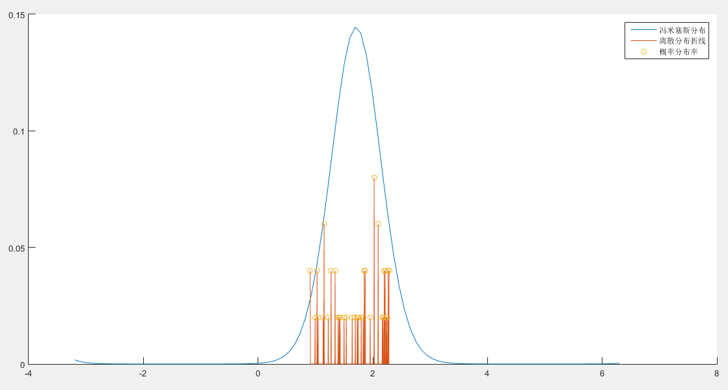

**用户5窗口34分布对比（-2.423978846934166,13.776164162705896,655441.2665092328）**

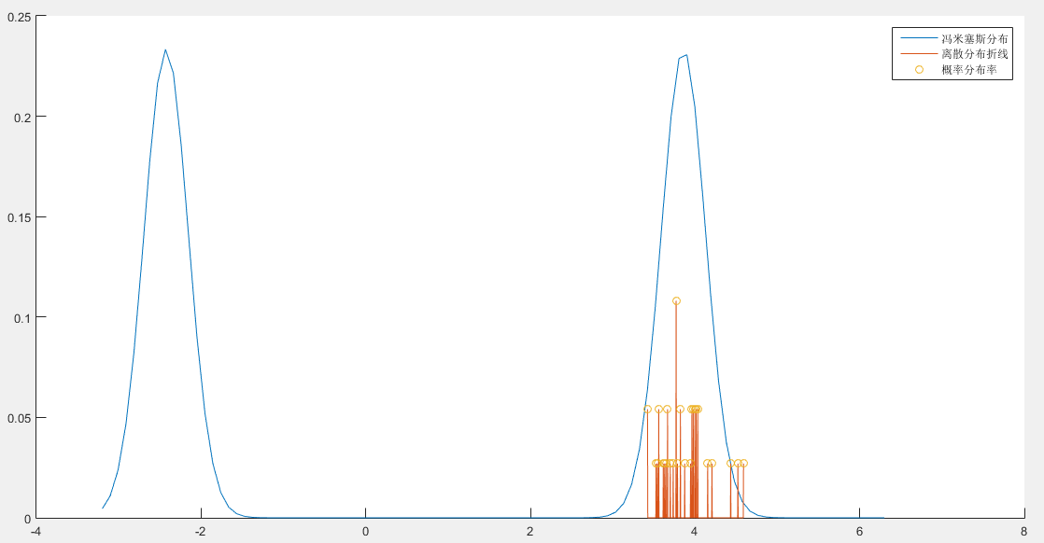

**用户6窗口34分布对比（0.09806258979626271,22.396500862227334,2838947149.301364）**

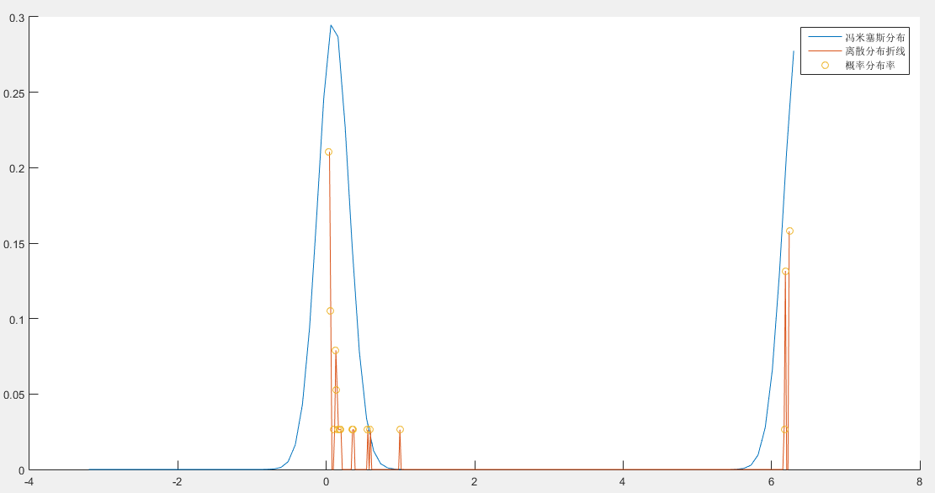

**用户7窗口34分布对比（-3.0321716052360257,3.2092953908226276,36.38843198438131）**

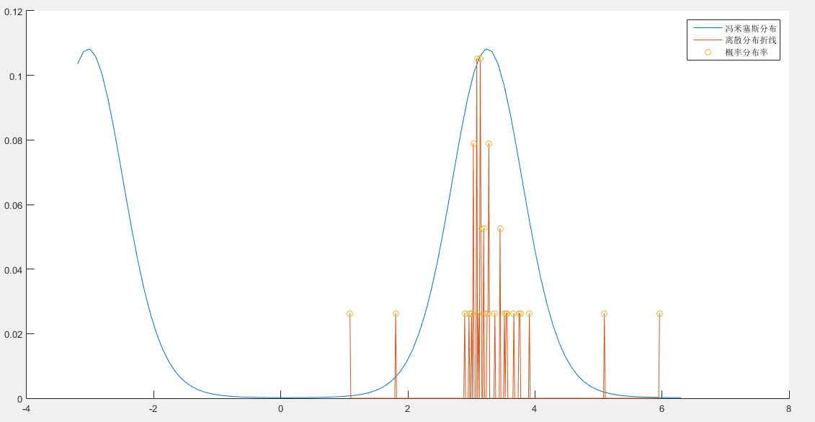

**用户9窗口34分布对比（-2.7843575900862705,2.5059345384684857,20.764764851705856）**

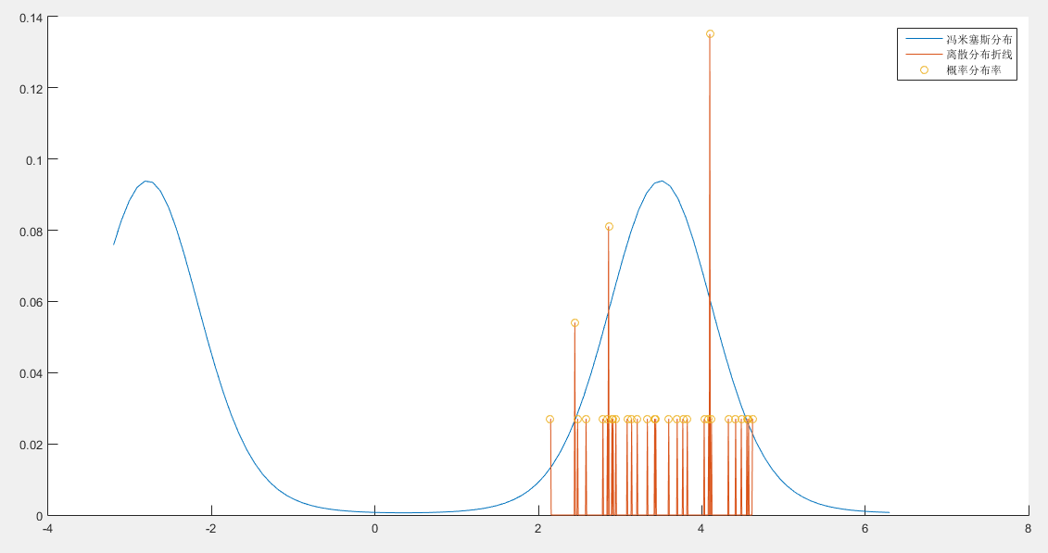

**用户10窗口34分布对比（-1.2937012629294238,2.047546678974772,14.808934432972697）**

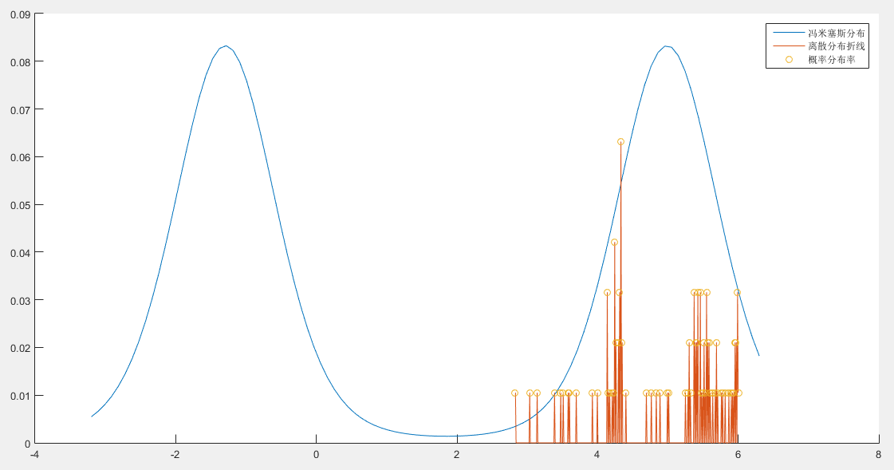

**用户11窗口34分布对比（-3.053996755999301,3.6851512192762392,54.21725564553704）**

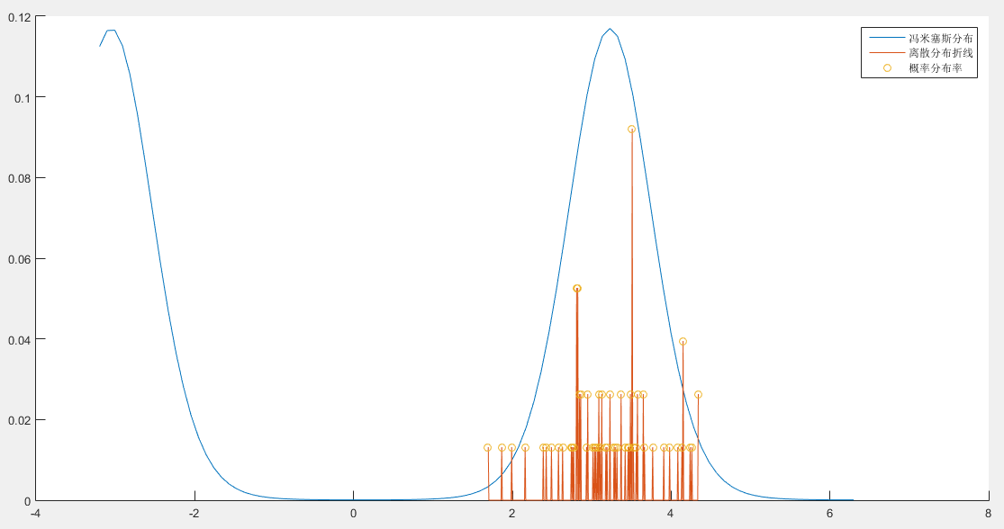

拟合度函数如下所示：（取值范围为0到1，值越大说明拟合效果越好。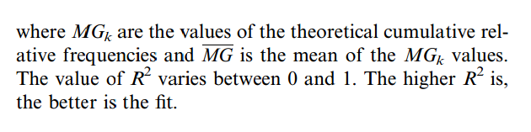



>> drawVonCompare(1,34);  
    0.2078

>> drawVonCompare(2,34);  
    0.1941

>> drawVonCompare(3,34);  
    0.2199

>> drawVonCompare(4,34);  
    0.2249  
  
>> drawVonCompare(5,34);  
    0.2544  
  
>> drawVonCompare(6,34);  
    0.2015  
  
>> drawVonCompare(7,34);  
    0.1898  
  
>> drawVonCompare(8,34);  
   NaN  
  
>> drawVonCompare(9,34);  
    0.1944  
  
>> drawVonCompare(10,34);  
    0.2221  
  
>> drawVonCompare(11,34);  
    0.2513