|  |  |
| --- | --- |
| **Project: New Haven Urgent Care Team# 18** | |
|  | **Test Date: 12/11/2018** |
| **Test Case ID#: 16** | **Name(s) of Tester(s):** Yiping Ren, Zhenyu Fan |
| **Test Description (What are you testing? – you must be specific):**  Does each patient have at least one doctor or PA assigned to them? The the system have a  mechanism to record the physical visit with the doctor/PA?  Num_of_Doctor indicates how many Service_provider the patient have seen. But we cannot decide who is the  Primary Service provider in this situation.  The test failed because we made Service_provider_ID uniques, so our system couldn't add a duplicate service provider id in the consult table. So the patient with pid 3 didn't get recorded  in the consult table |  |
|  |  |

**NOTE: The following information must be provided to be given credit for any test.**

**Test Data (Provide the file name of the script used to insert data, provide a screen capture to reflect data, or provide script here):**

The last insert will fail. Our system couldn't add a duplicate service provider id in the consult table so the patient with pid 3 didn't get recorded.

Filename:test16.sql

|  |
| --- |
| SET SQL_SAFE_UPDATES = 0; |
|  | set foreign_key_checks=0; |
|  | DELETE FROM Patient; |
|  | DELETE FROM Service_Provider; |
|  | DELETE FROM Consult; |
|  | INSERT INTO Patient (PID, DATE_of_birth, Emergence_contact_info, Phone_number, 18_or_not, Address, Name, Assessment_Id) |
|  | VALUES (1, '2001-07-03', '(272)-375-3506', 123, 1, '9113 Highbrook Drive, Dunedin, Marlborough, 84498', 'Quinn Jackson', 1); |
|  | INSERT INTO Patient (PID, DATE_of_birth, Emergence_contact_info, Phone_number, 18_or_not, Address, Name, Assessment_Id) |
|  | VALUES (2, '2003-08-03', '(613)-554-3096', 124, 1, '8217 Fatih Sultan Mehmet Cd, Bolu, Bilecik, 85598', 'Louisa Gonzalez', 2); |
|  | INSERT INTO Patient (PID, DATE_of_birth, Emergence_contact_info, Phone_number, 18_or_not, Address, Name) |
|  | VALUES (3, '2005-07-11', '(283)-746-3029', 125, 1, '7485 Spring Hill Rd, West Valley, Kansas, 83498', 'Chad Hall'); |
|  | INSERT INTO Service_Provider (Employee_ID, Service_provider_ID, name) VALUES (1, 12345, 'Ryan Gosling'); |
|  | INSERT INTO Service_Provider (Employee_ID, Service_provider_ID, name) VALUES (2, 23456, 'Emma Stone'); |
|  | INSERT INTO Service_Provider (Employee_ID, Service_provider_ID, name) VALUES (3, 34567, 'Andrew Garfield'); |
|  | INSERT INTO Consult (Employee_ID, Service_provider_ID, PID) VALUES (1, 12345, 1); |
|  | INSERT INTO Consult (Employee_ID, Service_provider_ID, PID) VALUES (2, 23456, 2); |
|  | INSERT INTO Consult (Employee_ID, Service_provider_ID, PID) VALUES (2, 23456, 3); |
|  | SET foreign_key_checks=1; |
|  | SET SQL_SAFE_UPDATES = 1; |

Reflect data

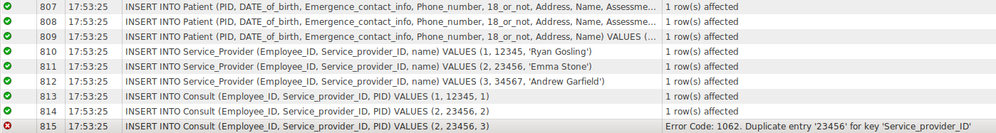

**SQL Query(s) used for testing:**

none