**MEMORANDUM State of Alaska**

**DEPARTMENT OF FISH AND GAME**

|  |  |  |  |
| --- | --- | --- | --- |
| TO: | Andrew Olson | DATE: | June 20, 2018 |
|  | Groundfish Project Leader |  |  |
|  | Commercial Fisheries, Region I  Karla Bush  Shellfish-Groundfish Coordinator Commercial Fisheries, Region I | FILE NO.: |  |
|  |  |  |  |
| FROM: | Jane Sullivan  Biometrician I  Commercial Fisheries, Headquarters  Ben Williams  Fishery Scientist I  Commercial Fisheries, Headquarters | SUBJECT: | NSEI sablefish assessment for 2018 ABC |

|  |  |  |  |
| --- | --- | --- | --- |
| **Summary Table** | | | |
| **Quantity** | **2017** | **2018** | **Percent change (%)** |
| Exploited abundance (adjusted for uncertainty in recruitment) | 1,927,382 | 1,931,191 | 0.2 |
| Exploited biomass (adjusted for uncertainty in recruitment) | 16,265,597 | 16,454,232 | 1.2 |
| $$F_{ABC}=F_{50}$$ | 0.0683 | 0.0635 | -7.0 |
| $ABC_{adj}$ (round lbs) | 850,113 | 965,354 | 13.6 |

# Summary

* The commercial catch in Chatham Strait in 2017 was 744,470 round pounds (Figure 1);
* The 2018 recommended Allowable Biological Catch ($ABC_{adj}$) for Northern Southeast Inside Waters (NSEI - Chatham Strait) at a full-recruitment fishing mortality level of $F_{50\%}$ = is 965,354 round pounds (Table 1). This is a 115,241 pound increase (13.6%) from the 2017 $ABC$ of 850,113 round pounds;
* The adjustment to the $ABC$ accounts for the high uncertainty in the 2014 year class, which is estimated to be the largest recruitment event for sablefish since 1977 (Hanselman et al. 2017). If the 2018 $ABC$ is not adjusted and assessment methodology remains constant from previous years, the $ABC$ would be 1,071,216 pounds, a 221,103 pound increase (26.0%) from 2017 (Table 1). Because fish younger than 7 years comprise 15-20% of the forecasted exploited biomass in 2018 and less than 50% of females are mature at this age, this adjustment will help protect future spawning potential for this year class;
* The adjusted population estimate from the 2017 mark-recapture study in Chatham Strait is 1,927,382 individuals (Table 1). This is a revised estimate and a change from the previous estimate of 1,564,409 individuals forecasted from the 2015 mark-recapture study. Had there been a marking survey in 2016, the increase in the population would likely have been observed a year earlier. The recommended forecast of abundance for 2018 is 1,931,191 individuals (Figure 2; Table 1);
* Female sablefish continue to be retained in greater proportion in the commercial fishery. The proportion of females observed in the commercial catch is greater than the proportion of females in the longline survey for all ages (Figure 3 and Figure 4);
* Catch per unit effort (CPUE) in the ADF&G Chatham Strait longline survey increased relative to 2016 from 0.20 to 0.23 numbers per hook (15.0%) (Figure 5). This reflects a 4.1% increase from the ten year average CPUE of 0.22 sablefish per hook;
* Commercial longline fishery CPUE decreased relative to 2016 from 0.91 to 0.82 pounds per hook (10.0%) (Figure 6). This is only a 3.7% decrease from the ten-year average CPUE of 0.85 pounds per hook. This apparent decrease may be attributed to the large influx of small fish recruiting to the fishery from the 2014 year class;
* Strong recruitment from the 2014 (and possibly 2013 and 2015) year classes were observed in the ADF&G longline survey age composition (Figure 7). The 2014 year class was first observed in the 2017 commercial fishery age-composition data (Figure 8). The federal stock assessment authors are treating this recruitment event with caution by capping the recruitment estimate at the previous maximum recruitment value from 1977 (Hanselman et al. 2017). As described earlier, the estimated abundance was adjusted to reflect this uncertainty;
* The federal stock assessment for sablefish reported a significant increase in abundance and associated quota. The recommended federal Acceptable Biological Catch for the 2018 commercial longline sablefish fishery is 14,957 tons, a 14.3% increase from the 2017 $ABC$ of 13,083 tons (Hanselman et al. 2017). The $F_{ABC}$ presented in the summary table above is not directly comparable to the federal harvest rate of $F_{40\%}$, because the methods used to assess abundance and determine $F$ values are different. Moreover, the federal assessment authors have taken additional conservation measures to adjust for whale depredation and dampen the predicted population increase from the strong 2014 year class (Hanselman et al. 2017).

# Changes to the NSEI sablefish assessment for 2018 relative to 2017

1. The 2017 estimate of exploited abundance used to determine the $ABC$ was adjusted to account for the high degree of uncertainty in recent recruitment events. The 15th percentile from the posterior distribution of abundance was selected as the input to the yield per recruit analysis and calculation of $ABC$ (Figure 9). In the Federal assessment, Hanselman et al. (2017) fixed 2014 recruitment equal to the previous high recruitment event in 1977. Because of differences in assessment methodology, an analogous approach was not followed. However, both approaches - the 15th percentile method and fixing 2014 recruitment at the same value as 1977 - are subjective, precautionary measures that stabilize the fishery and buffer against the negative impacts of overfishing if the 2014 recruitment strength is weaker than predicted. The resultant changes in $ABC$ from 2017 to 2018 are similar between NOAA and ADF&G. Hanselman et al. (2017) recommended a 14.3% increase, which was accepted by the North Pacific Fishery Management Council in December 2017. Here a 13.6% incease is recommended, which is likely larger than it would have been if there had been a 2016 tagging survey. The absence of a survey data point for 2016 resulted in a forecast of the 2017 biomass from the 2015 abundance estimate, causing the $ABC$ to be artifically low as a result. The relative impacts of adjusting the abundance based on uncertainty in recruitment can be seen in Table 1 and Figure 2.
2. In past years the mortality incurred by discarding small, unmarketable fish was not accounted for. Here discard mortality was incorporated into the population dynamics model and is therefore reflected in the *ABC*. The probability of a fish being discarded was informed by processor grade definitions and prices and modeled as a function of weight, sex, and age (Figure 10). Stachura et al. (2012) estimated discard mortality to be 11.7% using release-recapture data from a longline survey in Southeast Alaska to estimate discard mortality. However, it is likely that discard mortality in a fishery is higher due to careful fish handling on survey vessels during tagging experiments. To account for this, we used 16%, the discard mortality rate from the Pacific halibut fishery (Gilroy and Stewart 2013). The halibut fishery serves as a good proxy for sablefish, because they are fished with the same or similar gear and frequently by the same vessels and crew. Moreover, they are both considered sturdy fish that do not experience barotrauma and are known to survive well in laboratory experiments.
3. The mark-recapture models used in this analysis are based on analyses by Dr. Franz Mueter (Mueter 2010). Population estimates from a simple Chapman estimator are compared with estimates from several extensions of a stratified Peterson estimator that account for changes in capture probability through time, natural and fishing mortality, migration, and seasonal trends in catch rates. These alternative model structures are implemented in the Bayesian open source software JAGS 4.3.0 (Depaoli 2016). The Bayesian approach is preferred, because it allows the incorporation of prior information and additional parameter uncertainty into the model. Previous methods used arbitrary break points (e.g. 5 or 10 days) to define temporal strata throughout the fishing season (Mueter 2010, Van Kirk et al. 2016). Here cumulative catch over time is used to define temporal strata. A combination of convergence criteria, deviance information criterion (DIC; Spiegelhalter et al. 2002), and a visual examination of seasonal trends in abundance was used in model selection.
4. The NSEI Chatham Strait sablefish assessment was developed into a reproducible research product (de Leeuw 2001). It is publicly hosted on the web-based version control service GitHub at <https://github.com/commfish/seak_sablefish>. This effort included a thorough review of all data sources available for the NSEI. It involved detailed conversation with ADF&G programming staff, Scott Johnson and Paul Caldwell, as well as Region I Groundfish Project biologists, Andrew Olson, Aaron Baldwin, and Mike Vaughn. The outcomes of these discussions are documented in software code, README file, and Issues tab of the seak_sablefish repository. This product is considered conditionally reproducible, indicating that potential users must formally request any confidential data sourced in the code to produce the full assessment (Schwab et al. 2000). However, survey and other non-confidential data are made available, and all queries and subsequent transformations to the data are included in the analysis.

# Section I: 2017 Acceptable Biological Catch (ABC)

The 2017 marking survey released 7,096 tagged fish. We accounted for tags recovered outside of the NSEI or period of recapture, natural and fishing mortality, and differences in the size of fish captured in the pot survey and the longline fishery (Section II). Alternative candidate models that accounted for movement in and out of Chatham Strait and incorporated fishery CPUE were explored.

Due to the substantial increase in estimated abundance since 2016, coupled with uncertainty in recruitment, the point estimate for the 2017 exploited abundance was adjusted by taking the 15th percentile from the posterior distribution of abundance before conducting the yield per recruit analysis and calculation of $ABC$ (Figure 9). This adjustment stabilizes the fishery by slowing the rate of increase in harvest and reduces the risk of overfishing if the 2014 year class is smaller than currently predicted. Estimates of a single recruitment event can decrease significantly as the year class is observed over multiple years of age compositions (Hanselman et al. 2017, Figure 3.57). Moreover, there is a marked lack of old fish in the current population, indicating a need to allow this cohort to reach maturity in order to build up the population’s spawning biomass (Figure 7).

Lessons from Pacific cod, another groundfish stock in the Gulf of Alaska, highlight how poorly understood mechanisms for recruitment are and why the 2014 year class of sablefish should be treated with caution. Assessments for Pacific cod and sablefish show historically high recruitment events in 1977 in both species, coincident with the 1976/1977 regime shift from cooler to warmer temperatures in the North Pacific Ocean (Hanselman et al. 2017, Barbeaux et al. 2016, Mantua and Hare 2002). In the 2016 Pacific cod assessment, Barbeaux et al. (2016) estimated a large 2012 year class that was smaller but in the same order of magnitude as the 1977 recruitment event (Barbeaux et al. 2016). Last year, however, Pacific cod catch rates plummeted across the Gulf of Alaska, and there was a subsequent 80% decrease in catch limits for 2018 (Barbeaux et al. 2017). Currently the best available science points to above average water temperatures that persisted in the Gulf of Alaska from 2014 to 2016, nicknamed the Blob, as the leading cause for both the collapse of the Pacific cod stock and the spike in sablefish recruitment (Barbeaux et al. 2017, Hanselman et al. 2017). In the case of Pacific cod, the leading hypothesis states that high water temperatures reduced food availability and metabolic efficiency, leading to higher natural mortality and poor body condition (Barbeaux et al. 2017, Zador and Yasumiishi 2017). The mechanisms for how the Blob resulted in record high recruitment in sablefish are less clear. Preliminary results from laboratory studies at the Alaska Fisheries Science Center’s Ted Stevens Marine Research Institute indicate that the optimal thermal environment for age-0 sablefish is around 16°C, which is consistent with water temperatures observed during the Blob years (A. Sreenivasan, NOAA, May 20, 2018, pers. comm). A prior analysis of 40 years of sablefish recruitment in the Gulf of Alaska found that recruitment success was associated with positive annual sea surface temperature anomalies and strong northerly ocean surface current as measured by the PAPA Trajectory Index (PTI) and Ocean Surface Current Simulator (OSCURS; <http://las.pfeg.noaa.gov/oscurs>; Sigler et al. 2001). These findings are consistent with the 2014 PTI, which showed strong northerly subsurface wintertime water movement in that year (Zador and Yasumiishi 2017). Sigler et al. (2001) also found that sablefish growth of a year class was correlated recruitment strength, which suggests that tracking body condition may provide clues to overall health and survival of this year class. Alternative hypotheses include a change in the overall availability and thus selectivity of younger sablefish in the survey and fishery. The 2014 year class could have moved deeper at a younger age to find thermal refuge from the warm nearshore environment or to reduce intraspecific competition if sablefish density was high and food was limited in shallower waters (Hanselman et al. 2017; D. Hanselman, NOAA, and A. Baldwin, ADF&G, May 9, 2019, pers. comm.). If these fish were escaping warm temperatures, this could have inflated initial estimates of recruitment strength by changing the availability of fish to the fishing gear. Future investigations should include an examination of length/age compositions by depth and temperature if these data are available.

The recommended adjusted abundance estimate of 1,927,382 for 2017 was partitioned into sex-specific age classes from 2017 commercial fishery catch-at-age/sex data and projected into 2018 (Section III). This produced an estimated forecast of exploited abundance of 1,931,191 individuals for 2018. Multiplying by commercial fishery weight-at-age produced an estimate of exploited biomass of 16,454,232 round pounds. Mean weight-at-age was predicted from a weight-based Ludwig von Bertalanffy growth model fit to fishery-dependent weight and age data from 1997 to 2017. Similar to past assessments, the mean weight for the plus group (age 42+) was the mean weight from all samples aged 42 and older.

# Section II: Mark-recapture analysis

The mark-recapture study forms the foundation for current sablefish management in Chatham Strait. The most commonly used method for abundance estimation and the model that was used for many years by ADF&G is the Chapman estimator:

$$N=\frac{(K+1)(n+1)}{k+1}-1,$$

where $N$ is the estimated population abundance, $K$ is the total number of individuals tagged in the population, $n$ is the number of individuals checked for marks at the time of recapture, and $k$ is the number of marked individuals out of $n$. A description of all model variables is found in Table 2, and a coarse summary of the mark-recapture data since 2005 is found in Table 3. Note that ADF&G did not conduct a tagging survey in 2011, 2014, or 2016 due to budget restrictions.

There are four primary assumptions integral to the Chapman estimator, which have been discussed in detail in previous iterations of this memo (Williams and Van Kirk 2017, Dressel 2009, Mueter 2010). Briefly, these assumptions include a closed population (no movement in or out of the study area), equal probability of recapture, sufficient time between marking and recapture to allow for marked individuals to be randomly distributed throughout the unmarked population, and no tag loss or errors. Violations to these assumptions can be mitigated through study design, treatment of data, and changes to model structure. A combination of approaches were utlized to meet or relax these assumptions including:

1. Potential differences in the size selectivity between the pot survey and longline survey and fishery were accounted for by (1) estimating growth between May and August using known length recaptured individuals, (2) comparing the cumulative length distributions between tagged and recaptured fish, and (3) adjusting sample sizes accordingly. Despite the differences in selectivity between pot and longline gear, minimal differences in the cumulative length distributions between marked and recaptured since 2005 were found, which suggests that size distribution tagged in the pot survey is sufficiently large to be recaptured in the fishery (Figure 11). These findings run contrary to those of previous authors, who adjusted the number of marks using fixed selectivity curves instead of data (Williams and Van Kirk 2017, Mueter 2010).
2. To assess the assumption that there is sufficient time between marking and recapture to allow for tagged individuals to be randomly distributed, movement in the population between statistical areas was explored. Results suggest that the population is sufficiently mixed across study years (Figure 12). These findings are consistent with Mueter (2010) and lend support to the current study design of the mark-recapture project.
3. A suite of alternative models that are stratified by time were developed in order to account for natural and fishing mortality, potential changes in the probability of recapture, and tag loss from other fisheries or outside the NSEI. This allows for greater precision in the estimates of abundance, as each time-period compensates for changes in $K$, $n$, and $k$.
4. To account for potential violations of the closed population assumption, two of the alternative models estimate an additional parameter for migration (see Models 2 and 4, Table 4).
5. To further address a potential change in capture probability through time, two of the alternative models incorporate fishery CPUE data to account for seasonal changes in catch rates or fish abundance (see Models 3 and 4, Table 4).

The Chapman estimator serves as the null model (Model 0) and the basis of comparison to other models (Table 4). Models 1-4 were developed in a Bayesian framework using JAGS 4.3.0 (Depaoli 2016). Breakpoints for temporal strata were defined by dividing cumulative catch evenly over time.

## Model 1: Time-stratified Petersen estimator

The abundance of sablefish in Chatham Strait in a given time period $N_{i}$ was assumed to follow a normal distribution with an uninformed prior (precision = $1×{10}^{-12}$) centered on past assessments’ forecast of abundance.

For any given time period $i$ (see Table 2 for variable definitions):

$$K_{i}=\left\{\begin{matrix}(K_{0}-D_{0})*exp(-M*t_{i}) & i=1 \\ (K_{i-1}-k_{i-1}-D_{i-1})*exp(-M*t_{i}) & i>1\end{matrix}\right.$$

.

$$N_{i}=\left\{\begin{matrix}(N_{i}*exp(-M*t_{i}) & i=1 \\ (N_{i-1}-C_{i-1})*exp(-M*t_{i}) & i>1\end{matrix}\right.$$

The probability that a sablefish caught in a given time period is marked, $p_{i}$, is informed by the ratio of marks in the population to the total population at that time $K_{i}/N_{i}$. Each $p_{i}$ is assumed to follow a beta prior distribution $p_{i}=beta(α,β)$, where $α=(K_{i}/N_{i})*x$, $β=(1-K_{i}/N_{i})/x$, and a large $x$ indicates confidence in $K_{i}/N_{i}$. Because $N_{i}$ was previously assumed to follow vague normal prior, $p_{i}$ was assigned an informed prior by setting $x$ equal to 10,000.

In a given time period, the likelihood of recapturing $k$ marked sablefish given $n$ sampled individuals follows a binomial distribution, where

$$Pr(k|n,p)=\left({n \atop k}\right)p^{k}(1-p)^{n-k}.$$

The final estimate and credible interval reported for $N$ is the average $N$ across all time periods.

## Model 2: Accounting for movement

Following Mueter (2010), the time-stratified Peterson estimator was extended by estimating a parameter for net migration $r$. If $r$ is positive, it indicates that there was net positive movement of sablefish into Chatham Strait during the fishery. Conversely, a negative $r$ would suggest net movement out of Chatham during the fishery. Following Mueter (2010), $r$ was assigned a vague normal prior distribution, centered at +5,000 individuals (precision = $1×{10}^{-12}$). This parameter is incorporated into the model with the addition of $r$ into the abundance equation from Model 1:

$$N_{i}=(N_{i-1}-C_{i-1})*exp(-M*t_{i})+r*t_{i}.$$

## Models 3 and 4: Including fishery CPUE data

As an extension to the above models and to account for seasonal trends in abundance and fishing effort, fishery CPUE data was included in the model. An examination of fishery CPUE annually since 2005 (omitted for brevity), shows slight increasing and decreasing linear trends in fishery CPUE. This suggests a change in fish abundance or density throughout the fishing season and that the direction of this change is variable between years. Fishery CPUE in a given time period (defined as number of sablefish per 1,000 hooks) was back-calculated using mean fish weight in the fishery and weight of the landing from fish tickets.

Versions of Models 1 and 2 were adapted to include fishery CPUE data (Models 3 and 4 in Table 4) following the methods in Mueter (2010). Fishery CPUE was assumed proportional to total sablefish abundance in each time period

$$CPUE_{i}=q*N_{i},$$

where catchability $q$ is the constant of proportionality. These models were fit to the mark-recapture and fishery CPUE data by maximizing the combined likelihood (consisting of a binomial likelihood component for the mark-recapture data and a normal likelihood for the fishery CPUE data). Both likelihood components received equal weights in the combined likelihood, thus fishery CPUE and mark-recapture data contribute equally to the parameter estimation.

## Results and model selection

A total of 32 models (4 models $×$ 8 time periods) were fit for each tagging survey year from 2005 to 2017 (10 distinct years). Trace plots were examined visually, and the Gelman and Rubin’s convergence diagnostic was used to test the convergence of MCMC chains (Gelman and Rubin 1992). All models converged except for versions of Models 3 and 4 with fewer than 4 time periods. Models 3 and 4 used fishery CPUE data to estimate $q$, so these models require more observations of CPUE (i.e. more time periods) to converge. Therefore, Models 3 and 4 with fewer than 4 time periods were omitted from further consideration.

A combination of DIC and a visual examination of trends in abundance estimates were used in the remaining model selection. A tradeoff existed between the number of time periods $P$ and the ability to accurately describe seasonal trends. A visual comparison of Models 1-4 across a range of time periods $P$ showed that the final estimate of $N$ does not change after $P≥6$ for most years (Figure 13). Because capturing this temporal trend was a motivating factor in the development of these models, models with $P<6$ were eliminated and remaining candidates were compared using DIC.

The models with the most support in all years were Models 1 and 2 by DIC ($ΔDIC≤2$) (Burnham and Anderson 2003). The point estimate and credible interval for $N$ for the top candidate models for 2017 are found in Table 5. Models 1-4 have much lower estimates of abundance than the simple Chapman estimator, likely because the Chapman estimator does not account for natural or fishing mortality or changes in abundance throughout the season. Although Model 2 had statistical support via DIC, the resultant abundance estimates and variance from Model 2 were greater than Model 1 (Table 5). The estimates and credible intervals for net migration ($r$) were wide for all years, and the direction of net migration (positive or negative) was inconsistent across years (Figure 14). While Model 2 provides an interesting contrast to the other models, more research is needed before bringing this model forward for management. Models 3 and 4, though having a lower DIC weighting, had reasonable abundance estimates and fit the CPUE data well in most years (2017 was a notable exception; Figure 15). These models have potential for future development.

Ultimately, Model 1 with $P=6$ was selected to bring forward for the 2018 forecast and calculation of the 2018 ABC, because it had the lowest DIC and was most similar to models used for recent assessments (e.g. Williams and Van Kirk 2017). A retrospective analysis shows that Model 1 abundance estimates follow a similar trend and general magnitude as past model estimates (Figure 2). As discussed in Section I, the 15th percentile from the posterior distribution was used to adjust the abundance estimate for subsequent analyses (Figure 9).

# Section III: Determining Allowable Biological Catch

Using the adjusted abundance estimate, the vulnerable abundance-at-age for ages 2+ was calculated by partitioning the estimated exploited abundance into cohorts using commercial fishery catch-at-age proportions and incrementing annually:

$${\overset{^}{N}}_{t,a}=\sum_{k=1}^{2}{[}\frac{γ_{k}{\overset{^}{N}}_{y-1,a-1}ϕ_{y-1,a-1}}{s_{f,k,a-1}}s_{k,a}]^{-(s_{f,k,a-1}F_{t-1}+Dp_{a,k}s_{s,k,a-1}+M)}$$

for which ${\overset{^}{N}}_{y,a}$ is the estimated exploitable abundance-at-age $a$ in year $y$, $γ_{k}$ is the proportion of the commercial longline catch by sex $k$, $ϕ_{k}({\overset{^}{N}}_{y-1,a-1})$ is the fishery catch-at-age proportion at age $a-1$ in year $y-1$, $s_{f,k,a}$ is the commercial fishery selectivity-at-age for age (Hanselman et al. 2017), $s_{s,k,a}$ is the longline survey selectivity-at-age (Hanselman et al. 2017), and $F_{y-1}$ is the full recruitment fishing mortality implemented in year $y-1$. The discard mortality rate $D$ is assumed to be 0.16, the same as the discard mortality rate in the Pacific halibut fishery (Gilroy and Stewart 2013). The probability of a fish being discarded $p_{a, k}$ is informed by processor grade and price and defined as a function of weight, which is converted to age and sex using survey weight-at-age (Figure 10). The discarded portion of the fishery is modeled using survey selectivity and empirical weight-at-age to account for the fact that smaller fish are likely selected for discard. Natural mortality $M$ is assumed constant over time and age and is set to 0.1 (Johnson and Quinn, 1998).

Vulnerable abundance for age-2, the youngest age-class considered in the commercial fishery, is calculated as

$$\overset{^}{N_{y,2}}=\sum_{k=1}^{2}{\frac{γ_{k}({\overset{^}{N}}_{y-1,2}ϕ_{t-1,a-1})}{s_{k,2}}}s_{k,a}.$$

Application of the Baranov catch equation for which full-recruitment fishing mortality $F=F_{50\%}$, obtained from yield-per-recruit tables in conjunction with mean fishery weight-at-age $w_{a}$, is used to calculate the $ABC$:

$$ABC=\sum_{k=1}^{2}{\sum_{a=2}^{max(a)}{\frac{Fs_{a}}{Z_{a}}}}N_{a}(1-e^{-Z_{a}})*w_{a}$$

where $Z_{a}$ is the sum of natural mortality $M$ and $F$, and $F$ accounts for both retained and discarded fish that die post-release.

# Future work and recommendations

1. It is a priority for the Region I Groundfish Project and biometric team to develop and implement an integrated age-structured assessment for this stock. Due to changes in staff, no progress was made on the age-structured assessment in 2017. It is our goal to present this assessment in spring of 2019. As part of this effort, we will re-evaluate fishery and survey selectivity, which has been fixed at Federal values in this and past assessments.
2. Regardless of future changes to assessment methodology, the tagging survey will continue to be integral to understanding the population dynamics of sablefish in Chatham Strait and providing sound management advice. Consequently, we recommend the continuation of an annual tagging survey. The importance of an annual survey can be seen in the Summary table at the beginning of this memo, where the previously forecasted estimate of abundance in 2017 was much lower than our current estimate of abundance. This demonstrates that a biannual survey is insufficient to track changes in abundance, especially during periods of large recruitment events.
3. Data from mark-recapture studies prior to 2005 are currently not available and portions of the modern data are not entered in the ADF&G database. The authors recommend that these data are rehabilitated and entered into a database. Specifically, mark recovery data collected by port samplers through countbacks are stored in spreadsheets on the network drive. These spreadsheets are heavily formatted, do not use consistent data types, and contain no metadata. Consequently, they are difficult to use and could be changed by anyone with network access.

# Assessment timeline in 2018

Presentation to industry: Wednesday, March 7;

Initial Draft: Wednesday, May 2;

Internal ADF&G review: Thursday, May 9;

Final version approved by reviewers & managers: Friday, June 8;

Public announcement of formal quota: Friday, June 15.

# References

Barbeaux, S., A’mar, T., and Palsson, W. 2016. Chapter 2. Assessment of the Pacific cod stock in the Gulf of Alaska. *In:* Stock assessment and fishery evaluation report for the groundfish resources of the GOA and BS/AI as projected for 2017. North Pacific Fishery Management Council, 605 W 4th Ave, Suite 306 Anchorage, AK 99501.

Barbeaux, S., Aydin, K., Fissel, B., Holsman, K., Palsson, W., Shotwell, K., Yang, Q., and Zador, S. 2017. Chapter 2. Assessment of the Pacific cod stock in the Gulf of Alaska. *In:* Stock assessment and fishery evaluation report for the groundfish resources of the GOA and BS/AI as projected for 2018. North Pacific Fishery Management Council, 605 W 4th Ave, Suite 306 Anchorage, AK 99501.

Burnham, K.P. and Anderson, D.R. 2003. Model selection and multimodel inference: a practical information-theoretic approach. Springer Science & Business Media.

Depaoli, S., James P. Clifton, and Patrice R. Cobb. 2016. Just Another Gibbs Sampler (JAGS) Flexible Software for MCMC Implementation. Journal of Educational and Behavioral Statistics 41.6: 628-649.

Dressel, S.C. 2009. 2006 Northern Southeast Inside sablefish stock assessment and 2007 forecast and quota. Alaska Department of Fish and Game, Fishery Data Series No. 09-50, Anchorage.

de Leeuw, J., Reproducible Research. The Bottom Line, Department of Statistics, UCLA, Department of Statistics Papers, Paper 2001031101, March 2001. Available online at <https://escholarship.org/uc/item/9050x4r4>

Gelman, A and Rubin, DB (1992) Inference from iterative simulation using multiple sequences, Statistical Science, 7, 457-511.

Gilroy, H.L., and I.J. Stewart. 2013. Incidental mortality of halibut in the commercial halibut fishery (Wastage). In: International Pacific Halibut Commission Report of Assessment and Research Activities 2012, pp. 53-60. <http://www.iphc.int/publications/rara/2012/rara2012053_commwastage>. pdf

Hanselman, D. H., C. J. Rodgveller, C. R. Lunsford, and K. H Fenske. 2017. Chapter 3: Assessment of the sablefish stock in Alaska. *In:* Stock assessment and fishery evaluation report for the groundfish resources of the GOA and BS/AI as projected for 2018. North Pacific Fishery Management Council, 605 W 4th Ave, Suite 306 Anchorage, AK 99501.

Johnson, S. L., and T. J. Quinn II. 1988. Catch-Age Analysis with Auxiliary Information of sablefish in the Gulf of Alaska. Contract report to National Marine Fisheries Service, Auke Bay, Alaska. 79 pp. Center for Fisheries and Ocean Sciences, University of Alaska, Juneau, Alaska.

Mueter, F. 2010. Evaluation of stock assessment and modeling options to assess sablefish population levels and status in the Northern Southeast Inside (NSEI) management area. Alaska Department of Fish and Game, Special Publication No. 10-01, Anchorage.

Schwab M., M. Karrenbach, and J. Claerbout, Making scientific computations reproducible, Computing in Science & Engineering, vol. 2, no. 6, pp. 61-67, Nov. 2000. Available online at <http://sepwww.stanford.edu/doku.php?id=sep:research:reproducible:cip>.

Sigler, M. F., T. L. Rutecki, D. L. Courtney, J. F. Karinen, and M.-S.Yang. 2001. Young-of-the-year sablefish abundance, growth, and diet. Alaska Fish. Res. Bull. 8.1: 57-70.

Stachura, M. M., Lunsford, C. R., Rodgveller, C.J. and Heifetz, J., 2012. Estimation of discard mortality of sablefish (*Anoplopoma fimbria*) in Alaska longline fisheries. Fish. Bull. 110.2: 271-279.

Williams, B, Van Kirk. 2017. 2017 NSEI Sablefish Assessment. State of Alaska, Department of Fish and Game, Division of Commercial Fisheries Memorandum. March 16, 2017.

# Tables

Table 1. Estimated and forecasted exploited abundance, biomass, target fishing mortality $F$, and acceptable biological catch $ABC$ for 2017 and 2018. For abundance, biomass, and $ABC$, the 2017 value from last year (forecasted from the 2015 tagging survey) is compared to current 2017 estimates, both *status quo* and recommended values in bold that have been adjusted for uncertainty in recruitment.

|  |  |  |  |
| --- | --- | --- | --- |
| Quantity | 2017 | 2018 | Percent change (%) |
| Exploited abundance (2017 value from last year) | 1,564,409 | 1,931,191 | 23.4 |
| Exploited abundance | 2,138,742 | 2,142,969 | 0.2 |
| **Exploited abundance (adjusted for uncertainty in recruitment)** | **1,927,382** | **1,931,191** | **0.2** |
| Exploited biomass (2017 value from last year) | 13,502,591 | 16,454,232 | 21.9 |
| Exploited biomass | 18,049,305 | 18,258,627 | 1.2 |
| **Exploited biomass (adjusted for uncertainty in recruitment)** | **16,265,597** | **16,454,232** | **1.2** |
| $$F_{ABC}=F_{50}$$ | 0.0683 | 0.0635 | -7.0 |
| $ABC$ (round lbs) | 850,113 | 1,071,216 | 26.0 |
| $ABC_{adj}$**(round lbs)** | **850,113** | **965,354** | **13.6** |

Table 2. Notation for mark-recapture models used in the 2017 stock assessment.

|  |  |
| --- | --- |
| Variable | Definition |
| $$N_{0}$$ | Number of sablefish in Chatham Strait at time of marking during the ADF&G pot survey |
| $$K_{0}$$ | Number of tags released in the ADF&G pot survey |
| $$D_{0}$$ | Number of tagged fish that are not available to either the ADF&G longline survey or to the fishery (tags recovered in halibut fishery or outside of Chatham Strait) |
| $$i$$ | Subscript for each time period, which may refer to the ADF&G longline survey ( $i$ = 1) or to one of the fishery time periods based on time of landing |
| $$N_{i}$$ | Number of sablefish in Chatham Strait at the beginning of time period $i$ |
| $$D_{i}$$ | Number of tags lost in time period $i$ that should be decremented from the next time period |
| $$C_{i}$$ | Total catch (number of sablefish removed) during time period $i$ |
| $$K_{i}$$ | Number of tagged sablefish in Chatham Strait at the beginning of time period $i$ |
| $$t_{i}$$ | Number of days in time period $i$ |
| $$n_{i}$$ | Observed catch during period $i$ (number of sablefish that were checked for marks) |
| $$k_{i}$$ | Number of marked fish recovered in period $i$ |
| $$p_{i}$$ | Probability of recapture in time period $i$ |
| $$M$$ | Natural mortality decremented daily and fixed at 0.1 following Johnson and Quinn (1988) |
| $$r$$ | Net number of tagged individuals entering or leaving Chatham Strait (migration parameter) |
| $$q$$ | Catchability coefficient for the fishery relating fishery CPUE in period $i$ to sablefish abundance $CPUE_{i}=q*N_{i}$ |
| $$P$$ | Total number of time periods |

Table 3. A summary of data inputs to the mark-recapture models, including total individuals tagged ($K_{0}$), tags not available to the longline survey or fishery (captured in other fisheries or outside Chatham, $D_{0}$), recaptured individuals in the longline survey and fishery ( $k_{srv}$ and $k_{fsh}$), number of sampled individuals in the longline survey and fishery ( $n_{srv}$ and $n_{fsh}$), tags not available to the fishery (captured outside Chatham or in other fisheries during the survey, $D_{srv}$), and tags recaptured in other fisheries or outside Chatham during the fishery ($D_{fsh}$) for years with a tagging survey from 2005 to 2017.

|  |  |  |  |  |  |  |  |  |
| --- | --- | --- | --- | --- | --- | --- | --- | --- |
| Year | $$K_{0}$$ | $$D_{0}$$ | $$k_{srv}$$ | $$n_{srv}$$ | $$D_{srv}$$ | $$k_{fsh}$$ | $$n_{fsh}$$ | $$D_{fsh}$$ |
| 2005 | 7,118 | 9 | 60 | 17,495 | 44 | 690 | 180,999 | 84 |
| 2006 | 5,325 | 3 | 26 | 14,481 | 20 | 503 | 203,878 | 38 |
| 2007 | 6,157 | 2 | 33 | 15,253 | 10 | 335 | 150,729 | 61 |
| 2008 | 5,450 | 4 | 42 | 15,483 | 12 | 431 | 156,313 | 43 |
| 2009 | 7,071 | 7 | 42 | 14,946 | 9 | 285 | 105,709 | 62 |
| 2010 | 7,443 | 4 | 54 | 14,764 | 6 | 331 | 106,201 | 28 |
| 2012 | 7,582 | 23 | 66 | 18,047 | 4 | 380 | 97,134 | 53 |
| 2013 | 7,961 | 24 | 86 | 13,570 | 3 | 374 | 99,286 | 113 |
| 2015 | 6,862 | 1 | 63 | 12,274 | 10 | 242 | 70,273 | 32 |
| 2017 | 7,096 | 3 | 39 | 14,200 | 3 | 197 | 60,409 | 11 |

Table 4. A description of the mark-recapture models compared in 2017.

|  |  |  |
| --- | --- | --- |
| Model | Description | Parameters |
| Model 0 | Chapman estimator | $$N$$ |
| Model 1 | Time-stratified Peterson estimator with natural mortality | $N$, $p$ |
| Model 2 | Model 1 with migration | $N$, $p$, $r$ |
| Model 3 | Model 1 with fishery CPUE data | $N$, $p$, $q$ |
| Model 4 | Model 1 with migration and fishery CPUE data | $N$, $p$, $r$, $q$ |

Table 5. Results from candidate models in 2017, including abundance estimate (median) and 95% credible intervals, deviance, parameter penalty, and ΔDIC (DIC = 0 is the model with the most support).

|  |  |  |  |  |  |  |
| --- | --- | --- | --- | --- | --- | --- |
| Model | Estimate | Upper CI | Lower CI | Deviance | Parameter penalty | ΔDIC |
| Model0 | 2,517,481 | -- | -- | -- | -- | -- |
| Model1 | 2,122,673 | 2,585,530 | 1,778,852 | 38.11 | 3.66 | 0.00 |
| Model2 | 2,145,708 | 2,665,681 | 1,774,421 | 38.54 | 4.05 | 0.82 |
| Model3 | 2,107,460 | 2,566,178 | 1,755,491 | 87.01 | 7.49 | 52.73 |
| Model4 | 2,202,930 | 2,765,639 | 1,806,800 | 86.23 | 9.32 | 53.78 |

# 

# Figures

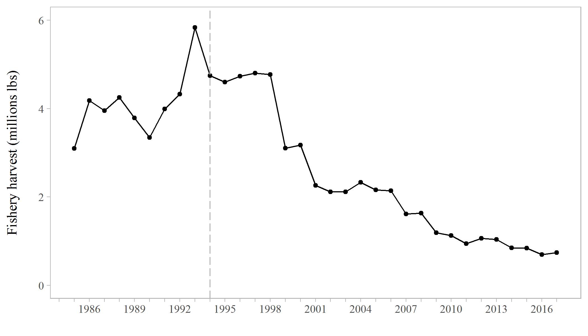

Figure 1. Fishery harvest in Chatham Strait from 1985 to 2017. The vertical dashed line marks the transition of the fishery from limited entry to equal quota share in 1994.

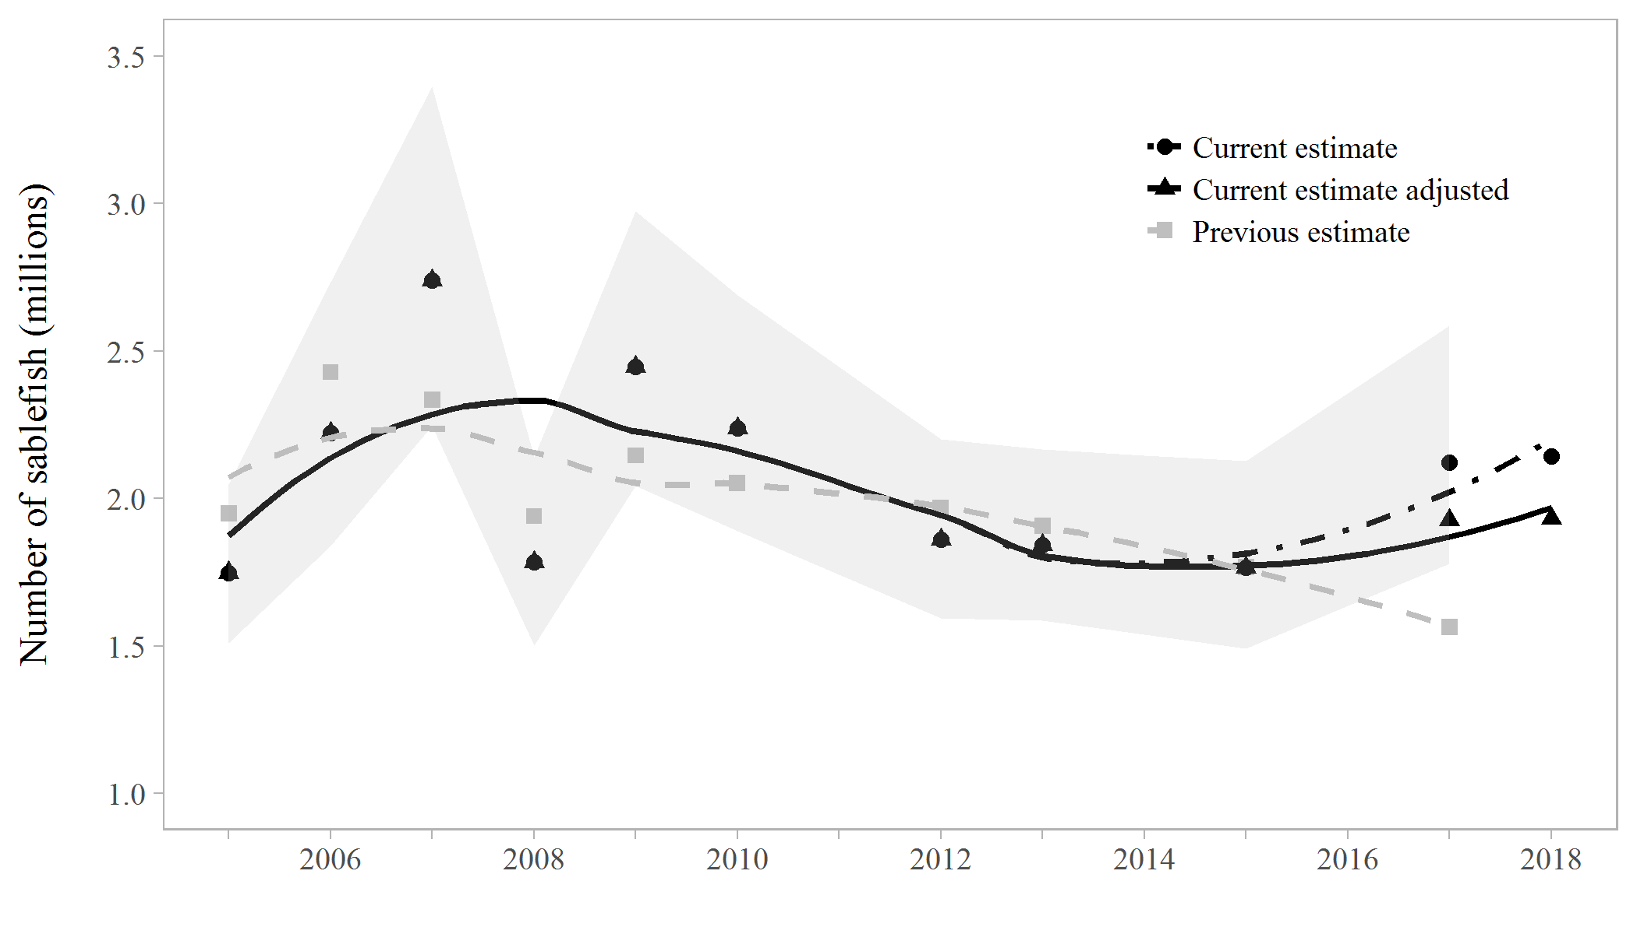

Figure 2. Abundance estimates from the current model (black points), adjusted current model (black triangles), and previous against previous estimates of abundance (grey squares) from 2005 - 2017. Shaded areas are 95% credible intervals from the current estimates’ posterior distributions. The grey square in 2017 is the forecasted abundance from last year, which was poorly estimated due to a lack of a tagging survey in 2016.

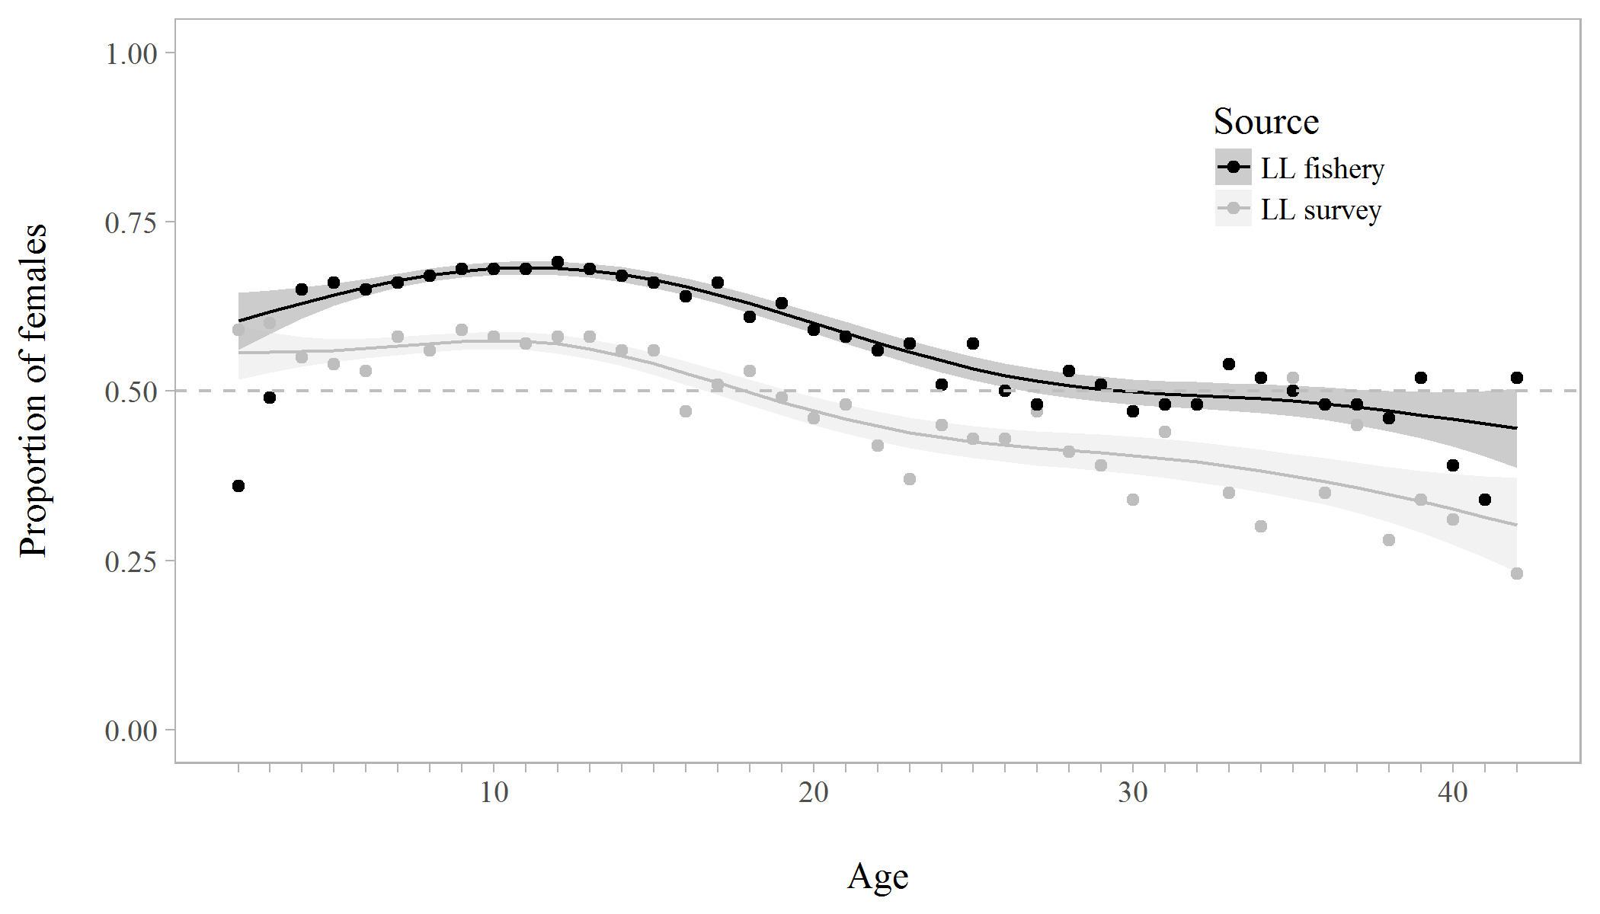

Figure 3. Proportion of females at age in the commercial longline fishery (black) 2002 to 2017 and longline survey (grey) 1988 to 2017. Shaded areas and smoothed curves are the predicted values and standard errors from a generalized additive model.

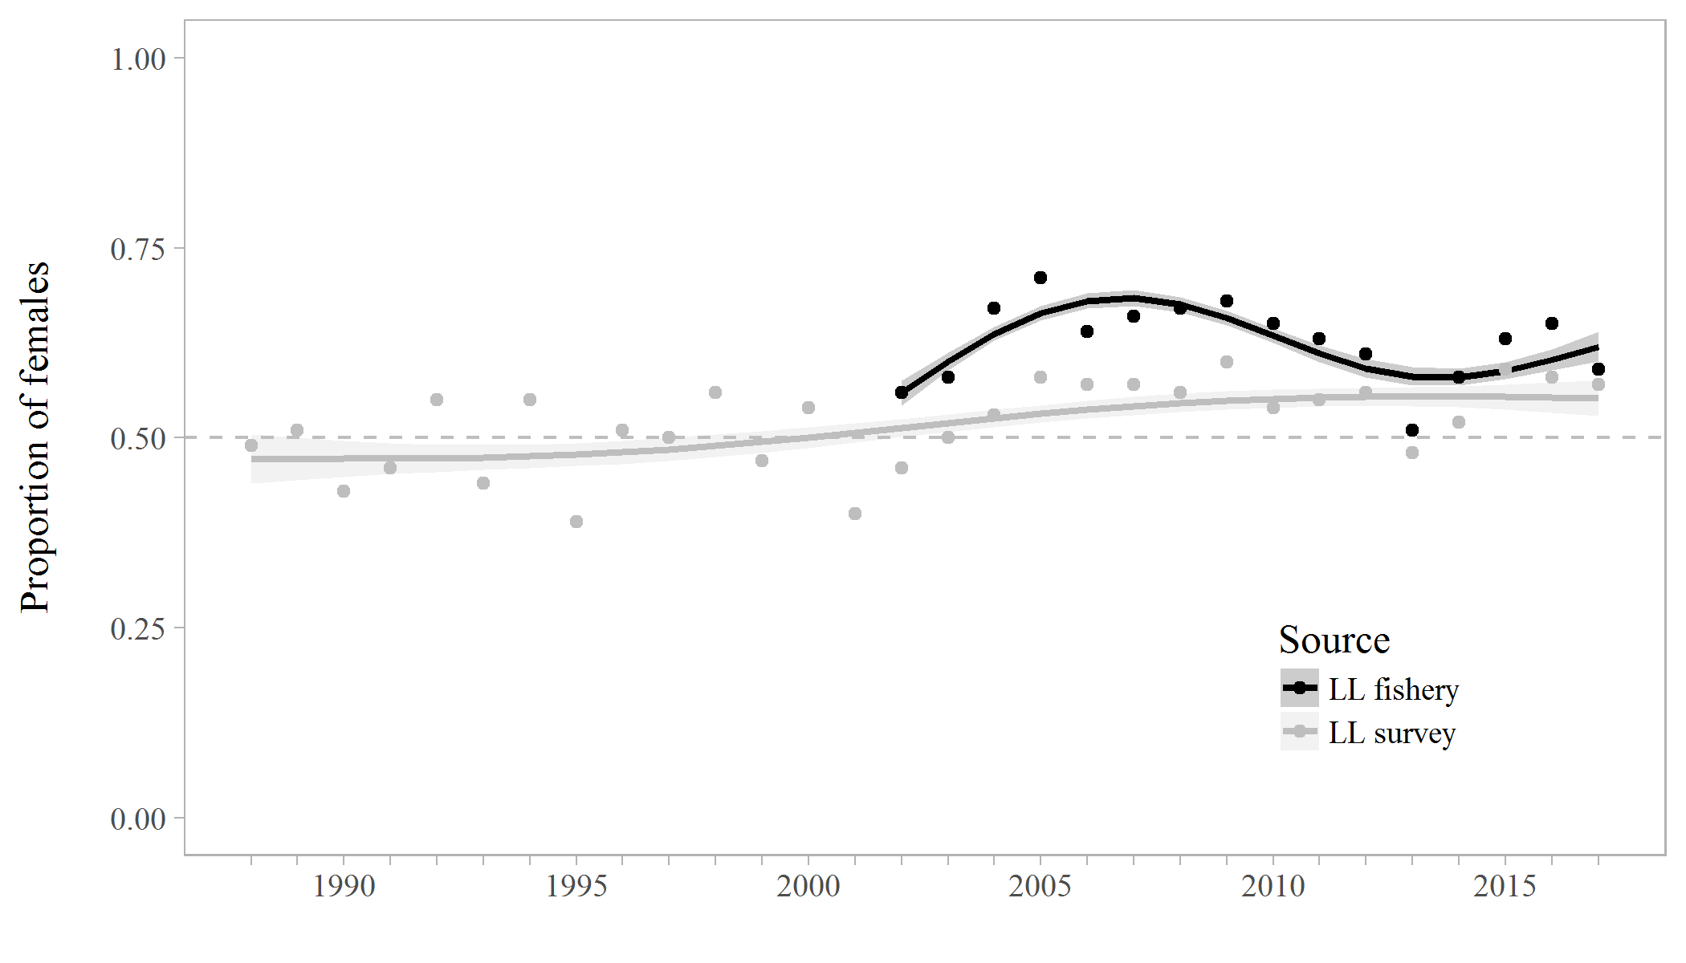

Figure 4. Proportion of females in the commercial longline fishery (black) from 2002 to 2017 and longline survey (grey) from 1988 to 2017. Shaded areas and smoothed curves are the predicted values and standard errors from a generalized additive model.

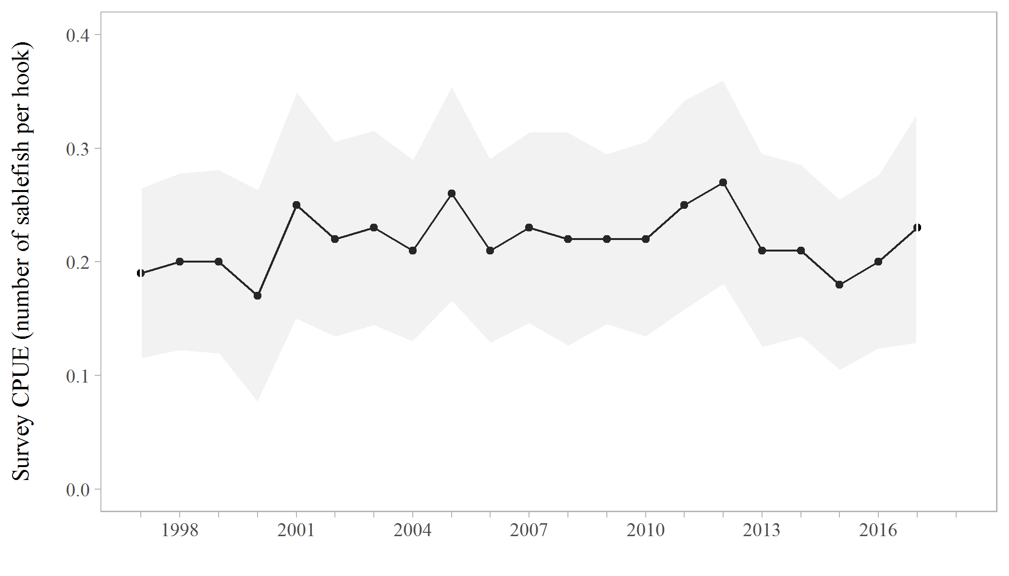

Figure 5. Longline survey CPUE in sablefish per hook (+/- 1 standard deviation), 1997 - 2017.

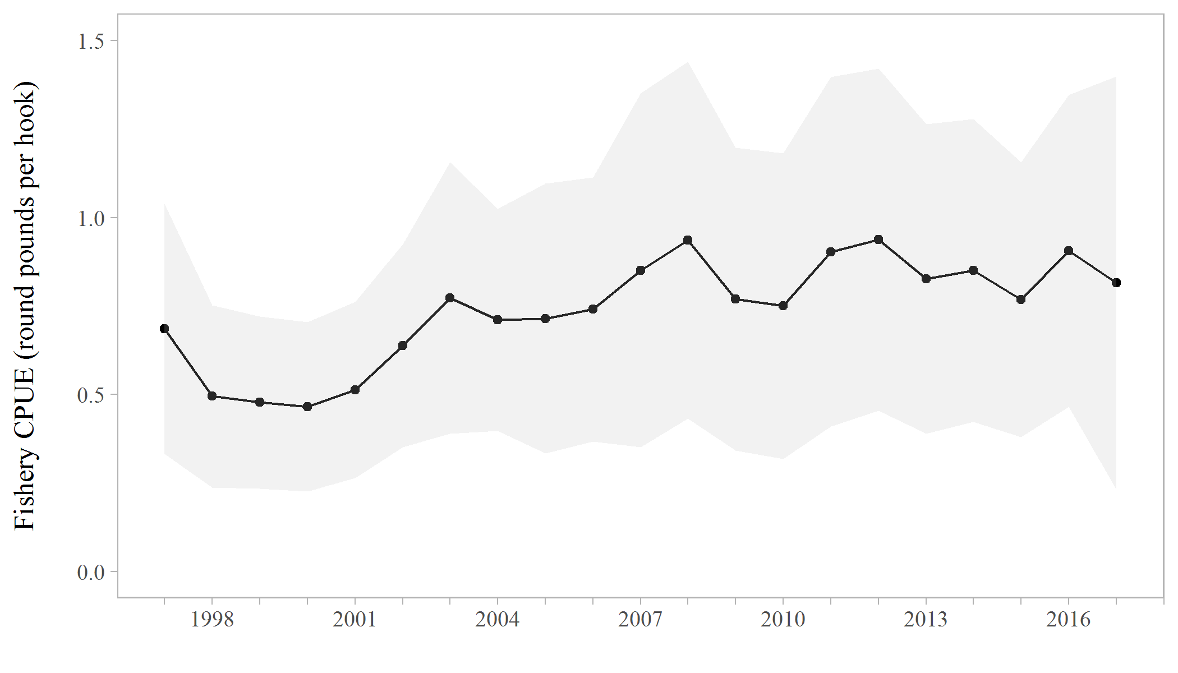

Figure 6. Commercial longline fishery CPUE in round pounds per hook (+/- 1 standard deviation), 1997 - 2017.

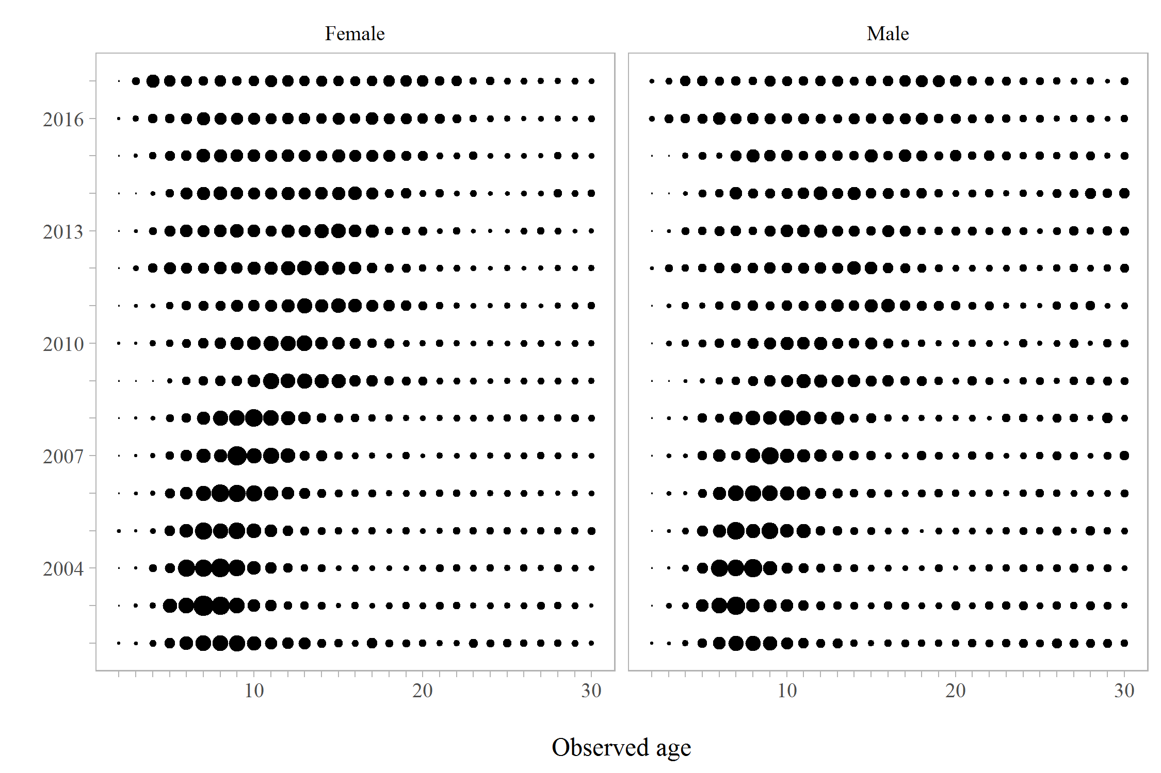

Figure 7. Proportions-at-age for males and females in the ADF&G longline survey, 1997 - 2017.



Figure 8. Proportions-at-age for males and females in the longline fishery, 2002 - 2017.

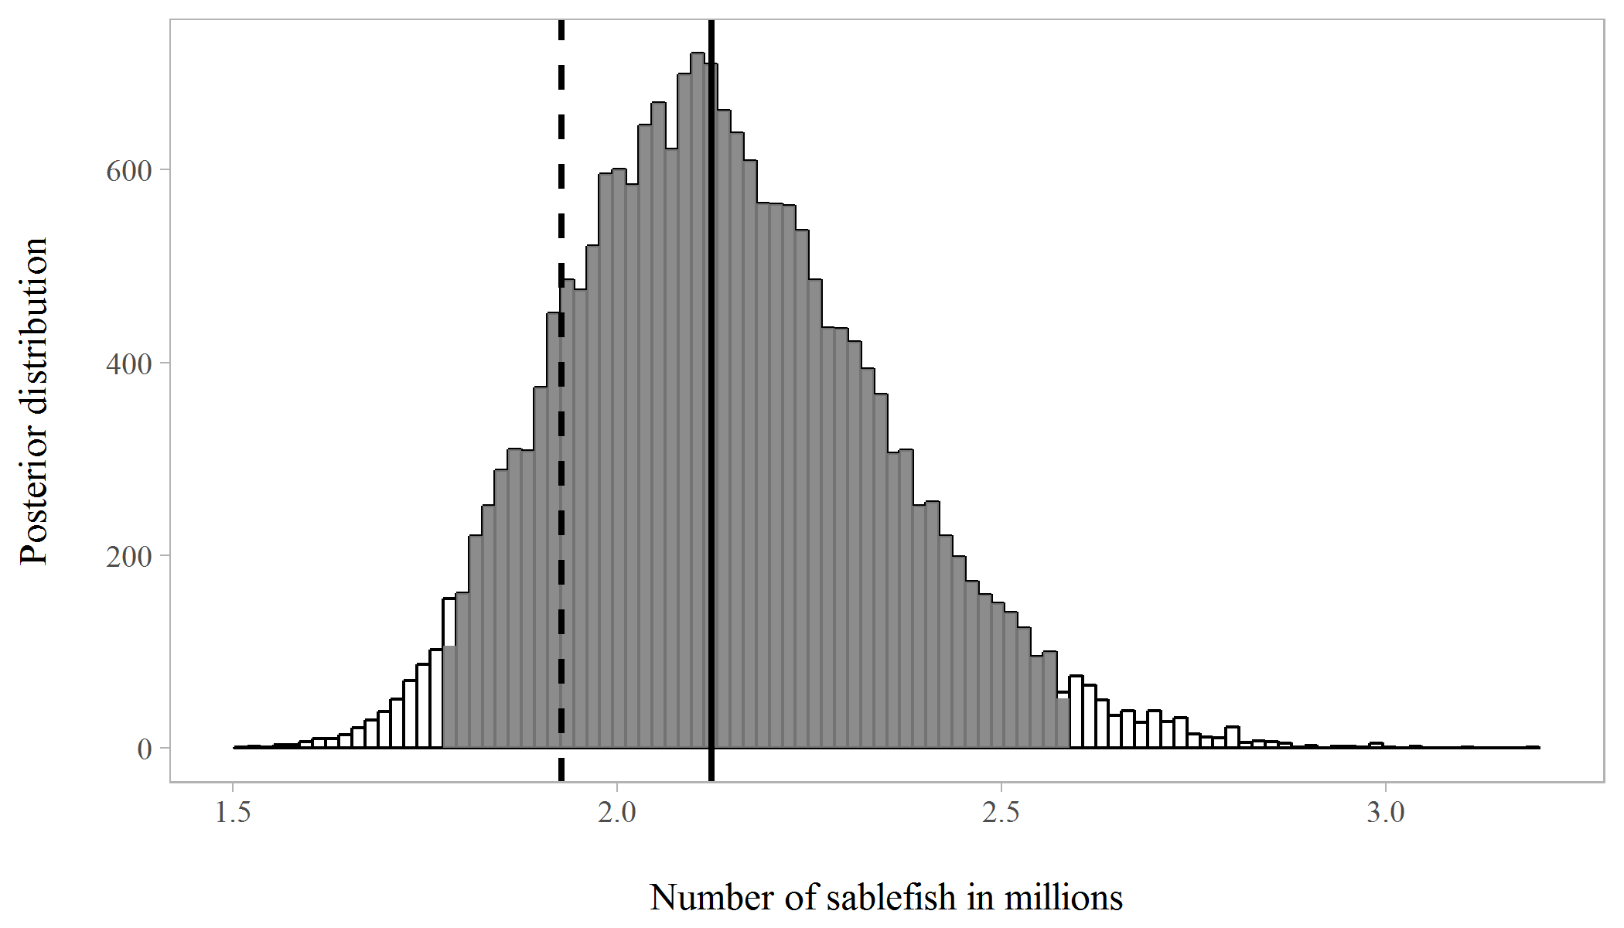

Figure 9. The posterior distribution of abundance (sablefish in millions) in 2017. The shaded area represents the 95% credible interval, the solid horizontal line is the median abundance estimate, and the dashed horizontal line is the adjusted abundance estimate (15th percentile) recommended for the 2018 forecast.

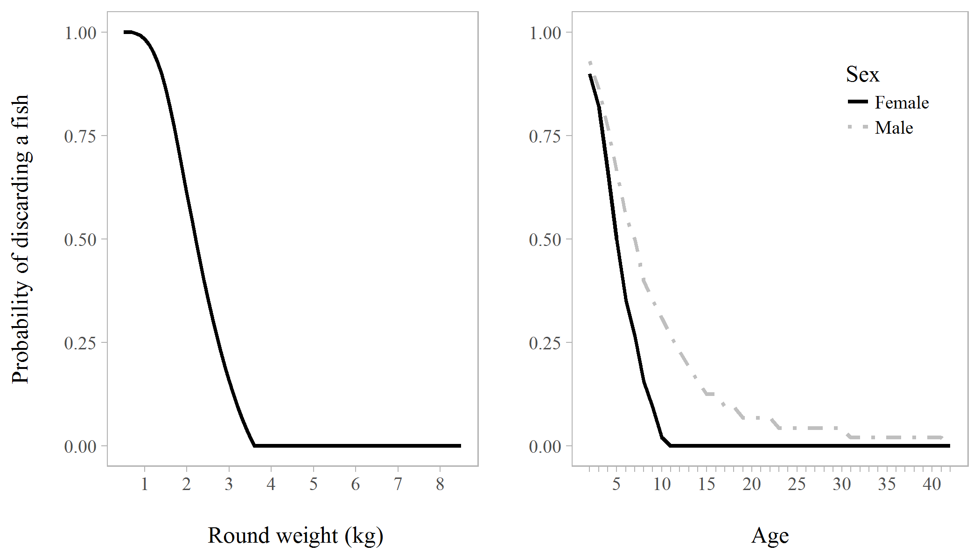

Figure 10. The probability of discarding a fish as a function of weight (left panel), sex, and age (right panel).

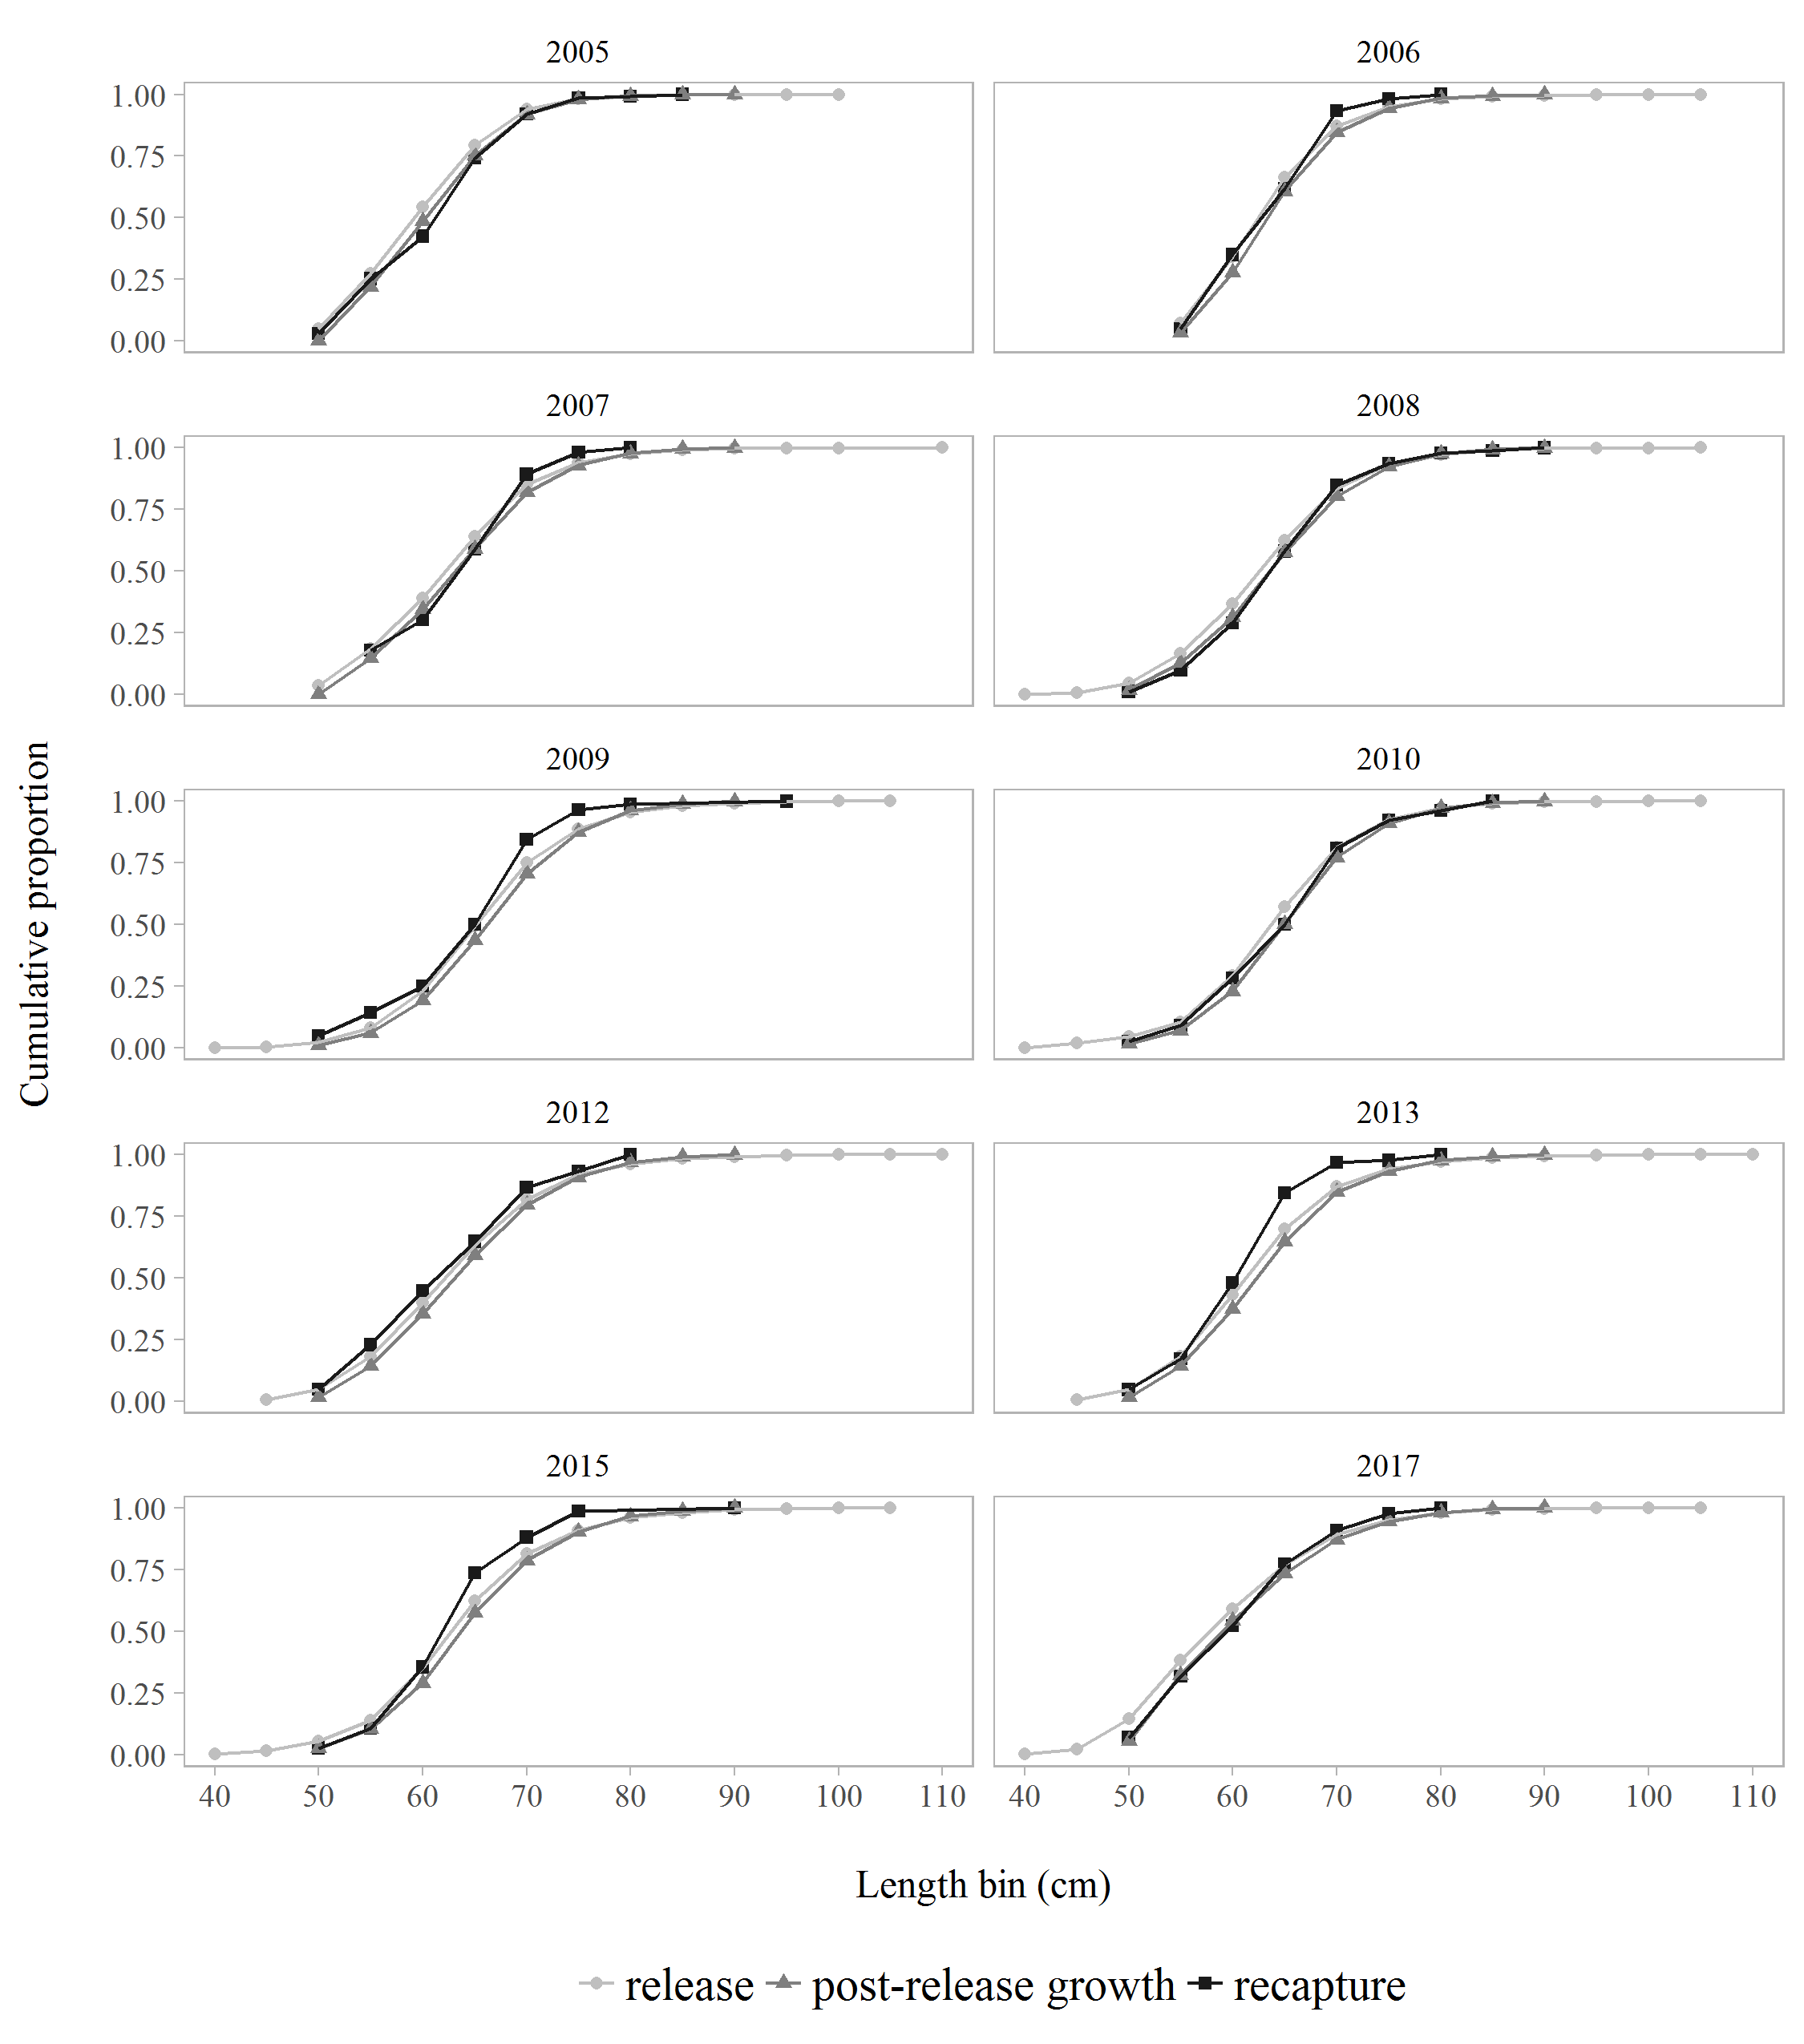

Figure 11. The proportion at length released (light grey), predicted growth after release (dark grey), and recaptured (black) in Chatham Strait by 5-cm length bins, 2005 - 2017.

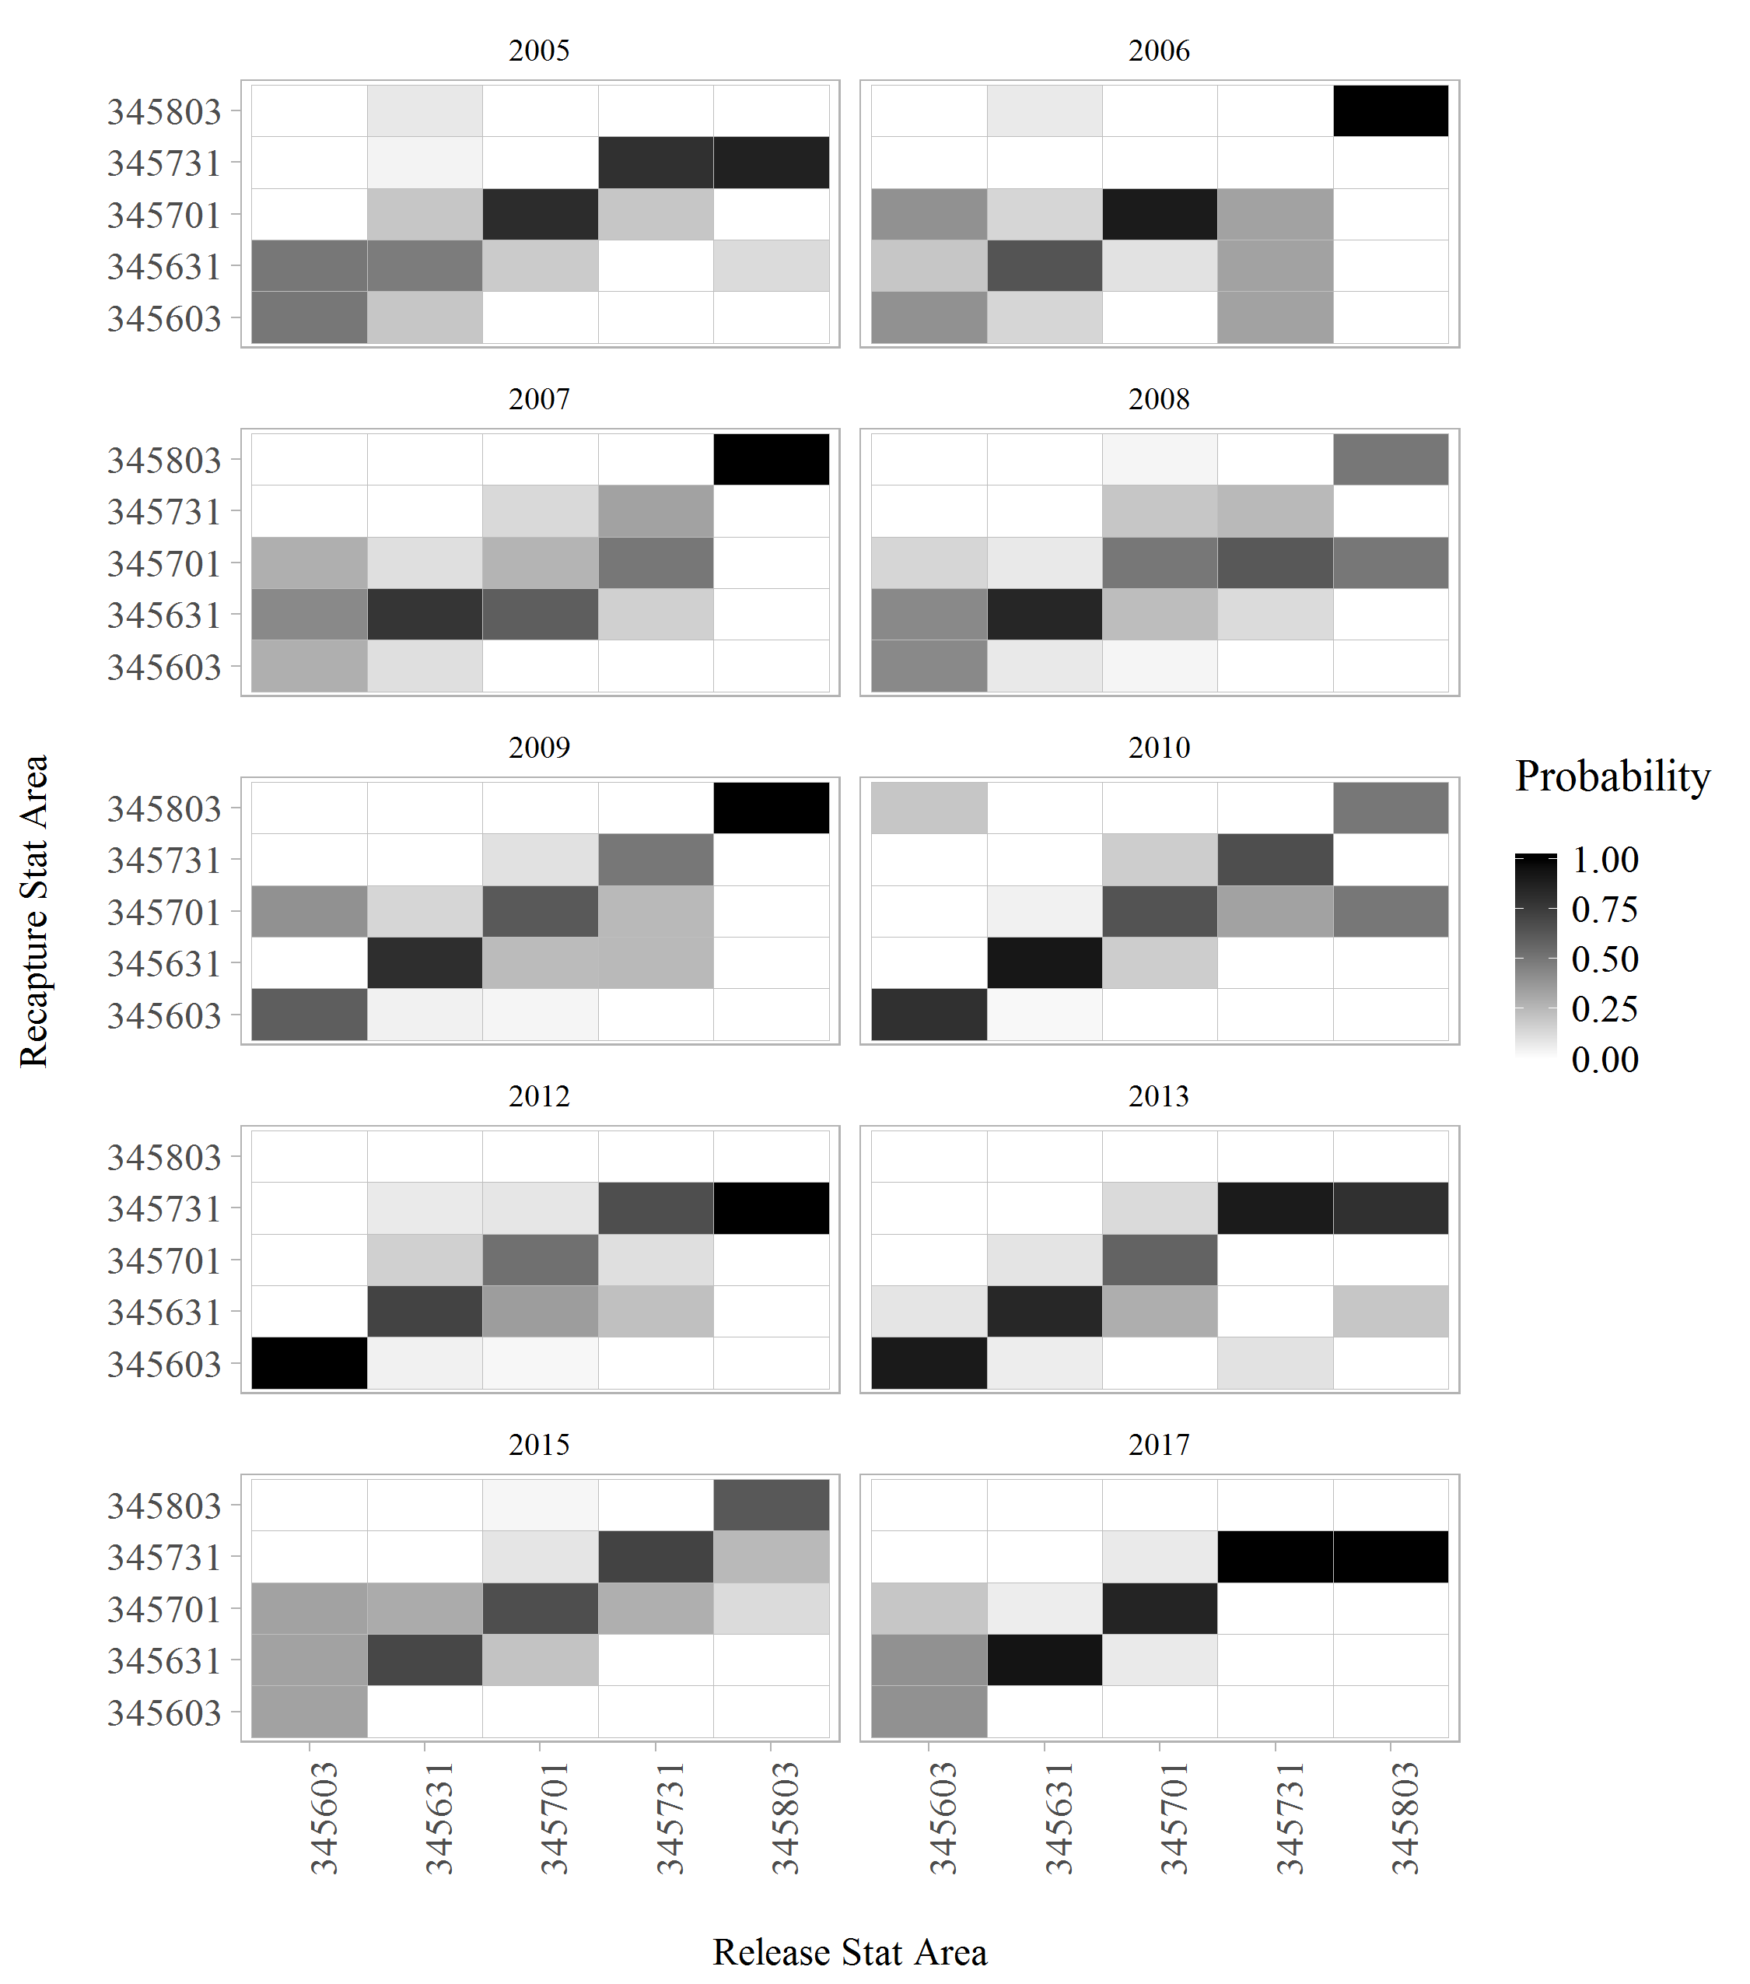

Figure 12. The probability of being recaptured in a statistical area given release area, 2005 - 2017. Statistical areas are arranged roughly north to south along each axis.

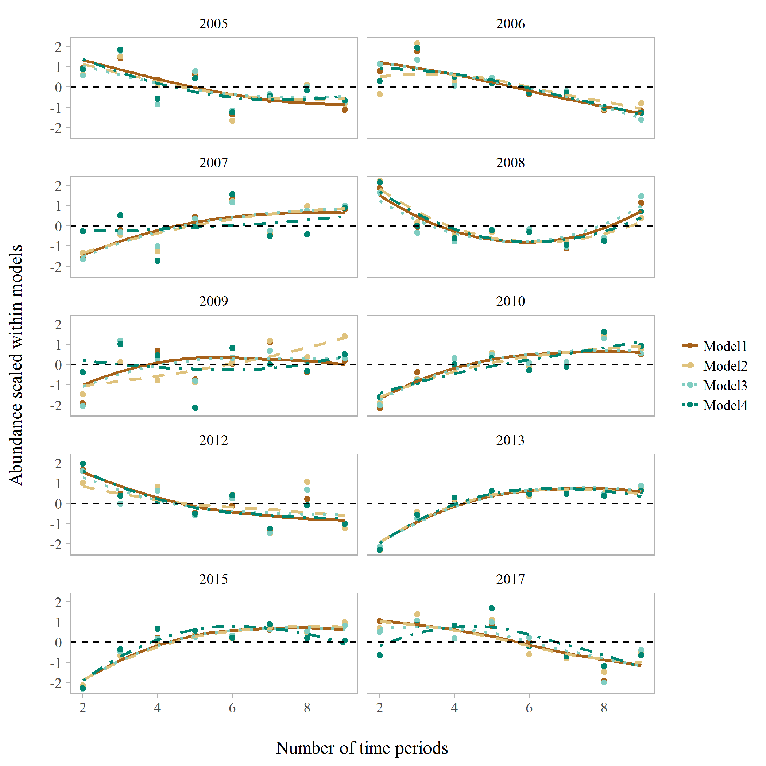

Figure 13. Centered and scaled abundance estimates from four mark-recapture models over a range of different numbers of time periods for years with a tagging survey, 2005 - 2017.

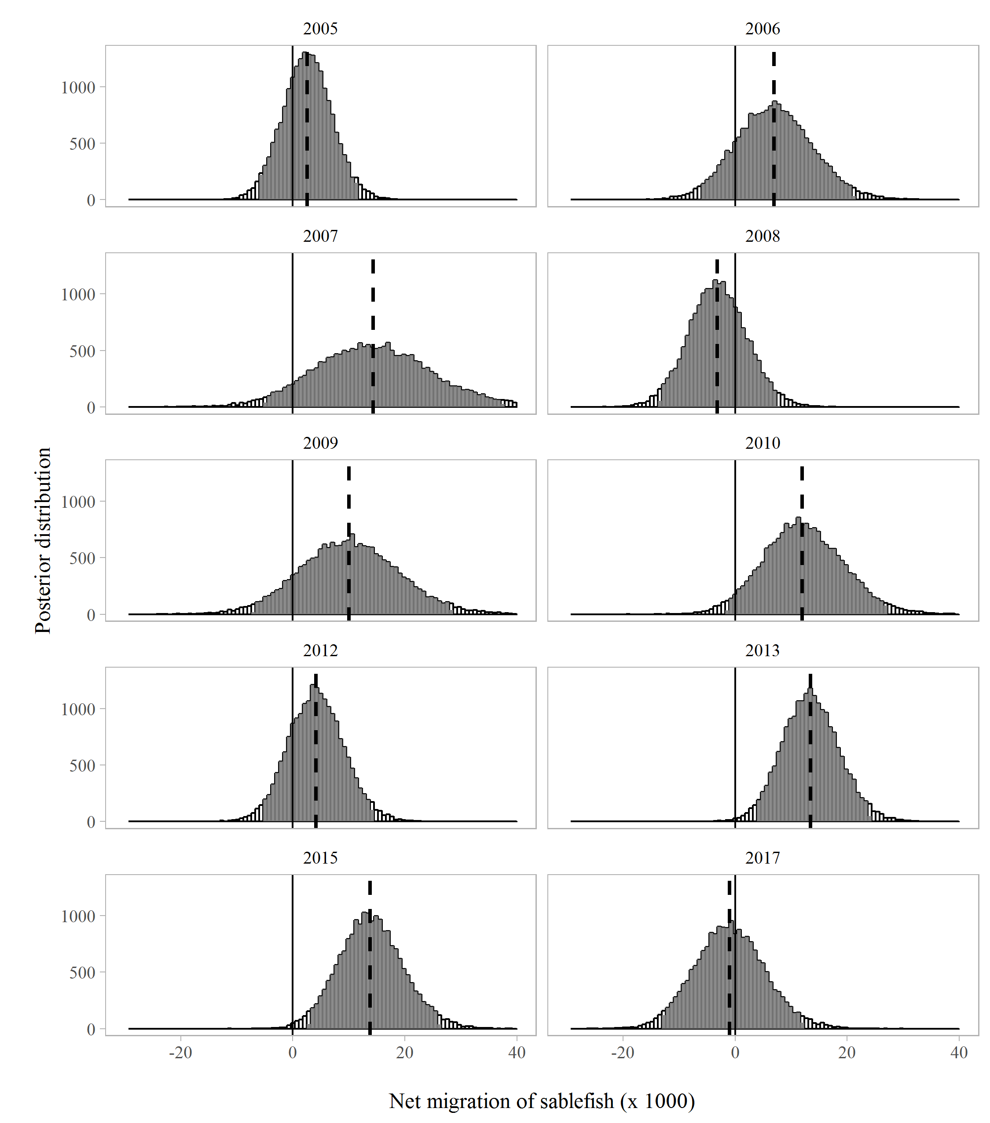

Figure 14. Posterior distribution of net migration into Chatham Strait with 95% credible intervals shaded (Model 2, P=6). The median is denoted by the dashed vertical line. The solid horizontal line at net 0 migration aids in visualization of results across years with a tagging survey, 2005 - 2017.

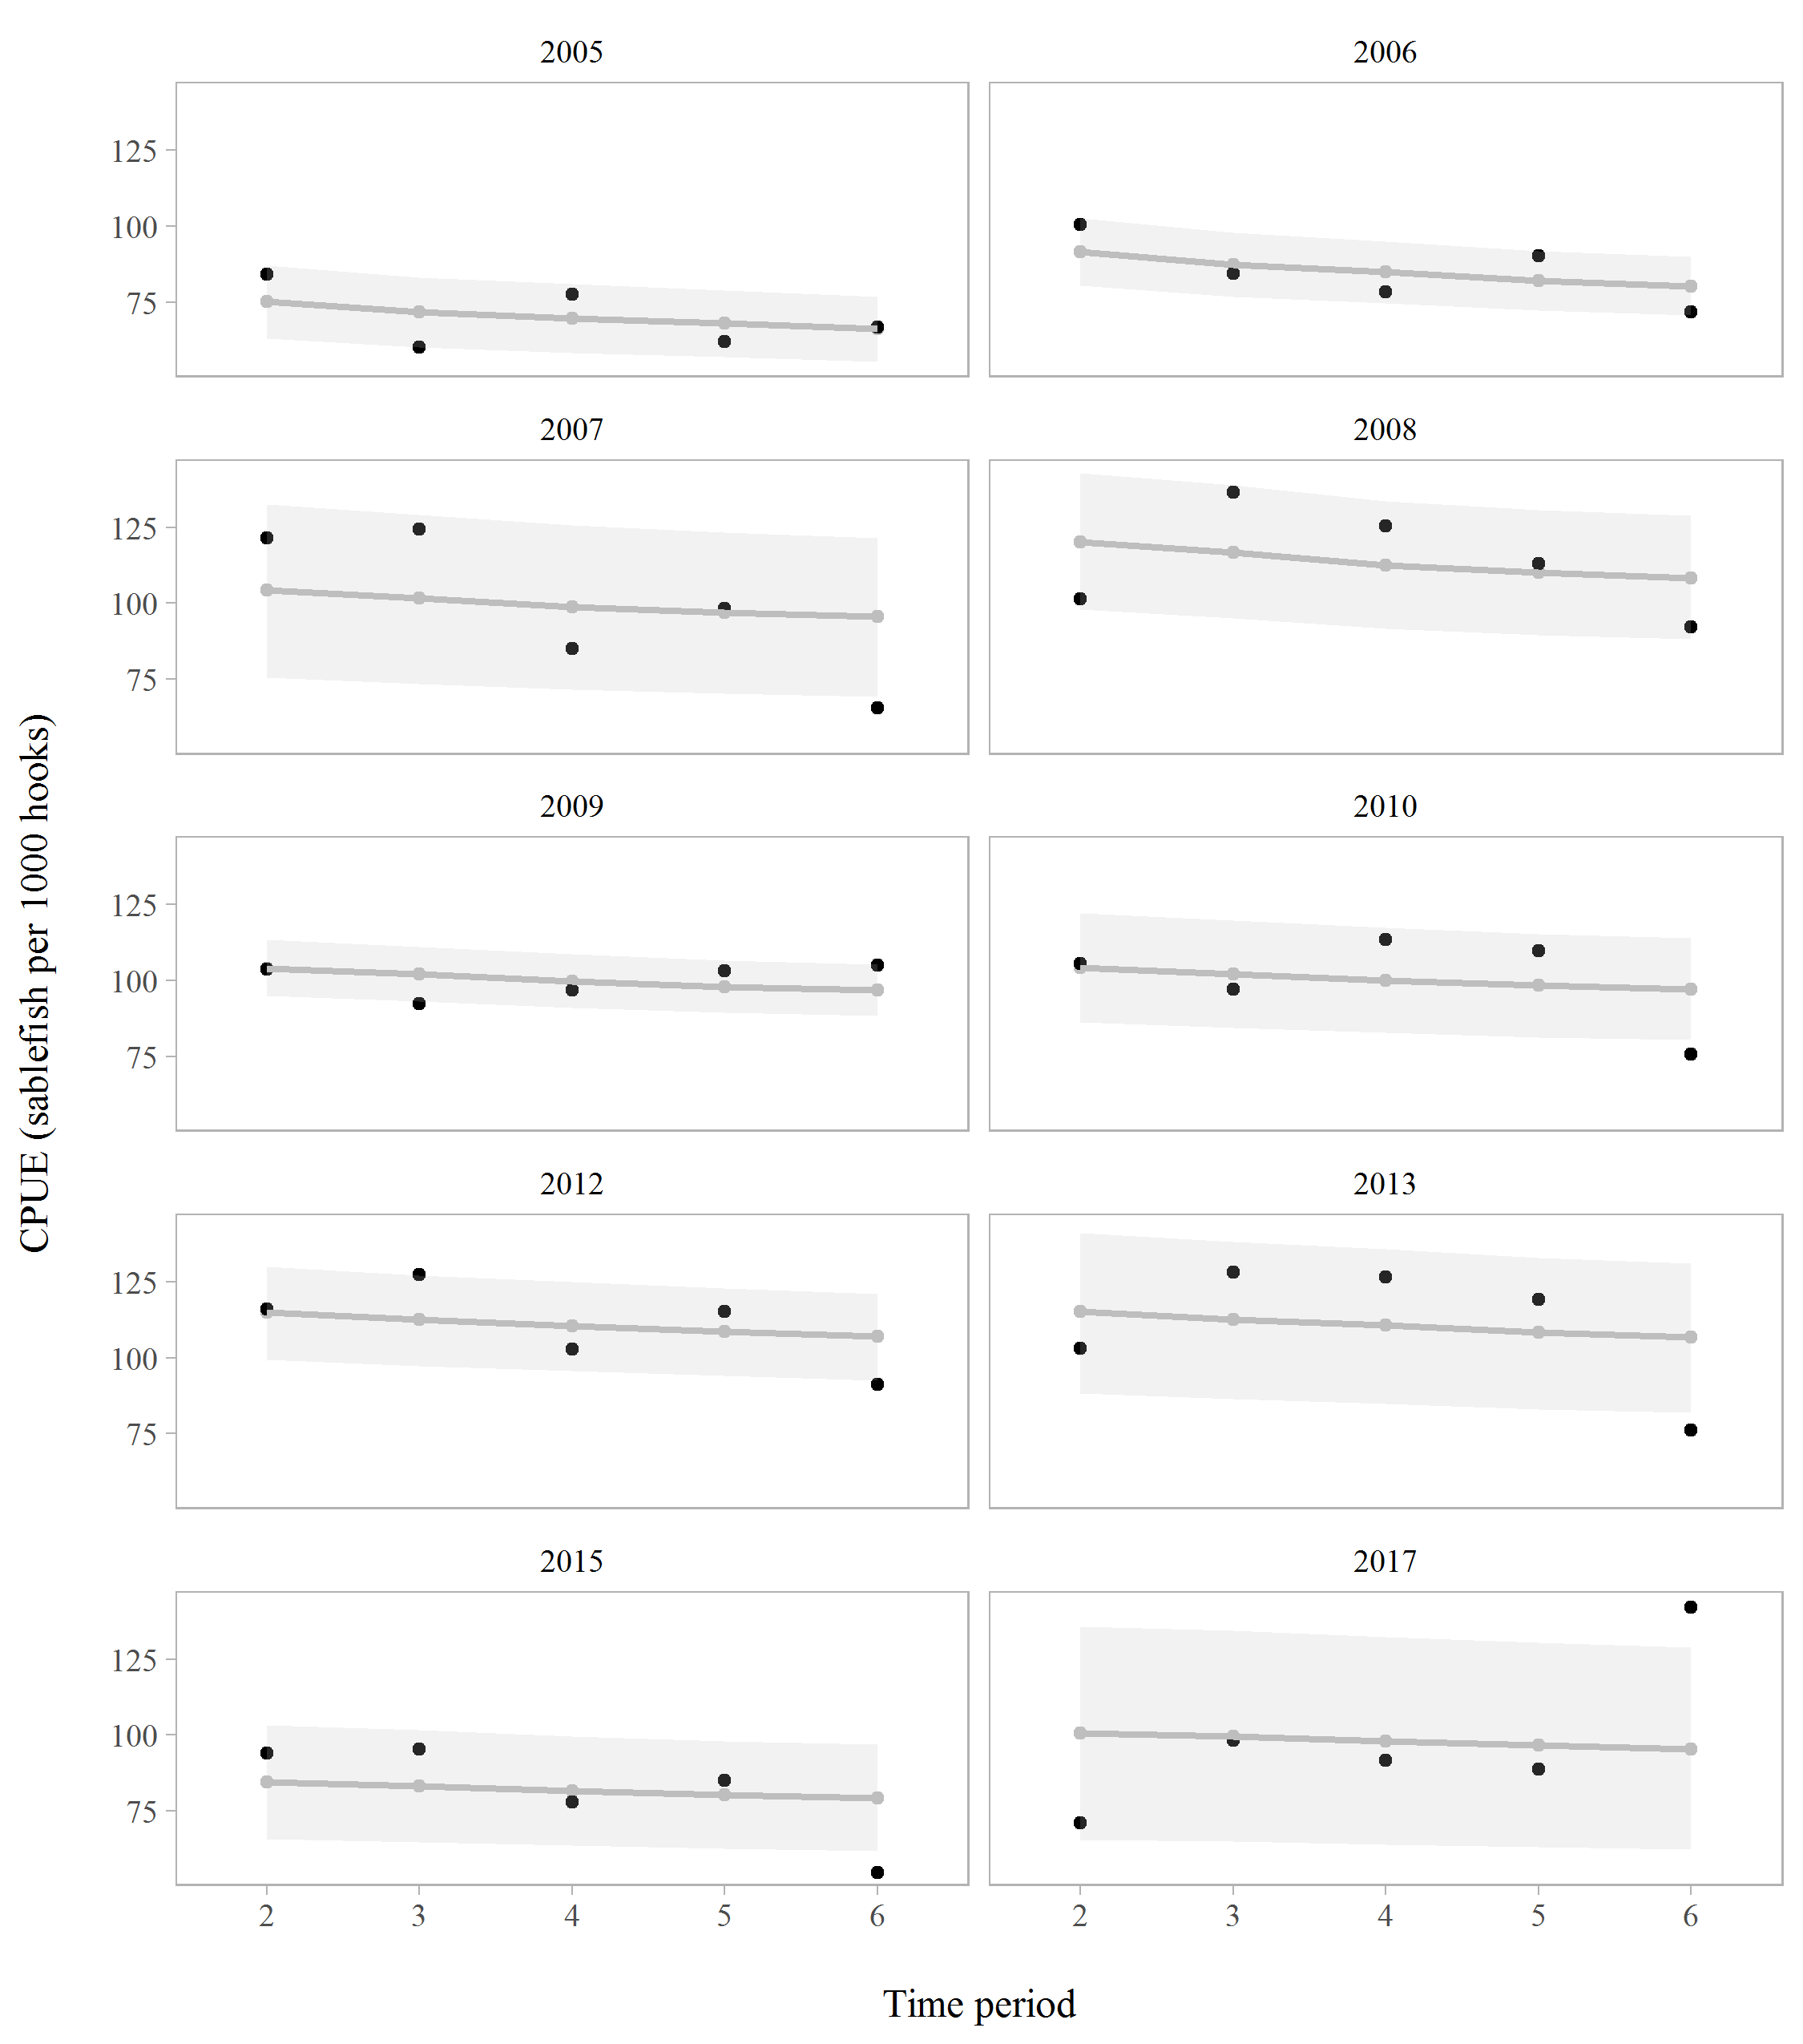

Figure 15. Observed (black) versus fitted (grey) CPUE (sablefish per 1000 hooks) in the longline fishery (Model 3, P=6) for years with a tagging survey, 2005 - 2017. Grey shaded areas indicate 95% credible intervals from the posterior distribution.